**Design Document For**

**FlyGuy**

**Game Description**

Imagine flying through the air as a superhero. Now you can! FlyGuy is a game in which a character is flying up through the sky and while trying to dodge incoming projectiles. The projectiles are have x positions that are randomly chosen between three different values. The clouds can appear in any three of those positions. The game is broken down into two levels, the sky level and the space level. In order for the player to progress to the next level they must pass a certain distance. If the player is hit by a projectile they fall and must restart from the beginning.

In level 1 which is the sky level the player must dodge incoming clouds. If they are hit by a cloud the game ends and the player must start over. In order to progress to the next level you must fly 8000 meters. In level 2, the player is flying through space where there are incoming meteors which must be dodged. The speed in level two increases to make it more difficult to continue.

Up,Up and away!

**Screen-shots**

The first level (right) and second level on left show the player dodging projectiles and collecting coins. There is also a score counter (counts coins) in the top left corner. (these are concept designs and are subject to change)

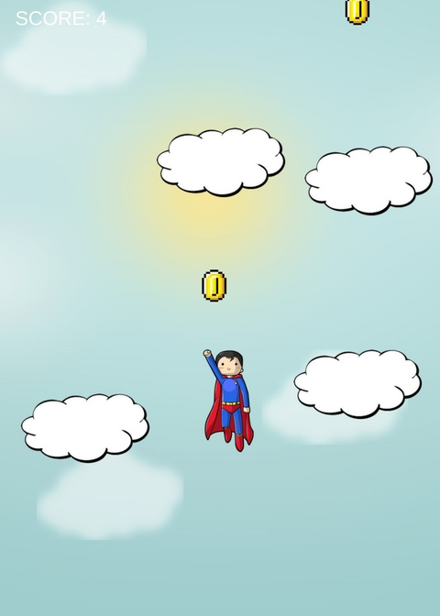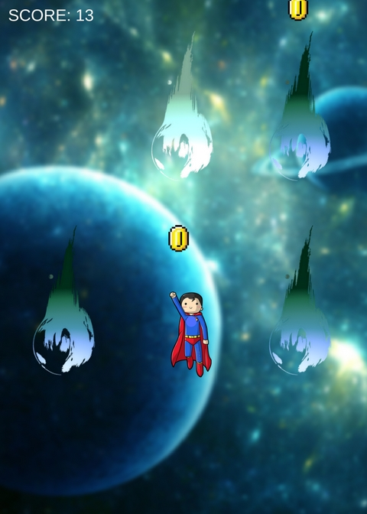

**How to Play**

1.To play the game, right click FlyGuy.py and select open with idle. Then press F5.

2.You will then be Greeted with a intro screen. Press the play button and the game will start.

3. Use the left and right arrows to move the flyer in order to dodge incoming projectiles.

4. q to quit . Good Luck!