Giải bài toán SVM hồi quy bằng cách đưa về bài toán quy hoạch toàn phương:

$$\left\{\begin{aligned}\min_{x}{\frac{1}{2}x^{T}Px+q^{T}x} \\ Gx≤h \\ Ax=b\end{aligned}\right.$$

Với các tham số trong bài toán quy hoạch toàn phương như sau:

x:

|  |
| --- |
| w1 |
| w2 |
| … |
| wn |
| b |
| z1 |
| z2 |
| … |
| zm |
| zs1 |
| zs2 |
| … |
| zsm |

P:

|  |  |  |  |  |  |  |  |  |  |  |  |  |
| --- | --- | --- | --- | --- | --- | --- | --- | --- | --- | --- | --- | --- |
| 1 (w1) |  |  |  |  |  |  |  |  |  |  |  |  |
|  | 1 (w2) |  |  |  |  |  |  |  |  |  |  |  |
|  |  | … |  |  |  |  |  |  |  |  |  |  |
|  |  |  | 1 (wn) |  |  |  |  |  |  |  |  |  |
|  |  |  |  | 0 (b) |  |  |  |  |  |  |  |  |
|  |  |  |  |  | 0 (z1) |  |  |  |  |  |  |  |
|  |  |  |  |  |  | 0 (z2) |  |  |  |  |  |  |
|  |  |  |  |  |  |  | … |  |  |  |  |  |
|  |  |  |  |  |  |  |  | 0 (zm) |  |  |  |  |
|  |  |  |  |  |  |  |  |  | 0 (zs1) |  |  |  |
|  |  |  |  |  |  |  |  |  |  | 0 (zs2) |  |  |
|  |  |  |  |  |  |  |  |  |  |  | … |  |
|  |  |  |  |  |  |  |  |  |  |  |  | 0 (zsm) |

q:

|  |
| --- |
| 0 (w1) |
| 0 (w2) |
| … |
| 0 (wn) |
| 0 (b) |
| c (z1) |
| c (z2) |
| … |
| c (zm) |
| c (zs1) |
| c (zs2) |
| … |
| c (zsm) |

G:

|  |  |  |  |  |  |  |  |  |  |  |  |
| --- | --- | --- | --- | --- | --- | --- | --- | --- | --- | --- | --- |
| X | -1 | 0 | | | | | -1 (zs1) |  |  |  | |
|  | -1 (zs2) |  |  | |
|  |  | … |  | |
|  |  |  | -1 (zsm) | |
| -X | 1 | -1 (z1) |  |  |  | | 0 | | | | |
|  | -1 (z2) |  |  | |
|  |  | … |  | |
|  |  |  | -1 (zm) | |
| 0 | 0 | 0 | | | | | -1 (zs1) |  |  | |  |
|  | -1 (zs2) |  | |  |
|  |  | … | |  |
|  |  |  | | -1 (zsm) |
| 0 | 0 | -1 (z1) |  |  | |  | 0 | | | | |
|  | -1 (z2) |  | |  |
|  |  | … | |  |
|  |  |  | | -1 (zm) |

h:

|  |  |  |  |  |  |  |  |  |  |  |  |  |  |  |  |
| --- | --- | --- | --- | --- | --- | --- | --- | --- | --- | --- | --- | --- | --- | --- | --- |
| ε+Y1 | ε+Y2 | … | ε+Ym | ε-Y1 | ε-Y2 | … | ε-Ym | 0 (z1) | 0 (z2) | … | 0 (zm) | 0 (zs1) | 0 (zs2) | … | 0 (zsm) |

A:

|  |  |  |  |  |  |  |  |  |  |  |  |  |
| --- | --- | --- | --- | --- | --- | --- | --- | --- | --- | --- | --- | --- |
| 0 (w1) | 0 (w2) | … | 0 (wn) | 0 (b) | 0 (z1) | 0 (z2) | … | 0 (zm) | 0 (zs1) | 0 (zs2) | … | 0 (zsm) |

b:

|  |
| --- |
| 0 |

Chạy giải thuật SVM hồi quy với dữ liệu:

|  |  |  |  |
| --- | --- | --- | --- |
| X | Y | c | ε |
| 1 | 5 | 10 | 1 |
| 2 | 10 |
| 3 | 12 |
| 4 | 15 |

Thu được kết quả:

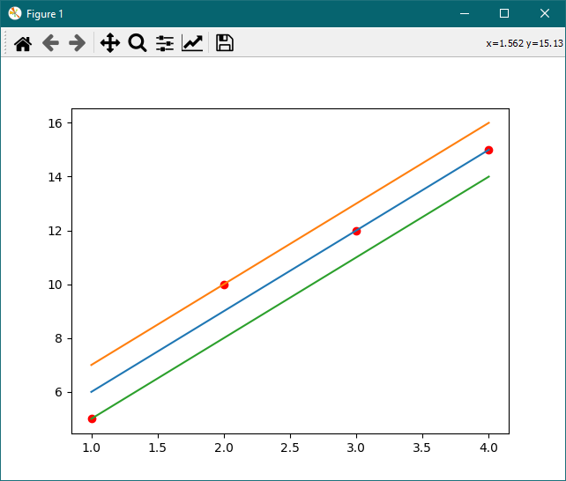

Bảng các tham số SVM hồi quy được lấy từ x

|  |  |  |  |
| --- | --- | --- | --- |
| w | b | z | zs |
| 3 | -3 | 0 | 0 |
| 0 | 0 |
| 0 | 0 |
| 0 | 0 |

Code Python:

from qpsolvers import solve_qp

import numpy as np

import matplotlib.pyplot as plt

def SVM(X: np.ndarray, Y: np.ndarray, c: int = 100, epsilon: int = 1) -> tuple:

m, n = X.shape

P = np.diag(np.hstack((np.ones(n), np.full(m*2+1, 1e-6))))

q = np.hstack((np.zeros(n+1), np.full(m*2, c)))

G = np.vstack((np.hstack((X,

np.full((m, 1), -1),

np.zeros((m, m)),

np.diag(np.full(m, -1)))),

np.hstack((-X,

np.ones((m, 1)),

np.diag(np.full(m, -1)),

np.zeros((m, m)))),

np.hstack((np.zeros_like(X),

np.zeros((m, 1)),

np.zeros((m, m)),

np.diag(np.full(m, -1)))),

np.hstack((np.zeros_like(X),

np.zeros((m, 1)),

np.diag(np.full(m, -1)),

np.zeros((m, m))))))

print(G)

h = np.hstack((epsilon+Y, epsilon-Y, np.zeros(m*2)))

A = np.zeros(n+1+m*2)

b = np.zeros(1)

res = solve_qp(P, q, G, h, A, b)

return np.split(res, [n, n+1, n+1+m])

def main():

X = np.array([

[1],

[2],

[3],

[4]

])

Y = np.array([5, 10, 12, 15])

plt.plot(X, Y, "ro")

epsilon = 1

w, b, z, zs = SVM(X, Y, epsilon=epsilon)

print(w)

print(b)

print(z)

print(zs)

x_svm = np.array([X.min(), X.max()])

plt.plot(x_svm, w*x_svm-b)

plt.plot(x_svm, w*x_svm-b+epsilon)

plt.plot(x_svm, w*x_svm-b-epsilon)

plt.show()

if __name__ == "__main__":

main()