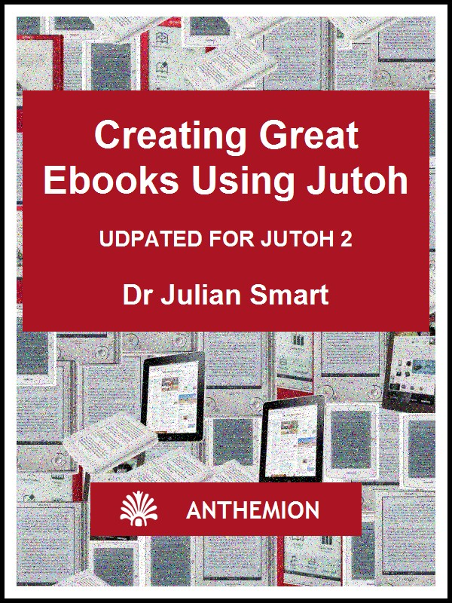

Creating Great Ebooks Using Jutoh
A complete guide to making ebooks for Kindle, iPad, Sony Reader, Nook, Kobo and more, from new project to publication
by Julian Smart
Published by Anthemion
Copyright Julian Smart 2014
Edition 2.1
Updated for Jutoh 2




All rights reserved. You are welcome to redistribute this book in its original form.
The author acknowledges the trademarked status and trademark owners of various products referenced in this work.
This book was created using Jutoh.
The author acknowledges the trademarked status and trademark owners of various products referenced in this work, which have been used without permission. The publication/use of these trademarks is not authorized, associated with, or sponsored by the trademark owners.
Table of Contents
From the Horse’s Mouth 9
Preface 10
Bring on the revolution 10
About the author 10
How this book is structured 11
Conventions and terms used in this book 12
Chapter 1: Introduction to Ebooks and Jutoh 14
Ebook formats 14
What is Jutoh? 15
What kinds of book can be created with Jutoh? 15
The book creation lifecycle 16
How to get content into Jutoh 17
Tools to use with Jutoh 17
Summary 19
Chapter 2: Getting Started 20
Creating a new project 20
Step 1. Metadata 20
Step 2. Project Location 21
Step 3. Layout Choice 22
Step 4. Import Options 23
Step 5. Import Method 24
Step 6. Single File Import 25
Step 7. Cover Design 26
Compiling the project 27
Summary 29
Chapter 3: The Jutoh User Interface 30
Menu bar and toolbar (1) 30
Organizer (2) 31
Control Panel (3) 31
Document area (4) 32
Log and error windows (5) 33
Formatting Palette (6) 34
Getting help 34
Project properties dialog 37
Customising the user interface 37
Summary 38
Chapter 4: Working With Projects 39
Overview 39
Creating and deleting documents 40
Moving documents 40
Managing project files 40
Where is my project? 41
Document types 41
Source code document 42
Summary 43
Chapter 5. Importing Files 44
What can Jutoh import? 44
Microsoft Word XML (DOCX) and OpenDocument Text (ODT) 44
Plain text 49
HTML 52
Epub 52
Importing into an existing project 52
Reimporting 52
Summary 52
Chapter 6: Editing and Formatting Content 53
Why divide a book into sections? 53
Basic content editing 54
Formatting text 55
Formatting paragraphs 56
Special symbols 57
Pictures 58
Page breaks 59
Non-breaking spaces and hyphens 59
Horizontal rules 59
Bookmarks 59
Links 60
Footnotes 60
Index entries 61
Comments 61
The basics of formatting using named styles 61
Using the formatting palette to apply styles 63
Applying styles using shortcuts and favourites 65
Using fonts 65
Line and paragraph spacing 66
Indentation 66
Alignment 66
Headings 67
Lists 67
Adding keywords 68
Editing document properties 69
Previewing your work 70
Summary 70
Chapter 7: Editing Your Book’s Metadata 72
The metadata panel 72
Metadata elements 73
Viewing the generated metadata 75
Specifying metadata defaults 76
Summary 76
Chapter 8: Creating Your Cover Design 77
Cover design basics 77
Using an existing design 78
Using the cover designer 78
Object size and position 79
Object background 79
Text 79
Exporting your design 80
Specifying a cover for Kindle 80
The cover page versus the cover image 80
Specifying the cover image format 81
Using multiple cover designs 81
Cover display on different devices 81
Summary 81
Chapter 9: Understanding Configurations 82
Configuration basics 82
Editing configurations 82
Using configurations 83
Configuration categories 85
Locations 85
Formats 86
Cover Design 86
Options 87
Styles 88
String Tables 89
HTML Formatting 89
Text Formatting 91
Images and Media 92
Advanced Formatting 93
Chapter Separators 93
Fonts and Colour 93
Mobile 94
Fixed Layout 94
Navigation 95
Conditional Sections 96
Commands 96
Comments 97
General 97
Summary 97
Chapter 10: Working With Pictures 98
Inserting and editing pictures 98
Editing basic picture properties 99
Editing size properties 100
Editing margin, border, background and advanced properties 103
Adding captions to images 104
Special considerations for iBooks 105
Inserting SVG pictures 105
Importing pictures from DOCX, ODT and HTML 105
Image export to ebooks 106
Exporting images to files 107
Working with large images 107
Using media objects to insert images 107
Summary 107
Chapter 11: Working With Indexes 108
Creating an advanced table of content 108
Editing table of contents properties 115
Adding multiple tables 115
Specifying and stripping link styling 116
Creating a table of contents manually 116
Creating an alphabetical index 116
Configuration 118
Importing index entries 119
Creating footnotes and endnotes 119
Configuration 119
Footnotes 120
Endnotes 120
Importing footnotes 121
Summary 121
Chapter 12: Working With Style Sheets 122
Introduction 122
Kinds of style 122
Editing style sheets 123
Editing paragraph styles 124
Editing character styles 127
Editing list styles 127
Editing box styles 130
Creating new styles 130
Applying named styles 130
Automatic styles 131
CSS dimensions 131
CSS customisation 132
Special style names 133
Importing and exporting style sheets 133
Finding and replacing styles 133
Style substitutions 134
Using styles to change ebook content 134
Summary 135
Chapter 13: Working With String Tables 136
Introduction 136
Troubleshooting string tables 137
Summary 137
Chapter 14: Working With Tables 139
Introduction 139
Creating and editing tables 139
Editing tables 141
Changing the size of cells, rows and columns 144
About table borders 144
Importing tables 145
Table compatibility in ebook readers 145
Editing the template gallery 146
Summary 146
Chapter 15: Working With Boxes 147
Introduction 147
Creating and editing boxes 147
Importing boxes 149
Using box styles 149
Text box compatibility in ebook readers 150
Summary 150
Chapter 16: Working With Tag Objects 151
Introduction 151
Inserting tag objects 151
Anatomy of a tag object 152
Code generation 152
Custom tag objects 153
Summary 153
Chapter 17: Adding Narration to Your Book 154
Introduction 154
Step 1. Mark up your document with spans and identifiers 154
Step 2. Add your narration audio files to Jutoh 155
3. Create a label file 156
4. Import the label track 157
Step 5. Specify a character style for highlighting narrated content 158
Step 6. Compile the book 159
Summary 159
Chapter 18: Creating Fixed Layout Books 160
The fixed layout sample 160
What is a fixed layout book? 160
Starting from an existing file format 161
What are the disadvantages of using fixed layout? 161
What formats and features are supported by Jutoh? 162
Creating a fixed layout project 163
Editing pages 164
Adding image and text objects 165
Clipboard operations 166
Selection and keyboard navigation 166
Aligning objects 166
Adding borders 167
Pre-rendering objects 168
Font size and dimension units 168
Embedding fonts 169
Table of contents 169
Cover 169
Generating and testing your ebook 169
Changing fixed layout configuration settings 170
Formatting for Kindle 171
Magnified regions in KF8 171
Recommended settings for KF8 172
Formatting for iBooks/Kobo 172
Further reading 173
Summary 173
Chapter 19: Adding Interactivity To Your Book 174
Introduction 174
Form objects 174
Using form objects 175
Summary 176
Chapter 20: Making Your Books Accessible 177
Introduction 177
Epub 3 and Jutoh 177
Editing your project for accessibility 179
How the style mapping works 180
Using speech in your books 180
Devices and software supporting Epub 3 181
Further reading 181
Summary 181
Chapter 21: Advanced Topics 182
Embedding fonts 182
Embedding media 183
Embedding a PDF 184
Setting a background image 184
Understanding encodings 185
Guide types 185
How to format drop caps 186
How to format small caps 187
How to add an ISBN to your books 187
How to specify which sections will be included in the ebook 188
Removing underlining from links in HTML-based formats 189
Jutoh and Epub 3 189
Summary 190
Chapter 22: Troubleshooting Your Book 191
What errors can occur? 191
Syntax errors 191
Structural errors 194
Formatting errors 196
Content errors 199
Platform errors 200
Smashwords errors 200
iBooks errors 201
Lulu errors 201
Import/export errors 201
Import errors 201
Export errors 202
Expectation errors 202
Third-party troubleshooting tools 202
When all else fails 203
Summary 203
Chapter 23: Understanding Ebook Formats and Platforms 204
Formats 204
Epub 204
Mobipocket 204
Adobe Portable Document Format (PDF) 204
OpenDocument Text (ODT) 205
MP3 206
Platforms 206
Amazon Kindle 206
Paragraph spacing in Mobipocket 207
Lists in Mobipocket 207
Setting the start page 207
Indenting table of contents items 208
Multimedia and JavaScript in Kindle books 208
Kindle book covers 208
Checking your Kindle ebook 208
iBooks 209
Barnes & Noble Nook 210
Kobo 210
Diesel eBook Store 211
Lulu 211
Sony Reader Store 211
Smashwords 211
Your own web site 212
Caveats about using multiple distribution platforms 212
Summary 213
Chapter 24: Marketing Your Book 214
Step 1: Describe your book 214
Step 2: Be able to talk confidently about it 215
Step 3: Find your Special Subject – be an expert or an enthusiast 216
Step 4: Build a platform 216
Further tips 217
Essential reading 218
Summary 218
Glossary 219
Appendix A: Installing Jutoh 223
Installing on Windows 223
Installing on Mac OS X 224
Installing on Linux 226
How to use Jutoh with an external drive 227
Overview 227
Using a mobile drive for data 228
Using a mobile drive for settings 228
Running Jutoh from a mobile drive 228
Launching Jutoh on Windows 229
Launching Jutoh on Linux 229
Launching Jutoh on Mac 229
Appendix B: Configuring Jutoh 230
Viewer applications 230
Conversion and checking applications 232
Text-to-speech configuration 233
Customising shortcuts and favourites 234
Shortcuts 234
Favourites 236
Customising toolbars 238
Customising auto-replace 239
Appearance options 241
Desktop options 242
Project options 243
Miscellaneous options 245
Appendix C: The Jutoh Box Model 247
Change Log 248

From the Horse’s Mouth
“We hit the Google trail in search of e-book enlightenment. If it wasn’t for Jutoh, we’d still be in the dark.”
– Australian Financial Review, July 27th, 2010 (“Jutoh writes a new chapter in the manual of e-publishing”)
“Jutoh is a remarkable program. In a complex field it offers a simple-to-use interface with generous options and faultless performance. It accepts a wide variety of input files and can create MOBI, EPUB and other standard ebook formats. It compiles and checks projects and links to preview software. It also allows for extensive metadata entry. All this in a neat and tidy presentation. When the only other options seemed to be an expensive and unnecessary outlay on something like Adobe In-Design, this came out of the blue and has answered all our prayers. I love it.”
– Ellis Delmonte, Hawkwood Books, Lincoln
“I just wanted to say your software is bloody genius. The Smashwords conversion went brilliantly... Jutoh has been a God-send and the learning curve will really pay off in the future. Having come across many many forums where new digital authors are having a painful birth in converting to the digital platform, Jutoh is something that many of them don’t know about. Your software will make a difference. My book is now live on the Amazon and Smashword sites. It reaches Apple in two weeks. Your software helped make that happen.”
– Will B.
“Jutoh is way ahead of any of the ebook editors – and I have tried a number of them, even Adobe’s InDesign.”
– Dan R.
“I just wanted to write and thank you a thousand times over for coming up with Jutoh... I can’t begin to tell you how much simple it has made my life. Create once and send out everywhere in all formats is a Godsend, and I have been able to supplement my own titles with those of others, through my publishing company. I learned a lot about proper formatting for eBooks, taking into consideration the various formats, from ePub to ODT and even plain text. I dreaded the thought of manually going through each one, only to have to wade through the inevitable feedback, in order to fix everything by trial and error. In a single evening, I was able to submit to both B&N and Smashwords, with flying colors, no less! Thank you for putting such a wonderful product together.”
– Dallas T.
“Thanks again for all the help. Jutoh is by far the best epublishing tool I’ve used so far!”
– Blaise M.
“Simply put, Jutoh is the best conversion tool out there. The user interface is very friendly, there are many extras built-in, and the documentation is thorough. Jutoh can take a very large book with many images and successfully convert to multiple ebook formats that pass the epub validation checks. Anyone who has a book in MS Word can save it to OpenOffice (which is free, and has a built-in PDF capability amongst other features) and import it to Jutoh. I have found the Jutoh developer to be extremely accessible, responsive and eager to receive feedback. This is a high-end, professional piece of software that is practically a give-away!”
– Kathy M.
“I wanted to thank you so much for the Jutoh tool! It’s been wonderful! I was so pleased with how it worked in creating a mobipocket Kindle edition of a book I’ve been writing.”
– Joshua D.
“Thank you for another quick, thorough response! Your customer service is amazing.”
– Kristine K.

Preface

Bring on the revolution
The publishing world is currently in turmoil largely thanks to the freedoms and opportunities that ebooks bring. Simultaneously freeing consumers from the physical realities of print and paper, and freeing authors from the gatekeeper mentality that has held back much good content (as well as less literary output, to be sure), the ebook phenomenon has just hit the mainstream now that ebook reader gadgets have become practical and affordable. Kindles, Kobos and a huge variety of tablets have become popular Christmas presents and each year will see more choice on offer.
To join the revolution, authors and publishers need to provide ebooks in essentially two popular formats – Epub and Mobipocket (Kindle). (Other formats, such as PDF, are sometimes used for creating ebooks but PDFs play less well on reader hardware and cannot be reformatted to adapt to reader constraints. While Jutoh can help with creating PDFs, we will concentrate on the two standard ebooks formats.) To some extent, creating an Epub or a Kindle file is a black art. You’ll find blogs and forums full of advice on using obscure XML and HTML markup. You’ll read about the hoops people are jumping through to get this or that formatting correct on iBooks or Kindle or Nook. You may see advice on editing XML to create a table of contents before adding it to an Epub zip file. For the uninitiated trawling through this information, the prospect of creating an ebook can look frankly terrifying.
Fortunately, with Jutoh it doesn’t have to be that way. You don’t have to deal with OPF files or HTML, unless your requirements are very complex; you can simply use a friendly editor tool that optimizes its output to take into account the whims of a variety of ebook reader software and hardware. Instead of hiring someone to convert your book, you can save money by using Jutoh to do it yourself – empowering you the author, in the spirit of the ebook revolution. (If you’re a publisher or consultant helping an author create ebooks, then you’ll appreciate the time-saving qualities of Jutoh just as much.) This book is here to help you learn and get the most out of Jutoh, bringing together wisdom that you might otherwise have to glean from around the web. Sometimes even Jutoh can’t entirely smooth over differences between formats, publisher requirements, and ebook reader behaviour, and these areas are documented as much as possible to save you frustration.
If you are a Jutoh user, this guide will be an adjunct to the software (version 2.10 and above) and the built-in user manual, which contains more detail, for example on each dialog presented by Jutoh. You can also type keywords into the Search Help control in the Jutoh toolbar. If you are thinking about using Jutoh, or are using a different method to create your ebooks, I hope you’ll still find some useful tips in these pages. Happy authoring!
Julian Smart, March 2014

About the author
Dr Julian Smart is technical director of Edinburgh-based Anthemion Software. He is the founder of the wxWidgets project, a popular construction kit for applications that run on a variety of computer platforms. Julian is the creator of Jutoh, and, with his novelist wife Harriet Smart, the Writer’s Café toolkit for writers, as well as the DialogBlocks and HelpBlocks tools for programmers.

How this book is structured
In Chapter 1: Introduction to Ebooks and Jutoh, we start off with a gentle amble around the concept of the ebook and how Jutoh relates to it. You’ll get an overview of the steps involved in overall ebook creation, with reference to those steps that Jutoh helps with.
In Chapter 2: Getting Started, we run through a simple example of creating a project and compiling an ebook. We’ll keep it very brief so you can see that Jutoh makes the simple things simple to achieve.
In Chapter 3: The Jutoh User Interface, we’ll take a look at the main elements of the Jutoh window, so you’ll know your way around. We also look at how you can customise the interface, for example defining new keyboard shortcuts and a ‘favourites’ menu.
In Chapter 4: Working With Projects, we describe what a project consists of, how to add documents to a project, and other aspects of controlling your Jutoh project.
In Chapter 5: Importing Files, we describe in detail the types of file that can be imported and how to tell Jutoh to split it into sections.
In Chapter 6: Editing and Formatting Content, you will learn all about the Jutoh editor and how to use it to edit and format text and pictures.
In Chapter 7: Editing Your Book’s Metadata, we look at ‘metadata’, the information that describes your book to the ebook reader.
In Chapter 8: Editing Your Cover Design, we put Jutoh’s built-in cover designer under the microscope. If you will only be using previously prepared artwork for your book(s), you can skip this chapter.
In Chapter 9: Understanding Configurations, the important concept of ‘configuration’ is explained and each configuration property is explained in detail.
In Chapter 10: Working With Pictures, we describe various aspects of importing pictures and specifying how they will appear in the generated book.
In Chapter 11: Working With Indexes, we explain how Jutoh can help you build a table of contents, and also an alphabetical index and footnotes or endnotes.
In Chapter 12: Working With Style Sheets, you’ll learn all about styles and style sheets, which are important in formatting your document consistently.
In Chapter 13: Working With String Tables, we describe a trick for customising your books by using keywords in your content that are substituted by values that can depend on the current configuration.
In Chapter 14: Working With Tables, we describe how to create and manipulate tables.
In Chapter 15: Working With Boxes, we describe how to use text boxes to highlight or group content.
In Chapter 16: Working With Tag Objects, we describe how you can use use extra markup to enhance your book. If your needs are simple, you can skip this chapter.
In Chapter 17: Adding Narration To Your Book, we see how audio files can be synchronised with your content to create narrated books.
In Chapter 18: Creating Fixed Layout Books, we describe the details of creating fixed layout books, particularly useful for children’s picture books or books containing a lot of pictures.
In Chapter 19: Adding Interactivity To Your Book, we look at the use of form objects for adding interaction in conjunction with JavaScript code.
In Chapter 20: Making Your Books Accessible, we see how you can make your book more accessible to disabled readers when creating Epub 3 files.
In Chapter 21: Advanced Topics, we look at a variety of advanced topics, such as character encodings, embedding font and media, guide types, and more.
In Chapter 22: Troubleshooting Your Book, we explain the ways in which you can check and improve your book after compiling it. If you find problems with your book, this chapter is your first port of call.
In Chapter 23: Understanding Ebook Formats and Platform, we describe some of the nuances of ebook formats and distribution platforms that you should be aware of.
In Chapter 24: Marketing Your Book, we take a look at various ways in which you can get your book to a wider audience.
The Glossary may be useful for getting used to various terms used within this guide and the software itself.
In Appendix A: Installing Jutoh, we look at how to install Jutoh on various operating systems.
In Appendix B: Configuring Jutoh, we describe how to configure various aspects of Jutoh, in particular useful third-party applications such as Kindlegen and EpubCheck.
In Appendix C: The Jutoh Box Model, we describe how content, padding, margins and border all relate to one another.

Conventions and terms used in this book
- The convention Menu | Command, such as View | Preferences, indicates a menu and the command on that menu.
- The notation Ctrl+S refers to holding down the control key while pressing the ‘S’ key. On Mac, you can interpret this as Command+S.
- Where we refer to right-clicking, if you’re on a Mac, this action will be performed by control-clicking since there’s only one mouse button.
- The terms compiling, building and generating an ebook all refer to the same act of creating an ebook from the information in your project.
- A context menu is the menu you get when right-clicking (or control-clicking on a Mac), or pressing the context menu button on a Windows keyboard.
- Document is a general term for each separate item that can appear in a Jutoh project outline, whether it’s a chapter of your book, an embedded font, an audio file, or any other supported document type.
- Book section refers to a specific kind of document in which you can edit text and graphics; it can contain a chapter, a title page, a table of contents or any individual part of a book. This may sometimes be abbreviated to section.
- A dialog is a window that opens in response to some command or condition; usually (but not always) it needs to be dismissed before you can continue working in the main window. Dialogs usually have a Help button that will give more detailed information than this guide can cover.
- Screenshots are taken on Windows, but the functionality is identical on Linux and Mac even if it looks slightly different.

Chapter 1: Introduction to Ebooks and Jutoh
In this chapter we explore ebook formats, and explain how Jutoh fits into the process of getting your book onto virtual shelves. We’ll take a look at how you get your content into Jutoh, and other tools that you can use alongside Jutoh.

Ebook formats
There are three major ebook formats in use today:
- Epub, an open standard supported by all non-Kindle reader devices.
- Mobipocket, a proprietary format specific to the Amazon Kindle but also supported on other devices.
- PDF (Portable Document Format), an Adobe proprietary format supported by most devices.
There are other formats, including plain text and HTML, but the Big Three above are the important ones.
Epub 2 is the industry standard with wide adoption, and is flexible enough for most ebook purposes. It’s basically a zip archive containing the content in XHTML form, plus ‘metadata’ that describes the content and provides navigation information. An Epub reader (such as Apple’s iBooks) tries to format the book in a standard way, but inevitably there are differences between implementations.
Most Epub ereaders handle Epub 2; the more advanced Epub 3 format does not have wide adoption yet, but there is software such as AZARDI and Readium that can read Epub 3. Jutoh supports a number of Epub 3 features, such as narration and interactivity via JavaScript.
Amazon bought and adopted the Mobipocket format for their Kindle devices. Mobipocket is like a cut-down version of Epub: in fact the Kindlegen application used to compile a Mobipocket book uses all the same files that you see in an Epub 2 book, distilling them to a proprietary format. However, the way a Mobipocket reader interprets the book is different from an Epub reader, with limitations on formatting that have to be borne in mind by the author, or worked around by the authoring software. Amazon’s new ‘KF8’ format eliminates many of these limitations, and Jutoh smooths over most of the differences between the two formats.
PDF has always had a strong showing in ebooks on the desktop, because it can faithfully render the layout you see in publications such as brochures, with a direct translation from a conventional word processor file. However it is less satisfactory on mobile devices, because PDFs cannot generally be ‘reflowed’ to take advantage of small screens and requests for different type size. So on a small screen you end up having to zoom in and out and pan around the document. Clearly this is not a good general solution for reading books, unless you have a device with a particularly large screen, and even then you will have trouble adjusting the type size without content either disappearing off the screen or leaving blank areas. We will not say much more about PDF in this book, but suffice it to say that if you need to support PDF, Jutoh can help you create these files by generating ODT which you can load into OpenOffice.org and from there, export to PDF.
Since Jutoh can handle all major ebook formats, it means that you can distribute your books for Apple iBooks on iPhone/iPod Touch/iPad, Amazon Kindle, the Sony Reader, any Android device, Kobo, Barnes & Noble Nook, and many other devices as well as for any PC or Mac.

What is Jutoh?
Jutoh is an editor for creating your ebooks; you can create a book from scratch in Jutoh, or you can import an existing book. As we’ve seen, Jutoh can generate the major ebook formats. Unlike most word processors, Jutoh divides ebook content into sections, which is more naturally suited to the way ebooks work. Jutoh is a bit like a word processor in that it supports content formatting, but it is geared towards generating a variety of ebook formats, with various tools to help with this task. You can add images to your documents, and (experimentally) sound and video where supported by the ebook reader.
For clarity, here are some things that Jutoh is not:
- Jutoh is not just a converter. Although you can import from several different file formats, it’s an editor so you can write content and apply formatting within Jutoh.
- Jutoh is not an HTML editor. You can pass some raw HTML and CSS through to the finished book if you wish, but Jutoh is control of most of the HTML generation and so you can’t edit all of the generated HTML from within Jutoh. (However the publisher’s version of Jutoh, Jutoh Plus, does have an HTML template facility to allow you to take over some or all of the HTML generation, and the ability to insert JavaScript files into the book. See www.jutoh.com/jutohplus.htm for more details.)
- Jutoh is not a full-blown page layout program. Don’t expect to do multiple columns or absolute positioning of images; Jutoh is optimized for the relatively simple needs of most ebooks which are generally read on small devices with little space for elaborate formatting. Having said that, Jutoh does support text boxes, tables and objects that float to the left or right of text; and some tricks are available if you need to go beyond Jutoh’s formatting capabilities.
Jutoh helps you create a cover page for your book with the simple cover designer, which can substitute information from the metadata (title, author and so on) into the design. Create a design from scratch, or start from one of the templates provided by Jutoh.
Jutoh has facilities for compiling a table of contents and index, and can compile references either at the end of a section or in a separate section. You can of course create links between pages, and links to external web sites.
In addition, Jutoh contains tools to help collate research that doesn’t belong in your finished book – for example text and image scraps – and has its own desktop where you can put ‘sticky’ notes, shortcuts to applications and documents, and even little image slideshows.
Jutoh works on Windows, Mac OS X and Linux (one licence is good for any or all platforms, which is handy if you have a variety of machines), and it can be run from a USB drive. All information for a given Jutoh project is stored within a single file with extension ‘jutoh’ which makes for easy transfer and backup.

What kinds of book can be created with Jutoh?
Jutoh is good for most book types, including:
- novels;
- short story collections;
- biography;
- self-help books;
- articles;
- manuals;
- photographic books;
- textbooks with simple layout requirements.
You can insert images into Jutoh, which can be photographic or artistic or could be used for symbols and decorative touches. Jutoh’s table support can be handy for scientific books; mathematic or other formulae aren’t supported but can be achieved by inserting pictures. As we said earlier, don’t expect the layout of a complex word processor document to be reproduced exactly, as if exporting to PDF.
Jutoh has experimental support for audio and video but these file types are not yet recognised by a wide variety of reader hardware and software and so should be approached with caution.
If you are feeling adventurous, you can explore Jutoh’s ‘form objects’ which allow addition of input controls for adding interactivity, in conjunction with JavaScript code. Jutoh also supports synchronisation of narration with book content. These features are supported by only a few ereaders at present.

The book creation lifecycle
These are roughly the steps involved in creating and distributing an ebook.
- Create a project, importing an existing file if you have one.
- Edit the book content, metadata and cover.
- Choose a configuration (approximately equivalent to the format) and compile the ebook.
- Check the file for errors, for example using using EpubCheck.
- If there are errors shown by step 4, go to step 2.
- Preview the file manually. If there are errors, go to step 2.
- Upload to one or more web sites.
- Publicise.
- Bask in the adulation of your readers.
Steps 1 to 5 are supported directly by Jutoh. As you can see, there are elements of both file conversion and editing in Jutoh. If you’re really lucky, you could import a file and find there’s nothing to do except generate the ebook. Or you can create a project from scratch, and do all your editing in Jutoh (which is what I’m doing for this book). More usually, you’ll import some work you have already done, and massage the book in Jutoh until you’re happy with it, going around the loop between items 2 and 6. You’re likely to want to improve the presentation of the book by tweaking the formatting, creating a table of contents, and so on.
Because Jutoh runs on Windows, Mac, and Linux, you can use most desktop or notebook machines for your editing and even switch between them, since the Jutoh file format is portable (and a single Jutoh licence is good for any operating systems you may be using). Jutoh can run from a mobile drive; you can read more about that in the Appendix and in the user manual.
A question people often ask is: “Can Jutoh create an encrypted ebook?” The short answer is No, but in fact this would be a useless feature. The sites that you will be uploading your book to requires unencrypted content, and it’s the ebook vendor site (such as Kindle, Smashwords or iBooks) that will be doing any encrypting. Unless you’re a big publishing company with a deal with Adobe, for example, you won’t be able to do any official encryption that can be recognised by any ebook readers. If you’re distributing the book yourself, probably the best policy is to make a virtue of the lack of encryption: customers tend to hate DRM (Digital Rights Management) and it restricts their freedom to use the book on different devices. So, just put a paragraph on the title page asking them politely not to copy the book in an unauthorised way. Any piracy that does happen may well boost your sales by increasing the buzz around your book. However, you can easily stop any person from freely downloading your commercial book from your own site, by signing up with a vendor service that serves a link to your book only after payment has been received.

How to get content into Jutoh
You can can create a blank project, add book section sections, and type away. Or, you can import existing content. This is best done when you first create the project. You can import a folder containing multiple text and HTML documents, one file per book section, or you can import a single file containing one of these formats: plain text, DOCX, ODT, HTML, or Epub.
Note that Jutoh has a different internal representation from any of the formats it can import, and so it won’t preserve the document formatting 100%. This varies according to format. With HTML and Epub import, Jutoh will read just a basic level of CSS styling and you may need to do further style and content editing after import, depending on the complexity of the original CSS and HTML.
The preferred import format is DOCX (Microsoft Word XML) or ODT (Open Document Text). You can convert a variety of word processing formats (such as DOC) to DOCX or ODT simply by opening them in OpenOffice.org (a free download) and saving as DOCX or ODT. Most style information from the DOCX or ODT document will be preserved. If you have an older version of Word that doesn’t support DOCX, you can download the “Microsoft Office Compatibility Pack for Word, Excel, and PowerPoint File Formats” which at the time of writing can be downloaded from:
www.microsoft.com/en-us/download/details.aspx?id=3.
This will add the ability to open and save DOCX files.
For import of DOCX, ODT and HTML files, Jutoh will help you split the book into sections by matching against heading styles or content.
You can also import DOCX, ODT, HTML and text into an existing project using the File | Import command.
For more information on importing, see Chapter 5: Importing Files.

Tools to use with Jutoh
No man is an island, and neither is Jutoh. These are some of the third-party tools you can use to help with your book creation.
EpubCheck, by Adobe, is a very useful checker for Epub files. It examines the HTML and XML files in your book and flags up errors, such as missing mandatory meta-data, ill-formed HTML, missing bookmarks, and so on. This tool is installed and configured by default with Jutoh; it needs Java to be installed on your system. Use the checker by clicking the Check button or by switching on Check Epub after compiling in the General Preferences dialog. You can get updated versions of EpubCheck from here:
code.google.com/p/epubcheck/
Amazon’s Kindlegen is essential if you want to create Mobipocket (Kindle) books. It’s not installed by default but you can download it from:
www.amazon.com/kindlepublishing
Configure Jutoh by going to the Helpers page in the Jutoh Preferences dialog and clicking on Help Me Install Kindlegen in the Helpers page or Setup dialog. Jutoh will install and configure Kindlegen for you.
To preview your Epub book, you can install Adobe Digital Editions:
www.adobe.com/products/digitaleditions/
or other Epub viewer. Jutoh will launch the default application associated with the epub extension when you click on Launch. If you need to use several viewers and choose between them, you can add viewers in the Helpers page of the Jutoh Preferences dialog, by clicking on Configure, then Add. Type the name of the helper application, and browse for the command to use. Now when you click on the Launch button, Jutoh will offer you a menu of applications to use.
Similarly, to preview Mobipocket books, you can use Amazon’s Kindle for PC and Kindle for Mac:
www.amazon.com/gp/kindle/pc
www.amazon.com/gp/kindle/mac
Formatting on this software can be different from on other devices, such as the Kindle device and iPhone/iPod Touch. Instead (or as well), you can use Kindle Previewer for Windows or Mac. This lets you select a number of different Kindle devices to test. However don’t rely on it; always do some testing on hardware if you can. Also, Kindle Previewer only responds to command-line arguments on Windows so cannot be used as a Jutoh helper application on Mac – you need to open the file from the Previewer application. Hopefully that will be fixed in future release. On Windows, you can use the Setup Wizard (available from the View menu) to download and install Kindle Previewer as well as Kindlegen.
Sony Reader Library can be downloaded from:
ebookstore.sony.com/download
This application will preview Epubs.
OpenOffice.org is a free download from:
www.openoffice.org
It’s useful for converting Word and other word processor files to DOCX or ODT for import into Jutoh. If you plan to create ODT files with Jutoh, as well, you can use OpenOffice.org to convert your books to PDF, Word and other files. And of course, you may grow to enjoy it as a regular word processor instead of using one that costs a lot of money!

Summary
We have learned a little about ebook formats, what Jutoh is, the steps involved in getting a book to the point of distribution, what files Jutoh can import, and what other tools can be used alongside Jutoh. Next, we dive into an example of creating a project and creating an ebook.

Chapter 2: Getting Started
In this chapter we’ll demonstrate how easy it is to go from an existing file to a new Jutoh project and a generated ebook. We’ll assume that you’ve installed Jutoh – see Appendix A: Installing Jutoh for details.

Creating a new project
In this tutorial we’ll be importing an ODT file called ‘Lena.odt’ – you can substitute it with your own file. Jutoh will accept OpenDocument (ODT), Word (DOCX), HTML, text and Epub files (DOCX and ODT are recommended for best results). If you want to create a project from scratch instead, just choose From scratch in Step 5 below.
Run Jutoh and click the New button on the toolbar (or type Ctrl+N or click on File | New Project). You will be shown a wizard that will take you through file import. Here are the steps for importing it, one step per wizard page.

Step 1. Metadata
This page is for entering information about your book.
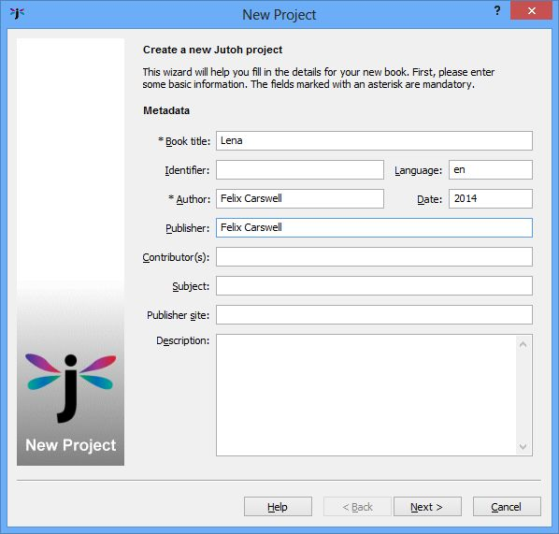
Step 1: Metadata page
Type ‘Lena’ into the Book title field, and a name into Author field. Leave the other fields as they are (you can fill them out later). If you wish you can clear the Identifier field so that Jutoh will generate a unique identifier (UUID) for each ebook format that you create. Now click on Next.

Step 2. Project Location
Here, you can specify the project name and folder. You can leave the Book Formats options as they are.
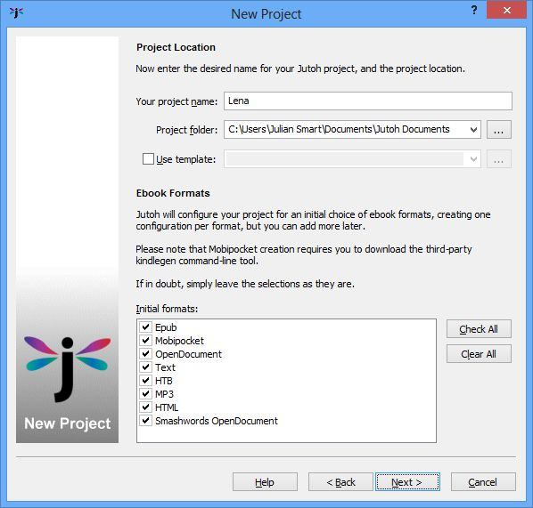
Step 2: Project Location page
Enter “Lena” into Your project name. If you wish you can change the location in Project folder. You can use an existing Jutoh project as a template if you wish, but you can leave the Use template option unchecked for this example. Press Next.

Step 3. Layout Choice
This page lets you choose between a reflowable ebook and a fixed layout ebook. Most of the time you will choose Normal reflowable book.
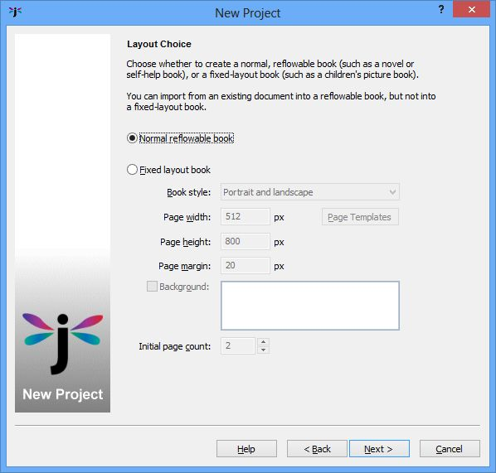
Step 3: Layout Choice page
Leave these options as they are, and press Next.

Step 4. Import Options
This page is for specifying various details about the import. You don’t need to change the defaults for this example.
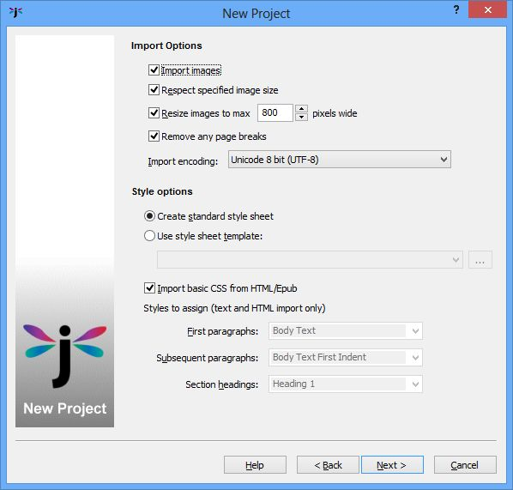
Step 4: Import Options page
Leave these options as they are, and press Next.

Step 5. Import Method
This page lets you specify a file to import.
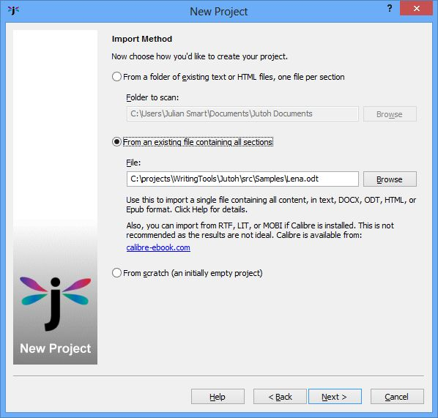
Step 5: Import Method page
Click on option From an existing file and browse for the file you wish to import. Then click Next.

Step 6. Single File Import
This page helps you specify how to split the book into separate sections, which you can do by specifying a heading style to identify as the chapter heading style, or heading text to match, or simply to split at page breaks.
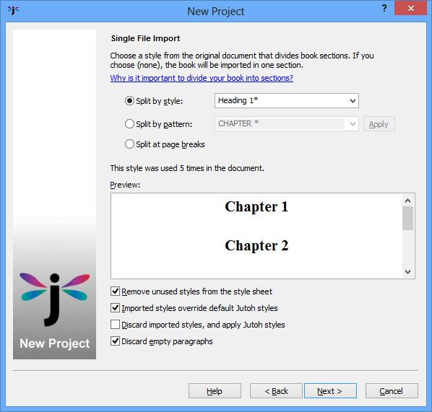
Step 6: Single File Import page
As you can see from the preview window listing the headings in the story, Jutoh has correctly guessed the paragraph style to use for splitting the story into sections, so in this case all you need to do is press Next. Don’t worry if your book is not correctly split at this point – you can split it manually using the menu command Edit | Split Document.

Step 7. Cover Design
The last page in the wizard lets you choose a cover design.
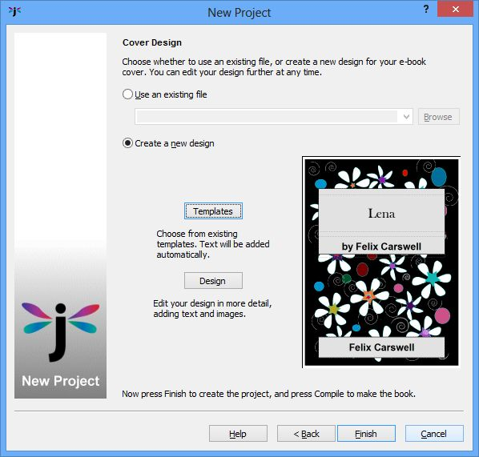
Step 7: Cover Design page
You can use the default design, or click on Templates to choose another template. You can change it later. Just press Finish to complete the import.
Jutoh will now create several sections, which are shown on the left in the Projects outline window. You can click on each section name and edit the text if you wish.
If you have made changes to the imported file, or wish to see if Jutoh can make a better job of splitting the book up by making different selections, you can save time by using the menu command File | Reimport Project which preserves your previous selections.

Compiling the project
Now we have the book in Jutoh, we can create an ebook. In the bottom-left part of the Jutoh window you’ll see the Control Panel listing configurations. (If you don’t see the Control Panel, press Alt+7 or choose View | Control Panel).
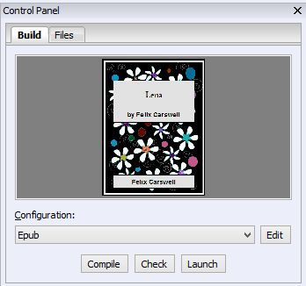
The Control Panel
Each configuration corresponds to an ebook format. Select ‘Epub’ if it’s not already selected, and click Compile. After it’s compiled, click Launch, and if you have an ebook viewer such as Adobe Digital Editions installed, your ebook will be shown.
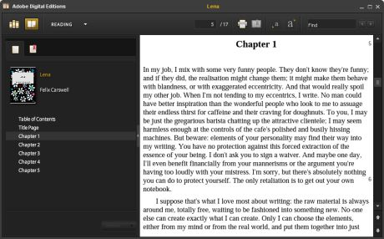
Viewing the ebook in Adobe Digital Editions
If you want to compile a Mobipocket file for the Kindle store, select the ‘Mobipocket’ configuration and again press Compile. (You need to have downloaded, installed and configured kindlegen for this to work – see Appendix A: Installing Jutoh and Appendix B: Configuring Jutoh) Press Launch, and if you have installed a Mobipocket viewer application such as Kindle for PC or Mac, or Kindle Previewer for PC, it will launch to show your ebook.
You can verify that the files have been generated by clicking on the Files tab in the Control Panel. You can select a file and then click Folder if you want to see where the file is on your disk.
Note that it’s important to use separate configurations to generate books in different formats, because a configuration has settings that optimizes the book for each format. For example, if you are distributing to both iTunes (Epub) and Amazon (Mobipocket), use the supplied configurations individually – don’t set multiple formats for the same configuration unless you are very sure of what you are doing.

Summary
Ta-da! You have imported content from a file and compiled an ebook. In the next chapter, we’ll have a closer look at Jutoh’s user interface so you can get to know your way around it.

Chapter 3: The Jutoh User Interface
In the last chapter, you learned how to import a file and compile it, without getting bogged down too much in the details of the Jutoh tools. Now we’re going to take a closer look at the Jutoh main window where you will do most of your ebook work.
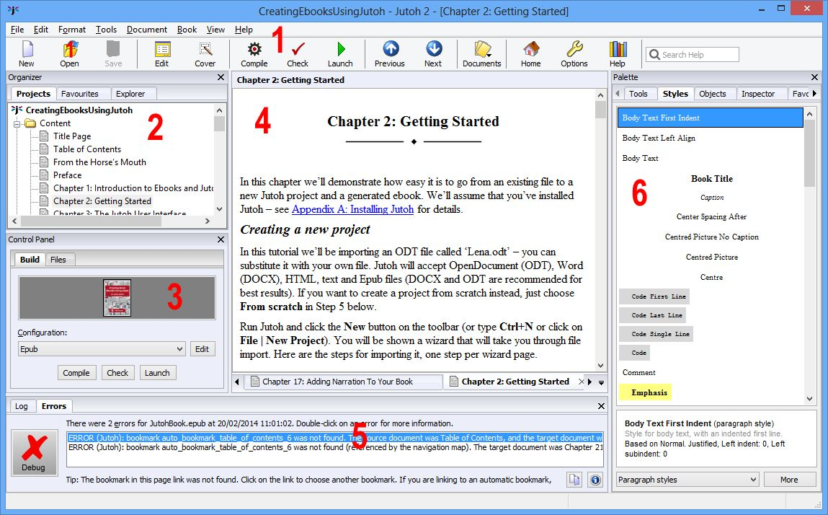
The Jutoh main window

Menu bar and toolbar (1)
As with most applications, Jutoh has a menu bar under the window title, containing all the commands you need to make things happen. The menus are File, Edit, Format, Tools, Document, Book, View, and Help and the groups are fairly self-explanatory. Run your mouse along the menu bar and explore these commands; as you hover over a command, a summary will be displayed in the status bar at the bottom of the window.
Under the menu bar, the toolbar contains a selection of these commands for convenience. You can change the commands on this toolbar by by right-clicking on it and selecting Customise, or selecting View | Customise Toolbars. These are the buttons available by default:
- New: creates a new project, showing the New Project Wizard for importing content or creating an empty project.
- Open: opens an existing project.
- Save: saves any changes in the current project.
- Edit: edits the Project Properties, including metadata, styles, covers and configurations. We’ll come to this later.
- Cover: edits the ebook cover design.
- Compile: compiles the ebook using the currently selected configuration.
- Check: checks an Epub using EpubCheck, listing any errors it finds in the ebook.
- Launch: launches the ebook in the application that your operating system associates with it (or a custom application that you define: see Appendix B: Configuring Jutoh).
- Previous: goes to the previous document in your book.
- Next: goes to the next document in your book.
- Documents: shows a menu of document types to add to the project. Normally you’ll just add Book Section documents, for example for each chapter and the title page.
- Home: goes to the Jutoh desktop, containing shortcuts to various features and documents.
- Options: shows the Preferences dialog.
- Help: shows or hides the help window containing the Jutoh manual.
- Search Help: type text and press return to search in the Jutoh manual and knowledge base. This is your first port of call when you get stuck.

Organizer (2)
The Organizer shows all the documents in your project, in the Projects tab. A document corresponds to a chapter or section such as a title page. You can click on each document to view and edit it. You can view multiple projects in the Organizer if you wish, though you will have to enable this first via the Preferences dialog. Documents can be dragged, to change the position in the book, and a context menu is available if you right-click over a document. We’ll go into this in more detail in Chapter 4: Working with Projects.
Next to the Projects tab are two more tabs: Favourites, and Explorer. The Favourites tool shows a list of favourite projects for quick access; you can add to or remove from this list. The Explorer tool lets you browse your disks and open projects, delete them or add to Favourites.

Control Panel (3)
The Control Panel has a Build tab which shows the current configuration (loosely, the current format to be generated), with buttons for compiling, checking and launching the book. Typically, you will:
- Select a configuration for a particular format, such as Epub;
- Click Compile to build the ebook;
- Click Check to check the ebook for errors (Epub only);
- Click Launch to view the ebook in an appropriate application, such as Adobe Digital Editions.
The control panel also shows the cover of the current project, which can be clicked to edit the design. Next to the configuration list is an edit button which will show the configuration editor – giving you the ability to change various things about the way the book is generated. We will cover configurations in Chapter 9: Understanding Configurations.
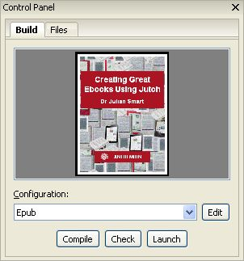
The Control Panel
Next to the Build tab, the Files tab shows all the ebook files that have currently been generated for this project, regardless of format. You can view the folder containing a selected file, view the file with the appropriate helper application, or (for Epubs) examine the structure of the generated book.

Document area (4)
The bulk of the window is taken up by the document area, where you can view and edit the documents (sections) in your book. At the bottom you’ll see a row of tabs, one for each document that you’re currently editing, and also one for the Jutoh Desktop. The Desktop contains a Welcome window and shortcuts for various Jutoh features and documentation, and it’s also a place you can add ‘sticky’ notes (as shown below), pictures, and even picture slideshows. Click on the Jutoh logo button at the bottom-left for available Desktop commands.
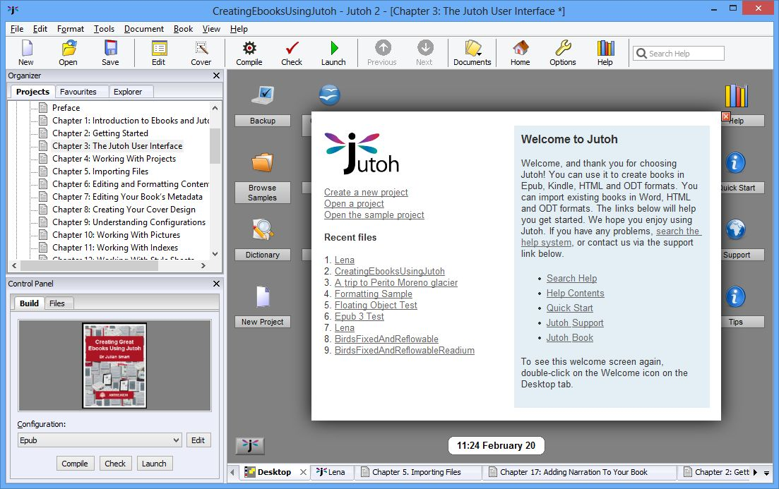
The Jutoh Desktop
At the top of the document area you’ll see the title for the currently-selected document. You can click on it to edit the title of the section as it appears in the outline, and in the generated book contents.
Under the title area, the book section editor shows a toolbar, which can be customised by right-clicking on the toolbar and choosing Customise.
The editor behaves in most respects like other editors and word processors you will have used, with some differences and simplifications. Formatting operations can be performed from the toolbar, Format menu, and the context menu (shown using right-click, or control-click on the Mac). Navigation around the document follows the usual pattern, for example using the control key combined with the left and right arrows to move a word at a time, and holding down shift to select text while navigating. Text editing and formatting operations can be undone and redone in the usual way. However, don’t expect the editor to be exactly like ones you have used, since it has been written from scratch especially to work on a number of different platforms.

Log and error windows (5)
The log and error windows display messages when compiling projects. You can show them with the mennu commands View | Log Window and View | Error Window, and there is also the option of showing them automatically when you compile an ebook. You can close these windows again using the X in the top-right corner.
The error window is shown when either Jutoh finds errors during a compile, or you perform an Epub check on a generated Epub book. If there are no errors, a green ‘tick’ will be shown. If there are errors, they are listed, and you can double-click on each to show the position of the error either within the original source, or within the HTML of the Epub book, depending on the type of error. From this you will be able to work out what you need to change in your project.

Formatting Palette (6)
The Formatting Palette is shown when you use the menu command Format | Formatting Palette, or Alt+P. It contains tabs for a range of formatting functions:
- Tools shows toolbar buttons and other controls for changing styling in your document.
- Styles shows the available paragraph, character, list and box styles. You can double-click on a style to apply it to the document, and right-click (or click More) to edit the style or create a new one. It also displays the styles for the content at the current editor position.
- Objects lists the tag objects (for example, ‘span’ and ‘input’) and other objects (such as images, text boxes and tables) that you can insert into the document.
- Inspector shows aspects of your document, such as all the bookmarks, or all the images.
- Favourites shows favourite shortcuts for styles or menu commands. For more information, see Appendix B: Configuring Jutoh.

Getting help
There are various ways to get help in Jutoh.
The help window containing the Jutoh manual is shown when you click on the Help button on the toolbar, or type Ctrl+H, or use the menu command Help | Contents. Use the same command to close it again. The help window shows in the main window – if you want to close it, maximize it to take up the whole main window area, or unpin it to show it as a separate window, use the buttons at the top-right of the help window (circled in red in the picture below). If you’ve maximized it, you can use the same button to restore it back to its normal size. You can drag an unpinned help window back to the main window by moving it until a blue rectangle appears near the edge of the main window, and then dropping it. The help window itself has controls for showing or hiding the help contents, changing the text size, and navigating around the help.
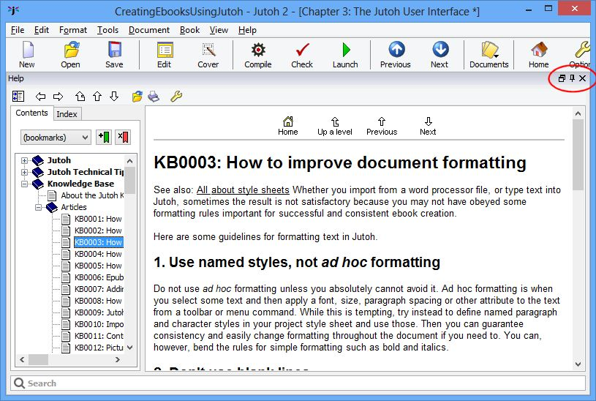
Maximized help within the Jutoh window, highlighting the window management buttons
Jutoh has a fast search facility, which you can access from the main toolbar or from under the help window itself. Here’s a screenshot of the help facility showing a help topic, a list of matching topics, and the controls to limit the topics that Jutoh searches. You can close any of these windows to see more of the help topic.
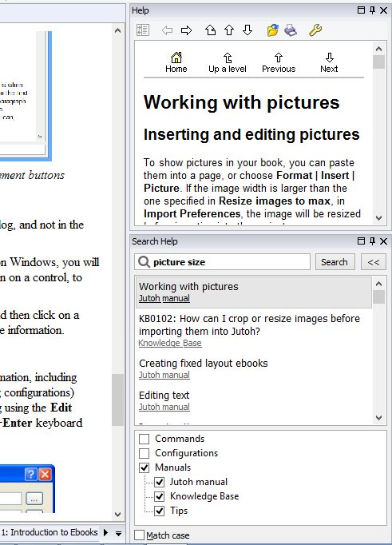
Jutoh help search controls
Most Jutoh dialogs have a Help button which shows the relevant help in a further dialog, and not in the main help window, so you don’t have to return from the dialog to see the help.
Also, you can use the F1 key to get help on the control that currently has the focus; on Windows, you will often see a little question-mark icon at the top of a dialog. You can click that, and then on a control, to see a tip explaining the purpose of the control.
On the main window (only), you can use the Help | Describe Window command and then click on a window to show a tip with explanation about the window, with a link to click for more information.

Project properties dialog
You’ll be using this dialog a lot, because it allows you to edit all sorts of project information, including metadata (the description of the book), formatting styles, the cover design, and (using configurations) behaviour specific to each format that you wish to generate. You can show this dialog using the Edit button on the toolbar, or the View | Project Properties menu command, or the Alt+Enter keyboard shortcut.
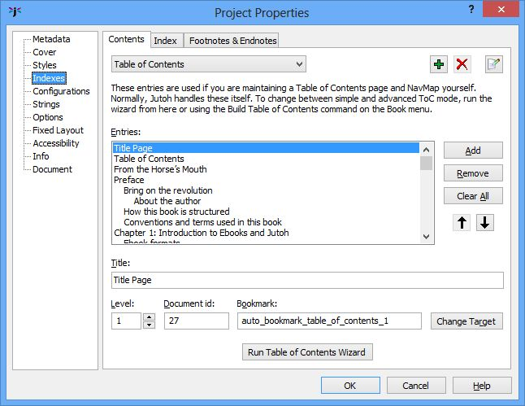
Project Properties dialog

Customising the user interface
These are the main options for tailoring Jutoh to your preferred way of working.
- Close windows – use the X button to close panels such as the Organizer, Control Panel or Log Window. Show them again from commands on the View menu.
- Rearrange tabs windows – drag a tab to the left, top, right or bottom of the window associated with the tab, to split the tabbed area and see more information at once. These changes won’t be restored on restarting Jutoh.
- Add or remove toolbar buttons – right-click on a toolbar to get the customise dialog, or use View | Customise Toolbars.
- Add or change keyboard shortcuts for menu commands, formatting styles, and symbols – use View | Customise Shortcuts. This interface is also used for adding menu items to the optional Favourites menu on the formatting toolbar – check Favourite for each shortcut item to be included in the menu.
- Change settings in the Preferences dialog (click the Options button on the toolbar, or View | Preferences on Windows and Linux, or Preferences on the application menu on Mac). You can choose whether to show a tip on startup, change the display language, set the width and surrounding colour of the edit window, and various other options that change the display and behaviour.
- Show Jutoh full-screen. If you are short of screen space or simply want to temporarily reduce clutter, you can use F11 or the View | Full Screen command to remove the title bar, menu bar and main toolbar. Press F11 again to restore normal viewing.
For more information on customising Jutoh to suit your preferences, see Appendix B: Configuring Jutoh.

Summary
In this chapter, we’ve seen more detail about the various parts of Jutoh that allow you to work with your projects. Next, we will help you achieve mastery over your projects, including how to manage the individual documents that they contain.

Chapter 4: Working With Projects
In this chapter, we’ll get to grips with how projects and documents within them are managed. It’s worth reading so you have a model of how Jutoh will handle your material and what you are able to do within a project. When using Jutoh, if you find the way documents work confusing, you might want to come back and re-read this chapter.

Overview
A Jutoh project contains a hierarchy of documents, some of which will be used to create your ebook. A document is a piece of information such as a book section, a text note, a picture, a shortcut to a file on your local disk, or a web link. Why might you add documents that are not part of your book, I hear you asking? Well, you may have textual or pictorial research that you want to store with the project, or perhaps you want to keep a note of what ebook sites you have uploaded the book to, and when. However, you don’t have to use any other kind of document apart from the book section. The different document types are listed towards the end of the chapter.
The project is shown in the project outline window within the Organizer:
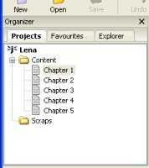
The Project Outline Window
Each document is displayed by clicking on its title in the project outline. Depending on your current settings, the document will be shown in a new tab or an existing tab in the document area. You can change this in Preferences under Project/Document Preferences, and determine which document types will be shown in separate tabs. You may prefer to reuse a tab per document to avoid having to manage a lot of tabs.
You can drag a tab to an edge of the document area to split the tabs and show multiple documents simultaneously. Drag the tab back next to another tab to go back to viewing one document at a time.
You can close a tab using the X button. This only closes the view of the document, and doesn’t delete it. If you right-click over a tab, you will see a menu with tab-management commands such as Close Other Tabs. This is very useful if you have a large number of tabs open.
Note that under the special Content folder, you should only create Book Section documents. Any other sort of document will be ignored, including folders.

Creating and deleting documents
If you import an existing document, Jutoh will already contain one or more book section documents. However you may wish to create further documents, or you may wish to create a project from scratch consisting of several chapters.
When you create a document, where it goes depends on what document is currently selected. If you have selected a folder, it will be added as a child of the folder. Otherwise it will be created as a sibling of the selected folder.
You can use one of the following methods for creating a new document:
- Click items on the Document menu.
- Use a keyboard shortcut, such as Ctrl+Alt+B to create a book section.
- Click on the document button on the toolbar and choose an item from the drop-down menu. The document button looks like this: Most frequently, you’ll be choosing Book Section from the menu.
- Right-click in the project hierarchy and select New Document from the menu. Now choose your document type and title in the New Document dialog that shows.
- Auto-paste by copying some data in another application, twice in quick succession (Windows only).
Now click on the title of the new document and enter the new page title.
You can delete a document by selecting in the project outline, and hitting the Delete key or right-clicking and selecting Delete. Note that this operation cannot be undone.

Moving documents
You can move a document in the project outline by dragging it to a new position using the left mouse button. If you drop the document onto a folder, the document will be placed inside the folder. Otherwise, the document will be inserted in front of the drop target. You can veto insertion into a folder by holding down the control key as you drag, and you can force adding the document as a child by holding down the shift key.
If you need finer control of where you move documents, you can use the cut and paste method. Right-click over the document you wish to move in the project hierarchy, and select Cut from the popup menu. Now go to where you wish to move the document, right-click again, and select Paste Before This Scrap, Paste After This Document or Paste As Child of this Document.

Managing project files
Each project file contains all the data needed for generating the ebook, including all book sections, style sheets, the cover design, configurations and project-wide options. You can save and open project files as you would any word processor file, and you can open multiple projects simultaneously within Jutoh if you enable the View multiple projects option in Preferences (the Project tab). This will allow you to copy and paste between projects.
As well as using the Open toolbar or file menu command, you can double-click in the list of Favourites (a tab next to the Projects tab). Or you can browse for the required project using the Explorer tool (next to Favourites). You can also use the File | Recent Projects menu. Yet another method is to double-click on the file in your operating system’s file manager, and more techie users might want to invoke Jutoh from the command line passing the project file name.
If you make a project edit, such as adding a new document or editing project properties, an asterisk will appear next to the project name in the title bar until the project is saved. If you edit an actual document such as a book section, an asterisk will appear next to the document title in the title bar. To save both document changes and any project changes, use the Save button, File | Save command, or type Ctrl+S.
By default, Jutoh will create a backup file (a file with jutohbak appended to the name) before opening the file, so if there is a problem, you can revert to the backup. Jutoh also regularly auto-saves any data that hasn’t yet been manually saved so if there is a computer crash it can restore the data the next time you open the project. This auto-save data is stored within the original project file. However, computer software and hardware can and does go wrong, so don’t forget to back up your files frequently, preferably to multiple locations. You can use Jutoh’s own simple archiving and backup facility if you wish (see File | Manage Backups and the description in the manual) but this is not automated.
If you find your project file getting a bit big, especially after a lot of editing and deletions, you can try compacting it. In Preferences, click on Project, then on Project Maintenance. Click on the Records tab, then Delete Orphans. Click on the Project tab, and then on Compact Project. All Jutoh data is kept in database tables and as data is changed, added and deleted, the database can become fragmented, so occasional compacting is necessary, like defragmenting a hard disk.

Where is my project?
If you have opened the project using a method that didn’t require you to specify the whole file (for example, File | Recent Projects) you might not know the location of your project. To find out, just click on the Edit button (Book | Project Properties) and then click on the Info tab. This tells you the name of the project, the folder, and what version of Jutoh was used to last save it. You can click on Show Folder to show the containing folder using your operating system’s file explorer.

Document types
The following document types may be created in Jutoh. Only create book section or fixed layout page documents under the special Content folder; but you can create any kind of document elsewhere in your project.
Book section document
A book section document represents a part of an ebook: for example, a chapter, a title page, or a table of contents. A book section document is similar to a text document, allowing styled text editing, but has its own property editor dialog with options relating to Epub generation and inclusion within an ebook depending on format.
Fixed layout page document
A fixed layout page document represents a page (or double-page spread) in a fixed layout project.
Text document
A text document lets the user type a text note. This is useful for storing information that shouldn’t be in the book itself, such as planning notes for your book, or a list of corrections to be applied, or maybe to keep track of the sites to which the book has been submitted. Typically you’ll add these under the Scraps folder.
Folder document
The folder document allows you to group your documents as you wish. For example you might have a Web Links folder, and a My Photos folder. Note that while folder documents are particularly suited to containing further documents, in fact any document may contain children. Don’t create folder documents under your book Content folder – this may only contain book section documents.
Image document
Use these to store images that won’t appear in the book, perhaps for research purposes. You can create an image document from an image on the clipboard, with Edit | Paste New Scrap (Ctrl+Alt+V). Or you can create a new image document and then paste the image into it with Ctrl+V or Edit | Paste. You can also resize the image and use a different format from the default format (PNG) using the image properties. Note that Jutoh normally saves images in full color, so it is best to use the compressed JPEG format for large images. JPEG images are saved at 90% quality, but try not to load and save JPEG images repeatedly or the image will degrade.
Web link document
A web link document contains a web address (or URL), and an optional description. These won’t form part of the book.
Shortcut document
A shortcut document contains the location of a document or application on your computer. Again, these won’t form part of the book – they are for your reference only.
Font document
A font document contains a TTF or OTF font for embedding in an ebook. The font data is stored within the project file and copied to the book when compiling. Embedding fonts is beyond the scope of this document, but you can find details in the Jutoh manual. It is recommended that you don’t embed fonts and that you only use basic fonts such as Times New Roman, which is guaranteed to be supported on all ebook readers.
Media document
A media document contains an audio, video or image file for use in a media object. Embedding media objects is beyond the scope of this document (not least because few ebook platforms support embedded media). If you are determined to embed media (for example, if only targeting iBooks Epub books) you can find details in the Jutoh manual, and also a brief description in Chapter 21: Advanced Topics.

Source code document
A source code document stores HTML, JavaScript or CSS code. The file is stored within the project file and copied to the book when compiling. Most users won't need this kind of document since Jutoh generates code from sections in your book, but sometimes it's helpful to include additional code, for example to update documents dynamically via JavaScript to implement a built-in quiz. At the time of writing, only iBooks allows this, but it will become more prevalent with the widespread adoption of Epub 3.
So that most users are not exposed to more complexity than necessary, source code documents can only be created and edited in Jutoh Plus. Standard Jutoh can still open, save and compile projects containing source code documents. For more information, please see the Jutoh Plus guide at www.jutoh.com/jutohplus.htm.

Summary
In this chapter you have learned how projects and documents work. It was probably filed in the ‘boring but important’ drawer in your brain. Next, we look at how you can get your existing work into Jutoh.

Chapter 5. Importing Files
In Chapter 2: Getting Started, we briefly showed how to import an existing file into Jutoh. In this chapter we will cover this aspect in more detail, including what the best import format is and why.

What can Jutoh import?
Jutoh can import from several different kinds of file, but with varying quality depending on the format. These are the supported formats:
- Microsoft Word XML (DOCX): this has been Microsoft Word’s native file format for some years, but older versions of Word can still be made to open and save DOCX – see the Introduction for more information.
- OpenDocument Text (ODT): this is the native file format of the free OpenDocument.org Writer and LibreOffice Writer word processors.
- Plain text: Jutoh can import from a plain text file or folder full of text files, though there will be no fancy formatting initially, since there is none in the original text.
- HTML: Jutoh can import in a limited way from HTML; some formatting will be lost, although of course most can be put back by applying styles within Jutoh.
- Epub: Jutoh can import from an existing Epub file, with the same HTML restrictions as mentioned above.
Although Jutoh can import from these formats after a blank project has been created, it’s usually best to import within the New Project Wizard because the wizard helps you split the file into sections.
Because Jutoh’s representation is different from each of the native file formats, it’s inevitable that some information will be lost in translation, for example fancy Word table borders, but you should rarely find that this is a problem.
Let’s look at the input formats in more detail, and how to import from each format in the Jutoh New Project Wizard.

Microsoft Word XML (DOCX) and OpenDocument Text (ODT)
The majority of users, especially on Windows and Mac, will probably have their manuscript in Microsoft Word format. If you’re using Linux, you’re more likely to have an ODT file. ODT format originally started as SXW (the native format of StarOffice which became OpenOffice.org). Now it’s a recognised international standard and supported in other word processors including recent versions of Microsoft Word. If your word processor doesn’t support ODT, then you can download a copy of OpenOffice.org for free and use it to convert from what your word processor outputs, to ODT. You might save from your word processor in RTF, for example, before loading it into OpenOffice.org and saving as ODT.
Jutoh recognises the styles, footnotes, index entries and bookmarks in an ODT or DOCX file and therefore these are the best formats to use for getting your existing book into Jutoh.
These are the steps to take when importing a DOCX or ODT file. First, use File | New Project or the New toolbar button to create a new project.
Steps 1-3: enter metadata, a project location and layout choice as per Chapter 2: Getting Started.
Step 4: you can leave the import and style options as they are. However, you may wish to adjust the Resize images to max option if you want pictures to be resized differently than the default (or not resized at all – resizing can be done at book generation time). Also, page breaks will be removed from the imported file by default, since book sections imply page breaks. Change Remove any page breaks if you need to retain page breaks.
Step 4: import and style options
Step 5: in the Import Method page, click on From an existing file containing all sections and specify the ODT file to import from.
Step 5: specifying the import method and file
Step 6: in the Single File Import page, tell Jutoh how to split the file into book sections, which is important for an ebook. You can split the file using one of three methods:
- By style: specify the heading paragraph styles that indicates the start of a section. Specify an asterisk to match against multiple styles, and separate multiple heading style patterns by the pipe character (‘|’).
- By pattern: specify a pattern to match against heading text. For example, you might label each chapter with the prefix “Chapter”. Again, use an asterisk to indicate multiple characters to match, for example “Chapter *”.
- Using page breaks: Jutoh will use page breaks to split the document.
Jutoh will show a preview of some of the section headings it has found based on your current split settings. It will make an initial guess. If you cannot persuade Jutoh to find suitable split points, you can split your book sections manually later. Or, you might decide it’s easier to edit the original ODT file to let Jutoh find split points. In this case, you can click on Back and then Next again to have Jutoh reread the changed ODT file.
You can also adjust a few other options, such as removing unused styles (the default), and discarding empty paragraphs (also the default). But the defaults are usually best.
Step 6: splitting the document
Step 7: in the final page, you can choose a cover design, either one of Jutoh’s templates or an existing image file. Click on Templates to see the selection of designs available, or click Design to edit the design using the cover designer (see Chapter 8: Creating Your Cover Design). You can of course change your mind about the cover design at any time after you’ve created your project, so it doesn’t matter too much what you choose in this page.
Step 7: choosing a cover
Now press Finish, and the ODT file will be imported, and (if possible) split into separate sections.
Your usual word processor may have hidden your use of ad hoc formatting; for example, it might have reported “Normal” in its style list when actually you had applied ad hoc styles such centring and paragraph spacing to that basic style. In Jutoh, you’ll see ad hoc formatting reflected in automatic styles in the style list – that is, styles containing a ‘+’ symbol such as “Normal + Centre Alignment”. You are strongly advised to replace ad hoc formatting with named styles, as detailed in Chapter 12: Working With Style Sheets.
If not all images are imported from your ODT file, it may be because they are in a non-standard format called SVM. Jutoh (and most other applications) are unable to convert these, but if you save your original file as an HTML file from your word processor, writing GIF files, then when importing from ODT Jutoh will try to substitute any missing SVM image files with the GIF files. Another solution is to insert the original images from files instead of pasting from the clipboard; or copying and pasting the missing images into Jutoh manually.

Plain text
Plain text can contain no formatting, and also generally doesn’t contain an indication of what ‘character encoding’ it has been written in, which is the key for an application to interpret how the data is converted to actual characters. The encoding is therefore specified by the user when importing. In general, UTF-8 is the best encoding to use when saving from a word processor since it can handle any language.
If you specify a folder of text files, each file will be used for a separate Jutoh section. If you specify a single text file, Jutoh will take you to a wizard page that lets you choose criteria for splitting up the file. You may wish to edit your original text file to make it easier for Jutoh to split it into sections – for example, labelling each chapter “Chapter...”, or adding a separator between chapters, such as “---”.
The steps for importing text are mostly the same as for ODT above, the main difference being the Single Text File Import page that appears after you have chosen your text file.
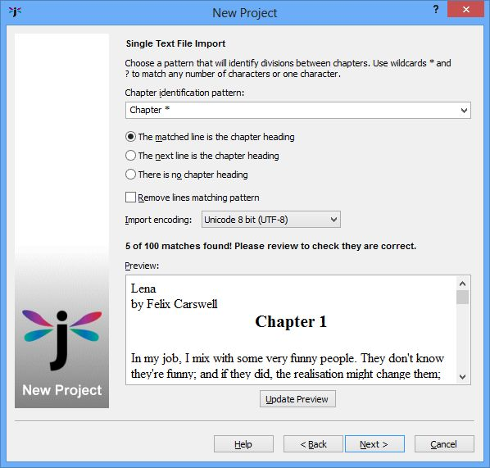
Splitting a text file
In this page you can specify a pattern to identify the start of chapters, including asterisks to denote ‘match zero or more characters’. If you need to match actual asterisks, prefix them with a backslash; for example to match “***” you can write “\*\*\*”.
You can also choose between the following mutually-exclusive options for telling Jutoh more about the matched text:
- The matched line is the chapter heading: choose this if your chapters are easily identifiable, as in the above example.
- The next line is the chapter heading: choose this if the text being matched is simply to denote a division (for example, “---”) and the next line contains the actual heading.
- There is no chapter heading: choose this if there is no chapter heading, just sections separated by some matchable text.
Check Remove lines matching pattern if you don’t want to keep section separators, such as “---”. Don’t check this if you’re matching against chapter headings.
Specify the Import encoding to match the encoding of the text file, as used by the tool that created the text file originally. Usually UTF-8 is the best format to use.
If you want to change the styles that Jutoh applies to the imported text (for initial paragraph, subsequent paragraphs, and section headings), you can change them in the Import and Style wizard page (see Step 3 above).
If you have a number of text files, one per chapter, you can select the folder instead of a single file, and you will be presented with the File Conversion Options page:
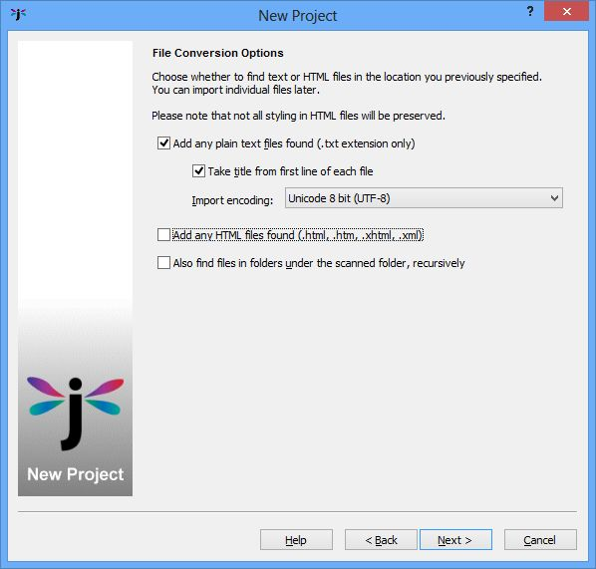
Multiple-file conversion options
You can specify whether to take the title from the first line of each file, and the file encoding. You don’t have to tell Jutoh how to split the content because it’ll simply create one section per found file.

HTML
Jutoh can import from a single HTML file, or a folder of several. As with plain text import, Jutoh will allocate a section per HTML file if importing from a folder; if importing from a single file, the same options will be presented as per DOCX or ODT import, allowing you to specify a pattern to use for recognising individual sections.
As already mentioned, HTML does not preserve all formatting, because it can only do a basic job of converting CSS (HTML styles) to Jutoh styles. CSS works very differently from Jutoh styles, so there can never be an exact conversion. You can either clean up the content and styles after import, or you can clear the option Import basic CSS from HTML/Epub and specify the styles for the first and subsequent paragraphs after each heading. This way, you can use import as a kind of cleanup mechanism, to convert complex HTML to a simple Jutoh project (and then back to HTML/Epub/Mobipocket).
Jutoh will attempt to read any images in the HTML. Footnotes and alphabetical indexes will be imported as standard HTML implemented using links since HTML does not define these explicitly. If you need these to be preserved, use DOCX or ODT import.
Where an HTML link defines both an anchor and a reference in the same “a” tag, a bookmark symbol is generated just before the linked content, since Jutoh can’t handle both simultaneously. This will be generated as an empty bookmark followed by the linked content.

Epub
You can specify an Epub as a single file in the New Project Wizard. Since Epub files contain HTML, the same import restrictions apply as for HTML. However Jutoh will be able to recreate the structure of the Epub accurately, and will use the metadata it finds in the Epub.

Importing into an existing project
You can still import from text, HTML, DOCX, ODT and Epub at any time after initially creating your project, using the File | Import command. However, you will not be assisted in splitting up your imported file; you will need to do it manually, for example with Edit | Split Document, except for Epub files which will use the found structure and will give you the option to import the whole Epub under a new folder – useful for merging several volumes into one book.

Reimporting
Jutoh makes it easy to duplicate an initial import operation, for example if you changed the original file or decided to use different settings. Use the File | Reimport Project command to show the New Project Wizard using the same default settings as you used originally, deleting the current project content before importing the file again.

Summary
In this chapter you have learned how to import your existing work. Next, we delve into the details of editing and formatting content.

Chapter 6: Editing and Formatting Content
Jutoh is not just a way of converting existing files to ebooks: one of its major strengths is the ability to edit and tweak your book before creating the ebook in the desired format(s). In this chapter we’ll learn how to edit and format your book’s text and graphics.

Why divide a book into sections?
First, a quick word about why Jutoh projects, and ebooks in general, are divided into sections. A section can be a chapter, a title page, a table of contents, and so on. Most ebooks are comprised of sections rather than being one enormous chunk like a Word document. One reason for this is because some ebook readers, with their restricted memory, simply can’t cope with large chunks of text; or if they can, slow down when loading and paging through such a book. Another reason is that it is is easy to compile a table of contents for a book that’s divided into sections (though Jutoh can also look inside sections for headings if required). Via section properties, you can tell the ebook reader that a section is a table of contents or other kind of section, which you couldn’t do if it was buried inside one huge section. Finally, you’ll find it easier and faster to navigate and edit a book divided into sections.
If Jutoh didn’t split up your book when importing, you can do it manually, one split at a time. Place the cursor on the paragraph you wish to be at the start of a new document, and use the command Edit | Split Document. If you change your mind, you can’t undo this with Edit | Undo, but you can join this document with the next one using Edit | Join Document. If the new document was inserted at the wrong place, you can drag it into the correct position.
You can edit the title of a particular section by clicking on the title above the editor, as shown in the illustration below, or using the Rename command on the project outline’s context menu (right-click to see it). This title will be used in the automatic table of contents.
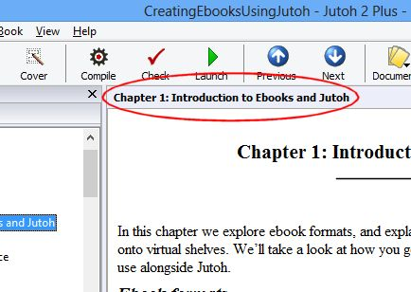
The clickable section title

Basic content editing
When you click on a book section in the project outline, or create a new book section with Document | Add Book Section Document, you are presented with the Jutoh editor. You can use this just to review the content in your book, or you can edit the text, graphics and formatting. Many of the editing keystrokes will be familiar from other editors, though there will be some differences. Here are the more important keyboard and mouse operations:
- Use the arrows to navigate a character or line at a time. Hold down the control key to move a word at a time.
- Use Page Up and Page Down to move up and down a page at a time. Home and End move to the beginning and end of the line respectively; hold down the control key (command key on Mac) to move to the start or end of the whole section.
- Use Shift+Enter to insert a line break character within a paragraph. Use this sparingly, if at all, since it can be confusing to edit paragraphs containing line breaks.
- Hold down shift with a navigation key to select content; you can use Ctrl+A to select all text in a section.
- Use double-click to select a word, and drag the mouse to select a region of text. Several separate areas of selection are not supported.
- In addition to the toolbar buttons and menu commands, you can use Ctrl+C to copy text, and Ctrl+V to paste text. To move text, you can use Ctrl+X to cut and Ctrl+V to paste.
- Use Edit | Paste Unformatted Text to strip formatting out of the text you are pasting, useful if the original formatting is not applicable to the current context.
- Use Ctrl+Z to undo an operation, and Ctrl+Y to redo it.
- Use the drop-down style control on the editor toolbar to apply paragraph styles – more on that later.
- Click on objects such as images to edit their properties, or use the properties command such as Image, Box, or Table on the context (right-click) menu.
Some editing commands are also available on the context menu, which appears when you right-click over the editor (control-click on a Mac).
You can change the size of the text for editing purposes (not the actual book text size) by clicking on the tool on the toolbar and then selecting Larger or Smaller, or you can go to the Appearance panel in the Preferences dialog and change the text size in Font for text documents. In this panel, you can also change the default text foreground and background colours and the maximum size of the editor window.
You can use the tools in the Formatting Palette for applying styling and inserting objects:
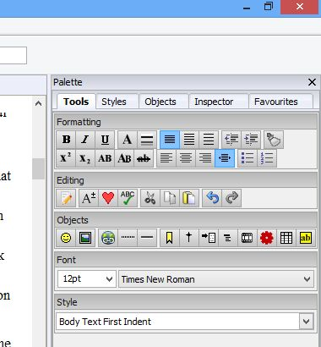
The Tools page in the Formatting Palette
The tool buttons are equivalent to commands on the Format menu.

Formatting text
If possible, text formatting such as font family, size, colour, bold and so on should be defined using named styles (see later in the chapter) and not on an ad hoc basis, sometimes called ‘direct formatting’. However, sometimes it’s convenient to change the formatting directly, for simple styling. You can select a span of text and use toolbar buttons or the Format | Character command which gives you size, colour, weight, style and other options, as shown below:
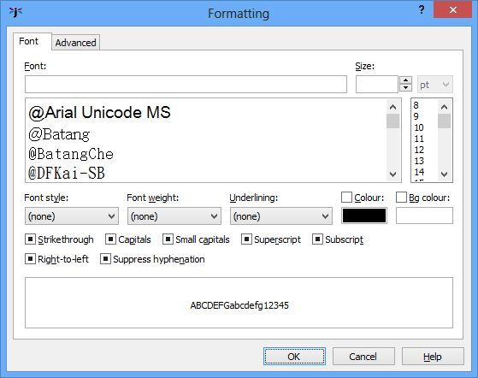
The font dialog
If there are currently no formatting attributes defined for the span of text you have selected, or there are no common attributes for the whole span, you will see that all controls have an ‘undefined’ appearance, as in the screenshot. This means that the text will inherit whatever attributes are defined in the paragraph. If you choose a particular attribute, such as font name, then only that attribute will be applied when you press OK. If your span of text has a particular attribute, such as colour, you can clear that attribute by clearing the checkbox or choosing “(none)” or clearing the control value, depending on the attribute in question. If you want to remove all formatting for a span of text, then you can use Format | Text | Reset Text Formatting instead of the font dialog.

Formatting paragraphs
As per spans of text, paragraphs should be formatted using named styles if possible, which we’ll cover below. But if you need to apply direct formatting, you can use the command Format | Paragraph.
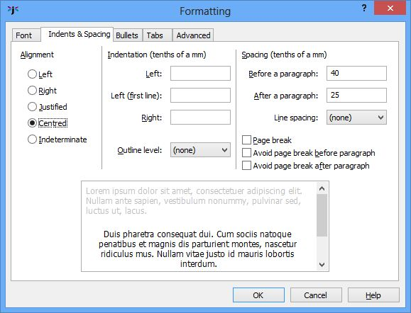
The paragraph formatting dialog
The paragraph formatting dialog contains a Font page as per the character formatting dialog, because a paragraph style specifies a font, which character formatting can override.
The Indents & Spacing page will be the one most frequently used when formatting paragraphs. You can change some of these properties more directly using tools in the Formatting Palette. The alignment and spacing values are discussed shortly.

Special symbols
Jutoh supports most left-to-right languages using Unicode, and you can insert special symbols in several ways:
- Use the Format | Insert | Symbol (Shift+Ctrl+Y) command to show the symbol selector dialog containing all the Unicode symbols (see the screenshot below).
- Using View | Auto-Replace Preferences, define symbols that will be inserted when you type a particular piece of text followed by space or paragraph return. For example, by default typing three dashes followed by a space will cause Jutoh to insert an em-dash (—). For more information, see Appendix B: Configuring Jutoh.
- Define a symbol as a keyboard shortcut and/or favourite, using View | Customise Shortcuts. A favourite is a style, command or symbol that is defined as a shortcut and also has its Favourite option checked. It will then appear on the Favourites toolbar button. (If this button is switched off, you will need to enable it using toolbar customisation.) For more information, see Appendix B: Configuring Jutoh.
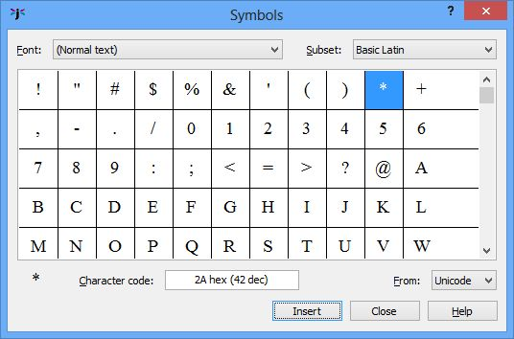
The symbol selector dialog
Note that not all ebook readers support non-English Unicode character sets using their default fonts. To show, say, Romanian diacritics in Adobe Digital Editions, you need to embed a suitable Unicode font (for example, DejaVuSans), and specify a font substitution in your configuration the embedded font is used. For more on embedding fonts, see Chapter 21: Advanced Topics.

Pictures
You can insert pictures into your document with Format | Insert | Picture (Shift+Ctrl+C), or simply by pasting a picture from the clipboard. If you use the insert method, the picture will be stored in the original file format; if you paste from the clipboard, the picture is stored as a PNG. By default Jutoh will convert pictures to JPEG when you actually generate the ebook, so you don’t generally need to worry about inserting a format that’s compatible with Epub or Mobipocket at time of insertion.
If you insert a picture that’s very large (in dimensions, not file size), Jutoh will resize it at the time of insertion. You can switch this off, and change the maximum size, using the Resize images to max setting in Import Preferences.
A picture is normally shown and edited in Jutoh as simply a character in a paragraph. Typically, a large picture will have its own paragraph. You can adjust properties by clicking on the picture: you can set the relative or absolute picture size or maximum size, whether the image will float to the left or right of other content, margins, alternative text and more.
We’ll go into more detail about images and how Jutoh optimizes them for ebooks in Chapter 10: Working With Pictures.

Page breaks
The ebook reader software will cause page breaks to appear between sections (such as chapters), so you don’t need to insert a break at the start of each section. If you need page breaks to appear within a section before a particular a paragraph, put the cursor on that paragraph and use Format | Insert | Page Break (Shift+Ctrl+E). To remove a page break, use the same command again. A dotted line will appear before the paragraph indicating the location of the break. How page breaks are interpreted visually is up to each ebook reader.

Non-breaking spaces and hyphens
You can insert non-breaking spaces and hyphens with Format | Insert | Non-Breaking Space (Shift+Ctrl+Space) and Format | Insert | Non-Breaking Hyphen (Shift+Ctrl+-). The non-breaking space is inserted as a Unicode character (160) but since some fonts can’t display the non-breaking hyphen character (8209), this is inserted as an object. If you enable the configuration option Convert non-breaking hyphen to hyphen, Jutoh will generate HTML with a regular hyphen and a span that prevents breaking, to be compatible with more Epub viewers. This is unnecessary for Mobipocket.
Some Epub viewers do not support a non-breaking horizontal bar, which is essential punctuation for Spanish. So if you are writing Spanish, you may wish to enable the configuration option Convert horizontal bar to em dash. This converts the horizontal bar (Unicode 8213) to an em dash (Unicode 8212) and adds a non-breaking span. For the non-breaking behaviour to work, the bar and non-space character to the left or right of the bar must be formatted in the same (or no) character style. (Note that when we talk about conversion, we are referring to the final generation of the ebook from the Jutoh content, not file import. So you can retain the horizontal bar in your Jutoh content and decide at any time whether or not to have it appear as an em dash in your book, without any permanent replacement of the original symbol).
You can also set the configuration option Styles suppressing hyphenation. This is a pattern matching all styles that should suppress hyphenation; the default value is ‘Heading*’, thus suppressing hyphenation for all headings. You can separate multiple patterns with the pipe (‘|’) character.

Horizontal rules
To add a horizontal rule, for example to indicate a division between scenes within a narrative, use Format | Insert | Horizontal Rule (Shift+Ctrl+B). You will see an object like this:
You can click on object to change properties such as width and colour. These properties won’t be reflected within the Jutoh editor, but will be output to the Epub or Mobipocket book.

Bookmarks
You can mark text or a picture with a named bookmark so that a link can point back to it. Use Format | Insert | Bookmark and give the bookmark a unique name, consisting only of alphanumeric characters and underscores. If you select content first, the bookmark will be associated with that content. No extra formatting will be shown, but the cursor will change as you move over it and you will be able to click on it to show the bookmark dialog. If you don’t select content first, a bookmark object will be placed at the cursor, like this:
Note that you don’t need a bookmark for a link to point to a whole section, only if you need to be able to refer to a specific point within a section.
Another type of bookmark is the object identifier. This is the ‘Id’ property in the Advanced page of the property dialog for paragraphs, text fragments and most objects. You can set the identifier for a paragraph using Format | Paragraph, and the identifier for a text fragment with Format | Character. However a more reliable method of setting the identifier for a text fragment (since styling can break a span of text into separate pieces) is to bracket the text with the ‘span’ tag object: see Chapter 16: Working With Tag Objects and Chapter 17: Adding Narration To Your Book.
A convenient way to show all the bookmarks in your current book section is to use the Inspector tab in the Formatting Palette, and select Bookmarks from the drop-down list. You can then click on a bookmark in the list to highlight that bookmark in the editor.

Links
To insert a link within the book, use Format | Insert | Link to Page (Shift+Ctrl+G). You will be shown a document browser – select a section document and, if you wish, a bookmark within that section. To edit or remove the link, just click on the linked text.
To insert a URL (an external web site address), use Format | Insert | URL (Shift+Ctrl+W) and type the address.
When you create a page link or URL, the dialog will give you the option of applying a style to the linked text. This style is mainly for editing convenience so you can easily see the links; ebook readers will provide their own styling for links. In order not to clash with the default link styling, when generating the ebook Jutoh will remove attributes (such as colour and underline) if they are also present in the ‘URL’ character style, but you can change this behaviour per configuration.
Automatic bookmarks have the prefix auto_bookmark and are removed before a page is indexed by the Table of Contents Wizard. If you want to make sure that a heading retains a constant bookmark that you can link to manually, change the bookmark to one without the auto_bookmark prefix. The Table of Contents Wizard will not remove this bookmark.
You can control-click on a page link (or alt-click, on Mac) to display the document that is the target of the link, with the bookmarked content selected.
When inserting a URL (not a page link), you normally simply specify the URL address, such as http://www.something.com. However if you want more control (in HTML-based formats only), you can include the entire contents of the ‘a’ tag and Jutoh will output the whole thing. The key is to include the ‘href=’ attribute within the URL. For example:
href="http://www.something.com" onclick="return popitup('http://www.something.com')"
In non-HTML formats, Jutoh will extract the actual URL automatically.

Footnotes
You can insert a footnote using Format | Insert | Footnote (Shift+Ctrl+N), and you will be able to edit the footnote text in a separate dialog. A footnote is represented by this symbol within the text:
Footnotes can either be shown at the end of the section containing the footnote, or as a separate endnotes section. The way footnotes are presented in the generated ebook is determined by settings within the Footnotes & Endnotes tab in the Project Preferences dialog, under Indexes.
Note that a footnote is always styled with the designated footnote paragraph style setting, overriding paragraph styles you use within the footnote editor, unless you choose otherwise in footnote settings.
For more information on footnotes, please see Chapter 11: Working With Indexes.

Index entries
If you mark your book with index entries, Jutoh can generate an alphabetical index section. Use Format | Insert | Index Entry (Shift+Ctrl+I) and enter the index entry name and, if necessary, one or two subcategories. This symbol will be inserted into the text:
The way the the index is presented is determined by settings within the Index tab in the Project Preferences dialog, under Indexes.
For more information about indexes, please see Chapter 11: Working With Indexes.

Comments
You can add comments anywhere in your project, by selecting the content you want to comment on and using the menu command Format | Insert | Comment (Ctrl+;) or the tool. Then click on comment object to edit it, hover over it to view the comment, or use the Inspector tab of the Formatting Palette to list all the comments in the current document.
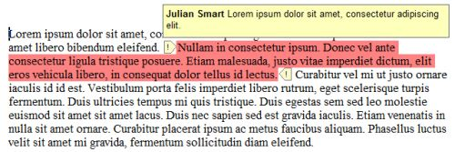
A comment showing its tooltip
If you fill out your user name and initials in Preferences (the General page), they will be associated with new comments.
You can choose to include selected comments in your ebook; by default, comments are not included, except when exporting to ODT. Comments are imported from DOCX and ODT files. For more information, see the topic Working with comments in the Jutoh online help.

The basics of formatting using named styles
Jutoh maintains a style sheet for each project, containing named style definitions that can be used to change formatting in your project. Each style definition (or just style, for short) specifies visual attributes such as italics, colour, alignment, and so on.
Jutoh supports four kinds of named style:
- Paragraph style. This kind of style applies to an individual paragraph, and you can see available paragraph styles in the drop-down control above the editor.
- Character style. This kind of style changes the formatting for a span of text within a paragraph. You can apply character styles using the context (right-click) menu, choosing Styles and then Character Styles.
- List style. This kind of style defines how list items are formatted at each depth; the two list buttons on the formatting toolbar simply apply two of the standard list styles (bulleted and numbered).
- Box style. This kind of style applies to images and text boxes, and defines attributes such as margins, padding, border, and background colour.
You can edit these styles, and add new ones, using the Styles page in the Project Properties dialog; or you can use Format | Edit Styles. Style changes will be applied to any open documents as soon as you close the dialog.
Whatever the formatting you apply, Jutoh must always be able to relate it to a named style. So if you use ad hoc styling, such as applying centred alignment using the toolbar, Jutoh will create a new automatic style (or find a suitable existing one), for example ‘Normal + Centre Alignment’. These automatic styles are maintained with each book section document and you can’t edit or delete them manually.
I cannot emphasize enough how important it is to use named styles, not ad hoc styles or automatic styles, wherever possible. This will make it far easier to maintain a consistent format for your book, since then when you need to change the presentation you may only need to change the named styles, and not every relevant paragraph. Also, it makes it easier Jutoh to perform tasks such as table of contents creation because it can search for specific paragraph styles. Having said that, it’s probably not worth maintaining and applying separate styles for occasional use of bold or italics.
When Jutoh creates a new project for you, it creates a default style sheet with such styles as ‘Body Text First Indent’, ‘Heading 1’ and ‘TOC Entry 1’. Some of these styles (such as ‘URL’) are used by features in Jutoh, in the case of ‘URL’ for applying a link style in various situations, for example in a generated table of contents or for a page link. So it’s best not to delete the standard styles unless you really know what you’re doing.
The following lists the styles that are added by Jutoh. The asterisked styles should not be deleted, and the other styles can be replaced by custom styles in various dialogs – but you may wish to play it safe and not delete any of them. By default, certain standard styles will be restored when opening a project. You can turn this behaviour off via Options in Project Properties, by clearing Restore missing standard styles.
- Body Text
- Body Text First Indent
- Bullet List 1 *
- Citation
- Centre
- Comment
- Drop Caps
- Endnotes Group
- Endnotes Heading
- Headers
- Footers
- Footnote
- Heading 1...6
- HTML *
- HTML Text *
- Index Entry 1...3
- Index Group Heading
- Index Heading
- Normal *
- Numbered List 1
- Preformatted
- Right
- Small Caps
- TOC Entry 1...6
- TOC Heading
- URL *
Since you can have multiple style sheets in a project, the style sheet that’s being used and edited at any given moment is the one that’s specified in the Style sheet property of the currently selected configuration. You don’t need to concern yourself with that if you will only be using the default style sheet, but it’s worth bearing in mind in case the Style sheet property is changed accidentally.
When you’re starting a project, think about what styles you’re likely to need, and if necessary create them. A bit of foresight here will save you time later compared with simply applying ad hoc styles.

Using the formatting palette to apply styles
The formatting palette provides a convenient way to understand, apply and modify the styles in your project. The palette shows a list of styles to the right of your document, similar to the Styles and Formatting pane in Microsoft Word. In this picture below, the ‘Heading 1’ style is being shown, and there’s a description of the details of the style at the bottom:
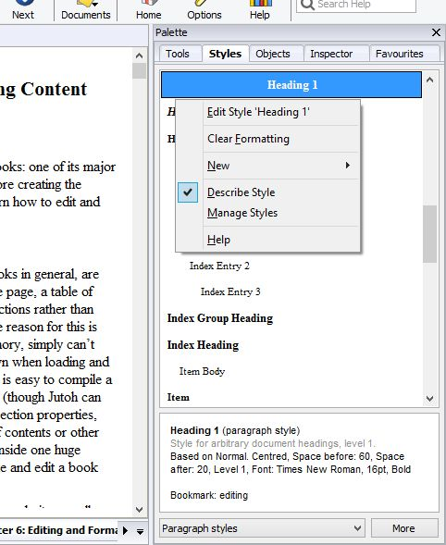
The formatting palette and context/‘More’ menu
You can show or hide the formatting palette using the command Format | Formatting Palette or Alt+P; then click on the Styles tab. There are four other tabs in the palette. The Tools tab shows all the available tools that are also shown on the horizontal toolbar; Objects lists the objects that can be inserted, such as bookmarks, tag objects and tables; Inspector shows selected kinds of content in the current document, such as bookmarks and images; and Favourites shows any styles, commands or symbols that you may have marked as favourites in the shortcut editor (see the next topic).
The formatting palette will only be presented when a document of the appropriate type is being edited; it will also disappear temporarily if you are using the built-in help window, to reduce clutter.
The style that’s highlighted in the list is either the one where your cursor is currently positioned, or the style you have selected in the list with the mouse or keyboard. You can single-click on the styles without worrying about changing your project accidentally; this lets you browse the styles and read descriptions of them in the pane under the list.
To apply a style, double-click on the style name. A menu appears when you click on More or right-click over the style list (or press the context menu button on your keyboard, if there is one). This menu contains commands for editing the current style, clearing formatting in the current paragraph, showing and hiding the style description pane, managing your styles (showing the Project Properties dialog on the Styles tab), and creating new styles.
The Clear Formatting menu command works like Reset Text Formatting in the Format menu, if you have selected some text: character styling within the selection will be removed. It’ll also reset character styling surrounding the cursor if you haven’t selected anything. However if there is no selection and no character styling under the cursor, it will remove ad hoc (direct) formatting from the paragraph. So, for example, ‘Body Text + Centre’ will become just ‘Body Text’. If you select multiple paragraphs, Jutoh will remove both ad hoc paragraph and character styling.
You can choose what kind of styles appear in the list, using the drop-down control next to the More button. By default it shows paragraph styles, but you can also show character styles, list styles, box styles, or all styles.

Applying styles using shortcuts and favourites
Especially if you have a lot of reformatting work to do, you’ll appreciate a quick way to apply styles. Press Ctrl+. and then Enter to start editing shortcuts for the styles in your project. Scroll down the list of shortcuts until you get to the styles section; then edit each relevant style and choose a primary shortcut (direct) or secondary shortcut (prefixed with Ctrl+.). You can also check Favourite to have it appear in the Favourites menu, as described above under Special symbols. For more about this, see Appendix B: Configuring Jutoh.

Using fonts
Ebook readers tend to have a limited range of fonts, so if possible, use as few fonts as possible. You’re on safe ground if you use ‘Times New Roman’, ‘Arial’ or ‘Helvetica’, and ‘Courier New’. If you must use different fonts, specify them in the named paragraph style and not on an ad hoc basis.
You cannot use fonts that happen to be on your system and expect them to turn up on someone’s ebook reader. If you have unusual font requirements, the only thing you can do is embed a font. For this you need to have a copyright-free font, such as fonts from the DejaVu family. Embed it by adding an Embedded Font Document and specify a font substitution in your Epub configuration, such as Times New Roman: DejaVuSans. For more details, see Chapter 21: Advanced Topics.
If your system doesn’t have a particular font that’s used in the project, then when the project is opened, Jutoh will use a special global string table called Font Substitutions to try to find an equivalent font that is available. If you use fonts not specified in this table, you can add more substitutions: go to Preferences, click Strings, select the Font Substitutions table, and add more strings or edit existing ones to add references to the other fonts. You can also change or disable the table that Jutoh uses via the setting Preferences/Advanced/Font substitution table.
If you’re using Linux, you can get the standard Microsoft fonts so that your project files are compatible when switching between operating systems. On Ubuntu, you can find the ‘Restricted extras’ package in the Software Centre, or use this command in a terminal window:
sudo apt-get install ubuntu-restricted-extras
Keep your main content, apart from headings, footnotes, captions etc., at 12pt – this is the point size that Jutoh regards as the ‘default’ size, and which can therefore be left unspecified in the generated ebook. The reader software, and user, will choose the best size. Any font above or below 12pt will be sized relative to the default font, using the HTML ‘em’ unit. The scaling factor to convert a point size in Jutoh to an em size in HTML can be adjusted in the Options panel in Project Properties, should you wish to tweak the way text size is calculated.

Line and paragraph spacing
Line spacing is the space between lines within a paragraph; paragraph spacing comes in two parts: spacing before a paragraph, and spacing after a paragraph.
To edit spacing for a named style, go to the Styles tab in Project Properties (Edit on the main toolbar). Select a style, click Edit and then click on Indents & Spacing.
Paragraph spacing is specified in tenths of a millimetre, which is converted to ‘ems’ for Epub and HTML (see Options in Project Properties for the scaling value). Note that Mobipocket doesn’t register spacing that’s less than 25 tenths of a mm – so if spacing isn’t what you expected, go back and check the values.
Line spacing is specified in multiples of single line spacing, for example 1.2.
Don’t be tempted to simply leave a blank paragraph to get inter-paragraph spacing; some reader software may ignore this and it will be very hard to change your project if you decide to use less or no inter-paragraph spacing. The exception to this is the title page and other cases where you need more than the usual spacing; but even here it’s best to use a special style for each kind of vertical space, so you only need one blank paragraph at a time.

Indentation
First and subsequent line indentation for the left margin can be specified in a style, again under Indents & Spacing in the style editor. So a hanging indent can be achieved by specifying, say, 0 for the first-line indent, and 60 for the normal indent, where the values are in tenths of a millimetre.
You can also specify the right indent, though it’s rare to need to do that. Again, the value is specified in tenths of a millimetre.
Don’t use tabs for indentation! Tabs are ignored in HTML-based formats.

Alignment
Paragraph alignment (left, right, centred, justified) can be specified in the Indents & Spacing tab in the style editor, or via the Format menu and toolbar commands. Generally it’s best to leave paragraph alignment unspecified, so that the ebook reader decides how to format text. But for list items, it can be better to force left-align since a short list item looks terrible when justified.
Note that if you justify text, it won’t show as justified in the Jutoh editor. However it will be justified when viewed in an ebook reader.

Headings
If you use heading styles of the form ‘Heading 1’ then Jutoh will output the styles with the HTML heading tag (such as ‘h1’). To use a different prefix, or to stop Jutoh from emitting ‘h...’ tags, edit the Heading style prefix configuration property.
For finer control of how heading styles map to HTML levels, see Chapter 20: Making Your Books Accessible.

Lists
List styles are the only way to achieve bulleted or numbered paragraphs; you shouldn’t try to apply bullets to an individual paragraph, although the Bullets page of the paragraph style editor is retained in case you imported a bulleted paragraph and need to reset the attributes.
List styles work on the principle that lists can potentially be nested, with different bullet or numbering styles depending on the level (depth) of the list. When you are editing a list, pressing the Tab or Shift+Tab keys will increase or decrease the level of the current paragraph in the list. It is dependent on the particular ebook reader whether the particular bullet or numbering style will be honoured, so you may see a different style in the ebook than in Jutoh.
The Bulleted List and Numbered List buttons in the toolbar apply the styles called “Bullet List 1” and “Numbered List 1” respectively. To apply a different list style, use the Format | Bullets and Numbering menu command, which will give you a choice of list styles to apply, along with the option to renumber the list.
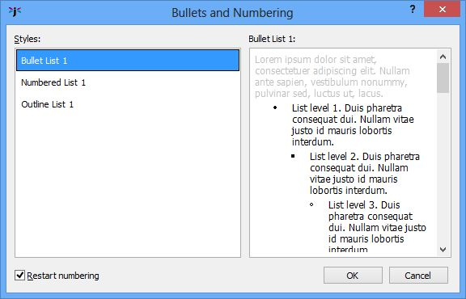
The Bullets and Numbering dialog
You can renumber a list without choosing a style, using the Format | Renumber command, and you can remove list styling from one or more paragraphs by clicking on a bullet or numbering toolbar button.
Non-contiguous list numbering is possible by repeated use of Format | Renumber, specifying the start number, but not all ereaders support this and it can cause EpubCheck errors, so use with caution and be sure that your ebook distributor doesn’t reject the file due to failing EpubCheck.
For any given paragraph in a list, both the paragraph style and list style are used. Since the current paragraph indent is added to the list style indent, choose a non-indented paragraph style for your lists to avoid a double indentation. Jutoh will warn you if you have used a paragraph style with indentation within a list. If you need to, create a special non-indented paragraph style for use within lists.
You can have multiple paragraphs per list by placing the editor cursor just behind the bullet or number, and hitting the backspace key. This will turn the item into a ‘continuation’ paragraph without a bullet or number but with the same indentation as a regular list item. Note that for Mobipocket output, this is simulated by putting line breaks between list paragraphs since genuine multiple list item paragraphs are not possible in KF7 format. Jutoh will make an attempt to convert indented paragraphs in DOCX documents to continuation paragraphs according to the context, but if this is tripped up by complex formatting you will need to correct it within Jutoh by appling a list style and then ‘deleting’ the bullets.
Another way of creating list-like formatting but without using list styles is to use an indented paragraph style with a non-indented heading for the item heading. For example:
Apples
Apples are roundish in shape, and crunchy.
They come in a variety of, well, varieties, with Granny Smith being one of the most popular.
Bananas
Unlike apples, bananas are long, bendy and squishy.
They have their own convenient wrapper utilising a zip-like mechanism, and all too soon they turn black.
For more on list styles, see Chapter 12: Working With Style Sheets.

Adding keywords
You can add keywords to your text, and if the configuration property Replace strings in content is enabled, keywords will be replaced by values in the compiled book. Keywords can come from string tables that you create, and also from your project metadata. The following metadata keywords are predefined:
%TITLE%, %ID%, %LANGUAGE%, %AUTHOR%, %CONTRIBUTORS%, %PUBLISHER%, %URL%, %SUBJECT%, %DESCRIPTION%, %DATE%, %RIGHTS%, %COVERAGE%, %TYPE%, %FORMAT%, %SOURCE%, %RELATION%
This can be a useful facility if you wish to provide different editions with only slightly differing content, or to allow quick editing of text used throughout the book, or to abbreviate a long piece of text such as an HTML fragment. Keyword names are case-sensitive and each keyword must be formatted with a single or no style. You can read more about string tables in Chapter 13: Working With String Tables.

Editing document properties
Although this isn’t directly related to formatting, it’s important to know how to edit properties associated with each book section document. To show the Book Section Properties dialog, you can do any one of these:
- Right-click (or control-click on Mac) over the title of the book in the project outline and click on Properties.
- Choose the Document | Document Properties menu command.
- Press Shift+Alt+Enter.
- In the Project Properties dialog, click Document and then Edit Document Properties.
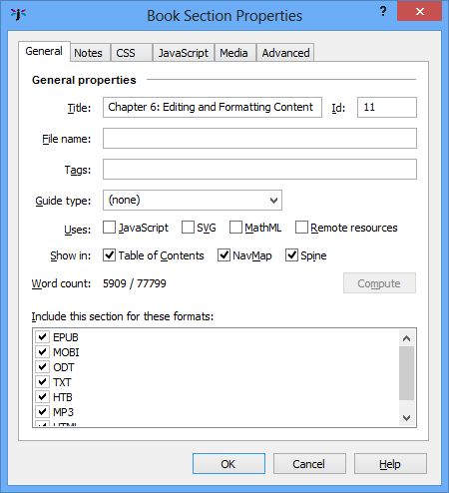
The Book Section Properties dialog
Here, you can edit the title of the document, the guide type (see Chapter 21: Advanced Topics for information on guide types), an optional HTML file name, tags, whether to show the document in the table of contents, NavMap and spine (Epub/Mobipocket only), whether to include the section for a particular file format, and notes for this document.
You can add tags to allow for conditional inclusion of exclusion of the section in your ebook: for more on that, see Chapter 21: Advanced Topics.
You can also see the word count for this document and the whole project (by clicking on Compute), and you can see the unique identifier of this document (not editable).
For more advanced use, there are tabs for extra CSS for this document, JavaScript code, timings for synchronising narration with content, and further properties for specifying an Epub type (for Epub 3 ebooks), JavaScript event handlers, and more.

Previewing your work
You can view your entire ebook by pressing Compile and then Launch to show the book in the default viewer application. However, this can be slow if you just want to see the results of a small change. So instead, you can use Book | Preview Section (Alt+/), and Jutoh will show the HTML of the current book section in your web browser, having written the HTML and relevant resources to a temporary folder (see the screenshot below). This won’t be exactly as the book will appear in various ereaders, but it will be close. Use a separate browser window sized appropriately and placed in front of your regular browser window, so the preview doesn’t interfere with your normal web browsing.
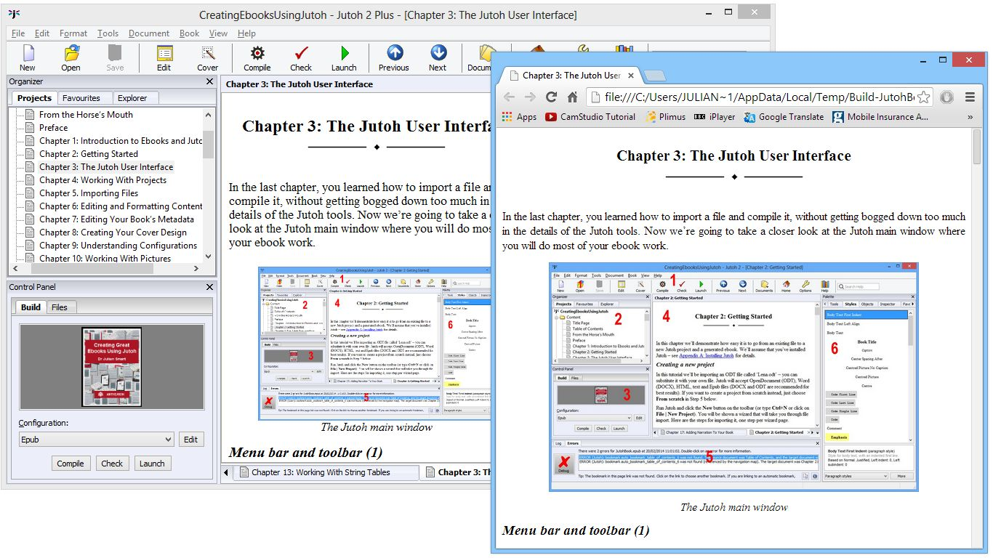
Previewing a Jutoh book section using Chrome
For further previewing and testing suggestions, search for KB0118 (‘How can I test my Epub and Kindle books?’) in Jutoh help.

Summary
Now you’ll have a good idea of what’s possible with content editing and formatting, and how to accelerate your typing and styling using shortcuts and favourites. You can read more about styles in Chapter 12: Working With Style Sheets. It’s worth repeating an essential point: create and use named styles wherever possible, and don’t use ad hoc formatting. When you come to tweak your book formatting, you’ll be glad if took this advice and planned ahead, rather than having to make potentially thousands of changes in your document.
Next, we’ll look at editing the project’s metadata – the information describing the book.

Chapter 7: Editing Your Book’s Metadata
Each project must have a minimal amount of metadata, which describes the project to the reading software to display if appropriate. It is required for Epub and Mobipocket formats. This chapter explains what metadata you should provide, and how to do it.

The metadata panel
When you create a project, you will be prompted for a small amount of the possible metadata that can be provided. You can edit more metadata via the Metadata tab of the Project Properties dialog (click on the Edit toolbar button).
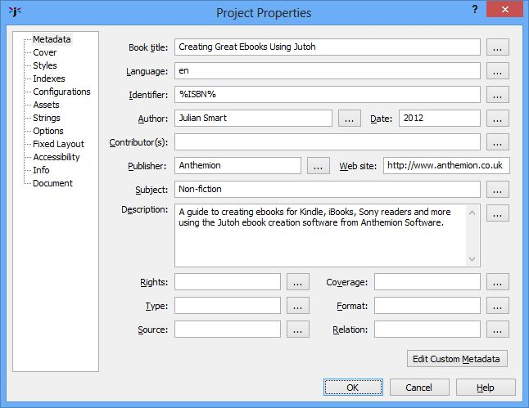
The metadata panel in Project Properties
A metadata field is called an element, in XML parlance. In most cases, there is one value per element. You can just type the value into the appropriate text field. For example, there is only title. However, in some cases, it’s possible and desirable to provide multiple values per element (for example, multiple contributors); or to add a special attribute within the element, to make the meaning of the value clearer. To achieve either of these, click on the ‘...’ details button next to a category to show the element editor.
Let’s say we want to add an ISBN identifier. Click on the details button (‘...’) next to Identifier, and in the element editor dialog, click on the first Add button to add a new element value. This shows a menu of possible element templates; click on ISBN. This adds a new element with ‘opf:scheme’ set to ‘ISBN’. You can type the ISBN number into the ‘Value’ property, and the XML that Jutoh will write to the metadata will be shown in the preview. In the following example of the element editor in action, we’ve deleted the original element so there’s only one kind of identifier in this book, the ISBN.
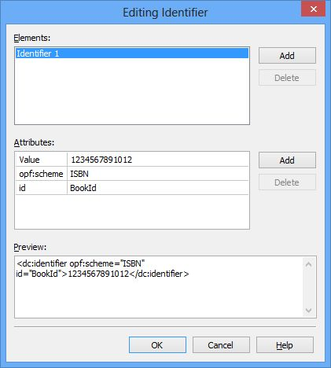
The Element Editor dialog
Some attributes have a convenient list of options; at present these are:
- ‘opf:scheme’ in the Identifier element;
- ‘opf:role’ in the Author element;
- ‘Value’ in the Language element.

Metadata elements
These are the most common metadata elements. Only the title is obligatory in Jutoh – other fields that are mandatory for Epub and Mobipocket and that are not filled in, will be generated.
Book title
The book title.
Language
The language the book is written in, such as ‘en’ for English or ‘fr’ for French. If left unspecified, the default value is ‘en’. You can select from a list of languages if you click on the details button and click on the ‘Value’ attribute.
It is important to specify the correct language, as otherwise ebooks can be rejected by some distributors, and the wrong dictionary may be used on the ebook reader.
Identifier
The identifier for the book, which can be arbitrary (if the ‘opf:scheme’ attribute is not specified), or it can be an ISBN; other kinds of identifier can also be used. Use the element editor to add different kinds of identifier. If left unspecified, the default value will be the title of the book.
You can use a keyword intead of an actual identifier, such as ‘%IBSN%’. Then use string tables to fill in the value according to the current configuration. This is described further in Chapter 21: Advanced Topics.
Another way to achieve per-configuration ISBNs is simply to leave the Identifier field blank in the project metadata, and use the Identifier configuration option instead. By default, this configuration option is filled in with a different UUID (globally unique identifier) for each configuration. It’s prefixed with ‘urn:uuid:’ so that the identifier scheme is known. You can also enter an ISBN instead, prefixed with ‘urn:isbn:’. However, this technique isn’t quite as flexible as the string table method, because you can’t use a keyword in the actual content (such as the front matter).
Author
Type your name here; you can specify multiple authors via the element editor. This becomes the ‘creator’ element in the metadata, and you can specify the creator roles using the element editor if you want to add creators other than author. If not specified, there will be no creator element in the metadata. For descriptions of attributes that give more information about the type of author, see:
www.loc.gov/marc/relators/relaterm.html
Date
Specify the date in the format YYYY-MM-DD, or YYYY-MM, or just YYYY (ISO 8601 standard). If not specified, the date of generation will be used. You can add an optional ‘opf:event’ attribute which can be one of ‘creation’, ‘publication’ and ‘modification’.
Contributors
You can have zero or more contributors. By default, Jutoh lists itself as a contributor. You can switch this behaviour off in your configurations. For descriptions of attributes that give more information about the type of contributor, see:
www.loc.gov/marc/relators/relaterm.html
Publisher
An optional field with the publisher’s name.
Web site
An optional field; this doesn’t have a direct equivalent in Epub metadata and uses a ‘relation’ element since the web site is notionally a related publication.
Subject
The subject of the book. If this is not specified, ‘General Fiction’ is used. There is no standard list of possible subjects, though your publisher might have some guidance.
Description
A description of the book.
Rights
An optional statement of the book rights.
Type
The optional book category (as defined by a particular publisher).
Source
Optional information about a resource from which the book was derived.
Coverage
An optional description of the extent or scope of the book’s coverage.
Format
An optional book media type, such as a MIME media type.
Relation
An optional identifier of an auxiliary resource or related publication and its relationship to this publication.
Custom metadata
If any elements you require aren’t catered for in the metadata panel, you can add custom ones by clicking the Edit Custom Metadata button at the bottom of the panel. You can add elements and then edit their values and edit multiple element values as with regular metadata. Unless you have advanced needs, you are unlikely to need this facility.

Viewing the generated metadata
If you want to see the actual metadata that Jutoh generates, which may differ slightly from the metadata you specify directly, you can generate an Epub file and use F6 or Book | Examine and click on the file content.opf. The metadata is contained between the metadata start and end tags.

Specifying metadata defaults
It can be annoying to type in the same metadata for each project, so Jutoh allows you to set the default for the most important metadata values, in the Advanced panel of the Preferences dialog under Metadata defaults.

Summary
We’ve seen how to describe your book to the ebook reading software, and your readers. Next we deal with another important aspect for communicating what your book’s about – the cover design.

Chapter 8: Creating Your Cover Design
An attractive cover design is important for catching the reader’s eye as he or she scans through a web site or virtual shelves. Jutoh can help you create a cover from scratch using its built-in editor; or if you have an existing design, then Jutoh can use that. This chapter covers everything you need to know about using cover designs in Jutoh.

Cover design basics
The cover design does not appear as a section in your project under the ‘Contents’ folder; instead you edit it in Project Properties. A preview of the cover design will appear in the Build tab of the Control Panel. To edit the cover design, simply click on the cover image in the Control Panel, or click on the Edit toolbar button and then on the Cover tab, or click on the Cover toolbar button.
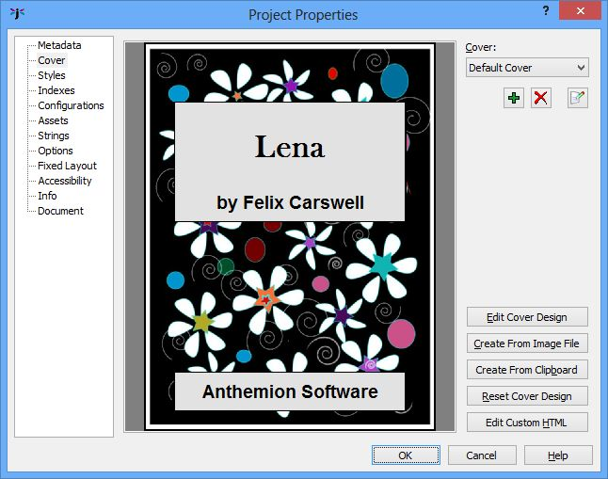
The Cover page in the Project Properties dialog
A good size for a cover image is 600 pixels wide by 800 pixels high, though on today’s pixel-packing devices, you might like to use a higher resolution. You can also look at the recommendations of the particular site or publishing platform you are using.
Because ebook covers are often shown as a small thumbnail on ebook sites, you need to make them readable when reduced to a small size; so simplicity is a virtue for ebook covers.

Using an existing design
If you have an existing image you wish to use, you can specify this in the New Project Wizard by selecting Use existing file in the Cover page and browsing for an image file.
Or, after you have created the project, start editing the cover within Project Properties and click Create From Image File. You can then choose a file to use.

Using the cover designer
In the Cover tab in Project Properties, click on Edit Cover Design. This will show cover designer dialog, shown below. A design comprises a list of rectangular objects, which are drawn from the top one first to the bottom one last, and so later objects will partially obscure earlier objects. The first object is always called “Background” and defines the overall size and the background colour or texture.
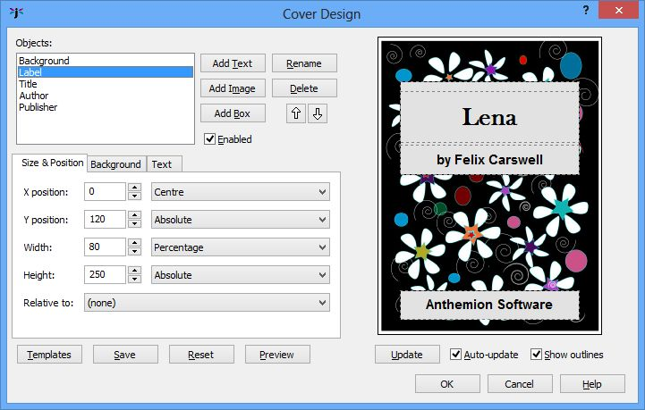
The Cover Designer dialog
Typically a design might have four other objects: one for making a ‘label’ area against the background, and three more for placing the title, author name and publisher name.
Add a new object with Add Text, Add Image or Add Box. They all add an object, but set up the initial values in different ways for convenience. You can Rename or Delete the selected object, and change the selected object’s order in the list with the up and down arrows.
You can save the current design as a template file to use for subsequent designs, using Save, and you can browse and apply other templates by clicking on Templates. Click on Reset to clear all objects apart from the background, and Preview shows the design at the actual pixel size.
The following topics describe the three tabbed editor pages, which are used to specify how the selected object is displayed.

Object size and position
In this page, adjust the size and position of an object using the up-down controls or by entering values manually. The X and Y positions can be absolute (relative to a parent object specified in the Relative to field), or a percentage of the parent, or centred with respect to the parent). The width and height can be absolute or a percentage of the parent. If no parent is specified, the object dimensions are relative to the background object, where applicable.

Object background
The object background page determines how the background texture is drawn.
The Style field takes one of a number of values:
- Transparent – the object is not drawn. This can be useful if the object is meant as a place-holder to be the parent object for other objects (for example, if the object represents the ‘label’ area of the book containing text).
- Colour – the object is drawn as a solid colour.
- Image – the specified image is drawn at the top-left of the object rectangle, without tiling or scaling.
- Centred image – the specified image is drawn centred within the object rectangle.
- Tiled image – the specified image is tiled to fill the object rectangle.
- Stretched image – the specified image is stretched to fill the object rectangle.
The Texture field shows either a solid colour or a specified image, depending on the Style setting. Click this field to choose a new colour or image, or you can paste an image into the field by clicking on the Paste button.
The Scale field can be used to adjust the scaling of the image.
Border style can be ‘None’, ‘Single’, ‘Double’ or or ‘Triple’. A double border uses the two border colours specified underneath the style field, while the triple border style uses the first border colour, the object background colour, and then the second border colour (using Border 2 Width for both the inner and the third border widths).

Text
Type text in the field provided if you wish to add text to this object. Click on Insert Keyword to see a choice of keywords that will be replaced when the cover design is regenerated. The keywords are taken from the metadata, and also from the currently selected global and project-specific string tables selected in the current configuration, if any.
You can also specify the font and the text colour.

Exporting your design
If you need a copy of your cover design, for example to upload to iTunes, you can export it to one of several popular image formats via File | Export | Cover Design using the Cover Design Export dialog.
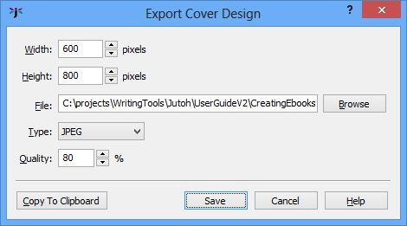
Export Cover Design dialog
This will use the cover design indicated by the current configuration. You can select a different width and height from the values used in the book, and your design will be scaled to this size. You can also use Copy To Clipboard to paste the image into another application.

Specifying a cover for Kindle
When uploading your ebook to Amazon, you don’t actually need to have the cover in your .mobi file, because you also upload a separate cover, higher-resolution cover to the KDP site. So if you wish, you can set the Cover design configuration option to ‘(none)’, and ignore the Kindlegen warning about the lack of a cover.

The cover page versus the cover image
If a design is specified, the image will always be included in the book. However, Jutoh can also generate an XHTML page that embeds the image. This is controlled by the configuration property Generate cover page. It is recommended that you enable this in your Epub configuration (unless uploading the Epub to Amazon without first converting to Mobipocket), and disable this in your Mobipocket configuration to avoid showing two covers.
If you check Exclude cover from reading order in your configuration, the cover page may not be shown as part of the book – for example, in iBooks, the cover will only appear on the bookshelf. If you want the reader to be presented with the cover page, clear this option. Don’t clear this for Mobipocket files, however. Note that Calibre has an unusual interpretation of exclusion from reading order and shows such sections at the end of the book.
You can specify the Cover page background colour in your configuration to fill in the area around the image with colour.

Specifying the cover image format
Normally the cover image will be output as a JPEG file compressed at 90%, but if your cover contains line art, you might prefer to set the configuration property Cover image format to ‘PNG’. This will result in a larger but higher quality file.
A cover design can contain a variety of text and graphics that is scaled, combined and rendered to a bitmap before the image file is created. If you want to provide your own cover image and make sure that no extra processing is done to the image, you can set Cover image format to ‘Original’. Then the image you imported from a file will be the exact image that is used as the cover. For this to work, there must be only one object in the cover design.

Using multiple cover designs
Typically you will have one cover design per project. However, Jutoh lets you define any number of cover designs. You might wish to experiment with several alternatives, or you might use different covers to target different ebook vendors. In that case, you’d have several configurations, with a different cover name assigned to the Cover design property in each configuration. You can manage your cover designs in the Cover tab of Project Properties; they are listed in the drop-down control. Initially you will have just one cover design, called ‘Default Cover’. You can add, delete and rename designs using the buttons under the drop-down list.

Cover display on different devices
On Kindle, the book will start at the first main page and you’ll have to page back to see the cover. There is nothing that can be done to change this behaviour. On iBooks, you’ll see the cover in the virtual bookshelf, and the first page shown will be the cover unless you have specified an alternative first page by using a document guide type. Other ereaders may or may not show the cover as the first page.

Summary
You now know how to add a cover to your project, from an existing design or from scratch using the built-in cover designer. Next, we’ll tackle the topic of configurations – the mechanism Jutoh uses to allow you maximum control over each individual file format or ebook platform that you’re targeting.

Chapter 9: Understanding Configurations
Ebook publishers often have slightly different requirements, even if the same format is used. You may also wish to tailor Jutoh’s output for your own reasons. Jutoh’s configuration feature lets you change the way that ebooks are generated, so that you can tweak the output for one format or ebook platform without affecting others. You may not need to worry about configurations for a bit but once in a while you may come across the need to change configurations or even add new ones; so it’s worth at least scanning this chapter so you know where to look.

Configuration basics
At first glance, ‘configuration’ seems like a fancy name for ‘format’. In the Build tab of the Control Panel, before compiling, you select the appropriate configuration such as ‘Epub’ or ‘Mobipocket’, each of which is generally named after the format it targets.
However, configurations are much more than that. They contain a whole host of user-editable options that will be used for that configuration; and you can add as many configurations as you like. So, for example, you might like to have two Epub configurations, called ‘iBooks Epub’ and ‘Barnes & Noble Epub’, with slightly different behaviour for each.
A configuration can specify which cover design or style sheet to use – so you can have alternate versions of your book with different cover designs or formatting, without having to maintain different versions of the book.
Or you could have different configurations for generating images with different sizes, tailored for use on different kinds of reader device.
When you create a Jutoh project, Jutoh’s New Project Wizard presents you with the option to create an initial set of configurations, one per format supported. Generally you can leave the defaults as they are unless you know you definitely won’t need some of them. Later, you can add, change and delete configurations.
Important note: although you can enable different formats in the same configuration, don’t be tempted to do this for generating, say, Epub and Mobipocket files from the configuration. Jutoh optimizes these formats differently, so you need to use independent configurations.

Editing configurations
To edit a configuration, you can click on Edit on the toolbar to show the Project Properties, and then click on Configurations. Or, you can click on the Edit button next to the drop-down list of configurations in the Control Panel; this will show you the currently-selected configuration.
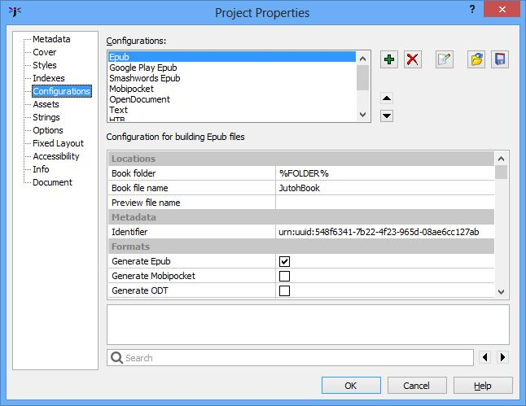
The Configurations page in the Project Properties dialog
Configuration properties are presented in a scrolling list, with names on the left and editable values on the right. Click on a property to see its description, displayed under the list. You can double-click on some properties (such as Notes) to show a larger text editor. To make it easier to find properties, you can type all or part of the property name in the search box at the bottom of the window; use the left and right arrows to cycle through the matches, selecting each matching property in turn. You can press the Return key to give the keyboard focus back to the property editor.
You can add a new configuration by clicking on Add – you will be given the option of basing the new configuration on an existing one (the values will be copied to the new configuration). If an existing configuration is not chosen, Jutoh prompts for a format and does some initialisation appropriate to the format. You can delete the selected configuration with Delete, and change its name with Rename. If you want to apply the same configuration settings to a different project, you can Save selected configurations to a file and then Load them in the other project. Use the up and down arrows to reorder configurations in the list.

Using configurations
You can select the current configuration in the control panel to the left of the Jutoh editor. This configuration will be used to determine paths and other settings for Compile, Check and Launch commands.
To compile a book using the current configuration, click on the Compile button on the Control Panel, or click on the Compile button on the toolbar, or use Book | Compile menu command, or use the F7 keyboard shortcut. If you prefer, you can compile using multiple configurations in one go, using the Book | Batch Compile command; a choice of configurations to use is presented, as shown below.
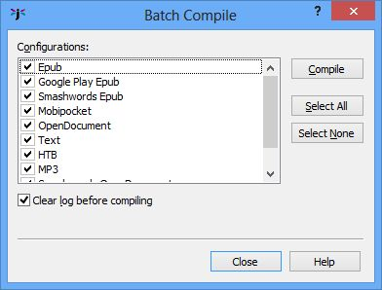
Batch Compile dialog
Note that if you use the File | Export menu command to quickly export your book to a specified format, any formats specified in the currently selected configuration are temporarily overridden. All the other settings in the current configuration will be used for the export, so normally it’s best to select the best configuration for the job and press Compile.
While we’re talking about compiling, it’s worth pointing out that you can use the Update Special Book Sections dialog instead of updating the table of contents, index, or endnotes individually from their respective dialogs.
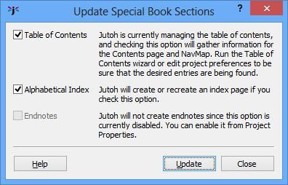
Update Special Book Sections dialog
If any of these special sections are out of date since the last compile (for example, you added headings, index entries or footnotes), you can show this dialog using Book | Update or F9, and click Update to update all checked special sections. Note that you can also elect to automatically update these sections when you compile (via controls in the Project Properties dialog), so you can be sure they are always up-to-date.

Configuration categories
Let’s look at the property categories in detail.

Locations
This category contains location-related properties. Usually you don’t need to edit these.
- Book folder: used to specify the folder in which the ebook for this configuration will be generated. The folder containing the project will be substituted for the keyword %FOLDER%, which is the default value.
- Book file name: this is %FILENAME% by default; you might want to change the name if you have multiple configurations for the same format. Note that an appropriate extension will be appended so you don’t have to include that in your file name value. For example, if your project is called MyBooks, you could use ‘%FILENAME%_ibooks’ to specify ‘MyProject_ibooks.epub’.
- Preview file name: this is only used for the HTML format where there may be multiple files generated, and indicates which file should be used when previewing (launching) the generated book.
Metadata
This category contains just one property, Identifier.
- Identifier: The unique identifier for your book. If the Identifier metadata field is left empty, the identifier for the current configuration is used. Note that initially, Jutoh generates a different UUID for each configuration.

Formats
Each configuration should have at least one format checked. You can have multiple formats checked, but this is not usually desirable. The one case where you might like to do that is in your Mobipocket configurations; if you also check Epub you will be able to check and view the source for your Mobipocket books.
These are the supported formats:
- Generate Epub: generates Epub 2 output, or Epub 3 if Epub version is set to 3.
- Generate Mobipocket: generates Mobipocket output, suitable for Amazon Kindle devices and software.
- Generate ODT: generates OpenDocument Text, a word processor format that can be converted to many other formats such as Word, using for example the free OpenOffice.org suite. Note that Word itself tends to create more compact .doc files than does OpenOffice.org, so you might want to re-save the file using Word if file size is an issue.
- Generate text: generates a single plain text file with no graphics.
- Generate HTB: generates a wxWidgets Help file, a simple zipped, HTML-based format.
- Generate MP3: generates MP3 files if you select a suitable voice engine and install the LAME MP3 encoder in Preferences (MP3).
- Generate HTML: generates a series of XHTML files. Book navigation controls can be enabled via properties in the “Navigation” category below.

Cover Design
This category gives you control over the way Jutoh generates the cover design and cover page for your book.
- Cover design: specifies the cover design to be used in this configuration.
- Cover page background colour: specifies an optional background colour for the XHTML page that contains the cover (Epub only). This RGB value should contain six hexadecimal digits, two digits per colour. To edit the colour, double click on the property name or click on the ‘...’ button. You might like to provide a background colour chosen from the cover image for filling in the area around the image.
- Generate cover page: check to generate an XHTML cover page for the book. Not recommended for Mobipocket.
- Expand cover to fit page: check to have the cover expand to the page height (the default).
- Include cover in NavMap: check to include the cover in the navigation map – not recommended.
- Exclude cover from reading order: check to hide the cover from the linear reading order (linear=no in the spine) – recommended. If this option is checked, the cover page may not be shown as part of the book – for example, in iBooks, the cover will only appear on the bookshelf. If you want the reader to be presented with the cover page first instead of the title page, clear this option. Don’t clear this for Mobipocket files, however. Note that Calibre has an unusual interpretation of exclusion from reading order and shows such sections at the end of the book.
- Cover image format: specifies the image format for the cover design. If ‘Original’ is specified, and the cover design has only one image object (for example, it was created from an existing cover image file), then the original file is used without change.
- Cover image width: specifies the cover image width in pixels, or -1 to use the default cover design width.

Options
This category contains miscellaneous options controlling how Jutoh generates ebook output.
- Generate title page: check to generate a title page for the book. It’s usually better to create your own by hand.
- Generate table of contents: check to generate a table of contents page for the book, either automatically (it will not be visible in the project) or manually whenever you run the TOC wizard (it will be visible in the project).
- Generate guide: check to generate a guide section in the OPF file – recommended.
- Generate title tag: check to generate a title tag for each HTML file.
- Optimize for iBooks: various optimizations are applied. In particular, dummy spans are added to centered paragraphs in order to fix centering in full justification mode. Use Generate font names to determine whether the specified-fonts option will be switched on in the iBooks XML file, or whether font names will be suppressed. This option will cause a file called com.apple.ibooks.display-options.xml to be added to the Epub file, under the folder META-INF. If you submit the Epub to Lulu, this may cause an “unmanifested file” error, so clear this option for Lulu submissions.
- Generate iBooks XML: if this option and Optimize for iBooks are both checked, generates the file com.apple.ibooks.display-options.xml when necessary.
- Optimize for Mobipocket: anchors are inserted before paragraphs to prevent style loss on navigation (as recommended by Amazon guidelines), and no paragraph tags are used within a list item.
- Mobipocket anchor optimization: if cleared, and Optimize for Mobipocket is checked, anchors are no longer inserted before paragraphs. You might want to clear this if you have long paragraphs containing footnotes, for example, and want to achieve accurate navigation regardless of any styling side-effects that can be caused by bookmarks within paragraphs on the Kindle platform.
- Credit Jutoh: adds Jutoh as a book producer in the Epub/Mobipocket metadata.
- Start page guide type: specifies the guide type that will be substituted for %STARTPAGE% in a section’s guide type to indicate the first reading page. For iBooks, it is ‘other.reader-start-page’, and for Mobipocket, it is ‘text’.
- Visible URLs: specifies whether the URL will be added to the text, for printable documents. If ‘None’, no URLs will be added. If ‘Always’, the URL will always be added. If ‘Intelligent’, Jutoh will check whether the URL is already in the linked text.
- Epub version: Specifies the Epub version to generate.

Styles
This category controls style-related options. More about styles can be found in Chapter 12: Working With Style Sheets.
- Style sheet: specifies the style sheet to be used in this configuration.
- Paragraphs to exclude: the comma-separated paragraph styles whose paragraphs should be excluded from the book. You can use * to mean all characters, for example ‘Only*’ will cause all paragraphs with a style name beginning ‘Only’ to be excluded, except for those specified in Paragraphs to include. For examples, see Chapter 12: Working With Style Sheets.
- Paragraphs to include: the comma-separated paragraph styles whose paragraphs will be exempt from exclusions. You can use * to mean all characters. For example, if this property has the value of ‘Only Epub’, paragraphs styles with ‘Only Epub’ will be retained, but (assuming ‘Only*’ in Paragraphs to exclude), all other paragraphs whose style name begins with ‘Only’ will be removed. Thus you can include or exclude paragraphs in your document depending on the configuration. For examples, see Chapter 12: Working With Style Sheets.
- First paragraph style: the style to use for first paragraphs after a heading when importing into an existing project from plain text, HTML or Epub.
- Normal paragraph style: the style to use for normal paragraphs when importing into an existing project from plain text, HTML or Epub.
- Chapter heading paragraph style: the style to use for chapter headings when importing into an existing project from plain text. Only relevant if you have Take title from first line of text files switched on in Project Properties/Options.
- Character style substitutions: Semicolon-separated character style substitutions, for example ‘Drop Caps: Drop Caps Epub; Emphasis: Red Emphasis’. This allows you to adjust styles per configuration without needing to use a different sheet.
- Paragraph style substitutions: semicolon-separated paragraph styles substitutions, for example ‘Normal: Normal Justified; Centred: Centred Bold’. This allows you to adjust styles per configuration without needing to use a different sheet.
- Heading style prefix: a prefix for determining whether a style is a heading for the purposes of HTML generation. The default is ‘Heading’. Clearing this field will prevent Jutoh from generating <h> tags. Note that from Jutoh 1.67, the generated CSS overrides heading formatting (if Heading style prefix specifies a valid prefix for existing heading styles) and so heading styles should be displayed as specified in Jutoh, and not according to ereader heading defaults.
- Styles suppressing hyphenation: A pattern matching all styles that should suppress hyphenation. Multiple patterns containing wildcards (‘*’ and ‘?’) can be separated by the pipe character (‘|’). For example, ‘Heading*|Book Title’. This works for Epub only, and generates the extra CSS adobe-hyphenate: none; hyphens: none;.
- Styles suppressing page break before: a pattern matching all styles that should suppress a preceding page break. Multiple patterns containing wildcards (‘*’ and ‘?’) can be separated by the pipe character (‘|’).
- Styles suppressing page break after: a pattern matching all styles that should suppress a following page break. Multiple patterns containing wildcards (‘*’ and ‘?’) can be separated by the pipe character (‘|’).

String Tables
Jutoh’s string tables feature allows customisation of metadata, cover design text and book content per-configuration, by substituting one string for another. This category controls how the configuration uses existing string tables. For more information, see Chapter 13: Working With String Tables.
- Project string table: specifies the project string table to be used in this configuration, if any. Project strings override global strings.
- Global string table: specifies the global string table to be used in this configuration. Project strings override global strings.
- Replace strings in content: check to replace strings in book content as well as metadata and cover designs.

HTML Formatting
This category contains various options used for HTML-based formats.
- HTML version: specifies how HTML code will be generated. If this value is ‘(auto)’, the value will be deduced from other settings.
- Use XHTML: specifies whether XHTML or HTML will be generated. If this value is ‘(auto)’, the value will be deduced from other settings.
- HTML left margin: sets a global left margin for Epub and HTML formats (not Mobipocket). Examples: 3%, 10mm, 0.2in, 20px. To remove the margin, clear the value.
- HTML right margin: sets a global right margin for Epub and HTML formats (not Mobipocket). Examples: 3%, 10mm, 0.2in, 20px. To remove the margin, clear the value.
- HTML top margin: sets a global top margin for Epub and HTML formats (not Mobipocket). Examples: 3%, 10mm, 0.2in, 20px. To remove the margin, clear the value.
- HTML bottom margin: sets a global bottom margin for Epub and HTML formats (not Mobipocket). Examples: 3%, 10mm, 0.2in, 20px. To remove the margin, clear the value.
- Styles for indent fix: specifies the styles whose left indent should be converted to a first-line indent, to fix the lack of full left indent support on Mobipocket (only). By default this is ‘TOC*’. To stop any such conversion, clear this setting. You can use star (*) to match multiple characters in the style name.
- Use relative dimensions: Jutoh can use the relative unit em to specify dimensions such as indentation and paragraph spacing, or it can use mm. If this option is checked, em is used and this allows better scaling when the text size is changed by your book audience. However, Mobipocket doesn’t allow precise specification of dimensions when using em, so it’s recommended to clear this option for Mobipocket and enable it for Epub and HTML formats.
- Dimension units: choose the units to use for non-font dimensions such as margin and size. Some platforms require pixel units for fixed layout books. If you specify ‘Default’, Jutoh will decide what units to use.
- Font size units: Choose the units to use for font sizes. Some platforms require pixel units for fixed layout books. If you specify ‘Default’, Jutoh will decide what units to use.
- Font pixel scale: When fonts are specified in pixels, the size shown in Jutoh can differ from pixel size as rendered in HTML. This scale factor helps to compensate for this difference.
- RTL direction: sets all paragraph styles to have right-to-left text direction.
- URL attribute removal style: specifies the character style containing URL attributes to remove, so that only the default link attributes specified by the book reader software (or in custom CSS) will be used. For example, if you specify ‘URL’ in this property containing blue and underlining attributes, then blue underlined links will have both attributes removed in the final book. However if a link was styled with red, then the red colour will be retained, and just any underlining removed. If this property is set to ‘(none)’ or left empty, then no attribute removal will be done.
- Use heading text size: if enabled, text sizes will be written for styles that match Heading style prefix. Clear this to use the ebook viewer's default heading sizes.
- Abbreviate style names: if enabled, style names in the HTML and CSS files will be abbreviated instead of being derived from the original style names.
- Optimize style sheet: if enabled, Jutoh will remove unused styles from the CSS style sheet.
- Emulate small caps: if enabled, Jutoh emits actual capitals and a smaller font size, for viewers such as ADE that ignore the font-variant attribute. On by default.
- Convert horizontal bar to em dash: converts Unicode 8213 (horizontal bar) to Unicode 8212 (em dash) and adds a non-breaking span. Some Epub viewers, such as Adobe Digital Editions, do not support horizontal bar, and it is essential punctuation for Spanish. For the non-breaking behaviour to work, the bar and non-space character to the left or right of the bar must be formatted in the same (or no) character style.
- Convert non-breaking hyphen to hyphen: converts Unicode 8209 (non-breaking hyphen) to an ordinary hyphen and adds a non-breaking span. Some Epub viewers do not support a non-breaking hyphen. For the non-breaking behaviour to work, the hyphen and non-space character to the left or right of the hyphen must be formatted in the same (or no) character style.
- Add thin spaces around punctuation: inserts non-breaking thin spaces around punctuation to conform with typographical convention for French books. If there is white space already in position, it is replaced by the thin space, but existing white space is not necessary.
- Thin space entity: the HTML code to use for a thin space. By default, it is &thinsp;. Not all fonts support this entity; you can sometimes work around it for Epub files by embedding a font that supports it. Some but not all Kindle devices will render it correctly. Or, you can use an image instead, although this can slow down rendering considerably. This code will insert an image (you should also add a media document with a suitable small, white bitmap):
<img width=4 style="width:4px;" src="media/emptybitmap4x1.png" alt=""/>
- Orphan control for single-letter words: inserts non-breaking spaces after single-letter words to avoid orphan words at the end of lines.
- Character substitutions: Semicolon-separated pairs of decimal Unicode substitutions. For example the value ‘8239:160;8201:160’ would convert two kinds of thin space to non-breaking spaces.
- Use div tag: determines whether the div tag is used instead of p.
- Extra metadata: extra meta elements for the metadata section of the Epub or Mobipocket OPF file.
- Widow control: A widow is the last line of a paragraph appearing alone at the top of a page. This option specifies the minimum number of lines of a paragraph that appear at the top of a page. Use ‘Default’ to use the ebook defaults, ‘None’ to switch off widow behaviour, or a number for the minimum number of lines.
- Orphan control: An orphan is the first line of a paragraph that appears on its own at the bottom of a page. This option specifies the minimum number of lines of a paragraph that must appear at the bottom of a page. Use ‘Default’ to use the ebook defaults, ‘None’ to switch off orphan behaviour, or a number for the minimum number of lines.
- Namespaces: Specifies the XHTML namespaces. Specify ‘auto’ to have Jutoh use the namespaces appropriate to the current Epub version.
- Table headers and footers: Check to emit headers and footers if specified in individual tables. Most readers cannot make use of this option.
- Emulate boxes using tables: Check to emulate boxes by using one-cell tables, for platforms such as Kindle for iOS that do not support boxes.
- Use minimum size for cells: Check to use min-width and min-height instead of width and height in table cells, for better ADE compatibility. If absolute sizes are used, content can overspill cell boundaries in ADE.
- Maximum table rows for inline-block: The maximum number of table rows before Jutoh no longer uses the ‘display:inline-block’ attribute for the table. While this attribute is useful for centering tables in Adobe Digital Editions, it stops Adobe Digital Editions rendering long tables. Set to zero to never use inline-block.
- Maximum box words for inline-block: The maximum number of words in a text box before Jutoh no longer uses the ‘display:inline-block’ attribute for the box. While this attribute is useful for centering boxes in Adobe Digital Editions, it stops Adobe Digital Editions rendering long boxes. Set to zero to never use inline-block.

Text Formatting
This category contains options for plain text and ODT (OpenDocument Text) output.
- Wrap paragraphs: check to wrap paragraphs at the maximum number of characters per line, for text output only.
- Add blank lines: check to add blank lines between paragraphs, for text output only.
- Characters per line: the maximum character per line if wrapping, for text output only.
- Left margin: the left page margin in mm, for ODT output only.
- Right margin: the right page margin in mm, for ODT output only.
- Top margin: the top page margin in mm, for ODT output only.
- Bottom margin: the bottom page margin in mm, for ODT output only.
- Paper size: the paper size, for ODT output only. The default is A4.
- Custom paper width: the custom paper width, for ODT output only. Specify mm (the default), cm or in. If custom width and height are both specified, the values will override the Paper size selection.
- Custom paper height: the custom paper height, for ODT output only. Specify mm (the default), cm or in. If custom width and height are both specified, the values will override the Paper size selection.
- Mirror margins: Check to mirror page margins, for example when creating a gutter for print on demand. For ODT output only.
- Dots per inch: the assumed number of dots per inch for images, used if no absolute dimensions are specified. For ODT output only. The default is 96.

Images and Media
This category contains options allowing you to control various aspects of image (picture) output. For more about images, see Chapter 10: Working With Pictures.
- Maximum image width: the maximum image width to use in your book. Specify -1 for no scaling. Note that this physically scales the image before it is written to the ebook, rather than simply setting the max-width CSS property. In contrast, Limit images to viewer size sets the max-width and max-height properties so scaling is done dynamically.
- Maximum image height: the maximum image height to use in your book. Specify -1 for no scaling. As with Maximum image width, this physically scales the image.
- Maximum image width units: units for the maximum image width and height – pixels or percentage.
- Maximum image optimization width: maximum image width to optimize; -1 for no optimization. Optimization improves quality for smaller images, but takes longer.
- Limit images to viewer size: whether to limit images to the maximum width and height of the viewer (Epub format only). Images smaller than the viewer size will show at their original size. The setting works by adding max-width:100% and max-height:100% styles, unless overridden by individual image settings. Note that some viewers, such as Nook, Aldiko and ADE, erroneously expand images that have their maximum width or height set. The fix is to specify the width (and/or height) in pixels or other units in the image properties. For example, if the image is 300x500, specify 300px in the Width field.
- Replace absolute widths: if enabled, absolute widths in cm are replaced with percentage widths more suited to ebook displays. This applies to images, boxes and tables. The current paper size and left and right margins, or the parent box dimensions, are used to calculate an appropriate percentage.
- Maximum percentage width: the maximum permissable percentage width relative to the display when using the Replace absolute widths option. Some viewers may not accept 100% without part of the object being off-screen.
- Flatten images: whether to flatten (remove alpha channel from) any images containing alpha transparency.
- Convert images to JPEG: whether to convert non-JPEG images to JPEG for reduced file size. Specify ‘None’ to leave the images in their original format, ‘All’ to convert all non-JPEG images, and ‘All except GIF’ to leave GIF files alone but convert the others. You can override conversion per image by checking Preserve original format in the Image Properties dialog.
- Image quality: the image quality when converting to JPEG, expressed as a percentage. Higher quality means larger file size; a good value for general use is 80%.
- Generate media objects: if enabled, any video and audio media files, and the tags that reference them, will be written to the book (XHTML formats only).
- Use specified image names: if enabled, names entered in the Image Properties dialog will be used to form image file names. It will be up to the user to specify unique filenames except where the same image is being used. Epub and Mobipocket only.
- Use SVG images: check to use SVG vector image alternatives where specified for each image. The SVG image should be added as a media object, and Generate media objects should be enabled. XHTML formats only.

Advanced Formatting
This category contains options for controlling the way special formatting is output – whether to use special fields for the word processor to use, or by generating the content explicitly.
- Special index formatting: check to output index entries as special items, if supported by the target format. If this option is cleared, links and an index page will be output explicitly. Smashwords ODT requires this to be switched off.
- Special footnote formatting: check to output footnotes and endnotes as special items, if supported by the target format. If this option is cleared, linked footnotes or endnotes will be output explicitly. Smashwords ODT requires this to be switched off.
- Use outline levels: check to output outline levels if specified in your heading styles. Currently applies to ODT output only, where checking this option allows a table of contents to appear in PDF files generated by OpenOffice.org Writer or LibreOffice Writer.

Chapter Separators
This category controls the output of textual separators between sections. By default there are no separators.
- Add chapter separators: check to output an extra paragraph at the end of each chapter, to visually separate one chapter from the next.
- Chapter separator text: the text to add at the end of a chapter.
- Chapter separator style: the paragraph style of the text to add at the end of a chapter.

Fonts and Colour
This category contains options related to font handling.
- Embed fonts: check to embed any fonts listed under Resources.
- Font substitutions: semicolon-separated font substitutions, for example ‘Times New Roman: Deja Vu Serif, Times New Roman; Arial: Deja Vu Sans’. This allows you to use embedded fonts in place of the font specified in your book, and you can use a list of comma-separated names for fallbacks. This only works for XHTML-based formats, and not on all ebook platforms.
- Generate font names: clear this to use the reader default font name. If checked, enables the specified fonts in iBooks (specified-fonts option in com.apple.ibooks.display-options.xml).
- Generate generic font names: clear this to avoid generating generic font names for HTML-based formats. The generic names are serif, sans-serif, cursive, fantasy, monospace. If you disable both this and Generate font names, no font-family attribute will be written to the CSS.
- Generate colour: clear this to avoid generating any colour style information.

Mobile
This category contains options for tailoring the way HTML pages are displayed in mobile devices.
- Enable viewport: enables viewport meta tag for mobile browsing (HTML and Epub formats only).
- Viewport content: the content of the viewport meta tag for mobile browsing (HTML and Epub formats only). The default value is ‘initial-scale=1.0, maximum-scale=1.0, user-scalable=no, width=device-width’ which keeps the formatting appropriate to the width of the device.

Fixed Layout
This category contains options relating to fixed layout ebooks. Currently, fixed layout books are supported on iBooks, Kindle and Epub 3. For more information, see Chapter 18: Creating Fixed Layout Books.
- Enable fixed layout: this should always be enabled for fixed layout books.
- Allow reflowable and fixed layout: check this if your book contains reflowable and fixed layout content. The mainstream platforms (iBooks, Kobo, Kindle) don’t allow mixing types of content, but Epub 3 allows it.
- Orientation lock: whether the book will be locked in portrait or landscape mode. This doesn’t refer to the actual aspect ratio of an individual page: this is entirely up to you.
- Pages per spread: how many pages (HTML files) will be created per double-page spread. This may differ from the way you created your pages – Jutoh will split or merge pages accordingly.
- Synthesize spreads: whether left and right pages should be ‘stuck together’ to form a seamless spread, or whether the pages should be shown as being separate (even if next to each other). If not ‘Default’, this setting overrides individual page settings.
- Page width: the overall width of the book. This may be different from your individual page sizes if the Pages per spread setting indicates that Jutoh should split or merge pages.
- Page height: the overall height of the book. Currently Jutoh doesn’t split or merge pages in the vertical direction so this should always be the same as your page heights.
- Book type: this is only used for Kindle and need not be set; if you select ‘comic’, it enables automatic zooming facilities on some Kindles and changes the rendering of double-page spreads. There may be rendering side-effects when specifying a book type, so test the book carefully. Please see the notes below regarding setting KF8 options.
- Open to spread: if checked, the book will open directly to a full-page spread. This is only applicable to iBooks.
- Write page image as background: if checked, the page background will be written using the background-image CSS property, which for KF8 will disable default zooming but will also prevent the background from being shown independently from the rest of the content when clicking/double-tapping on the background.
- Pre-render objects: if set to ‘Default’, any text or image objects that have Pre-render this object checked in their region properties (or inherited page or project properties) will be rendered to the background image instead of being written to the ebook as a separate object. If this option is ‘Always’, all objects will be pre-rendered, and if ‘Never’, no objects are pre-rendered.
- Font pixel scale: this option is in the HTML Formatting group rather than Fixed Layout, but it is useful for making the text size in ebooks closer to the size as shown in Jutoh. Try a value of 0.85 if the ebook text is too large. It is only used when font sizes are expressed in pixels. If your font sizes are in points, you can scale the text size in ebooks by setting the Custom DPI in Project Preferences/Options.
- Auto region magnification: for KF8 output only, this option enables Jutoh’s automatic generation of magnification regions for backgrounds, text objects and image objects. For more on this, see below. You may wish to switch this off if targeting e-ink Kindle devices since it can cause interruption of normal page navigation.

Navigation
This category contains options for tailoring the way navigation is supported in HTML pages (for the HTML format only). HTML templates specified here will be inserted into the HTML pages. Navigation controls can be placed at either the start or end of the page, or both. For each header or footer, there are three templates, to account for the fact that the presence of Next and Previous links will change according to whether you are currently viewing the first page, the last page, or the pages in-between. The default HTML templates give reasonable navigation between pages using text links; you could provide more fancy navigation, perhaps using images that you copy to the folder of HTML files after generation by Jutoh.
In the HTML templates, you can use these keywords: %TOCFILE%, %TOCTITLE%, %PREVIOUSFILE%, %PREVIOUSTITLE%, %NEXTFILE%, %NEXTTITLE%, %FIRSTFILE%, %FIRSTTITLE%, %LASTFILE%, %LASTTITLE%, %THISFILE%, %THISTITLE%. They will be replaced by the associated HTML file names and section titles.
- Enable HTML header: enables navigation controls at the top of each HTML page.
- Enable HTML footer: enables navigation controls at the bottom of each HTML page.
- HTML header first page template: specifies the HTML to be placed in the header, for the first page in the book.
- HTML header middle pages template: specifies the HTML to be placed in the header, for all but the first and last pages in the book.
- HTML header last page template: specifies the HTML to be placed in the header, for the last page in the book.
- HTML footer first page template: specifies the HTML to be placed in the footer, for the first page in the book.
- HTML footer middle pages template: specifies the HTML to be placed in the footer, for all but the first and last pages in the book.
- HTML footer last page template: specifies the HTML to be placed in the footer, for the last page in the book.

Conditional Sections
This category lets you include or exclude sections from the final ebook. Note that if you use these properties to change the way sections are included in your book, you will need to regenerate the table of contents, alphabetical index, and endnotes for each configuration since these will also change according to configuration.
- Include sections matching tags: enter a comma-delimited set of tags which match against tags specified in the Properties dialog for each section. For a given section, if any of the tags specified here are mentioned in its own tags, or this property is empty, the section will be included in the book.
- Exclude sections matching tags: enter a comma-delimited set of tags which match against tags specified in the Properties dialog for each section. For a given section, if any of the tags specified here are mentioned in its own tags, the section will be excluded from the book.
- Include media documents matching tags: comma-delimited tags matching tags of media documents that should be included. If no tags are specified, all media documents match.
- Exclude media documents matching tags: comma-delimited tags matching tags of media documents that should not be included. If no tags are specified, all media documents match.

Commands
Sometimes you may wish to execute an external command before or after the compilation of your book. These properties allow you to specify such commands. Note that if executing a command using an interpreter such as Java or Python, you must specify the interpreter command in addition to the script to be executed.
Here’s an example command that runs the Kindlestrip program:
c:\python27\python.exe c:\apps\kindlestrip1.35\kindlestrip.py "%FOLDER%\%FILENAME%.%EXT%" "%FOLDER%\%FILENAME%_new.%EXT%"
- Pre-compile command: a command to execute before compilation. You can use the keywords %FOLDER%, %FILENAME%, %EXT% and %APPDIR%.
- Pre-compile command: a command to execute after compilation. You can use the keywords %FOLDER%, %FILENAME%, %EXT% and %APPDIR%.

Comments
These options control how comments are included in your ebooks.
- Comments to include: a pattern for including comments in the compiled book. Use wildcards to match against text, author and tags. Separate alternate values with commas. Examples: * (include all notes), none (include no notes), author:JS (match author JS), author:JS,AB;tags:todo (match where the author is JS or AB and the todo tag is present).
- Comment style: the character style to be used for comments.
- Comment content style: the character style to be used for marked up content referenced by comments.
- Special comment formatting: check to output comments in the native format where supported (currently ODT only). If this option is cleared, comments will be output as for other formats, interspered with the text and subject to the Comments to include option.

General
This category contains just one option at present.
- Notes: a place to write notes about this configuration, which will be displayed when you click on the configuration.

Summary
We’ve looked at configurations in some depth, and you should now know where to look when you wish to change the way Jutoh generates a particular ebook. Next, we go into the details of inserting, sizing and converting the pictures in your book.

Chapter 10: Working With Pictures
In addition to text, Jutoh supports pictures (also referred to as ‘images’ within the Jutoh user interface). Jutoh has a variety of methods to convert and resize pictures; this chapter tells you all you need to know.

Inserting and editing pictures
To show pictures in your book, you can paste them into a page, or choose Format | Insert | Picture (Shift+Ctrl+C). Inserting the picture will show a browser that displays thumbnails of all the pictures in a folder.
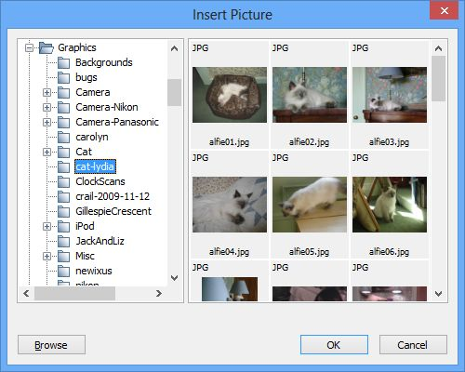
The picture browser dialog
If the inserted or pasted image width is larger than the one specified in Resize images to max, in Import Preferences, the image will be resized before insertion into the project.
You can use these formats in Jutoh:
- PNG – good for high-quality artwork that should not be compressed. PNGs tend to take up a bit more space than JPEGs, sometimes a lot more space depending on how the image was saved.
- JPEG – a ‘lossy’ format good for keeping file size down, and best for photographs. Not so good for diagrams or images containing text, since compression artefacts can be visible.
- GIF – an older format similar to PNG. Jutoh cannot flatten this format (remove transparency) except by converting to JPEG.
- TIFF – a popular general-purpose file format that usually produces larger files than JPEG.
By default, Jutoh will convert non-JPEG image files to JPEG when compiling an ebook – see Image export to ebooks below for more details. In the case of TIFF images, you need Jutoh to convert them to JPEG since Epub and Mobipocket do not support TIFF.
A pasted image will always be inserted as a PNG. If you want to insert an image as a particular type, such as JPEG, you can use Format | Insert | Picture to insert it as a file, instead.
Note that separate image documents in your project (created via Document | Add Image Document or the toolbar new document command) are not included in your ebooks. These documents are purely to help you organize pictures that might or might not be pasted into the book at some point.

Editing basic picture properties
To edit picture properties, click on the picture or right-click (control-click on Mac) and choose Picture. The tabbed dialog illustrated below will be shown.
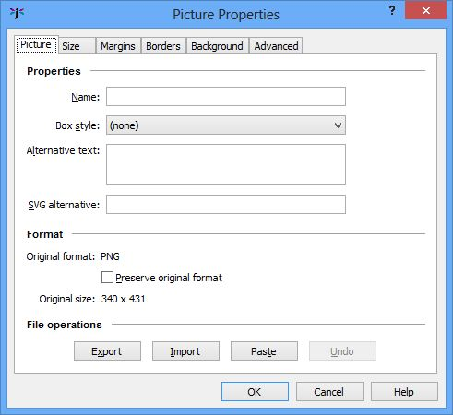
Editing picture properties
If the Name field has a value, it will be used to form the file name of the picture, and if several pictures have the same name, only the first will be output to the ebook. This means that you can repeat pictures without them taking extra space in the ebook file. However, if you find that pictures are repeated erroneously, you can disable this behaviour by clearing the configuration option Use specified image file names.
The Box style field can be used to assign a named style for specifying borders, margins and other box attributes without having to redo individual attributes for each image. If you specify a box style, and also change attributes individually, an automatic style will be generated based on the original style.
Alternative text is used to provide brief descriptive text that can be used in the absence of the ability to see the image.
SVG alternative is used to provide an SVG vector image instead of the bitmap image, and is discussed further below.
If you check Preserve original format, Jutoh will ignore configuration settings and always write the picture in the original format. This can be useful for making exceptions when most pictures are fine as compressed JPEGs, but some pictures don’t look good when compressed, such as line art or charts.
The controls under File operations allow you to export, import and paste pictures without changing other properties. Undo will undo import and paste operations performed within the dialog, but you cannot undo these operations once you close the dialog.

Editing size properties
Clicking on the Size tab shows this page:
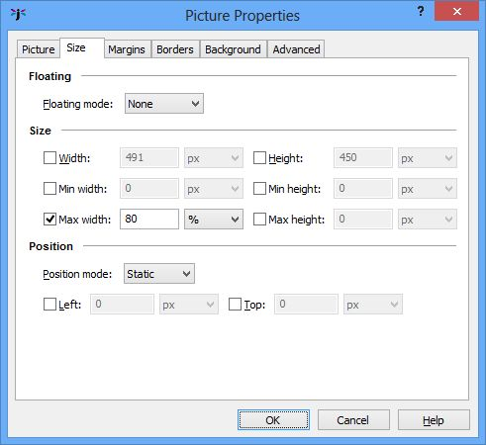
Editing picture size properties
The first control in this page is Floating mode. Normally, a picture takes up a character position and will flow with the rest of the content. However, if you set Floating mode to ‘Left’ or ‘Right’, the picture will be shown next to other content. This behaviour can be shown within the Jutoh editor; it can be disabled to make it easier to see where in the content the image has actually been inserted. Use View | Preview Floating Objects (Alt+F10) to toggle this mode on and off.
The screenshot below shows a picture with a border and background colour floating to the right of other text. It impinges on both the paragraph it’s associated with, and the next paragraph (depending on the size of display). The picture has been set to have a width of 50% of the display width: set a proportional width for a floating object, to be sure that there will be sufficient space for it to float.
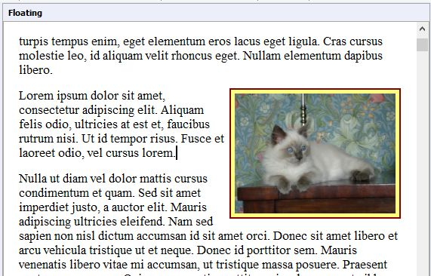
A picture floating to the right of text
Kindle KF7 doesn’t support floating pictures, but KF8 does, and so do all ereaders that use Epub, so floating pictures should work on all recent devices.
Next, we have Width and Height, which you can specify in pixels, cm or percentage, or not at all (the ereader will use the physical picture size to decide how big it should be on the screen). Minimum and maximum size can also be specified; it’s a good idea to specify a maximum size as a percentage to stop the picture exceeding the device display size. Percentage size is relative to the containing object: a text box, a table cell, else the overall display size.
Image size specified in the individual image properties (as distinct from the resizing done by Jutoh as described below) is respected by some viewers and not others. In particular, early Kindle devices will ignore the specified pixel width and height and will use the original resolution, scaled to fit if necessary, whereas newer versions of Kindle hardware and software take pixel, cm and percentage size specifications into account. However, KF8 still ignores the maximum width and height values, instead making sure the pictures don’t exceed the display size. Most Epub viewers recognise pixel, cm and percentage size specification.
See also the advice below on using the Replace absolute widths configuration option to turn absolute widths into percentages at book compile time (not permanently).
Users sometimes ask what DPI (dots per inch) a picture should be saved in before inserting it into Jutoh. When adding pictures to Jutoh, it's more helpful to think in terms of pixels. You need to balance the need for an adequate resolution so the image doesn’t appear pixelated on high-resolution devices, versus the need to keep the ebook file size within reasonable limits. For a photograph to be displayed full-width on the ereader device, you might consider inserting images with widths of around 1000 pixels. You can always use Maximum image width in your configurations to limit the physical image sizes in the generated ebook, perhaps setting different maximum sizes depending on ebook format. See also the recommendations on image sizes for individual platforms such as iBooks and Kindle.
You will only rarely, if ever, need to change the Position mode and related controls. The position mode determines how positioning is specified, and currently Jutoh only supports ‘Static’ (the object behaves like a single character) and, if the object is floating, ‘Relative’ (the Left and Top fields determine the offset from the regular floating position). Only the Top offset affects the display within the editor. DOCX import supports these offsets.

Editing margin, border, background and advanced properties
The Margins page shows fields for margins (the space outside any border) and padding (the space between any border and the object).
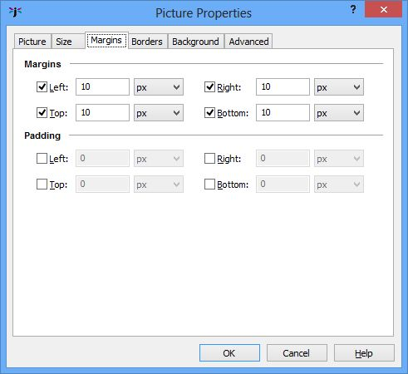
Editing picture margins
To visualise the difference between margins and padding, see Appendix C: The Jutoh Box Model.
In the Borders page, you can specify the border width in pixels, cm or points. The style of the border is restricted to solid, dotted or dashed within the editor, but other selections may show in the ereader.
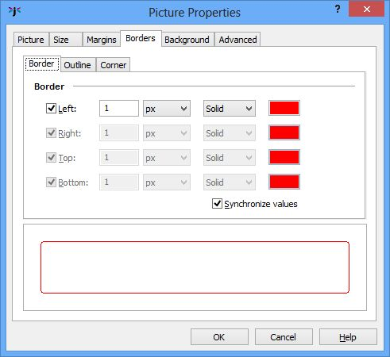
Editing the picture border
You can specify a rounded corner, although this is only supported on some ereaders. You can also specify an extra border called the outline, but this is not recommended as it is not supported in all export formats.
The Background page simply allows specification of the background colour (which will only show for a picture if you also specify some padding).
Finally, the Advanced page lets you enter an identifier, Epub type, JavaScript event handlers and other properties that only more complex books are likely to need.

Adding captions to images
You can add captions as normal paragraphs above or below an image. However, you may find that page breaks appear between the image and the caption, which is not ideal. For Kindle books, it seems that nothing can be done about it for now, but for most other ereaders, you can get Jutoh to glue them together using a non-breaking ‘div’ tag.
To do this, apply a named style to your captions, using different style names depending on whether the caption is above or below the image. Now show the Project Properties dialog and click on Accessibility. Check Add figure and caption tags, and type style patterns for captions below images and captions above images. You can leave one of them blank if all your captions are in the same position. Ensure Avoid page breaks within figures is checked.
If you need to add a caption to a floating image, or the caption needs to be restricted to the exact width of the image, or you have multiple images per caption, create a text box with a percentage or absolute width. Add the image, setting the width to 100%, and then add the caption.
Note that these tips also apply to table captioning.

Special considerations for iBooks
A problem that many people find with images in iBooks Epub files is that iBooks ignores width and height specifications in images, and fits images to the page instead. This can be bad because you may wish to include high-resolution images which will look good on high-resolution devices such as retina-display iPads, while keeping the image to a particular size. The workaround for this is to use a parent ‘div’ tag that takes the image’s size, and have the image expand to the size of the parent. This optimization is applied when Optimize for iBooks is checked in your configuration. An image that is on its own in a paragraph (without any other content), and has its size dimensions specified in its properties, is generated using a ‘div’ tag that takes the dimensions of the image, and dimensions are removed from the image itself.
So, to support a variety of device resolutions, it’s a good idea to specify high-resolution images and specifiy the desired size (just one of the dimensions will do). Currently this won’t work if you have multiple images or other content in a paragraph.

Inserting SVG pictures
The SVG format is used for scalable vector graphics, and in some cases can provide better quality than bitmaps. Not all ebook software and hardware support SVG but it's an increasingly popular format. Jutoh doesn't directly support insertion of SVG files into the editor, but there are two ways of getting SVG pictures into your ebooks.
In both cases, you should add media documents to your project, containing the SVG images. Now you have two options:
- Insert a reference to the media object with Format | Insert | Media Object. Choose the image you previously added as a media document. A placeholder icon is added, and you can click on it to change the properties.
- Insert a regular image (PNG, JPEG) that duplicates the look of the SVG image. In the image properties, type the name of the SVG image in the field SVG alternative, such as media/mypicture.svg. Now check the configuration property Use SVG images to write SVG images instead of bitmaps. You may need to specify the image width and height in image properties for the SVG to be displayed correctly.
With the second option, you can use configurations to control whether SVG or bitmap images are exported, so this allows you to maintain different configurations for creating ebooks with either SVGs or bitmap images for different sites or devices.

Importing pictures from DOCX, ODT and HTML
You can control some aspects of picture import when they are part of documents imported via the New Project wizard. In the Import Preferences pane in the Preferences dialog, or in the Import Options page in the New Project Wizard, you can choose whether to import images or not, and whether to resize them and to what size.
If you want to specify the image size later, you can clear the Respect specified image size option. This will force images to be imported either at the width you specify, or at the maximum resolution they have in the original file. Then you can specify the maximum image width and height in your configurations for later resizing (see Image export to ebooks below).
Some types of picture cannot be imported from ODT documents (in particular SVM, the StarView Metafile format). These pictures should be pasted or inserted by hand after import. Or, export an HTML file using OpenOffice or LibreOffice, to the same folder that contains the ODT and with the same root name as the original file. For example, thing.odt should be exported as thing.html. GIF files will be written to the folder, and Jutoh will use these images when importing from ODT.
Pictures pasted from the clipboard into a DOCX file are stored as Windows Metafiles. These can be imported by Jutoh on Windows, although picture size may be slightly different from the original. On Linux and Mac OS X, metafiles are ignored, so you have several options:
- perform the document import on a Windows machine and copy the .jutoh file afterwards to your Linux or Mac machine;
- in your original DOCX file, replace pasted images with images inserted from PNG or JPEG files and then perform the import; or
- paste or insert the missing images into your Jutoh project.

Image export to ebooks
By default, Jutoh will convert non-JPEG images to the more space-efficient JPEG format. You can switch this off via the Convert images to JPEG configuration setting. You can also choose the compression ratio when converting, using the Image quality configuration property – the higher the value, the better the quality. 80% is usually a good value.
You can also control the maximum image width and height, using the Maximum image width and Maximum image height properties. If one or both values are specified, Jutoh will resize each image on export if one or both of its dimensions exceed the specified maximum. In this way, you can easily create multiple books with images optimized for different screen sizes.
An additional option – Maximum image optimization width – applies an optimization for images whose width is the same or smaller, by simply doubling the size before rescaling back down. This improves image quality at the expense of longer compile times, so you might like to have a configuration with this set to -1 for ‘preview compiles’ if you have a lot of images.
The above options determine the maximum image size at the time the image is written to the ebook. However, often you will not know in advance what size is best for the device that is being used. Kindle viewers will automatically scale images to fit, but for Epubs, you might like to check Limit images to viewer size – this generates CSS that limits the image size to the maximum width or height of the current viewer. This will only work if you have one image on a line, since two images side-by-side will get a combined 200% of the viewer width or height. You can override the maximum width and height on a per-image basis by specifying these values in the image properties dialog. If your image is too big for the device display, it could break across two pages – this can cause the Epub to be rejected by iTunes, so make sure Limit images to viewer size is checked if your book contains large images.
If you have specified absolute sizes for images in centimetres – quite likely after importing from a word processor file – you may find the images are too large for small ereader displays, or they are not in the proportion originally intended relative to the display width. It can be better to use percentages, and you can apply this to all images (and boxes and table objects too) when exporting ebooks by checking the Replace absolute widths configuration option. Jutoh will use the paper size and left and right margins defined in the configuration (or the parent object’s width, if it’s an absolute value) to calculate a percentage width for a given object width.
If your PNG images contain alpha transparency, by default Jutoh will ‘flatten’ them, that is, remove the transparency and give the images a white background. You can suppress this by clearing the Flatten images configuration option. If you do not flatten images, they may end up as black boxes in your ebook. Note that GIF images cannot be flattened, unless converting to JPEG.
If you find your images look a little blurry (particularly if you’re using images for symbols or equations), switch conversion to JPEG off in your configuration(s), or use GIFs and set Convert images to JPEG to ‘All except GIF’. Or, you can leave JPEG conversion on, but for selected images such as symbols and diagrams, check the Preserve original format option in each image’s properties.
As mentioned above, if you have multiple instances of the same image in your project, you can indicate to Jutoh which images should only be exported once by choosing a unique name for the Name field in the image properties dialog; the first image with a given name will be exported, and subsequent occurrences will use the same image. The name will also be used as the root of the image file name. Don’t use non-ASCII characters, such as Chinese characters, for file names or EpubCheck and/or Kindlegen will fail.

Exporting images to files
If you need to extract all images from your book, in their original format and size, you can use the File | Export | Images command. It will prompt you for a folder that will contain the files. If you need to get hold of the files that have been converted to JPEGs and resized as part of the book compilation process, then you can unzip the Epub file using an archive tool, renaming the extension to zip first if necessary.

Working with large images
If your project contains a lot of large images that slow Jutoh down and cause extreme computer resource usage, you can switch images off temporarily, or you can tell Jutoh to load images on demand. These options are in Project Preferences/Advanced and are Enable images and Load images on demand. You need to change these options before you load the relevant project.

Using media objects to insert images
Instead of inserting images directly, you can insert media documents and then add media objects that refer to them. For more on this, see Embedding media.

Summary
We’ve seen how to insert pictures and adjust the way they are saved in your compiled ebooks. Next, we look at further refinements for your books, namely getting Jutoh to help create various kinds of index section.

Chapter 11: Working With Indexes
Jutoh can help you with three kinds of index – table of contents, alphabetical index, and endnotes (or footnotes at the end of each section). For a simple book, you don’t have to know how to use these, and Jutoh will generate a simple table of contents automatically by default.

Creating an advanced table of content
In an Epub 2 book, there is always a NavMap (navigation map) which tells your ebook reader to list the sections in your document. Optionally, you can create a page listing the contents of the book – more like the contents you’ll see in a book. It’s just a regular page with hyperlinks to your book sections. In Jutoh we’ll call these ‘NavMap’ and ‘table of contents’ respectively. The following screenshot of Adobe Digital Editions illustrates the difference between a NavMap (on the left) and a table of contents (on the right):
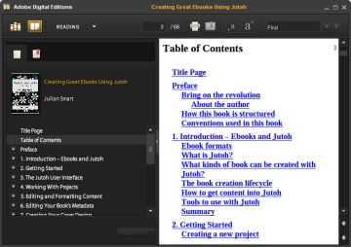
Adobe Digital Editions showing a NavMap and table of contents
Ebook readers will present the NavMap in different ways, and some may label it the ‘table of contents’. The main point is that in an Epub you have to have a NavMap, but a separate table of contents page is optional.
Mobipocket files also have a NavMap, but in Kindle hardware it’s not actually shown. On Kindle for PC and Mac, you can show the NavMap using Show Document Navigation, and on Kindle Previewer this is available via NCX View, as follows:
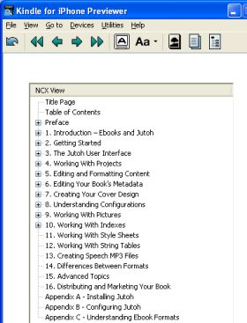
Kindle Previewer showing the NCX View (NavMap)
When creating an Epub file, Jutoh always creates a NavMap (by default, from the titles of your book sections). Jutoh can also create a basic table of contents page simply by checking the Generate table of contents property in the current configuration (Project Properties/Configurations). The extra page will appear in your book, but will not be visible in your Jutoh project.
Jutoh supports an additional, advanced method of building a NavMap and table of contents. In this mode, you maintain an explicit list of contents entries, with help from Jutoh. The entries appear in the Contents page of the Project Properties dialog (under Indexes/Contents), and are also editable in the Table of Contents Wizard. Use this wizard (with the command Book | Build Table of Contents) to switch to advanced mode and specify how contents entries will be gathered from headings in your documents.
Why would you want to use this advanced method instead of the default table of contents generated by Jutoh? Well, you get more control of styling and of which entries will appear in the contents, and you can generate a table of contents that’s several levels deep (the default method only gives you one level). So for most projects it’s worth the extra effort.
Here’s how the contents entries appear in Project Properties, after running the Table of Contents Wizard at least once:
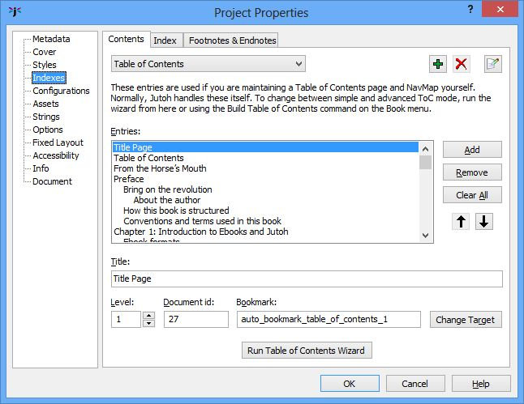
The Table of Contents page of the Project Properties dialog
Let’s have a look at the Table of Contents Wizard, invoked by pressing Run Table of Contents Wizard in the Project Properties dialog or from Book | Build Table of Contents. Here’s the first page:
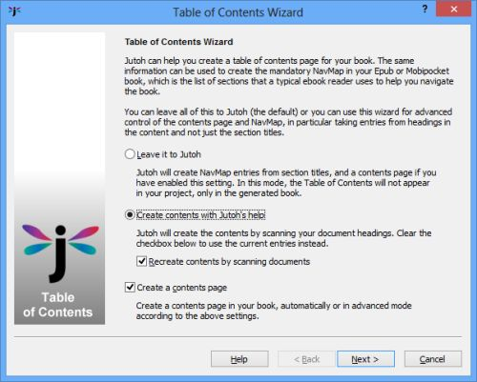
Table of Contents Wizard: first page
To create an advanced table of contents with both a NavMap and a separate table of contents page, check Create contents with Jutoh’s help, and also Recreate contents by scanning documents, and Create a contents page. In the next wizard page, we specify the settings that Jutoh will used when finding headings in the document.
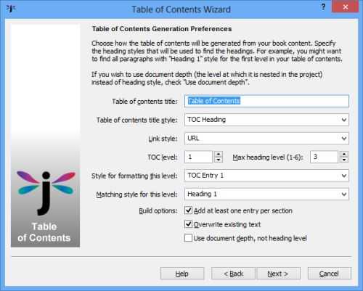
Table of Contents Wizard: generation preferences page
Let’s explain the options presented here.
Table of contents title specifies the text of the title that will be inserted in the table of contents.
Table of contents title style lets you choose the paragraph style that will be used to format the table of contents title.
Link style specifies the character style that will be used to format the linked entries in the table.
Max heading level lets you choose the maximum number of levels that will appear in the NavMap and table of contents.
If you check Overwrite existing text (the default), the whole table of contents page will be replaced when regenerating it. Usually this is what you want, but you might want to clear this option if you have entered extra text that you want to keep and you want to manually edit out the old entries later.
Add at least one entry per section determines whether Jutoh will add an entry for a section even if it didn’t match any headings. Usually it’s best to keep this option checked.
Use document depth, not level can be checked if you want to bypass matching headings, and instead generate one link per section and use the hierarchy of your project to determine how the NavMap and table of contents is built. You can create or move book section documents under other ones to create a hierarchy; if you are not using Use document depth, an actual hierarchy isn’t necessary since headings give an implicit hierarchy, but it’s an option that you have.
TOC level shows the current level we’re editing, affecting the next two fields. There will be as many levels available here as we specified in Max heading level.
Style for formatting this level is the paragraph style that will be applied to the entry at this level (depth) of the contents page.
Finally, Matching heading style for this level tells Jutoh that when this style matches within the project, we will treat this paragraph as a heading at this level. You can match against multiple styles by specifying asterisk (‘*’) for ‘match multiple letters’, and you can specify multiple patterns by separating them with the pipe character (‘|’).
In the example, we’re allowing Jutoh to look at three headings levels, and for the first level, we’re going to search for the ‘Heading 1’ style and format each table of contents entry with ‘TOC Entry 1’. Click on the TOC level control to change the level number and specify the heading styles that will be used for the other two levels.
When you click on Next, Jutoh will build the table of contents and show the results in the next page, for you to edit or accept as-is:
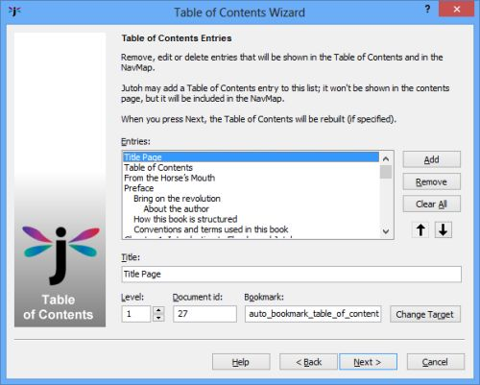
Table of Contents Wizard: entries page
If you find that Jutoh hasn’t found the headings you thought it would, click Back, edit the options, and try again. You might need cancel the wizard and apply styles to your content, for example if you don’t have consistent heading styles. You also need to make sure that Jutoh will find headings without skipping levels; Jutoh will complain if there are such jumps. For example, going from level 1 to level 3 is not allowed, although you don’t have to ‘unwind’ the headings similarly; you can happily jump from level 3 back to level 1. It probably indicates a problem with your document if you have, say, a ‘Heading 1’ followed by a ‘Heading 3’. While this may achieve the look you want, you also need to think about a proper structure for your document.
When you click Next, the final page will be shown with an option to automatically build the table of contents whenever generating the Epub or Mobipocket – you can leave it unchecked if you can remember to use Update whenever a heading has changed in your project.
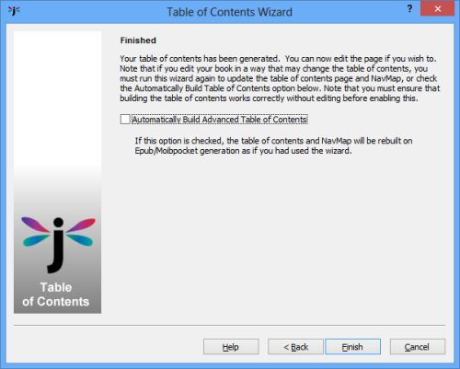
Table of Contents Wizard: final page
Click on Finish to quit the table of contents wizard.
Note that to make best use of the advanced table of contents facility, you need to use consistent heading styles in your document, so Jutoh can work out the heading levels (in the structure implicit in your document) and add bookmarks to them. For example, you might use ‘Heading 1’, ‘Heading 2’, ‘Heading 3’ and so on.
If you haven’t opted to add a table of contents page, Jutoh will still use the found entries to create the NavMap. To revert to ‘simple mode’ again, run the wizard and the entries will be deleted, telling Jutoh to generate a basic contents page (if specified).
If an explicit table of contents page is found in the project (by searching for the title ‘Table of Contents’ or by finding a document whose Guide Type is set to ‘toc’ in its document properties) then Jutoh will suppress the basic contents page to avoid duplication.
Note that if you are using basic contents creation, the entries are formatted with ‘TOC Entry 1’ (if available) and the contents heading is formatted in ‘TOC Heading’ (if available).

Editing table of contents properties
To edit the detailed properties of your table of contents when you're not using the table of contents wizard, show the Project Properties dialog, click on Indexes, then click on Contents. Now click on Edit on the top row of buttons and you will see the Table of Contents Properties dialog:
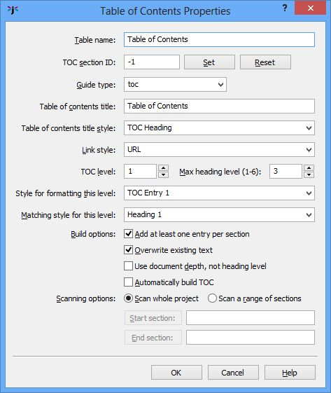
The Table of Contents Properties dialog
Most of the settings are as per the table of contents wizard, but some give additional control for multiple pages (see below).

Adding multiple tables
Jutoh allows you to add further tables, for example tables of figures, or the contents for a part of the overall book.
Click on Add at the top of the Contents tab, and give a unique identifier for this table. You can change the title used for the table page, and set a range to scan if you're interested in a particular set of pages. If you already have a section that you want to use for the new table, you can click Set next to TOC section ID to specify the document to use.
Switch between tables with the drop-down list at the top of the Contents tab. When you click on Run Table of Contents Wizard, it will use the currently selected table. If you haven't specified a document to use for the table, one will be created, which you can move to the desired place in the project later.
To edit properties of your table, such as the title, the range of pages, and styles, click on Edit .

Specifying and stripping link styling
Links from the contents page will be formatted using the character style specified by Link style in the Table of Contents Wizard Preferences page. By default, this is the style called ‘URL’, that Jutoh adds to your style sheet by default. This makes the links look good in Jutoh, but if your book reader uses different colours for links by default, you may have a colour clash. So, you can have Jutoh strip out the URL styling when generating the ebooks by specifying the value of URL attribute removal style in your configuration. It’ll only strip out attributes that are the same in the style to you specify in the configuration, and the actual link, which means you can have specific colours and other attributes in your content without them also being removed. The same logic applies to indexes and footnotes.

Creating a table of contents manually
If Jutoh’s automatic contents-building facility isn’t for you, you can construct the NavMap and table of contents page manually. Build your NavMap in Project Preferences under Indexes/Contents, by creating individual entries and linking them to bookmarks (or overall sections). Now you have a choice of how to create the table of contents page. You can run the Table of Contents Wizard, clearing Recreate contents by scanning documents so it only regenerates the contents page without scanning headings and recreating the NavMap. Or, you can create the table of contents page entirely by hand by adding a section, giving it a Guide Type of ‘toc’ (see the document properties, available from the project outline context menu, or Document | Document Properties) and adding links. This is laborious, so it’s likely that you’ll want to use one of the automatic or semi-automatic methods.

Creating an alphabetical index
Jutoh can create an alphabetical index if you insert index entries throughout your book. The items in the index are linked to the appropriate position in the book.
Insert index entries by selecting some text for the entry and using the Format | Insert | Index Entry menu command. Or, you can leave the text unselected and type the entry in the Index Entry dialog.
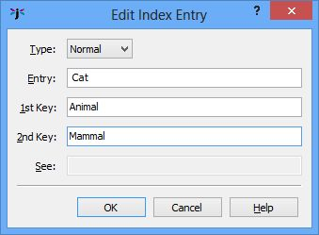
Index Entry dialog
When you press OK, the index entry will be inserted and shown as this symbol:
To edit the entry, simply click on the symbol.
You can create a multi-level index by filling in the Key 1 and Key 2 fields. These represent a category and a sub-category, and will be written with suitable indentation in the index section. For example, if you fill in the Entry, Key 1 and Key 2 fields with ‘Cat’, ‘Animal’ and ‘Mammal’ respectively, you would get Animal, Mammal, Cat in the index. The Entry field is always the final (most specific) item.
The index section is not created until you instruct Jutoh to do so, via the Index Properties page, or the Book | Update command.
In the following screen shot, two index entries have been added: Cat and Dog, each with Animal and Mammal keys. The items are linked back to their original position in the document; if there are multiple locations for the same index entry, linked numbers are shown instead following each entry.
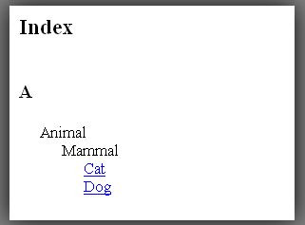
Two index entries
If you need to add a ‘see’ or ‘see also’ entry, you can choose one of these options from the Type dropdown control, and then type text into the See entry. It will be placed by the relevant entry in the index, according to the entry and key fields. This kind of index entry doesn’t have to live anywhere in particular but is easy to lose, so consider inserting all ‘see’ and ‘see also’ entries into the same page.

Configuration
You can edit various aspects of index presentation in the Index Properties page. Click on Edit on the toolbar or Book | Project Properties, or type Alt+Enter, then click on Indexes, then Index, and finally on the Options tab.
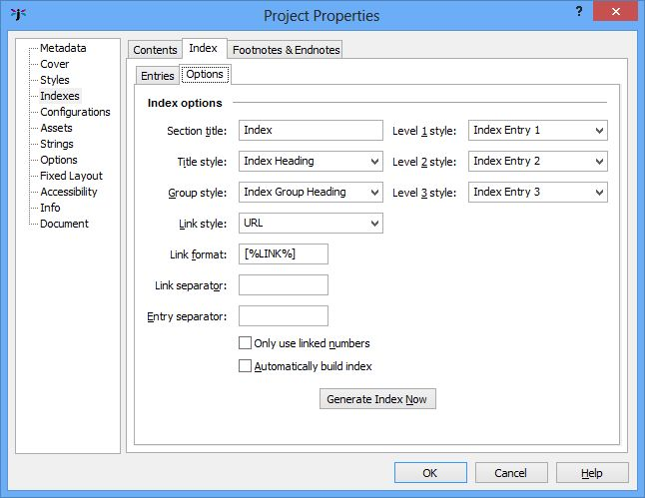
Index options
Settings include the title of the section and how items are to be formatted. Using the Link format field, you can choose whether items will be bracketed. You can customise separators between the entry text and the link, and between links. With the Only use linked numbers option, you can determine whether an item with a single link will have clickable entry text (off), or a more consistent look using a single linked number (on).
You can specify that the index should be recreated every time the book is compiled (check Automatically build index) so you don’t have to remember to rebuild the index after editing.
You can edit the index itself in the Entries tab: you can change the text of items, remove them, and reorder them. These edits will only be retained if you answer No after clicking the Generate Index Now button. If you update the index from the Update Special Book Sections dialog, the index will be rebuilt from scratch from the entries in the book content, losing any edits in the Entries tab.

Importing index entries
Index entries are imported from ODT and DOCX documents. However, no special formatting (such as italics) can be applied to parts of entries or keys – they are simple text strings all formatted with the same style.

Creating footnotes and endnotes
A Jutoh book can have either footnotes at the end of each chapter (the default), or a separate endnotes section. Footnotes are always automatically created when the book is compiled, but the endnotes section must be explicitly updated or told to update itself automatically before each compilation.
You can insert footnotes or endnotes using the Format | Insert | Footnote menu command. Type the note text in the editor dialog, press OK, and this note symbol will appear in the text:
To edit the note, just click on the symbol. You may wish to resize the editor to see more items on the toolbar. Since you cannot use menubar commands from the footnote editor dialog, you can instead use the context (popup) menu to format text – this is shown with right-click on Windows and Linux, or control-click on Mac.
Note that currently, Jutoh applies the ‘Footnote’ style to all footnotes when appended to a section or collated in the Endnotes section, unless Always apply style is cleared in index properties.

Configuration
You can configure the way footnotes and endnotes are presented via the Footnotes and Endnotes page in Project Properties. Click on Edit on the toolbar or Book | Project Properties, or type Alt+Enter, then click on Indexes and finally on Footnotes and Endnotes.
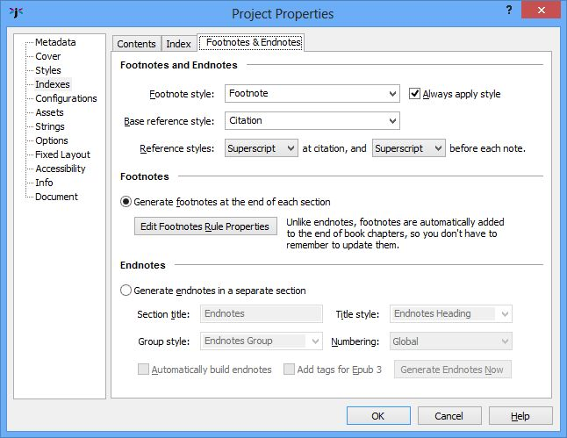
Footnote and endnotes options
In the footnotes and endnotes properties page, you can choose whether the citations will be represented by superscript numbers or numbers in square brackets.
You can influence how the citation numbers are styled by changing the Base reference style (by default, ‘Citation’), or editing the ‘Citation’ style definition in the style sheet editor. By default, the ‘Citation’ style applies no extra formatting.

Footnotes
In footnotes mode (the default), your footnotes will not show within Jutoh (unless edited), but if there are any footnotes in a chapter, they will be appended to the chapter when the book is compiled, after a horizontal rule (divider). Footnotes are always added, so if you were to import footnotes from an ODT file and then compile it without altering any settings, they will show up.
For Epub books, you can change the horizontal rule properties from the footnotes and endnotes properties page. For example, you can set it to be coloured red and occupy 30% of the page width. For ODT files, Jutoh will insert an image reflecting some of the configured properties.

Endnotes
If you switch to endnotes mode, you need to use the Book | Update menu command to create the endnotes, or create the section from the Footnotes and Endnotes properties page. From this page, you can choose to always rebuild the endnotes page by checking Automatically build endnotes.
In the properties page, you can choose the endnotes title and styles for the title, per-chapter heading, and whether the numbering will be global (continuous numbering) or whether it should restart for each chapter. Note that a chapter should be a separate section, or numbering won’t start for each chapter.
Normally, whether the numbering is global or starts again for each chapter, the chapter headings will be shown. You can suppress chapter headings by leaving the Group style blank.

Importing footnotes
Footnotes are imported from ODT files, but not from HTML files since there is no representation for footnotes in HTML and it’s impossible to distinguish them from regular linked text. So if importing from HTML, you will need to copy the footnote text into new Jutoh footnotes.

Summary
We’ve seen how to build special index sections in Jutoh. We’ve mentioned styles and style sheets from time to time throughout this guide; now we’ll devote a chapter to them as styles are important in Jutoh.

Chapter 12: Working With Style Sheets
In this chapter we explain how to work with styles – important for formatting your books consistently, and also important for such features as automated table of contents creation.

Introduction
Style sheets are important in controlling the appearance of a book when converted to the supported formats. Style sheets contain styles for paragraphs (paragraph styles), spans of text (character styles), lists (list styles), and boxes and pictures (box styles) . You can have more than one style sheet, and switch between them by changing the Style sheet property in a configuration, or by having multiple configurations specifying different style sheets. Most users will probably stick with one style sheet.
If your document appearance isn’t as you wish, instead of editing the formatting within the editor, first try editing the style sheet, since this will affect the whole document if named styles have been applied consistently. For example, suppose that the first paragraph in each section uses the style ‘Body Text’, which is not indented. You may wish the first paragraph of each section to be indented; so you could either change the style for each such paragraph, or you could adjust the definition for ‘Body Text’ to match the indentation of ‘Body Text First Indent’.
For Epub and Mobipocket formats, Jutoh generates a Cascading Style Sheet (CSS) that contains equivalent definitions for the Jutoh style sheets.

Kinds of style
Jutoh supports four kinds of named style:
- Paragraph style. This kind of style applies to an individual paragraph, and you can see available paragraph styles in the drop-down control above the editor.
- Character style. This kind of style changes the formatting for a span of text within a paragraph. You can apply character styles using the context (right-click) menu, choosing Styles and then Character Styles. There’s no drop-down control for character styles, but to see the named style at the current text position, you can use the Formatting Palette.
- List style. This kind of style defines how list items are formatted at each depth; the two list buttons on the formatting toolbar simply apply two of the standard list styles (bulleted and numbered).
- Box style. This kind of style defines size, border, margin and other attributes that used by box-like objects such as text boxes and images.
There is always a named paragraph style for any given paragraph, but a given span of text may not necessarily have any named character style. If more than one named style applies to text, their attributes are combined, in the order paragraph, list, and character (with each style overriding the previous). You can remove the character style from a span of text and choosing Format | Text | Reset Text Formatting.

Editing style sheets
You edit style sheets in the Project Properties dialog, as shown here:
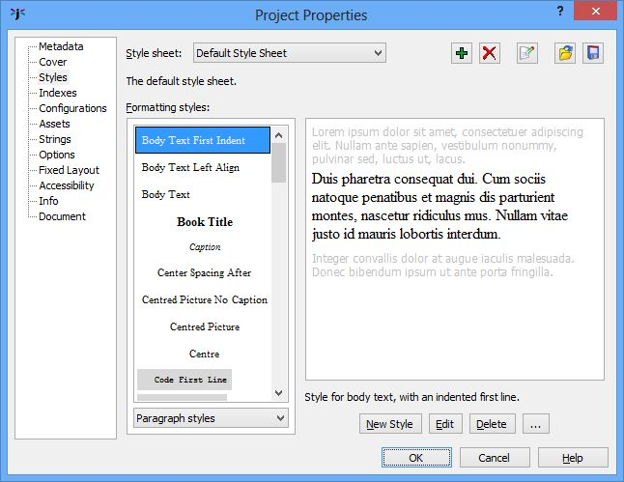
The Styles page in the Project Properties dialog
A default style sheet is provided, including these paragraph styles: ‘Normal’, ‘Body Text’, ‘Body Text First Indent’, ‘Heading 1’, ‘Heading 2’, ‘Heading 3’, ‘Heading 4’, ‘Comment’ (stripped out of all generated books), ‘Headers’, ‘Footers’, ‘HTML’ (output verbatim to HTML-based formats), ‘Centre’, and ‘Right’.
You can edit the attributes (visual characteristics such as indent or font) of all styles, and add your own. Be careful when deleting styles, though, since your book may not work correctly if styles that it uses are missing (Jutoh will warn you about this, and you can then add them back or replace the styles in the offending paragraphs.)
By default, the dialog shows the paragraph styles. You can view the character styles, list styles, box styles, or all styles at once by using the drop-down control under the style list.
You can also edit styles from the Formatting Palette by right-clicking on a style and selecting Edit.

Editing paragraph styles
To edit the attributes of a selected style, click on Edit. The style dialog will be shown; for paragraphs, it will look like this.
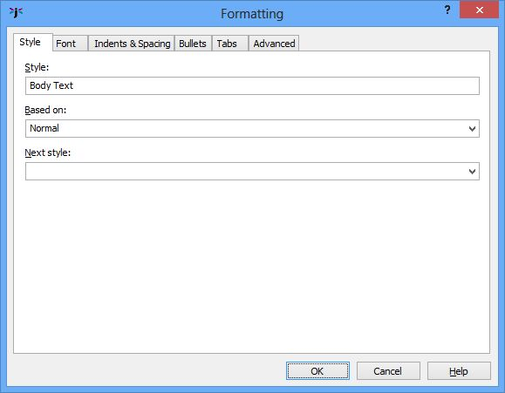
Paragraph style dialog: Style page
The Style page shows the name of the style, the ‘base’ (or parent) style from which the style inherits, and an optional ‘next style’ that indicates what style will be set when you press return on a style of this kind. For example, a heading style might have a next style of ‘Body Text’ so you don’t have to change the style manually back to ‘Body Text’ after writing a heading.
The Font page lets you adjust font-related attributes that will apply to the whole paragraph.
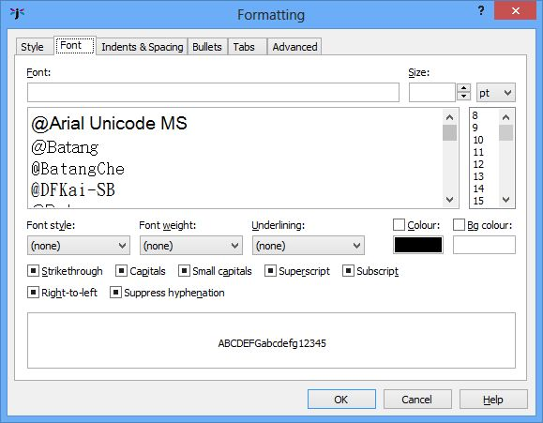
Paragraph style dialog: Font page
In the example above, no font attributes are actually set, but the the style will inherit any attributes from the parent style. A paragraph style or at least its parent needs to have the size set (12 means ‘normal text size’) and also the font name, which should usually be kept to something simple such as Times New Roman, Arial (or Helvetica), or Courier New.
The next page is Indents & Spacing, which deals with indentation, line and paragraph spacing, and also text alignment, whether a page break will be inserted in front of the paragraph, and the outline level (an optional indication of heading depth – you can ignore this).
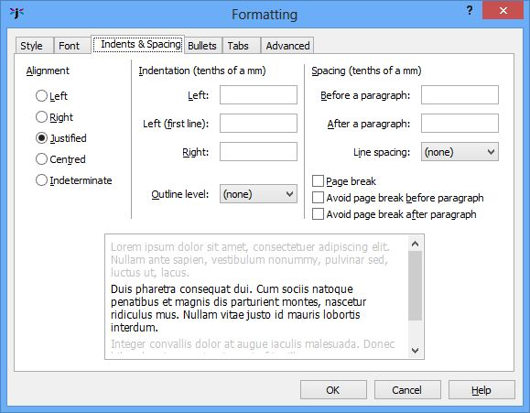
Paragraph style dialog: Indents & Spacing
The alignment buttons determine whether the paragraph will be left-justified only, right-justified, justified (straight on both sides), centred, or indeterminate (no alignment specified unless inherited from a base style). Note that if you specify justified text, Jutoh won’t show it in the editor but it will usually be respected by the ebook reader software.
Indentation and paragraph spacing values are specified in tenths of a millimetre, which will be converted either to relative ‘em’ units, or to mm, when written to HTML, Epub or Mobipocket formats (see below for details of the conversion). You can specify both the left indent and first line left indent, and also the indent for the right-hand-side. In Mobipocket KF7 format, the right indent is ignored, and a left indent will be shown using a single, standard indent size (except for the first-line indent, which can be customised).
You can specify the before-paragraph and after-paragraph spacing. For normal text paragraphs, you’ll probably specify at most an after-paragraph value. For headings, it’s likely you’ll specify spacing before and after the paragraph. If you leave these values empty, they will either inherit values from the base style, or will effectively be zero.
It’s worth remembering that when the configuration option Use relative dimensions is checked, Mobipocket KF7 ignores spacing values that are less than 25 tenths of a mm.
Line spacing – the spacing between lines within a paragraph, not between paragraphs – is specified as ‘none’ (takes a default or inherited value), single spacing, or in 0.1 increments up to 2 times the normal line spacing.
You can ignore the Bullets and Tabs pages as far as ordinary paragraphs are concerned, since bullets are only defined as part of a list style, and tabs are not supported in Jutoh (or most ebook formats).
In the Advanced page, you can also specify whether to give this style custom CSS that will be used directly instead of using the Jutoh-generated CSS (for HTML, Epub and Mobipocket formats only). This gives you more control over how the content will appear on the rare occasions that Jutoh-generated styling is inadequate. Remember that if you check Use custom CSS, any changes that you make to the style attributes using the style dialog will have no effect in the generated ebook because Jutoh is no longer in control of the CSS for this style.
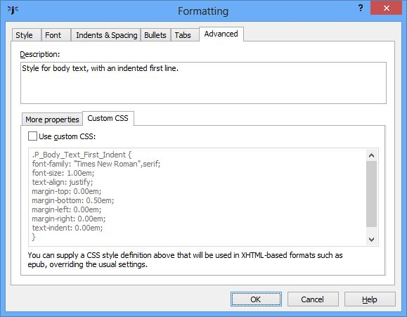
The style editor Advanced page
CSS customisation is described in detail later in this chapter.

Editing character styles
To edit a character style, first view all character styles by selecting ‘Character styles’ in the drop-down box under the style list, then select a style, and click Edit. The character style editor has a Style page, similar to the paragraph style editor but without the Next style field, and a Font page. No other attributes apply to character styles.

Editing list styles
To edit a list style, first view all list styles by selecting ‘List styles’ in the drop-down box under the style list, then select a style, and click Edit. The list style editor has Style, Font, Indents & Spacing, and List Style pages.
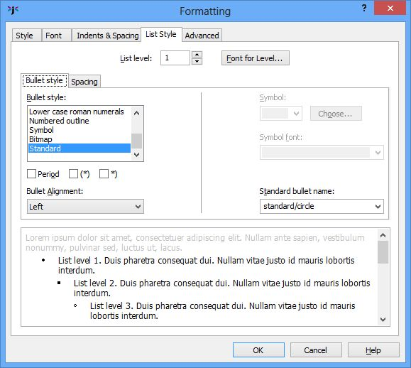
List Style page
List styles work on the principle that lists can potentially be nested, with different bullet or numbering styles depending on the level (depth) of the list. When you are editing an actual list in the Jutoh editor, pressing the Tab or Shift+Tab keys will increase or decrease the level of the current paragraph in the list.
On the List Style page, click on List level to edit a different level (up to 10), and then adjust the attributes to be shown for that level. The attributes listed on the Spacing sub-page will be merged with the attributes on the Indents & Spacing page.
Various bullet styles can be defined, but it’s best to keep it as simple as possible because not all book formats and readers allow complex bullets. For bulleted lists, it’s best to keep with a Standard bullet style and then select from the pre-defined bullet types in the Standard bullet name dropdown. Even this may be ignored by the ebook reader if it chooses to use its own bullets.
In the Spacing sub-page, define indentation appropriate for the current level.
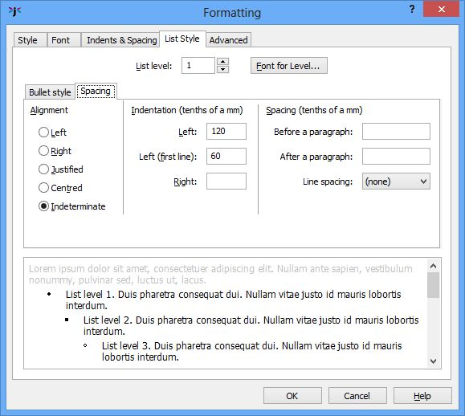
List Style Editor spacing sub-page
The first line left indent defines the distance between the left margin and the bullet, while the left indent defines the distance between the left margin and the start of the list item text. These values may be ignored, depending on format and ebook reader.
List styles are the only way to achieve bulleted or numbered paragraphs (you can’t define bullets per paragraph).
Note that the bulleted and numbered list buttons in the toolbar are hard-wired to apply the styles called ‘Bullet List 1’ and ‘Numbered List 1’. So if you delete either of these styles, the relevant button will no longer work. To apply a different list style, use the Format | Bullets and Numbering menu command, which will give you a choice of list styles to apply, along with the option to renumber the list.
For some Epub and Kindle devices, you can specify a custom bullet image for lists. This is how:
- Add a media document with a bitmap, e.g. ‘media/bullet1.png’.
- Edit or create a list style, and in the List Style tab, click on Bitmap for the bullet style and enter the media document path under Standard bullet name, e.g. ‘media/bullet1.png’.
- Format a list item with this style.

Editing box styles
You can edit size, floating mode, margins, and border attributes for box styles; for more information, see the description of the picture property dialog in Chapter 10: Working With Pictures.

Creating new styles
To create a new style, click on New and choose from paragraph, character, list style or box style.
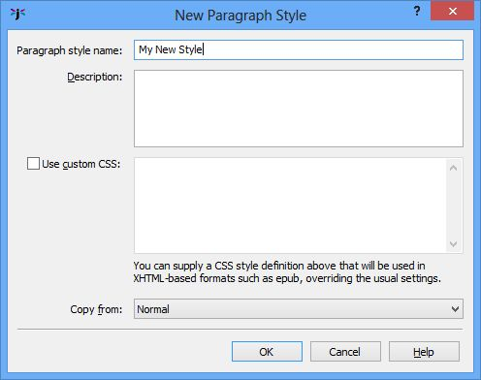
New style dialog
Enter the name, optional description, any custom CSS, and a style to use as a template. Note that the value of Copy from in this dialog will only be used to set up initial attributes for the new style, and will not be the value of the ‘base’ (parent) style in the new style.

Applying named styles
There are various methods for applying named paragraph styles to text in your document:
- Select a paragraph and choose a style from the drop-down style control in the editor toolbar;
- select a paragraph, click Format | Styles, choose a style and click OK;
- right-click (or control-click on Mac), choose Styles in the context menu, and click on a style name.
- use custom keyboard shortcuts and Favourites, as explained in Appendix B: Configuring Jutoh.
You can also apply named character styles to ranges of text:
- Select some text, click Format | Styles, choose Character Styles, choose a style and click OK;
- right-click (or control-click on Mac), choose Styles | Character Styles in the context menu, and click on a style name.
- use custom keyboard shortcuts and Favourites, as explained in Appendix B: Configuring Jutoh.
Note that when a character style is applied via the context menu, it is merged with the attributes in the selected text, forming a new automatic style (see below), unless there are no attributes in the selected text, in which case the original character style name will be retained. So if it’s important that the specific character style name is retained in your book, first reset the existing character styling for the selected text using Format | Text | Reset Formatting.

Automatic styles
If you apply direct or ad hoc styling – that is, apply attributes such as bold, centring, paragraph spacing, and so on directly without choosing a named style with those attributes – then Jutoh will construct an automatic style with those attributes. You can tell an automatic style by the presence of ‘+’ symbols in the name, for example ‘Normal + Centre Alignment’. Automatic styles are stored in each section document, not in the editable style sheet, so they won’t be visible except in the drop-down style control.
If you import from a DOCX (Word) or ODT (OpenDocument Text) file, you may find a lot of your content is unexpectedly formatted with automatic styles. If this is the case, your original document also had automatic styles but your word processor hid this by showing only the basic style name in the drop-down style control.
It’s becoming a familiar refrain in this book, but avoid use of automatic styles whenever possible. When you need to apply formatting, consider if you can create a named style for this purpose, such as ‘Centred Picture’ or ‘Picture Caption’. If you change your mind about the details of formatting later, you can then simply edit the named style rather than dozens, hundreds or even thousands of occurrences of the formatting throughout your document. You’ll end up with a much better and more easily-edited document if you take the trouble to create and use named styles. Also, if you use a rational naming scheme for headings, you’ll find it much easier to persuade Jutoh to create an advanced table of contents. And finally, with named styles, Jutoh won’t have to generate so many automatic styles in the generated ebook, which could reduce its efficiency and increase file size.

CSS dimensions
When exporting to ebook formats other than Epub and Mobipocket, paragraph dimensions for indentation, left margin, right margin, line spacing and paragraph spacing are specified in absolute dimensions (tenths of a mm). When exporting to epub and Mobipocket, Jutoh will convert these dimensions to em, which is a unit based on the current text size, or to mm, depending on the value of the Use relative dimensions configuration option. You can adjust the scale factor used for the conversion using the Options page in the Project Properties dialog. Since Mobipocket KF7 doesn’t handle em units very well, it’s recommended that you clear Use relative dimensions in your Mobipocket configuration (it is disabled by default for new projects).
Note that when marking up individual spans of text with either a character style containing a text size, or an ad hoc text size, the text size will be generated as an absolute point size, not in ems. This is because if it were in ems, the relative size would combine with the paragraph relative text size. So, please avoid using text size in ad hoc styles – define text size in paragraph styles where possible. Otherwise you will see inconsistent text size when scaling the ebook. You can eliminate non-paragraph styling by selecting text and then choosing Format | Text | Reset Text Formatting.

CSS customisation
If you find that Jutoh’s CSS style creation is inadequate for any reason, you can tell Jutoh what CSS style to use instead of the current definition, via the Advanced page in the style editor. These will be used only for HTML, Epub and Mobipocket file generation. The CSS customisation fields are illustrated in the style editor dialog shown above.
You can see the current CSS definition as it will be output to Epub and Mobipocket. Check Use custom CSS and edit the definition if you want to use an alternative definition. Remember that if you subsequently make changes to the style through the usual dialogs, it won’t change your CSS definition until you clear the Use custom CSS option.
Note that if you customise style definitions, or use the HTML style, be sure to click Check after generating an Epub file in case you have introduced HTML errors. When you check a project, Jutoh invokes Adobe’s EpubCheck tool to examine the Epub structure and content. You need to have Java installed for EpubCheck to work.
If you need further CSS customisation, you can edit the sheet properties by clicking the Style Sheet Properties button and checking Use custom CSS.
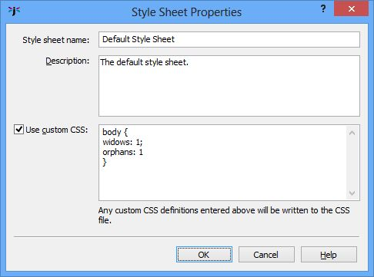
Style Sheet Properties dialog
Add any CSS definitions you like in the field, and they will be added to the beginning of the CSS file that Jutoh generates, as well as the individual style definitions generated by Jutoh or specified explicitly by the user.

Special style names
In some cases, Jutoh will use the name of a style to influence the e-book output.
- ‘Heading 1’, ‘Heading 2’ and so on are output to HTML as h1, h2, etc. You can change the value of the Heading style prefix configuration property to a different prefix, or clear it to prevent Jutoh generating HTML heading styles. Since the ebook reader will apply its default heading styling to paragraphs marked as headings, you may find precise control of heading appearance easier to achieve if you switch this off in your configuration.
- The ‘HTML’ paragraph style outputs the content of the paragraph directly to the HTML file without processing.
- The ‘HTML Text’ character style outputs the spanned text directly to the HTML file without processing.
- The word ‘Preformatted’ in a style indicates that HTML should use the pre tag.

Importing and exporting style sheets
When creating a new project, or editing an existing one, you can import style sheets that were previously saved with a .stylesheet extension. In the Styles tab of the properties dialog, import style styles with Import, and save selected style sheets (one or more) with Save. When importing, stylesheets will replace any existing style sheets of the same name.
Please note that these are not CSS style sheets – they are Jutoh-specific binary files. You will be warned if you attempt to import a regular .css file.

Finding and replacing styles
You can search for paragraphs with particular named styles, and replace them with other styles, using the Find and Replace dialog, available from Edit | Find (Ctrl+F).
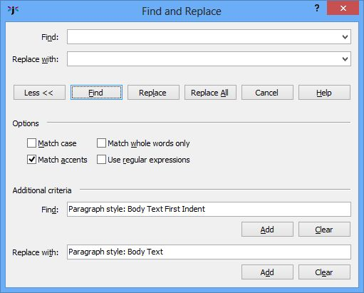
The Find and Replace dialog
Click on More >> if the extra options aren’t currenly shown. Then click Add and choose a paragraph style, for each of the Find and Replace with criteria.
You can use asterisks in the style to find, so for example the string ‘Body Text*’ will match against ‘Body Text’, ‘Body Text First Indent’, and also automatic styles derived from ‘Body Text’ styles, such as ‘Body Text + Centre Alignment’.

Style substitutions
You can replaces styles on a per-configuration basis by using the Paragraph style substitutions configuration property. For example, a value of ‘Normal: Normal Justified’ will temporarily replace all instances of ‘Normal’ with ‘Normal Justified’ when the book is compiled. This can be useful to apply minor tweaks without the need to maintain different style sheets for different configurations.

Using styles to change ebook content
In each configuration there are two properties that let you use styles to include or exclude content.
In Paragraphs to exclude, you can specify the comma-separated paragraph styles whose paragraphs should be excluded from the book. You can use ‘*’ to mean all characters, for example ‘Only*’ will cause all paragraphs with a style name beginning ‘Only’ to be excluded, except for those specified in Paragraphs to include.
In Paragraphs to include, you can specify the comma-separated paragraph styles whose paragraphs will be exempt from exclusions. You can use ‘*’ to mean all characters. For example, if this property has the value of ‘Only Epub’, paragraphs styles with ‘Only Epub’ will be retained, but (assuming ‘Only*’ in Paragraphs to exclude), all other paragraphs whose style name begins with ‘Only’ will be removed. Thus you can include or exclude paragraphs in your document depending on the configuration.
When a new project is created, Jutoh sets up some paragraph styles for each format prefixed ‘Only’, for example ‘Only Epub’, which you can use together with the configuration properties. Of course, you may need several styles per configuration for different formatting, for example ‘Only Epub Centred’. If you use ‘*’ in your properties, you can specify variants so you don’t have to mention every single style to include or exclude.
Here’s another example. Say we are going to create a Smashwords OpenDocument file which says ‘Published by Acme at Smashwords’, but all other formats will just say ‘Published by Acme’. We create two paragraph styles, one called ‘Only Smashwords OpenDocument’ and another called ‘Non-Smashwords Formats’. In our title page, we have the two paragraphs:
Published by Acme at Smashwords
Published by Acme
The first is formatted with ‘Only Smashwords OpenDocument’, and the second with ‘Non-Smashwords Formats’. In our ‘Smashwords OpenDocument’ configuration, we set these properties:
Paragraphs to exclude: Only*,Non-Smashwords Formats*
Paragraphs to include: Only Smashwords OpenDocument*
In all other configurations, we keep the default properties, for example for ‘Epub’:
Paragraphs to exclude: Only*
Paragraphs to include: Only Epub
Now when we compile the ‘Smashwords OpenDocument’ configuration, all ‘Only*’ styles will be excluded except for ‘Only Smashwords OpenDocument’, and ‘Non-Smashwords Formats’ will also be excluded. When we compile another configuration, such as ‘Epub’, the ‘Non-Smashwords Formats’ paragraphs will be included by default (it doesn’t need to be mentioned explicitly). Since we are using wildcards (‘*’), it doesn’t matter if we apply ad hoc formatting to the paragraphs in question, since the wildcards will match the rest of the style name.
Another way to exclude content from your book depending on configuration is to add a style substitution in the Paragraph style substitutions property. If you added ‘Epub Only:Comment’ to this property, paragraphs formatted with ‘Epub Only’ will be omitted from the final ebook, since paragraphs with the ‘Comment’ style are removed.

Summary
In this chapter you have learnt a lot about styles and how to edit and apply them. Next, we’ll look at Jutoh’s ‘string table’ feature which gives you another way of customising your books.

Chapter 13: Working With String Tables
The string table feature gives you extra flexibility in customising your book, by defining how keywords will be replaced by text at compile-time, for all versions of your book or per-configuration.

Introduction
Sometimes you may wish to change text that Jutoh generates, for example the heading ‘Table of Contents’ if generating a table of contents. You may also wish to define strings that can be used as keywords in cover designs, or change the way metadata is presented. This is where string tables come in. You can define several global string tables, independent of any project; and you can also define one or more project-specific string tables. Then in your configuration, you can select the global string table and/or project string table that should be used, and if there is a value corresponding to the string name, that value will be used instead of the original name.
For example, in Preferences, you could add a global table ‘English’, then add a string with name ‘Table of Contents’ with value ‘Contents’. Then select the ‘English’ string table for the Global string table property in all your configurations. The word ‘Contents’ will now be used instead of ‘Table of Contents’ in your generated book.
Jutoh knows to check the string tables for certain keywords when generating documents or parts of an ebook, so the ‘Table of Contents’ substitution will be done when generating a table of contents title as well as in your own content. Other examples include ‘Cover Page’, ‘Guide’, ‘Contributions by’, and ‘Published by’.
Continuing with the example, you can also use the keyword %Table of Contents% in your cover designs, and the word ‘Contents’ will be substituted.
You can also include keywords in your metadata and, if the Replace strings in content configuration property is checked, in your book content, and they will be expanded before inclusion in your generated ebook. Note that string replacement in content only works for strings within the same paragraph formatted in the same character style.
Here’s another example: say you wanted the Smashwords edition of your book to contain different information from the other versions of your book. In the picture below, a string table called ‘Smashword Strings’ has been added to the project properties, to be used to tailor the content of the book according to the Smashwords publishing platform:
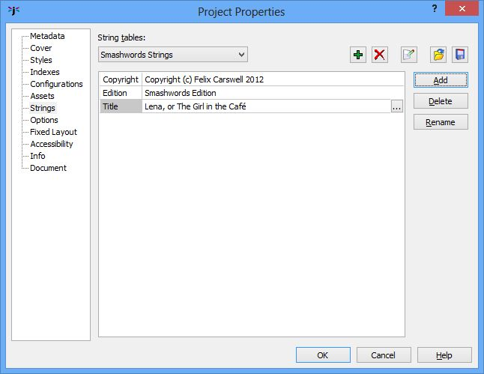
The Strings page of the Project Properties dialog
The Project string table property of the Smashwords configuration will be set to ‘Smashwords Strings’ and the keywords %Copyright%, %Edition% and %Title% can be used in the book text, so that the Smashwords edition of the book contains the appropriate strings. A string table would be defined for each configuration, or perhaps one fallback table ‘General Strings’ would be used for non-Smashwords editions.

Troubleshooting string tables
If keywords are not being substituted, check that these requirements are met:
- Each keyword name in the content must be formatted with either no style, or a single style.
- Keyword names are case-sensitive.
- Each keyword must be enclosed in % symbols.
- You must set the project and/or global table names in your configuration.
- You must check the configuration property Replace strings in content.

Summary
You may never use string tables, but now you know the feature is there and what it’s for, you have an extra tool in case you need to do global or per-configuration customisation of the text within your ebook. Next, we look at how you can use tables in your book.

Chapter 14: Working With Tables
This chapter describes how to create and edit tables in Jutoh for presenting tabular data.

Introduction
You can create tables within Jutoh, or import them from HTML/Epub, DOCX and ODT, and include them in your generated ODT, Epub and Kindle files. Supported features include:
- border and cell background colour;
- several border line styles;
- column and row spanning;
- an editable gallery of table templates;
- arbitrary content in cells including graphics and nested tables;
- multiple cell property editor and table property editor.
Don’t expect to use all of the advanced table features in your favourite word processor, such as shading, fancy border styles, and vertical text. But you can still create a wide range of table appearances, and Jutoh’s table tools should be more than sufficient for all but the most demanding user.
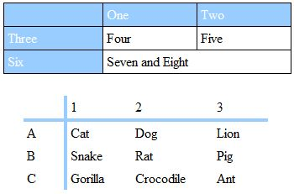
Simple examples of tables in Jutoh

Creating and editing tables
To create a table, use the Format | Table | Insert Table menu command, or the Ctrl+Shift+A keyboard shortcut, or click on the New Table button on the toolbar. This will show the Insert Table dialog, as illustrated below.
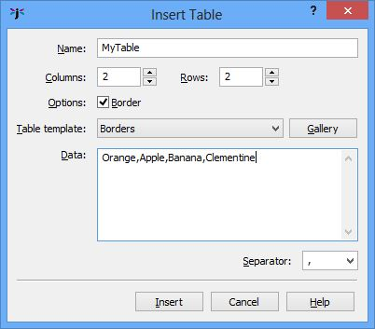
The Insert Table dialog
From here, you can choose the number of rows and columns in your table, and also choose from a gallery of table templates if you wish by clicking on the Gallery button or using the drop-down list of templates.
If you selected text before adding a table, the text will be assumed to be data that you wish to add to the table cells, separated by commas or other separator that you specify. You can also enter the data yourself in the Insert Table dialog.
Jutoh provides a standard set of templates from you to choose from, but you can add your own if you wish. This is what the Table Template dialog looks like when you press Gallery in the Insert Table dialog:
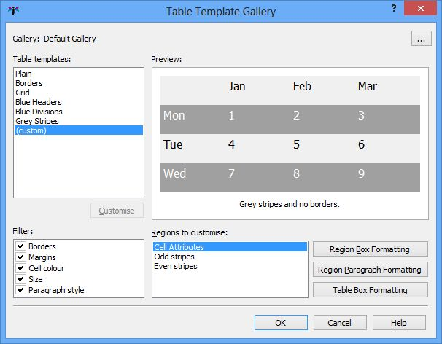
The Table Template dialog
If you press Customise, as has been done in the example, the dialog will show the regions that comprise the table template, which can be edited by adjusting colour, spacing, and so on. Click Region Box Formatting to adjust box attributes such as size, line colour and spacing for the selected region, and click on Region Paragraph Formatting to choose font and paragraph formatting attributes for that region. Click Table Box Formatting to edit table-wide properties such as overall size. Changes will be reflected in the preview.
You can also choose to omit some properties of the table template, such as cell colour, by clearing items in the Filter list.

Editing tables
To edit your table, use the following:
- the Table Properties dialog via Format | Table | Table Properties or the Table command on the editor context menu;
- the Cell Properties dialog via Format | Table | Cell Properties or the Cell command on the editor context menu;
- the various editing commands on the Format | Table menu or the Table Formatting menu on the editor context menu.
From the Format | Table menu, you can add and delete rows and columns, merge and split cells, change row and column dimensions, and change vertical alignment in cells.
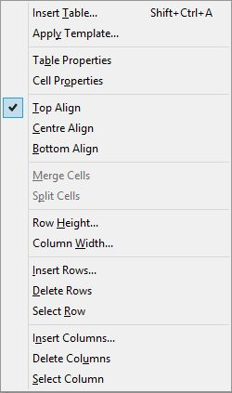
The table formatting menu
You can often save time by selecting a group of cells for paragraph or cell formatting operations. If you select a group of cells before invoking the Table Properties dialog, this group of cells will be edited instead of the overall table. Similarly, selecting several cells before invoking the Cell Properties dialog will format the selected cells.
You cannot select rows, columns or the whole table with one click, as you can with some word processors. However you can use the mouse to drag a selection of multiple cells, and you can use the Format | Table | Select Row/Column commands.
Here is an example of using the Table Properties dialog:
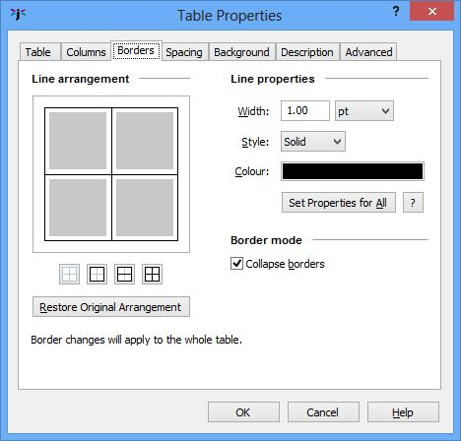
The Borders page of the Table Properties dialog
The Borders page is the most complex aspect of the Table Properties dialog and deserves detailed explanation here. For further help on this and other aspects of the dialog, click on the Help button.
This page shows a summary of the borders surrounding the table, and the horizontal and vertical dividers. Since these can vary throughout the table, it is an approximation based on a sample of borders, but you can select a group of cells and change the borders for that group if you need to change specific borders and dividers. The dialog reminds you what rows and columns any changes will apply to – in the example above, changes will apply to the overall table.
The borders will only be applied if they were changed in the dialog, which means you can’t accidentally change the table simply by showing the dialog and pressing OK.
Clicking on a border line cycles through three states: ‘on’, ‘off’, and ‘no change’ (indicated by a thick grey line). When you choose the ‘on’ state by clicking one or more times, it will take on the new line properties as specified in the Line properties group of controls. Alternatively, right-click or control-click on a line to have it immediately take on the current line properties instead of cycling through the three states.
If you want the line property controls to reflect the state of one of the lines, shift-click on that line.
To set the current line properties for all lines that are currently present, use Set Properties for All.
Note that this page uses cell borders to achieve an overall table border. You can set an additional table border via Box settings in the Table page, but this will only work for HTML-based formats.

Changing the size of cells, rows and columns
You can influence the size of columns, rows and the table itself in a variety of ways:
- specifying cell width and height in the Cell Properties dialog;
- specifying column and table width in the Table Properties dialog;
- specifying row and column size using menu commands;
- adding content to fill out the column or row;
- specifying whether a cell should wrap text (break it into lines);
- adding padding (spacing between the content and the border).
You can’t currently change the sizes of columns and rows by dragging their dividers, but you can achieve the same result by specifying column widths and row heights using the table formatting commands and the Table Properties dialog. Specifying the size of a single cell may have an impact on the row or column size, depending on whether it changes the maximum row or column size.
If you wish cells to calculate their size from their content, you can specify zero in the column width and row height commands, or in the Columns page of the Table Properties dialog, or by clearing width and height settings in Cell Properties.
You can specify whether cells should wrap their text (break the text into lines) in the Spacing page of the Table Properties dialog. This may be overridden if there is not enough space to show an unbroken line of text.
You should generally specify padding for cells, that is, the space between the content and the border of the cell. Otherwise the table will looked cramped. Specify padding in the Spacing page of the Table Properties dialog, or in the Cell Properties dialog.
Specifying minimum and maximum sizes for cells in Cell Properties won’t have an effect in the editor, but ereaders may use these values.
To understand more about the relationship between content, padding and borders, refer to Appendix C: The Jutoh Box Model.
If you have specified absolute sizes for cells or tables in centimetres – quite likely after importing from a word processor file – you may find the tables are too large for small ereader displays, or they are not in the proportion originally intended relative to the display width. It can be better to use percentages, and you can apply this to all tables, boxes and images when exporting ebooks by checking the Replace absolute widths configuration option. Jutoh will use the paper size and left and right margins defined in the configuration (or the parent object’s width, if it’s an absolute value) to calculate a percentage width for a given object width.

About table borders
When creating a table with borders, you may wonder if you need to add every border of every cell, given that the side of one cell can act as the side of an adjacent cell. You can actually do either – supply all borders, or just the ones necessary to give the desired effect. Jutoh’s Table Properties dialog works on the assumption that the minimum possible number of borders will be applied. The crucial setting is Collapse borders in the Table Properties dialog: if checked, the borders will be merged so you will only see one border for any given cell edge, not two adjacent borders. HTML-based formats and ODT all understand collapsed borders.
You can edit borders using the Table Properties dialog, which lets you specify borders for the whole table or a group of cells; or you can edit them for an individual cell via the Cell Properties dialog (click on Cell on the context menu).
Another issue that can be slightly confusing is that a table can have an overall border in addition to cell borders. This means that you have two ways of specifying the overall border: using cells, or the table box properties. However, only HTML-based formats know about the extra table border – not ODT or DOCX – so it’s best to use cell borders to form the table border. This is what the Table Properties dialog does.
You can specify a rounded corner for the overall table border, but even in HTML this won’t work if you use collapsed borders, and it probably won’t work in many ereaders.
If your table border doesn’t show up in the ebook, try increasing the width. On iBooks, widths below 1pt are invisible.

Importing tables
Tables can be imported from DOCX, ODT and HTML/Epub. Most aspects will be retained, but these will not:
- Shading and images in cell backgrounds (solid colours are supported);
- vertical text;
- double borders or border line styles other than solid, dotted, and dashed;
- custom image borders;
- banding in conditional table formatting where the bands are more than one row or column in size (DOCX);
- horizontal and vertical inner borders in conditional table formatting (DOCX).
In summary, unless your table formatting is particularly fancy, import should be fine.

Table compatibility in ebook readers
Tables should work well in most ereaders. Older Kindle ereaders supporting only KF7 (‘Kindle DX’ mode in Kindle Previewer) will not show border styles other than solid, and all borders are either on or off – there is no choice of which cell borders are shown. Jutoh includes both KF7 and KF8 formatting for Kindle files, so most Kindles will show full table formatting.
Adobe Digital Editions doesn’t handle absolute cell size very well, so cell size is converted to CSS minimum size properties unless a minimum size has been explicitly set. This should still work across all ereaders; but you can switch it off via the Use minimum size for cells onfiguration option.
Repeated table headers and footers are not supported by most readers, and Adobe Digital Editions does not rearrange the headers and footers from the standard HTML syntax (defined at the start of the table) to be at the actual top and bottom of the table. On the other hand, for Jutoh’s HTML output, Firefox and Internet Explorer printing does the right thing and places headers and footers on each page. Because of the lack of support for headers and footers in ereaders, they are switched off by default in all configurations. You can switch them on using the Table headers and footers configuration option.
Adobe Digital Editions has a unique problem when rendering large tables. In order to support centred tables in ADE, the CSS attribute ‘display:inline-block’ must be used. However, tables with this attribute do not span multiple pages – the part of the table that isn’t displayed on the first page will simply be lost. To work around this conundrum, set the configuration property Maximum table rows for inline-block to the number of rows above which you consider a table to be large and in danger of being rendered across page boundaries. The default is zero. Tables larger than this size will omit the ‘display:inline-block’ attribute to favour correct rendering across pages over centring. Centring should work correctly on most other ereaders without the need for this attribute, since we also use ‘margin-left:auto;margin-right:auto’ to implement centring.
Note that using inline-block can cause tables to be rendered incorrectly on some ereaders (with the overall table border becoming separated from the cells). Also, if you have the configuration option Maximum table rows for inline-block set to a non-zero value, the generated HTML table may have an extra paragraph tag around it in order to support centring on some platforms. Set the option to zero to ensure that a table that is alone in a paragraph is not enclosed within outer paragraph tags, which can cause problems in some situations, including unexpected text sizes. Use Maximum table rows for inline-block with extreme caution!
As noted above, ODT files, and DOCX files converted from ODT, do not support an extra, overall border so if word processor compatibility is required, you will need to form the table border using individual cell borders. The Table Properties dialog helps you do this, since the Borders page applies only cell borders.

Editing the template gallery
As we’ve seen, inserting a table or using Format | Table | Apply Template lets you choose from a gallery of templates, using the Table Gallery dialog. Jutoh adds a standard set of templates by default; you can add your own or delete existing ones using the advanced menu options in the gallery dialog (click on the ‘...’ button).
The default table gallery is stored in a file in the standard application data area, but you can open and save gallery files in arbitrary locations if you wish. This could be useful for sharing templates with other users.
A template is defined as a series of formatting commands, each command dealing with a range of cells. You can’t add an existing table from your document to a gallery, but it’s not too hard to use the Table Template Editor dialog to define new templates, and it’s more flexible than a simple reproduction of an existing table. Having defined the formatting commands, the user will be able to customise them as regions in the gallery dialog, for example choosing a different colour for a “Header” region. For more information on creating templates, click on Help in the Table Template Editor dialog.

Summary
You should now have a good idea of how to create and edit tables. Next, we look at how you can use text boxes in your book.

Chapter 15: Working With Boxes
This chapter shows you how to create and use boxes, and how to manage differences in box layout between platforms.

Introduction
Text boxes allow you to enclose text and other content within a rectangular area, optionally with a background colour and border. Normally boxes act as a single character within the rest of your document, but you can set the floating mode to be left or right as for images, to allow text to flow to the right or left. This won’t show in the editor, but will be shown in the generated ebook if the ereader supports it.
To understand the way margins, padding and borders work when showing a box, refer to Appendix C: The Jutoh Box Model.
Here’s a selection of boxes from the project Formatting Sample provided with Jutoh:
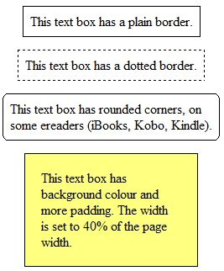
Sample boxes in Jutoh

Creating and editing boxes
There are several ways to create boxes interactively:
- using the menu command Format | Insert | Text Box;
- using the context menu command Insert | Text Box;
- double-clicking on a box style in the Formatting Palette with no existing box selected.
If any content is selected before you create the box, it will be moved inside the box.
When you click inside the box, you can edit content as usual, and editing and formatting commands will apply to the contents of the box.
You can edit the box properties with the Box command on the context menu. This shows a formatting dialog with various pages, namely Box, Size, Margins, Borders, Background and Advanced.
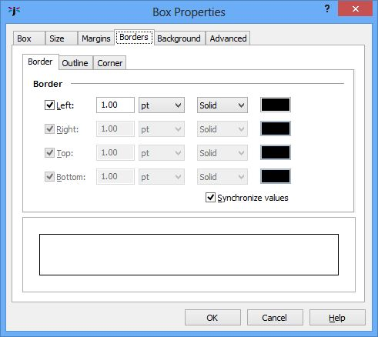
The Box Properties dialog showing the Borders page
In the Box page, you can define a style (see below) and also whether the box is treated as an ‘aside’ (outside the main flow of the text) for the purposes of Epub 3.
You can define borders with a small range of styles (solid, dotted and dashed), a width, and colour. You can also define a rounded corner radius, but rounded corners are not supported on many ereaders. For example, Adobe Digital Editions, Nook and Bluefire Reader do not support them. However they are supported on Kindle (KF8), Kobo and iBooks. If rounded corners are specified, the whole border will have just one style and width: individual differences between sides will be ignored.
To delete a box, click outside the box and delete it as you would a single character. If you want to preserve the contents of the box, you will need to cut and paste it elsewhere before deleting the box.
By default, boxes size to their content (and any padding), but you can set a specific width and/or height using the box properties dialog. Currently, you can’t resize a box interactively.
If you have specified absolute sizes for boxes in centimetres – quite likely after importing from a word processor file – you may find the boxes are too large for small ereader displays, or they are not in the proportion originally intended relative to the display width. It can be better to use percentages, and you can apply this to all tables, boxes and images when exporting ebooks by checking the Replace absolute widths configuration option. Jutoh will use the paper size and left and right margins defined in the configuration (or the parent object’s width, if it’s an absolute value) to calculate a percentage width for a given object width.
Although you can specify vertical alignment for a box in Jutoh, and the content will be shown vertically aligned in Jutoh, currently this won’t be reflected in any exported formats due to restrictions in the expressiveness of those formats. In a future release this limitation may be worked around; meanwhile, if you really need vertical alignment, you could use a one-cell table, or use the option Emulate boxes using tables. Note that if you don’t specify the box height, and specify a padding around the content, you can achieve the look of vertical centre alignment, since the box will be sized symmetrically around the content.
If a box doesn’t appear to have a border in the generated ebook, when it does within Jutoh, try increasing the thickness of the border.
If you set the Floating mode for a box to Right or Left, make sure that the text box will fit on small displays. Otherwise the ereader may choose not to make it float. You could specify a percentage width, such as 50%, to ensure that the box will fit.

Importing boxes
Text boxes will be imported from DOCX, ODT and HTML files.
In DOCX import, in addition to import of ‘true’ text boxes, any paragraph that has a border will be interpreted as a text box.
For text box import to work in HTML, the box must have a border.

Using box styles
You can create box styles just as you would create paragraph and other styles, but with a different set of pages for editing box attributes. Box styles can be used with text boxes and images, but not tables.
If you select a box style in the box properties dialog, or apply one using the Formatting Palette, the box will reflect any changes in the box style. For example if you defined a ‘Warning’ box style and applied it several times in your project, you could decide to change the border and background colour in the box style, and it would automatically be reflected in the boxes that use the style, assuming that the changed attributes weren’t overidden by the individual boxes. Images that have box styles are similarly updated.
Currently, you can’t specify within a box style what paragraph styles should be applied to box content.
To apply a box style to a text box or image using the Formatting Palette, show the available box styles by selecting Box styles or All styles in the drop-down control. Then select the image or box, and double-click on the box style in the palette.
If the current editing position is inside a text box, but nothing is selected, the style will be applied to the text box.
If the current editing position is not inside a text box, and nothing is selected, double-clicking the box style will create a new box with this style. You can also force text box creation instead of style application by holding down the control key (or on Mac, command key) while double-clicking.
TIP: If the content of your box is formatted strangely, check the paragraph style for the paragraph containing the box. Set the style for the paragraph to something innocuous such as ‘Normal’ so the box doesn’t pick up unwanted attributes.

Text box compatibility in ebook readers
Text boxes should work well in most ereaders. Older Kindle ereaders supporting only KF7 (‘Kindle DX’ mode in Kindle Previewer) will not show boxes unless you use the configuration option Emulate boxes using tables, since KF7 implements tables better than it does boxes.
Adobe Digital Editions has a unique problem when rendering large boxes, as it also does with tables. In order to support centred boxes in ADE, the CSS attribute ‘display:inline-block’ must be used. However, boxes with this attribute do not span multiple pages – the part of the box that isn’t displayed on the first page will simply be lost. To work around this conundrum, set the configuration property Maximum box words for inline-block to the number of words above which you consider a text box to be large and in danger of being rendered across page boundaries. The default is 200 words. Boxes larger than this size will omit the ‘display:inline-block’ attribute to favour correct rendering across pages over centring. Centring should work correctly on most other ereaders without the need for this attribute, since we also use ‘margin-left:auto;margin-right:auto’ to implement centring.
A problem with the case when ‘display:inline-block’ is not used, is that a text box will not automatically shrink to fit its content. If you do not care about ADE compatibility, you can set Box word threshold for inline-block to a large number so that it always uses ‘display:inline-block’. Otherwise, you can make sure that when a text box needs to be narrower than the surrounding text, you give it an explicit width, such as 50%.
Note that if you have the configuration option Maximum box words for inline-block set to a non-zero value, the generated HTML box may have an extra paragraph tag around it in order to support centring and shrink to fit. Set the option to zero to ensure that a box that is alone in a paragraph is not enclosed within an outer paragraph, which can cause problems in some situations, including unexpected text sizes.

Summary
You now know all about Jutoh text boxes. The next chapter describes tag objects for advanced markup; you can skip this if your needs are relatively simple.

Chapter 16: Working With Tag Objects
This chapter describes the use of ‘tag objects’, which allow you to add markup that you can’t achieve with styles. You can skip this chapter if your ebook creation needs are simple.

Introduction
Jutoh 2 introduces the notion of tag objects, for advanced markup such as grouping content into sections, indication of voice gender for spans of text, marking emphasised text, and so on. Tag objects normally have a close relationship with an equivalent HTML tag, but this may not always be the case.
A tag object always has a start and an end; Jutoh will check whether the tags match up when compiling a book. Here’s an example of using an ‘em’ tag to mark an emphasised word without explicitly using italic formatting:
An example of em (emphasis) tag
This guide doesn’t go into details of how exactly to use individual tags. However you can find out quite quickly by searching online for the syntax of particular tags, attributes and CSS properties.
Even if you don’t add any tag objects yourself, if you use Jutoh’s accessibility features, Jutoh may be inserting tag objects during code generation, and when looking at the generated HTML code, it may be helpful to bear in mind this process.

Inserting tag objects
You can insert a tag object either using the Object Palette, or by using the command Format | Insert | Object (Shift+Ctrl+P) which shows the Object Selection dialog from which you can select a tag object (as well other kinds of object such as text boxes and tables). If you have selected content first, the tags will be placed around the selection. Right-click (or control-click on Mac OS X) to show a menu for inserting just a start or end tag.
Tag objects that relate to a block of content (for example the ‘section’ tag) should be placed in their own paragraph if possible. The containing paragraph will be ignored when the code is generated. Or, place the start tag at the start of a paragraph, and the end tag at the end of another paragraph.
You can copy and delete object tags just like ordinary text.
This is what the Object Palette looks like:
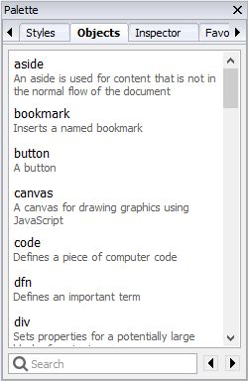
The Object Palette
You can type in the Search field to find a tag object, and press return to insert the selected object into the editor. Or just double-click on an object; or right-click (control-click on Mac) and choose Insert, Insert Start Tag, or Insert End Tag.

Anatomy of a tag object
A tag object consists of a tag name, a set of attributes, and a set of CSS-like ‘advanced’ properties that are not dealt with via formatting dialogs. Like other objects, paragraphs, and text fragments, a tag object can have an identifier, Epub type and custom attributes, amongst others. CSS properties such as Voice family are output inline to the ‘style’ attribute; or you can define regular and advanced properties in a Jutoh style so that they are defined in a CSS style instead of inline.
Currently, only a few extra CSS properties are listed in the Advanced tab. These will be added in future releases, but meanwhile you can use Custom properties to add arbitrary CSS properties. Be aware, though, that Jutoh will not know which Epub version these custom properties are valid for, so will output them to both Epub 2 and Epub 3 files unless the tag object itself is valid for Epub 3 only.

Code generation
Tag objects will only have an effect on the generated book if:
1. The format is HTML-based, such as HTML, Epub and Mobipocket, and
2. the tag and its properties and attributes are compatible with current settings, in particular the Epub version setting.
So unless you use custom attributes and properties that are not checked by Jutoh, you don’t have to worry about Jutoh generating inappropriate code, even if the document is optimized for Epub 3 using HTML5 tags.
If you use tag objects, it is easier to make mistakes than when using straightforward editing and formatting functionality. So be sure to use Jutoh’s Check functionality to invoke EpubCheck and confirm that the HTML/Epub is valid.

Custom tag objects
You can create custom tag objects per project that appear in the object palette and which are aliases for other tag objects, potentially with different default attributes and properties. For example, you might prefer to mark text with a ‘female’ tag that has a preset Voice family property, rather than create a ‘span’ tag and manually set Voice family to ‘young female’.
To do this, right-click over a tag object and choose Make Custom Tag from the popup menu. If this command is not available, it means that the chosen object is not a tag object.
Say we wanted to create a new tag ‘female’, with which we will mark up certain content to be spoken in a female voice. Customise the ‘span’ tag; enter the name ‘female’, click on OK and then in the Advanced tab of the Object Properties dialog, enter ‘young female’ into the Voice family property. Now click on OK.
The ‘female’ tag now appears in the object palette. Select some text in your document, and double-click on the ‘female’ object. Tags will appear around the selected text. If you click on the start tag, you can confirm that in the Advanced tab of the properties dialog, the Voice family property contains the value you entered as a default value. When writing to an Epub 3 file, the custom tag will be written as a ‘span’ tag with appropriate properties.
Note that custom tag definitions are associated with the project, so you will need to use a template containing the definitions if you wish to create multiple files with the same custom tag definitions. This ensures that custom tag definitions do not get lost when projects are transferred to other computers.

Summary
Now you have an idea of how to manipulate tag objects, you can use this knowledge when marking up a document for narration synchronisation – the subject of the next chapter.

Chapter 17: Adding Narration to Your Book
This chapter describes how Jutoh can help you add audio narration to one or more documents in your book, using Epub 3 media overlay (SMIL) files.

Introduction
Synchronised audio narration, where content is highlighted as the audio track progresses, is appropriate for some kinds of books, in particular young children’s picture books. An audio track may also enhance accessibility for disabled readers.
At present, narration works with iBooks and Kobo for fixed layout books only; some Epub 3 readers such as Readium will also handle narration for reflowable books.
You will need to set your configuration option Epub version to 3.
Here’s a procedure for adding narration (you may choose to use different tools or ordering):
- Mark up your document with spans and identifiers.
- Add your audio files to the Jutoh project.
- Create a label file in the audio editor Audacity to mark up clip timings that correspond to span identifiers.
- In Jutoh document properties, import the labels file to a ‘timing set’.
- Specify a character style for highlighting narrated content.
- Compile the project.
These tasks are described further below.

Step 1. Mark up your document with spans and identifiers
Jutoh will need to match each segment of text with a clip in an audio file. So first you need to mark up your document with ‘span’ tags, either manually using the Object Palette, or automatically using the command Book | Bulk Bookmark Management. This can add spans around words and sentences, complete with generated identifiers. You can manually fix spans that haven’t been placed correctly.
Use the Inspector Palette to view all the identifiers in the document (both object ‘Ids’ and bookmarks). This is particularly useful when you’re using paragraph identifiers, which are not visible in the editor. The screenshot below shows marked-up content for the first few paragraphs of Moby Dick, with the identifiers and their context listed in the Inspector. To show span tag identifiers next to each tag as in the screenshot, right-click over ‘span’ in the Object Palette, click on Edit Object in the menu, and set the Display mode setting to Show all valid properties.
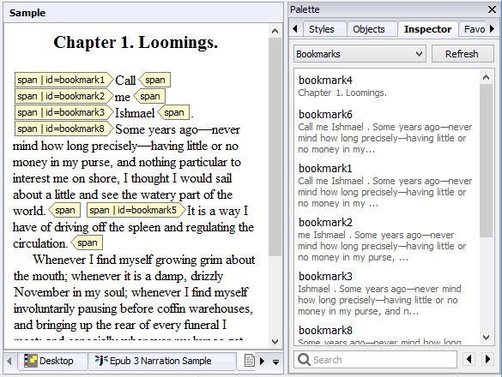
Marked-up content and the Inspector showing bookmarks

Step 2. Add your narration audio files to Jutoh
For each audio file – you can have several per document if you wish – create a media document from the Documents toolbar button and specify the audio file. Typically the file will be in MP4 format. Note that if the audio file changes, you will need to import the file again: Jutoh doesn’t automatically use the changed file. An example media document within Jutoh is shown below.
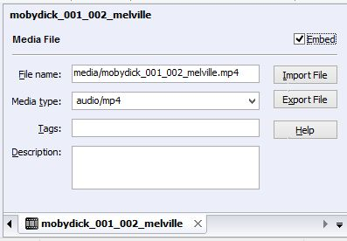
An audio file as a media document in Jutoh

3. Create a label file
Audacity is a widely-used audio editor program available for Windows, Linux and Mac. (Fun fact: Audacity uses the wxWidgets GUI library also used for Jutoh; wxWidgets was created by Jutoh’s author.) Audacity is recommended by Apple for creating label files for media overlays, in case that gives you extra confidence. Here’s a screenshot of Audacity with an audio track and label track:
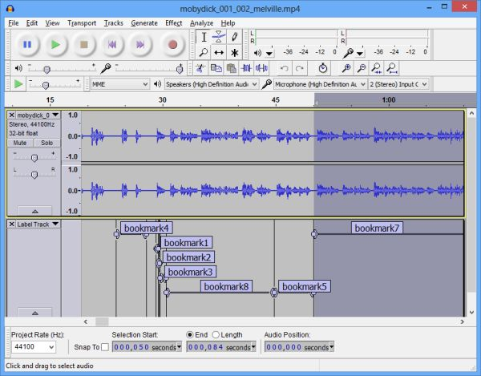
Audacity with an audio track and label track
Run Audacity, and open the narration audio track. If the audio file is in a format not supported by Audacity, you may need to convert it to (for example) WAV or MP3 first. You can use software such as FFmpeg to do this, or you can use an online file converter.
Now add a label track in Audacity using Tracks | Add New | Label Track. Use View | Zoom In (Ctrl+1) as many times as you need to view enough detail. At high zoom levels, you will be able to see roughly where word, phrase and sentence boundaries are by the appearance of the wave form.
To add a label, define the clip start and end positions using a drag movement or more precise dragging of the start and end positions. Press Play to see if you have got the clip position right. When you have, use Tracks | Add Label at Selection (Ctrl+B) and start typing. For each span identifier in your Jutoh document, add a label with the same name in the Audacity label track. When doing this, you can refer to Jutoh’s Inspector Palette with its list of bookmarks (including span identifiers) and their context.
When you have finished marking up the clips, save the label track as a text file using File | Export Labels. You can have several label tracks for a document if you wish.

4. Import the label track
The Jutoh book section properties dialog has a Media page within which you can define ‘timing sets’ for narration synchronisation. A timing set is simply a list of start and end times (clips), each with a label. The label will identify which part of the content the clip applies to. As noted above, you can have as many timing sets as you wish for each document, since you might have several audio files for the document, and corresponding label files. A timing set in Jutoh corresponds to an Audacity label file, but we give it a neutral name ‘timing set’ since you may define your timings in a different way, such as adding each one manually (though this would be laborious!)
Here’s a screenshot of the Media page with a timing set defined:
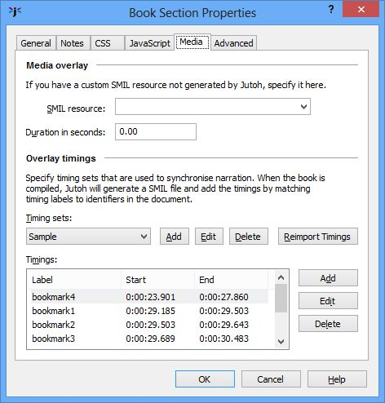
The media page of the Book Section properties dialog
When you add a timing set by clicking on Add next to the drop-down list of timing sets, you can specify the Audacity label track file name, and the associated audio resource within the Jutoh project that you have added (or will add) to the project.
Jutoh will import the timings when you create the timing set, and also if you edit the timing set. You can click the Reimport Timings button to reimport the label files for all the timing sets in the document. Currently you can’t do this per project, only per section document.

Step 5. Specify a character style for highlighting narrated content
Edit your project properties and in the Accessibility page, click on the Speech tab. In the field for Character style for narration highlighting, specify a character style that will be used to highlight the text that is currently being narrated. You can leave this blank to use the ereader default.

Step 6. Compile the book
When the ebook is compiled, Jutoh will create a SMIL file for each document that reflects both the structure of the document and the identifiers that specify the timing for that content. You can look at the generated files by using Book | Examine and clicking on the .smil file(s).
You can test the book using Readium add-on for the Chrome browser, or on iBooks or a Kobo device or app if you have created a fixed-layout book. On some systems, you can click on or touch a region of content to start reading immediately from that point.

Summary
We’ve seen how we can add audio files and synchronise them with book content, with a little help from the third-party audio editor Audacity. For iBooks and Kindle, we can only use narration in fixed layout books: so let’s look at that next.

Chapter 18: Creating Fixed Layout Books
This chapter shows you how to create fixed layout books using the new ‘Fixed Layout’ document type, and various configuration settings that are specific to this kind of book.

The fixed layout sample
You can use the supplied sample, ‘Birds.jutoh’ (available via the Help | Browse Samples command) in conjunction with this chapter. The sample shows a book fixed in landscape orientation, with image and text objects laid onto an image background. The pages are edited as double-page spreads rather than left and right pages. Some of the graphics are pre-rendered onto the page background when compiling, to allow transparency. It compiles as an iBooks fixed layout book, and as a Kindle KF8 fixed layout book with automatic magnification panels for text and images.

What is a fixed layout book?
This is a book with a fixed number of pages whose content doesn’t reflow. It’s a format suited to magazines, children’s picture books, comics, ‘coffee-table’ books, amongst others. In contrast, most novels, biographies and other books with mostly text content should usually not be fixed layout books. Much of the content will be pre-rendered in bitmap images, but text should, if possible, be specified as actual text rendered by the ebook reader and not as images, to increase quality and reduce file size. In some cases, fixed layout books will be interactive via the provision of custom JavaScript code and dynamic content modification.
Reflowable books can easily match the different orientation of ebook readers with little or no effort on the book author’s part, but a few more choices must be made by the author in the case of fixed layout books. Here are some of the questions to be answered:
- What will my page size be?
- Should I create individual left and right pages, or single double-page spreads?
- Will the user be able to change the device orientation to read in either portrait or landscape, or will the book be fixed to either portrait or landscape?
- Can my separate left and right pages be joined together (‘synthesized’) to form a seamless double-page spread?
Some of these questions must be answered before work starts (for example, page size) but others can be changed in your configurations – with different settings in different configurations, to suit the target device or publishing platform. Jutoh will apply the current configuration settings with reference to the individual page settings, and compensate where necessary and possible.
Note that there is no fixed page size or aspect ratio that an ereader requires. If you have the luxury of targeting the aspect ratio (width and height) of a particular device, great, but displays come in so many shapes and sizes that you shouldn’t worry about it too much – choose the aspect ratio that suits your book, and the device will do the best it can.
Also, since pages are scaled by the device, the physical page size you choose isn’t critical. However, the larger the page size you work with, the greater the accuracy and the less chance there is for imprecise conversions (for example, conversion of font point sizes to pixels). You can still provide page background and other images that have more detail than the physical size shown in Jutoh. Extra resolution can be used for zooming, but also be aware of size and performance constraints when using large images.
You cannot mix fixed layout documents and reflowable book section documents: a project must contain one or the other, or the result will be unpredictable.
Typically, because fixed layout books tend to be more graphical than reflowable books, you will need other tools in addition to Jutoh; at minimum, a simple bitmap editing tool for resizing, cropping and so on.

Starting from an existing file format
If your existing book was designed using an application such as Adobe InDesign or Adobe Illustrator, you will not be able to import it into Jutoh directly, but you can export a page as a bitmap and paste that into Jutoh one page at a time. Then, optionally, copy paste text and further images from your original file into Jutoh as text and image objects that overlay the page background. If you are starting from scratch, you can prepare your pages with Jutoh in mind, again pasting or inserting images and text from your design tool of choice.

What are the disadvantages of using fixed layout?
It’s worth emphasizing some of the issues you might find with fixed layout, which might influence you in your choice between reflowable and fixed layout.
- Text may not appear exactly as shown in Jutoh. Even when font sizes are expressed in pixels, HTML-based systems simply render text differently and according to their own rules. So, especially if you have a lot of relatively small text, it may take less or more space than expected, leaving extra white space or causing overlapping. You can mitigate this to some extent by embedding fonts and choosing a suitable Font pixel scale value in your configuration. When using small amounts of large text, this will not be such an issue, and of course you can pre-render text into the book images if the text is sufficiently large not to have significant quality problems.
- Text cannot reflow between pages or boxes. All text will be restricted to its own box, so certain kinds of book may be difficult to implement.
- It’s harder work to create a fixed layout book, not only because each page requires precision, but because there are several different fixed layout standards, and you have to make sure that your book is optimized for each one – this can usually be accomplished via Jutoh configuration settings, but it’s definitely more time-consuming to keep all requirements in mind, and test on different devices.
- How good a fixed layout book looks on a particular device is much more variable than for a reflowable book, given the different device sizes, aspect ratios and resolutions. With a reflowable book, the user can crank up the text size or change the font, but with fixed layout, parts of pages must be zoomed on small devices, and for some devices there isn’t an automatic zoom facility anyway. Some ereaders can zoom images in reflowable books to full-screen – an advantage that may be lost with fixed layout books.
- You are restricting your audience, since not all devices can cope with fixed layout. However, this may not be a problem if you’re targeting a particular device or class of devices. Note that Barnes & Nobles Nook fixed layout format is not supported by Jutoh and in fact is a proprietary format that cannot be used without a non-disclosure agreement with Barnes & Noble. This will probably be replaced by Epub 3 soon, but meanwhile, if you wish to allow Nook users to read your books, you will need to make a reflowable version for them. Kobo uses the iBooks format, but not all ebook redistributors will allow you to upload fixed layout Epubs. Check first!
- Using specific fonts isn’t so important in a reflowable book, but in a fixed layout book, you are likely to want to embed specific fonts, both for aesthetic reasons and also to preserve the layout as much as possible. Since embedding fonts in an ebook requires legal rights to do so, this may require a rethink about what fonts you can use compared with an existing print book.
- Fixed layout books may have a large file size, especially if you pre-render text in large background images. If you have a lot of pages, you may hit file size restrictions sooner than for a reflowable book.
- Fixed layout books cannot be imported from an existing file format such as ODT or DOCX, and they cannot be exported to ODT or DOCX.
Consider whether you really need fixed layout; will it benefit the readers? For example, a guide book may look snazzy in fixed layout format, but a tourist trying to zoom in on areas of text on a phone or small tablet may get frustrated.

What formats and features are supported by Jutoh?
These features are supported:
- iBooks Epub output (also used by Kobo);
- Kindle KF8 output;
- Epub 3;
- text and image objects, positioned using absolute coordinates;
- automatic generation of magnification panels in KF8 for text objects, image objects, and background images;
- the option of pre-rendering text and images to support transparency and other requirements.
These features are not supported:
- HTML templates;
- the ability to show magnified objects that are different from the source objects (for example, showing a hidden object in response to touching an area in the page);
- the ‘read aloud’ feature sometimes used in children’s books;
- percentage units for Kindle;
- relative positioning of images and boxes.
In addition, the usual limitations of Jutoh formatting apply to text boxes, such as no columns, tables and further text boxes without resorting to raw HTML.

Creating a fixed layout project
When you run the New Project Wizard in Jutoh 2, you will see a new ‘layout choice’ page, offering a choice between a regular reflowable book (as before), and a fixed layout book:
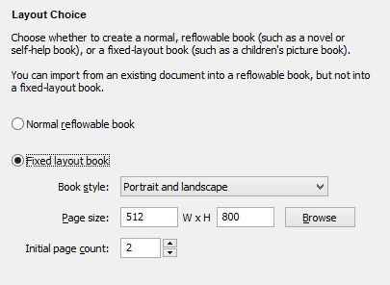
The layout choice page of the new project wizard
If you choose Fixed layout book, you will not be able to import from an existing document but Jutoh will create some empty pages for the new book. Select the kind of layout you will be using from the Book style dropdown, as follows:
- Portrait and landscape: your book will be viewable in both orientations, showing a single page portrait mode, and showing two pages at a time in landscape mode.
- Portrait only: only the portrait orientation will be allowed.
- Landscape only, two pages per spread: only landscape orientation will be allowed, but each Jutoh document will be half of the final landscape page.
- Landscape only, double-page spread: only landscape orientation will be allowed, and each Jutoh document will show as the full landscape page.
For books that have independent left and right pages, the first option is recommended. The choice you make here can be changed later in the Options page of the Project Properties dialog. The main effect of the book style choice is to allow Jutoh to do two things: firstly, to set the Orientation lock configuration property whenever a configuration is created; and secondly, to initialize the page type for each Jutoh fixed layout document. The page type will be used to determine whether the page is on the left or right, amongst other things, as we shall see later.
The page size can be any size you want, but you may wish to choose a size that’s targeted at a particular device’s aspect ratio. Devices with different aspect ratios will still show the book, but with more unused display. Most devices will scale the book to the largest size that fits the display so the absolute size is not as crucial as the aspect ratio. In most cases you will probably choose Portrait and landscape. Click on Browse to choose from some predefined sizes; you can also add your own for use later. Specify a margin if you are going to add text and image objects to your pages and you want to have them snap to within a margin. You can change these settings later per-project, and per-page.
Finally, choose how many pages to create initially. You can add more later.
Click Next to move to the Cover wizard page, then Finish to create the project.

Editing pages
When you first click on a page in the project, you will see a blank page. The first thing is to assign the image you want to show as the background to the whole page. It can be a higher resolution than the page size – in this case, it will allow scaling and zooming without so much loss of detail.
The following picture illustrates a typical session:
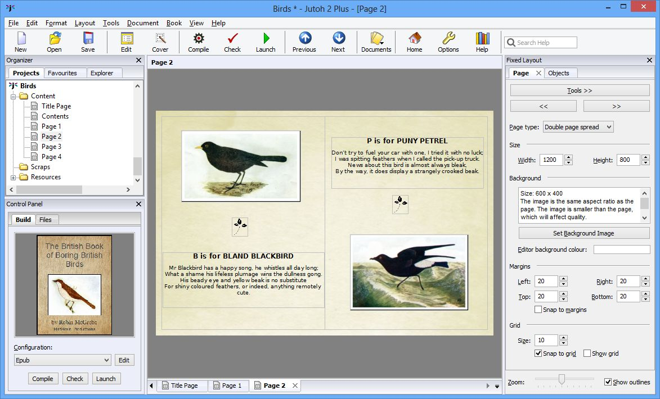
Editing a fixed layout page
When you are editing a page, the Fixed Layout palette appears on the right, with two tabs: Page and Objects. The Page tab contains controls for editing the page type, size and background image, among other things. The Objects tab contains a list of additional images and text objects that should be shown on top of the background image. You can add and delete these, and set their properties, such as size and colour. Under both tabs, there are controls for zooming and showing object outlines.
The Page type control indicates what kind of page this is. The type is used mainly for Kindle books that outputs a type per page file. The possible values for this control are:
- (unspecified): Jutoh will guess the page type.
- Single left page: this is a left-hand page that can stand on its own in portrait mode.
- Single right page: this is a right-hand page that can stand on its own in portrait mode.
- Spread left page: this is a left-hand page that is part of a double page spread.
- Spread right page: this is a right-hand page that is part of a double page spread.
- Double page spread: this page handles the whole of a double page spread.
- Blank: this is a blank page, used as a place-holder, for example at the end of a book with an uneven number of pages. Currently this type is not used by Jutoh.
The page width and height can be edited, but it’s recommended you use the same size for all pages.
The Tools menu gives you access to various useful commands such as alignment, copy and paste, and more. The same menu is shown when you right-click over the page background. Use the << and >> buttons to quickly navigate between fixed layout pages.
Set the background image with the Set Background Image button. The resolution and file name will be described, along with a hint about whether the image and page sizes match and whether the aspect ratio is appropriate for the page size. As we mentioned, do set a higher-resolution image than the page dimensions, to increase quality. The background image will also be scaled to fit the page size.
You can set margins for the page if you wish, and check Snap to margins if you want objects to be constrained within the margins when positioning them.
You can also set the notional grid size and check Snap to grid to make object positioning easier.

Adding image and text objects
With some books, you can simply provide a single image per page; but ebook distributors generally recommend that as much content as possible is provided as actual text layered on top of the page image. Also, if you add image objects that float above the page image, Jutoh can provide zooming. For example, in a photography book, the reader can double-tap on an image on the page to view it in more detail.
To add an object, click on Objects and then New Text or New Image. You will be prompted for a name for the object; this allows you to keep track of them in the object list, where you can move them up and down in order to specify their positions in the z-order (how they are layered).
Double-click to edit inside a text object. When you are editing text, the Formatting Palette will be displayed (you may need to press Alt+P if the palette is not displayed). It will be hidden automatically when you are not editing text. Text objects can contain most of what a regular, reflowable Jutoh page can contain, including images but currently excluding currently footnotes.
You can give a text or image object borders, a background colour, margins and more by clicking on Properties next to the object list (or by using the Properties command on the context menu, or by alt-left-clicking on the object). Reposition the box by dragging it or editing its properties, and resize it by dragging the bottom-right corner or (again) editing its properties. You can also set the position and size directly using the controls in the Objects tab.
If you have light-coloured text, you can change the editing background colour to a more suitable one with the Editor bg control in the Page tab. This can be changed per page.

Clipboard operations
You can paste text and image objects from text and bitmaps on the clipboard by using the Paste command or Ctrl+V. When an image is pasted (or inserted from a file), the box that surrounds the image is scaled proportionately to how much ‘extra’ resolution there is in the background image compared with the actual page size. This means that if you are working with a background image at a certain resolution, and cutting out images to paste onto your page, they will appear at the correct relative size.
You can paste background images from the clipboard using Paste Background Image from the context/tool menu. The original resolution will be retained, and the image will be scaled to fit the page. Images pasted from the clipboard are always saved in PNG format internally, and not JPEG, so that they don’t lose any detail.
You can paste the background image to the clipboard for editing and re-pasting back to the page, using Copy Background Image. Similarly, you can paste image objects to the clipboard using Copy.

Selection and keyboard navigation
The ‘focused’ object has a dotted outline. There can only be one focused object, which will receive keyboard input such as Return to edit its properties, but there can be multiple selected objects, for example by dragging a rectangle around several shapes, or by control-clicking on several objects. Selected objects have a dotted outline, but also have a checkbox in the top-left corner.
You can manipulate objects via the keyboard by first clicking on the canvas background to give it the keyboard focus, and then using:
- Tab to cycle forwards through the objects;
- Shift+Tab to cycle backwards through the objects;
- Shift+Return to edit the object’s properties;
- Return to start editing a text object;
- Delete to delete the selected shape(s) or focused shape.
- Left, right, up and down arrows to move the the shape by a pixel, or 10 pixels if you hold down the shift key.

Aligning objects
A book often looks best when there is a good margin around the content. You can set the left, top, right and bottom margin sizes in pixels using controls on the Page tab. If you also check Snap to margins, when you move objects they will be limited to the area inside the margins.
You can align objects relative to the page or other objects. For example to align object B with respect to object A, click first A, then B, right-click (or control-click on the Mac), or click on the Tools button, and choose Align | Left. The first-clicked object will be the reference object, with respect to which the other selections will be aligned.
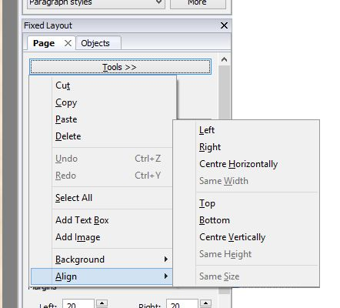
The Tools/context menu
If you only select a single object, it will be aligned with respect to the page if possible (applicable horizontal or vertical alignment). These are the available alignment commands:
- Left: align the left side of an object with the left side of the reference object;
- Right: align the right side of an object with the right side of the reference object;
- Centre Horizontally: horizontally align the centre of an object with the centre of the reference object, or the centre of the page;
- Same Width: give an object the same width as the reference object;
- Top: align the top of an object with the top of the reference object;
- Bottom: align the bottom of an object with the bottom of the reference object;
- Centre Vertically: vertically align the centre of an object with the centre of the reference object;
- Same Height: give an object the same height as the reference object;
- Same Size: give an object the same size as the reference object.
In addition to snapping to margins, you can snap positions to a notional grid (Snap to grid) whose granularity you can control with the Size field. You can also check Show grid to show the gridlines.

Adding borders
You can add borders when editing the properties of each object. These borders will be created using HTML and CSS; if you wish to add a border permanently to an image, you can right-click on an image and choose Add Border. A dialog will be shown for you to choose an outer border and an optional inner border. You also have the option to add a larger border to take into account the scaling of the image, if the image resolution is greater than the size of the object on the page.

Pre-rendering objects
Pre-rendering can be done for none, all, or some text and image objects in your project. Pre-rendered objects will be drawn onto the background image and will no longer have their own independent existence in the ebook. Pre-rendered objects cannot be magnified on Kindle. You can override per-object settings with the Pre-render objects configuration option, for example if one ebook platform requires background-image-only pages and another platform benefits from independent objects.
Here are some reasons why you might wish to check Pre-render this object in your object region properties:
- An image has transparency, which is not supported by most ereaders. Pre-rendering the object will allow transparency to work, and is appropriate for decorative images.
- An image does not need to be magnified, and merging it with the background may reduce file size, especially if the original image was provided at a high resolution.
- A text object needs to be rendered precisely in advance, and it’s hard to predict final text layout when using actual text.
- The book must be delivered with text in special fonts, but those fonts cannot be embedded in the file for copyright or other reasons.
The quality of rendering depends on the resolution of the background image and (if it’s an image object) the object’s original image resolution. For example, if the background image resolution is much greater than the page size, text will be rendered at a relatively high quality because it will be scaled up and drawn onto a large background image.
Note that images are currently not pre-rendered with any specified borders or margins; text objects are rendered without full justification and are subject to the visual restrictions of the editor, so any CSS customisation won’t show. Any hyperlinks will not work. Also, if there is no background image, no pre-rendering is done and pre-rendered objects will not show on the page at all.

Font size and dimension units
Currently, position and size of pages and objects should be expressed in pixels. (To clarify, dimensions within text boxes can have different units, such as percentage image widths, but the actual top-level object position and size must be in pixels.) You can use the configuration options Font size units and Dimension units to specify whether the font sizes and dimensions should be written to HTML as points, pixels, cm or em. The iBooks author’s guide recommends using pixels, but for Kindle, you must use em if you want panel magnification to work for text. You can also specify font sizes in pixels in styles and ad hoc formatting.
Conversion to pixels requires a value for dots per inch; by default the current display DPI is used, since this corresponds best with what’s displayed on your screen. However, for consistency between platforms, you can also specify the DPI value to use in the Options page of Project Properties, with Use custom DPI for conversions. If using pixel fonts (and specifying pixels in Font size units), you can use the Font pixel scale configuration option to adjust the text size shown in Jutoh to a value closer to that used in the ebook. Different ebook renderers will render fonts in slightly different ways, so this value may need to be adjusted separately for different configurations.
In future, Jutoh may convert appropriate units of top-level object dimensions to percentages for Kindle configurations as recommended by the Amazon publishing guidelines. However, pixels currently work fine, and all pixel dimensions are scaled relative to the overall page size.

Embedding fonts
It’s highly likely that if you include text boxes in your project, you will want to embed a font in order to maintain the look of your project. Embedding fonts is covered in the Advanced Topics chapter, but as a quick reminder:
- Check the configuration options: Embed fonts, Generate font names, Generate generic font names.
- Add Embedded Font Documents in your project. If there are several font files per family (for example, for italic and bold variants), make sure the font name in each font document is the same, and adjust the style and weight settings to suitable values. The ereader will use this information to render the correct font according to the text formatting.
- If you can add the fonts to your system, do so, and make sure the font name in your Font Documents match those in the document. If for some reason they don’t match, use the Font substitutions configuration option to map the font names in your project to the names used in your embedded fonts.
Embedded fonts are supported by all systems that support fixed layout books, notably iBooks, KF8 and Epub 3.
If you don’t wish to embed fonts, consider pre-rendering text objects (see the above topic).

Table of contents
If you have a table of contents, it will need to be created as a fixed layout document, with one or more text boxes linked to the other pages in the usual way. Don’t forget to assign it the ‘toc’ guide type, in the document properties.
A text box containing hyperlinks must have its region properties set so that it doesn’t show any magnified panel on Kindle. Otherwise, nested links are generated and the ereader may crash.

Cover
If you enable the configuration option Generate cover page, Jutoh will generate a cover HTML page using the page size given in the configuration. Alternatively, you can set Cover design to ‘(none)’ and create your own cover page as the first page in the project. Set the guide type in the document properties to ‘cover’.
As mentioned later, specifying a cover can cause duplicate covers to appear on Kindle: this is a Kindle rather than a Jutoh issue.

Generating and testing your ebook
As usual, you now just need to choose a suitable configuration (Epub or Mobipocket) and press Compile to create your iBooks Epub or Amazon Kindle book. You can test Kindle books with Kindle for PC or the Kindle Previewer; some Previewer modes don’t currently display all aspects of fixed layout books, and in some cases layout is better on the device than the Previewer. For example, images with a percentage width inside a text box can be shown full size on Previewer, and correctly on devices.
Currently Adobe Digital Editions doesn’t handle fixed-layout ebooks. You can try the Azardi viewer or Readium, an app for the Chrome browser. You can also preview a fixed layout page in a web browser with Book | Preview Section.

Changing fixed layout configuration settings
While the ‘book style’ that you chose in the New Project Wizard or changed in Project Properties is a rough indicator of the layout of your book, it is only used as a hint when creating new pages or new configurations. When Jutoh generates a book, it actually looks at the configuration settings to determine how it will create the necessary HTML and other files.
The relevant settings are listed below. Remember, you can search for settings using the search box at the bottom of the configuration page (click on the box, or use Ctrl+F, and start typing).
- Enable fixed layout: this should always be enabled for fixed layout books.
- Allow reflowable and fixed layout: check this if your book contains reflowable and fixed layout content. The mainstream platforms (iBooks, Kobo, Kindle) don’t allow mixing types of content, but Epub 3 allows it.
- Orientation lock: whether the book will be locked in portrait or landscape mode. This doesn’t refer to the actual aspect ratio of an individual page: this is entirely up to you.
- Pages per spread: how many pages (HTML files) will be created per double-page spread. This may differ from the way you created your pages – Jutoh will split or merge pages accordingly.
- Synthesize spreads: whether left and right pages should be ‘stuck together’ to form a seamless spread, or whether the pages should be shown as being separate (even if next to each other). If not ‘Default’, this setting overrides individual page settings.
- Page width: the overall width of the book. This may be different from your individual page sizes if the Pages per spread setting indicates that Jutoh should split or merge pages.
- Page height: the overall height of the book. Currently Jutoh doesn’t split or merge pages in the vertical direction so this should always be the same as your page heights.
- Book type: this is only used for Kindle and need not be set; if you select ‘comic’, it enables automatic zooming facilities on some Kindles and changes the rendering of double-page spreads. There may be rendering side-effects when specifying a book type, so test the book carefully. Please see the notes below regarding setting KF8 options.
- Open to spread: if checked, the book will open directly to a full-page spread. This is only applicable to iBooks.
- Write page image as background: if checked, the page background will be written using the background-image CSS property, which for KF8 will disable default zooming but will also prevent the background from being shown independently from the rest of the content when clicking/double-tapping on the background.
- Pre-render objects: if set to ‘Default’, any text or image objects that have Pre-render this object checked in their region properties (or inherited page or project properties) will be rendered to the background image instead of being written to the ebook as a separate object. If this option is ‘Always’, all objects will be pre-rendered, and if ‘Never’, no objects are pre-rendered.
- Font pixel scale: this option is in the HTML Formatting group rather than Fixed Layout, but it is useful for making the text size in ebooks closer to the size as shown in Jutoh. Try a value of 0.85 if the ebook text is too large. It is only used when font sizes are expressed in pixels. If your font sizes are in points, you can scale the text size in ebooks by setting the Custom DPI in Project Preferences/Options.
- Auto region magnification: for KF8 output only, this option enables Jutoh’s automatic generation of magnification regions for backgrounds, text objects and image objects. For more on this, see below. You may wish to switch this off if targeting e-ink Kindle devices since it can cause interruption of normal page navigation.

Formatting for Kindle
Kindle fixed layout books have specific rules relating pages-per-spread and orientation: if you fix your orientation to ‘Landscape’, then Pages per spread must be ‘One’. If you’ve created each left and page individually, then this may seem to be a problem, but Jutoh will merge the left and right pages if your configuration settings are consistent with each other, and will warn you if they aren’t. The only wrinkle is that you don’t have the option to show the pages separately: they will be immediately adjacent to each other. However, if you want there to be a gap, just choose ‘(none)’ for Orientation lock and then the individual page types will indicate whether the pages are synthesized (joined) or not.
You can have different settings for different configurations; so you can make Jutoh split or merge pages when using one configuration, and do something different for another configuration. You can also add new configurations for the same format, for example to create several styles of Kindle layout. If you do this, don’t forget to change the Book file name setting for each configuration or files for different configurations will overwrite each other.
You may find that Kindlegen complains about the image file size, if you have very large images. This can be a problem if your image files are larger than the viewport, and especially if Jutoh is stitching two images together to make a spread. You can get Jutoh to resize the images when generating the book, by specifying Maximum image width/height in your configuration. You can choose a size that eliminates the error message. This currently only works if not splitting or merging pages. Also be aware of the 50MB overall file size imposed on Amazon KDP uploads.
You can specify a cover image with the same aspect ratio as your page size, but for the HTML cover page, it may be better to switch off Generate cover page in your configuration and make your own cover page, setting the guide type to “cover” via the document’s properties.
The Kindle publishing guideliness recommend adding an HTML cover page (whether automatically via Jutoh or explicitly), but at present it will result in two covers being shown - the image, and the page. So you may decide to switch off HTML cover page generation to avoid that.

Magnified regions in KF8
KF8 supports a technique called ‘panel magnification’ for zooming into parts of a page. Jutoh can generate magnified panels for text objects and image objects if you check the Auto region magnification configuration option. When you touch a text object, it will be shown in a larger box at 150% magnification; similarly, an image object will be shown at 200% (by default). You can edit visual characteristics such as the magnified panel’s border width and colour, and zoom factor, using the Region tab of the object properties dialog. Or, you can edit these characteristics for a whole page using the Regions tab of the document properties dialog, or for the whole project if you use the Regions tab of the Project Properties dialog. You can make page or object properties override the higher-level properties.
To make an image show full-screen, give it a large zoom factor such as 500%, and it will be limited to the available space.
If a page has no separate image or text objects, Jutoh will generate five magnification regions for the background image: top-left, top-right, bottom-left, bottom-right, and centre. The whole page will be zoomed when one of these regions is touched.
Note that Kindle Previewer does not always display magnified regions properly; sometimes it will give up altogether after a few zooms, until Previewer is restarted.

Recommended settings for KF8
Unless you are forcing landscape mode:
- Set Book type in your configuration to ‘comic’. This way, double pages will work in landscape mode on LCD Kindles, and on e-ink Kindles the book will be fixed to portrait with no option for landscape (which can be illegible in landscape anyway due to the low resolution). When book type is set to ‘none’, the Kindle Keyboard renders fixed layout books terribly – they are fixed to landscape (rotated), but only one page is shown at a time!
- Also clear the Auto region magnification configuration option or the Kindle Keyboard will cycle through the regions when paging.
Note that these recommendations are for the current state of Kindle apps and Kindle Keyboard hardware as of May 2013; changes from Amazon may render the advice obsolete. Behaviour of fixed layout books with different combinations of settings can be a little unpredictable from one device to the next, as you can see from one author’s tabulation of the permutations. Do test your book on as many devices as possible.

Formatting for iBooks/Kobo
iBooks Epub files need two pages per spread, and unlike Kindle, can never be a single page (or file) per double-page spread. So you need to set Pages per spread to ‘Two’ if your actual Jutoh project contains double-page spreads implemented in a single page, forcing Jutoh to split the pages.
Apple specifies that there should always be a cover, which appears on the right-hand of the first spread, meaning that left pages are even-numbered and right pages are odd-numbered. You can use the cover generated by Jutoh, which will be optimized for absolute layout and the configuration page size, or you can switch automatic cover generation off (set Cover design to ‘(none)’ and clear Generate cover page) and add it as the first page of your project. In this case, don’t forget to set the ‘toc’ guide type in the document’s properties.

Further reading
These resources may be useful in conjunction with this guide:
Kindle Publishing Guidelines:
http://kindlegen.s3.amazonaws.com/AmazonKindlePublishingGuidelines.pdf
Kindle fixed layout templates:
https://kdp.amazon.com/community/thread.jspa?threadID=9978&start=255&tstart=0
Tutorials on both Kindle and iBooks fixed layout:
http://authoradventures.blogspot.co.uk/p/tutorials
MobileRead.com page on fixed layout Epub:
http://wiki.mobileread.com/wiki/Fixed_layout_ePub

Summary
This chapter has described the details of creating fixed layout pages in Jutoh as well as the pros and cons of fixed versus reflowable layout. In the next chapter, we see how simple interaction can be added via Jutoh, if you have (or have access to) JavaScript skills.

Chapter 19: Adding Interactivity To Your Book
This chapter describes the facilities available in Jutoh for adding interactivity to ebooks. You will need to have JavaScript skills to make use of these features, and currently not many ebook platforms support JavaScript.

Introduction
Jutoh supports interactivity in Epub 3 books via form objects that you can insert into your document without writing HTML, and the ability to add JavaScript code via the document properties. The form objects have identifiers and callbacks which provide the links to the JavaScript code.
These are examples of interactive content you might have in your book:
- a multiple choice quiz;
- a calculator illustrating scientific principles;
- an animation demonstrating an important point in the text;
- retrieval of up-to-date information from a remote database.
Epub 3 supports HTML5 and JavaScript; currently only iBooks and some Epub 3 readers such as AZARDI and Readium support a decent subset of Epub 3. The Kindle platform doesn’t yet allow arbitrary JavaScript, but is sure to in the future.
Jutoh Plus users can also edit multiple JavaScript files within Jutoh and control the HTML for a document more fully.

Form objects
Via the Object Palette, Jutoh supports the following objects that you can use to input or display data:
- button: a button you can use to submit form data or take some other action.
- canvas: an area for drawing graphics.
- form: wrap your form objects in a form tag in order to submit data to a JavaScript event handler or remote server (if permitted). Using a form is not necessary for interactivity.
- input: this implements many types of input field depending on the value of its Input type attribute.
- meter: a gauge control for representing an amount.
- output: a place for output, where you can specify which input objects contribute to the output.
- progress: a progress bar.
- select: a control that gives the user a choice of values.
- textarea: a text field.
The screenshot below shows some of the available controls, taken from the Epub 3 sample project:
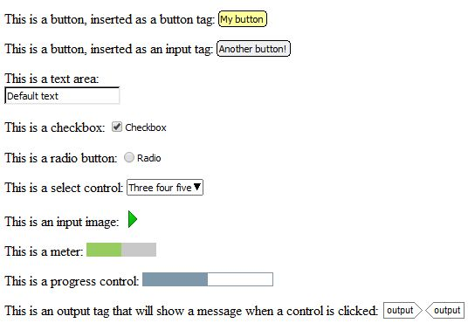
A selection of form objects
The form objects aren’t ‘live’ within Jutoh but give a rough representation of their eventual appearance given their current attribute settings.
Click on an object to edit its attributes. Where appropriate, you can edit visual attributes such as the object’s size, margins and so on via the pages in the Object Properties dialog. Attributes edited in this way will be generated ‘inline’ in the style attribute, so you can instead specify a Jutoh style (or alternatively a CSS class) that will apply to the object.
The most interesting attributes are in the Advanced page of the dialog; here you can edit object-specific properties such as List options, and specify JavaScript event handlers such as for onclick.

Using form objects
It is beyond the scope of this manual to give a tutorial on JavaScript and HTML5, but briefly, you can add identifiers and event handlers to your form objects, and then write JavaScript to handle the events, writing results to controls such as ‘output’ or simply to a paragraph or span in the document.
JavaScript code can be defined inline within the JavaScript tab of the document properties dialog, or in Jutoh Plus it can be specified as a resource created as a code document.
You can test your code by compiling with the HTML configuration, with the Epub version configuration option set to 3. Launch will show the HTML in the default web browser.
Or, you can use the command Book | Preview Section, which will show only the current section in the web browser: this is good for quickly testing changes.
You can search online for Epub 3/JavaScript examples and tutorials. The supplied project “Epub 3 Sample” has very simple JavaScript code that outputs the identifier of the clicked form object, using the onclick event handler.

Summary
We’ve seen how advanced properties in Jutoh objects, plus the ability to include JavaScript files and code, can let you make pages interactive for those platforms that support it. In the next chapter, we describe how you can add extra structure to make your Epub 3 books easier for disabled readers to navigate.

Chapter 20: Making Your Books Accessible
In this chapter, we discuss how your books can be made more accessible to disabled readers. Since the most commonly used ereader hardware and software do not support accessibility features, this chapter may not yet be relevant to you.

Introduction
If you intend to create books that are accessible to disabled readers, you need to understand how to use Jutoh to add extra information to your book. Jutoh has features that can help automate the insertion of accessibility information, and the remaining manual settings are quite straightforward. However, for best results, you will need to do some reading around the subject to understand the principles of accessibility.
At present, a reasonable level of accessibility (as illustrated by the features listed in this topic) is only supported by Epub 3, the DAISY digital talking book (DTB) standard, and annotated PDF. Of these formats, only Epub 3 is supported by Jutoh. Epub 3 is taking longer to become mainstream than expected, but iBooks supports an Epub 3 subset and some countries have adopted Epub 3 rapidly due to its support for their languages; and many large publishers are using Epub 3 internally. As a replacement for the DAISY DTB standard, Epub 3 is in a transitional period and DTB is likely to be around for a long time to come. Despite these caveats, it seems highly likely that Epub 3 will be adopted more widely in future. Plus, some of the features that promote accessibility (such as sections, figures, and asides) are in fact HTML5 constructs – a standard in wide use today.
Note that Jutoh doesn’t currently cover all conceivable aspects of accessibility. But we hope that the current functionality is a big step in the right direction, and we will be listening to feedback in order to improve it.
Some accessibility features can still be useful for Epub 2 and Mobipocket generation – the caption detection will insert non-breaking ‘div’ tags around the object and caption in Epub 2 mode so that they stay together (not currently supported by Kindle). You can use the style mapping facility to map styles to phrase tags such as ‘em’ and ‘strong’ in Epub 2, Epub 3 and Mobipocket.

Epub 3 and Jutoh
Epub 3 uses HTML5 and some additional Epub-specific constructs to provide semantic markup that ereaders can use to orientate users with a range of abilities.
Given that time available for editing documents is usually in short supply, Jutoh tries to automate as much as possible, in particular relying on using a well-planned and consistently used set of styles in your project. If this doesn’t describe your project, please take the time to create named paragraph styles for headings, images, captions, and so on, and apply them to your book. Some forethought should save a lot of time in the long run.
Here are the accessibility features that Jutoh currently supports.
1. Epub type
The ‘epub:type’ attribute (‘Epub type’ in Jutoh) can be associated with many elements, including the document body, section tags, links, headings, and so on. A range of values allows meaning to be assigned to elements. Jutoh allows editing the Epub type in the Advanced tab of various property dialogs, and also in the document properties. Multiple space-separated types can be specified.
2. Section tags
Use of the ‘section’ tag gives hierarchy (and an Epub type) to components of a book chapter, allowing easier navigation. Section tags often (but not always) contain a single heading. Jutoh can insert section tags based on a mapping from headings that you can edit in the Accessibility page of Project Properties.
3. Navigation document
The navigation document is a compulsory part of an Epub 3 file containing a table of contents and landmarks section; Jutoh generates this automatically from the navigation map and document guide types.
4. Speech and narration support
Epub 3 defines properties such as ‘-epub-voice-family’ (‘Voice family’ in Jutoh), to allow passages of text to use a distinct voice. Some of these are supported via the advanced properties tab in style definitions, paragraphs, text spans and objects. In order to apply these and other properties to spans or blocks of content, Jutoh supports the insertion of tag objects via the Object Palette.
In addition, Jutoh can generate a SMIL file for each section document, without media or timings, so that TTS systems can help the blind user navigate the content.
Jutoh supports the synchronisation of speech with the content either by provision of existing SMIL files, or by importing Audacity label files which are matched against identifiers in the content to produce a SMIL file with timings.
5. Phrase tags
You can insert phrase tags such as ‘em’ and ‘strong’ as objects around text; or you can get Jutoh to automatically insert the tags based on character styles that you use in your document. Again, this is achieved using the style mapping edited in the Accessibility page of Project Properties. It works for Epub 2, Epub 3 and Mobipocket generation.
6. Figures and captions
Wrapping images and tables up in ‘figure’ tags containing captions ensures that the ereader knows which text is associated with which figures. Jutoh can insert these tags if you enable the option in the Accessibility page of Project Properties. You can specify styles you have used for captions, and Jutoh will look for figures near the caption (currently, only a single image or table above the caption). In addition, Jutoh will optionally insert image ‘alt’ (alternative) text and table descriptions using an HTML5 ‘details’ tag that displays extra an description when clicking on a button next to the caption. Obviously, for the best results, enter descriptions into all your images and tables. For images that are purely for decoration, set the Epub type to ‘presentation’, so that Jutoh knows to ignore them for the purposes of captioning.
If your configuration specifies Epub version 2, then ‘div’ tags are added instead of ‘figure’ tags.
7. Table headers
The sighted user can easily distinguish a table heading from the rest of the table if it has been formatted in an appropriate way; to help disabled readers, make it plain which are header rows in table properties by specifying the number of rows that are part of the header, in the Repeat header control. If several rows are part of the header, and there are spanned columns, Jutoh will generate code to indicate to the other table cells which all the appropriate header cells are.
If you have header cells that outside the main header rows, you can mark them as such individually using the Cell headers control in the table properties dialog.
8. The ‘aside’ tag
It’s important for a disabled person to know what parts of the content are part of the main flow, and which are not. The HTML5 ‘aside’ tag caters for this, and for text boxes, Jutoh lets you indicate in the box properties dialog whether it is an ‘aside’ or a normal block. You can configure footnotes to use asides by checking the configuration options Popup footnotes and Hide footnotes. You an also insert ‘aside’ tag objects manually if you wish.

Editing your project for accessibility
To make best use of Jutoh’s accessibility features, you need to have a well-defined set of styles that you apply consistently.
- Have one heading style for chapters, another for appendices, and so on, so Jutoh can apply a different Epub type for each kind. Several heading styles can still use the same outline level.
- A consistent caption style will help Jutoh group images and tables, and their captions, within figure tags.
- Create character styles for strong and emphasised text, and other phrase tags listed in the Tag drop-down control in the Style Mapping dialog, so Jutoh can insert the appropriate tags instead of just visual formatting.
Other things you can do:
- Ensure images that aren’t purely decorative have alternative text. Mark images that are decorative with the role attribute value ‘presentation’, so that Jutoh won’t try to place it in a figure and speech systems can ignore it. Replace table images with actual tables if possible.
- Ensure tables have a description, and the number of header rows marked so that Jutoh can link table cells with the appropriate header cells.
- In each document’s properties, set the Epub type. Effectively this will be the type of the first level (outer section) of that document, so if the document-wide type is present, Jutoh will only add section tags for the second and subsequent levels, if there are any.
- Set the Epub type for content (paragraphs, spans of text, objects) wherever appropriate.
- Set the project’s language in the metadata.
- Mark changes in language with span tags, setting the ‘Language’ attribute.
If appropriate, mark changes in voice with span tags, setting the ‘Voice family’ attribute.
For logical sections that do not contain headings, insert section tags manually.

How the style mapping works
The purpose of inserting sections is to assign more meaning than a simple heading confers. For example, you might have two titles, ‘Chapter 1’ and ‘Acknowledgements’ both using the style ‘Heading 1’. If the configuration option Heading style prefix is set to ‘Heading’ (the default), then at least the paragraph will be generated using the h1 tag. However, it still doesn’t give much information about the type of section that this heading introduces.
What we would really like to do is enclose the heading (and the text below it) in a section, and assign the type ‘chapter’ to the section within the Chapter 1 document, and the type ‘acknowledgments’ within the Acknowledgements document.
For example:
<section epub:type="chapter">
<h1 epub:type="title">Chapter 1</h1>
...
</section>
Similarly, subsections should also have their own sections, whether or not they have an explanatory type (unfortunately Epub types don’t have enough expressivity for all possible subsections, but adding sections is still useful even without the type.)
When creating an Epub 3 file, Jutoh scans the mapping for style patterns that match paragraph styles. If there is a match, Jutoh will insert a section tag in front of the heading paragraph, and will close the tag either when a subsection with a greater level is encountered, or the document ends. At the same time, the mapping item can assign the heading level, an Epub type for the section, and an optional Epub type for the heading itself (such as ‘title’).
A caveat for this is that if you have defined an Epub type for the whole document, in the document properties dialog, then Jutoh will not create a section that defines the same type as the top-level section, since it will assume that the type (added to the HTML body tag) defines an overall section for the document.
You can define any number of mapping items for the same heading level, so it is a more powerful way of indicating headings than the simple Heading style prefix configuration option, and overrides it.
Similarly, for phrase tag mappings, character styles are matched against entries in the mapping and the appropriate tags inserted. For ‘em’ and ‘strong’ tags, any italic and bold attributes are removed. Also be aware that any advanced properties or advanced attributes such as identifier or Epub type will be removed as well (for ‘em’ and ‘strong’ tags only).

Using speech in your books
Jutoh can help generate SMIL media overlay files both with and without associated media files and timings. Unfortunately, the largest ebook vendor – Amazon – doesn’t yet support SMIL files, but this may change.
In the Accessibility page in Project Properties, click on the Speech tab and check Generate overlays for TTS. Now Jutoh will create a SMIL file for each section document describing the document at the paragraph level, if other document-specific settings do not take precedence. Even without an associated sound track, this provides useful information to suitably aware ereaders.
To add narration to your book, which also makes use of media overlays, see Adding narration to your book.
You can add lexicons to your project to help text-to-speech systems pronounce difficult words or phrases. In the Accessibilities/Speech tab, under Lexicons, click Add and then in the Lexicon dialog, choose either PLS resource or String tables.
If you choose PLS resource, you can specify a .pls file that you have added (or will add) to the project as a media resource or code document. It needs to be a path relative to the other content files, for example lexicons/lexicon_en.pls.
If you choose to use string tables, specify a global and/or project string table that contains string names and values corresponding to the word or phrase in question, and phonetic description, respectively.
You may add as many lexicons as you wish. They will be referenced by all documents in the project without further intervention. The language specified for the lexicon will be used if it matches the reader’s localisation preferences.
You can also use the SSML attributes ssml:ph (‘Phoneme’ in Jutoh) and ssml:alphabet (‘Alphabet’ in Jutoh) to define pronunciation for a particular content element.
Not many systems yet support the extra speech markup. However, by including it now in your books, they will automatically get the enhanced features when the state of Epub 3 technology advances.

Devices and software supporting Epub 3
Apple’s iBooks supports Epub 3, and iOS devices have good general accessibility support. However it’s not clear how much of the extra Epub 3 markup is used in support of accessibility.
AZARDI is software for Windows and Mac that can read Epub 3 files. However, at present, it does not have accessibility features.
Gitden Reader is available for Android and iOS, and is a highly conformant Epub 2 and Epub 3 reader.
The Readium Chrome extension supports Epub 2 and 3.

Further reading
Epub 3 Accessibility Guidelines from IDPF:
http://www.idpf.org/accessibility/guidelines/
Accessible Epub 3:
http://shop.oreilly.com/product/0636920025283.do

Summary
This chapter has taken a brief look at how your documents can be made more accessible for future deployment, even if the required Epub 3 support in ereaders is quite rare at the moment. The next chapter is a rag-bag of advanced topics such as font embedding and setting a background image.

Chapter 21: Advanced Topics
This chapter describes a variety of advanced topics that the newcomer to Jutoh can most likely ignore.

Embedding fonts
Jutoh lets you embed fonts into Epub books. You might wish to do this to ensure that non-Western characters are rendered correctly, especially for viewing in Adobe Digital Editions, which fails to render non-European languages without embedding; or you may just wish to give your ebook a different look. However embedded fonts are not supported by all ebook readers, and there may be copyright issues; so you should only embed fonts if absolutely necessary.
An example of a Unicode font that you can freely embed in your ebook is DejaVu, available from:
dejavu-fonts.org/wiki/Main_Page
If you wish to create a Greek Epub, you can use the free Gentium font, available from:
scripts.sil.org/cms/scripts/page.php?site_id=nrsi&id=gentium
To embed a font, follow these three steps.
- Add a font. Use the Documents toolbar button or Document | Add Embedded Font Document menu command. Select a font file when prompted. A copy of this font will be added to the project and you can change the font family name and other parameters. Change the font family name to match the font name used in your ebook styles, if applicable.
- Enable embedding in your configuration. In your Epub configuration(s), available from the Configurations tab on the Project Properties dialog, scroll down to the Fonts group and check Embed fonts if not already checked. Note that if Embed fonts is enabled, as well as Optimize for iBooks, Jutoh will generate a file called com.apple.ibooks.display-options.xml with specified-fonts set to true. This enables font embedding for iBooks.
- Specify font substitutions. If the font is installed on the computer and is therefore available from Jutoh’s dialogs, and is specified in your book, then you’re done. But if the font you want to use is not specified in your document, you must specify a font substitution in the Font substitutions property in your configuration. For example, ‘Times New Roman: DejaVu Sans, Times New Roman’. This will use DejaVu Sans, Times New Roman for the font family wherever Times New Roman is found in style definitions and content. The ebook reader will fall back on Times New Roman if it can’t find the embedded font DejaVu Sans. You can specify multiple font substitutions by separating them with semicolons.
If you have multiple font files for a single font family, for example regular, bold and bold italic variants, you can use the same font family name in all of these font documents (for example, DejaVu Serif) and specify the italic style and weight properties in each font document, as in the following:
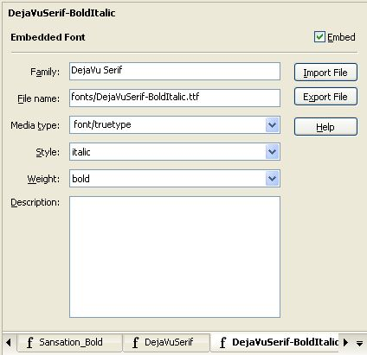
Font document
Jutoh will generate the appropriate CSS so that the viewer can use the correct font file for each combination of italic style and weight.
If font embedding isn’t working at first, check that the font family specified in the font document is identical to the font name you use within styles, or within your font substitutions. Otherwise the ereader will not be able to find the correct font to use.

Embedding media
Jutoh lets you embed audio and video into Epub and Mobipocket books. This is only supported in some readers (for example, iBooks), and Amazon may not accept Mobipocket containing multimedia (and media in locally-transferred Mobipocket files may be blocked).
For video in iBooks, Apple recommends that you use H.264 compression at VGA resolution. The poster image should be 150x300 pixels. Audio should be stereo, AAC/MP4, 256kps, encoded using iTunes.
Amazon's guidelines for formatting Kindle books, with information about audio and video formats, is available at:
kindlegen.s3.amazonaws.com/AmazonKindlePublishingGuidelines.pdf
To embed a media object, follow these three steps.
- Add a media document. Use the Documents toolbar button or Document | Add Media Document menu command. Select a media file when prompted. A copy of this file will be added to the project (it may take a long time if the file is large) and you can change the file name to be used and other parameters.
- Insert a media object into your content. Use the Insert | Media Object command on the Format menu or the context menu, and when prompted, choose the file name from the list of media objects currently in this project. Enter other parameters if you wish, such as a title, and fallback text to show if the reader does not support the audio or video tags. You can preview your file in Kindle Previewer, setting the device to (for example) iPhone or iPad, to see the effect of adding media.
- Ensure media objects are switched on in your configuration. Under the Images and Media group in your configuration, check that Generate media objects is enabled. If you switch this off, no media files will be included in the book and the media tags will not be included in the XHTML.
You can also use media documents and objects to insert images. The image won’t show up in the editor when you insert a media object that references the media document, but there is an advantage – you could add several media documents with the same name, at different resolutions, and use configurations to selectively include and omit media documents from the generated ebook. You do this by specifying tags in your media document, (for example, ‘hires’, ‘lores’) and then specifying tags in the configuration options Include media documents matching tags and Exclude media documents matching tags. This technique is also useful for very large images that take a long time to load into the editor when inserted directly.

Embedding a PDF
Currently embedding a PDF into your book works in iBooks only.
- Add the PDF and PNG files to the project as media objects (Document | Add Media Document).
- Add this to your content, in its own paragraph:
<p><a href="media/subwaymap.pdf"><img src="media/map.png" alt="img"/></a></p>
substituting your own file names.
- Apply the ‘HTML’ style to the above paragraph.
EpubCheck will complain about the syntax, which you can ignore.

Setting a background image
The following method works for some Epub viewers, including Adobe Digital Editions.
- Insert a new image into the Resources section of your Jutoh project using Document | Add Media Document and selecting an image.
- Ensure that Generate media objects is enabled in your configuration.
- Right-click on the section(s) you want to have a background image, select Properties, and insert the following into the Extra CSS field:
body {
background-image: url(media/image.png);
background-repeat: repeat;
margin: 0 0 0 0;
}
where media/image.png is the path specified in the media object. Alternatively, if you want it on all pages, you could add this once to the the style sheet (click on the Edit button at the top of the Styles page in Project Properties, check Custom CSS and paste the code).

Understanding encodings
When importing text files, Jutoh needs to know what the encoding of your files is, since otherwise the files are just streams of bits that could represent anything. A ‘standard’ ASCII file only represent the basic symbols, whereas files encoded in Unicode can represent most symbols in use on the planet. Jutoh’s favoured Unicode encoding is UTF-8, in which plain text is encoded with one character per symbol (and so is readable in any text editor) and more complex symbols are represented by two or more characters.
When you save text from a word processor, you need to make sure it’s going to write using the encoding that you’ve specified in the New Project Wizard or Project Properties. For example, when saving a document as plain text from Microsoft Word, Word will show you a further dialog. Click on Other encoding and select ‘Unicode (UTF-8)’. Don’t check Insert line breaks, since you want each paragraph to be one line.
If you forget to save in the right encoding, you may be able to fix it, as follows. When you get an Jutoh error indicating an encoding problem (or the file doesn’t show properly in the finished book or the editor), open the file in an encoding-savvy application such as Programmer’s Notepad. It should auto-detect the encoding, which you can check by typing Alt+Enter to see the document’s properties. Now select the whole document and copy it to the clipboard. Create a new file, change the encoding to UTF-8 in the document’s properties, and paste the text into it. Save this over the original file – it’s now in the correct encoding.
If you can’t change the encoding of the original file, you can specify it in the Import Options section of the New Project Wizard, or the Options page of Project Properties if you’re importing a file after initial project creation. Also, if you are importing HTML or Epub and the encoding is missing from one or more HTML files, Jutoh will use this setting – it will also warn you about the missing encoding so you can go back and specify it. For example, if the file was created on Windows without specifying UTF-8, you could try the value ‘Windows Western European’.

Guide types
Each document in a book can have a ‘guide type’ which is written to the guide section of the Epub or Mobipocket file, and indicates the role of the document. You can set the guide type by right-clicking on the document in the outline, selecting Properties to show the Document Properties dialog, and then changing the Guide type selection.
These are the possible guide types:
- acknowledgements
- bibliography
- colophon
- copyright-page
- cover
- dedication
- epigraph
- epilogue
- foreword
- glossary
- index
- loi – list of illustrations
- lot – list of tables
- notes
- other.back-cover
- other.intro
- other.ms-firstpage – the place to start reading. Kindle only, deprecated in favour of ‘text’.
- other.reader-start-page – the place to start reading. iBooks only.
- preface
- start – the place to start reading. Kindle only, deprecated in favour of ‘text’.
- text – the first chapter of main body of text; it should not be used more than once
- title-page
- toc – table of contents
When Jutoh generates a section without it being present in the project outline (for example, the cover page and simple table of contents page), it will set the appropriate guide type.
If you use the keyword %STARTPAGE% for the guide type, it will be replaced by the appropriate type for Mobipocket or Epub, as specified by the current value of the configuration option Start page guide type. However, this has become unnecessary since all ereaders now recognise (or quietly ignore) the ‘text’ guide type.

How to format drop caps
Jutoh doesn’t support drop caps directly, but you can use CSS to achieve it (at least in Epub, with slightly less success on Mobipocket). There’s some information about the general principles here (external link).
In recent versions of Jutoh, a ‘Drop Caps’ character style is created automatically in the default style sheet, which you may wish to adjust to your preferences.
If Jutoh has not already added a ‘Drop Caps’ character style, go to Project Properties/Styles, click New Style, choose Character Style. Enter the name ‘Drop Caps’. Press OK. Still in the Styles panel, in the drop-down under the styles list, choose Character styles. Select ‘Drop Caps’, click Edit, go to the Font tab and choose a large font, say 20pt, and choose Bold under Font weight. This is just to show a large bold font in the editor; this exact formatting won’t show in the ebook. Press OK to dismiss the ‘Drop Caps’ editor and now click on Properties to show the Drop Caps property dialog. Check Use custom CSS and paste in this text:
.C_Drop_Caps {
overflow: hidden;
line-height: 90%;
height: 0.75em;
font-size: 280%;
margin-right: 0.075em;
float:left;
}
This should replace the existing text – if you used a different name for the Drop Caps style, make sure it’s reflected in the name after the dot in the CSS.
Now press OK, OK again and in the editor, select the first letter of your paragraph and apply ‘Drop Caps’ to it. You can do this with right-click (or control click on Mac), Styles, scroll to the bottom of the menu, click on Character Styles, choose ‘Drop Caps’.
Now when you compile the Epub and show it in, say, Adobe Digital Editions, you should see something approximating a drop caps. In Kindle it’ll be shown as a large letter, just not dropped. You may need to tweak the CSS to work better with your choice of font sizes.

How to format small caps
Small capitals can be applied to a named style or directly to text via the Font tab of the style editor. For convenience, you could add a character style called ‘Small Caps’ that just has this attribute defined.
When generating Epub and Mobipocket ebooks, Jutoh can generate small caps either by using the official font-variant CSS attribute, or by emulating it by emitting capital letters and shrinking the text. Adobe Digital Editions and some other ereaders do not support font-variant, but all ereaders will do a reasonable job using small caps emulation, so by default emulation is used. To use font-variant instead, clear the Emulate small caps configuration option. For those ereaders that support it (for example, Kindle readers, iBooks, and the Azardi software), font-variant is a superior method since it renders real capitals larger than the lower case letters. However, if you’re targeting multiple ereaders, emulation is safer.
If you wish to add small caps to the first few words of your chapters, there’s a handy option in the Document Cleanup dialog (accessed from the Book menu) to do just that. Before using it, you’ll need to create a ‘Small Caps’ character style.

How to add an ISBN to your books
Some platforms require you to supply an ISBN for your ebooks. For example, to get your books into the premium Smashwords catalogue, you need an ISBN for each ebook. This needs to be separate for each book edition – paperbacks, hardbacks and distinct ebook editions for different platforms all need separate ISBNs. You can buy a set of ISBNs from the relevant agency (in the UK, it’s Nielsen), or you can see if your ebook publisher such as Smashwords can supply ISBNs.
Having got your ISBN, where do you put it? Go to the metadata in Project Properties (just click on the Edit button on the toolbar) and click on the ‘...’ button next to the Identifier field. Click Add to add a new value to this element, and choose Add ISBN. Enter the ISBN (just the number, including dashes) into the Value field. Now delete the original value, ‘Element 1’.
OK, so you have different ISBNs for different ebook editions – but you want to publish your ebook to different platforms, with different ISBNs, without having to edit separate Jutoh files for each edition. The way to accomplish this is via string tables. String tables allow you to set up substitution tables; since we can specify a different table for each configuration (Mobipocket, Epub and so on), we can put a variable called, say, %ISBN% into the ISBN value field, and substitute a different ISBN value from the different tables, depending on the current configuration.
Let’s assume that you are using two configurations, Mobipocket and Epub. The Mobipocket book is going to the Kindle store, and the Epub book is going to the iTunes store.
- Click Edit on the toolbar, then the Strings tab. Click the ‘+’ button to add a new string table, and call it Kindle.
- Click Add and enter ‘ISBN’ to add a new string whose name is ISBN.
- Click on the value field (second column) and enter the ISBN for the Kindle store.
- Repeat the above, adding a new string table called iBooks and adding the second ISBN value.
- Click OK to dismiss the Project Properties.
- Click Edit on the toolbar again, then the Configurations tab.
- Click on the Mobipocket configuration, and scroll down to the String Tables group.
- Select ‘Kindle’ in the Project string table property.
- Click on the Epub configuration, and scroll down to the String Tables group.
- Select iBooks in the Project string table property.
- Click on the Metadata tab and enter %ISBN% into the Identifier field.
- Press OK.
Now when you select a configuration, a different string table will be used and the %ISBN% variable will be filled in with the value of ‘ISBN’ in the appropriate string table.
If you have different editions of your book with the same format (for example, a Mobipocket file you put on your web site, and one that you upload to Kindle), you can just add another configuration (taking care to set the format property correctly) and a string table to go with it. So you can have as many configurations as you have sites that you upload to.
You can use the string table to change other things in your metadata and (if you check the Replace strings in content configuration property) your book pages.
For more information on string tables, see Chapter 14: Working with String Tables.

How to specify which sections will be included in the ebook
In Chapter 13: Working With Style Sheets we saw how we could change the content of the book using styles. Another way of changing content is to include or exclude entire sections. There are two ways of doing this: specifying in the Book Section Properties dialog whether this section will be included for a given format, and specifying inclusion or exclusion by tags.
Specifying inclusion by format is inflexible, because you might have different configurations for the same format. To use tags, first enter tag names into the Book Section Properties dialog for each section document. You can show this using the Document | Document Properties command (Shift+Alt+Enter). Let’s say you only want the first three chapters of you book to be shown in your book sample; you have created a new configuration called ‘Sample Epub’. Now add the tag ‘sample’ to your title page, table of contents (if there is one) and the first three chapter documents.
Next, edit your ‘Sample Epub’ configuration and in the property Include sections matching tags, type the value ‘sample’. Regenerate your table of contents and compile. You should now have an Epub that contains only the sample content.
If you have a section that should only be included for a particular configuration, then give it a tag and enter that tag in Exclude sections matching tags.
You might also make use of this to have alternate title pages, intended for different distribution channels.

Removing underlining from links in HTML-based formats
There is no provision in Jutoh for specifying this level of detail, so it needs to be done using custom CSS. You can add CSS either globally if you want no underscores throughout, or per section. To add it globally, go to the Styles page on the Project Properties dialog and click on Edit Properties at the top of the dialog. Check Use custom CSS and paste in the CSS code.
Let’s say we want to make the link colour red, and remove underlining. You can use the following code:
a:link { color: red; text-decoration: none; }
a:visited { color: red; text-decoration: none; }
a:hover { color: red; text-decoration: none; }
a:active { color: red; text-decoration: none; }
Alternatively, if you want the colour to be the same as the surrounding text, but keep underlining, you could use:
a:link { color: inherit; text-decoration: underline; }
a:visited { color: inherit; text-decoration: underline; }
a:hover { color: inherit; text-decoration: underline; }
a:active { color: inherit; text-decoration: underline; }
To apply CSS to an individual section only, right-click over a section in the project outline, select Properties, and then check Extra CSS. Paste in the above page and press OK.
You might notice that when you look at the HTML generated by Jutoh for links, the style you applied to the link has been removed. This is because if the configuration property option URL attribute removal style has a style value, the attributes in the style will be removed from the link before it is written to the HTML file. This avoids clashes between the styles specified in the editor and defaults used by the ereader – such clashes can make links look untidy, especially if the Jutoh and ereader URL colours are slightly different. It’s better that the ereader shows links in the default syle than in a mixture. You can reapply the intended attributes using CSS properties, as above.

Jutoh and Epub 3
There is support for some Epub 3 features – you can switch Epub 3 support on by setting the Epub version configuration property to 3. The adaptations to Epub 3 are currently as follows:
- The new-style table of contents file is generated, while the old NCX file is included for backwards compatibility;
- Epub 2 guide types are converted to Epub 3 equivalents where possible;
- if documents contain guide types, a ‘landmarks’ table of contents is generated;
- metadata is generated using the new Epub 3 syntax, with mandatory date metadata;
- XHTML files have the correct preamble;
- JavaScript code can be embedded (also in ‘Epub 2.5’, i.e. iBooks);
- Eub 3 document structure can be added: see Chapter 20: Making Your Books Accessible.
- narration audio files can be synchronised with content: See Chapter 17: Adding Narration To Your Book.
Jutoh is distributed with EpubCheck 3, which means it can check both Epub 2 and Epub 3 files if you have Java installed.

Summary
This chapter has described a variety of features that advanced books might need. For other miscellaneous topics, you may also find it useful to search Jutoh’s help by typing into the Search Help field in the Jutoh toolbar.
Next, we look at various strategies to cope with errors that might occur in your book.

Chapter 22: Troubleshooting Your Book
Once you’ve compiled your book, you need to check it and fix any formatting or other errors that might be present. This chapter explains why you need to do this, what errors are likely to crop up, and how to fix them.

What errors can occur?
If you’re lucky, your ebook will be perfect the first time you compile it. In the real world, however, it may contain flaws. These are the seven categories of error or imperfection that we can identify:
- Syntax errors: in particular, bad generated XHTML.
- Structural errors: for example, bad page links, chapters that are too long for ebook readers to cope with, and missing sections such as table of contents or cover.
- Formatting errors: poor or inconsistent formatting.
- Content errors: spelling and grammar mistakes, poor writing, factual errors and so on.
- Platform errors: formatting or content that is fine on the face of it, but falls foul of a particular publishing platform’s guidelines.
- Import/export errors: problems with importing existing files into Jutoh, and exporting to other applications.
- Expectation errors: when Jutoh isn’t designed to do what you’re trying to do.
The optional third-party Epub checker can highlight syntax and structural errors, while Jutoh itself checks for some structural errors during book compilation.
Let’s deal with each of these categories in turn.

Syntax errors
Let’s focus on the Epub format to begin with. When you click on Compile in Jutoh, and you have an Epub configuration selected, an Epub file is created that contains a variety of XML and XHTML files.
Jutoh takes great care that the files are well-formed, but occasionally errors may be introduced. For example, you might delete a bookmark needed for a link, or you might enter bad metadata such a date in the wrong format. Or, if you have inserted verbatim XHTML into your book using the special “HTML” style, the error could be badly-formed XHTML syntax such as a missing angled bracket.
This is where Epub checking comes in. You can use the Check button in the Control Panel, or the Book | Check menu command, or the F8 key, or the Check toolbar button:
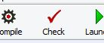
The Check toolbar button
Click it to run the third-party EpubCheck tool (written by Adobe, in the Java language) which is bundled with Jutoh.
It’s recommended that you enable automatic checking after each Epub compile, by going to Preferences, and in the General Preferences page, enable the Check Epub after compiling option. This will save you from forgetting to check the file, and will also combine the Epub errors together with errors that Jutoh itself spots.
Assuming Java has been installed, checking will either give a clean bill of health, or will show errors that have been identified in the Epub. These errors are listed in the Error Window at the bottom of Jutoh, the same window that Jutoh will use for general errors that it finds during compilation:
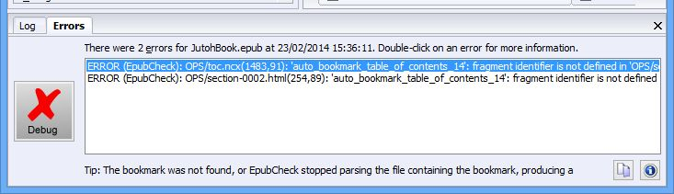
The Error Window
If you click on an error, you can see part of a tip underneath the list. To see more, click on the information button next to the message. For example:
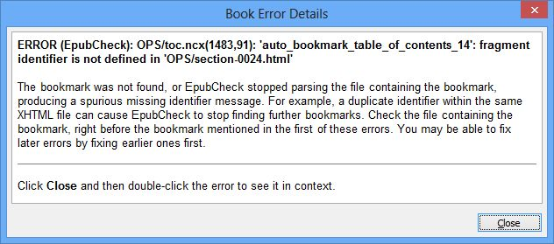
The Book Error Details dialog
As you can see, there is an error from EpubCheck, followed by a tip from Jutoh that explains more about how that error has arisen and how you might fix it.
To see exactly where the error is in the Epub file, click on the Debug button or double-click on an error message. You’ll see the Book Viewer window:
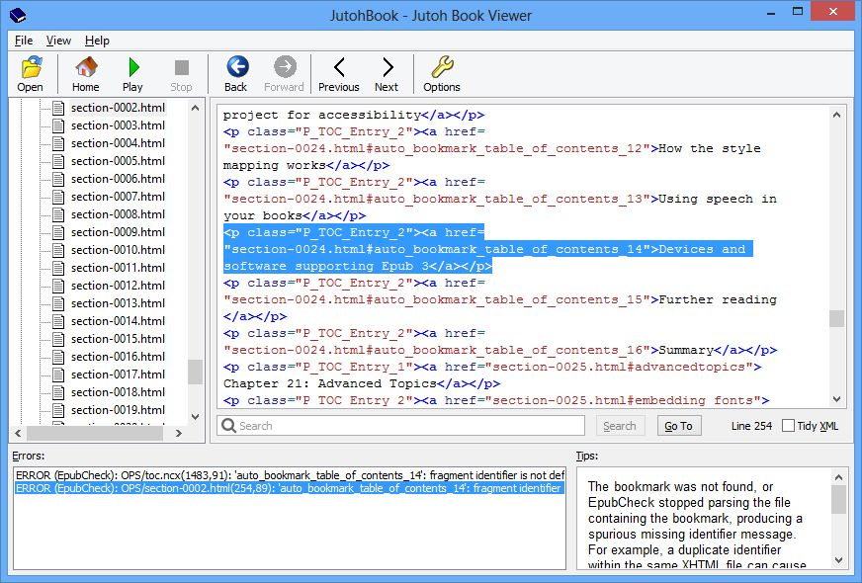
The Jutoh Book Viewer
This is a separate window (but still part of the Jutoh application) that displays the hierarchy of files inside your Epub, with a viewer for the XHTML and other files. The errors and tips are displayed at the bottom, and by clicking on each error, you can see the context of the problem and the relevant tip.
Incidentally, you don’t have to have errors in your book to examine your Epub file. At any time, so long as the Epub file exists, you can use the Book | Examine menu command (F6) to browse the Epub file. You can also use the File | Examine Epub command to examine an arbitrary Epub file that’s on your disk, even if it wasn’t created by Jutoh.
Now, you can’t actually edit the XML and XHTML source directly. You need to deduce the source of the error (such as a missing bookmark) and correct it in the Jutoh project, before running another check. The reason for this is that some information is lost when generating the Epub, and it wouldn’t be possible for Jutoh to precisely reconstruct that information from the generated and hand-edited XML and XHTML. But you should be able to get used to tracking down problems by examining the Epub files, for the small number of occasions that errors make it into the Epub and weren’t identified by earlier Jutoh error messages that lead you directly to the context. If you see errors from both Jutoh and EpubCheck, look at the Jutoh errors first since they show you where in the text they occur; fixing these may also fix the Epub errors.
These are some of the more common errors that can be flagged up by EpubCheck.
- Bad URL syntax (‘use of non-registered URI schema’). If you find something like <a href="doc:17">My Page</a> in the Epub, it means Jutoh couldn’t find the referenced page – it might have been deleted. So you can go back to the editor, and fix this link. In fact, Jutoh will also give you its own, more specific error message about this and will allow you to pinpoint the paragraph containing the bad link, so normally you can fix it without reference to the XHTML. Fix the earlier bad link error, and the XHTML problem will go away.
- Bad date (‘date value ... is not valid’). If you enter a date in the metadata that is not in the correct format, EpubCheck will warn you, giving details of what’s allowed.
- Unfinished element. This can happen if you miss out important metadata, such as the book title.
- File name contains non-ascii characters. Don’t put Unicode characters, for example Chinese characters, in an image file name (as specified in the Image Properties dialog).
You can apply Epub checking to Mobipocket configurations, since Jutoh generates Epub-like files before converting them to Mobipocket, but you will need to check Generate Epub in your Mobipocket configurations. Note that the generated Epub will initially have the same file name as that generated by your Epub configuration, so to avoid a clash, you may want to change the Book file name property in your Mobipocket configuration, to perhaps %FILENAME%_Mobipocket.
Note that checking a Mobipocket file can result in a lot of spurious ‘a’ tag (bookmark) errors because Jutoh optimizes the location of bookmarks in Mobipocket configurations in a way that EpubCheck doesn’t like. You can ignore these spurious errors. To labour the point, if both Epub and Mobipocket options are enabled within a configuration, then the Epub file generated by this configuration will be Mobipocket-oriented and therefore should only be used for checking purposes, and not delivered to customers.
The chances are high that if your Epub configuration passes the EpubCheck test, then files generated by your Mobipocket configuration will also be good, from a syntactic point of view at least. Also, Jutoh will catch most common errors, and the Kindlegen compiler will catch further fatal errors. So you may be content to use EpubCheck for your Epub configuration only.

Structural errors
Structural errors are overall problems with the project, some of which may be flagged by Jutoh at the end of the compile.
Here are some common structural errors.
- Missing bookmark (‘fragment identifier is not defined’). The first thing to try is simply regenerating the table of contents if you have used the advanced table of contents mode. Quite often, editing text can disrupt bookmarks, so try pressing F9 to update the table of contents and then compile and check again. So say you find the error is in XHTML containing the text <a href="section-0003.html#auto_bookmark_table_of_contents_1">Chapter 1</a>, you can look in Chapter 1 and see why the bookmark auto_bookmark_table_of_contents_1 doesn’t exist. In this case, regenerating the table of contents will put back this automatically-generated bookmark.
- Bookmark names change. If you’re using advanced table of contents generation, Jutoh will generate bookmarks such as auto_bookmark_table_of_contents_14. If you link to a bookmark, and then Jutoh renumbers it in a later table of contents recreation, your links may be wrong. To avoid this, edit the bookmark and rename it to something without the auto prefix. Jutoh will now use this bookmark instead of an automatic bookmark next time it regenerates the table of contents.
- Missing or displaced cover. If the cover for your Epub appears as an icon but not within the book, consider clearing the configuration option Exclude cover from reading order. The option suppresses the cover from appearing within the book content, to avoid the cover appearing twice, but on some platforms you may wish the cover to appear first instead of the title page. Note that Calibre has an unusual interpretation of exclusion from reading order and shows such sections at the end of the book; again, clearing the Exclude cover from reading order option will prevent this from happening. If your cover is still missing, it may be that the Cover design configuration option is not set to the correct cover design name.
- Missing Table of Contents. See whether the configuration property Use guide is checked in your configuration – if it’s not checked, some of the ‘Goto’ commands in a Kindle book won’t work.
- Section too long. Jutoh may complain about a section being more than 300Kb in length; this means that some Epub readers will fail to display the book correctly because they can’t cope with large sections. You will need to break this section up, perhaps by creating a hierarchy of subsections under one chapter.
- Unresolved URL. Jutoh complains about missing page link targets, which might happen if you link to a page that you later delete. When compiling ODT files, will also complain if you have a page link that does not reference a bookmark, since this is required for linear documents such as ODT files that are not composed of individual XHTML sections.
- Unresolved footnote or index entry. These errors are flagged by Jutoh after a compile, and usually mean that you forgot to use Book | Update to update the endnotes section or index section after adding index entries.
- Headings used improperly. This is part-formatting, part-structural – however if you don’t apply heading styles in a rational way (for example if you follow a ‘Heading 1’ with a ‘Heading 4’ instead of a ‘Heading 2’) then it will be hard for Jutoh to construct an advanced table of contents and navigation map that reflects the implicit structure of your book.
- An item in the navigation map doesn’t navigate to correct item on Kindle. Check in Project Properties/Indexes/Table of Contents that the link in question is pointing to a bookmark, and not just the relevant HTML file. Without bookmarks, the navmap can malfunction.
- An item in the table of contents points to the wrong part of a section. If there is an image at the beginning of a section, Jutoh may not be able to correctly place an automatic bookmark. Insert a bookmark manually before the image so Jutoh can use that, and rebuild the table of contents.
- Start page not working. You can specify the section that the ereader will initially open by setting the guide type to ‘text’ in the relevant section document properties. However, on Kindle, this can sometimes malfunction. If you send a .mobi file via email to your Kindle instead of directly via USB or via your own web site, and sometimes when you download a sample, the start page that you have set may not work. The reasons for this are unclear but it may be that Amazon are converting the file to a lowest-common-denominator format such as KF7, that does not support the ‘text’ guide type. The start page should still work for the full book from the Amazon web site or if you copy the book to the device directly.

Formatting errors
Some formatting problems are merely subjective aesthetic issues, and some will cause actual problems in your book.
I’m going to emphasize one particular issue before I list potential formatting problems, because this is crucial and sometimes hard to get across. The most common formatting mistake is using ad hoc styles throughout the document instead of planning ahead and creating styles for particular formatting needs, such as “Centred Picture”. Ad hoc styling (applying different attributes such bold, centre, font size and so on directly to your text without selecting a named style) makes it very hard to change formatting throughout your document later, it introduces amateurish-looking inconsistencies in the project, and it generally makes editing the book difficult. So, please plan ahead and have a set of named paragraph styles you use for each formatting situation, for example headings, pictures with captions, pictures without captions, emphasized paragraphs, first paragraph after a heading, subsequent paragraphs, book title text, and so on.
Here are some of the issues you might have surrounding formatting.
- Missing paragraph or character styles. Jutoh will tell you during book compilation if you have paragraphs or objects that use styles that are not in your style sheet. You might have deleted the original styles from your style sheet, for example, or you may have copied and pasted styles using an earlier version of Jutoh that didn’t copy the styles. If named styles are missing, you can choose another style from the drop-down style list in the editor, or you can recreate the style in the style sheet, in Project Properties. If automatic styles are missing, you can normally trigger their recreation by reapplying the styles either to the existing content, or to some dummy content that you subsequently delete.
- Overuse of ad hoc/automatic styles. Yes, I’m about to repeat the point I made above, in case you missed it! Jutoh won’t warn you about this, but if you have used a lot of ad hoc formatting either in the file you imported, or within Jutoh, you may find it very hard to get consistent formatting and to change the formatting later. Ad hoc styling leads to automatic styles (generated style names containing ‘+’ symbols) which have long names and make it hard to understand and improve document formatting. Create and use named styles whenever possible. In particular, use consistent heading styles that reflect the structure of your document – ‘Heading 1’, ‘Heading 2’ and so on – so that Jutoh can deduce a table of contents. You can use custom shortcuts and favourites or the Formatting Palette to make this quick and painless.
- Indentation doesn’t work. Don’t use spaces for indents, since they will be ignored; use named paragraph styles with indentation. Apply styles with the drop-down style control on the editor toolbar, or with Format | Styles, or via the context menu. For example, use the ‘Body Text First Indent’ style in the style sheet that Jutoh creates. Also, Mobipocket KF7 has poor indentation support (no right indent, and fixed indentation size) so it may simply be a limitation of the format.
- Paragraph spacing doesn’t work. Mobipocket KF7 doesn’t recognise spacing dimensions of less than 25 tenths of millimetre when the configuration option Use relative scaling is checked, so check the numbers in the style dialog, or clear Use relative scaling in your Mobipocket configuration. Also, check that the paragraph in question has a named (not automatic) style and then examine its style definition in Project Properties. It may have a base style that is providing some of the attributes, if those properties are not defined in the actual style. Another problem might be that you are using blank lines to space paragraphs out. Don’t do that! Use named styles with the appropriate after-paragraph and before-paragraph spacing. Occasional use of blank lines is permitted though, especially on the title page.
- Unexpected page break in large paragraphs. Some readers, including the Sony Reader, don’t cope elegantly with large paragraphs and break them early, leaving large amounts of space before the end of the page. This is related to ‘widows and orphans’ handling. You can try a combination of breaking up large paragraphs, and adding this custom CSS to the Jutoh project: body { widows:1; orphans:1; } (all on one line or on multiple lines, it doesn’t matter which). See Chapter 13: Working With Style Sheets (‘CSS customisation’) for how to add custom CSS to the style sheet file that Jutoh generates.
- Justification problems. In your paragraph styles, you can define left alignment, right-alignment, full justification, centering, or indeterminate alignment (leave it up to the reading software). Jutoh won’t display full justification in the editor, but it will appear in the ebook. Note that leaving alignment indeterminate may cause justification in some readers (such as Mobipocket) but ragged-left on others (such as Adobe Digital Editions).
- Paragraphs aren’t centred. iBooks has a bug (or feature?) that means centring can be ignored. You can fix this by checking Optimize for iBooks in your Epub configuration (it generates a span tag for each paragraph that causes centring to work).
- Multiple paragraphs per list item are all numbered or bulleted. You can create ‘continuation paragraphs’ by placing the text cursor to the right of a bullet, and pressing Backspace. The bullet will disappear and the paragraph will be a continuation of the previous item.
- Fonts don’t appear as expected. Ebook reader software has a limited range of fonts, and if you format your book with fonts that happen to be on your system, don’t expect this to be reflected in your book. Use a small range of fonts instead, such as Times New Roman, Courier New, and Arial or Helvetica. The ebook reader software will usually substitute something appropriate. Although you can embed fonts in your project, not all readers support it and you also need to make sure you have the legal right to distribute the font. If you change a font in Jutoh and then on loading, the font has reverted back to a previous font name, it is probably because Jutoh tries to use fonts that are likely to be present on your platform – so, for example, Helvetica may be changed to Arial when opening the project on Windows. If you want, you can specify a font substitution in your configuration using the Font substitutions property in order to use a particular font name in the finished ebook.
- Garbage characters appear. Some readers do not cope well with non-Western European languages, or need special consideration. First try setting the Language metadata field in Project Properties to the language used in the book, such as ‘hu’ for Hungarian. If that doesn’t work, you may need to consider embedding a Unicode font. See Embedding Fonts for more information. It’s also worth doing a quick search online for whether the reader software or hardware supports the language you’re writing in.
- Text size and fonts are inconsistent. Sometimes you may have hidden text formatting, where spans of text, or whole paragraphs, are formatted with ad hoc or named character styles in addition to the named paragraph style. So several paragraphs appear to have the same named style, and yet look different from one another. Often you can solve formatting problems like this by selecting the text and applying Format | Text | Reset Formatting to remove all formatting (except links).
- Paragraphs with the same indent or margin show different dimensions in the ebook. If the font sizes of the paragraph styles differ, because Jutoh uses relative units (em) to define margins, the same margin or other size can show up differently in the Epub or Mobipocket. Ems are relative to the paragraph style font, even if overridden by a character style. You can solve the problem by either applying a consistent paragraph style or styles with the same underlying font size, or in your Epub configuration, clearing the option Use relative dimensions and recompiling.
- Invisible text on a black background. If text disappears when you select white on black in your ebook reader, it means your text colour has been hard-coded to black. You can eliminate all of these occurrences using Document Cleanup (see below).
- Images are blurry. If you need most images to be compressed JPEGs, but you need some of them to be uncompressed to eliminate JPEG artefacts (for example, in line drawings or symbols), then insert GIFs from files and change Convert images to JPEG to ‘All except GIF’. Also, blurriness can be caused by scaling up from a small image, especially on a high resolution device such as an iPad. You can improve matters by pasting a higher-resolution image into Jutoh and specifying an absolute or percentage width in the image properties.
Jutoh has a way to help clean up project formatting documents – it’s the menu command Book | Document Cleanup, which will show you the following dialog:
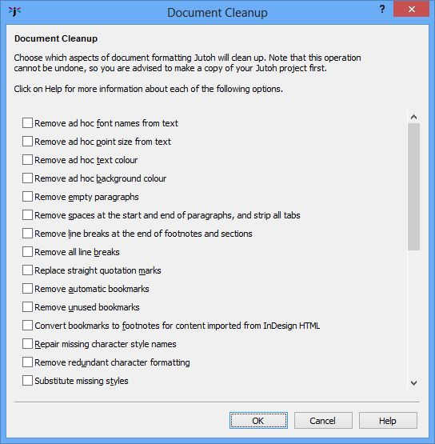
The Document Cleanup dialog
This will give you the option of removing erroneous spaces, ad hoc (automatic-style) font and size styling within spans of text, empty paragraphs, line breaks, and automatically-generated or unused bookmarks. It can also replace missing styles with specified ones, and convert blank lines to proper style-based spacing. Use this feature with caution since it can make a lot of changes to your project – back up your project first.
Another handy way of correcting styles is to use style find and replace, via the Edit | Find command, to do mass replacement of one style with another throughout your project.
You might want to use the Formatting Palette: show or hide it using the Format | Formatting Palette command or Alt+P. It gives you a list of styles to apply and makes it easy to see just what style has been applied at the current cursor position. It also has a tab listing all the favourite commands, styles and symbols that you have defined. For more on this, see Chapter 6: Editing and Formatting Content.

Content errors
Obviously there is a limit to what Jutoh can do about general content problems (writing style, typos, inaccuracies, and so on). However, there are a few features that can help:
- Use the spelling checker (Edit | Check Spelling).
- Print out a ‘linear’ version of your book to make proofreading easier. This is where Jutoh’s ability to write to ODT and (via OpenOffice.org) PDF comes in handy.
- If you own an ebook reader, create an ebook in that format for convenient reading even if it’s not the format you’re actually aiming for. For example, you may be creating an Epub book, but you can create a Mobipocket file for a Kindle reader if you have one.
- Add text notes under the ‘Scraps’ folder to record or plan edits.
Finally, it’s worth remembering that other people will usually be able to spot mistakes in your book much more easily than you can, so enlist the help of further pairs of eyes if you can.

Platform errors
Some publishing platforms have requirements over and above the usual ones, and can be picky about some style and content issues. We’ll look at several of the main platforms.

Smashwords errors
More general information about Smashwords can be found in Chapter 16: Understanding Ebook Formats and Platforms, so here we will confine ourselves to some of the errors that Smashwords might alert you to.
- Paragraph separation error. Smashwords doesn’t like you to have both paragraph spacing, and a first-line indent, so you can either modify the style you use, or (if you would like to maintain your current styles for non-Smashwords configurations), add a paragraph substitution in your configuration. For example, in the Paragraph style substitutions property for your ‘Smashwords ODT’ configuration, type the string ‘Body Text First Indent: Body Text’ (without quotations, of course). This will cause the Smashwords ODT file (only) to use non-indented paragraphs, assuming you have these styles defined and are using them.
- Misidentified publisher error. Check that your title page is as Smashwords wants it, in particular that you are using the same publisher name as defined in your Smashwords account. For example, ‘Published by Anthemion at Smashwords’.
- Copyright page error. You need to specify a copyright line in your title or copyright page, such as ‘Copyright Julian Smart 2011’.
- Can’t create a NavMap (NCX). Meatgrinder will look either for section headings starting with ‘Chapter’, or a linked table of contents. You can create an advanced table of contents using Jutoh and Meatgrinder will happily use that for its own table of contents and NavMap.
- EpubCheck failure. This may be a genuine error, but sometimes the whole Meatgrinder conversion process fails even when Jutoh is capable of creating perfect Epub files directly. You may have to wait until Smashwords fixes the bug, though you can try removing any complex formatting – lists seem to be a particular problem. Sometimes the bug is with EpubCheck itself. Unfortunately, without an EpubCheck pass, you won’t be able to submit your book to the Premium Catalog, which includes distribution by Sony and Apple.
- File too large. There is a Smashwords file limit of 5MB at the time of writing, so if your ebook is too large, consider reducing the quality of your images, or even deleting some. If your images are originally in a format other than JPEG (or were pasted from the clipboard), you can use the Image quality setting in your configuration, but if you inserted JPEG images, you will need to replace each image.

iBooks errors
When you submit your Epub for iBooks to the iTunes site, you may find the book is rejected even though the file doesn’t cause problems with other retailers. See also Chapter 16: Understanding Ebook Formats and Platforms.
- Images break across one or more pages. Make sure your images never exceed the size of the device display by checking the configuration option Limit images to viewer size.
- EpubCheck failure. Most errors that cause rejection from iTunes will be identified by running EpubCheck, which you can do by clicking on Check within Jutoh.

Lulu errors
- “Contains unmanifested files” error. If you check Optimize for iBooks in your Epub configuration (the default setting), it includes the file com.apple.ibooks.display-options.xml in the folder META-INF inside the Epub. So try clearing this setting in your configuration, to remove this file. Also check that iTunesMetadata.plist hasn't been added by iTunes – if so, compile the file again.

Import/export errors

Import errors
You may sometimes get unexpected results when importing into Jutoh. Here are some potential issues.
- Imperfect styles. Jutoh does its best to convert CSS (HTML styles) to Jutoh styles, but the two systems are very different and it cannot do a perfect job. So if you import from HTML, you may need to edit the styles, or replace them. Alternatively you can clear the option Import basic CSS from HTML/Epub, and have Jutoh use a small number of styles for headings and paragraphs.
- Unexpected automatic styles. When importing from DOCX or ODT, you may be surprised to find a lot of automatic styles in your document where they did not appear to be automatic when edited in your word processor. This is because the word processor may hide the fact you have applied ad hoc styling, and show you the ‘base’ style; Jutoh simply shows the automatic style names, and this can reveal an inconsistently formatted document. Ad hoc and inconsistent styles can also give rise to frustration when splitting the file in the New Project Wizard and creating an advanced table of contents, because it’s hard to specify how Jutoh will search for headings when they are formatted differently throughout the document. Some of this can be smoothed over by using wildcards (‘*’) to match against variants of a base style, but it’s always better to start with a clean, consistent document.
- Missing images. If images don’t make it from your DOCX or ODT file, Jutoh may not have been able to handle this particular image type. You will need to paste or insert the images separately. If you are importing from HTML, the images may not have been in the correct path as specified within the HTML. When importing from ODT, also export an HTML file using OpenOffice or LibreOffice, to the same folder that contains the ODT and with the same root name as the original file. For example, thing.odt should be exported as thing.html. GIF files will be written to the folder, and Jutoh will use these images when importing from ODT.
- Poor list formatting. Due to the differences between the way lists are represented in different formats, sometimes lists are less than perfect after import, for example containing erroneous bullet symbols or inconsistent indenting. Try selecting the list and re-applying a list style using the toolbar list buttons or Format | Bullets and Numbering. Also, try to ensure that the list items are formatted with a paragraph style with no indent, and delete any blank lines between list items.

Export errors
This is not really about Jutoh errors, so much as things that can go wrong in a chain of conversion starting with Jutoh output.
If you generate an ODT and wish to convert to, say, a Microsoft Word file, you can use OpenOffice.org or LibreOffice (an offshoot of OpenOffice.org) to convert it. However, the results can vary in quality depending on which version of the word processor you use, and what version of Word you choose to export to. If you have a copy of Word, you can experiment with what combination works best. In particular, if there are problems with list bullets, you can adjust the bullet font and Unicode symbol used for each kind of bullet, from the Options page on Jutoh’s Project Properties dialog.
It’s worth checking through a file exported by Jutoh and then converted to a different format before submitting to a distribution site such as Smashwords, to fix any errors such as the above. The majority of ebooks probably won’t encounter them anyway, particularly fiction books.

Expectation errors
While not exactly an error, this class of problem still causes head-scratching and support questions. If you come to Jutoh (and ebooks in general) with expectations of PDF-like complex layout, you will probably think there’s something wrong with the application when it refuses to import this kind of file. Because Epub and Mobipocket files are reflowable, they don’t tend to use absolute positioning and complex layouts. Likewise, Jutoh can’t import such files with much fidelity. If you have a book with elaborate layout, you will need to think about redesigning it to make use of simpler cues such as small images (such as ), indentation, colour, spacing, and pictures laid out simply.
If you want custom web-like features, this isn’t possible in Jutoh and indeed most ebook readers wouldn’t support it anyway. (Having said that, Jutoh Plus allows you edit HTML and JavaScript to create interactive ebooks if you have the necessary programming skills.)
It’s been my experience that users often want Jutoh to work in the particular way that their own favourite word processor works; customising shortcuts can help a bit there, but Jutoh is a specialist ebook creation tool and inevitably it works slightly differently than other applications. Your expectations, background, and the kind of book you will be creating with Jutoh can lead to quite different experiences with Jutoh but with a little use you should soon find it intuitive.

Third-party troubleshooting tools
We’ve mentioned the Epub checker, which will give you the assurance that you don’t have syntax errors in your books.
For previewing your Epub and Mobipocket files, you can download Adobe Digital Editions and Kindle for PC or Mac. They will become the default viewers when you click on Launch in Jutoh.
If you’re going to be creating Mobipocket books, another essential tool in your armoury is Kindle Previewer, which you can download for Windows and Mac from Amazon’s site. On Windows, you can get Jutoh to download and install Previewer automatically using Jutoh’s Setup Wizard available from the View menu. Previewer shows your book in an emulator for Kindle devices and also for the Kindle app running on the iPhone and iPad. There can be small differences in the display and navigation behaviour compared with Kindle for PC or Mac, plus you get to see what your book will look like on a much smaller screen, which might influence formatting decisions. On Windows, you can configure Kindle Previewer as a helper application (see Appendix B: Configuring Jutoh) so that when you click on Launch you have a choice of Default (Kindle for PC/Mac, if you have installed it) or Kindle Previewer. (Unfortunately this won’t work on Mac because Amazon haven’t yet implemented file name passing on this platform – but we can take credit for persuading Amazon to at least add it for the Windows version!)
You can install Nook and Kobo desktop applications to preview your Epubs though they don’t co-operate well with Jutoh and you’ll have to open books directly in these tools. In my view they’re pigs to use for local files, and are geared towards getting you to part with money for books in their catalogues. So you may be content to use Adobe Digital Editions to preview your work.
If you are distributing your book on Smashwords, the Meatgrinder application that runs when you submit the book may give you some information about the quality of formatting in your book.
Finally, of course, you can get a variety of ebook reader hardware as they’re getting ever cheaper, and test your files on these.
When using external reader applications alongside Jutoh, such as Kindle for PC, be aware that if the book is open in that application, Jutoh may not be able to create it again until you quit the book or close the application. Also, you should delete the book from the application’s library before launching it again because quite often you can end up looking at the old version of the book and wondering why nothing seems to have changed.

When all else fails
If you just can’t figure out what is going wrong with your book, do contact us (see the Support page for contact details), preferably sending your Jutoh project or a suitable sample and a detailed description of the problem. You never know, it might be a bug in Jutoh; in any case, we want to help you fix your problem if nothing in this chapter has helped. You can also join the anthemion-writingtools mailing list and raise the issue there. Don’t suffer in silence!

Summary
This chapter has armed you with the knowledge and tools to correct errors that you may encounter as you create your books. In the next chapter, we describe specific ebook formats and distribution platforms.

Chapter 23: Understanding Ebook Formats and Platforms
In the Introduction, we looked briefly at the ebook formats that Jutoh supports (either directly, such as Epub, or indirectly, such as PDF). In this chapter, we’ll go into more detail about these formats, and also describe the major distribution platforms that you may wish to use for selling your ebooks.

Formats

Epub
Epub is a free and open standard for reflowable ebooks, maintained by the International Digital Publishing Forum (IDPF). The most popular version of the standard is version 2, as used by all current Epub-based reader hardware and software, and a specification of version 3 is now available but implementations are not widely used in the real world. Version 3 adds more flexibility for absolute positioning, addition of sound and video, and web-like custom features using Javascript. Jutoh currently targets Epub version 2 and a subset of version 3 features.
An Epub file is basically a zip archive containing HTML content, metadata describing the book, and a navigation map describing the structure of the book. An Epub can be encrypted, but this depends on cooperation between a particular platform platform (such as iBooks) and the corresponding reader software. When you submit an ebook generated by Jutoh to an established publishing platform, the platform will deal with encryption issues.
Note that even though Epub is a standard, there are always quirks in the way ebook reader software and hardware implement the standard. Jutoh tries to smooth over these differences; for example, Jutoh’s iBooks optimization feature fixes problems with iBooks failing to honour centre alignment and image sizing.

Mobipocket
Mobipocket is a format purchased by Amazon to be used by Amazon’s Kindle hardware and software; now Amazon are the odd man out in being the only ebook player using a non-Epub format. However, Mobipocket is based on Epub and Amazon’s Kindlegen application (formerly Mobigen) takes a set of Epub-like files (including the OPF file) as input to generate Mobipocket as output.
The older variant of Mobipocket is called KF7, and the newer, more capable variant is called KF8. KF8 can handle fixed layout books and richer formatting. Most older Kindle devices can be upgraded to use KF8, but certain early devices are restricted to KF7. Jutoh generates HTML that is optimized for both KF7 and KF8, and then calls Kindlegen to create the Mobipocket file.
Mobipocket files have the .prc or .mobi extension.
We will talk more about the Kindle platform later in the chapter.

Adobe Portable Document Format (PDF)
PDF is a popular format for complex, fixed-layout documents, but is not ideal for devices with small screens and the ability to choose text size, which requires the ability to reflow the document. Jutoh can create OpenDocument Text (ODT) files which can then be turned into PDF, for example using the File | Export as PDF command in OpenOffice.org Writer or LibreOffice Writer. You can view the PDF in Adobe Acrobat Reader or Adobe Digital Editions (ADE). On Windows, you can force the document to be viewed in ADE by using Open With... in Windows Explorer’s context menu, or you can drag the document to ADE.
When displayed in Adobe Digital Editions, a PDF containing bookmarks will show a table of contents in the left-hand pane. Jutoh will generate styles with the required outline information if they are specified in the named styles, and then OpenOffice.org Writer or LibreOffice Writer will be able to save the bookmarks for the headings in the document. For this to work, you will need to make sure that ‘Heading 1’ has its outline set to 1, ‘Heading 2’ has an outline of 2, and so on. (And of course you will need to be using these styles in your project!) The outline setting can be found on the Indents & Spacing tab of the Jutoh style editor dialog. You can switch off outline output using the Use outline levels configuration property, for example if your document doesn’t use heading styles consistently and it would create a poor table of contents in Adobe Digital Editions. If your Jutoh styles don’t have outlines, you can achieve the same effect by using the Tools | Outline Numbering command in Open/LibreOffice to set numbering for your heading styles.
Jutoh outputs appropriate metadata to ODT files so that when you export to PDF, the title and author will appear in the left-hand pane in Adobe Digital Editions. If your cover design is on the first page of your ODT file, it will be used for the thumbnail in Adobe Digital Editions.
See also the next topic for creating headers and footers and a hyperlinked table of contents with page numbers for your PDF file.

OpenDocument Text (ODT)
OpenDocument Text is a word processor format that can be converted to many other formats such as Word and PDF, using for example the free OpenOffice.org suite, or LibreOffice which is an offshoot of the OpenOffice.org project. Note that Word itself tends to create more compact .doc files than does OpenOffice.org or LibreOffice, so you might want to re-save the file using Word if file size is an issue.
Before creating an ODT file, you might like to change the Paper size and margins in your configuration. You can also use the Mirror margins setting if you are creating a printed book, for example via Amazon’s CreateSpace service.
Jutoh doesn’t generate any headers or footers; to add page numbers to an ODT file generated by Jutoh, follow these steps in LibreOffice (OpenOffice.org doesn’t currently support the Format | Title Page command):
- Open the file in LibreOffice Writer.
- Mark the title page using Format | Title Page; enter 2 into Number of title pages (to skip the cover and title page) and choose Convert existing pages to title pages. Check Reset Page Numbering after title pages. Press OK.
- Choose Format | Choose Footer | Default. Click on the first available footer and choose Insert | Fields | Page Number.
- Select the page number field and centre it.
You can also add a header if you wish, perhaps containing the title of the book.
To add a table of contents with page numbers and not just links, follow these steps in OpenOffice.org Writer or LibreOffice Writer:
- Delete the Jutoh-generated table of contents.
- Click on Format | Indexes and Tables | Indexes and Tables to show the Insert Index/Table dialog.
- We need to associate heading styles used in the document with levels in the table of contents, similar to how Jutoh works when searching for headings to put in the table of contents. Check Additional Styles, and click the ‘...’ button. Assuming you are using ‘Heading 1’, ‘Heading 2’ and so on for headings in your document, click on each of these in the list and click on the >> button to position each at the appropriate point in the table: ‘Heading 1’ at position 1, ‘Heading 2’ at position 2, and so on. Press OK but don’t dismiss the Insert Index/Table dialog yet.
- Now we need to make the entries hyperlinked. Click on the Entries tab and in the Structure area, click in the box just before the E# button, then click Hyperlink. Click in the box just after the E and click on Hyperlink. This creates LS and LE marks (Link Start and Link End). Click All to apply this to all entries, and then click OK to dismiss the dialog.
- Right-click over the special ‘Table of Contents’ field that has been inserted in the document and choose Update Index/Table and you should find that a table of contents with page numbers appears.

MP3
Jutoh can output audio books in the form of MP3 files, using the operating system’s built-in text-to-speech engine or one of several other engines such as eSpeak. Obviously this is not going to be as good as a human reading the book, but it can be helpful in some circumstances, such as listening to a book when commuting. Also note that when using some voices, the generated MP3 files can’t be distributed commercially without permission from the original voice license-holder.
Creation of MP3 files requires an MP3 encoder; Jutoh uses the LAME encoder, as described in Appendix A: Installing Jutoh.

Platforms

Amazon Kindle
Kindle books account for maybe half of all ebooks sold, so it’s obviously important to be in the Kindle store. Fortunately, Amazon makes this very easy for the independent author or small publisher using their publishing tools, in the USA and UK (check for support in other countries). You can upload your Jutoh-generated Mobipocket file, and Amazon will encrypt it for you if you wish. One of the great things about supporting the Kindle platform is that your books can be read on most smartphones, tablets, PCs, and Macs as well as on Amazon’s Kindle hardware.
To create files suitable for processing by Kindlegen, Jutoh generates HTML, CSS and other files that are nearly identical to the ones used for Epub creation. However, the original Mobipocket format (KF7) is not quite as flexible as Epub and there are restrictions as well as features unique to Mobipocket. Jutoh proves the configuration option Optimize for Mobipocket which does the following:
- Within lists, there are no paragraph classes, only list item classes, since adding paragraph tags in lists breaks KF7 rendering.
- Multiple paragraphs in a list item are faked using line breaks.
- Link anchors are inserted before paragraphs, not within them, because a Mobipocket bug can cause styling loss if navigation causes only part of the paragraph to be visible.
Jutoh optimizes code so the book will look as good as possible on both older KF7 devices and newer devices supporting KF8. Where generated CSS code is different for each platform, Jutoh uses ‘media queries’ so the appropriate code is used on each platform. Jutoh may perform other tweaks in future releases. The Optimize for Mobipocket option is switched on by default for the initial Mobipocket configuration.
Although Jutoh takes care of most of the low-level Mobipocket/Kindle technical details, you may also wish to read Amazon’s guidelines for advice on presentation, image size, and so on:
s3.amazonaws.com/kindlegen/AmazonKindlePublishingGuidelines.pdf
It is possible to upload Epub files to Amazon instead of converting to Mobipocket first, but if you do, you may miss out on Jutoh’s Mobipocket optimizations, giving poor results on some devices. Also, it’s better to preview the Mobipocket file on your machine than to rely on Amazon’s conversion before previewing with ‘Look Inside’.

Paragraph spacing in Mobipocket
You may be wondering why there is no inter-paragraph spacing in your Mobipocket file on KF7 devices, even though you specified it in Jutoh.
When the configuration option Use relative dimensions is checked, Mobipocket rounds paragraph spacing (before or after) to the nearest ‘em’ unit, so for example 1.4em becomes 1em and 1.5em becomes 2em. In fact you specify spacing in tenths of a mm within Jutoh, which are then converted to em by multiplying by 0.02, so 25 tenths of a mm become 0.5em. From this you can see that 25 is the minimum value you should use to add spacing in a Mobipocket file, since anything less will be rounded to zero. It’s best to ensure that your Mobipocket configuration is using absolute dimensions (mm), by clearing the option Use relative dimensions.
Mobipocket does not honour line spacing, although this can be changed by the book end-user on some readers.
KF7 may also omit inter-paragraph spacing if there is a left indent.

Lists in Mobipocket
KF7 doesn’t support list type specification, so ordered lists can only have arabic numbering. Also, paragraph style specification will only work for the outer list level due to the paragraph tag not honouring paragraph margins. To work around this, Jutoh places the vertical margins (before and after paragraph spacing) on the list item tags for the first level only. Specifying the margins for nested items would cause space to be accumulated after closing list item tags.
Mobipocket lists don’t honour custom indentation specification so the defaults will be used.

Setting the start page
By default, the Kindle reader will choose a suitable page to associate with the Beginning menu item or button in the reader. However you can change this by changing the document guide type to ‘text’. To do this, right-click on a document in the project outline to show the Book Section Properties dialog. Select ‘text’ from the Guide type dropdown list. You can also use the keyword %STARTPAGE%, in which case Jutoh will substitute the value of the property Start page guide type in the current configuration. This allows you to use a start page appropriate to the target device depending on configuration. Press OK and compile the book again.

Indenting table of contents items
You may find that the table of contents page isn’t indenting items as you expect, when viewing the Mobipocket version of your ebook. This is because Mobipocket (KF7) implements first-line indent, but not full left indent (or hanging indents). The solution is to edit the paragraph styles for table of contents entries, such as ‘TOC Entry 2’, and give them first-line indents instead of full left indents. Go to Project Properties/Styles and in Indents & Spacing, set Left to 0 and Left (first line) to a non-zero indent value such as 120.
The downside of this is that long items that wrap will not be fully indented, but in most cases the items will fit and will appear indented.
Alternatively, you can adjust the Mobipocket configuration option Styles for indent fix, which converts matching paragraph styles to first-line indent instead of full left indent. The default setting is ‘TOC*’ which applies this change to all table of contents entry styles. You can clear this entry if you do not want to adjust any styles.

Multimedia and JavaScript in Kindle books
Although the Amazon Publishing Guidelines describe how to embed audio and video, it seems that they will currently not accept books containing multimedia and any existing books containing audio or video were submitted during an experimental beta phase. Locally downloaded Kindle books will have their multimedia blocked. This may change in future.
At the time of writing, JavaScript is not supported in Kindle books submitted via KDP.

Kindle book covers
When submitting a .mobi file to Amazon KDP, you are also required to submit a high-resolution version of your cover separately; so strictly speaking, you don’t need a cover in your .mobi file. You can set the Cover design configuration setting to ‘(none’). However when previewing it’s nice to see a cover and there is no harm in leaving a low-resolution cover in your .mobi file when you upload it.
You may be surprised that Kindle books don’t open on the cover. This is an Amazon decision and it’s not possible to force books to do this.

Checking your Kindle ebook
For automated checking, you can can check the Generate Epub option in your Mobipocket configuration so that Check can work on the Epub equivalent of the Mobipocket file (the formats share files and most formatting). Some Mobipocket-specific HTML will be included in this Epub so you may need to ignore a few of the errors, in particular those flagging up incorrectly positioned ‘a’ tags (bookmarks). If you are also generate Epub files, be sure to change the name of your file using the Book file name option in your ‘Mobipocket’ configuration, otherwise you will overwrite the file generated by the ‘Epub’ configuration, which will have different optimizations.
We recommend that you review your Kindle book in both Kindle for PC/Mac and Kindle Previewer. Kindle Previewer lets you set the current simulated device type. For checking how books will look on iOS, unfortunately you need an iOS device. However, checking on other simulated devices is usually good enough. See KB0118 in Jutoh help (‘How can I test my Epub and Kindle books?’) for more details.

iBooks
Apple’s Epub-based iBooks platform is administered through iTunes. Unfortunately, only the USA is supported at the time of writing, unless you are already set up to do business in the USA. Fortunately, you can use Smashwords and other aggregators to target iTunes, from any country. If you’re creating fixed layout books, first check that these will be accepted by an aggregator – quite often they’re not.
Epub files for iBooks need a little tweaking to perform well on iOS. Edit your Epub configuration(s) and check the Optimize for iBooks property. Jutoh will then apply a few small changes the next time the book is generated. These are:
- Font names are removed from styles (unless Generate font names is enabled).
- Dummy span tags are added to centered paragraphs, since otherwise the centering is lost in full justification mode.
- An image that is on its own in a paragraph, and has its size dimensions specified in its properties, is generated using a div that takes the dimensions of the image, and dimensions are removed from the image itself. This is because iBooks ignores width and height specifications in images, and using a parent div is a widely used workaround.
- If either Generate font names or Embed fonts is enabled, at the same time as Optimize for iBooks, Jutoh will generate a file called com.apple.ibooks.display-options.xml with specified-fonts set to true. This will tell iBooks to respect the fonts that are specified in the book; otherwise iBooks will choose standard fonts.
Please note that if the configuration option Exclude cover from reading order is checked, the cover image does not appear in the actual iBooks reader, only in the iBooks bookshelf.
Here are some of the recommendations Apple gives for creating Epub files for iBooks.
- Use guide types such as ‘toc’, ‘title-page’, ‘preface’, ‘other.back-cover’ and so on – use the Book Section Properties dialog, available by right-clicking on a document in the project outline and choosing Properties, or by using the Document | Document Properties, Shift+Alt+Enter, or Alt+Click.
- The first page displayed will be determined from the guide type in this order of preference: text, acknowledgements, dedication, epigraph, foreword, preface, other.intro. Override this with the other.reader-start-page guide type. You can also use the keyword %STARTPAGE%, in which case Jutoh will substitute the value of the property Start page guide type in the current configuration. This allows you to use a start page appropriate to the target device depending on configuration.
- For cover art, use TIF, JPEG, or PNG image using RGB colours and at least 600 pixels on the larger axis. So at least, say, 400x600. Don’t include pricing or a reference to the physical edition on the cover.
- Limit embedded images to 2 million pixels, and don’t use text in images if at all possible.
For further information, see the file iBookstoreAssetGuide.pdf available if you have an iTunes Connect account.

Barnes & Noble Nook
Barnes & Noble uses the Epub format for their range of Nook devices and apps; you can get your books on their site via Smashwords, or directly from their ‘PubIt!’ publication site at pubit.barnesandnoble.com. The PubIt! site contains formatting and submission guidelines. Nook readers are popular in the USA and came to the UK in late 2012. These are some of the guidelines mentioned on the PubIt! site:
- The page margins should be set at 30 pixels on the top and sides, with 20 pixels on the bottom. In Jutoh, these can be set in your configuration (for example, HTML left margin).
- Embedded fonts are allowed, but discouraged due to the extra size and licensing issues.
- A Title Page is mandatory.
- The Copyright page should show the ebook ISBN.
- Cover image sizes range between 500x600 to 600x730.
When generating for Nook, switch off Generate iBooks XML in your Epub configuration or the file may be rejected.
The Nook doesn’t honour the ‘text’ guide type and so it is not possible to specify the first page when the reader first opens the book.
Your ebook cover – when viewed inside the book – will have margins around it; this is due to the fact that the Nook controls the margins (although you switch between several sizes in the Nook settings).
The Barnes & Noble ‘Nook Kids’ fixed layout format is very non-standard, requires a non-disclosure agreement from Barnes & Noble, and is unlikely to be supported by Jutoh; but regular reflowable Epubs are fine on the Nook.
To test your files using the Nook Android app, use a file manager app to copy the Epub file to the Nook/My Documents folder on the memory card. The book will then appear when you next run the Nook app. On the PC version of Nook, go to My Stuff and then Add Item, and add your book.

Kobo
Kobo uses the Epub format; again, you can get your books on their site via Smashwords, or directly via the Kobo Writing Life site. Kobo has free apps for most smartphones, tablets and desktop operating systems, and sells its own ebook readers.
At the time of writing there are no known issues with Kobo’s Epub implementation that require special consideration. Conveniently, Kobo uses the same fixed layout Epub file format as used by Apple’s iBooks.
When generating for Nook, switch off Generate iBooks XML in your Epub configuration or the file may be rejected. It’s not clear whether the XML file can be included in iBooks-compatible fixed layout Kobo books.
It’s difficult to test ebooks with the desktop Kobo reader applications (on Mac or PC) since they don’t accept arbitrary files on your hard disk. However, the Android Kobo application has an option for importing local content, so once you have the file on your Android device (for example using file transfer, Dropbox, web site, or email), you can then view it using Kobo.

Diesel eBook Store
Diesel uses a variety of formats, including Mobipocket and Epub; you can get your books on their site via Smashwords. At the time of writing there are no known issues with Diesel’s Epub implementation that require special consideration.

Lulu
Lulu uses the Epub format and combines the advantages of print-on-demand with ebook publishing. There are a couple of considerations that we are currently aware of:
- You need to have more than one chapter in the book, or Lulu will complain about the table of contents.
- You should switch off Optimize for iBooks or Generate iBooks XML so that Lulu doesn’t complain about ‘unmanifested files’ – in iBooks mode, Jutoh adds the file com.apple.ibooks.display-options.xml in the folder META-INF inside the Epub. So try clearing this setting in your configuration, to remove this file. Also check that iTunesMetadata.plist hasn't been added by iTunes – if so, compile the file again.
- The author metadata needs to be output to Epub with opf:role set to ‘aut’, and the date metadata needs to have opf:event set to ‘publication’, or Lulu will compain. This is done automatically if they are not already set, but you can adjust these values using the ‘...’ buttons next to each item of metadata.

Sony Reader Store
Sony Reader Store uses the Epub format; you can get your books on their site via Smashwords. At the time of writing there are no known issues with Sony’s Epub implementation that require special consideration.

Smashwords
Smashwords is very popular with authors, especially as it has distribution deals with other major ebook platforms in addition to selling them directly from the Smashwords site in multiple formats. So if you want to be listed on sites that you can’t upload to on your own, and/or want to save yourself the hassle of submitting to multiple sites, this is great.
You submit a file in Microsoft Word format, so you need to do that extra conversion step in OpenOffice.org Writer or Microsoft Word after generating an OpenDocument file destined for Smashwords. Note that Microsoft Word creates a more compact file.
Smashwords will take your Word file and pass it through their ‘Meatgrinder’ program to convert it into the various formats supported by Smashwords (Epub, Mobipocket, HTML, PDF and more). The conversion is pretty good most of the time, but you may find that the output is not quite as good as if you generated the file directly using a program such as Jutoh.
When you create a Jutoh project, a ‘Smashwords OpenDocument’ configuration is added in addition to ‘OpenDocument’. The only difference between these is that the Smashwords variant has the Special index formatting and Special footnote formatting properties disabled, since Meatgrinder doesn’t like the special formatting associated with these options. So instead of using special fields, Jutoh will generate the index and footnote text in full.
There are two methods for helping Meatgrinder create a NavMap from the word processor document:
- Create a linked table of contents page, which Jutoh will do automatically, or you can build your own. Don’t use Word or OpenOffice’s automatic table of contents generation facility since Meatgrinder doesn’t like field codes.
- Start each section with the word ‘Chapter’.
Please see the Smashwords Style Guide at www.smashwords.com; Jutoh will help you conform to them but some aspects you will have to take care of yourself, such as careful use of text size, sparing use of empty space and consistent heading style usage. Much of what the Smashwords Style Guide says can be used when working with Jutoh, such as advice on use of indentation, paragraph spacing, images, and so on.
Recently, Smashwords has started allowing authors to upload Epub files. However, this is only used for delivery of the Epub format and you still need to upload Word files for the other formats.
See also Chapter 22: Troubleshooting Your Book for tips on dealing with Smashwords submission problems.

Your own web site
Of course, there’s nothing to stop you uploading Jutoh-generated files to your own web site using an FTP client such as FileZilla. If you’re making them available for free, there’s not much else to do except upload the files in different formats and add links to your web site. Or, you could simply link to the files on other platforms such as the Kindle store or Smashwords.
If you want to make your books commercially available, you could use a service such as Plimus, which will serve files up to your users after payment. The files won’t be encrypted, but you can add a paragraph to the title page to request that people do not redistribute the file; this should discourage some piracy. A little bit of piracy may actually be a good thing in spreading the word about your books, and in my opinion, there will always be a majority of law-abiding citizens prepared to pay! Besides, determined pirates will crack encryption or scan or retype books. And offering unencrypted books can be a selling point, since customers generally hate encryption and Digital Rights Management since it restricts how the product can be read and stored. If you’re determined to encrypt your books, simply use a store such as Kindle, Smashwords or iBooks.

Caveats about using multiple distribution platforms
You might think it was obvious that the more platforms you sell to, the better. However, there are some wrinkles. If one platform sells your book at a lower price than another, then you can find the other platform price-matching; so you effectively trigger a price war with yourself, hurting your margins. (On the other hand, if you want to sell a book for the smallest possible price on Amazon, you might use this to your advantage: have it available for free on other platforms, so Amazon price-matches.)
Also, if you use Smashwords to target Kindle, for example, you can’t then sell the identical edition on Amazon directly. Why would you want to do that? Well, Smashwords doesn’t always produce as good an ebook file as if you created it directly with a tool such as Jutoh, so you might want to handle some sites yourself, and have Smashwords distribute to the remaining ones.
If you want to take advantage of Amazon’s free ebook promotions, you need to sell it exclusively on Amazon – an annoying restriction, but the promotions can be very worthwhile for visibility and collecting reviews.

Summary
In this chapter, we’ve explored the differences between the major ebooks formats, and we’ve looked at the most significant distribution platforms, and their pros and cons. Next, we’ll try to give some general advice on how you might market your ebooks.

Chapter 24: Marketing Your Book
by Harriet Smart
Your book exists. You have toiled over it – now you need people to know about it. Easier said than done. There are a lot of people shouting and waving their books out there. How are people going to know about you and what you have written?

Step 1: Describe your book
Of course you know what your book is about. But can you describe the contents briefly and in an understandable and enticing way? Look at the blurbs on the back of printed books or the descriptions on Amazon and see how it is done.
Here’s one for a Young Adult novel by Michael Pryor:
“Aubrey Fitzwilliam is the son of a prominent ex-prime minister. He’s also brilliant at magic, but he’s stuck at military school. At least he has his best friend, George, there to back him up. George would follow Aubrey anywhere – and with Aubrey’s talent for thinking up daring schemes that will get them both in trouble, that’s no easy thing to do. At a royal hunting party, the boys discover a golem, a magical creature built to perform one task: to kill Prince Albert. Aubrey and George are hailed as heroes for foiling the murder attempt – but who sent the golem, and why? Aubrey is far too curious to let the authorities handle this one, and he and George start investigating...”
Here is one for Phil Rickman’s latest novel, The Bones of Avalon:
“It is 1560, and Elizabeth Tudor has been on the throne for a year. Dr John Dee, at 32 already acclaimed throughout Europe, is her astrologer and consultant in the hidden arts... a controversial appointment in these days of superstition and religious strife. Now the mild, bookish Dee has been sent to Glastonbury to find the missing bones of King Arthur, whose legacy was always so important to the Tudor line. With him – hardly the safest companion – is his friend and former student, Robert Dudley, a risk-taker, a wild card... and possibly the Queen’s secret lover. The famously mystical town is still mourning the gruesome execution of its Abbot, Richard Whiting. But why was the Abbot really killed? What is the secret held by the monks since the Abbey was founded by Joseph of Arimathea, uncle of Christ and guardian of the Holy Grail? The mission takes Dee to the tangled roots of English magic, into unexpected violence, necromantic darkness, the breathless stirring of first love... and the cold heart of a complex plot against Elizabeth.”
This is the Amazon description for a very famous self-help book:
“THE 7 HABITS OF HIGHLY EFFECTIVE PEOPLE is recognised as one of the most influential books ever written. In this seminal work, Stephen R. Covey presents a holistic, integrated, principle-centred approach for solving personal and professional problems. With penetrating insights and pointed anecdotes, Covey reveals a step-by-step pathway for living with fairness, integrity, honesty and human dignity – principles that give us the security to adapt to change, and the wisdom and power to take advantage of the opportunities that change creates. Translated into thirty-four languages and with phenomenal sales, THE 7 HABITS OF HIGHLY EFFECTIVE PEOPLE has been the key to the success of legions of business leaders and individuals the world over.”
And finally the description of a new biography of Georgette Heyer by Jennifer Kloester.
“Georgette Heyer remains an enduring international bestseller, read and loved by four generations of readers and extolled by today’s bestselling authors. Despite her enormous popularity she never gave an interview or appeared in public. Georgette Heyer wrote her first novel,The Black Moth, when she was seventeen in order to amuse her convalescent brother. It was published in 1921 to instant success and ninety years later it has never been out of print. A phenomenon even in her own lifetime, to this day she is the undisputed queen of regency romance. During ten years of research into Georgette Heyer’s life and writing, Jennifer Kloester has had unlimited access to Heyer’s notebooks and private papers and the Heyer family records, and exclusive access to several untapped archives of Heyer’s early letters. Engaging, authoritative and meticulously researched, Georgette Heyer: Biography of a Bestseller offers a comprehensive insight into the life and writing of a remarkable and ferociously private woman.”
All of these are between 150 and 190 words long and yet they all manage to say an awful lot about the book. They are little masterpieces of copywriting and you should strive to create a little masterpiece for your own book. It is not easy, but it is worth taking the time to do – because then you will have a ready-made and persuasive description of your book readily to hand.
When writing, try to remember what the reader is looking for and emphasise those elements. In the case of a novel you want to to suggest to them that this a good story with intriguing characters and lots of possibility for drama. You will notice that both the novel descriptions contain questions – the central meat of a drama is a question. Will the prince be able to save the princess? Will the heroine be able to overcome the obstacles and find the man of her dreams? Make sure you draw attention to the sexiest, shiniest parts of your novel: the glamorous setting, the dreadful things at stake or the potential for deep emotional involvement.
Non-fiction descriptions are a little more utilitarian but they are still in the business of making an offer the reader can’t refuse. They emphasise the authority of the writer and the unique angle that the book offers on a topic that is of general importance and interest. Notice how words like “offers” or “reveals” are used to suggest that the book is treasure-chest of useful and and authentic information.
One way to look at such descriptions is to imagine them as a slice from the beautiful cake that is your book. You are not telling them all the ingredients or how you laboured to mix them up, but merely presenting the overall effect. You want them to eat the whole cake, of course, so give them a slice that makes them hungry for more, in no more than 200 words.

Step 2: Be able to talk confidently about it
Writing your book description and studying other book descriptions is a very good way to see what it is that makes people interested in books, what excites them. You will have a much clearer idea of what your book is and who might be interested and indeed what is special about your book. The next thing to do is to refine that description even further – into a sentence or two you can use when you meet people and they ask about your book. The latest evidence suggests that word of mouth is one of the most important drivers of ebook sales. Word of mouth begins with a conversation, be it virtual or in real life. When people ask you what your book is about, you need to have an answer ready. Even better, have several answers ready to suit the sort of person you are talking to.
Never apologise for your book – be bold and talk it up. Share the passion you felt in writing it. Don’t say “Oh, it’s just a romance novel” say “It’s a love story inspired by a set of old letters I found in a thrift shop. It made me cry when I was writing it.” Don’t say: “It’s a rehash of some research I did on stress” – but “It’s a book about how you can manage your stress levels.”
Now I am not saying this is easy. It isn’t. Writers are naturally shy and retiring and like to hide behind a wall of comforting text. But to get people to know your book exists you have to have a pithy description at your finger tips.
Practice saying in private and aloud, “My book is about...” Refine what you say. Evolve it into a neat phrase that you can say as easily as your name.
Books and blogs on pitching and log-lines for the screenwriting industry have lots of helpful hints on expressing the idea of a thing in a succinct and appealing way.

Step 3: Find your Special Subject – be an expert or an enthusiast
The next question to ask yourself is: what is your area of unique knowledge and how is it connected to the book you have written?
Why is a special subject important? It gives you a voice: it is an excuse to speak, be it on an online forum, a blog, in the local newsletter, even to the person at the bus stop. You are no longer just someone with a book to sell. You are instead an interesting person who happens to have written a book which might be equally interesting.
How do you find your special subject? If you have written a collection of gluten-free bread recipes because you have a gluten allergy then it is easy to see you are well qualified to take gluten-free cooking as your special subject. Historical novelists have a head start here as they are usually deeply involved in historical research and have a burning interest in the past – that’s what drove them become historical novelist in the first place. They are often de facto experts.
However, sometimes it can be difficult to find your specialist subject. Perhaps you are writing contemporary fiction or a memoir and it doesn’t seem at all clear. Your subject seems too general. Don’t despair – ask yourself some more questions and try to tease out your special subject.
For example, look at the setting – does your work have a regional flavour? Is your romance set in France? Why did you choose France? Is it because you live there and know it well or because you love the very idea of France, all that style and elegance. If the first, think: “Living in France – all you need to know – notes from an expat” or if you don’t know France that well except through research and imagination, you can go the “I Heart France” route, and explore the style and culture of the country. Chances are that people who also love France in the same way may be interested in reading your wonderfully romantic love story set in their favourite country.
Both of these approaches give you plenty of angles for blogging, participating in relevant forums and generally getting the word out there.

Step 4: Build a platform
Get yourself known online. Gather a tribe. The word is that traditional publishers are making it a stipulation that newly signed authors already have a blog or are at least prepared to start one. Others are suggesting that their existing authors get onto Twitter. For an indie author an online presence of some description is even more essential.
The good news is that nowadays you don’t need an elaborate or expensive website with flashing graphics. In fact I would advise strongly against a static, classic web page that is difficult to maintain and update. What you need is a simple dynamic site where you can talk about your special subject and hopefully create some interest about your writing. Fortunately there are lots of free, very easy to use blogging platforms that make the process a whole lot less painful than it used to be.
These are the big three:
- www.wordpress.com
- www.blogger.com
- www.tumblr.com
The secret to successful blogging is to have frequently updated, quality content. It is hard work and it takes some time to pay off but it is also good writing practice. Preparation helps a lot so focus on your special subject and brainstorm out a list of topics for future blog posts. If there is something in the news that links to your special subject seize the moment and blog about it. Make sure each post you create is well tagged so that people can find it easily. And keep everything as fresh and interesting as possible – post videos, pictures and make podcasts just to keep everything lively. Have a blog roll of other blogs that connect to your special subject and engage and comment on those blogs. You will find this drives people back to your blog if your comments are relevant and not overly self-promotional. Make sure you have clear links to your books on the site so that if you have written a good piece, people can find out more about you and your writing easily – but again the key is to make the blog more about the content than the promotion. You can also create an author’s page on Facebook and invite your friends to become fans. There it is all about engagement with users.
Now you have a blog. Where do you find readers?
One place to look is on the book-lover forums – for example Kindle Boards, Amazon reader forums. Again the message here is do not over-promote – become part of the community. Share your own enthusiasm and participate in the conversations that are taking place. People are very turned off by relentless self-promotion. It pays to be discreet.
And then we have Twitter. Twitter gets a lot of flak. Its very name seems to suggest triviality but in fact it is a very useful tool in building an online presence. It is easy to find like-minded people supplying you with support and lots of information, especially about indie publishing and marketing. It is also a great book promotion tool if used correctly. Once again the advice is: be subtle. Do not go on and on about your book. Try to be interesting and supply interesting information related to your special subject. Find the people who are interested in your special subject and follow them.
There is still a role for traditional media in marketing your book, be it a local newspaper or a special interest magazine. They are looking for stories, but once again be creative. Find a hook and an angle that is fresh. Create a story from your special subject rather than pitching a piece about an indie-published novel.
Another area worth exploring is, can you do an event? Is there a tie-in with a local event that you can devise and pitch to the organisers? Would local societies be interested in hearing about your special subject? They may become willing readers if you give a good performance.
This is barely scratching the surface of what you can do. Often these things don’t cost money but they do cost time and imagination. Think laterally and be creative. Allow time to do the job properly and don’t be discouraged if it takes time. Overnight best sellers are black swans – exceptional events. But there is a lot you can do to help your beloved book along the way.

Further tips
Since ebooks don’t always have a page count that will be displayed alongside your book description, you might like to include one in your description so that people know they will be getting value for money. Use the book word count in the Document Properties dialog and divide by a reasonable word-per-page figure, say 600.
To avoid separating your book from the description(s) you write, you can store your book description, and perhaps a publicity plan, in a text document under the ‘Scraps’ folder in your project. This information won’t be included in your book.
You should consider getting an ISBN number for your book – this is necessary if you want to get on the premium Smashwords catalogue, for example. You can buy a block of ISBNs yourself or obtain some from Smashwords or other book distribution site.
Consider getting a small number of your books printed using low-cost print on demand and perhaps a service that will undertake cover design as well as organising printing. You can then use it as a sales tool, sending them to journalists and bloggers, selling them at events, and even donating them to your libraries to raise your profile.
Consider promotional give-aways. Giving your book away can be a very effective tool for getting publicity and reviews. On Amazon, you can give your book away for a few days, so long as your book isn’t for sale via a different retailer. Often a free book will rise to the top of the free book charts for a particular genre, giving it visibility that it may never have had before.
Make a little money from promoting Jutoh! You can sign up as an affiliate at www.bluesnap.com, and take a percentage for every copy of Jutoh that is sold as a result of visiting your site.

Essential reading
Marketing Your Book: An Author’s Guide, by Alison Baverstock
The Smashwords Book Marketing Guide, by Mark Coker
This book, Chapter 23: Understanding Ebook Formats and Platforms

Summary
We’ve covered some common-sense approaches to publicising yourself and your books. If you have further ideas, do write in and tell us so we can include them in a future edition of this book.
We’ve also come to the end of the book – I hope you enjoyed it; if so, do pass the book around to your friends and colleagues. If you don’t already have a copy of Jutoh, why not visit www.jutoh.com and give the demo a whirl. We support Windows, Mac and Linux, and one purchase is good for all platforms so you don’t have to worry about migrating to another operating system later. We’re also quick to respond to technical support requests, and even if you haven’t yet bought a copy of Jutoh, we’re happy to discuss your needs.
We wish you the best of luck in the exciting world of ebook publishing!

Glossary
Ad hoc styling
This is the application of a combination of individual attributes such as bold, centering and so on, to an existing span of text or paragraph without defining those attributes as part of a named style. The result of using ad hoc styling is the creation of automatic styles (uniquely-named styles) and, when used widely, problems in maintaining consistency or applying certain Jutoh features such as table of content creation that search for specific named styles. Minimize ad hoc styling by editing and applying existing named styles, and creating new ones. Ad hoc styling can also be referred to as ‘local’ or ‘direct’ styling.
Application
You can ‘appy’ styles to paragraphs, and text spans, and lists. This means giving your content some formatting attributes, such as centering or bold. It is best to apply named styles from the style sheet.
Asset
An ‘asset’ in Jutoh terminology is a fragment of HTML used either as a template to help Jutoh write a book section HTML file, or as some other part that is inserted into the template. Assets are associated both with individual documents, and with the project as a whole. A document’s assets can be edited using Format | Asset Editor, and the project assets via the Assets page in the Project Properties dialog. Most users will not need to edit assets. See the Jutoh Plus guide for more details.
Automatic style
An automatic style is a named character or paragraph style that Jutoh imports or generates when ad hoc styling is applied to a span of text or a paragraph. An automatic style contains one or more ‘+’ symbols. These styles are not usually shown in the style sheet because they are quietly maintained with each document in the project. You should minimize your use of automatic styles because it makes maintaining document consistency harder.
Character style
Named character styles are applied to spans of text within a paragraph. For example, the “URL” style is defined by default, and applies blue and underlining to text. You can view and edit character styles using Project Properties | Edit and clicking on Styles. Then click on Character styles in the drop-down box under the list of styles.
You can apply character styles by right-clicking on selected text, then choosing Styles | Character Styles in the context (popup) menu. You can also use keyboard shortcuts and the Favourites menu – see Customising the user interface.
Compiling
The process of creating (generating, building) an ebook from a Jutoh project.
Configuration
A configuration, in Jutoh terminology, is a group of properties that together determine how an ebook will be generated, including file format, maximum image size, style sheet to use, cover design to use, and so on. Initially, Jutoh has one configuration per format; however, you can create as many configurations as you wish. For example, you might have a general “Epub” configuration, and also an “iBooks Epub” configuration which contains iBooks-specific copyright information and cover design.
Context menu
A menu that is shown by right-clicking over a window (Windows and Linux) or control-clicking (on the Mac). A context menu can also be shown by pressing the context key if available on your keyboard. Notable context menus are those associated with the project outline, the content editor, and the formatting palette.
Dialog
A dialog is a window that appears after invoking a particular command; for example, the Project Properties dialog, or the Preferences dialog. Most, but not all, dialogs have to be dismissed before you can work with your project.
Document
A Jutoh project is comprised of documents; mostly you will be working with ‘book section documents’, perhaps one per chapter, one for the title page, another for acknowledgements, and so on. There are other kinds of document, such as the embedded font document, text document, image document, URL document and more, but most users will only create book section documents. If you have imported an existing file, Jutoh may have created all the documents you need. Otherwise, you can add more with the Documents toolbar button or commands on the Document menu. All documents in a project are stored in the same Jutoh project file.
Epub file
This is the industry-standard, open file format for ‘flowable’ ebooks; it uses XHTML for the content. EPUB is defined in detail at idpf.org. Version 2 of the standard is currently the most used, but version 3 is gradually being implemented. Jutoh can generate Epub 2, and some features of Epub 3. All ebook readers apart from Amazon’s Kindle can read Epub 2 files. Epub readers usually have quirks of their own, and so some optimization of Epub can be required for each platform.
Favourite
There are two kinds of favourite in Jutoh – the dominant meaning used in the documentation is favourite style, command or symbol, that can appear on the Favourites toolbar button or in the Favourites tab of the Formatting Palette. These are defined using the command View | Customize Shortcuts. The other, less used, meaning is a favourite project file as listed on the Favourites tab on the Organizer palette. When you open a project, it is added to these favourites for quick access later.
Keyboard shortcut
A key combination for applying a command or style, or inserting a symbol. There are two kinds of shortcut in Jutoh – primary shortcut (such as Ctrl+B) and secondary shortcut (such as Ctrl+. Ctrl+T). A secondary shortcut allows a greater number of shortcuts to be defined by using the Ctrl+. prefix.
Fixed layout ebook
A fixed layout ebook has a set number of pages and each page has a layout that cannot be altered by adjusting font size or other variables, in contrast with a reflowable ebook. A fixed layout book will be scaled to fit the display, and there may be flexibility about whether double-page spreads or single pages are displayed depending on device orientation. This style suits certain kinds of book such as children’s picture books, photography books, and comics. The main variants of fixed layout file format are Epub 3, Kindle KF8, and iBooks. Jutoh supports the creation of fixed layout books.
Metadata
The description of the book, such as title, author, publication date, and so on. Metadata is edited in the first tab of the Project Properties dialog.
Mobipocket file
This is the native file format for Amazon’s Kindle books, and uses the MOBI or PRC file extension. Mobipocket files are created either using Mobipocket Creator, or (in Jutoh’s case) using Amazon’s ‘kindlegen’ application, which takes a subset of the Epub format as input. The Mobipocket KF7 file format is not as capable as Epub, but Kindle is the single most popular ebook platform by some margin. The KF8 format supercedes the less capable KF7 format and is equivalent to Epub 2 in most respects.
ODT file
Short for OpenDocument Text file, this is the native format of OpenOffice.org which is a free download and can be used as a converter between Jutoh and other popular word processor file formats. Recent versions of Microsoft Word can also open ODT files. Jutoh’s recommended file import format is ODT, and Jutoh supports ODT book export.
Paragraph style
Named paragraph styles are applied to whole paragraphs, and are important in enforcing consistency throughout a project. For example, the Normal style is defined by default. You can view and edit paragraph styles using Book | Project Properties or Edit on the toolbar and clicking on Styles. You can apply paragraph styles using the drop-down list in the formatting toolbar, or by right-clicking on selected text, then choosing Styles styles in the context (popup) menu.
Reflowable ebook
A reflowable ebook does not have a fixed number of pages since pagination is dependent on display size and user customisations, such as font size and device orientation. Jutoh can create both reflowable and fixed layout ebooks.
Style sheet
Usually used to describe the Jutoh style sheet, a collection of paragraph, character and list style definitions. A Jutoh project can have multiple style sheets. Jutoh style sheets are only indirectly related to CSS sheets, and you cannot import from a CSS sheet. However you can export Jutoh style sheets for import into other projects.

Appendix A: Installing Jutoh
This appendix describes how to install Jutoh and associated third-party software on the main supported platforms.
Note that you can check for updates and install new versions using Check for Updates on the Help menu.

Installing on Windows
Jutoh
Download the setup file from www.jutoh.com/download.htm, and run the installation program. This will create a program group called Anthemion Jutoh x.y (or other name if you have chosen a different name). This folder can be accessed via the Start menu under Programs. The folder contains shortcuts to the program, ReadMe, and Uninstall program.
You can uninstall Jutoh either by double-clicking the Uninstall Jutoh icon in the Jutoh group, or by invoking the Windows Control Panel, double-clicking on Add/Remove Programs, and then choosing the Anthemion Jutoh item.
There is also a PortableApps version which you can download instead of using the setup file. The PortableApps installer uses a version of Jutoh that is not tied to the registry and so can be easily run off an external drive. (Jutoh also has its own way of running from external drives so if you have installed the regular version of Jutoh, you can use the Mobile Preferences dialog invoked via View | Mobile Preferences to install Jutoh onto an external drive.)
Kindlegen
You will need to download and install Amazon’s Kindlegen if you wish to create Mobipocket (Kindle) files.
In the Jutoh Preferences dialog under Helpers, or in the Setup Wizard, click on Help Me Install Kindlegen. Then, as per the instructions for Windows above, click on Download and Install to get Jutoh to perform the whole process automatically.
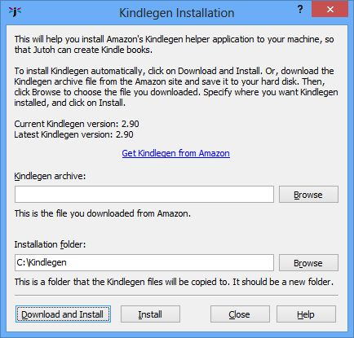
Kindlegen Installation dialog
If Download and Install doesn’t work for any reason, download the zip file manually, click Browse to set the location of the zip file, and click Install. If you wish to install Kindlegen manually instead, perform the following installation steps.
Download the zip file from www.amazon.com/kindlepublishing and unarchive it into a suitable folder, such as c:\Kindlegen. Then set the path of the kindlegen program in the Helpers page of the Preferences dialog. An example path might be c:\Kindlegen\kindlegen.exe.
If Kindlegen isn’t working within Jutoh, first check that the path in the Helpers dialog refers to a file that exists. If that’s not the problem, perhaps Java isn’t installed. Go to www.java.com and download and install Java.
eSpeak
If you wish to encode MP3 files with the eSpeak text-to-speech system instead of using the built-in SAPI voices, you can download the installer from espeak.sourceforge.net/download.html and run it. Then configure Jutoh for using eSpeak in the Speech tab of the Jutoh Preferences dialog.
LAME
If you wish to encode MP3 files, you will also need the LAME MP3 encoder. Download it from lame.sourceforge.net/links.php#Binaries and set the full path of the LAME executable (lame.exe) in the MP3 tab of the Jutoh Preferences dialog.

Installing on Mac OS X
Jutoh
Download the Mac version of Jutoh from from www.jutoh.com/download.htm, and open the Jutoh-x.y.img file. The disk image will be mounted automatically, and you can then copy the Jutoh folder to a suitable place on your hard disk such as the Applications folder. You can drag the Jutoh icon to the dock for quick access.
You can uninstall Jutoh by simply dragging its folder to the trash can.
The first time you run Jutoh, you may need to control-click and select Open, to stop Mac OS X trying to protect you from an unknown program. For details, please see www.jutoh.com/macinstall.htm.
Kindlegen
You will need to download and install Amazon’s Kindlegen if you wish to create Mobipocket (Kindle) files.
In the Jutoh Preferences dialog under Helpers, or in the Setup Wizard, click on Help Me Install Kindlegen. Then, as per the instructions for Windows above, click on Download and Install to get Jutoh to perform the whole process automatically.
To install Kindlegen manually, download it from www.amazon.com/kindlepublishing; at the time of writing it is bundled as a zip file, which you can unarchive to any suitable folder such as /Applications/Kindlegen. Then set the path of the kindlegen program in Jutoh’s Preferences dialog, under Helpers. For example, the path might be /Applications/Kindlegen/kindlegen.
If Kindlegen isn’t working within Jutoh, first check that the path in the Helpers dialog refers to a file that exists. If that’s not the problem, perhaps Java isn’t installed. You can check this by opening a terminal window and typing java. If there’s an error message that indicates that the command is not found, go to www.java.com and download and install Java.
eSpeak
If you wish to encode MP3 files with the eSpeak text-to-speech system instead of using the built-in Apple Speech Manager voices, you can download the zip file from espeak.sourceforge.net/download.html. Once you’ve unzipped the files, you need to copy the espeak-data files to either your home directory, or to /usr/share. So assuming you downloaded the zip file to, say, /tmp, you might then do this in a terminal window:
cd /tmp
unzip espeak-1.37.zip
cp -r espeak-1.37 /Applications/espeak-1.37
cp -r espeak-1.37/espeak-data ~/espeak-data
# Clean up
rm -f -r espeak-1.37
rm espeak-1.37.zip
Now you can configure Jutoh in Speech Preferences to use the binary file /Applications/espeak-1.37/speak.
LAME
If you wish to encode MP3 files, you will also need the LAME MP3 encoder. You can get a package file containing LAME for Mac from the Thalictrum web site, at www.thalictrum.com/index.php?pageid=2.
Run the .pkg file that appears on the desktop. The lame command will now be available, and you need to set /usr/local/bin/lame as the executable in the Jutoh MP3 Preferences page.

Installing on Linux
Jutoh
Download a suitable file from from www.jutoh.com/download.htm. There are versions for several methods of installation (tarball, Debian package and RPM), and also 32-bit and 64-bit variants.
If you are using a Debian or Ubuntu-derived version of Linux, you can use the .deb archive. If you are using Fedora, Mandriva, SuSE Linux, PCLinuxOS, you can use the .rpm archive.
To install the generic tarball version, unarchive Jutoh-x.y-i386.tar.gz to a temporary location, such as /tmp. Then run the script installjutoh and follow the instructions. This will copy the application files and launch script jutoh2 to locations of your choice. If you want to install it system-wide, log in as root first or use sudo. So you would type something like:
cd /tmp
tar xvfz ~/Downloads/Jutoh-2.10-i386.tar.gz
sudo ./installjutoh
To install the .deb version, use a command like this:
sudo dpkg -i jutoh_2.10-i386.deb
To install the .rpm version, use a command like this:
sudo rpm -i jutoh-2.10_i386.rpm
Now you should be able to run Jutoh with an icon installed in the desktop environment’s menu, or by running jutoh2 from a terminal.
You can uninstall Jutoh by running uninstalljutohx.yz if you used the tarball installation, or dpkg -r jutoh2 for the Debian installation, or rpm -e jutoh2 for the RPM installation.
If you need to invoke Jutoh directly (without using the launcher script), either launch them from the appropriate application directory or set the environment variable JUTOHDIR to the respective application directory.
On rare occasions, Jutoh may crash on startup if there is a conflict with the current KDE or Gnome desktop theme. Changing the theme should make the problem go away.
Kindlegen
You will need to download and install Amazon’s Kindlegen if you wish to create Mobipocket (Kindle) files.
In the Jutoh Preferences dialog under Helpers, or in the Setup Wizard, click on Help Me Install Kindlegen. Then, as per the instructions for Windows above, click on Download and Install to get Jutoh to perform the whole process automatically.
To install Kindlegen manually, download it from www.amazon.com/kindlepublishing; at the time of writing it is bundled as a gzipped tar file, which you can unarchive to any suitable folder such as ~/Kindlegen. For example:
mkdir ~/Kindlegen
cd ~/Kindlegen
tar xvfz ~/Downloads/kindlegen_linux_2.6_i386_v1.2.tar.gz
Then set the path of the kindlegen program in Jutoh’s Preferences dialog, under Helpers. For example, the path might be /home/fredbloggs/Kindlegen/kindlegen.
If Kindlegen isn’t working within Jutoh, first check that the path in the Helpers dialog refers to a file that exists. If that’s not the problem, perhaps Java isn’t installed. You can check this by opening a terminal window and typing java. If there’s an error message that indicates that the command is not found, go to www.java.com and download and install Java.
eSpeak
If you wish to encode MP3 files with the eSpeak text-to-speech system instead of using the built-in SAPI voices, you can download the installer from espeak.sourceforge.net/download.html and run it. Then configure Jutoh for using eSpeak in the Speech tab of the Jutoh Preferences dialog.
LAME
If you wish to encode MP3 files, you will also need the LAME MP3 encoder. You can get and install LAME using your favourite package management software. For example:
sudo apt-get install lame
Or, you can get a binary or the source code from lame.sourceforge.net.
After installing, the lame command will now be available, and you just need to set lame (no full path required) as the executable in the Jutoh MP3 Preferences page.

How to use Jutoh with an external drive

Overview
Jutoh helps you access your data on a mobile drive such as a USB flash memory drive. You can also run Jutoh from a mobile drive, so that all Jutoh settings are stored on the drive and not on the computer. This is convenient if you will be writing on multiple machines – perhaps home and work – and you don’t want to install Jutoh permanently on any one machine.
Note: mobile drives are easily lost and they can fail, so please remember to back up your files regularly to another disk.
These are the different combinations that are possible:
- Not mobile: running Jutoh from your computer as normal, storing files on your hard drive. Application settings, such as templates, icons, window sizes, and registration information, are also stored on your computer.
- Data mobile: running Jutoh from your computer as normal, but storing your project files on a mobile drive. Application settings are stored on your computer.
- Settings mobile: running Jutoh from your computer, but storing Jutoh’s settings on a mobile drive.
- Fully mobile: running Jutoh from the mobile drive, and storing your files and applications settings on the mobile drive.
In scenarios (2), (3) and (4), you can use your data on different computers and different types of computer. You can be working on a Mac one day, a Linux machine the next, and Windows the day after that. (Of course, you can still do this with (1) but it will be more awkward to copy files between machines.)
With scenario (4) – ‘fully mobile’ – you can store the Jutoh application and its data files on the mobile drive, as well as your own projects. Jutoh can install itself onto the mobile drive, for Windows, Linux and Mac operation, and no components of Jutoh will need to be stored on the computer’s hard drive.
In the next section, we’ll see how to use a mobile drive for storing just your data.

Using a mobile drive for data
Jutoh can use the current mobile drive when loading project files.
To have Jutoh prompt you for a drive name when starting, go to the Mobile Preferences dialog, select or type a mobile drive name, and check Store your data on the external drive. If you want the drive name to be stored between sessions, check Remember between sessions, but it is recommended that you don’t check this in case the drive letter or name changes (especially when using different computers).
Jutoh stores documents in the Documents folder on the mobile drive, by default.
You may be wondering how Jutoh opens recently edited files, if the drive name and even the operating system changes between Jutoh sessions. Jutoh does this by saving the last known external drive when it quits, so when it runs again, it can convert the old file names to new ones if it turns out that they were relative to the external drive.

Using a mobile drive for settings
If you use the mobile drive for storing settings, you can keep important information mobile such as your registration key, auto-replace customisation, cover design templates, and other data that Jutoh makes use of. This is independent of your own project files.
Go to the Mobile Preferences dialog, and in the Portable Settings section, check Store all settings on an external drive. You will be asked to restart the program. When Jutoh runs again, you will be prompted for a drive, and any new settings will be stored on that drive. Your registration information will be copied to the drive, but no other settings will be copied. The new settings will be stored in folder Application Data/Jutoh on the external drive. If you wish to copy previous setings, see Jutoh files for where to find the old settings.

Running Jutoh from a mobile drive
The most portable method of using Jutoh is to install the software on the mobile drive. If you do this, all settings will also be stored on the drive, as described in the previous section.
To install Jutoh to a mobile drive, go to the Mobile Preferences dialog and click Install Jutoh on External Drive. You will be presented with the Mobile Installation Wizard which will take you through the necessary steps. You can install Jutoh from the web, from the version you’re currently running, or from zip files you downloaded earlier.
You can install Jutoh for different operating systems, and they will all share the same application data files. The Windows version of the software is installed to Applications/Jutoh/Windows/Jutoh x.yz, and other platforms are installed to similar paths but with an appropriate platform name in place of Windows.

Launching Jutoh on Windows
If you installed the Windows version from a Windows computer, a shortcut will appear on the mobile drive top-level folder. You can double-click that from Explorer to get started.

Launching Jutoh on Linux
The Linux version has a launcher script called jutoh-linux which uses a relative path to the actual binary, so when using it your current directory should be the drive itself.
You may find that you don’t have execute permission on the external drive, particularly if the drive is formatted with a Windows file system such as FAT32. In this case, you need to mount the drive with different options, and you can do that by editing the file /etc/fstab as root. You should add a line that tells the system to use special options. Here’s an example:
/dev/sdb1 /media/usbdisk vfat rw,shortname=mixed,uid=1000,gid=1000,user,auto,exec 0 0
To find out the device name and mount point (the first two entries in this file), insert your drive and when automounted, type mount in a terminal window. You should see an entry for the external drive. The exec option causes all files on the drive to be seen as executable, and auto causes the drive to be mounted automatically when the device is inserted.

Launching Jutoh on Mac
On Mac, there is no alias, so you need to navigate to the Applications/Jutoh/Mac/Jutoh x.yz folder and launch it from there.

Appendix B: Configuring Jutoh
There are many ways to configure Jutoh to suit your use of it, whether it’s telling Jutoh how to launch helper applications, or changing behaviour such as automatically checking Epub files after creation. We’ll describe the most important configuration options here, and you can find more by exploring the pages of the Preferences dialog.

Viewer applications
A ‘viewer application’ is simply third-party software that can display an ebook file that Jutoh creates. Examples include Adobe Digital Editions, Kindle for PC, and Kindle Previewer. If an application knows how to open a file that’s passed to it, then Jutoh can run the application passing it the ebook file name, and the file will be shown in the helper application. You can set Jutoh up to know about as many viewer applications per file type (such as Epub) as you like. If you do this, Jutoh will show you a menu of available applications when you click on Launch after compiling an ebook. You can configure the applications using the Helpers page in the Preferences dialog, shown below:
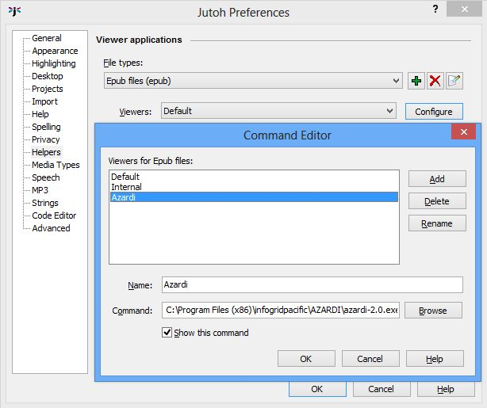
Configuring commands for Epub
Here, we selected Epub files (epub) and clicked on Configure. To add a new application, click on Add and enter the application name and full command path. The Default application is always present and means, run the application currently associated with this file type by the operating system. If only one application is defined for a file type, then a menu will not be shown when launching the application for that file type.
The following screenshot illustrates what happens when a Mobipocket helper for Kindle Previewer has been defined for Kindle Previewer, and the user clicks on Launch. The default viewer is Kindle for PC, so the user has a choice between running Kindle for PC or Kindle Previewer for the current Mobipocket configuration.
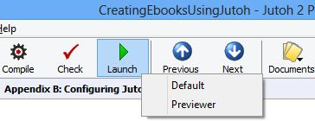
Clicking Launch with several viewer applications defined
Note that this mechanism relies on applications accepting file names on the command line; most do, but a few don’t, such as the Nook viewer, and in these cases you will need to use the application’s user interface to view the book. (You’ll be glad to know that we persuaded Amazon to add command-line file name handling to Kindle Previewer – if only on Windows!)

Conversion and checking applications
Jutoh uses a number of third-party applications to help it create and check books. The two Epub checker commands are already configured, but if you wish to create Mobipocket files, you will need to configure Kindlegen. These commands are specified in the Helpers page of the Preferences dialog.
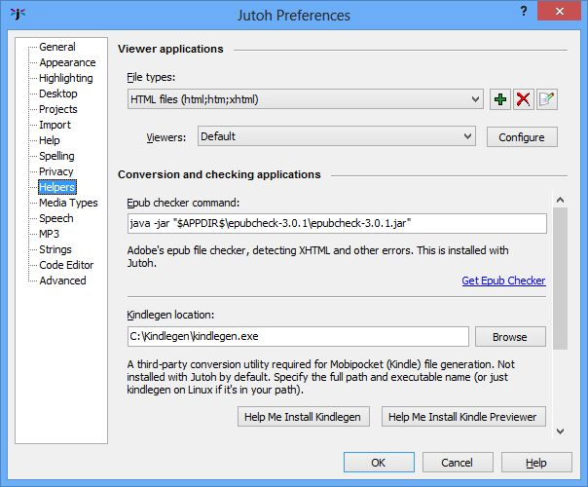
Configuring Jutoh helper applications
When configuring the Java checker applications, you can use $APPDIR$ to denote the folder in which the Jutoh application is found. You need to specify a full Java command, such as:
java -jar "$APPDIR$\epubcheck-1.1\epubcheck-1.1.jar"
For the Kindlegen compiler, specify the full path of the Kindlegen executable on Windows and Mac, and just kindlegen on Linux. If you’re not sure how to install or configure Kindlegen, you can click on Help Me Install Kindlegen in the Preferences dialog under Helpers, or in the Setup Wizard. The Kindlegen Installation dialog will help you either download and install Kindlegen, or install Kindlegen from a manually downloaded Kindlegen archive. On Windows, the Setup Wizard will also help you download, install and configure Kindle Previewer for Jutoh – which is much easier than doing it by hand!

Text-to-speech configuration
If you wish to generate speech files using Jutoh, you can select a text-to-speech engine in the Speech page of the Preferences dialog. Normally you choose Microsoft SAPI on Windows and the Apple Speech Manager on Mac, but you can also choose the Cepstral engine if you have a Cepstral voice installed, and eSpeak is another option. On Linux, only Cepstral and eSpeak are available. In the Speech page, you can choose and test the voice to use.
To configure the MP3 encoder, use the MP3 page of the Preferences dialog and choose the location of the LAME executable.
See also Appending A: Installing Jutoh for how to install eSpeak and LAME.

Customising shortcuts and favourites
Shortcuts and favourites give you quick ways to to execute commands, apply styles and insert symbols. This can save you from a lot of tedious mousing and clicking, especially when tidying up formatting in a long document.

Shortcuts
Jutoh allows you to customise the keyboard shortcuts used for:
- applying commands that you can find in the menubar;
- applying named paragraph and character styles to the current paragraph or selection; and
- inserting symbols or text into the active editor.
Jutoh defines two kinds of shorcut: primary and secondary.
A primary shortcut is a shortcut that you type directly, such as Ctrl+O to open a project file.
Because primary shortcuts are in short supply, you can also define secondary shortcuts that are prefixed with a primary shortcut. Jutoh defines Ctrl+Period to be the prefix for secondary shortcuts. So, for example, if you defined the secondary style shortcut Ctrl+1 for “Heading 1”, you would type Ctrl+Period Ctrl+1 to apply that style.
When you type the prefix shortcut, Jutoh shows a little window called the Secondary Shortcut Window.
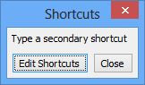
The Secondary Shortcut Window
Now you can type a secondary shortcut and the window will disappear after the command is executed; or you can click on Edit Shortcuts to customise shortcuts. This will show the Shortcut Customisation dialog, from which you can view existing shortcuts, edit individual ones, or reset all shortcuts to their default values.
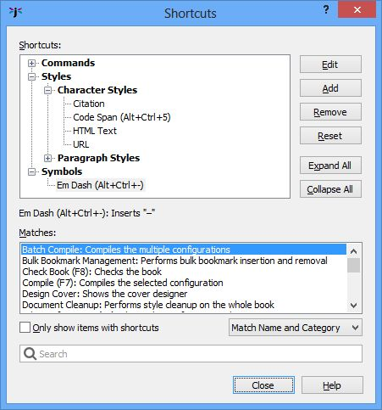
The Shortcut Customisation dialog
When you edit shortcuts, you’ll see all the named paragraph and character styles for the currently-selected project (excluding automatic styles). If you make changes to the shortcuts for these styles, they will be saved with the project. In contrast, command and symbol shortcuts are global.
All available commands and styles (whether they have associated shortcuts or not) appear in the shortcut customisation dialog, so you don’t need to add these. However you need to add any symbol shortcuts that you need with the Add button. By default, there are no symbol shortcuts defined.
When you click on Add or Edit, the Edit Shortcut dialog is shown, as pictured below:
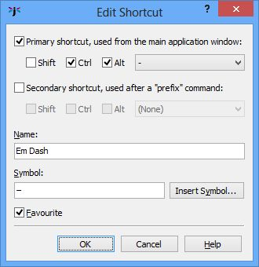
The Shortcut Editor dialog
You can specify the primary and/or secondary shortcut key combinations, and whether the shortcut should appear on the Favourites menu (see below). If the shortcut is a symbol shortcut, for inserting one or more text characters, you can also type the text in the Symbol field, or select it from a grid of Unicode symbols by clicking Insert Symbol.
Global shortcuts are saved to the file shortcuts.dat in the application settings folder (see Jutoh Files for details), so another way of resetting command shortcuts is to delete this file before running Jutoh.

Favourites
Another way to save time is to enable the Favourites button on the editor toolbar (right-click on the toolbar and select Customise, or use the View | Customise Toolbars command and select the Text Section toolbar).
Now click on the Favourites button; you will be asked if you want to edit the favourites. If you answer Yes, you will be shown the shortcut editor. Select a command, style or symbol that you want to be on your list of favourites, and check the Favourite control. Press OK to dismiss all dialogs and click on Favourites . You will now be shown a menu containing the commands, styles and symbols you chose, as follows:
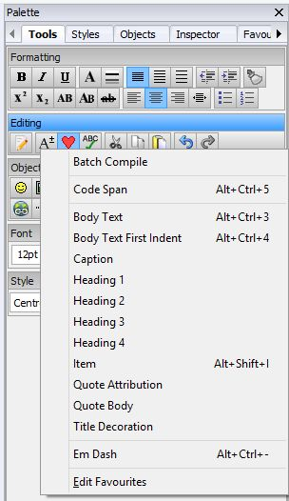
The Favourites menu
In this example, you can see that we have a command (Batch Compile), a character style (Code Span), several paragraph styles, and a symbol shortcut (Em Dash). Any primary shortcuts are displayed next to the item names.
You can also view and use favourite shortcuts in the Favourites tab of the Formatting Palette:
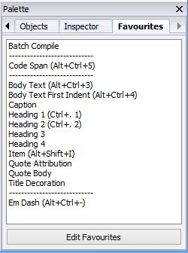
The Favourites tab in the Formatting Palette

Customising toolbars
Most of the toolbars in Jutoh can be customised; that is, tools can be switched on or off, and in the case of the main toolbar, the text labels can be switched on or off. You can use View | Customise Toolbars to view the Customise Toolbar dialog:
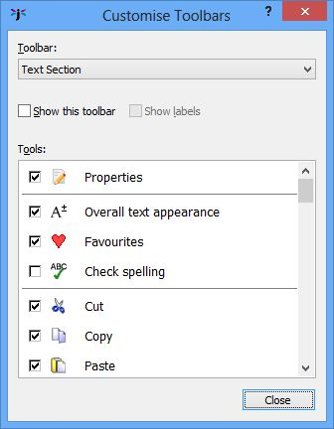
The Customise Toolbars dialog
Select the toolbar to customise using the drop-down Toolbar control. Then click on the checkbox next to each tool name to enable or disable that tool. You can’t change the ordering of tools; separators will be removed automatically if a whole group of tools is disabled.
Another way of showing the Customise Toolbars dialog is to right-click on a toolbar and select Customise from the context menu. It will select the appropriate toolbar.

Customising auto-replace
Auto-replace allows you to type text and have it replaced by a different symbol or sequence of symbols. To edit auto-replace items, use the View | Auto-Replace Preferences command. The Auto-Replace Preferences dialog has two tabs: one called Replace with general textual replacement options, and one called Custom Quotes.
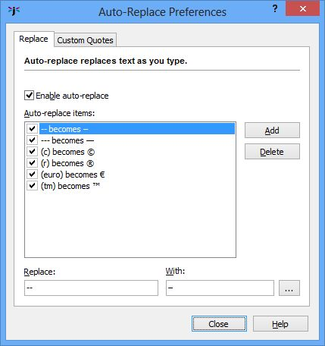
The Auto-Replace Preferences dialog
To add an auto-replace item, click Add and enter the Replace and With text. Click on the “...” button to use a symbol selection dialog that shows all the possible Unicode characters.
Auto-replace works when you have entered the target text and then a space (or punctuation followed by a space). Jutoh will search back and see whether the text matches any in its list, and if so, replaces it with the appropriate text. For example, typing (c) will insert the symbol ©.
Replacing quotation marks is a special case and has its own tab:
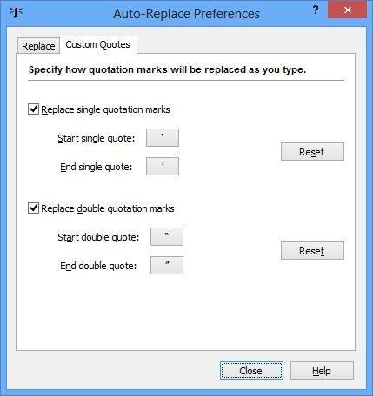
The Custom Quotes tab
This dialog specifies how single quotation marks and double quotation marks are replaced when you type the standard quotation marks with the keyboard. Jutoh recognises whether the mark is at the start or end of the text. Click on the buttons to select the symbol that will be used in each case, using the symbol selection dialog. You can use the Reset buttons to revert the values to their original settings.

Appearance options
You can adjust various settings relating to Jutoh’s appearance using the Appearance page in the Preferences dialog:
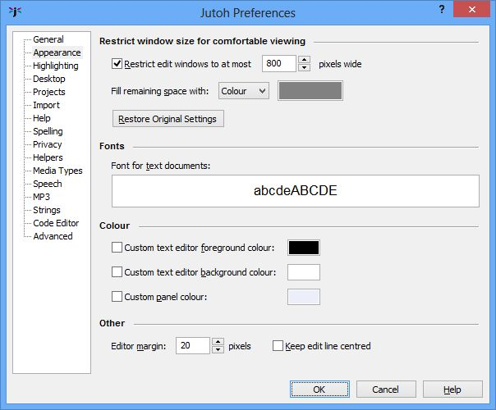
The Appearance Preferences page
Here, you can:
- set the maximum width of the editing window;
- set the colour of the editor surrounding background;
- set the text size for the editing (this will not affect the generated ebook text size);
- set the text editor text and background colours;
- set the margins around the text editor (to give you more ‘breathing space’);
- opt to centre the text cursor vertically as you move around the text.
These settings are global, so they apply to all styled text editors in Jutoh, in all projects on this machine.

Desktop options
The Jutoh desktop (accessed via the Desktop tab near the bottom of the Jutoh window) is a handy place to store third-party tool shortcuts, links to documents, and ‘sticky’ notes. You might not use it all, but if you do, you can tailor various aspects about it from the Desktop page in the Preferences dialog:
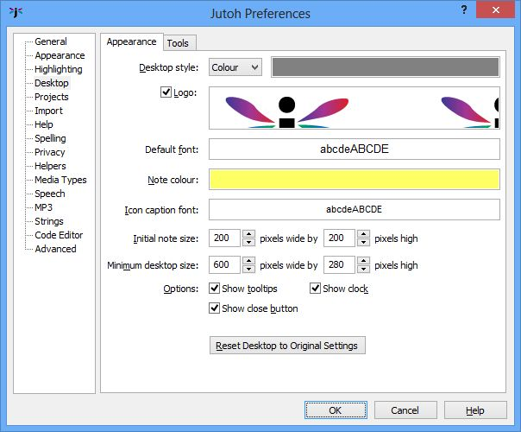
The Desktop Preferences page
You can change the desktop background, the logo displayed on it, the font and colour used for ‘sticky’ notes, and various other settings. You can also change the settings back to the original defaults.
There is a Tool tab in this page that lets you add and remove tools that will be placed on the desktop (and also on the Tools menu on the Jutoh menubar). For more details, click on the Help button on the Preferences dialog..

Project options
You can change behaviour relating to project handling (not per-project settings: that’s the job of the Project Properties dialog) using the Projects tab in the Preferences dialog.
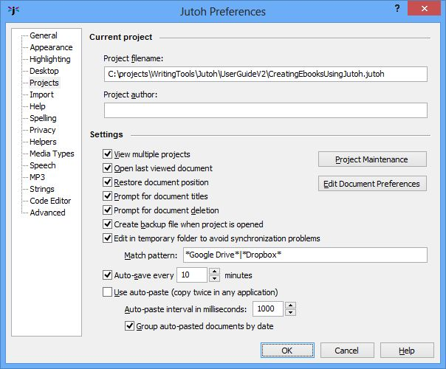
The Projects Preferences page
If you want to allow Jutoh to have several projects open simultaneously, rather than close the previous project when opening another, check View multiple projects.
If you want Jutoh to create a backup before editing a project, check Create backup file when project is opened.
You can also change auto-save frequency, and whether to auto-paste information into a new document when copying twice in quick succession in another application (Windows-only).
Using Edit Document Preferences, you can change the auto-saving and tab creation behaviour of classes of document. For example, you can specify that book section documents should reuse a single tab instead of spawning a new tab for each document. It’s fairly unlikely you’ll want to change these settings.
The Project Maintenance button shows a dialog for cleaning up a project. In this dialog, you can:
- Delete troublesome documents without opening them.
- Delete individual records in the project database, in particular ‘orphan’ documents that are no longer in the project index (this occasionally happens when Jutoh is closed unexpectedly).
- Compact a project that has been fragmented by much document creation and deletion.
It is recommended that you back up your project before doing project maintenance.

Miscellaneous options
The General page in the Preferences dialog has a variety of useful settings for changing the way Jutoh behaves:
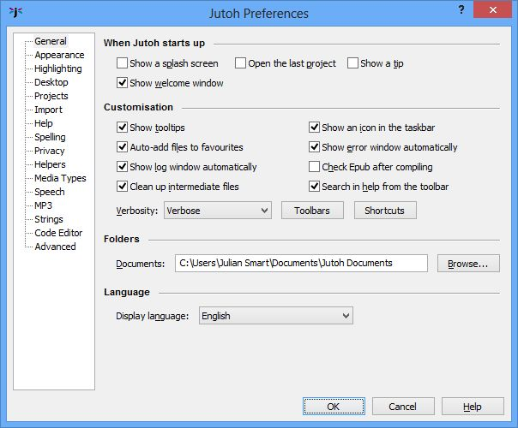
The General Preferences pages
Here, you can switch off the opening ‘splash screen’ and/or the startup tips, and elect whether to automatically open the last project when starting Jutoh.
There are further controls for showing tooltips, enabling the Jutoh Desktop, and whether to add projects to the Favourites window automatically. The Verbosity control lets you choose how much text gets written to the Log window, and Show log window automatically specifies whether to show the Log window as soon as you start compiling a project – handy if you want to hide the Log window when you’re editing.
An option you may well want to enable is Check Epub after compiling, so you can guarantee you’ve always checked your Epubs with EpubCheck without having to remember to press Check.
You can specify the default document folder, and finally you can choose the user interface display language – currently just English, but this will be expanded in future as people contribute translations.

Appendix C: The Jutoh Box Model
To understand the way margins, padding and borders work when showing a text box, table, table cell or image, consider this simplified illustration of the box model used by Jutoh, as well as by CSS and to some extent other formats.
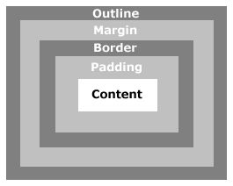
The box model
At the centre, you have the content area containing the paragraphs in your box. Separating the content and the border is padding, which gives breathing space around your content. The optional border is itself surrounded by the margin, and outside the margin you may have an outline, which is a secondary border drawn around the overall box. It’s very rare to use the outline, though, and only HTML-based formats support it.
So, when considering the space taken up by a box, you need to include the content, margin, padding and any border and outline.
The box model applies to cells within tables, and tables themselves. In the case of tables, the cells are the table content, and so the padding represents the gap between the outer table border and the cells, and the padding is also used for the inter-cell gaps.
When you specify width and height in Jutoh, the dimensions refer to the overall box size. In HTML, they refer to the content part only, so when generating HTML, Jutoh calculates the content size by subtracting other dimensions, if an explicit size has been provided.
When ebook software calculates the size of an object, the object maximum width and/or height will be taken into account, if set. Similarly, the minimum width/and or height may be taken into account, although minimum size is not currently used for layout within the Jutoh editor. The ebook layout algorithm may choose to ignore or adjust sizes where necessary, so you may see slightly different results on different devices.
Note that Kindle KF8 currently ignores maximum size.

Change Log
Version 2.1, April 18th 2014
- Added new configuration options HTML version and Use XHTML.
- Updated notes on Maximum table rows for inline-block to reflect the possibility of incorrect table rendering.
- Added Comments group of configuration options.
- Added Replace absolute widths and Maximum percentage width configuration options.
- Mentioned Replace absolute widths in the pictures, boxes and tables chapters.
- Added a section on editing comments to Chapter 6.
Version 2.0, March 4th 2014
- Added chapters on tables, boxes, narration, interactivity, accessibility, tag objects and the Jutoh box model.
- Added new configuration options Font pixel scale, Table headers and footers, Emulate boxes using tables, Use minimum size for cells, Maximum table rows for inline-block, Maximum box words for inline-block, Mirror margins, and fixed layout options.
- Updated other chapters for Jutoh 2.
Version 1.8, February 25th 2014
- Added new configuration options Cover image width, Identifier and Mirror pages.
- Replaced screenshot for Table of Contents properties and wizard pages and added screenshots for index and footnote options.
- Updated the section on creating Kindle books.
Version 1.7, July 24th 2013
- Added new configuration options Mobipocket anchor optimization, Pre-compile command, Post-compile command.
Version 1.6, May 15th 2013
- Added new configuration options Styles suppressing page break before, Styles suppressing page break after, Character substitutions, Character style substitutions, Orphan control for single-letter words, Emulate small caps, Dimension units, Font size units, Generate colour, Generate iBooks XML, Widow control, Orphan control, Namespaces.
- Removed references to the obsolete preflight checker, which has been removed from Jutoh since version 1.67.
Version 1.5, January 18th 2013
- Added a description of the formatting palette to the Editing and Formatting Content chapter.
- Added a description of how to fix the “unmanifested content” Lulu error, to the Troubleshooting chapter.
- Updated screenshots to reflect UI changes.
- Mentioned Jutoh Plus in the Introduction, in relation to custom HTML provision.
- Updated the Glossary.
- Elaborated on ‘viewer applications’ in Configuring Jutoh.
- Documented the new configuration options Generate colour, Generate generic font names, Character substitutions, Orphan control for single-letter words, Custom paper width, Custom paper height, Dots per inch, Extra metadata, Include media documents matching tags, Exclude media documents matching tags.
- Added some more tips to the troubleshooting chapter.
Version 1.4, August 22nd 2012
- Added notes about using SVG images to Working with Pictures.
- Added references to DOCX import where ODT import is mentioned.
- Added a troubleshooting tip for black text on a black background.
- Added a description of the font dialog in Editing and Formatting Content.
- Added a description of ‘continuation’ list paragraphs in Editing and Formatting Content.
- Added iBooks section to Troubleshooting Your Book.
- Added a description for the new configuration option Cover image format.
Version 1.3, July 18th 2012
- Documented the Insert Non-Breaking Hyphen and Insert Non-Breaking Space commands in the Editing and Formatting Content chapter.
- Documented the new configuration options Convert non-breaking hyphen to hyphen, Enable fixed layout, Page width, Page height, Add thin spaces around punctuation, and Thin space entity.
- Extended the section on fonts in Editing and Formatting Content, documenting the Font Substitution string table.
- Enhanced the section on embedding fonts in Advanced Topics.
- Added a section Creating fixed layout ebooks in Advanced Topics.
- Mentioned the new template facility in the Getting Started and Importing Files chapters.
- Fixed an incorrect reference to the View menu when mentioning Check for Updates in Appendix A.
Version 1.2, March 15th 2012
- Documented the Import basic CSS from HTML/Epub option in the New Project Wizard.
- Updated the mentions of KF8.
- Added a description of the new Type and See fields in the index entry dialog.
- Added descriptions for the new configuration options Epub version, Orientation lock, Optimize style sheet, Abbreviate style names, Use heading text size, Visible URLs, Use outline levels, Styles suppressing hyphenation, HTML top margin, HTML bottom margin, and Convert horizontal bar to em dash.
- Documented the search box and reordering buttons in the Configurations page.
- Changed erroneous 200Kb section size limit to 300Kb.
- Clarified the effect of width and height settings for various formats.
- Expanded the section on creating PDF documents.
- Corrected typos kindly pointed out by Jim Kerwin.
Version 1.1, November 8th 2011
- Removed text asserting that hanging indent is not supported in Mobipocket, since this is fixed in Jutoh 1.39.
- Fixed text describing how to insert page numbers in OpenOffice.org/LibreOffice, noting that the Format | Title Page command is only available in LibreOffice.
- Documented the configuration option Use relative dimensions, new in Jutoh 1.39.
Version 1.0, October 26th 2011
- First edition.

