Name: Hoy Wu
Role: Setting up Visual Studio Code and connecting it to Github
Process Overview
Following what the “Visual Studio Code + GitHub Starter Guide” google docs link in the Learn homepage states. To potentially get the bonus marks, I used AI to generate a design for the splash screen that’s journey or jenga inspired. I chose this generated work because I think it would make a cool introduction page or splash screen and it just looks cool. It has the requirements of jenga and journey inspired because there are jenga blocks and there is a journey quote with “Your journey begins one block at a time”

Process Evidence
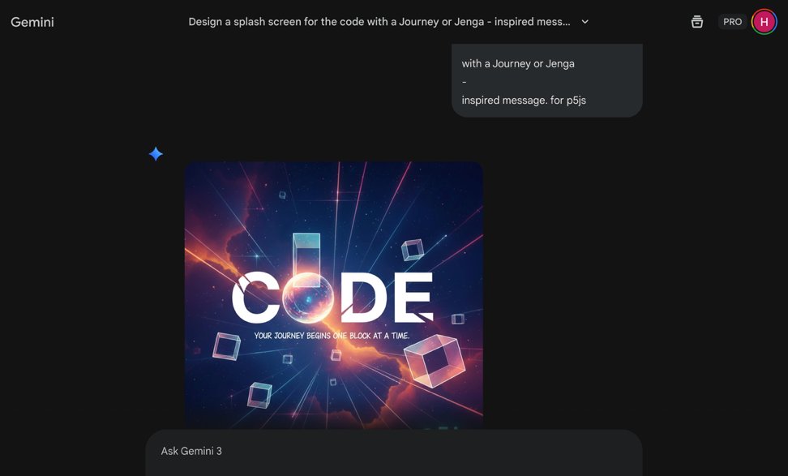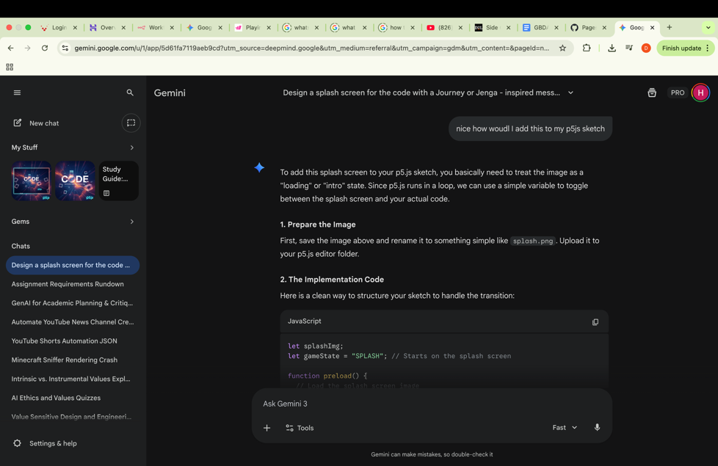
GenAI Documentation
Date Used: January 23, 2026
Tool Disclosure: Gemini 3/Nano Banana Pro
Purpose of Use: I thought AI could do a better job and be more time efficient in designing the splash screen. I also though tthat AI could do a much better job at coding than me, so I used AI in it.
Summary of Interaction: The tool contributed in writing the code for the project and designing the splash screen
Human Decision Point(s): The images were generated in the wrong aspect ratio, so I had to clarify it to change it.
Integrity & Verification Note: Re-reading the assignment instructions, the work seemed perfect
Scope of GenAI Use: I wrote the other parts of the documentation such as this process documentation and changed the pathing for the image to load.
Limitations or Misfires: It did perfectly fine.

Appendix
AI Transcript: https://gemini.google.com/share/9d1cdec7b9fd

