# **SQL-JOINS**

use sql_joins;

show tables;

CREATE TABLE TableA (

    A INT

);

INSERT INTO TableA (A) VALUES (1), (1), (1), (0), (0);

CREATE TABLE TableB (

    B INT

);

INSERT INTO TableB (B) VALUES (1), (0), (1);

select * from tablea;

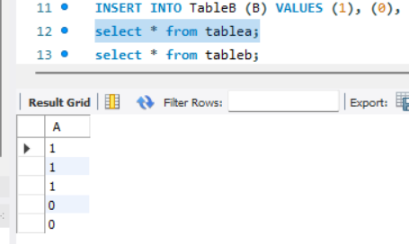

select * from tableb;

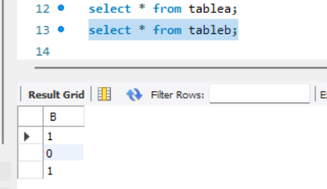

Select * from tablea left join tableb on tablea.A = tableb.B;

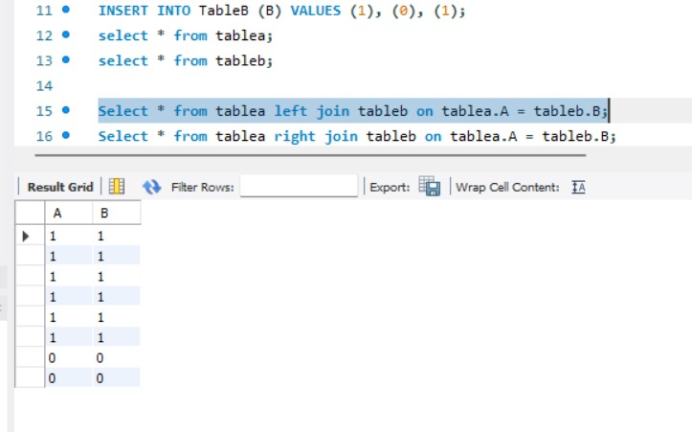

Select * from tablea right join tableb on tablea.A = tableb.B;

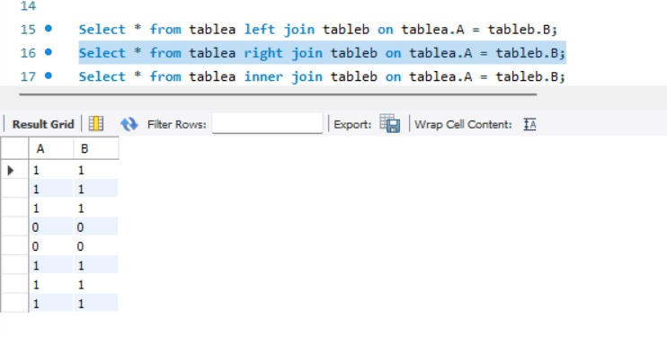

Select * from tablea inner join tableb on tablea.A = tableb.B;

