Welcome to the Cold Saw Replication Guide.

Refer to the document called Build Preparation.

Source material components 101 to 122.

Source tool components 150 to

Table of Contents
Cut Materials 2
2” x 3” Steel Flat Lengths 2
1” x 4” Steel Flat Lengths 2
1/8” x 1” Steel Flat Lengths 2
3” Dia Steel Round Lengths 2
2” Dia Steel Round Lengths 3
1.25” Dia Steel Round Lengths 3
1.25” Dia 1/8” Thk Round Tube Lengths 3
Make Operation Handle 4
Mark Bend Length 4
Clamp Metal Tube 4
Torch Bend Region 4
Bend Metal Tube 4
Make Raisers 5
Mark Metal Flat 5
Angle-cut the Metal Flat 7
Surface Grind Top and Bottom 10
Make Blade Guard 11
Drill Thin Metal Flat 11
Bend Thin Metal Flat 11
Mount Metal Sheet 11
Torch Inner Circle 11
Torch Outer Circle 11
Torch In Half 11
Mount Halves 11
Weld Thin Metal Flat 11
Make Base 12

Cut Materials

2” x 3” Steel Flat Lengths
Cut Length Tolerance – 1.6mm (1/16”)
Cut Angle Tolerance – <1 degree
4 – 26mm (1.0236”) for Short Spacers [Positive Tolerance Only!]
1 – 50.8mm (2”) for Handle Block
4 – 76.2mm (3”) for Long Spacers
4 – 101.6mm (4”) for Clamp Blocks
4 – 127mm (5”) for Clamp Jaws
2 – 300mm (11.81”) for Swivel Blocks
2 – 400m (15.75”) for Vise Moving Blocks and Vise Fixed Block

1” x 4” Steel Flat Lengths
Cut Length Tolerance – 1.6mm (1/16”)
Cut Angle Tolerance – <1 degree
1 – 140mm (5.513”) for Short Support Flat
1 – 200mm (7.87”) for Bridge Flat
2 – 280mm (11”) for Long Support Flat and Rotation Support Flat

1/8” x 1” Steel Flat Lengths
Cut Length Tolerance – 13mm (1/2”)
Cut Angle Tolerance – <5 degree
1 – 101.6mm (4”) for Indicator Flat
2 – 381mm (15”) for Blade Guard Supports

3” Dia Steel Round Lengths
Cut Length Tolerance – 1.6mm (1/16”)
Cut Angle Tolerance – <1 degree
3 – 25.4mm (1”) for Axial-Radial Shaft Collars

2” Dia Steel Round Lengths
Cut Length Tolerance – 1.6mm (1/16”)
Cut Angle Tolerance – <1 degree
6 – 20mm (0.787”) for Shaft Collars
1 – 76.2mm (3”) for Shaft Coupling

1.25” Dia Steel Round Lengths
Cut Length Tolerance – 1.6mm (1/16”)
Cut Angle Tolerance – <1 degree
1 – 25.4 (1”) for StopShaft
1 – 90mm (3.54”) for Spindle
4 – 350mm (13.78”) for Vise Shafts, Vise Handle, Support Shaft

1.25” Dia 1/8” Thk Round Tube Lengths
Cut Length Tolerance – 1.6mm (1/16”)
Cut Angle Tolerance – <1 degree
1 – 127mm (5”) for Operation Handle Support
1 – 609.6mm (24”) for Operation Handle

Make Operation Handle

Mark Bend Length

Clamp Metal Tube

Torch Bend Region

Bend Metal Tube

Make Raisers

Mark Metal Flat
Get the 1” x 4” x 11” steel flat.
Mark the flat for 2 raisers as shown below:
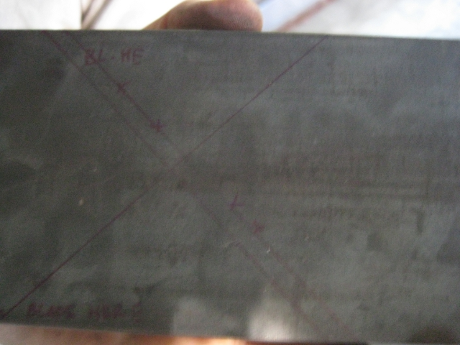
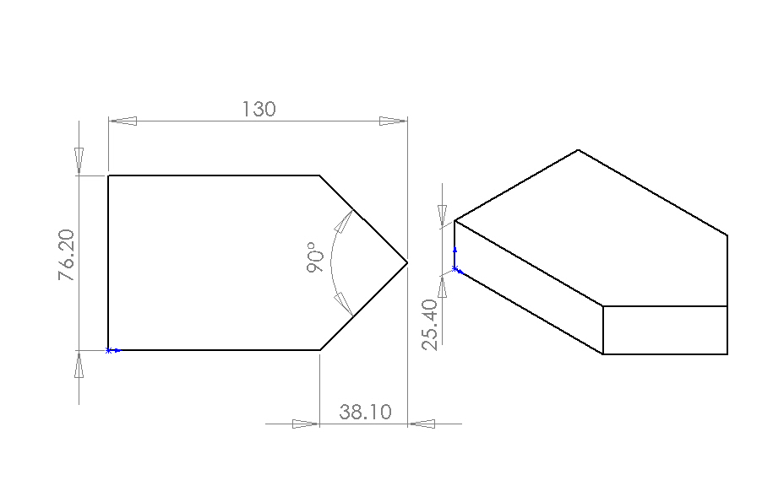

Angle-cut the Metal Flat
Use a speed square to orient the metal flat at 45 degrees on the ironworker.
Remove the speed square.
Clamp the metal flat.
Shear the metal flat!
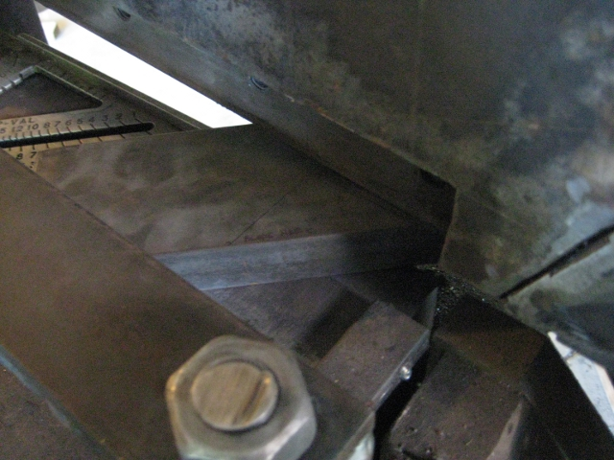

Reclamp one metal flat for the right cut angles.
Shear the first!
Reclamp and shear the second!
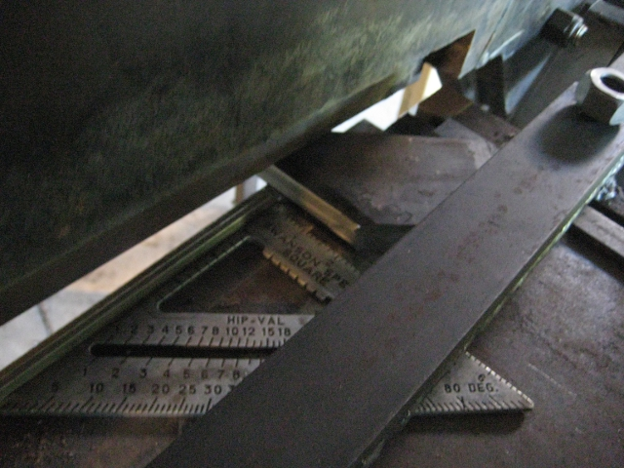
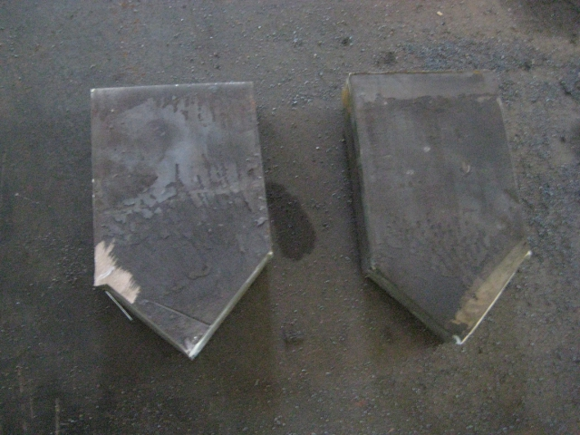

Surface Grind Top and Bottom
15/1000” for top
2/1000” for bottom
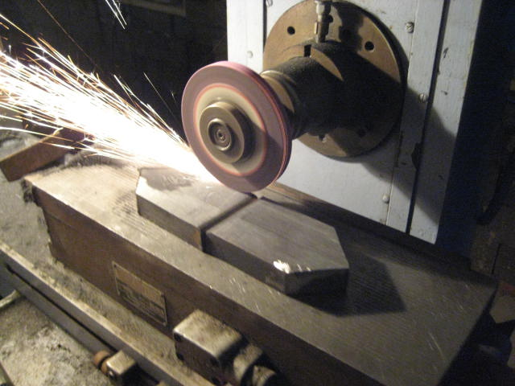

Make Blade Guard

Drill Thin Metal Flat

Bend Thin Metal Flat

Mount Metal Sheet

Torch Inner Circle

Torch Outer Circle

Torch In Half

Mount Halves

Weld Thin Metal Flat

Short Support Flat

Drill Hole

Rotation Support Flat

Drill Small Holes

Torch Large Hole

Long Support Flat

Drill Small Holes

Drill Large Hole

Clamp Block

Drill Small Hole

Mill Lip

Fixed Block

Drill Large Holes

Drill Small Holes

Moving Block

Tack Weld to Fixed Block

Drill-Start Large Holes

Grind Off Fixed Block

Drill Large Holes

