**What is Radiation Therapy Dosimetry?**

The most common treatment machine used for radiation therapy is the linear accelerator (Linac). These machines deliver ionising radiation to tumours with the aim to either cure the disease or improve the quality of life of patients living with cancer.

Linacs need to be incredible accurate and reliable to ensure the required dose of radiation goes to the disease while minimising the dose to surrounding normal tissue. Often the thing that limits how much dose we can give a patient is amount of dose the surrounding organs can tolerate. With this in mind, radiation treatments have become very complex to maximise tumour control while minimising side effects.

The ACDS are independent auditors who can measure the dose delivered from a linac to ensure the machine is performing correctly, the algorithms are calculating correctly and the software is operating as expected.

**What do we measure?**

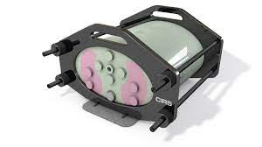Sometimes we use models (called phantoms) which simulate the shape of patients. They even have lungs that are a lower density than the rest of the phantom and a spine which is a higher density like bone.

Each ‘case’ is a different treatment delivery or beam configuration.

Each ‘point’ is a different location measured within the phantom.

Each case may be delivered several times to measure multiple energies (beam strengths) or different planning algorithms.

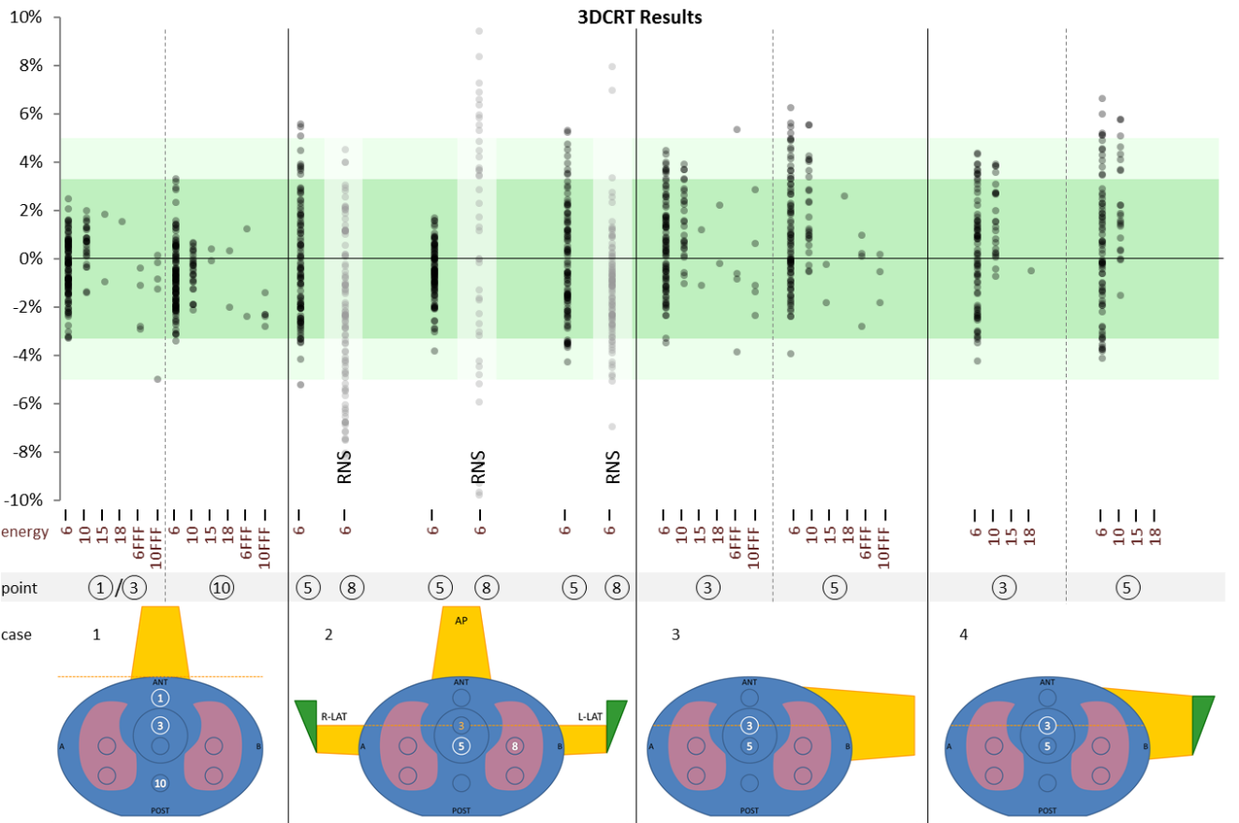

**Calibration and ionization chambers**

To make sure the treatment machines delivery the correct dose we measure each one with ionization chambers and electrometers.

There are variations from chamber to chamber which need to be accounted for when we calculate the dose. To work out what the chambers’ individual correction factor is, it is compared to the Primary Standard Dosimetry Lab’s (PSDLs) 60Co gamma ray source. Cobalt-60 (60Co) is used as the dose is highly accurate due to it being a radioactive source, constantly emitting a uniform dose. Linacs are driven by electricity and can have many points of uncertainty in the production of the radioactive beam.

Chambers can also be cross calibrated (or compared) against a chamber which has been calibrated at the PSDL. An example of this would be Roos chambers used to measure electron beams. As the primary standard is an x-ray beam, Roos chambers can be cross calibrated with farmer chambers or similar.

Dose can be measured in air or in water. For our purposes water is used, as this closely resembles human tissue. We use a combination of water tanks and solid water phantoms (water equivalent density).

**Chambers**

* Convert dose to charge

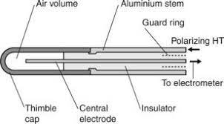

**Electrometers**

* Measure charge

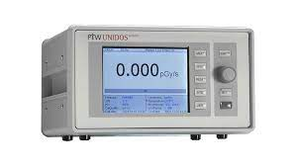

**Glossary**

k – Correction factor

N – Calibration Factor

D – Dose

w – Water

a - Air

Q – Beam Quality (or beam energy)

B – Magnetic field

Q_o - Reference quality used for the calibration

Gy – Unit of dose (Gray)

* mGy - milliGray

C – Unit for electrical charge (Coulomb)

* nC – nanoCoulomb

FS - Field size – the size of the beam at the ISO

LR – Left to Right

SI – Superior (head) to Inferior (feet)

GT – Gun to Target – direction moving from the back of the machine to the front (mostly the same as SI)

RLAT – Right lateral

LLAT – Left lateral

AP – Anterior to Posterior (generally means gantry = 0 in our situation)

Sym/Asym – symmetric and asymmetric fields. Symmetric beams have field edges equidistant from the isocentre.

Wedge – beams can be modified to have more dose on one side of the field than the other.

Col. Angle – Collimator angle – the collimator houses the jaws (what defines the field size). As the collimator turns, the field rotates.

MLC – Multi leaf collimator – long fingers of lead so that the beam can be shaped in unique patterns

IMRT – Intensity Modulated Radiation Therapy – The MLCs can move while the beam is being delivered to modulate (or alter) the dose, giving higher doses in some regions and lower doses in others. With IMRT the gantry is static (still) but the leaves move.

VMAT - Volumetric modulated arc therapy – Similar to IMRT however the gantry also moves while the dose is being delivered. VMAT can also use beams of different intensities as the gantry moves around.

SSD – Source to Surface Distance – distance from the source (or x-ray target) to the surface of the phantom/patient

SAD – Source to Axis Distance – distance from the source (or x-ray target) to the ISO

ISO – isocentre – point in air that the machine moves around. Wherever the machine is moved, the centre of the beam points towards the isocentre. Linacs typically have an isocentre 100cm from the “source” of the beam.

TAR - Tissue Air Ratio – ratio of absorbed dose in tissue to absorbed dose at the same point in air. Dependant on beam energy, field size and measured depth.

TPR – Tissue Phantom Ratio – ratio of dose at a point in a phantom to the dose at the same point with a fixed reference depth.

TPR20,10 - Tissue-phantom ratio in water at depths of 20 and 10 g/cm-2, for a field size of 10cm x 10cm and a SCD (source to point of calibration distance) of 100cm, used as the beam quality index for high-energy photon radiation.

R50 - Half-value depth in water (in g cm-2), used as the beam quality index for electron beams.

kQ,B - For MR Linacs a factor needs to be applied that corrects for both beam quality *Q* and the presence of the magnetic field *B*.

N_D,w,Q_o

Calibration factor in terms of absorbed dose to water for a dosimeter at a reference beam

quality Q_o. mGy/nC

N_D,w,Q_cross

Calibration factor in terms of water of absorbed dose for a dosimeter cross calibrated with another chamber

k_s

Factor to correct the response of an ionization chamber for the lack of complete charge

collection (due to ion recombination).

k_pol

Factor to correct the response of an ionization chamber for the effect of a change in polarity

of the polarizing voltage applied to the chamber.

kQ,Q_o

Factor to correct for the difference between the response of an ionization chamber in the

reference beam quality Qo used for calibrating the chamber and in the actual user beam

quality, Q. The subscript Qo is omitted when the reference quality is 60Co gamma radiation

(i.e., the reduced notation kQ always corresponds to the reference quality 60Co).

K_Shad - Shadowing – correction to take into account the effect of the density of the dosimeter in the phantom. A beam travelling through a dosimeter will not be as strong on the back side due to attenuation

Linear accelerator diagrams:

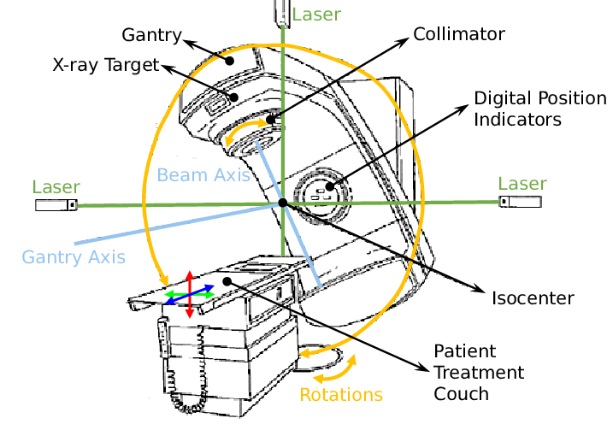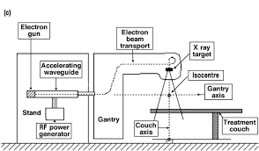

References

TRS-398

Absorbed Dose Determination in External Beam Radiotherapy: An International Code of Practice for Dosimetry based on Standards of Absorbed Dose to Water

PUBLISHED BY THE IAEA ON BEHALF OF IAEA, WHO, PAHO, AND ESTRO