AMR Intake Form Guide
Oct 15, 2026 · @Sifu
This guide turns an app team's requirements into a correct Azure Managed Redis (AMR) request: follow the quick start, pick each value from the field tables, and check the combined rules before you submit. A few issues in the current form need fixing before teams rely on it; see Form review.

Quick start
Do these six steps for every new cache, in this order.
- Collect the requirements from the app team. Ask:
  - Which environment (dev, qa, uat, prod) and which region?
  - How much data, and how much traffic?
  - Must it keep running if a whole region goes down?
  - Is it OK to lose data on a restart (pure cache), or must data survive?
  - Does the app need search, JSON, Bloom filters or time series?
  - How do apps connect: with an access key, or with an Entra ID identity?
- Pick the topology with the decision flow in Pick the topology.
- Fill the Database Parameters tab (see Database Parameters tab).
- Fill the Advanced Settings tab (see Advanced Settings tab).
- Check the combined rules in Rules that combine fields. The form should block bad combinations; check anyway.
- Review and submit. Re-check the values you can't change later: name, location, topology and modules (see After creation).
After you submit, the platform pipeline runs Terraform and creates the cache. For Entra ID caches, request data access for each app identity as a separate step.

Pick the topology
Answer up to three yes/no questions and the answers decide the topology. Treat qa or uat as production when other teams depend on it.
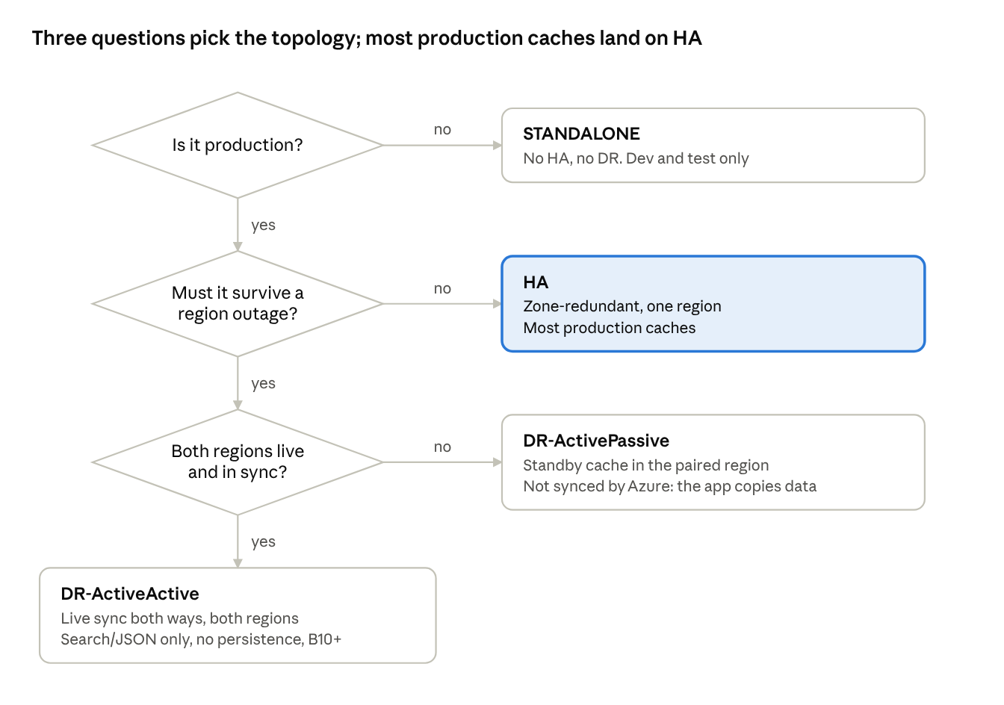
topology decision · 3 questions, 4 outcomes
Topology | High availability | Second region | Sync between regions | Persistence | Modules | Use for
STANDALONE | No | No | n/a | Any | All four | Dev and test
HA | Yes, zone-redundant | No | n/a | Any | All four | Most production caches
DR-ActivePassive | Yes | Yes, standby | None from Azure; the app copies data | Any | All four | Prod that must recover in the other region and can accept a switch-over
DR-ActiveActive | Yes | Yes, live | Live, both directions | Off (forced) | RediSearch, RedisJSON | Prod that must keep serving from both regions
The region pair is East US 2 and Central US; the DR region is chosen automatically from the Location field.

Database Parameters tab
Every field on the first tab, what to enter, and when. The JSON key is what the form sends to Terraform.
Field | JSON key | Required | Allowed values | Default | What to pick
Environment | environment | Yes | dev, qa, uat, prod | dev | Where the app runs. It picks the subscription, resource groups and network, and adds -<env> to the name.
Instance Name | instance.name | Yes | Lowercase letters, numbers, hyphens. Start with a letter, end with a letter or number. Max 39 characters | none | Short and app-based, e.g. orders-cache. Don't add the environment. Must be unique in the environment. Can't be changed later.
Database Component App Service ID | see Form review | Yes | appsvc + digits; lowercased on submit | none | The owning app's approved ID. Used for ownership, support routing, cost and tags.
Location | instance.location | Yes | East US 2 (eastus2), Central US (centralus) | East US 2 | The region the app runs in. For DR topologies the DR region is automatic: East US 2 pairs with Central US. Can't be changed later.
Node Type + Node Number | instance.node_type | Yes | Tier + size, sent as one value, e.g. Balanced + 10 = Balanced_B10. Sizes per tier in the next table | Balanced_B0 | Balanced unless the app has a reason for another tier. Size for the expected data plus room to grow.
Deployment Topology | instance.deployment_topology | Yes | STANDALONE, HA, DR-ActivePassive, DR-ActiveActive | STANDALONE | Use the decision flow in Pick the topology.
Redis Modules | instance.redis_modules | No | RediSearch, RedisJSON, RedisBloom, RedisTimeSeries | none | Only what the app needs: search or vector search, JSON documents, Bloom filters, time series. Create-time only. Limits in Rules.
Authorization Mode | instance.authorization_mode | Yes | AccessKey, MicrosoftEntraID | AccessKey | AccessKey: apps connect with a key, simplest. Entra ID: no keys; each app identity needs a data-access grant after create. Prefer Entra ID for prod when apps support it.
Database Platform | see Form review | Yes | dps, cfes | dps | dps for all deployments; cfes only for internal ones.
Alert Emails | see Form review | No | People in the directory | Requester | Who gets alerts when alerting is on.
Node types and sizes
Tier | JSON prefix | Valid sizes | Use when | Sizes allowed for DR-ActiveActive
Balanced | Balanced_B | 0, 1, 3, 5, 10, 20, 50, 100, 150, 250, 350, 500, 700, 1000 | Most apps: balanced memory and CPU. B0 and B1 suit dev and test | 10 and up
Memory Optimized | MemoryOptimized_M | 10, 20, 50, 100, 150, 250, 350, 500, 700, 1000, 1500, 2000 | Lots of data, moderate traffic (more memory per vCPU) | All
Compute Optimized | ComputeOptimized_X | 3, 5, 10, 20, 50, 100, 150, 250, 350, 500, 700 | High traffic or very low latency (more vCPU per GB) | 10 and up
Flash Optimized | FlashOptimized_A | 250, 500, 700, 1000, 1500, 2000, 4500 | Very large datasets at lower cost; part of the data sits on flash. RedisJSON is the only module | 500 and up
A bigger number means more memory; the Azure Managed Redis pricing page lists the exact memory and vCPU per size. Scaling up within a tier usually happens in place, but you can never move between Flash and the other tiers.

Advanced Settings tab
These settings decide whether data survives a restart and what happens when memory is full.
Field | JSON key | Required | Allowed values | Default | What to pick
Persistence Mode | instance.persistence.mode | Yes | AOF, RDB, DISABLED | Form: AOF. Template: DISABLED | DISABLED for a pure cache whose data can be rebuilt. AOF when data must survive with the least loss. RDB when losing up to the snapshot interval is OK. Forced to DISABLED for DR-ActiveActive.
AOF Append Fsync | instance.persistence.aof_frequency | Only with AOF | 1s (Every Second), always (Always) | 1s | 1s for almost everything. always writes every change to disk and is slower.
RDB snapshot frequency | instance.persistence.rdb_frequency | Only with RDB | 1h, 6h, 12h | 12h | The most data you can lose is one interval. Pick the shortest one the app needs.
Backup | see Form review | n/a | Yes, No | Yes | No matching AMR setting: persistence is the backup.
Eviction Policy | instance.eviction_policy | Yes | AllKeysLRU, AllKeysLFU, AllKeysRandom, VolatileLRU, VolatileLFU, VolatileRandom, VolatileTTL, NoEviction | Form: VolatileLRU. Template: AllKeysLRU | Use the next table. Forced to NoEviction when RediSearch is selected.
Enable Alerting | see Form review | No | Yes, No | No | Yes for anything a team relies on.
Tags | instance.tags, application_id, lob | Auto | Loaded from the App Service ID | Loaded | Set once, at create. Later tag changes are ignored. topology, environment and managed_by are always set by Terraform.
Which eviction policy
The app's data | Pick | What happens when memory is full
Pure cache: every key can be rebuilt | AllKeysLRU | Least recently used keys are removed
Cache where popular items must stay | AllKeysLFU | Least frequently used keys are removed
Cache keys with a TTL mixed with keys that must stay | VolatileLRU | Only keys with a TTL are removed. With none left, writes fail
Keys with a TTL; drop the soonest-expiring first | VolatileTTL | Keys closest to expiry are removed
Must never lose data: primary store, queues, RediSearch | NoEviction | Nothing is removed; writes fail. Size the cache with room to spare
The Random variants (AllKeysRandom, VolatileRandom) suit only data where every key is equally likely to be read; rarely the right pick.

Rules that combine fields
Ten rules tie fields together; Terraform fails the request (or forces the value) when one is broken, so the form should enforce them up front.
When | Then | What the form should do
Topology is DR-ActiveActive | Only RediSearch and RedisJSON modules are allowed | Disable RedisBloom and RedisTimeSeries, with the tooltip "Not supported with active-active geo-replication"
Topology is DR-ActiveActive | Persistence is forced to DISABLED | Set Persistence to Disabled and lock it
Topology is DR-ActiveActive | Size must be Balanced 10+, Compute 10+, any Memory Optimized, or Flash 500+ | Block smaller sizes
RediSearch is selected | Eviction becomes NoEviction and clustering becomes Enterprise | Lock Eviction to No Eviction, with the note "Search requires No Eviction"
Tier is Flash Optimized | Only RedisJSON is allowed | Disable the other modules
Any module + Entra ID | Data-access grants can only be full access; read-only and limited roles fail (Azure preview limitation) | Warn, and hide limited roles in the access request
Topology is STANDALONE | No high availability; scaling and maintenance can lose data | Warn when Environment is prod
Topology is DR-* | Location must be one half of the region pair (East US 2 or Central US) | Show the DR region the cache will use
Persistence is AOF | Fsync must be 1s or always | Send exactly 1s or always
Any request | Instance Name must be unique within its environment | Check against existing caches before submit
Terraform fails the request on the module, Flash and AOF rules, forces the persistence and RediSearch values, and only warns on a too-small DR-ActiveActive size, which Azure then rejects at create. The intake schema (redis-intake-schema.json) checks the module and eviction rules in its allOf block, which the form can reuse for validation.

Worked examples
Five common requirements and the values to enter for each. Sizes are starting points; adjust to the app's data volume.
Requirement | Environment | Topology | Node type | Modules | Auth | Persistence | Eviction
Dev sandbox; data can be lost | dev | STANDALONE | Balanced_B0 | none | AccessKey | DISABLED | AllKeysLRU
Prod session store in one region; sessions must survive a restart | prod | HA | Balanced_B10 | none | MicrosoftEntraID | AOF, 1s | VolatileLRU (sessions have a TTL)
Prod search over JSON documents, live in both regions | prod | DR-ActiveActive | Balanced_B20 | RediSearch, RedisJSON | MicrosoftEntraID, full-access grants only | DISABLED (forced) | NoEviction (forced)
Prod cache with a standby in the second region, using Bloom filters | prod | DR-ActivePassive | Balanced_B10 | RedisBloom | AccessKey | RDB, 1h | AllKeysLRU
Very large product catalog stored as JSON, cost first | prod | HA | FlashOptimized_A250 | RedisJSON | AccessKey | AOF, 1s | AllKeysLRU
In the standby example, the DR cache isn't kept in sync by Azure: the app team copies data or writes to both caches.

After creation
Name, location, high availability, active-active and modules are fixed at creation: changing any of them destroys the cache and creates a new, empty one. Get these right before submitting.
Change to an existing cache | Result
Instance Name | Destroyed and recreated: new hostname, new keys, data lost
Location | Destroyed and recreated
STANDALONE to HA, or back | Destroyed and recreated (high availability is fixed at creation)
HA to DR-ActivePassive | Adds the DR cache; the primary is unchanged
Any topology to or from DR-ActiveActive | Primary destroyed and recreated (the geo-replication group is fixed at creation)
Add, remove or change modules | Primary and DR destroyed and recreated
Size up within the same tier | Usually in place. HA keeps data; STANDALONE loses data while scaling
Size down, or a different tier | Azure decides; may recreate. Never to or from Flash
Eviction Policy | In place
Persistence | In place (stays DISABLED for DR-ActiveActive)
Authorization Mode | In place. Move every client to the new credential type first
Tags | Ignored after creation
Delete request | Deletes the cache, even with deletion protection on
To move a cache to a new name or region, request a new cache, migrate the apps and data, then delete the old one.

Errors you may see
When a request fails, find the message below; the first two have already happened in dev.
Error contains | Cause | What to do
"SKU ... is not supported for your subscription in East US 2" | The subscription isn't enabled for AMR in that region. Changing the size doesn't help | Platform team raises an Azure support ticket. Meanwhile use Central US, or wait
"AuthorizationFailed ... Microsoft.Authorization/locks/write" | The pipeline identity can't create the deletion-protection lock. The cache itself was created | Platform team grants the lock role, or turns deletion protection off for that environment
"Insufficient capacity" | Azure has no room for that size in the region right now | Retry later, or the platform team asks Azure support
"already exists" on a retry | A failed earlier attempt left a half-created cache | Delete the failed cache in the portal, then retry
"redis-modules contains an invalid module name" or "supports only the RediSearch and RedisJSON modules" | A module that isn't allowed for the topology or tier | Fix the module selection (see Rules)
"persistence-aof-frequency must be 'always' or '1s'" | The form sent another value, e.g. EVERY_SEC | Form fix: send 1s or always
Warning "does not support geo-replication" | Size too small for DR-ActiveActive | Pick an allowed size (see Node types and sizes)
"Custom access strings aren't supported" on a data-access request | The cache has modules; Azure allows only full access | Request full access, or use a cache without modules
For any other error, send the platform team the request name and the full error text, including the CorrelationID.

Form review
Three issues will make real requests fail and should be fixed before teams use the form; ten more are gaps to close. Checked against the form screenshots of 15 Oct and the template 3.1.0 / module 5.3.0 copy.
# | Severity | Finding | Fix | Status
1 | High | AOF fsync is sent as EVERY_SEC (Review page). The template accepts only 1s or always, so plan fails | Map Every Second to 1s and Always to always | Open
2 | High | Deletion protection isn't on the form, so the default true applies. Every request then tries to create a lock, and the pipeline identity lacks locks/write (failed 29 Sep) | Grant the lock role, or set the default per environment, e.g. off for dev | Open
3 | High | Location defaults to East US 2, where the dev subscription can't create AMR yet (failed 29 Sep) | Until Azure support enables it, default dev to Central US or show a warning | Open
4 | Medium | Database Platform, App Service ID, Application ID, Alert Emails, Enable Alerting and Backup aren't read by the template version reviewed. Live runs use dps- resource groups, so the current version may map some of them | Confirm each field's JSON key in the current template; drop fields nothing reads | Open
5 | Medium | Backup has no AMR setting, and Backup Yes with Persistence Disabled contradicts itself | Remove it, or define it as "persistence on" | Open
6 | Medium | Review & Submit opened with Instance Name and App Service ID empty (reached through the tab links) | Block submit until every required field is valid | Open
7 | Medium | DR-ActiveActive rules (no Bloom or TimeSeries, persistence Disabled, minimum size) aren't visible in the screenshots | Enforce them as in Rules | Open
8 | Medium | No sign that Eviction locks to No Eviction when RediSearch is ticked | Lock it, with a note | Open
9 | Medium | Node Number help lists Balanced sizes only | Change the size list with the tier | Open
10 | Low | Name help says "max 39" but not "start with a letter, end with a letter or number" | Add both checks, plus uniqueness in the environment | Open
11 | Low | Form defaults (AOF, VolatileLRU) differ from the template's (DISABLED, AllKeysLRU). VolatileLRU on a cache with no TTL keys fills up, then rejects writes | Default Eviction to AllKeysLRU, or require an explicit choice | Open
12 | Low | Editing existing caches isn't shown. Name, location, topology and modules recreate the cache if changed | Make them read-only after creation | Open
13 | Low | The Review page doesn't show the DR region for DR topologies | Show "DR region: Central US" (or East US 2) | Open

Request JSON
The form shows friendly labels, but it must send the exact values below; Terraform rejects anything else.
Form shows | Send
Standalone · High Availability · DR Active-Passive · DR Active-Active | STANDALONE · HA · DR-ActivePassive · DR-ActiveActive
Balanced + 10 · Memory Optimized + 20 · Compute Optimized + 10 · Flash Optimized + 250 | Balanced_B10 · MemoryOptimized_M20 · ComputeOptimized_X10 · FlashOptimized_A250
East US 2 · Central US | eastus2 · centralus
AOF · RDB · Disabled | AOF · RDB · DISABLED
Every Second · Always | 1s · always
Volatile LRU, All Keys LRU, No Eviction, and so on | The same words without spaces: VolatileLRU, AllKeysLRU, NoEviction
RediSearch · RedisJSON · RedisBloom · RedisTimeSeries | The same names, in a list
Requester Email | requested_by
A complete request for a prod HA cache with search over JSON:
{
"type": "instance",
"request_type": "create",
"environment": "prod",
"requested_by": "jane.doe@example.com",
"instance": {
"name": "orders-cache",
"location": "eastus2",
"deployment_topology": "HA",
"node_type": "Balanced_B10",
"redis_modules": ["RediSearch", "RedisJSON"],
"authorization_mode": "MicrosoftEntraID",
"persistence": { "mode": "AOF", "aof_frequency": "1s" },
"eviction_policy": "NoEviction",
"application_id": "appsvc123456",
"lob": "cc-0001",
"tags": { "criticality": "high" }
}
}
- request_type is create for both new caches and changes; delete removes the cache.
- The platform sets deletion_protection_enabled, redis_module_args and geo_replication_group_name; the form doesn't send them.
- Never send client_protocol or public_network_access. Terraform fixes them to Encrypted and Disabled.
- Which JSON key the App Service ID and the other form-only fields map to is an open question; see Form review #4.

