Jaihind Educational trust’s
ZULAL BHILAJIRAO PATIL COLLEGE,
DHULE
Department of Computer science



A
PROJECT REPORT
ON

“ONLINE BOOK EXCHANGER SYSTEM”

GUIDED BY
Prof. Prasad Joshi sir

SUBMITTED BY
Miss.Ankita S.Bhavsar.

SUBMITTED TO
North Maharashtra University,
Jalgaon.
2013-2014

ZULAL BHILAJIRAO PATIL COLLEGE, DEOPUR, DHULE
E-mail: ankitabhavsar@gmail.com
Website: www.jaihindcollege.ac.in
PHONE NO.:- 222343 FAX: - (02562)220678

CERTIFICATE

PROJECT REPORT ON:

“ONLINE BOOK EXCHANGER SYSTEM”
SUBMITTED BY:-
This is to certify that, Mr. Ankita sanjay Bhavsar. Have satisfactory completed the project entitled “Online Book exchanger System”. He has submitted this report in the partial fulfillment of the requirement for the degree in MSC(Computer). In the Academic year 2017 - 2018.

PROJECT GUIDE HEAD OF DEPT.

(Prof. Prasad joshi) (Prof. G.B.Desale.)

External examiner-l External examiner-ll

CERTIFICATE

This is certify that, Miss.Ankita sanjay Bhavsar. has been completed his project work entitled “ONLINE BOOK EXCHANGER SYSTEM” that is in our firm during the work progress he was found very sincere & hard working. We are recommending for his good one always in the concerned field.

Proprietor-
Shri Agrasen Medical

ACKNOWLEDGEMENT

It is with great pleasSure and effort that I am able to present this project report. I have tried my level best that make it complete in all respect. I would like take opportunity to give my sincere thanks to those people who helped me directly or indirectly during the completion of this project.

I wish to express sincere thanks to Prof. Mr. G.B.Desale sir, Head Of the Department Zulal Bhilajirao Patil College, Dhule for proving necessary facilities for the completion of this work.

I am especially thankful to project guide Prof. Mr. Prasad joshi sir for his guidance and making me available with all possible recourses for this project.

I would like to mention my special thanks to all faculty members of Zulal Bhilajirao Patil College, Dhule and all my friends who have contributed me much to complete this project.

Miss.Ankita Bhavsar.

INDEX

Chapter | Topic | Name | Page
1. |  | Introduction | 6-10
 | 1.1 | Background of Shri Agrasen Medical Shop
 | 1.2 | Need Of Computerization
 | 1.3 | Advantages Of Computerization System
2. |  | Hardware & Software System | 11-19
 | 2.1 | Hardware Requirements
 | 2.2 | Software Requirements
 | 2.3 | Introduction To VB.NET
 | 2.4 | Introduction to Access
 | 2.5 | Normalization
3. |  | Feasibility Study | 19-23
 | 3.1 | Need For Feasibility Study
 | 3.2 | Type Of Feasibility
 | 3.3 | Benefits Of System
4. |  | System Description | 24-46
 | 4.1 | Data Dictionary
 | 4.2 | Data Flow Diagram
 | 4.3 | Entity Relationship Diagrams
 | 4.4 | Input & Output Screens
5. |  | Implementation | 47-49
 | 5.1 | User Training Guide
6. |  | Conclusions & Suggestions | 50-52
 | 6.1 | Suggestions To New Organizations
7. |  | References | 53-54

CHAPTER 1

INTRODUCTION

INTRODUCTION

1.1 BACKGROUND OF SYSTEM

With our application you can swap your books for books you really want.
Do you have a ton of books sitting on your shelves? Would you like to get rid of them and make space for new books?
The Book Exchange System combines computer software and hardware and this project consists of two part Book Exchange Web service and application on wp7.
Part 1: Book Exchange web service used by application to upload the books and users information to the data base.
Main Goal
A main goal of (BES) system is to allow the users to search for any book in easy way by enter book ISBN, book name or by book author.
Book exchange returns the full information about the book such as edition, book status.
Also (BES) allow student to add books to required list or available list.
Mission Statement
The use to help the students to find book they needed and exchange or swap the book with no longer used, By using book exchange application
Application Advantage's
Help students to exchange book between them in easy way.
Add books with no longer used to the available list.
Add books student need to the required list.
Book exchange returns the status rate for a specific user.
Search by Title, Author, or ISBN.
this application purpose is to make it easier for the student to use book exchange to save money, effort in search and buy all these books.
Part 2:
Book Exchange application allow the student to search for any available books and which student own this book and show the information for that student ,also add books to the available list book.

MANUAL SYSTEM

The manual system of book exchange was not convenient because no one knows the which book to whom and which book is available.

INTRODUCTION ABOUT PROJECT AND SYSTEM

As the manual system is quite full of problem I tried to overcome these problem and develop the book exchange system. I tried to fulfill the requirement of student and book record through the computerized book exchanger system on which they can take the important decisions about the detail of book and student/user.
Forms are design in such a way that unknown user can get the idea of various parts of system.
This system is useful to know the exact report about the available book and students and it also check the availability of book.

SCOPE OF WORK

Maintenance of Records.
The system maintains the complete record of books.
Check the availability of book.
It puts the information of all the users.
Report.
It gives transaction wise report.

OBJECTIVES

Connectivity is Productivity
My book exchange system is a social networking platform that allows students to buy and sell their textbooks to other students. After loading the system, students create a profile, with a username and password This ease of use feature allows users to identify and share common personal and academic interests.

Connectivity is key to the mastermind behind book exchange system. “The peer to peer concept in the system is different from what a website like Amazon offers. Amazon’s concept derived from an easy shipping perspective. My book exchange system focuses on convenience and connectivity, which is why the system has an internal messaging system, to provide users a convenient way to contact each other, but also allows for users to reach each other by email, call or text. With a centralized focus on cultivating relationships, My system wants users to experience the benefits of their new connections beyond just the exchanging of their textbooks. The app is supposed to help you build relationships for part, or the entirety of your academic career.”

In addition to being a social networking platform, the sytem in feature has a geolocation feature that enables users to easily locate the textbook they are looking for locally based on their zip code, not solely based on which school they are attending. Users can narrow their search by specifying the title, author, price range, keyword, ISBN, or they can simply scan the barcode of the book for a list of potential buyers and sellers within the specified zip code. My system also has built in a price comparison feature of online bookstores, which provide links to new, used, e-textbook and textbook rental agreements available, in case you are looking for more than just a textbook to own.

With several features to enhance the textbook buying/selling experience My Book Exchange system wants to provide for all your textbook buying/selling needs. Bookmarking a specific ad allows users to easily keep track of any textbook that meets their needs for later use. Wishlist enables users to be informed when another user has created an ad for the specific textbook they are looking for. And of course, quickly add to your list of friends to remain in contact for homework help, to form study groups or to exchange with again.

1.2 Need Of Computerization:

In order to bring down the available down time to zero & to reduce the available down time particularly management should get machine utilization. A down time breaks up reports with high accuracy & well within the time & for this the application of computer is essential.
Computer can turn out huge amount of complicated work several thousand of faster than a human being. Huge capacity of work of very high speed & absolute reliability are the three qualities that have made the computer the right vehicle to bring home the harvest of science & technology.

It becomes easy to maintain the book and user information by computer to keep track of availability of book and users, & transactions.

1.3 Advantages Of Computerization System:

With the of computer work can speed up alternative tries out & optimum solution Can be avoided within the target time.
Computer is helpful in many practical situations to obtain the best solution instead of solution obtained from efforts.
In the calculation all necessary factors can be considered. Thus eliminating doubtful assumption and crude approximations.

Huge amount of data can be stored which helps for periodical results & periodical review.

CHAPTER 2

Hardware and software requirements

Hardware and software requirements:

The system can be installed on Computers these machine(s) must have minimum configuration. Along this we use printer for taking printouts. So software and hardware used are:-

Hardware Requirements: -

Pentium (Any) - Processor or equivalent Processor
1 GB RAM or Above
40GB of Hard Disk or Above
233 MHz Processor or Above
Printer (Inkjet or Laser)

2.2 Software Requirements: -

Operating System: -WINDOWS 98 OR ONWARDS.
Front End Environment: - php, javascript, html, wamp server
Back End Environment: - mysql

Introduction PHP
- Introduction :-

What is PHP?
- PHP is an acronym for "PHP: Hypertext Preprocessor"
- PHP is a widely-used, open source scripting language
- PHP scripts are executed on the server
- PHP is free to download and use

What Can PHP Do?
- PHP can generate dynamic page content
- PHP can create, open, read, write, delete, and close files on the server
- PHP can collect form data
- PHP can send and receive cookies
- PHP can add, delete, modify data in your database
- PHP can be used to control user-access
- PHP can encrypt data

Why PHP?
- PHP runs on various platforms (Windows, Linux, Unix, Mac OS X, etc.)
- PHP is compatible with almost all servers used today (Apache, IIS, etc.)
- PHP supports a wide range of databases
- PHP is free. Download it from the official PHP resource: www.php.net
- PHP is easy to learn and runs efficiently on the server side

- The Structure of a PHP Script
- PHP is an embedded scripting language when used in web pages. This means that PHP code is embedded in HTML code. You use HTML tags to enclose the PHP language that you embed in your HTML file — the same way that you would use other HTML tags. You create and edit web pages containing PHP the same way that you create and edit regular HTML pages.
- The PHP language statements are enclosed in PHP tags with the following form:
- <?php ?>
- Sometimes you can use a shorter version of the PHP tags. You can try using <? and ?> without the php. If short tags are enabled, you can save a little typing. However, if you use short tags, your scripts won’t run if they’re moved to another web host where PHP short tags are not activated.
- PHP processes all statements between the two PHP tags. After the PHP section is processed, it’s discarded. Or if the PHP statements produce output, the PHP section is replaced by the output. The browser doesn’t see the PHP section — the browser sees only its output, if there is any.
- Basic PHP Syntax
- A PHP script can be placed anywhere in the document.
- A PHP script starts with <?php and ends with ?>:
- <?php
// PHP code goes here
?>
- The default file extension for PHP files is ".php".
- A PHP file normally contains HTML tags, and some PHP scripting code.
- Below, we have an example of a simple PHP file, with a PHP script that uses a built-in PHP function "echo" to output the text "Hello World!" on a web page:
- <html>
<body>
<h1>My first PHP page</h1>
<?php
echo "Hello World!";
?>
</body>
</html>

PHP MySQL Database
With PHP, you can connect to and manipulate databases.
MySQL is the most popular database system used with PHP.

What is MySQL?
- MySQL is a database system used on the web
- MySQL is a database system that runs on a server
- MySQL is ideal for both small and large applications
- MySQL is very fast, reliable, and easy to use
- MySQL uses standard SQL
- MySQL compiles on a number of platforms
- MySQL is free to download and use
- MySQL is developed, distributed, and supported by Oracle Corporation
- MySQL is named after co-founder Monty Wideness’s daughter: My

- What is a database?
- When an amount of data is stored in an organized way, that is called a database.
In computers, a database is managed by a software called Database Management System.

- What is a table?
- A table is a set of data values. These values are organized using a vertical columns and horizontal rows. Columns are identified by their names.

- MySQL create database
- In MySQL, CREATE DATABASE statement creates a database with the given name. To use this statement, you must have the CREATE privilege for the database. You will get an error, if the database exists and you did not specify IF NOT EXISTS clause..
- Limits on Number of Databases: MySQL has no limit on the number of databases. The underlying file system may have a limit on the number of directories.
- CREATE SCHEMA is a synonym for CREATE DATABASE.

2.5 Normalization:

The normalization is most important part where the database management system is concerned. The normalization is nothing but the simplest form relating to the data & the data entity. The main considerable function of the normalization is data redundancy. The process known, as normalization is a technique used to group attributes in ways that eliminate these types of problems. More specific goals of normalization are to minimize redundancy & functional dependency from the value of another attribute. By definition, then all non-keys attribute will be functional dependent on the primary key in every relation. When one attribute of a relation does not uniquely define another attribute, but limits it to set of predefine values, this called the multi-valued dependent on only one attribute of a concatenated key. Transitive dependencies occur when a non-key attribute is functionally dependent on one or more other non-key attribute in the relation.
Normal form of database design is specific stage, which can be easily tested by set of condition.
Normalization is measured in terms of normal forms & process of normalization consists of tasking appropriate steps to reach the next normal.

Normalization is a process used to design a database in a most efficient way. Basically there are 3 stages or rules to applied known as First, Second & Third Normal Form.

First Normal Form
A database in first normal form must not contain repeating attributes.

Second Normal Form
A table in second normal form if it is in first normal form & no column that is not parts a primary key dependent on only a portion of the primary key.

Third Normal Form
A database is in third normal form if it contains no ‘non key dependencies’.

Chapter 3

FESSIBILITY STUDY

“FESSIBILITY STUDY”

Feasibility study is conducted to select the best solution from the various alternatives. The selection should meet the requirement & should meet the system requirement should be able to perform well.
The system required performance is defined by a statement of constraints, identification of system objective and description of output.

3.1 NEED FOR FEASIBILITY STUDY: -

Feasibility study is need to
1. Answer the question whether a new system is to be installed or not?
2. Determine the potential of the existing system.
3. Improve the existing system.
4. Know what should be embedded in the new system.
5. Define the problem and objective involved in a project.
6. Avoid costly repairs at a later stage when the system is implemented.
7. Avoid crash implementation of a new system.
8. Avoid the “Hardware approach” i.e. getting a computer first and then deciding how to use it.

3.3 TYPE OF FEASIBILITY STUDY: -

1. Technical feasibility.
2. Economic feasibility
3. Operational feasibility of the project and
4. Social Feasibility.

- TECHNICAL FEASIBILITY:-

Can the work for the project be done with the present equipment, current procedures, existing software technology and available personal? If new technology is needed, what it should be? These will require a close examination of the present system. The technical feasibility should ask questions related to:
Adequate of available technology.
Adequacy of hardware.
Available of computer.
Operating time and support facilities.

- ECONOMICAL FEASIBILITY: -

Existing computer will be utilized for the proposed system , additional expenditure will not incurred. The fully computerized astern will reduce the man hours and overheads by simplifying by today activities. Thus the computerized system is beneficial for organization & economically feasible.

- OPRATIONAL FEASIBILITY: -

Here the training cost of the system users also considered. The cost of the training program & as well as space required for implementation of system is also available and the basic computer knowledge & favorable atmosphere also found and utilization of software like menu driven system , will make the system more user friendly.

- SOCIAL FEASIBILITY : -

The introduction of the system does not disturb the working style of automotives. The organization unity remain intact and online reports keep organization healthy & avoid conflicts in the organization the system will provide timely sale certificate & various timely services to outsiders & so improved service will get.

BENEFITS OF SYSTEM:-

Work Done is Very Fast:-
Calculation is performed more accurately and very fast by computer which increases efficiency and accuracy.

Automation is Included:-

By using proposed system most of critical and repetitive type work is automated e.g. to calculate distribution, Payment etc.

Well Designed reports are Printed :-

At the end of each month system will print vehicle purchase report, vehicle sale report etc.

System Development Life Cycle :-

In the traditional approach, SDLC concentrate on feasibility analysis, project management, Hardware & software selection and personal consideration. The basic idea of SLDC is that there is a sell defined process by which a system is conceived, developed and implemented. SDLC recognizes the existence of a life cycle. The phase in the life cycle is described differently by different authors.

Chapter 4

SYSTEM DISCRIPTION

SYSTEM DISCRIPTION

Data Dictionary

The data dictionary is a catalog of all elements or attributes in the system. It is a document that collects, coordinates & confirms what a specific data turn means to different people organization.
The data dictionary is also referred as Meta Data (data about data) & centralized depository.

Data Dictionary:-

CONFIRM TABLE

SR. NO. | FIELD NAME | DATA TYPE | DESCRIPTION
1 | CONFIRMATIONNO | INT(3) | CONFIRMATIONNO
2 | CONFIRMATION  DATE | DATE | CONFIRAMATIONDATE
3 | UPLOADNO | INT(3) | UPLOADNO
4 | TOUSER | TEXT | TOUSER
5 | FROMUSER | TEXT | FROMUSER

INTREST TABLE
SR. NO. | FIELD NAME | DATA TYPE | DESCRIPTION
1 | INTRESTNO | INT(3) | INTRESTNO
2 | INTRESTDATE | DATE | INTRESTDATE
3 | UPLOADNO | INT(3) | UPLOADNO
4 | USERID | INT(3) | USERID
5 | UPUSERID | INT(11) | UPUSERID
6 | DEAL | TEXT | DEAL

UPLOAD TABLE
SR. NO. | FIELD NAME | DATA TYPE | DESCRIPTION
1 | UPLOADNO | INT(3) | UPLOADNO
2 | USERID | INT(3) | USERID
3 | TITLE | TEXT | TITLE
4 | UPLOADDATE | DATE | UPLOADDATE
5 | CATEGORY | TEXT | CATEGORY
6 | LANGUAGE | TEXT | LANGUAGE
7 | EDITION | VARCHAR  (25) | EDITION
8 | PUBLICATION | TEXT | PUBLICATION
9 | AUTHOR | TEXT | AUTHOR
10 | ORIGINAL PRICE | INT(5) | ORIGINAL PRICE
11 | BOOKIMAGE | TEXT | BOOKIMAGE
12 | STATUS | TEXT | STATUS

USER TABLE
SR. NO. | FIELD NAME | DATA TYPE | DESCRIPTION
1 | USERID | TEXT | USERID
2 | USERNAME | TEXT | USERNAME
3 | ADDRESS | TEXT | ADDRESS
4 | CONTACTNO | TEXT | CONTACTNO
5 | EMAILID | TEXT | EMAILID
6 | PASSWORD | TEXT | PASSWORD

Data Flow Diagram
CONTEXT DFD

USER
Main Book exchange system
User

4.1.2 FIRST LEVEL DFD

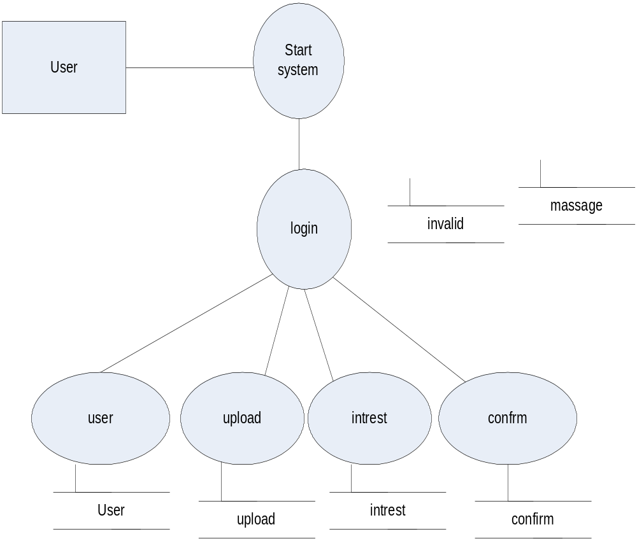

4.1.3 SECOND LEVEL DFD

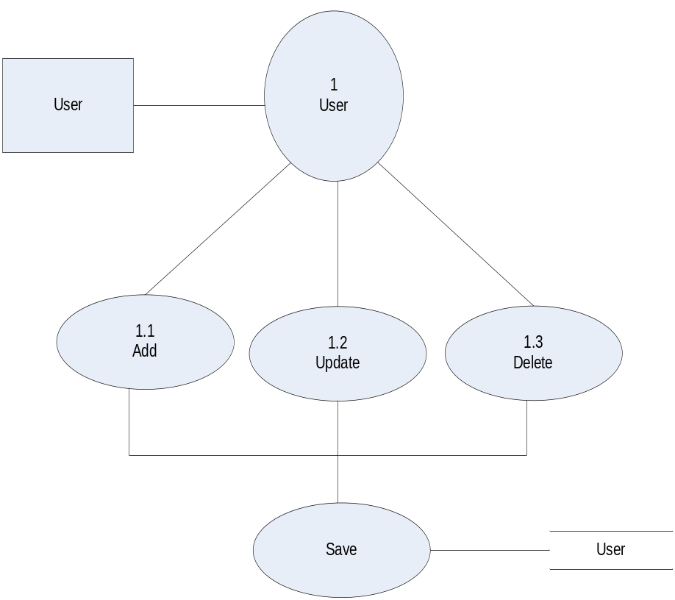

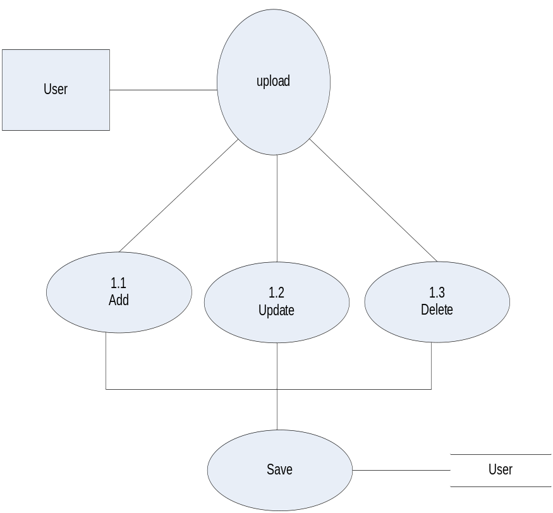

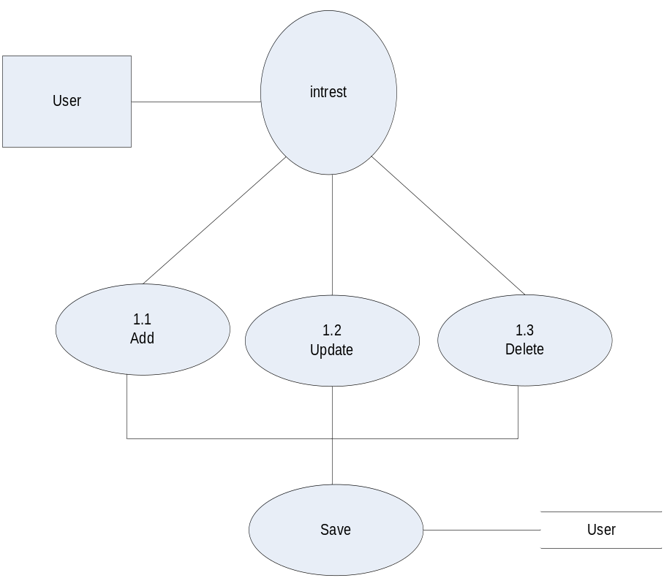

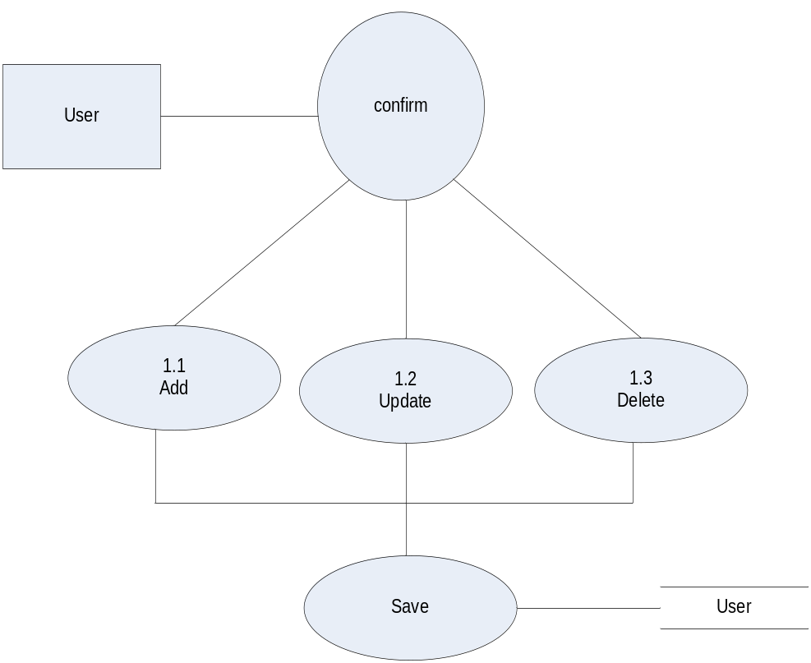

4.1.3 U.M.L (USES CASEB DIAGRAM)

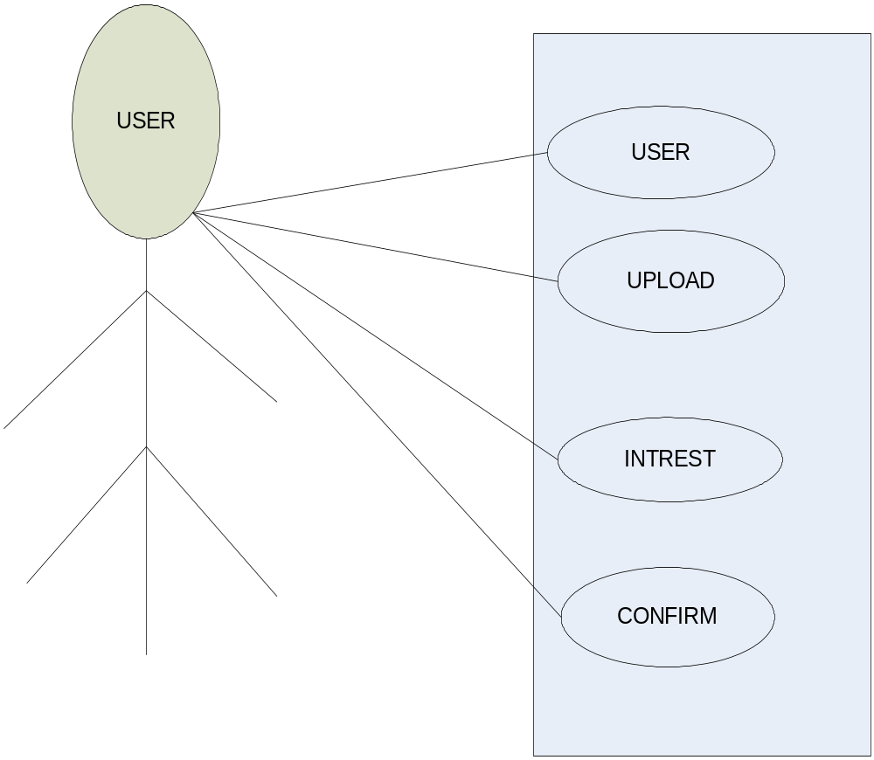

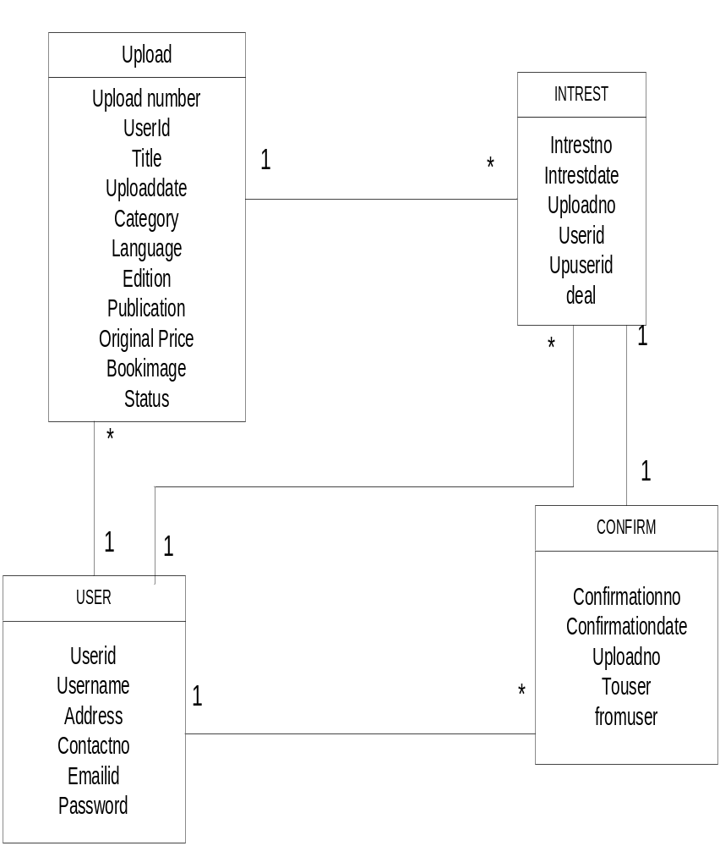

Entity Relationship Diagrams :-

Relation between USER & UPLOAD

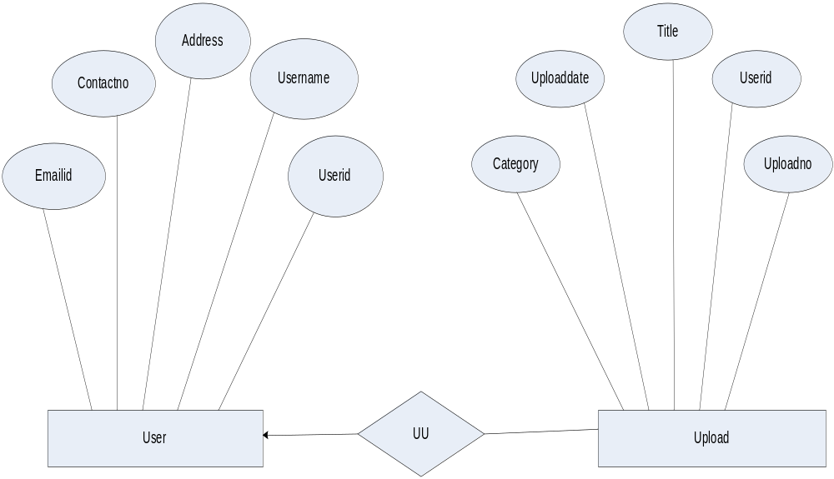

1.1.2 Relation between USER & INTREST

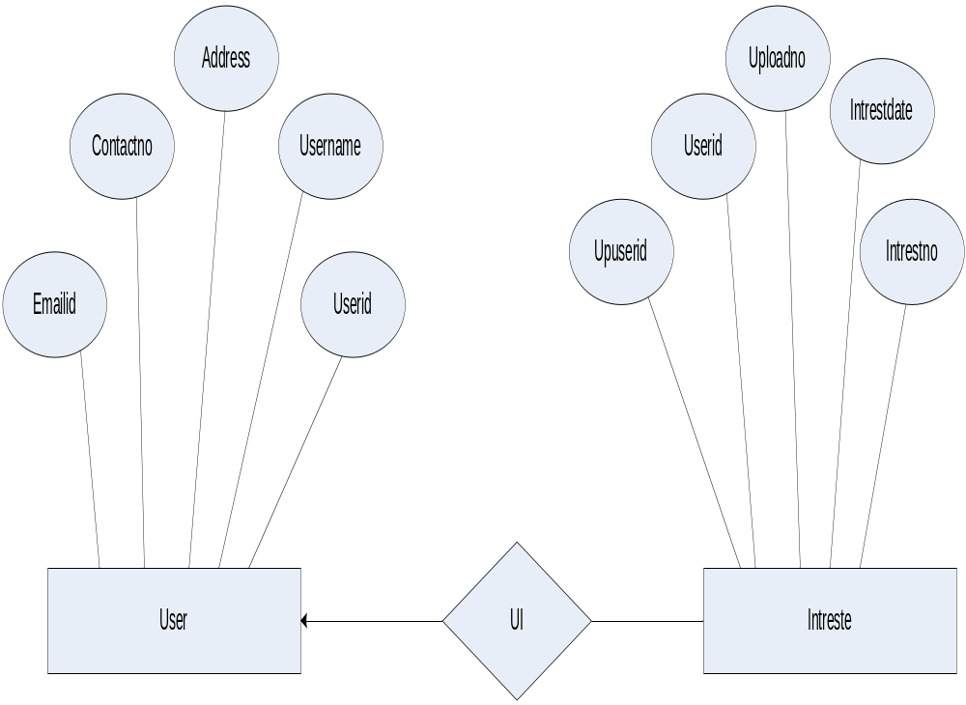

1.1.3 Relation between USER & CONFIRM

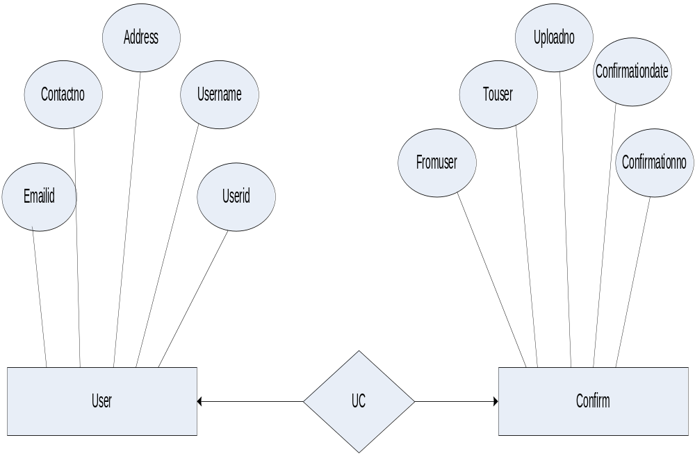

1.1.4 Relation between UPLOAD & INTREST

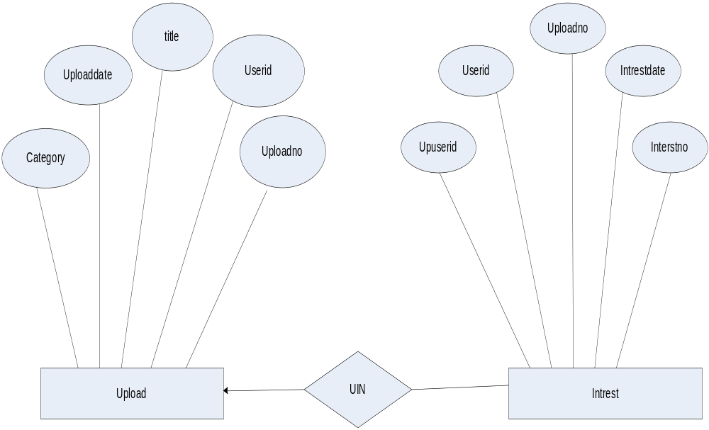

1.1.5 Relation between INTREST & CONFIRM

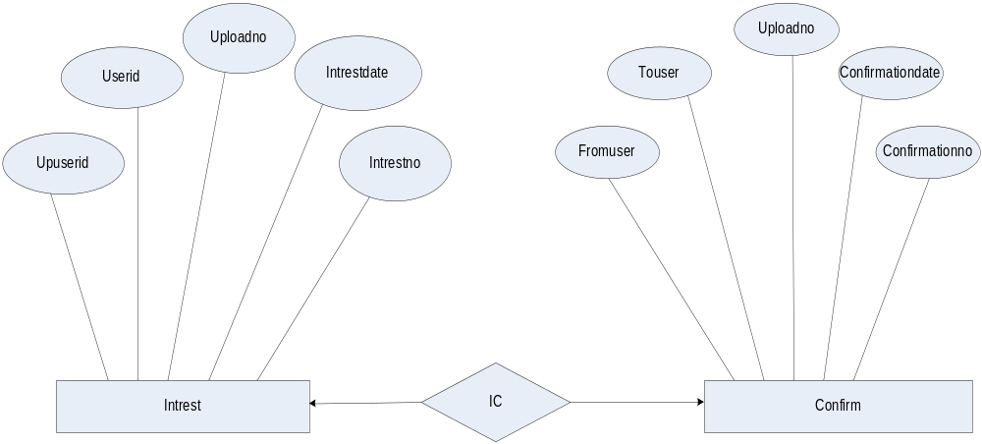

Input Report

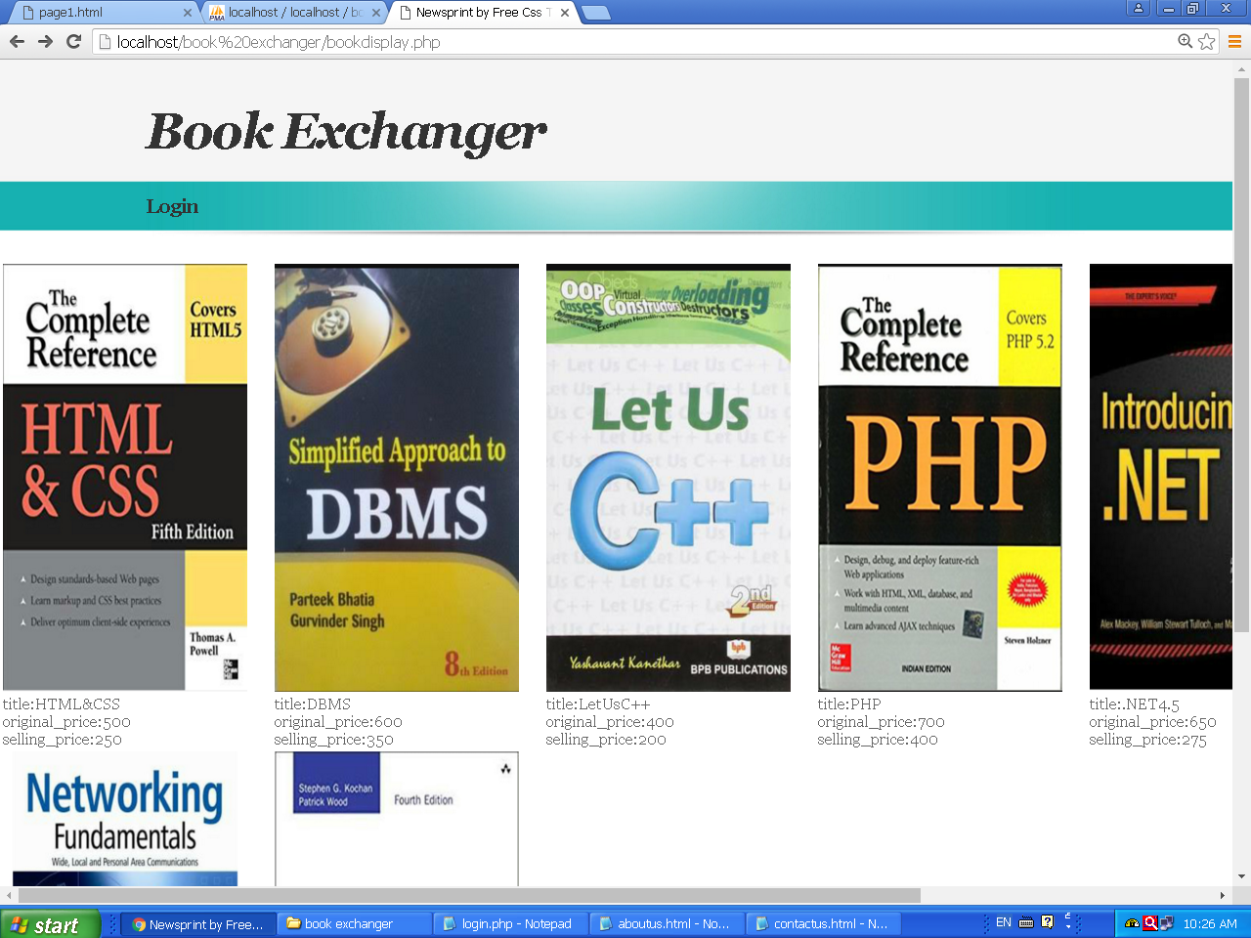

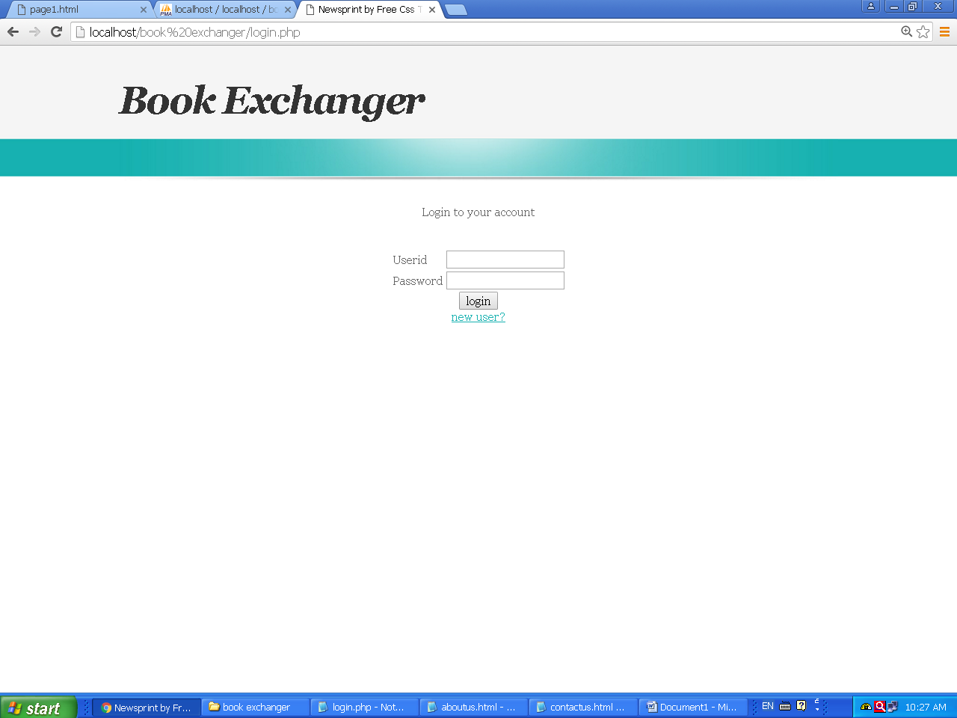

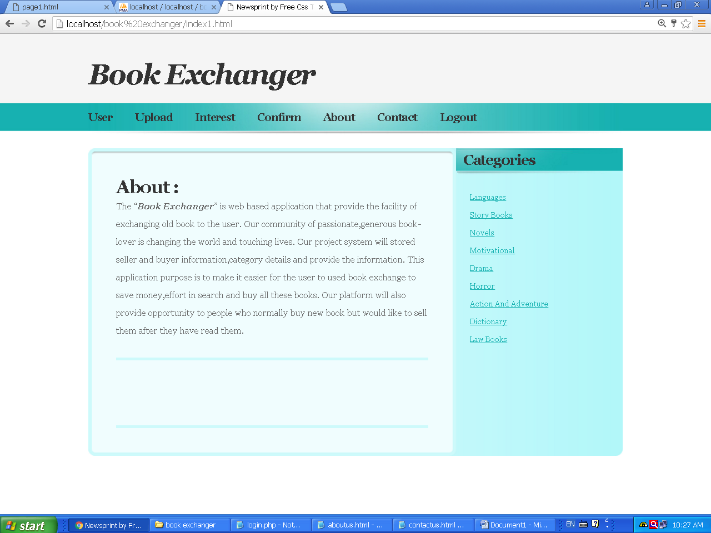

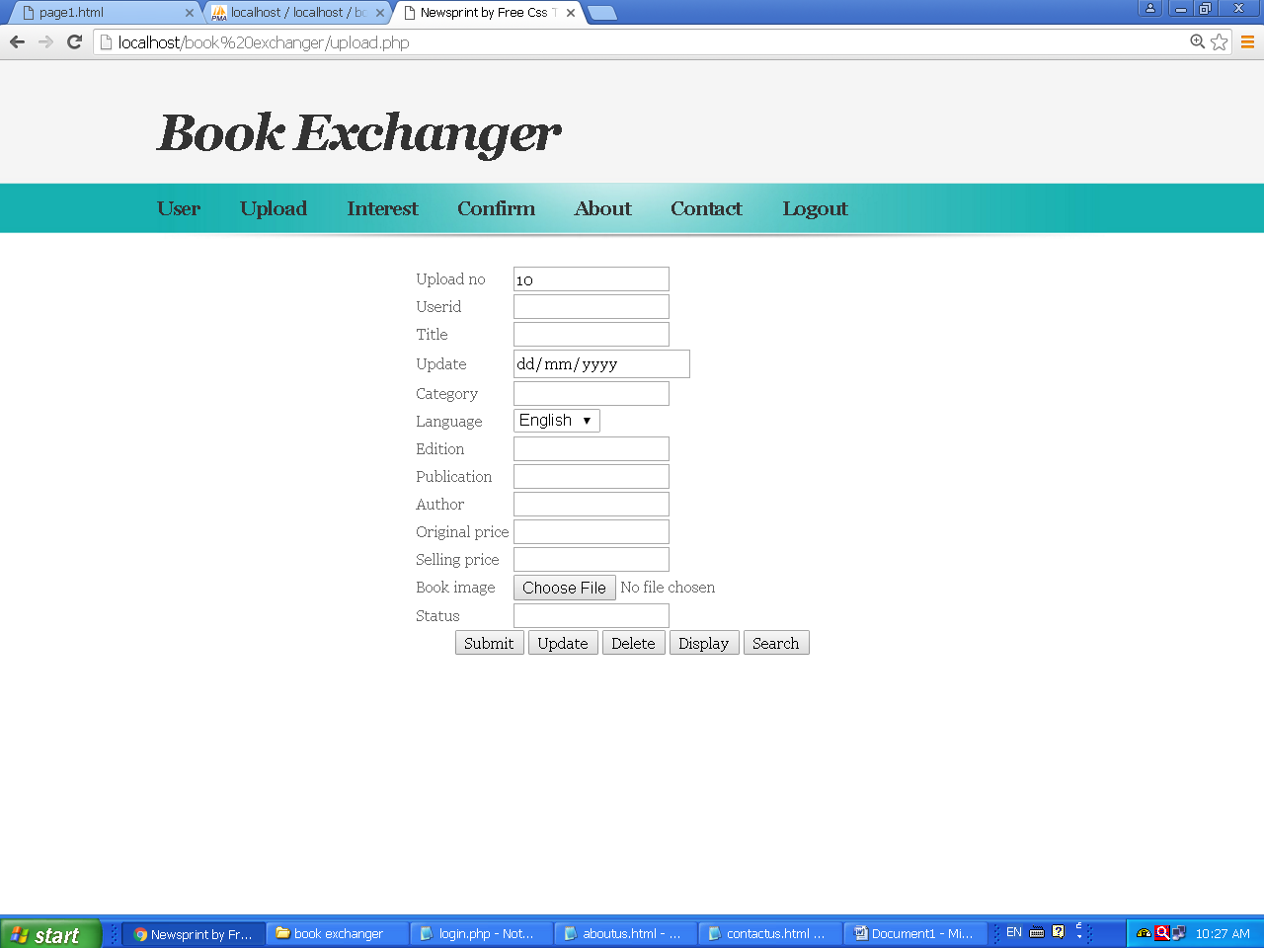
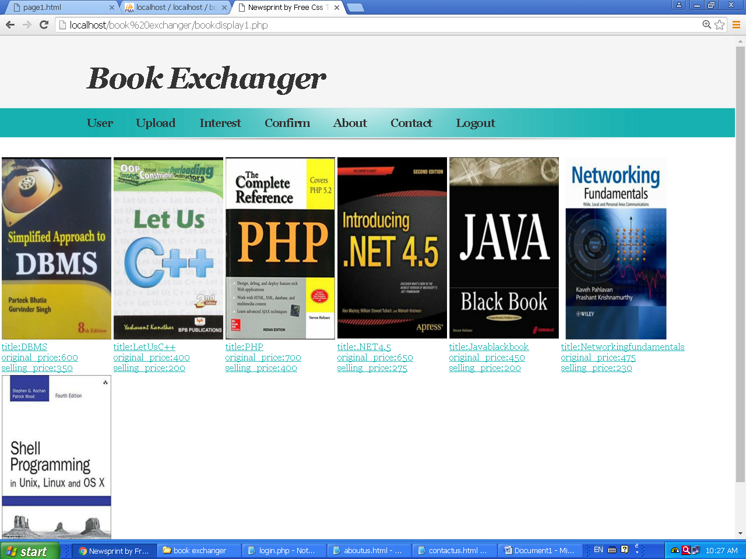

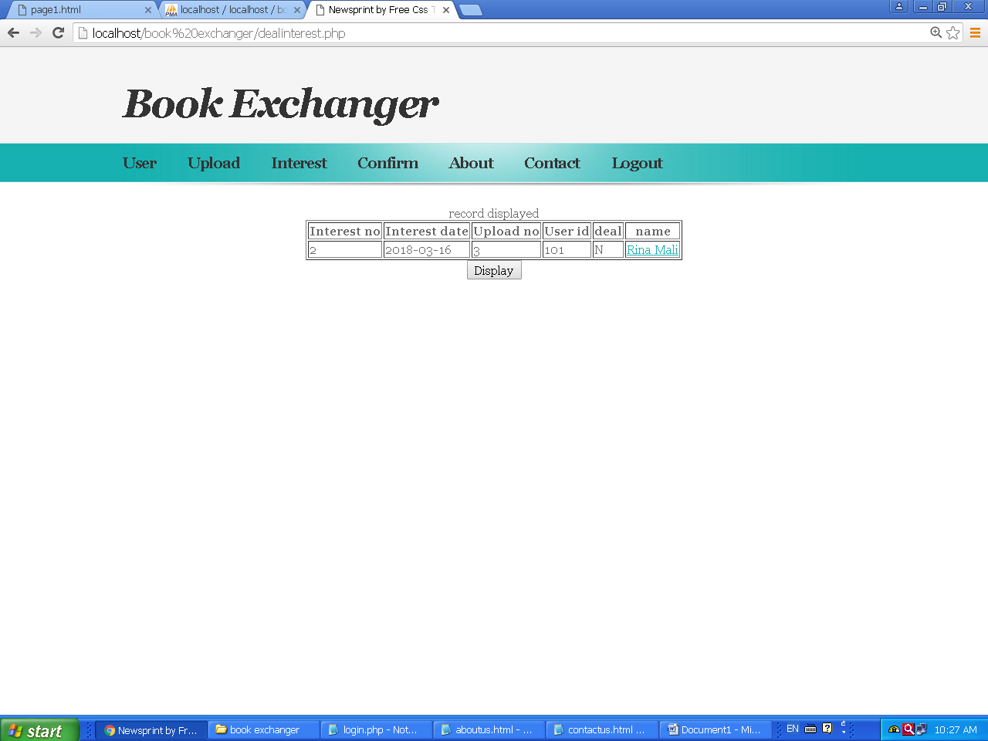

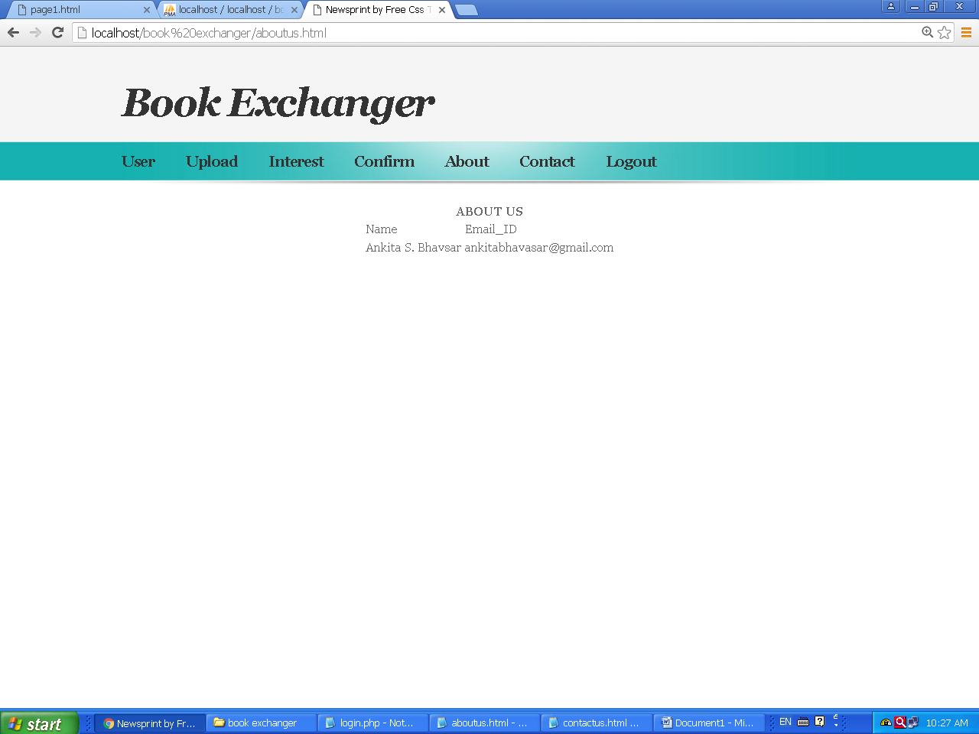

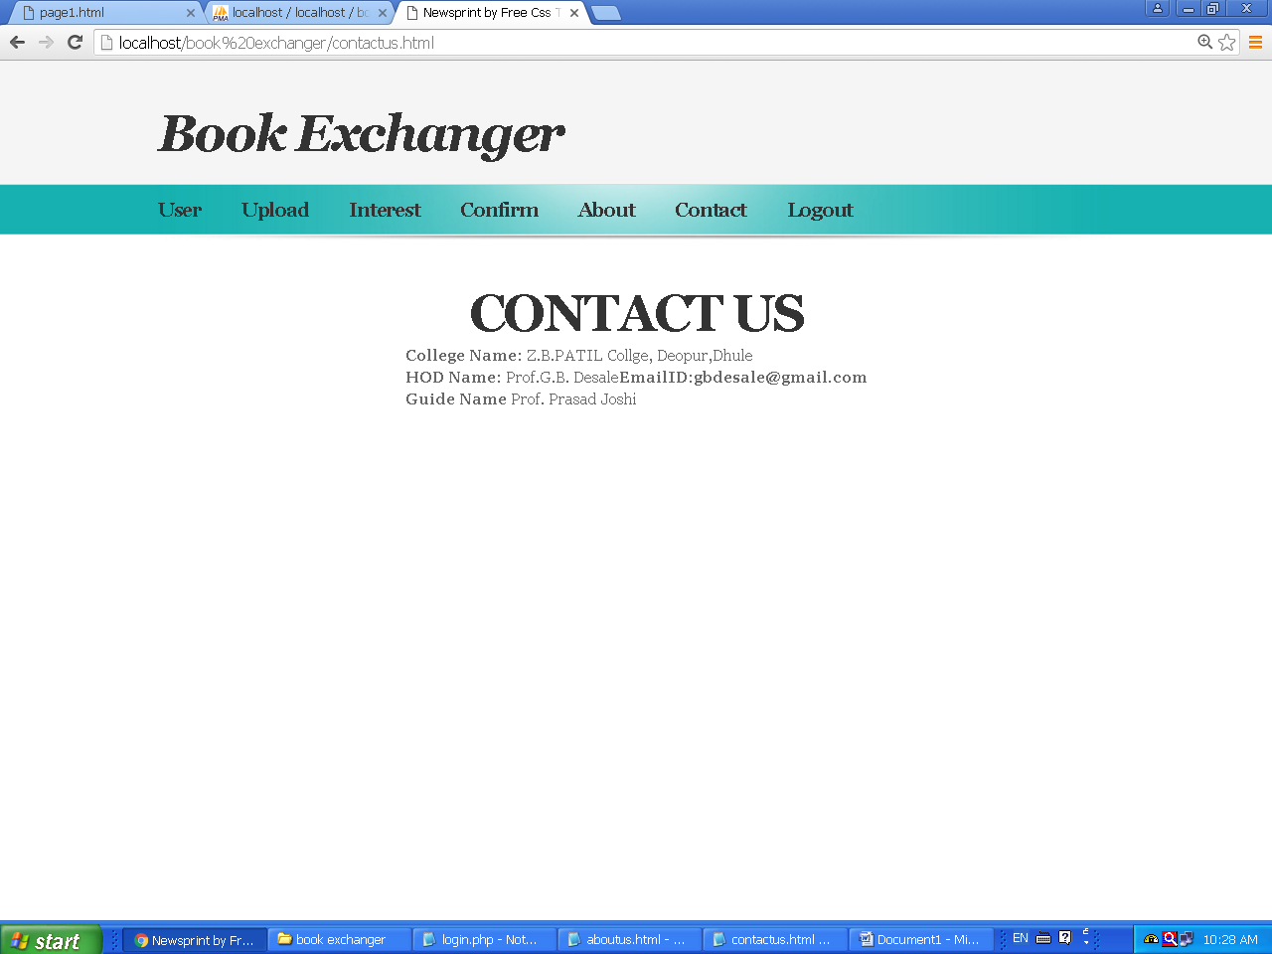

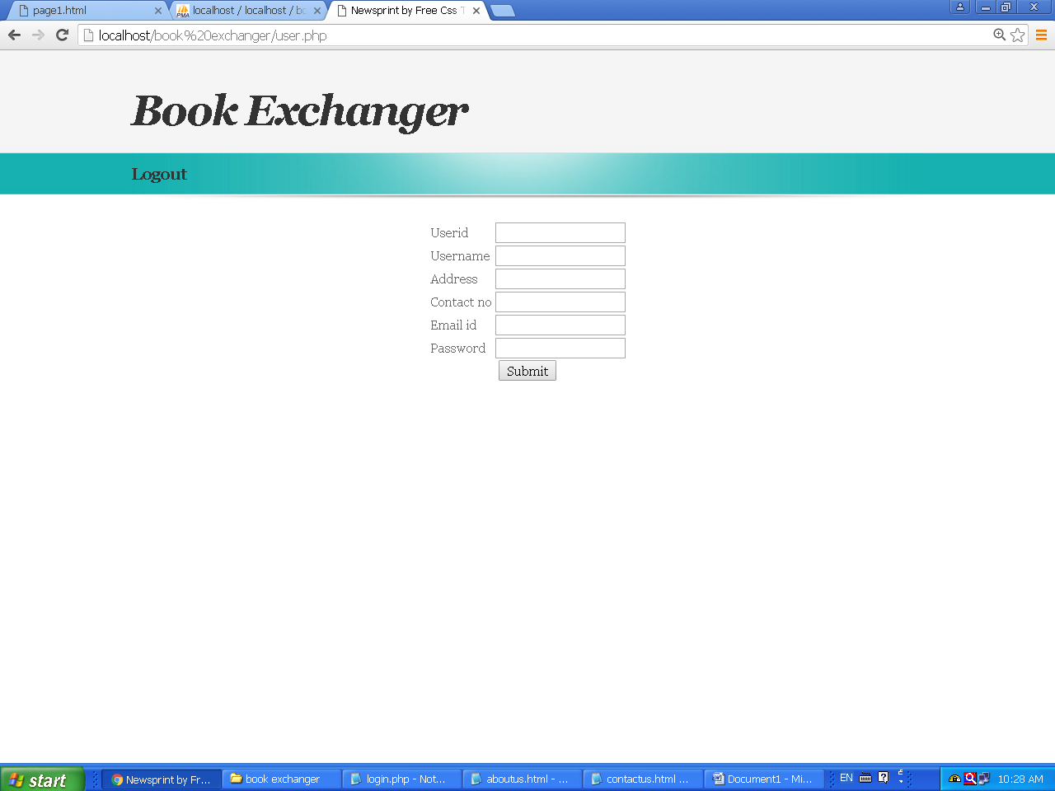

Output Report

Report List

Chapter 5

Implementation

5.1 User Training Guide

An analysis of user training is based on two factors user capabilities and nature of the system being installed. User range from the native to the sophisticated user.

Generally sophisticated user to learn form manuals while operational user learn form demonstration and form on line help.

User must read manuals but they will learn for demonstration through Visual aids. User also tends to be natural teacher. For many user training is most important to take the information’s means it is necessary to provide documentation that user will read and refer to over the file of system. An important document that can be provided is introduction of the system and the sheets instruct the user and how to start the system about the various functions that contain description of each menu.

Another users training element is a training demonstration, live demonstration with personal contacts are externally effective for training user. In demonstration a new concept that is known in many ways (see it, do it) os quickly learned. It is most important that at the time of demonstration the user receive encouragement and attention.

Hearing and asking question and making mistakes help on understanding the system and improve self-confidence. The three main phases in implementation take place in series; there are the initial installations the text of the system and the evaluation maintain of control of the system.

Expected Problems and Solution:-

No body is perfect therefore you make mistake when using a computer here we discuss the few of the more common problems & how to correct them. The printer off:-
When the printer is off the computer will indicate the printer problems & the desired report will not print, simply turn the printer on & return.

File not Found:-

The only way this can happen if we forget to place telephone fault. System files in particular directory of proper drive, simply check and place disk in correct drive to avoid this mistake.

Lost the Last Data Enter:-

As in any other computer, programmer of telecom system open its, files to be read, record information etc, or any unauthorized user deletes the record of files then to avoid these problem when we return to the dos form main we should take the backup of all data files.

Chapter 6

Conclusion
&
Suggestion

6.1 Merits:-

No. of Manual Process.
Saving of money and time
Loss of dockets or report/ analysis can be generated immediately.

6.2 Demerit:-

This is not generalized system; it is useful for only Maharashtra State Road Transport Corporation. For making is for another exchange there must be made some changes.

6.3 Suggestions to New Organization:-

The system should be completely user friendly. But it must be done carefully handling or menus to complete task must be in proper sequence.
As the staff of Maharashtra State Road Transport Corporation must be well trained before handling. The software or to appoint new staff to handle this software.

Chapter 7

References

References

Mastering Visual Basic

By- Patrick Naughton

Database System Concepts

By- Henry F. Korth

Mcgrraw- Hill International Edition

System Analysis and Design

By- Elias .M. Awd
.
Galgotina Publication Pvt.Ltd.

Software Engineering, A Practitioner’s Approach

By- Roger S. Pressman

McGraw - Hill International Edition.

