demo

# Some Main Header

some more text to show things… some more text to show things… some more text to show things… some more text to show things… some more text to show things… some more text to show things…

## Some Level 2 Header

even more text but this time with code even more text but this time with code even more text but this time with code even more text but this time with code

plot(rnorm(1000))

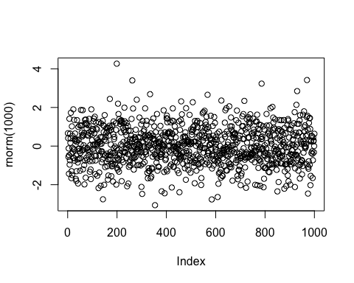

even more text but this time with code even more text but this time with code even more text but this time with code even more text but this time with code