History of aviation

From Wikipedia, the free encyclopedia

[Jump to navigation](https://en.wikipedia.org/wiki/History_of_aviation#mw-head) [Jump to search](https://en.wikipedia.org/wiki/History_of_aviation#p-search)

[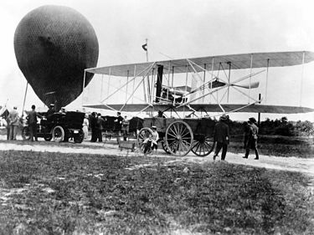](https://en.wikipedia.org/wiki/File:Wright_Military_Flyer_arrives_at_Fort_Myer_VA_DA-SD-05-00659.JPEG)

The [Wright Military Flyer](https://en.wikipedia.org/wiki/Wright_Military_Flyer) aboard a wagon in 1908.

[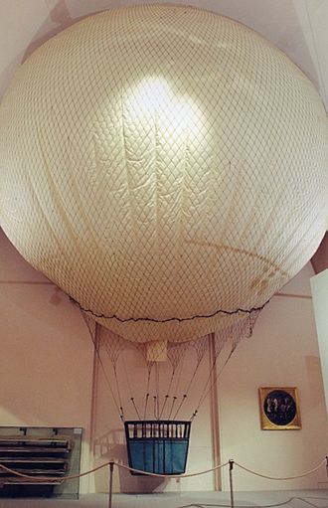](https://en.wikipedia.org/wiki/File:HGM_Kriegsballon_W%C3%BCrzburg_1796.jpg)

French reconnaissance balloon [*L'Intrépide*](https://en.wikipedia.org/wiki/L%27Intr%C3%A9pide) of 1796, the oldest existing flying device, in the [Heeresgeschichtliches Museum](https://en.wikipedia.org/wiki/Heeresgeschichtliches_Museum), Vienna.

[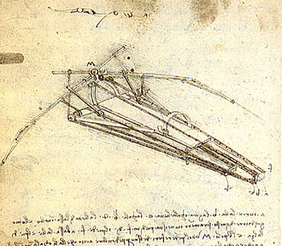](https://en.wikipedia.org/wiki/File:Design_for_a_Flying_Machine.jpg)

[Leonardo da Vinci](https://en.wikipedia.org/wiki/Leonardo_da_Vinci)'s [Ornithopter](https://en.wikipedia.org/wiki/Ornithopter) design.

[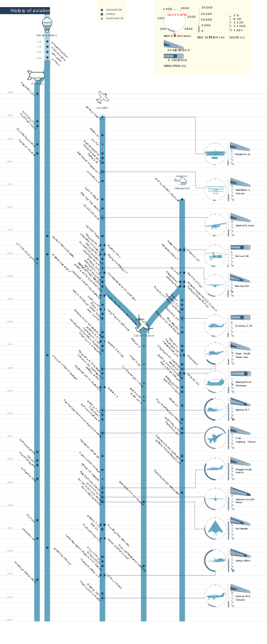](https://en.wikipedia.org/wiki/File:History_of_aviation.svg)

Aviation timeline

The **history of aviation** extends for more than two thousand years, from the earliest forms of [aviation](https://en.wikipedia.org/wiki/Aviation) such as [kites](https://en.wikipedia.org/wiki/Kite) and attempts at tower jumping to [supersonic](https://en.wikipedia.org/wiki/Super_sonic_flight) and [hypersonic](https://en.wikipedia.org/wiki/Hypersonic) flight by powered, [heavier-than-air](https://en.wikipedia.org/wiki/Heavier-than-air_flight) [jets](https://en.wikipedia.org/wiki/Jet_aircraft).

Kite flying in [China](https://en.wikipedia.org/wiki/China) dates back to several hundred years BC and slowly spread around the world. It is thought to be the earliest example of man-made flight.

[Leonardo da Vinci](https://en.wikipedia.org/wiki/Leonardo_da_Vinci)'s 15th-century dream of flight found expression in several rational but unscientific designs, though he did not attempt to construct any of them.

The discovery of [hydrogen](https://en.wikipedia.org/wiki/Hydrogen) gas in the 18th century led to the invention of the [hydrogen balloon](https://en.wikipedia.org/wiki/Hydrogen_balloon), at almost exactly the same time that [the Montgolfier brothers](https://en.wikipedia.org/wiki/Montgolfier_brothers) rediscovered the hot-air balloon and began manned flights.[[1]](https://en.wikipedia.org/wiki/History_of_aviation#cite_note-wings-tom-1) Various theories in [mechanics](https://en.wikipedia.org/wiki/Mechanics) by physicists during the same period of time, notably [fluid dynamics](https://en.wikipedia.org/wiki/Fluid_dynamics) and [Newton's laws of motion](https://en.wikipedia.org/wiki/Newton%27s_laws_of_motion), led to the foundation of modern [aerodynamics](https://en.wikipedia.org/wiki/Aerodynamics), most notably by [Sir George Cayley](https://en.wikipedia.org/wiki/Sir_George_Cayley).

Balloons, both free-flying and tethered, began to be used for military purposes from the end of the 18th century, with the French government establishing Balloon Companies during the [Revolution](https://en.wikipedia.org/wiki/French_Revolution).[[2]](https://en.wikipedia.org/wiki/History_of_aviation#cite_note-hallion-2)

The term aviation, noun of action from stem of Latin avis "bird" with suffix -ation meaning action or progress, was coined in 1863 by French pioneer Guillaume Joseph Gabriel de La Landelle (1812–1886) in "Aviation ou Navigation aérienne sans ballons".[[3]](https://en.wikipedia.org/wiki/History_of_aviation#cite_note-3)[[4]](https://en.wikipedia.org/wiki/History_of_aviation#cite_note-4)

Experiments with gliders provided the groundwork for heavier-than-air craft, and by the early-20th century, advances in engine technology and aerodynamics made controlled, powered flight possible for the first time. The modern [aeroplane](https://en.wikipedia.org/wiki/Aeroplane) with its characteristic tail was established by 1909 and from then on the history of the aeroplane became tied to the development of more and more powerful engines.

The first great ships of the air were the rigid dirigible balloons pioneered by [Ferdinand von Zeppelin](https://en.wikipedia.org/wiki/Ferdinand_von_Zeppelin), which soon became synonymous with [airships](https://en.wikipedia.org/wiki/Airship) and dominated long-distance flight until the 1930s, when large [flying boats](https://en.wikipedia.org/wiki/Flying_boat) became popular. After [World War II](https://en.wikipedia.org/wiki/World_War_II), the flying boats were in their turn replaced by land planes, and the new and immensely powerful [jet engine](https://en.wikipedia.org/wiki/Jet_engine) revolutionised both air travel and [military aviation](https://en.wikipedia.org/wiki/Military_aviation).

In the latter part of the 20th century the advent of digital electronics produced great advances in flight instrumentation and "fly-by-wire" systems. The 21st century saw the large-scale use of pilotless drones for military, civilian and leisure use. With digital controls, inherently unstable aircraft such as flying wings became possible.