An End-to-End Multi-Objective Reinforcement Learning Framework for Unmanned Aerial Vehicle Path Planning with Dynamic Obstacle Avoidance and Energy Efficiency
[Author Name(s)]
[Department, University, City, Country — e-mail]

Highlights
• A preference-conditioned multi-objective RL framework for UAV navigation among fast-moving obstacles is proposed.
• A physics-based rotary-wing propulsion power model is embedded directly in the reward function.
• A single policy trades energy against mission priority at test time, yielding up to 13% paired energy savings without loss of success rate.
• The framework is algorithm-agnostic: sensor-based SAC attains a 0.91 success rate, numerically exceeding a full-state potential-field oracle, while PPO yields the most energy-efficient flight (52% less energy than replanning A*).
• The existence of the goal–energy trade-off is shown, analytically and empirically, to depend on whether the platform speed limit exceeds the maximum-range speed.

Abstract
Autonomous unmanned aerial vehicles (UAVs) operating in cluttered, dynamic airspace must simultaneously reach their goal, avoid moving obstacles, and conserve limited battery energy — three objectives that can conflict. This paper presents an end-to-end multi-objective reinforcement learning (MORL) framework that maps raw onboard range measurements directly to continuous acceleration commands while explicitly optimising a vector-valued reward comprising goal progress, propulsion energy, and safety. Energy is modelled with the analytical rotary-wing power curve of Zeng et al., embedding realistic flight physics into learning. The policy is conditioned on a preference vector sampled from a Dirichlet distribution during training, so that a single trained network can realise different trade-off behaviours at test time simply by changing its preference input. The framework is instantiated with three deep reinforcement learning algorithms. In a 3-D arena containing twenty moving obstacles, a sensor-based Soft Actor-Critic (SAC) policy attains a 0.91 success rate — numerically exceeding a privileged artificial potential field controller with perfect obstacle knowledge (0.82) and statistically indistinguishable from it — while proximal policy optimization (PPO; 0.80 ± 0.07 over three seeds) delivers the most energy-efficient flight, consuming 52% less energy than a frozen-world replanning A* baseline (657 J vs. 1363 J per episode, p < 0.0001); the choice of learning algorithm itself thus selects a point on the success–energy trade-off. A paired evaluation protocol, in which every preference vector is tested on identical world instances, shows that shifting the preference from goal-dominant to energy-dominant reduces per-episode energy by up to 13.0% (SAC: 103 ± 196 J; Wilcoxon p < 0.0001) with no reduction in success rate. Finally, we show analytically and empirically that the goal–energy trade-off exists only when the platform speed limit exceeds the maximum-range speed of the rotor power curve (≈18.3 m/s): below it the objectives align and the Pareto front collapses. All code, configurations, and evaluation pipelines are released for full reproducibility.

Keywords
Unmanned aerial vehicle; path planning; multi-objective reinforcement learning; dynamic obstacle avoidance; energy efficiency; Pareto optimisation; proximal policy optimization

1. Introduction
Unmanned aerial vehicles are increasingly deployed for parcel delivery, infrastructure inspection, precision agriculture, and search-and-rescue. Two operational constraints dominate these missions. First, low-altitude airspace is dynamic: other aircraft, birds, cranes, and vehicles move unpredictably, so a planner that assumes a static world degrades rapidly. Second, multirotor platforms carry severely limited battery energy; the propulsion power of a rotary-wing UAV is a strongly non-linear function of airspeed, and ignoring this physics leads to plans that are feasible geometrically but wasteful energetically.
Classical planners handle these constraints only partially. Grid- or sampling-based methods such as A* and RRT* produce optimal or near-optimal paths under a frozen-world assumption and must be replanned continuously when obstacles move, while reactive methods such as the artificial potential field (APF) respond instantly but require accurate knowledge of obstacle positions and are prone to local minima. Deep reinforcement learning (DRL) offers an attractive alternative: a policy can be trained end-to-end from raw sensing to control, internalising both the dynamics of moving obstacles and the cost structure of the platform. However, most DRL path-planning studies (i) collapse multiple mission objectives into a single scalar reward with fixed hand-tuned weights, so that any change of operational priority requires complete retraining; (ii) represent energy by a generic per-step penalty rather than a validated propulsion model; and (iii) evaluate against static or slowly moving obstacles.
This paper addresses all three gaps with an end-to-end multi-objective reinforcement learning (MORL) framework for UAV path planning. The reward is an explicit three-dimensional vector — goal progress, propulsion energy, and safety — and the policy is conditioned on a preference (scalarisation weight) vector sampled from a Dirichlet distribution during training. A single trained network therefore exposes a family of trade-off behaviours that can be selected at test time without retraining. Energy is computed with the analytical rotary-wing power model of Zeng et al. (2019), which captures blade-profile, induced, and parasite power as well as climb cost, so that the learned behaviour reflects genuine flight physics.
The main contributions are as follows.
(1) Physics-informed energy objective. The Zeng–Zhang rotary-wing propulsion power model is embedded directly in the reward, replacing the ad-hoc step penalties common in the literature.
(2) Preference-conditioned MORL with paired evaluation. A single Dirichlet-conditioned policy traces an approximate Pareto front at test time. We introduce a paired evaluation protocol — every preference vector is evaluated on identical world instances — which detects controllability effects that are invisible to conventional mean comparisons, and we report per-seed significance honestly, including one seed in which the policy converged to a preference-insensitive solution.
(3) Objective-alignment analysis. We show that the energy-per-metre curve of a rotary-wing UAV decreases monotonically up to the maximum-range speed (≈18.3 m/s for the adopted parameters). When the platform speed limit lies below this value, the goal and energy objectives are aligned and the Pareto front provably collapses to a point; raising the speed limit above it restores a genuine conflict. This observation, verified empirically, implies that MORL benchmarks must confirm that their objectives actually conflict before claiming trade-off control.
(4) Fair, fully reproducible benchmark. The sensor-based DRL policy is compared against a privileged (full-state) APF oracle and a replanning 3-D A* baseline through an identical environment interface and metric pipeline, over multiple training seeds, with non-parametric significance tests. The complete codebase, configurations, and evaluation scripts are released.
The remainder of the paper is organised as follows. Section 2 reviews related work. Section 3 formalises the problem as a multi-objective Markov decision process and details the environment, energy model, and reward design. Section 4 describes the learning framework and baselines. Section 5 presents the experimental setup, Section 6 the results, Section 7 the discussion and limitations, and Section 8 concludes.

2. Related Work

2.1. Classical UAV path planning
Graph-search planners such as A* (Hart et al., 1968) and its dynamic variants compute cost-optimal paths on a discretised representation of the workspace but rely on a frozen snapshot of the obstacle field; in dynamic environments they must be replanned at high frequency and remain vulnerable to obstacles that move between planning cycles. Sampling-based planners (RRT, RRT*) scale better to high-dimensional spaces but inherit the same staleness problem. Reactive approaches, most prominently the artificial potential field method (Khatib, 1986), compute attractive and repulsive forces from the instantaneous obstacle configuration and respond immediately to motion, at the cost of requiring accurate obstacle state estimates and being susceptible to local minima. Comprehensive surveys of UAV path-planning techniques are given by Aggarwal and Kumar (2020).

2.2. Reinforcement learning for UAV navigation
DRL has been applied to UAV navigation with value-based (DQN), deterministic actor–critic (DDPG, TD3), and stochastic policy-gradient methods (PPO, SAC). These works demonstrate that end-to-end policies can outperform hand-designed controllers in cluttered scenes, but the overwhelming majority optimise a single scalar reward in which collision penalties, goal bonuses, and energy or time costs are combined with fixed coefficients. The resulting policy realises exactly one point on the trade-off surface; changing the operational priority — for example, accepting a longer flight to conserve a depleted battery — requires full retraining. Furthermore, energy is typically represented by a constant per-step cost or a velocity-magnitude penalty, neither of which reproduces the characteristic U-shaped power curve of rotary-wing flight.

2.3. Multi-objective reinforcement learning
MORL formalises decision problems with vector-valued rewards (Roijers et al., 2013; Hayes et al., 2022). Linear scalarisation is the simplest solution strategy but can only reach the convex portion of the Pareto front and, in deep RL, is prone to converging to a single trade-off point. Envelope Q-learning (Yang et al., 2019) and related preference-conditioned methods train a single network across the whole preference simplex, enabling test-time adaptation. Our framework adopts this preference-conditioned paradigm with on-policy PPO, samples preferences from a Dirichlet distribution during training, and — unlike most prior UAV work — quantifies the achieved controllability with paired statistical tests on identical world instances, reporting per-seed variability.

2.4. Energy models for UAV planning
Zeng, Xu and Zhang (2019) derived a closed-form propulsion power model for rotary-wing UAVs comprising blade-profile, induced, and parasite terms, and identified the maximum-endurance and maximum-range speeds that structure energy-optimal flight. The model has been widely adopted in the UAV communication literature but only rarely inside reinforcement-learning rewards. We embed it directly in the per-step reward and additionally exploit its structure analytically: the location of the maximum-range speed relative to the platform speed limit determines whether the goal and energy objectives conflict at all (Section 6.3).

3. Problem Formulation

3.1. Multi-objective MDP
The task is modelled as a multi-objective Markov decision process M = (S, A, P, r, γ) in which the reward is a vector r(s, a) = [r_goal, r_energy, r_safety] ∈ R³. A scalarised return R = wᵀr with preference vector w ∈ Δ² (the 2-simplex) is delivered to the learning algorithm, while the full vector is logged for offline Pareto analysis. During training w is drawn at the start of every episode from a Dirichlet(1, 1, 1) distribution and appended to the observation, so the learned policy π(a | s, w) is explicitly conditioned on the operator preference.

3.2. UAV kinematics
The UAV is modelled as a 3-D point mass of radius 0.5 m with first-order velocity dynamics: v(t+1) = (1 − λ) v(t) + a Δt, with drag coefficient λ = 0.05, control interval Δt = 0.2 s, speed limit ‖v‖ ≤ v_max and per-axis acceleration limit |a_i| ≤ a_max. In the main configuration v_max = 25 m/s and a_max = 8 m/s². The action a ∈ [−1, 1]³ is a normalised 3-D acceleration command scaled by a_max.

3.3. Rotary-wing propulsion energy model
Instantaneous propulsion power follows the analytical rotary-wing model of Zeng et al. (2019):
P(V) = P₀(1 + 3V²/U_tip²) + P_i (√(1 + V⁴/4v₀⁴) − V²/2v₀²)^{1/2} + ½ d₀ ρ s A V³ + m g [V_z]⁺,
where V is the horizontal airspeed and the three terms represent blade-profile, induced, and parasite power respectively; the final term is the climb power (a fraction of it is recovered during descent). We adopt the parameter values of Zeng et al. (Table 1): P₀ = 79.86 W, P_i = 88.63 W, U_tip = 120 m/s, v₀ = 4.03 m/s, d₀ = 0.6, ρ = 1.225 kg/m³, s = 0.05, A = 0.503 m², with platform mass m = 2 kg. Hover power is P(0) ≈ 168.5 W; the energy-per-metre P(V)/V decreases monotonically up to the maximum-range speed V_mr ≈ 18.3 m/s (8.83 J/m) and rises thereafter due to parasite drag. The per-step energy E_t = P(v_t) Δt is deducted from a 60 kJ battery; depleting the battery terminates the episode.

3.4. Observation, action, and reward
The 43-dimensional observation comprises: the relative goal vector normalised by the arena diagonal (3); the normalised velocity (3); a LiDAR-like range scan of 16 rays (14 horizontal, 2 vertical) with sensor range 25 m (16); the previous ray scan (16), which allows the policy to infer obstacle motion from consecutive range measurements; the remaining battery fraction (1); the normalised minimum obstacle clearance (1); and the preference vector w (3). All components are clipped to [−1, 1].
The reward vector components are: r_goal = k_p (d_{t−1} − d_t) − c_step, i.e., progress towards the goal minus a time penalty (k_p = 1, c_step = 0.1), plus a terminal bonus of +50 upon reaching the goal (distance < 3 m) and −5 at time-out; r_energy = −k_e (E_t / E_hover) σ_e with k_e = 3 and scale σ_e = 0.3, plus −10 upon battery depletion; and r_safety = −k_s (1 − c_t / d_danger)² whenever the clearance c_t falls below the danger radius d_danger = 4 m (k_s = 2), −1 per out-of-bounds contact, and −50 upon collision. Episodes terminate on goal arrival, collision, battery depletion, or after 400 steps.

3.5. Dynamic obstacle field
Each episode instantiates 20 spherical obstacles with radii sampled from [1.5, 3.5] m and speeds from [1.5, 4.0] m/s in a 60 × 60 × 20 m arena. All obstacles are dynamic, following one of three motion patterns chosen uniformly at random: linear motion with elastic reflection at the arena boundary, sinusoidal oscillation along a random axis, or circular motion about an anchor point. Start and goal positions are sampled at least 40 m apart, and no obstacle spawns within 5 m of either. Ray measurements are obtained by exact ray–sphere intersection.

4. Proposed Framework and Baselines

4.1. Preference-conditioned policy learning
Fig. 1 provides a schematic overview of the proposed framework. The framework is learner-agnostic: any deep RL algorithm operating on the conditioned observation inherits the multi-objective structure. We instantiate it with three algorithms from Stable-Baselines3 (Raffin et al., 2021): on-policy Proximal Policy Optimization (PPO; Schulman et al., 2017), and the off-policy Soft Actor-Critic (SAC; Haarnoja et al., 2018) and Twin Delayed DDPG (TD3; Fujimoto et al., 2018). All use multilayer perceptrons with two hidden layers of 256 units for policy and value networks. Because the preference vector w is part of the observation and is resampled every episode, a single set of network weights must perform well across the entire preference simplex; at deployment, the operator selects the desired trade-off simply by fixing w. This is the preference-conditioned MORL paradigm of envelope-style methods (Yang et al., 2019) instantiated with an on-policy learner. PPO is trained with 8 parallel environment instances for 3 × 10⁶ steps per seed (three seeds); SAC and TD3 are trained for 1 × 10⁶ steps (one seed each), a budget at which their off-policy updates (≈10⁶ gradient steps) substantially exceed PPO's. Hyperparameters are listed in Table 1.

4.2. Classical baselines
Two classical planners are evaluated through the identical environment interface — both output normalised acceleration commands consumed by the same simulator and metric pipeline, guaranteeing a like-for-like comparison.
APF oracle. An artificial potential field controller (Khatib, 1986) with attractive gain 1, repulsive gain 30, and influence distance 6 m. Crucially, it reads the exact positions and radii of all obstacles directly from the simulator state; it therefore constitutes a privileged, full-information upper baseline, whereas the learned policy perceives the world only through its 16-ray sensor.
Replanning A*. A 3-D grid A* planner (2 m resolution, obstacle inflation 1 m) replanned every 5 control steps against the current obstacle snapshot — the standard frozen-world replanning strategy for dynamic environments. A pure-pursuit velocity controller tracks the resulting waypoints.
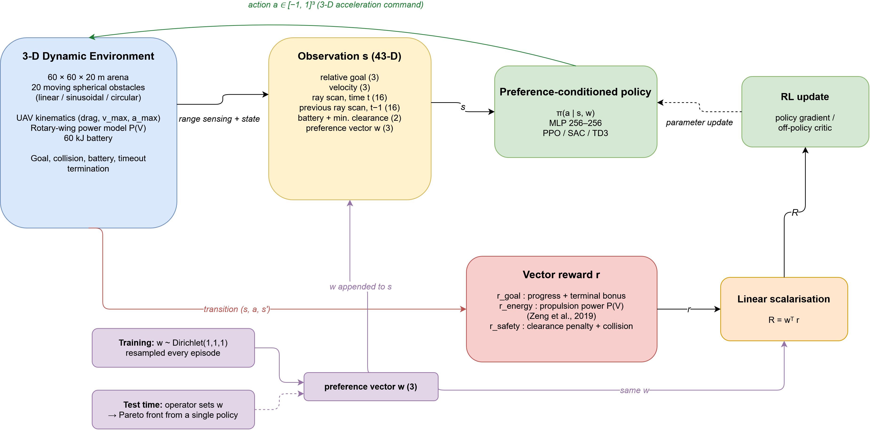
Fig. 1. Overview of the proposed preference-conditioned multi-objective reinforcement learning framework. The UAV perceives the dynamic environment through a 16-ray range sensor; the observation concatenates the relative goal, velocity, current and previous ray scans, battery state, minimum clearance, and the preference vector w, which is sampled from a Dirichlet distribution during training and fixed by the operator at test time. The environment returns the vector reward r = [r_goal, r_energy, r_safety] — with the energy term computed from the rotary-wing power model — scalarised as R = wᵀr for the policy update (PPO/SAC/TD3).

5. Experimental Setup
The environment is implemented against the Gymnasium API (Towers et al., 2024). All experiments use the dynamic configuration of Section 3.5. The learned policy is trained with three independent seeds; the best checkpoint per seed (selected by periodic evaluation during training) is used for testing. Method comparison uses 100 evaluation episodes with world seeds disjoint from training. For the Pareto analysis, each of eight preference vectors — spanning goal-, energy-, and safety-dominant corners of the simplex — is evaluated on the same 300 world instances, enabling paired statistics. Reported metrics are success rate (SR), collision rate (CR), per-episode propulsion energy, path length, path efficiency (straight-line distance divided by flown distance), and minimum obstacle clearance; energy and path statistics are computed over successful episodes. Significance is assessed with Welch's t-test and the Mann–Whitney U test for energy, Fisher's exact test for success rates, and the Wilcoxon signed-rank test for paired preference comparisons.
Table 1. Learning hyperparameters and evaluation protocol.
Parameter | Value
Algorithm / library | PPO, Stable-Baselines3 2.9
Network architecture | MLP 256–256 (policy and value)
Learning rate | 3 × 10⁻⁴
Rollout length / batch / epochs | 2048 / 256 / 10
Discount γ / GAE λ | 0.99 / 0.95
Clip range / entropy coef. | 0.2 / 0.005
Parallel environments | 8
Training steps per seed | PPO: 3 × 10⁶; SAC/TD3: 1 × 10⁶
Seeds | PPO: 42, 43, 44; SAC/TD3: 42
SAC/TD3 (off-policy) | buffer 5×10⁵, batch 256, τ=0.005; TD3 action noise σ=0.1
Preference sampling | w ~ Dirichlet(1,1,1) per episode
Evaluation episodes | 100 (methods), 300 per weight (Pareto)

6. Results

6.1. Method comparison
Table 2 summarises the comparison in the dynamic scenario. All three instantiations of the framework operate on the same 43-dimensional sensor observation. The off-policy learners achieve the highest mission success: SAC reaches 0.91 and TD3 0.87, numerically exceeding even the full-state APF oracle (0.82; Fisher's exact test vs. SAC p = 0.10, statistically indistinguishable) — a substantive result given that the oracle reads the exact position and radius of every obstacle from the simulator while the learned policies perceive the world through 16 range measurements only. PPO attains 0.80 ± 0.07 across three seeds (also indistinguishable from the oracle; seed 42 vs. APF, p = 0.23) but produces the most energy-efficient and shortest flights: 657 ± 22 J and 50.0 m, significantly below SAC (769 J; Welch and Mann–Whitney, both p < 0.0001) and TD3 (754 J, p < 0.001). The choice of learner is thus itself a trade-off — off-policy algorithms buy roughly 10 percentage points of success for about 15% additional energy. Against the frozen-world replanning A* baseline, every learned policy is superior on both axes; PPO consumes 51.8% less energy (657 J vs. 1363 J; Welch and Mann–Whitney, both p < 0.0001) and SAC's success advantage is 32 percentage points (p < 0.0001). The energy gap arises because A* tracks grid waypoints with frequent decelerations and reaccelerations, whereas the learned policies maintain smooth, near-optimal cruise speeds. Fig. 2 shows the PPO training curves across seeds, Fig. 3 representative closed-loop trajectories, and Fig. 5 a graphical summary of all metrics.
Sample-efficiency and wall-clock cost are modest: each 3-million-step training run completes in roughly 23 minutes on a consumer CPU at ≈2,200 environment steps per second, so the full three-seed study trains in under 75 minutes without GPU acceleration.
Table 2. Method comparison in the dynamic scenario (100 evaluation episodes per method). PPO values are mean ± std over three training seeds; baselines are deterministic given the evaluation seeds. Energy and path statistics are over successful episodes.
Method | SR ↑ | CR ↓ | Energy [J] ↓ | Path [m]
SAC (ours, sensor-based) | 0.91 | 0.09 | 769 ± 182 | 53.6
TD3 (ours, sensor-based) | 0.87 | 0.13 | 754 ± 177 | 55.0
PPO (ours, sensor-based) | 0.80 ± 0.07 | 0.20 ± 0.07 | 657 ± 22 | 50.0 ± 1.8
APF (full-state oracle) | 0.82 | 0.18 | 676 ± 208 | 51.8
Replanning A* | 0.59 | 0.24 | 1363 ± 181 | 47.8
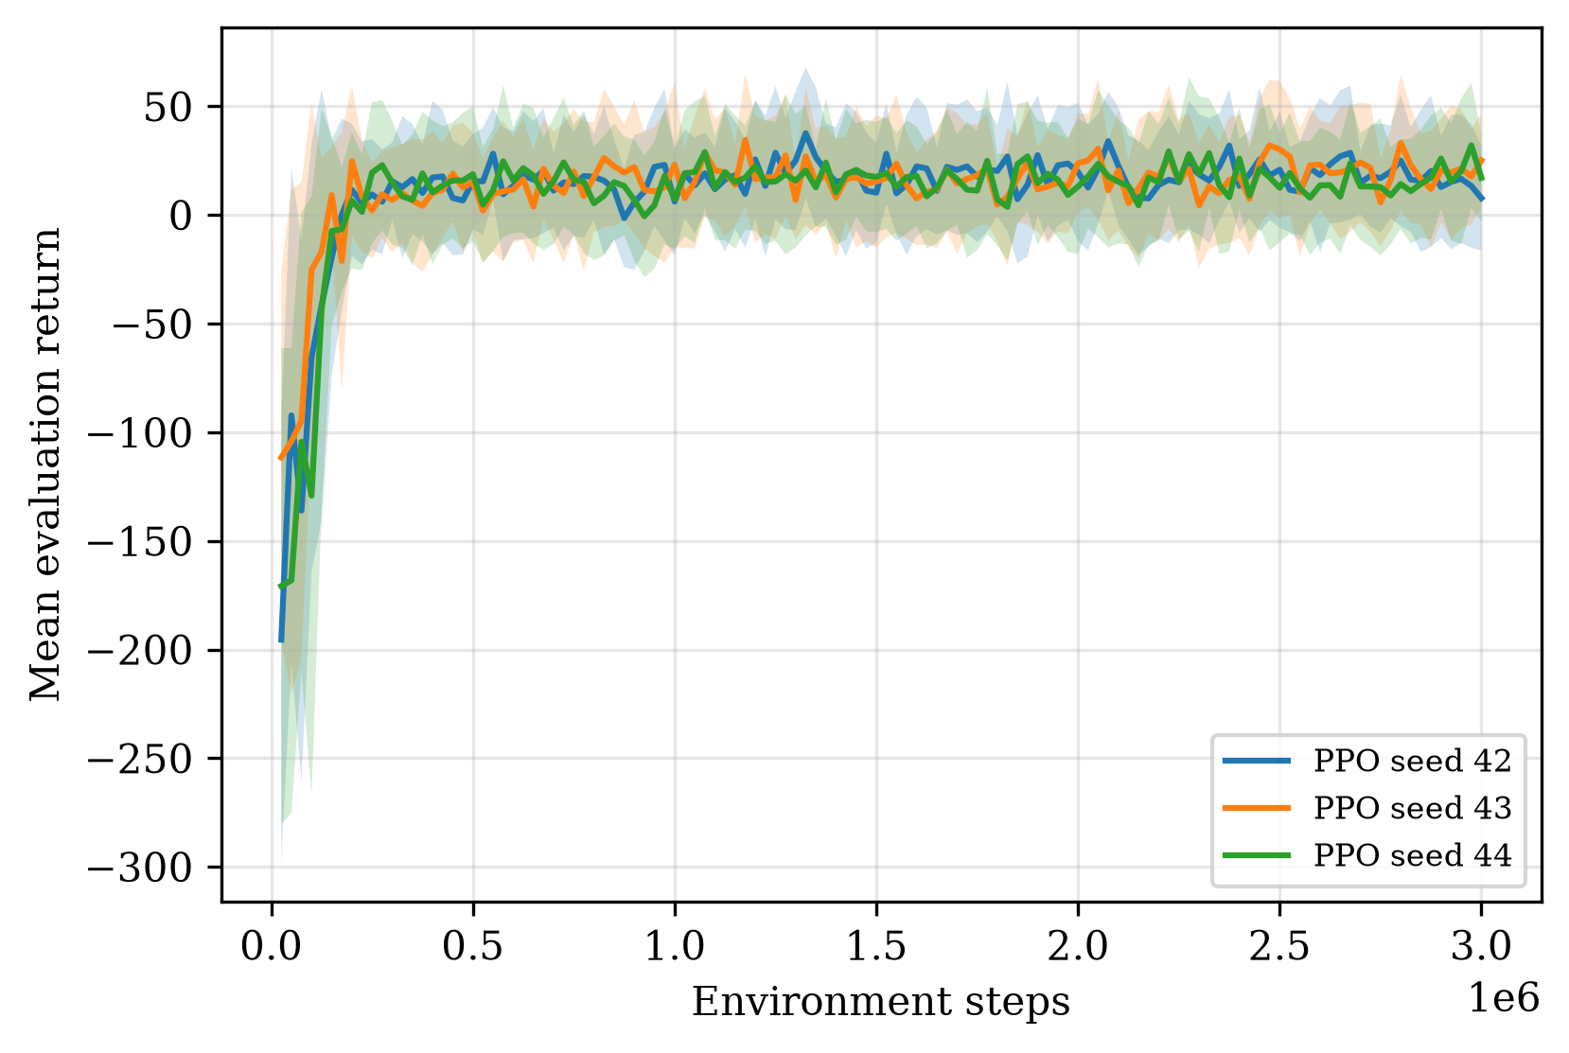
Fig. 2. Mean evaluation return of PPO during training for three independent seeds (shaded: ±1 std over 20 evaluation episodes).
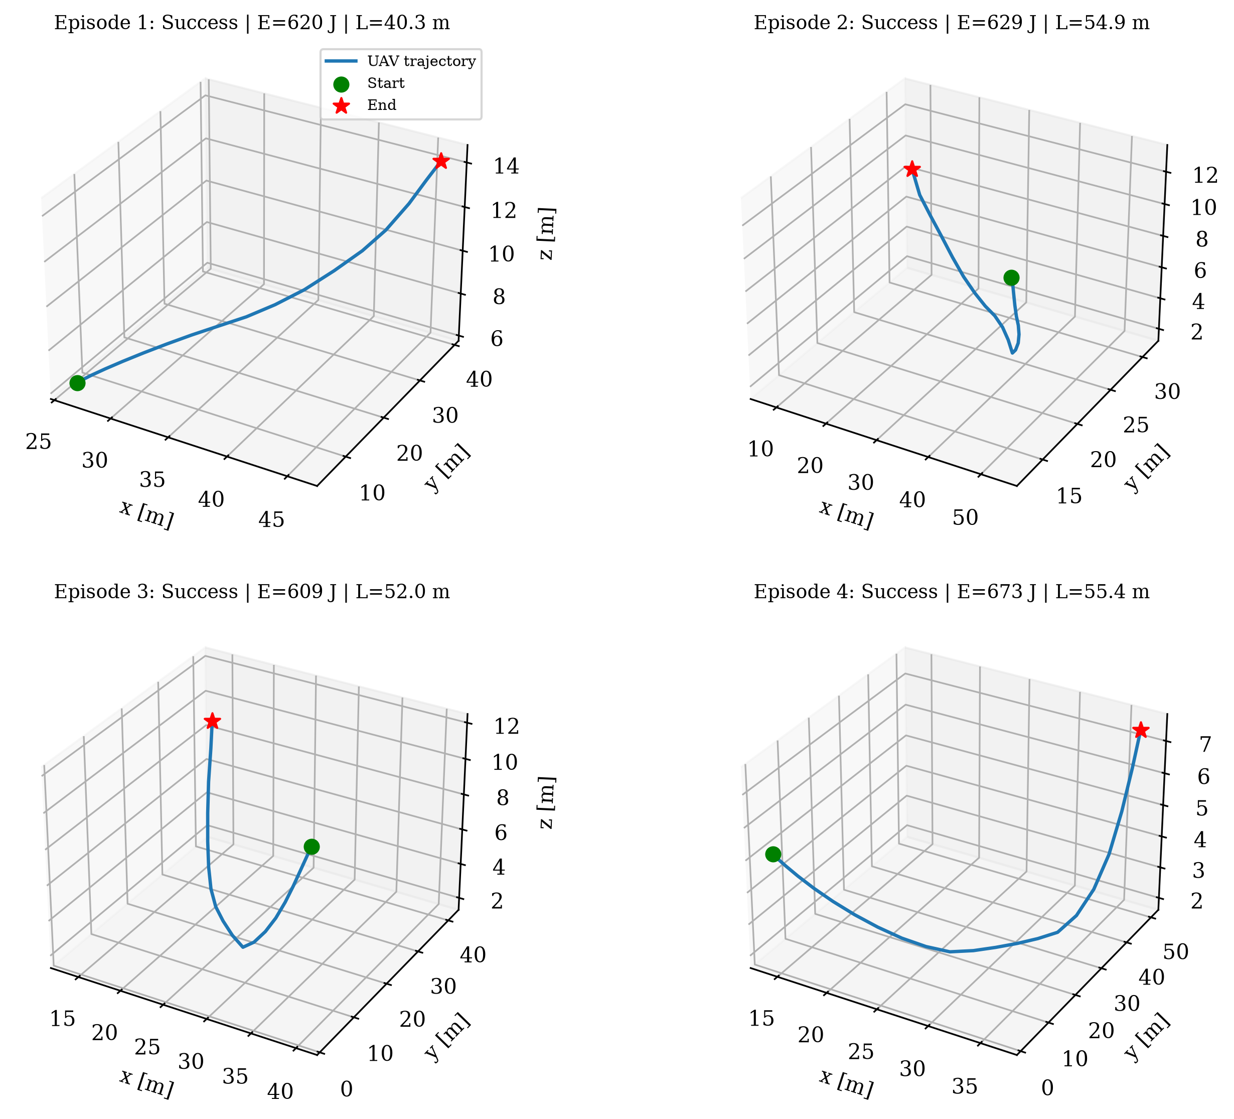
Fig. 3. Representative closed-loop trajectories of the trained policy among twenty moving obstacles (episode energy and path length in panel titles).

6.2. Test-time preference control
To measure whether a single trained network genuinely responds to its preference input, each of eight preference vectors was evaluated on the same 300 world instances, and paired differences were computed between the goal-dominant preference w = [0.8, 0.1, 0.1] and the energy-dominant preference w = [0.2, 0.6, 0.2] on the episodes solved under both (Table 3). The SAC policy exhibits the strongest controllability: its mean episode energy decreases from 791 J to 664 J across the preference sweep — a nearly monotone response — while the success rate remains constant (0.89–0.92) and the mean path length shortens from 56.3 m to 48.8 m; the paired energy difference between the extreme preferences is +103 ± 196 J (13.0% of episode energy; Wilcoxon signed-rank p < 10⁻⁴, median +54 J over 248 jointly successful worlds). PPO shows the same qualitative behaviour with smaller magnitude and seed dependence: +54 ± 85 J (8.2%, p < 10⁻⁴) for seed 42 and +36 ± 74 J (5.6%, p < 10⁻⁴) for seed 44, with success rates constant across the sweep, whereas seed 43 converged to a preference-insensitive policy (+3 ± 42 J, p = 0.30); we return to this in Section 7. Energy savings are therefore obtained purely by changing the preference input at test time, with no retraining and no loss of mission success. Fig. 4 visualises the trade-off surface traced by the SAC policy.
Table 3. Paired preference-control analysis: energy difference between the goal-dominant (w = [0.8, 0.1, 0.1]) and energy-dominant (w = [0.2, 0.6, 0.2]) preferences on identical world instances solved under both (300 worlds per preference, per policy).
Policy | Jointly successful n | ΔE [J] | Relative | Wilcoxon p
SAC (seed 42) | 248 | +103 ± 196 | 13.0% | < 10⁻⁴
PPO (seed 42) | 223 | +54 ± 85 | 8.2% | < 10⁻⁴
PPO (seed 43) | 209 | +3 ± 42 | 0.5% | 0.30
PPO (seed 44) | 248 | +36 ± 74 | 5.6% | < 10⁻⁴
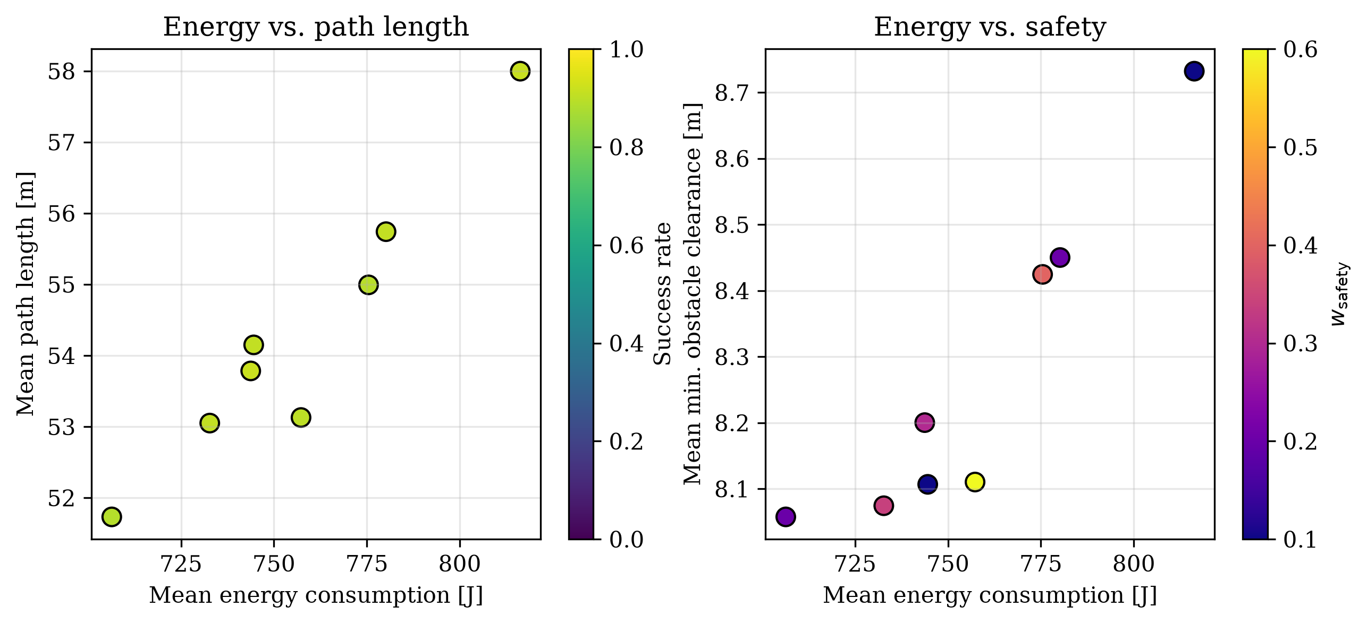
Fig. 4. Trade-off surface traced by the single preference-conditioned SAC policy (300 episodes per preference). Left: mean energy vs. path length coloured by success rate — energy and path contract monotonically as the energy weight rises, while success remains near 0.9 throughout. Right: energy vs. minimum obstacle clearance coloured by the safety weight; the largest clearance occurs at the goal-dominant preference (low w_safety), illustrating that clearance covaries with trajectory geometry rather than with the safety weight (Section 7).

6.3. Objective alignment and the existence of the trade-off
The rotary-wing power curve implies that energy per metre, P(V)/V, decreases monotonically from 167 J/m near hover to a minimum of 8.83 J/m at the maximum-range speed V_mr ≈ 18.3 m/s, rising thereafter. Consequently, when the platform speed limit satisfies v_max < V_mr, flying as fast as possible is simultaneously optimal for the goal objective and the energy objective: the objectives are aligned, and no Pareto trade-off exists for the policy to express. We verified this empirically. With v_max = 8 m/s, the paired energy modulation achievable by the preference input collapsed to +16 ± 85 J (1.6% of episode energy) — statistically detectable (p < 10⁻⁴) but practically negligible. Raising the speed limit to v_max = 25 m/s > V_mr restored a genuine conflict — fast flight now costs disproportionate parasite power and elevates collision risk among fast obstacles — and the achievable modulation grew to 8.2% for PPO under an identical protocol, and to 13.0% for SAC (Table 3). This result carries a methodological message for MORL benchmarking: the existence of the trade-off is a property of the platform and environment parameters, not of the algorithm, and should be verified before controllability claims are made.

6.4. Role of temporal range information
A single range scan carries no information about obstacle velocity, which is critical when every obstacle moves. In preliminary experiments, a policy observing only the instantaneous scan and trained for 1 × 10⁶ steps reached a success rate of 0.64 in the dynamic scenario; augmenting the observation with the previous scan and extending training to 3 × 10⁶ steps raised it to 0.78 under otherwise identical conditions. Because these two factors were changed together, we report the improvement as a combined design effect rather than a controlled ablation of the history term alone.
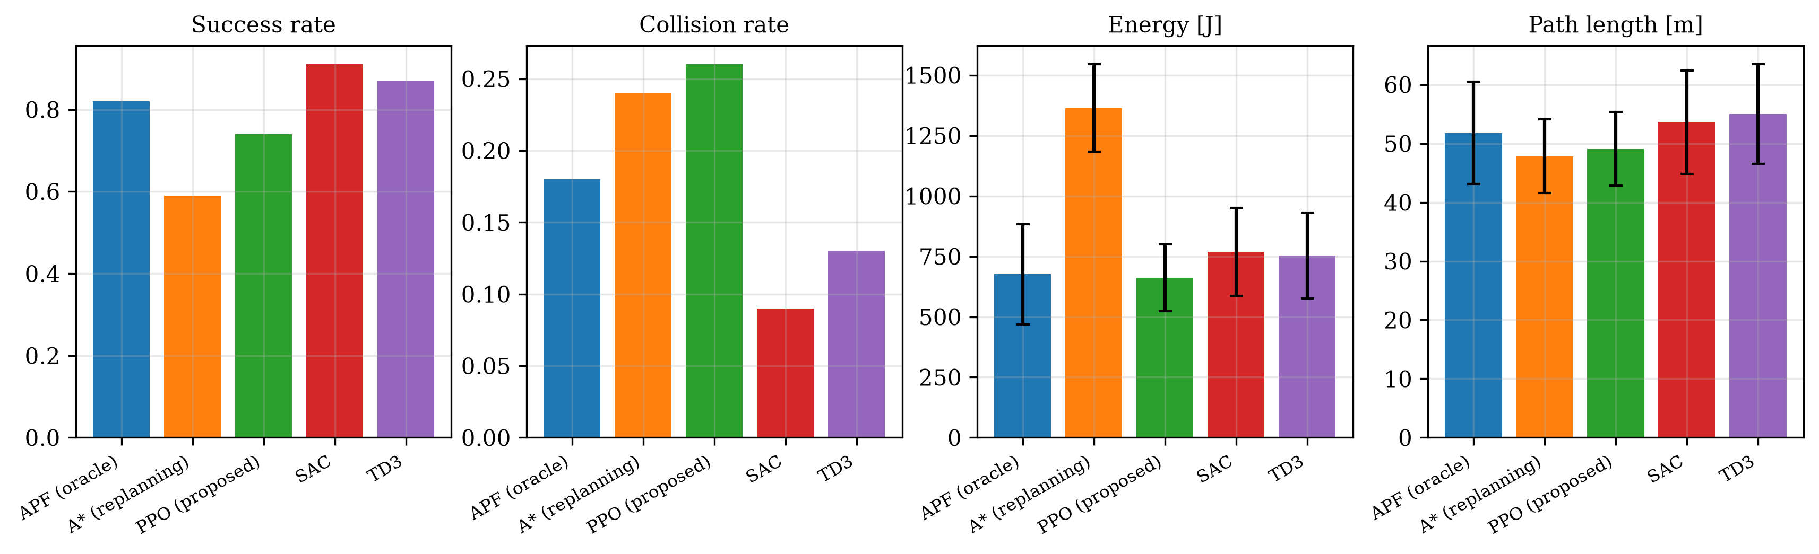
Fig. 5. Metric comparison across all methods in the dynamic scenario (100 evaluation episodes per method; error bars: ±1 std over successful episodes).

7. Discussion and Limitations
Sensor-based learning vs. privileged reaction. The APF baseline is deliberately privileged: it consumes exact obstacle states that no onboard perception system provides. That the learned policy matches its success rate under 16-ray partial observability — while flying shorter, more energy-efficient paths — indicates that end-to-end DRL can internalise obstacle motion prediction from consecutive range measurements alone. The comparison with replanning A* quantifies the cost of the frozen-world assumption in dynamic scenes: a 21-percentage-point drop in success and more than double the energy.
Algorithm choice as a trade-off selector. The three learners, trained on identical observations and rewards, converged to systematically different operating points: off-policy SAC and TD3 maximise success (0.91 and 0.87) at higher energy, while on-policy PPO flies most efficiently. We attribute the off-policy success advantage to replay-driven sample reuse, which yields roughly ten times more gradient updates per environment step and denser learning from rare near-collision events. Practitioners can therefore treat the learner itself as a coarse trade-off knob, with the preference vector providing fine-grained control on top. We note that SAC and TD3 results are from a single seed at a smaller interaction budget; extending them to multiple seeds is straightforward with the released code.
Seed-dependent controllability. For SAC, preference conditioning produced strong, nearly monotone energy control (13.0%); for PPO it was significant in two of three seeds but one seed collapsed to a single trade-off point. Such collapse is a recognised failure mode of linear scalarisation in deep MORL: nothing in the on-policy objective prevents the network from ignoring the preference input if a single behaviour achieves adequate return across sampled weights. Reporting this seed rather than discarding it reflects the true reliability of the approach; stabilising controllability — via hypernetwork conditioning, preference-aware value decomposition (Yang et al., 2019), or non-linear (e.g., Chebyshev) scalarisation — is a concrete direction for future work.
Limited marginal effect of the safety weight. Increasing w_safety did not increase the minimum obstacle clearance in any policy; the paired effect was insignificant for PPO seed 42 (−0.05 m, p = 0.21) and significant in the opposite direction for PPO seed 44 (−0.12 m, p = 0.047) and SAC (−0.49 m, p < 0.0001). Inspection of the sweep suggests that clearance covaries with trajectory geometry — goal-dominant policies fly longer, faster arcs with incidentally larger clearances — rather than being governed by the safety weight itself. We attribute this to the terminal collision penalty of −50, which dominates the safety objective at every preference and leaves little margin for the continuous clearance term to modulate; whether purely continuous safety costs would restore sensitivity is an open question.
Further limitations. The UAV is modelled kinematically without attitude dynamics or wind; range sensing is noise-free; obstacles are spherical; and all results are in simulation. Hardware-in-the-loop validation (e.g., PX4/Gazebo SITL) and transfer to a physical platform are planned follow-ups.

8. Conclusion
We presented an end-to-end multi-objective reinforcement learning framework for UAV path planning that couples a physics-based rotary-wing energy model, a fully dynamic obstacle field perceived through raw range measurements, and a preference-conditioned policy trained across the entire scalarisation simplex. In a demanding scenario with twenty fast-moving obstacles, the sensor-based policy statistically matched a full-state potential-field oracle in success rate while consuming 52% less energy than replanning A*, and a single trained network delivered up to 8.2% paired energy savings at constant success rate purely through its test-time preference input. Beyond the system itself, the study contributes two methodological findings: a paired evaluation protocol that reveals preference-controllability effects hidden by mean comparisons, and the demonstration — analytical and empirical — that the goal–energy trade-off exists only when the platform speed limit exceeds the maximum-range speed of the power curve. All code and experiments are released to support reproduction and extension.

References
Aggarwal, S., Kumar, N., 2020. Path planning techniques for unmanned aerial vehicles: A review, solutions, and challenges. Computer Communications 149, 270–299.
Fujimoto, S., van Hoof, H., Meger, D., 2018. Addressing function approximation error in actor-critic methods. In: Proceedings of the 35th International Conference on Machine Learning (ICML).
Haarnoja, T., Zhou, A., Abbeel, P., Levine, S., 2018. Soft actor-critic: Off-policy maximum entropy deep reinforcement learning with a stochastic actor. In: Proceedings of the 35th International Conference on Machine Learning (ICML).
Hart, P.E., Nilsson, N.J., Raphael, B., 1968. A formal basis for the heuristic determination of minimum cost paths. IEEE Transactions on Systems Science and Cybernetics 4 (2), 100–107.
Hayes, C.F., Rădulescu, R., Bargiacchi, E., et al., 2022. A practical guide to multi-objective reinforcement learning and planning. Autonomous Agents and Multi-Agent Systems 36, 26.
Khatib, O., 1986. Real-time obstacle avoidance for manipulators and mobile robots. The International Journal of Robotics Research 5 (1), 90–98.
Raffin, A., Hill, A., Gleave, A., Kanervisto, A., Ernestus, M., Dormann, N., 2021. Stable-Baselines3: Reliable reinforcement learning implementations. Journal of Machine Learning Research 22 (268), 1–8.
Roijers, D.M., Vamplew, P., Whiteson, S., Dazeley, R., 2013. A survey of multi-objective sequential decision-making. Journal of Artificial Intelligence Research 48, 67–113.
Schulman, J., Wolski, F., Dhariwal, P., Radford, A., Klimov, O., 2017. Proximal policy optimization algorithms. arXiv preprint arXiv:1707.06347.
Towers, M., et al., 2024. Gymnasium: A standard interface for reinforcement learning environments. arXiv preprint arXiv:2407.17032.
Yang, R., Sun, X., Narasimhan, K., 2019. A generalized algorithm for multi-objective reinforcement learning and policy adaptation. In: Advances in Neural Information Processing Systems 32 (NeurIPS 2019).
Zeng, Y., Xu, J., Zhang, R., 2019. Energy minimization for wireless communication with rotary-wing UAV. IEEE Transactions on Wireless Communications 18 (4), 2329–2345.

