DISCONNECT AUTOMATIC AGENT IF HIS ACCOUNT_SIP IS INACTIVE

An operator is on its guests' whit softphone 'N*SIP XXX', it connects to xivoclient whit hist N*agent and his 'N*SIP XXX', in order to enter the queues and receive calls :

A – The softphone is disconnects from asterisk .
B – The operator ends his day , he closes his softphone and forgetting its disconnection ctixivo.
C – The operator is at home, the VPN tunnel stop

In these 3 examples , the operator is not able to know whether or not it can receive calls because there is no alert at XIVOclient and in the phone . The operator is in a status quite normal .

I_proper functioning
A PERSPECTIVE AGENT :
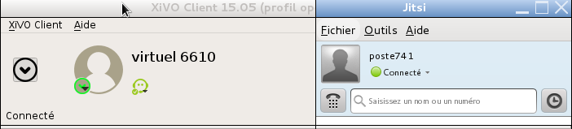
A PERSPECTIVE XIVO :
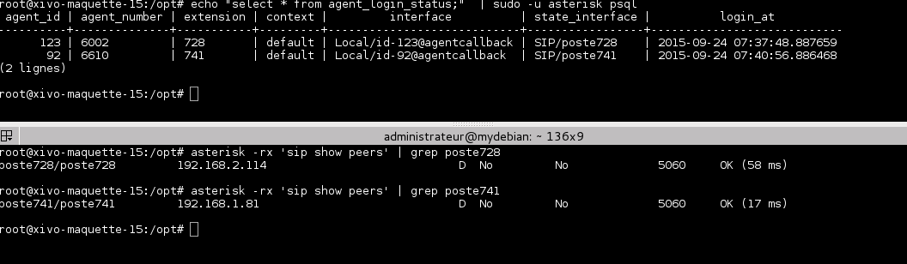
II_ANOMALY
A PERSPECTIVE AGENT :
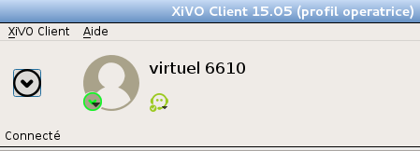
For this simulation we force the closure of the virtual phone :

We note that our agent stays connected , and there is no information on the xivoclient
A PERSPECTIVE AGENT :
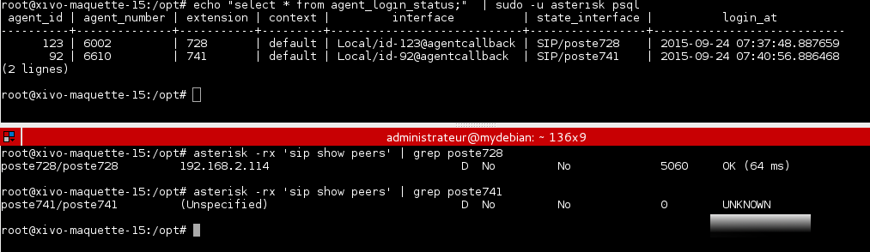
We notice good status poste741 inactive, but active for our agent_number6610
III _ ACTION OF SCRIPT
The script notices that the compteSIP is disconnected, it will automatically disconnects the agent associated to that numbe
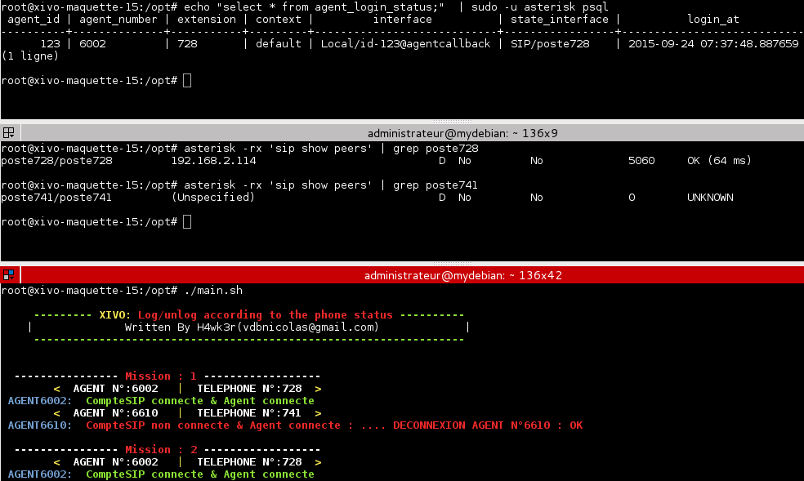
My operator now knows that his agent is offline :
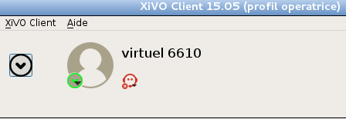

h4wk3r ( vdbnicolas@gmail.com )

