**Aidan Brown**

**GEOG 511 Fall 2023**

# Question 1

**MAN**(MName)

**WOMAN**(WName)

# Question 2

STUDENT(StNumber, StName, *Dormitory_Bname*)

DORMITORY(BName, Address)

# Question 3

SHIPS(Regn#, Name, Tonnage, *Fools_SIN*)

FOOLS(SIN, Name, Address)

# Question 4

CUSTOMER(PolicyNo, Name, Address)

CAR(VIN, Make, Model)

ACCIDENT(AccID, Data, Location, *Car_VIN*)

# Question 5

There are more dependents living in **cooperative housing group 1** than in private dwellings.

# Question 6

45 buildings contain apartments with 1 female living in them. I found this by performing a **Select By Attributes** in the **Apartments** table with the query: 'ADULT_FEMALES' is equal to '1', then selecting related data: is Within Building.

# Question 7

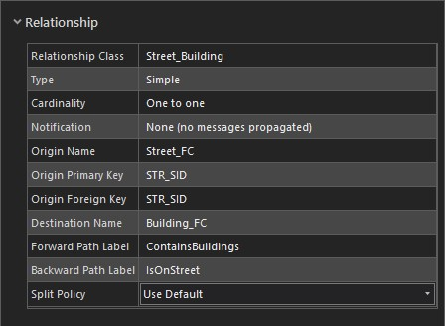

# Question 8

The apartment with 5 children under 18 in it is on Barvinsky street.

# Question 9

70 adult males live on Hrushevsky Street.

# Question 10

103 apartments are within the Cooperative housing group 1 and have 0 children living there.

# Question 11

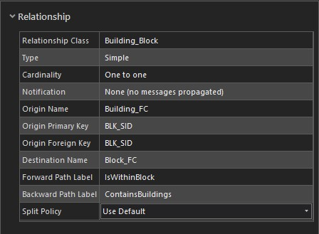

**Question 13**  19 buildings in BLK_SID 37