**Aidan Brown**

**GEOG 521 Fall 2023**

# Deliverable 1

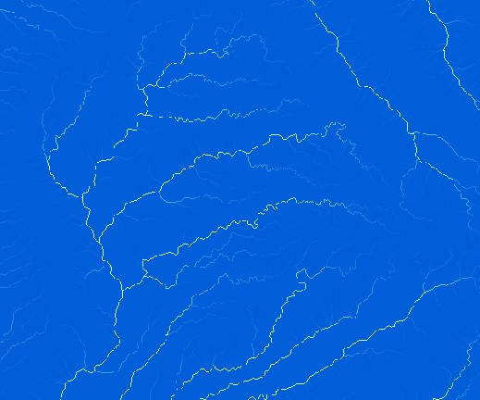

# Deliverable 2

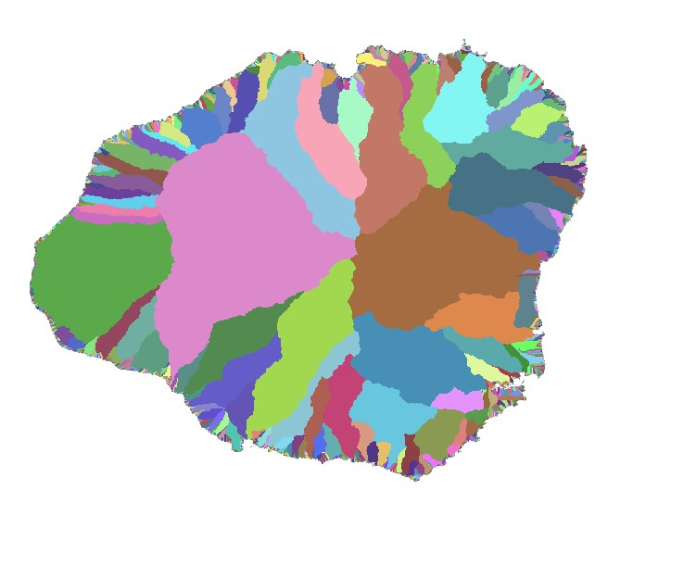

# Deliverable 3

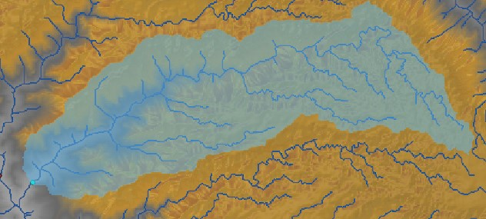

# Deliverable 4

Using the threshold value of 0 is a more accurate depiction of the streams in the watershed.

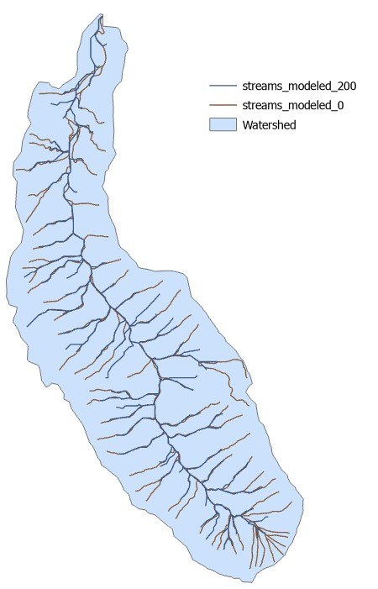

The screen capture above depicts the difference in values for each of the thresholds.

Deliverable 5:

The streams with a threshold value of 200 does capture quite a lot of the stream network, but to a lesser accurate extent, a direct comparison does reveal that some streams aren't even included in the output. This doesn't mean that this threshold is bad, it just depends on the application used. In maps requiring a more general scale of hydrological features it would make sense to use a higher value scale, as opposed to this map where the watersheds are the main analysis point.

The streams with a threshold value of zero is a more accurate representation to the physical streams as it considers all cell values as potential streams, the results are more detailed and would be the clear choice for hydrological maps like this.

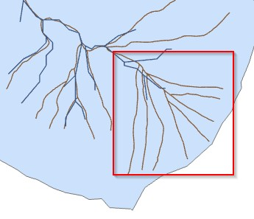

Highlighted area shows the omission of streams when comparing the threshold values.

# Deliverable 6

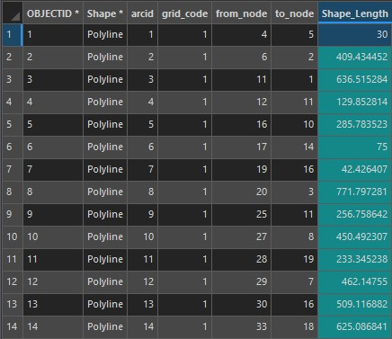

**Shape_Length** can be measured for each polyline of both modeled stream networks.

**From_node** can be used to measure the distances from the nodes to another to compare the distance between each streams.

# Deliverable 7

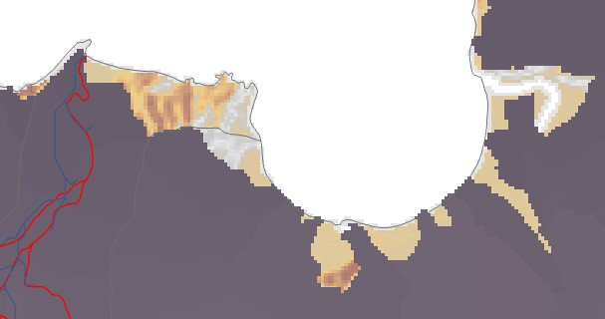

The above screen capture depicts the difference between the watershed boundaries. The threshold values have a direct impact of some of the pour points from the watersheds. We can see the impact of the difference in size between the two watershed classes.