**Aidan Brown**

**GEOG 521 Fall 2023**

# Deliverable 1

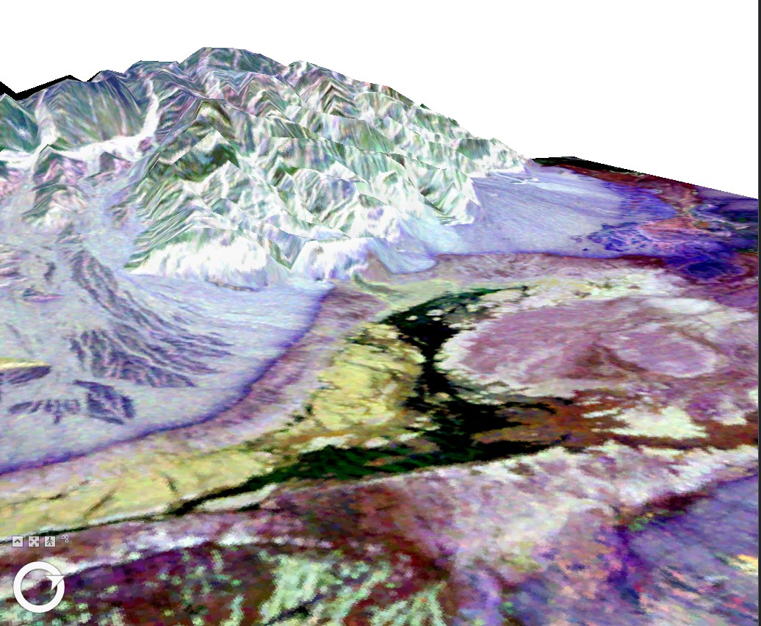

# Deliverable 2

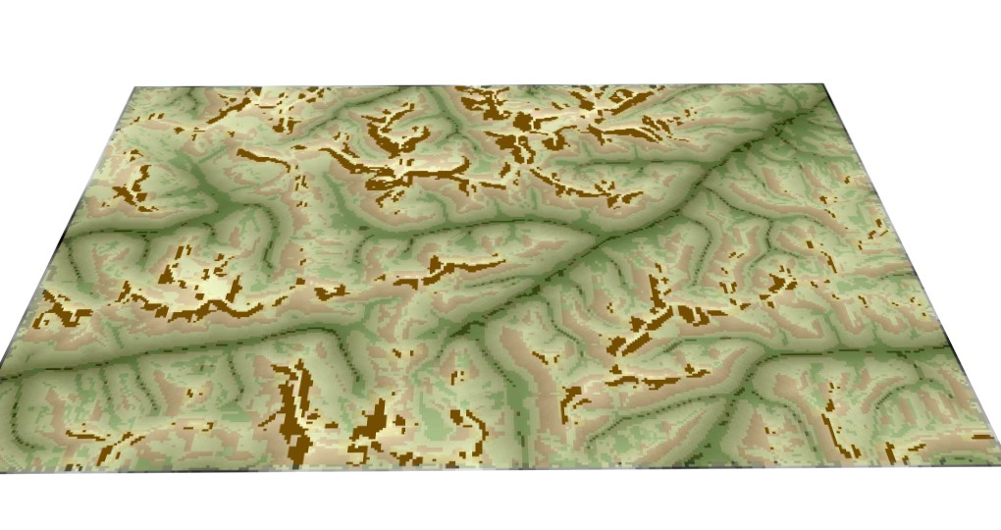

# Deliverable 3

The triangles elevation stays the same per triangle, but the shape of each triangle is different depending on the slope. The aspect changes drastically per triangle.

# Deliverable 4

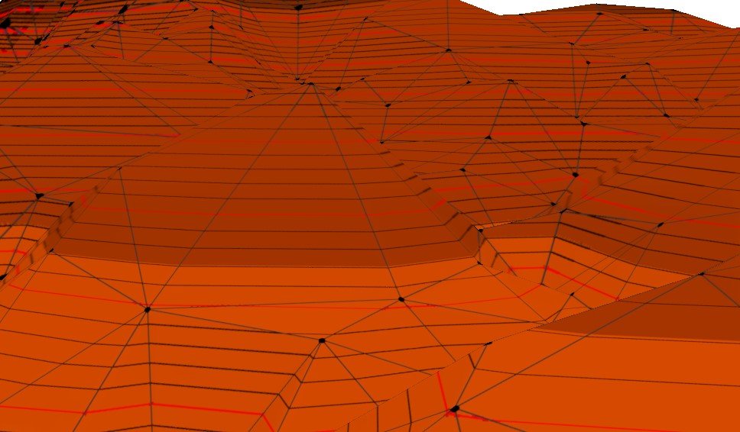

# Deliverable 5

The points are far denser on the map where there is more terrain, and when the surface is flatter there is less points. This proportion does make sense in this context as the study area contains a large valley with defined slopes, these slopes need to be defined more quantitatively by point data.

# Deliverable 6

The created spline contour lines have smooth rounded peaks to depict elevation points while the base TIN contour lines have very stiff jagged peaks to depict the elevation height. The TIN lines more accurately depict elevation as it more visually demonstrates elevation dips, whereas the created contour lines only really only follow the shape of the slope.

# Deliverable 7

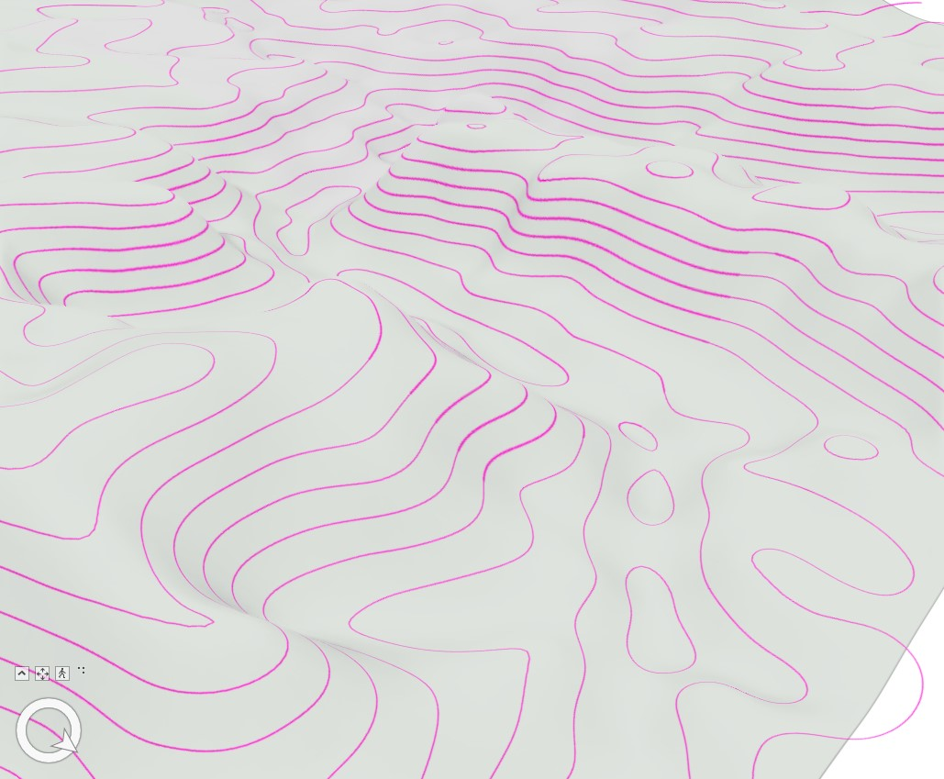

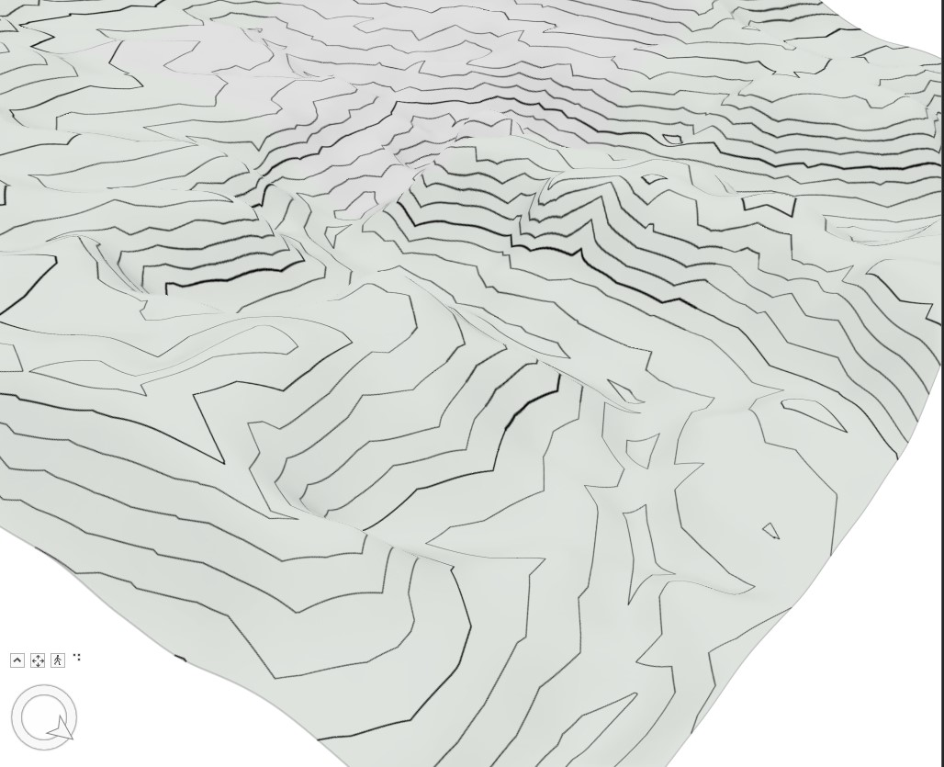

# Deliverable 8

The shape of the lake changes and is consumed more by the 2D layer bbeartin the closer the zooming to the lake becomes, resulting in what looks like missing areas from the lake.

# Deliverable 9

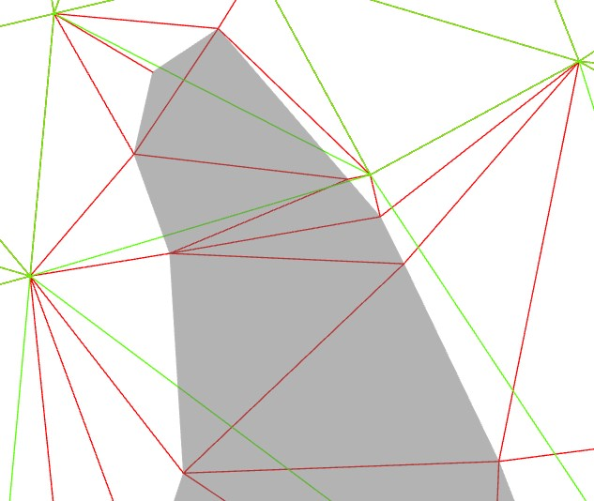

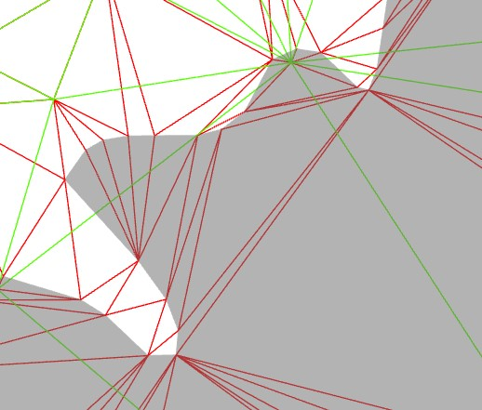

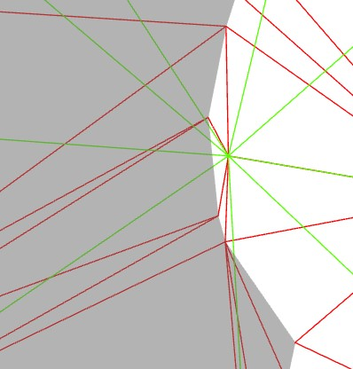

# Deliverable 10

First the TIN was edited to allow the boundaries of the Bearlake shapefile to be within the TIN. Then the elevation properties were set so that any triangles in the boundaries of the lake were hard replaced using the option within the properties. The cartographic offset was a last step to visually have the lake above the ground level of the TIN.