**Aidan Brown**

**GEOG 521 Fall 2023**

# Deliverable 1

The cell values indicate the visibility of each location, for example cell value of 1 would indicate that one location is visible from one of the observation points, etc.

# Deliverable 2

Displaying the chart based on count of each of the 3 towers:

SUM - MAX / SUM

229,508 - 185,196 / 229,508 x 100

= **19.3%**

# Deliverable 3

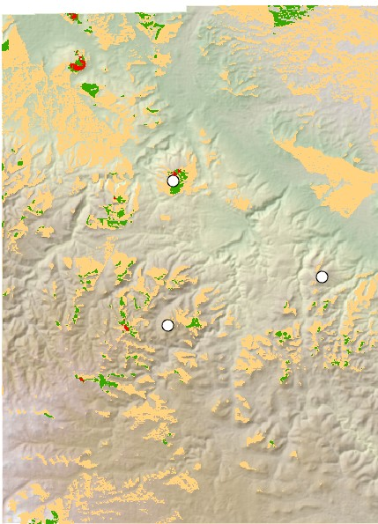

# Deliverable 4

The cell values depict visibility from each observer point. A value of 1 tells us that the point is visible from 1 other observer point.

# Deliverable 5

Created a new viewshed using all of the summits.

Used *Extract Values to Points* tool with all Summits as the input, and The newly created viewshed as the input raster.

Examined resulting features attribute table with new RASTERVALUE field for results.

# Deliverable 6

**Bear Den Mountain** is the most visible, from 9 total summits.

# Deliverable 7

Anchor Hill

Bear Den Mountain

Crook Mountain

Itself

Pillar Peak

Whitewood Peak

# Deliverable 8

Calculated the number of none visible cells by summarizing the statistics of the new visibility raster within the park boundary:

Number of cells not visible = 486,571 / 685,311 (total number of cells) x 100 = **71%** of the park cannot be seen from the road.

# Deliverable 9

When the observer point is a polyline, visibility values are assigned to each part of the polyline based on whether they have line of sight to other cells.

# Deliverable 10

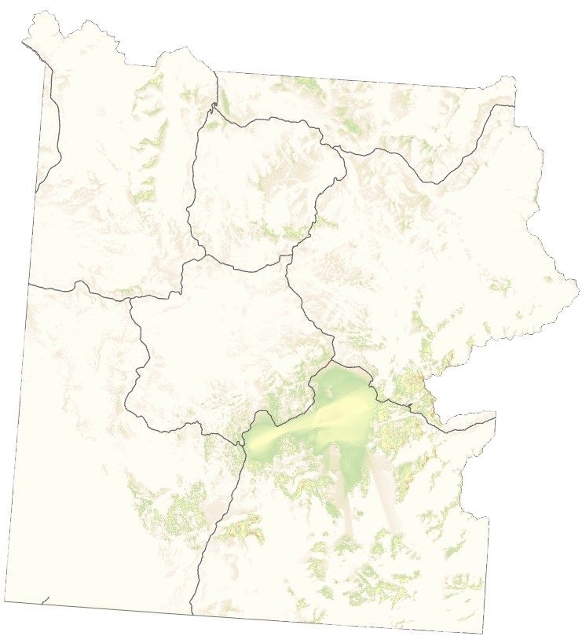

# Deliverable 12

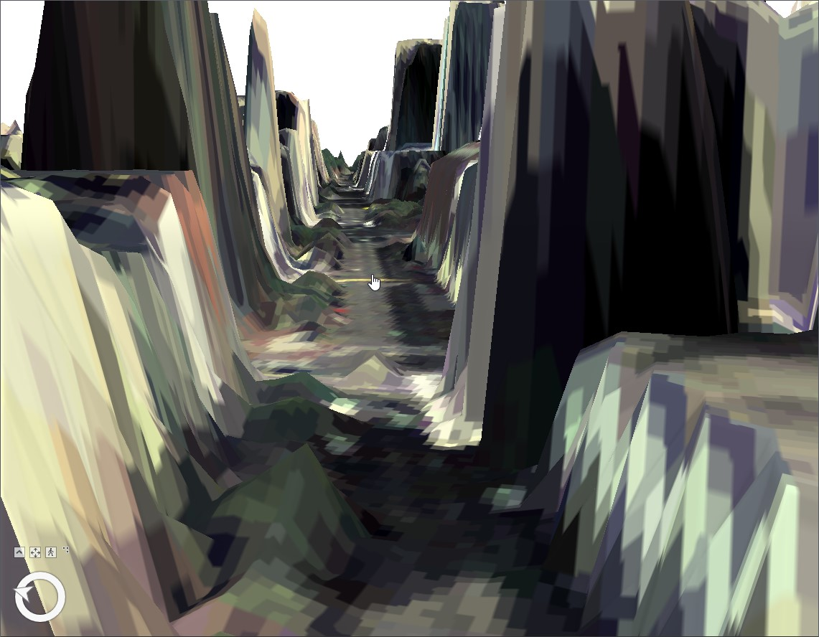

# Deliverable 13

The initial camera didn't quite cover the full street, so I added another camera on the street behind at a 90 degree angle to capture the remaining coverage. The second camera was added just before the finish line at a 30 degree angle. This is so it could capture runners coming in right before finish, which beyond the aesthetic purposes could provide more useful data, for example; speed performance of the runners crossing the finish line.

# Deliverable 14

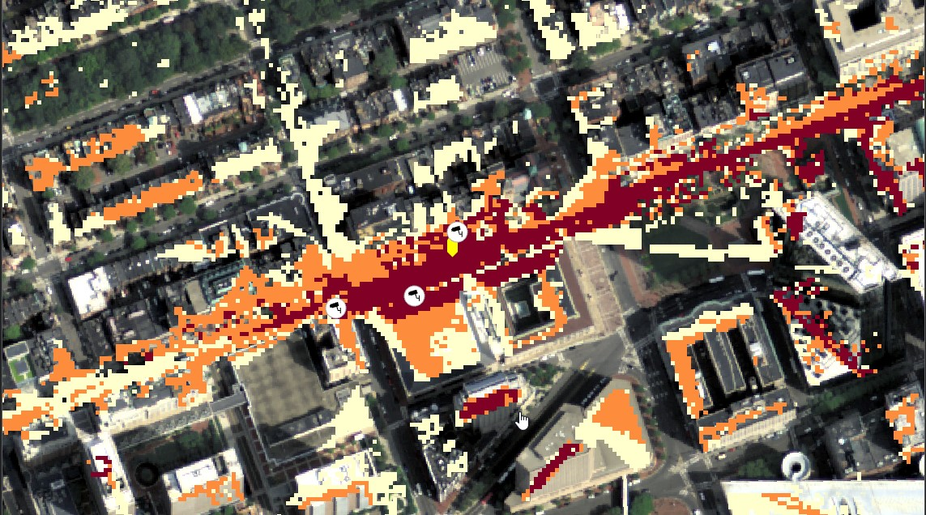

# Deliverable 15

There are 225 sight lines because there are 15 total summit points. Each summit point has a LOS for each other, 15 summit points x 15 lines of sight is 225 sight lines.

# Deliverable 16

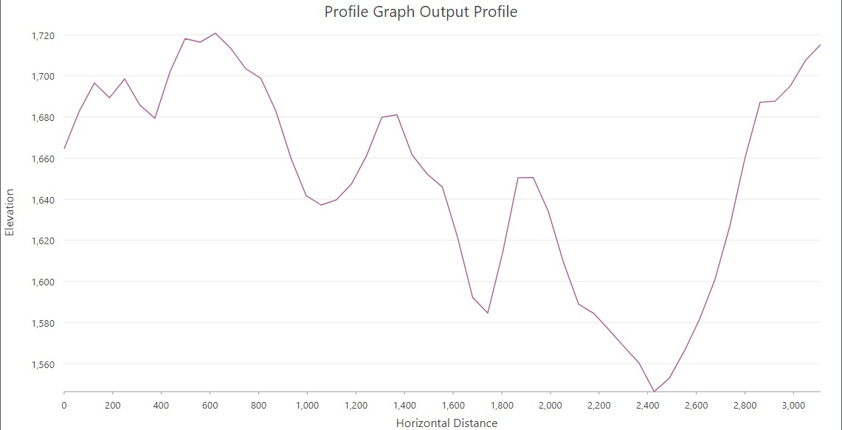

# Deliverable 16

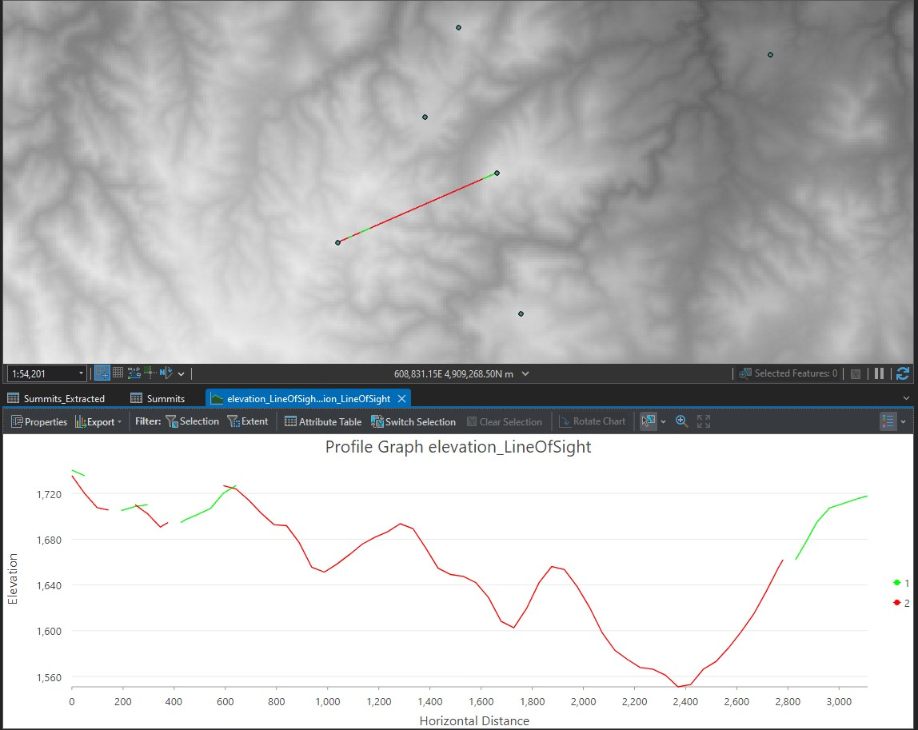

# Deliverable 17

Based on my selected line of sight and the elevation the obstruction points I initially thought there would be an even larger number of obstructions, based on comparing the first two parts of the graph screen capture below:

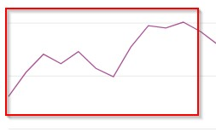

Profile Graph

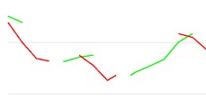

LOS Graph

But I understand that the observer point is sitting at a higher elevation, so it does make sense that the LOS graph displays these obstructions. When the elevation height is greater than that of the observer it would obscure vision.

# Deliverable 18

**15** total records in the attribute table.

**OID** is the unique field for each object.

**Shape** is the geometric shape of the line.

**SourceOID** is the source of the LOS (in this case it's Pillar Peak).

**VisCode** is the status of visibility if it is obstructed or not **TarIsVis** is a Boolean value of 0 or 1 of the targets visibility.

**OBSTR_MPID** Identifies features of obstruction.

**Shape_Length** - Length of the lines.