**Aidan Brown**

**GEOG 521 Fall 2023 Lesson 1:**

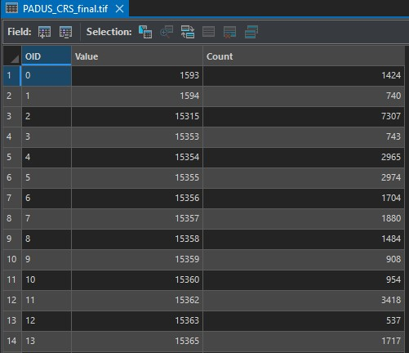

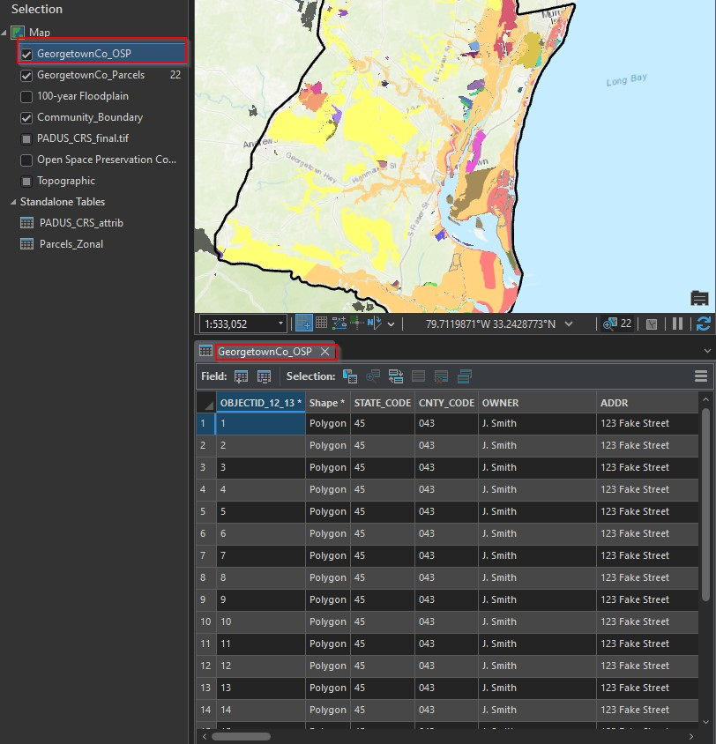

**Lesson 2**

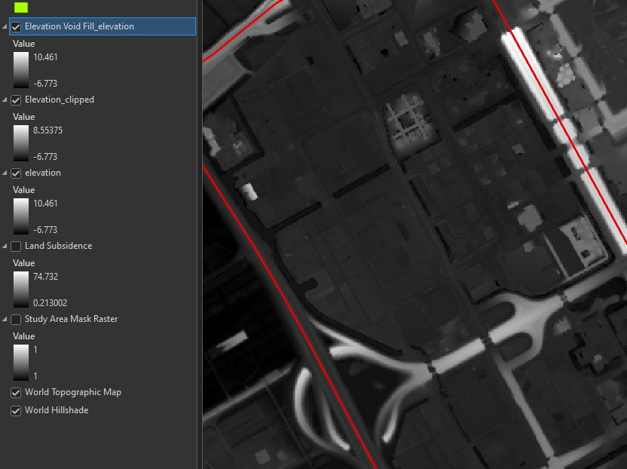

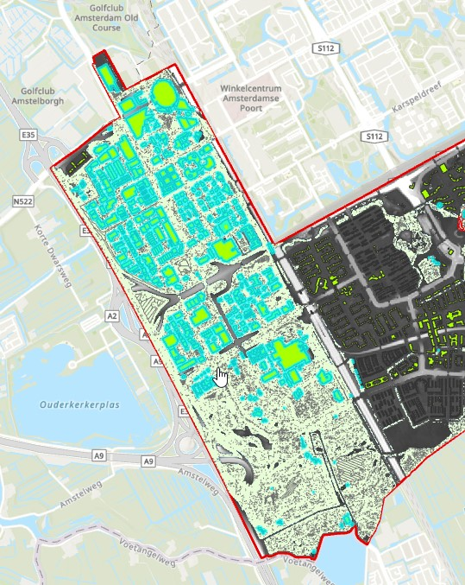

Received an error when trying to run the model builder in this tutorial and could not proceed:

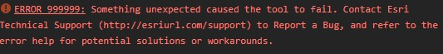

[https://pro.arcgis.com/en/pro-app/3.1/tool-reference/tool-errors-and-warnings/999001-999999/toolerrors-and-warnings-999998-999999-999999.htm](https://pro.arcgis.com/en/pro-app/3.1/tool-reference/tool-errors-and-warnings/999001-999999/tool-errors-and-warnings-999998-999999-999999.htm)

My working directory is C:EsriTraining, so I don't think the problem is the path length as it's discussed in the problem article. I also tried running as admin and got the same issue..