**Aidan Brown**

**GEOG 521 Fall 2023**

# Deliverable 1

The location of my point is at the start of a section of the Nanaimo Parkway Trail, loosely covered by a forested area close to a residential neighbourhood. There are multiple ways to get to this location, Either following the Parkway Trail North all the way until the tunnel that runs underneath the highway. Instead of taking the highway take the left paved trail and continue along the path until you see a bike post. The exact point is a few meters away from a set of mailboxes on the sidewalk. You can also get to this point by driving into the neighbourhood of North Jinglepot, on Willowmere Crescent. Here you can park along the street and will be able to see the Nanaimo Parkway trail head, along with the mailboxes.

# Deliverable 2

Average X coordinate: 424899.82381

Average Y Coordinate 5450.697465

68 Percentile precision: 3 meters

95 Percentile precision: 5 meters

# Deliverable 3

Based on measuring distance between the average waypoint to all recorded waypoints the average horizonal distance accuracy is: 2.6m.

# Deliverable 4

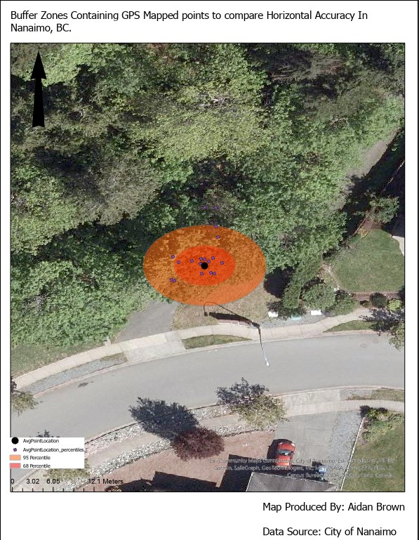

# Deliverable 8

My line area feature is in the same area as my point feature, this is a part of the Nanaimo Parkway trail that starts at the trailhead on Willowmere Crescent in Nanaimo BC, and ends right at the intersection of the parkway trail. By starting at the street in the residential neighbourhood, and walking in the north direction you will find a mailbox to the right side. Continue along the paved path until you get the intersection where the paved trail continues left and right. On the left side you will see a tunnel that goes underneath the highway, and to the right the trail continues up a gradual sloped hill. Standing here is where my line features end.

# Deliverable 9

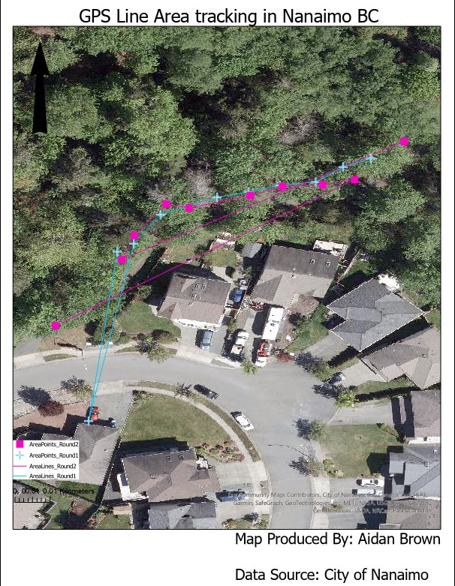

# Deliverable 10

There was definitely some disparity between my points when going back to collect the 2nd round of gps entries. The method of collecting data was simply walking 10 steps in the north direction to collect the data points. Going off of memory of the collection points with some nearby objects to reference where the starting points were (the mailbox, specific trees). The data could have been a lot more accurately collected using a simple flagging system for each collection point.

# Deliverable 11

RMSE = 3.062

Mean = 2.668

Median = 2.445

95th Percentile = 5.693

68th Percentile = 3.176

90th Percentile = 4.668

Min = 0.143

Max = 6.955

# Deliverable 12

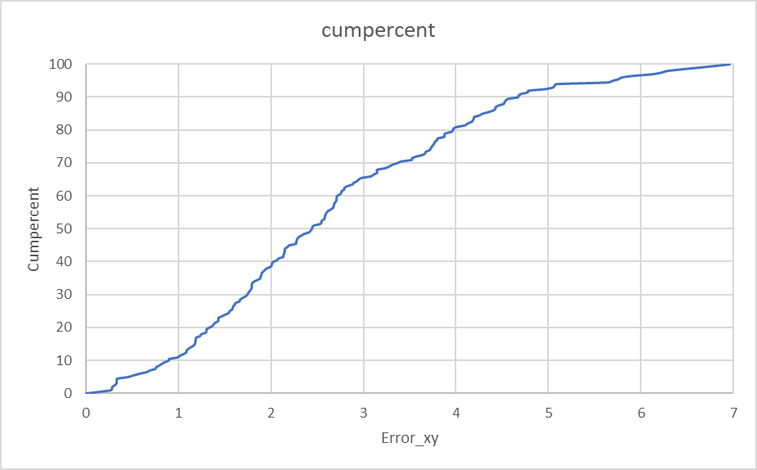

# Deliverable 13

The created CDF represents the magnitude of the x and y errors and provides a simplified view of the values. IE: the maximum value at 100% is the maximum calculated error from the coordinate values. The Cumulative percentage represents the percentage of errors that fall below a specific value threshold.

# Deliverable 14

