**Aidan Brown**

**GEOG 523 Fall 2023**

# Question 1

|  |  |
| --- | --- |
| **Identifier** | **LU/LC Class** |
| 1 | Urban |
| 2 | Forest |
| 3 | Water |
| 4 | Agriculture |

# Question 2

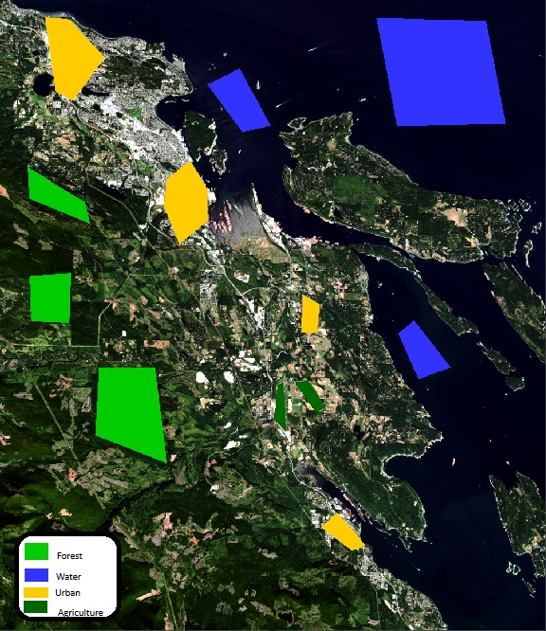

# Question 3

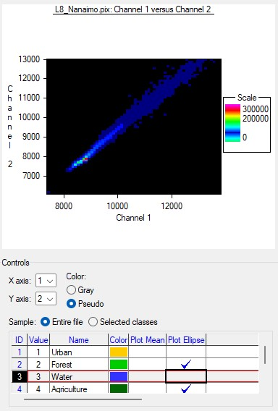

# Question 4

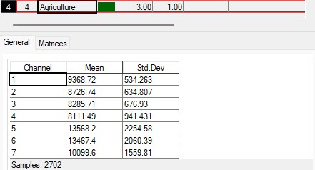

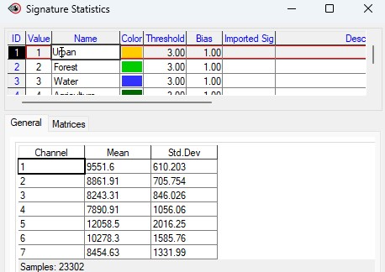

Based on my signature statistics, the **Urban** and **Agriculture** classes have the most reflection variation compared to the other classes. This could be because agriculture land is commonly where Urban land resides, this could skew some results to have both classes mixed with each other.

# Question 5

**Agriculture** & **Forest** classes are the most similar classes. They both cover areas of vegetation in large amounts, and both can appear to be similar in satellite imagery. **Question 6**

Selecting the right bands for the classified data.

Using multiple data sources to visually see differences.

Using the histogram or image stretching to better enhance imagery.

# Question 7

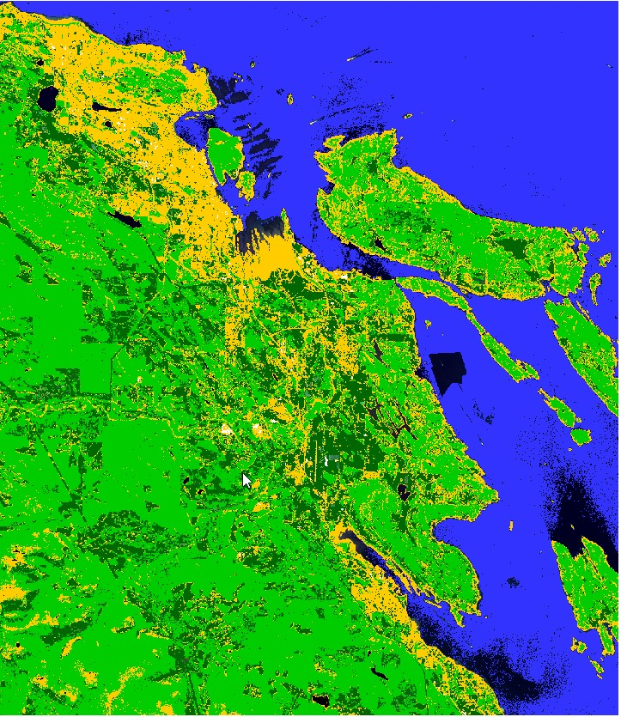

Based on the output from running the parallelepiped classification, the unclassified class represents shallow water. **Question 9**

The dominating LU/LC class is the forest class as it encompasses the majority of the study area.

# Question 10

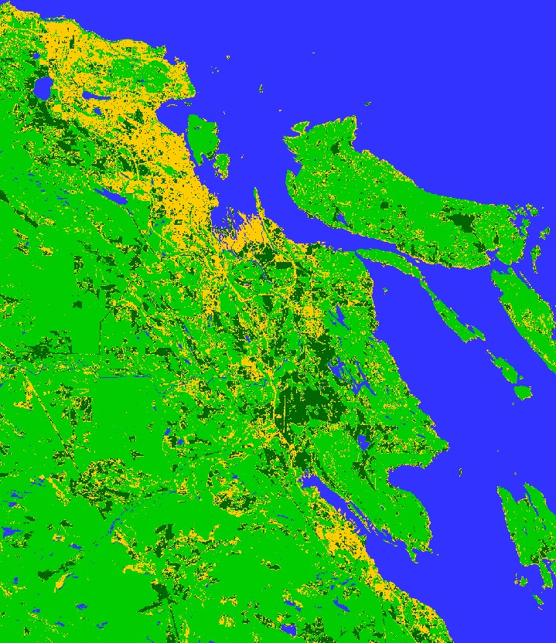

**Minimum Distance** classification had the best results visually compared to the other classifications. Although looking at the results given, there is still some anomalies. For example, it took my **Urban** class and grouped it with beaches, and many agriculture areas.

# Question 11

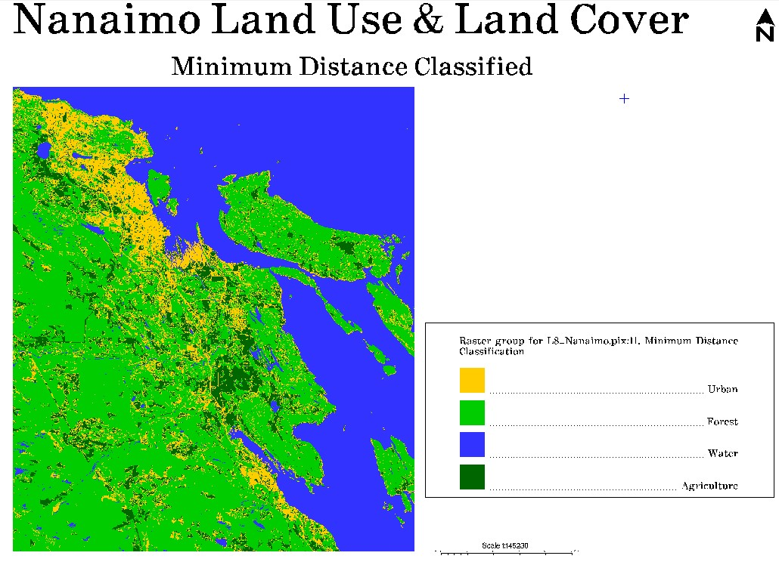

# Question 12

In summary, A threshold is determined by segmenting two separate classes based on histogram values of the classes. The two classes are **objects** and **background**. From here the two categorized classes are weighted by a threshold that is calculated by minimum and maximum values. ([https://www.sciencedirect.com/topics/computer-science/isodata-algorithm)](https://www.sciencedirect.com/topics/computer-science/isodata-algorithm)

# Question 17

**Categorization** - easy to manage and interpret data into groups for the end user to perform analysis on the classes.

**Data Discovery** - clustering algorithms can make remote sensing data that could be hard to distinguish more concise and reveal data that before applying could be missing or hidden.

# Question 18

Advantage - **Readability** - Results are easy to interpret based on the classes defined in the classification.

Disadvantage - Only classes that are already defined can be classified, therefore domain knowledge is needed to specify new classes.