**Aidan Brown**

**GEOG 523 Fall 2023**

# Question 1

A geographical transformation is a model to convert spatial data geographic coordinate systems. the first exercise was using the NTv2 method, which is a grid based transformation correction method for converting between NAD27 and NAD83.

# Question 2

The transformation error area may be up to 1.500 meters based on the pdf from converting from NAD 1927 to NAD 1983.

# Question 3

I got the same X and Y point values after performing a transformation: (X = 430997.071934, Y =

5439740.15095)

This could be because the data transformation was successful in correcting any errors after applying the transformation method, I suppose this represents the accuracy of the NTv2 transformation.

# Question 4

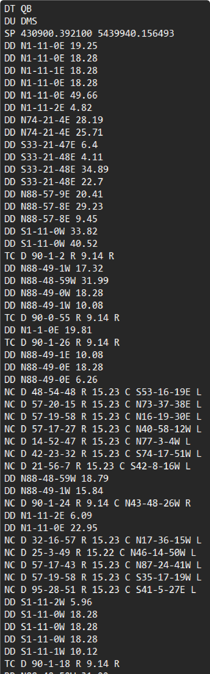

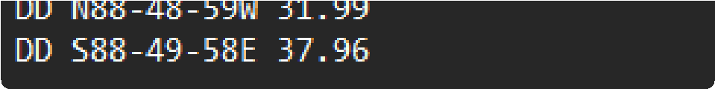

# Question 5

The compass traversal method corrects starting and ending points of a traverse to improve accuracy of the grid by adjusting angles between points on the traverse. It calculates the sum of the insides and outsides of angles, ensuring they are equal. If they are not then it goes through the corrective process, which will edit all angles according to the defined traverse.

# Question 6

The compass method could have the endpoint to shift slightly as it needed to account for new adjustments after using the Feature Vertices to Points tool. Furthermore, this tool could also have affected the outcome as the tool may have not 100% accurately represented the correct vertices that the traverse has.

# Question 7

**Closed Traverse** - Connected lines that form a closed loop or circuit, starting and ending at the same point.

**Open Traverse** - Lines that don't form a closed loop, does not have to return to the starting point.

Used for creating road lines or power lines, etc.

**Side Shots** - Additional Survey lines that are used from created points on an existing traverse, that provide more context to the traverse (in this case they completed parcels in the traverse).

# Question 8

COGO stands for "Coordinate Geometry". It's a suite of tools and techniques for managing and analyzing geographic/spatial data utilizing coordinates. COGO is mainly used for surveying, creating parcel data, establishing legal boundaries, and traversal survey line discrepancies.

# Question 9

GIS professionals, Surveyors, Civil Engineers, Area Planners all could use COGO in some capacity.

# Question 10

**CAD** - COGO tools and systems are very much apart of CAD programs, which use precise geometry and coordinate calculations for designs.

**GIS** - COGO is well integrated into GIS software, as any mapping scenario greatly benefits with COGO applications, especially in the creation of boundary mapping, or geocoordinates.

**Engineering Software** - Any civil engineering software tasks that need precise measurements, like creating infrastructure, road network designs, site or area planning, heavily lean on utilizing COGO to ensure accuracy of spatial information.

# Question 11

Some advantages of using COGO for map creation:

**Accuracy** - Accurate placement of geometric objects is necessary for surveying.

**Traverse Calculations** - Allowing angles, lines, points to be as accurate as possible when calculating a traverse area.

**Legal Boundaries** - Presents accuracy for parcel creation, for legal documentation, or property boundaries.

Disadvantages:

**Time** - Time consuming when creating precise COGO based models and can be tedious.

**Software Consistency** - Accuracy can depend on the type of software used, which can present other issues like a larger learning curve for new users.

# Question 13

COGO is responsible specifically for converting the NAD27 to NAD83 geographic coordinate systems. This also includes the projected coordinate system and the units of measurements from the conversion.