**Aidan Brown**

**GEOG 523 Fall 2023**

# Question 1

The dataset contains data of stream sediment and water geochemical data on Vancouver Island.

The data was collected starting in 1976 and continues to 2010.

# Question 2

The spatial features are depicted as river polylines on the map.

# Question 3

The coordinate system is using NAD 1983

# Question 4

688 total observations in the attribute table.

Most of the points are found on or around any rivers. Looking at the element table of the gathered data, consistencies occur with re-occurring elements, especially those with large found amounts of mercury.

This seems like one factor these data points would be chosen.

# Question 5

Field workers go to sites to assess and collect sample materials, the samples are evaluated and prepared for analysis. The samples go through a control process where the parent sample is duplicated for accurate results and to compare if there are any inconsistencies. The data is archived and is updated on a regular basis.

# Question 6

Lat/Long, ppm, Date, PH, List of elements measured in the RGS_92F table:

ZINC

Copper

Lead

Nickel

Cobalt

Silver

Manganese

Iron

Molybdenum Uranium

Tungsten

Tin

Mercury

Arsenic

Antimony

Barium

Cadmium

Vanadium

Bismuth

Chromium Selenium

# Question 7

Unit of measurement of pH is ppm, the measurement precision is based on the type. It is to the first decimal place in this case.

# Question 8

In this case the pH variable is used a a *response* because the pH data presented in this lab is based on other data factors, which would be the elemental data associated with each collection point.

# Question 9

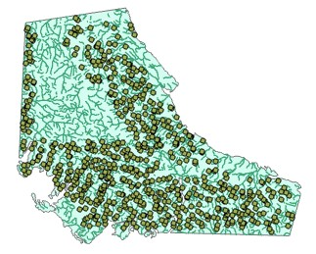

All points of the study area from the dataset are covered, except one large area, which doesn't contain any data because Strathcona park is a provincial park.

# Question 10

Going to layer properties and into Spatial Reference the coordinate system it lists WGS 1984 as the Geographic coordinate system.

# Question 11

Based on the histogram the model most fits a *bimodel* curve, as there are two distinct peaks of values, being 6.7 on the left side of the curve, and 7.2 on the right side of the curve.

# Question 12

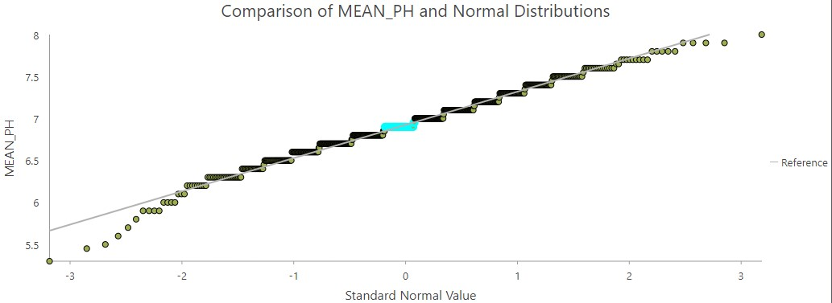

QQ Plot of Mean pH values

Based on the QQ Plot above, we see that the mean values roughly follow the same line and are distributed evenly. From this assessment we can say that this data is normally distrubuted. **Question 13**

Adjusting the search neighbourhood, and specifying a minimum and maximum neighbours concentrated the statistical output of the distance weighing. These options along with optimizing the power value improved the overall RMSE value.

# Question 14

Order of Polynomial 2:

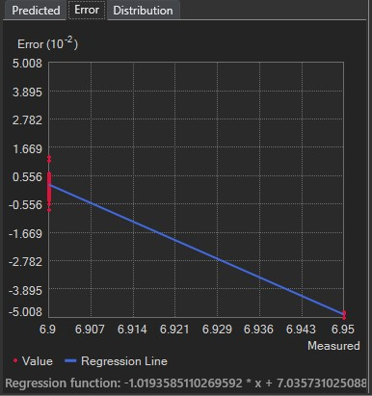

Order of polynomial 6:

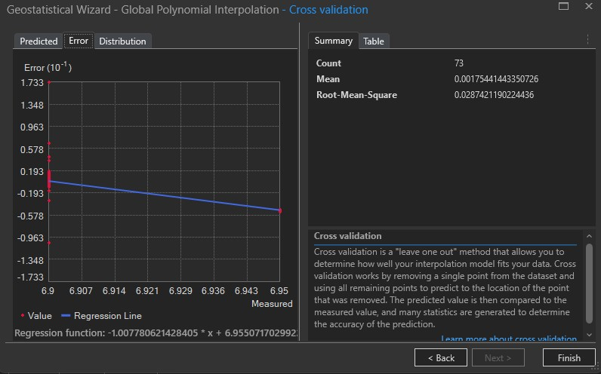

Based on the two option the error trend using a 2 polynomial value the trend is skewed downwards a lot more than the 6 value.

# Question 15

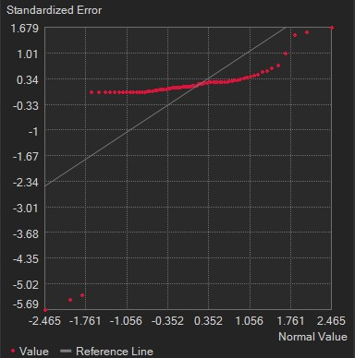

The neighbouring pH values are more likely to be similar than the distant values are, as the semivariogram.

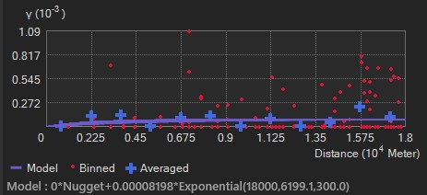

# Question 16

Based on the results of the semivariogram pH is anisotropic. This is because The distance between points are greater than they are together. This is the definition of an anisotropic spatial dependency.

# Question 17

Universal Kriging:

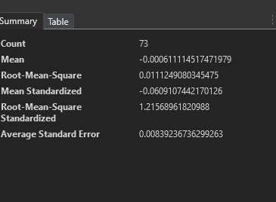

Universal kriging with anisotropy:

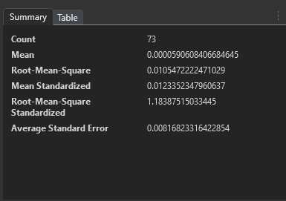

Value changes slightly, from 1.18 to 1.21 using universal kriging.

# Question 19

Inverse Distance Weighing ranked the highest as the isotropic model, best approximating the source points. Using Inverse Distance weighing, Global polynomial interpolation, and IDW Ellipse Neighbourhood models.

# Question 20

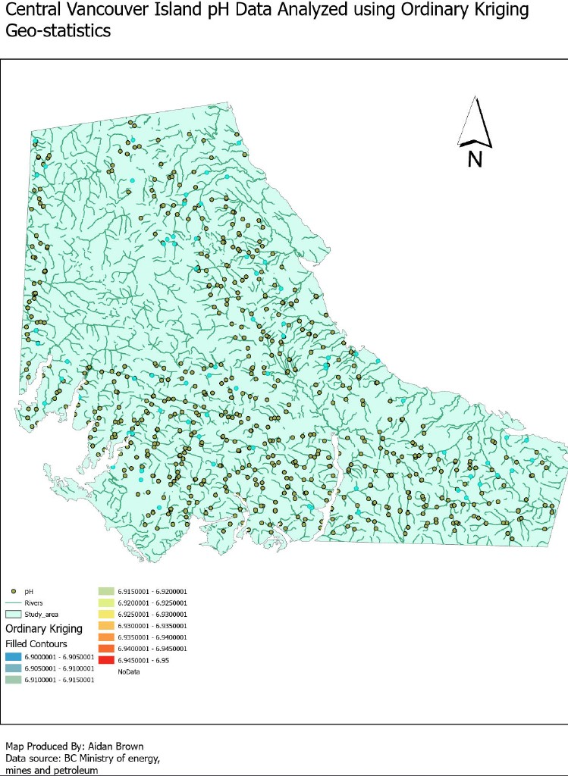

Based on running the Geostatistical layer geoprocessing, Ordinary Kriging ranked the first as the best anisotropic method, with the input parameters of the ordinary kriging model, and universal kriging models.

# Question 21

Semivariogram results of comparing Mean pH to Elevation:

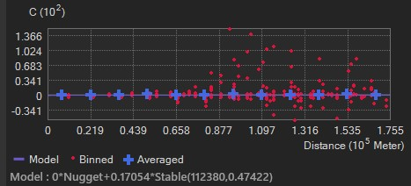

# Question 23

Farming or mining can affect pH levels by introducing chemicals and pollution into bodies of water.

Variations temperature can also affect carbon levels in water at higher elevations.

**Question 26**

Square root of the Error2 column = 19.288987868 / count of records = 0.02553443619

# Question 27

Kriging Standard Error can be used as a stochastic result, which measures the reliability of predicted values and spatial variability between points.