class04.R
hyuntaean
2026-10-08
#Class 4 my frist R script
x <- 1:50
plot(x)
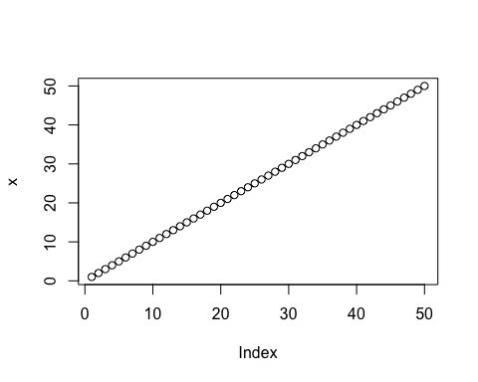
plot(x,sin(x))
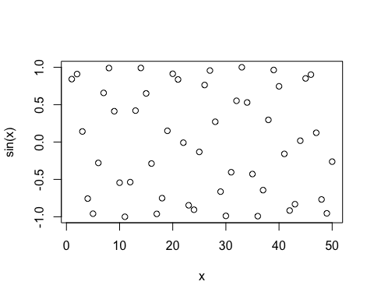
plot(x,sin(x), type="l", col="blue",lwd=3)


