Task 1: Figure out what security precautions are already used in your 'dvd_rental' database.
Authentication:
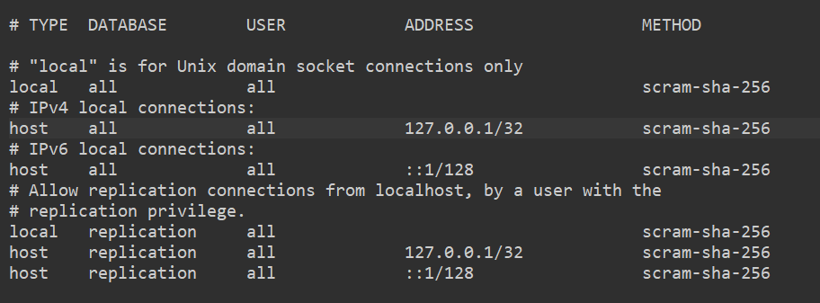
As we can see from the pg_hba.conf file, scram-sha-256 authentication protocol is in place for all connection types and users.

In-transit security:
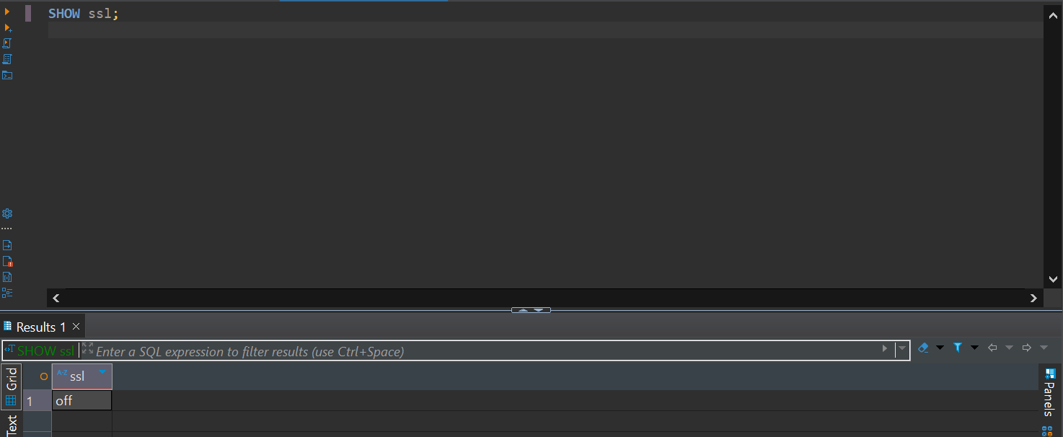
As we can see, SSL encryption is off, which leaves in-transit data vulnerable for possible data theft.

Roles:
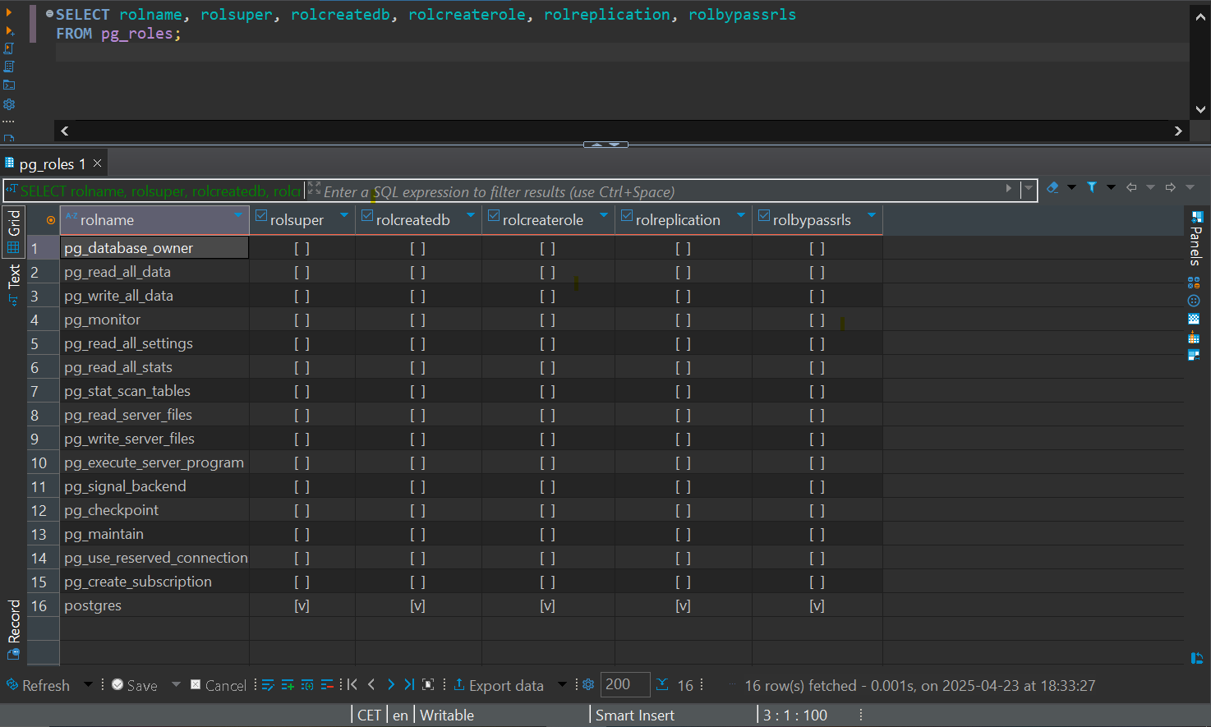
There are already several roles in place for the database, with postgres being the only superuser. None of the other roles have DB creation, role creation, replication or RLS bypassing priviliges.
Priviliges:
When checking priviliges, we see that PUBLIC only has SELECT priviliges on tables and schemas, and postgres (being a superuser) has unrestricted access to the entire database .

