**Group #1**

**Rudrashis Poddar**

**Balaji Arcot Kulasekaran**

**Rabie Ahmed M Alsaihati**

**Harsh Kantilal Sharma**

**University of Cincinnati**

**College of Applied Science and Engineering**

**Machine learning**

**Professor Anca Ralescu**

**Homework 6**

**Problem 1**

As hinted in the assignment we tried to find the values of m for n=2,3,4 and d=2,3 respectively.

|  |  |  |
| --- | --- | --- |
| n | d | m |
| 2 | 2 | 6 |
| 2 | 3 | 10 |
| 2 | 4 | 15 |
| 3 | 2 | 10 |
| 3 | 3 | 20 |
|  |  |  |

We can use binomial theorem in recursion for this problem. We know that binomial theorem has n+1 distinct terms. Now we can break any number of terms inside the bracket into a binomial form (A+B) such that we can calculate the number of terms in the expansion.

m =n+dCd

m gives us the number of terms in (x.z+1)d We basically want to find the number of distinct terms in the expansion.

This equation works for all values of m,n, and d.

As when n=2 and d=2 ,4C2=6=m

n=2 , d=3 ,5C3=10=m

n=2, d=4, 6C2=15=m

n=3 , d=2 , 5C2=10=m

n=3, d=3 , 6C3=20=m

**Problem 2**

1. The SMO algorithm has been implemented For the Hard margin SVM and the optimal separating hyperplane was found as follows:

Figure shows the separating hyper plane. Here +1 is for green and -1 is for red.

From our graph we can see that the data is linearly separable .However there can be many lines between the red and green circles.Therefore we have to use SVM to come up with the optimal decision surface.

1. Alpha Initialization was based on the following code section

Calculating total number of positive and negative instances for Y and setting the alpha i for +ve Yi = 1/(no of +instances ) and alphai for -ve Yi=1/(no of -ve instances)

ctr1=sum([1 if i==1 else 0 for i in Y])

ctr2=sum([1 if i==-1 else 0 for i in Y])

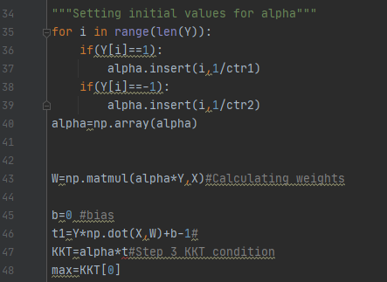

This way $\sum_{i}{αi*yi}$ =0

1. Predicted matrix is shown as below

Predicted [-1, 1, -1, 1, 1, -1, 1, -1, -1, 1, 1, -1, -1, -1, -1, -1, -1, -1, 1, 1, -1, 1, -1, -1, 1, 1, 1, 1, 1, 1, 1, -1, -1, -1, 1, 1, 1, -1, -1, 1, -1, 1, 1, -1, -1, -1, 1, -1, -1, -1, 1, 1, 1, -1, -1, -1, 1, -1, -1, 1, -1, 1, 1, -1, -1, 1, -1, 1, -1, 1, -1, 1, -1, 1, -1, -1, 1, -1, -1, 1, -1, -1, 1, -1, 1, 1, 1, 1, -1, -1, 1, 1, 1, 1, -1, -1, -1, -1, -1, -1, 1, 1, 1, 1, 1, -1, -1, 1, -1, 1, 1, -1, 1, 1, 1, -1, 1, 1, 1, -1, 1, 1, 1, 1, 1, 1, 1, -1, 1, 1, 1, -1, 1, -1, -1, -1, -1, -1, -1, -1, 1, 1, -1, -1, -1, 1, 1, 1, 1, 1, -1, -1, 1, -1, -1, -1, -1, -1, 1, 1, 1, 1, 1, -1, -1, 1, -1, -1, -1, 1, 1, 1, -1, 1, -1, 1, -1, 1, 1, 1, 1, -1, -1, -1, -1, 1, -1, -1, -1, 1, -1, 1, 1, -1, -1, 1, 1, -1, -1, 1, -1, 1, 1, 1, -1, 1, -1, 1, 1, -1, -1, -1, -1, 1, 1, -1, -1, -1, 1, -1, 1, -1, 1, -1, 1, 1, 1, 1, -1, 1, -1, -1, -1, -1, 1, -1, -1, -1, 1, -1, 1, 1, 1, -1, 1, -1, -1, 1, -1, 1, 1, 1, -1, 1, 1, -1, -1, 1, -1, 1, -1, -1, -1, 1, 1, 1]

1. Accuracy 0.9962406015037594