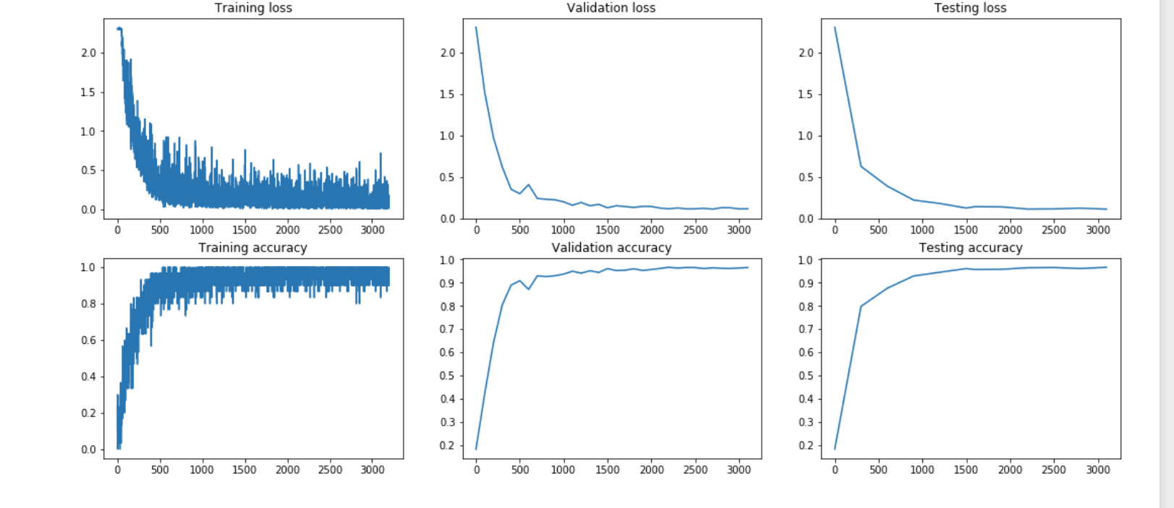
ACCURACY OVER ITERATIONS

Epoch 0:
Test accuracy=0.09820, loss=2.30259
Validation accuracy: 0.09933, loss: 2.30259
Iteration 0: accuracy=0.03333, loss=2.30259, regularization loss= 0.00520545506372957
Validation accuracy: 0.44117, loss: 1.45460
Iteration 100: accuracy=0.53333, loss=1.45495, regularization loss= 0.08752150147507047
Validation accuracy: 0.71942, loss: 0.91726
Iteration 200: accuracy=0.56667, loss=1.76639, regularization loss= 0.18765073612855335
Test accuracy=0.81660, loss=0.53832
Validation accuracy: 0.82792, loss: 0.51360
Iteration 300: accuracy=0.90000, loss=0.39229, regularization loss= 0.17864027089700724
Validation accuracy: 0.83583, loss: 0.59713
Iteration 400: accuracy=0.86667, loss=0.41873, regularization loss= 0.17987872894554474
Validation accuracy: 0.70317, loss: 1.20196
Iteration 500: accuracy=0.63333, loss=1.36451, regularization loss= 0.17645583954616623
Test accuracy=0.87960, loss=0.41050
Validation accuracy: 0.88175, loss: 0.40615
Iteration 600: accuracy=0.83333, loss=0.49651, regularization loss= 0.16562664521309917
Validation accuracy: 0.87067, loss: 0.48089
Iteration 700: accuracy=0.80000, loss=1.57661, regularization loss= 0.15769914182477082
Validation accuracy: 0.90167, loss: 0.33412
Iteration 800: accuracy=0.86667, loss=0.45793, regularization loss= 0.16000910634030024
Test accuracy=0.81160, loss=0.66589
Validation accuracy: 0.81917, loss: 0.63385
Iteration 900: accuracy=0.86667, loss=0.40807, regularization loss= 0.14243313354775805
Validation accuracy: 0.90992, loss: 0.29001
Iteration 1000: accuracy=0.80000, loss=0.65342, regularization loss= 0.13790030875765996
Validation accuracy: 0.92050, loss: 0.25061
Iteration 1100: accuracy=0.83333, loss=0.52617, regularization loss= 0.1096034721049119
Test accuracy=0.91920, loss=0.26430
Validation accuracy: 0.91992, loss: 0.27511
Iteration 1200: accuracy=0.80000, loss=0.73641, regularization loss= 0.10376651102532178
Validation accuracy: 0.94308, loss: 0.18982
Iteration 1300: accuracy=0.93333, loss=0.21114, regularization loss= 0.09298543657595684
Validation accuracy: 0.94675, loss: 0.17043
Iteration 1400: accuracy=0.93333, loss=0.49069, regularization loss= 0.08933335051198583
Test accuracy=0.94540, loss=0.18614
Validation accuracy: 0.94025, loss: 0.19476
Iteration 1500: accuracy=0.93333, loss=0.11933, regularization loss= 0.08556868177822265
Epoch 1:
Test accuracy=0.92790, loss=0.24367
Validation accuracy: 0.92608, loss: 0.23817
Iteration 0: accuracy=1.00000, loss=0.03536, regularization loss= 0.09135827669888771
Validation accuracy: 0.93467, loss: 0.20147
Iteration 100: accuracy=1.00000, loss=0.00869, regularization loss= 0.0947095989031581
Validation accuracy: 0.91808, loss: 0.26161
Iteration 200: accuracy=0.96667, loss=0.12461, regularization loss= 0.09781144970646673
Test accuracy=0.93650, loss=0.20276
Validation accuracy: 0.93400, loss: 0.21383
Iteration 300: accuracy=0.86667, loss=0.31719, regularization loss= 0.10161784471996338
Validation accuracy: 0.93042, loss: 0.24273
Iteration 400: accuracy=0.93333, loss=0.33645, regularization loss= 0.10196131141735254
Validation accuracy: 0.95608, loss: 0.14465
Iteration 500: accuracy=0.93333, loss=0.11400, regularization loss= 0.09622003966119004
Test accuracy=0.96140, loss=0.12865
Validation accuracy: 0.95858, loss: 0.13157
Iteration 600: accuracy=0.93333, loss=0.16676, regularization loss= 0.09508023074825475
Validation accuracy: 0.94358, loss: 0.19118
Iteration 700: accuracy=0.93333, loss=0.20654, regularization loss= 0.09277604718738494
Validation accuracy: 0.96092, loss: 0.12708
Iteration 800: accuracy=0.93333, loss=0.09891, regularization loss= 0.09254975272701314
Test accuracy=0.95830, loss=0.13246
Validation accuracy: 0.96000, loss: 0.13305
Iteration 900: accuracy=1.00000, loss=0.08032, regularization loss= 0.0919272031150221
Validation accuracy: 0.96475, loss: 0.11773
Iteration 1000: accuracy=1.00000, loss=0.09101, regularization loss= 0.09262899270689484
Validation accuracy: 0.95433, loss: 0.14535
Iteration 1100: accuracy=0.86667, loss=0.38503, regularization loss= 0.09678575009119106
Test accuracy=0.96350, loss=0.11903
Validation accuracy: 0.96417, loss: 0.12066
Iteration 1200: accuracy=1.00000, loss=0.03620, regularization loss= 0.09881750447902309
Iteration 1300: accuracy=0.96667, loss=0.07690, regularization loss= 0.09962899230689186
Validation accuracy: 0.95433, loss: 0.13121
Iteration 1400: accuracy=1.00000, loss=0.03104, regularization loss= 0.09761931270129485
Test accuracy=0.97770, loss=0.05614
Validation accuracy: 0.96767, loss: 0.11546
Iteration 1500: accuracy=1.00000, loss=0.02540, regularization loss= 0.09910291870482324

MY FINAL TEST ACCURACY IS 0.97770

REPORT:

Here we use the following notations in this report:
f: Out_channels, o_h: output_width,
c: In_channels, o_w: output_height,
x_w: input_width, k_h: kernel_height,
x_h: input_height, k_w: kernel_width
d: Batch size

Convolutional Layer:
+ Forward: First, I implement the logic of img2col, that takes in images of shape (d,c, x_w, x_h) and transform into X_col of shape (c*k_h*k_w, d*o_h*o_w)
Then, output = W_col * X_col + bias_col.

+ Backward:
X_col is the same as in Forward Function.
W_grad = in_grads_reshaped * X_col
Bias_grad has shape (f,), and we have :
Bias_grad[i] = sum(in_grads[:,i,:,:])
First, we calculate out_grads = W_reshaped * in_grads_reshaped.
Here, out_grads has shape (c*k_h*k_w, d*o_h*o_w)
Finally, we need to reshape out_grads to (d, c, x_h, x_w), with the logic known as col2img.

Pooling Layer:
+ Forward: Iterating through each window, then find the maximum or the average value in the window depending on the Pooling Type. I loop through each window using 4 for-loops:
for d in range(batch_size):
for c in range(in_channel):
for I in range(in_height):
for j in range(in_width):
+ Backward:
To simplify my explanation here, I will assume that batch size is 1 and in channel is 1(but I do not assume these in my implementation).
For I in range(out_h):
for j I range(out_w):
if(“AVERAGE_POOLING”):
add (in_grads[i, j] / Pool_size) to every elements (a, b) of out_grads, such that the element at (a,b) of inputs was in the pooling window used to calculate outputs[i, j]

if(“MAX_POOLING”):
add in_grads[i, j] to the maximum element at (a, b) in the pooling window used to calculate outputs[i, j]

DROPOUT:
+ Forward:I create a mask of the same shape as the inputs, then each value is either 0 or 1, with probability following Binomial(p=dropout_rate).
So: Output =( mask * inputs ) / ( 1 – dropout_rate)
But that formula is only used if this is training stage. If testing stage, output = input.
+ Backward:
Out_grads = (In_grads * mask) / (1 – dropout_rate)

FULLY CONNECTED LAYER:
+ Forward: Outputs = Inputs * weights + bias
+ Backward: W_grad = inputs.T * in_grads
b_grad[i] = np.sum(in_grads[:, I])
out_grads = in_grads * (weights.T)

SOFTMAX CROSS ENTROPY

+ Forward: First, calculate the output of Softmax Function:

probs[i] = e^(h_i) / ( sum(e^(h_k), where k is in range(num_class)) )

Then, calculate loss as:
Loss = sum(y_i * probs[i]) / batch_size, and sum it over all batch_size elements.
Where y_i is the ground truth 0/1 of whether this is the correct label of this element or not.

+ Backward:

We can prove that:
out_grads[i, j] = [probs[i, j] – f(i, j)] / batch_size

Where: probs[i, j]: The probability of the i_th element has label j.
f(i, j): is 1 if j == correct_label_of_i, otherwise it is 0.

ARCHITECTURES:

NOTE: USE final.py to re-run the architecture.

CONVOLUTION (32*3*3)
RELU
POOLING (2*2)
CONVOLUTION (32*3*3)
RELU
POOLING (3*3)
DROPOUT (rate = 0.25)
FLATTEN
FCLAYER (800 → 256)
RELU
FCLAYER (256 → 128)
RELU
FCLAYER(128 → 10:num_class)
SOFTMAX_CROSSENTROPY

I use Adam Optimizer, learning rate = 0.01 learning rate scheduler using decay constant equal to learning_rate / epoches.
Batch _ size = 64.

Insights:
- I add a DropOut Layer with rate 0.25 in order to help control overfitting ( in tandem with L2 regularization). Because of that, I add one more FCLayer, so it helps better classify the features returned by convolution and pooling layers. However, adding an extra DropOut Layer make the overall time slower.

- Adam Optimizer runs better than SGD Optimizer in this case.

- I used data augmentation to increase the number of training datasets. I double the size of training dataset and testing dataset. Half of the extra images are rotated image, with a random angles from -30 to 30 in training dataset, and with a fixed angle in testing dataset. The other half of extra images are shifted image, with a random shift in training dataset, and a fixed shift in testing dataset.

- I checked if there are class imbalances in the dataset(i.e many samples of a certain class, but few samples of another class). Thankfully, this is not an issue in MNIST dataset. In case there are class imbalances, we should make use of techniques to embrace the dataset(e.g oversample the minority class).

- I used a small batch size(64), because as pointed out in research, having a very large batch can reduce the generialization ability of the model. However, the trade-off for smaller batch size is slower training time.

- I used 32 as the number of kernels, and 5x5, 3x3 as the size of convolution kernels. I use stride 1 in convolution layer, and stride 2 in Pooling Layer. These follow the guideline shown in class.

- I notice that using max-pooling has better performance than using average-pooling. My reasoning is that max-pooling represents “this type of feature was detected in this general area”, but it loses low-activation feature in the blocks(I think this is not important in our task). For average-pooling, if in the blocks we have high and low activations they will cancel each other. However, average-pooling is able to retain low activations. Average-pooling is useful in Image Contrast Learning.

WHERE I FAILED: I used 2 DropOut Layer with drop out rate = 0.5, but too much regularization caused my model to underfit.

WHERE I FAILED: At first, I was to greedy that I created a huge amount of data augmentation, but this really drags down the performance of my model. Finally, the cause is because Augmentation also has a regularizing effect, and too much of it together with L2 and DropOut caused my model to underfit.

- WHERE I FAILED: I aimed to use Xavier Initialization for my weights, but it seems like my understanding of fan_in and fan_out is not correct.
Here is my understanding for fan_in and fan_out for Convolutional Layer:
+ Fan_in = in_channel * kernel_h * kernel_w
+ Fan_out =out_channel * kernel_h * kernel_w / (size_of_next_pooling)

FCLayer:
+ Fan_in = input_features
+ Fan_out = output_features

With this understanding, there are weight overflows in my training, leading to NaN error.

