**Q1. How to reverse a string?**

**Method: Using Built-in Functions**

1. **Convert the string into an array**
2. **Reverse the array**
3. **Join the array back into a string**

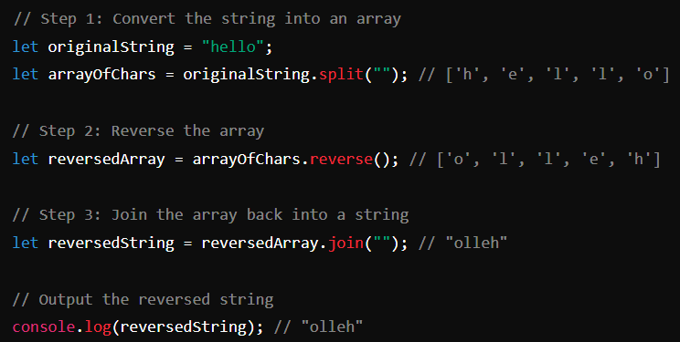

**Explanation:**

**split(""):**

**The split method splits a string into an array of substrings. The argument "" specifies that the string should be split between each character, effectively turning the string into an array of its characters.**

**reverse()**:

**The reverse method reverses the order of the elements in an array in place. This means the array is modified directly and returns the reversed array**.

**join("")**:

**The join method joins all elements of an array into a string. The argument "" specifies that there should be no separator between the array elements, effectively concatenating the characters back into a single string.**

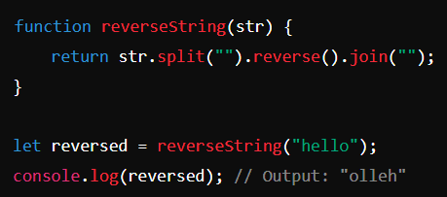**Complete Code Example:**

**Additional Method: Using a Loop**

**You can also reverse a string using a loop, which may be more intuitive for beginners:**

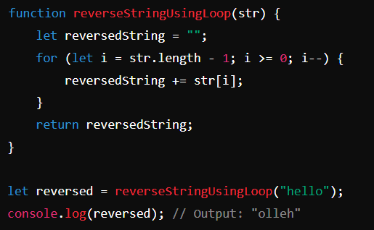

**Explanation of Loop Method:**

1. **Initialize an empty string** **reversedString to store the reversed string.**
2. **Loop through the original string starting from the end (i.e., str.length - 1) to the beginning (i.e., 0).**
3. **Concatenate each character** **to reversedString in each iteration.**
4. **Return the reversed string** **after the loop completes.**

***Both methods are effective, but the method using built-in functions (split, reverse, join) is more concise and leverages JavaScript's array manipulation capabilities.***

**Q2. How to find even and old number in array ?**

**To find even and odd numbers in an array using JavaScript, you can iterate through the array and use the modulo operator (%) to determine if a number is even or odd. Here's an example of how you can achieve this:**

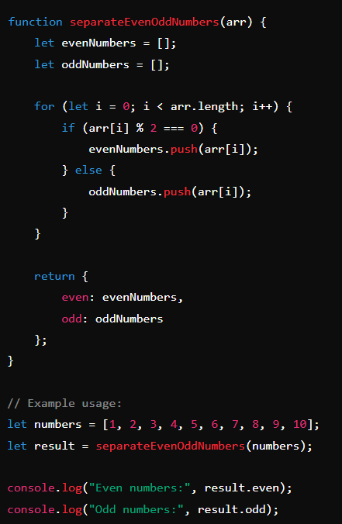

**In this code:**

1. **The separateEvenOddNumbers function takes an array arr as an argument.**
2. **Two empty arrays, evenNumbers and oddNumbers, are created to store the even and odd numbers, respectively.**
3. **A for loop iterates through each element in the input array.**
4. **Inside the loop, the if statement checks if the current element (arr[i]) is even using arr[i] % 2 === 0. If it is, the number is pushed to the evenNumbers array. If it is not, the number is pushed to the oddNumbers array.**
5. **Finally, the function returns an object containing the evenNumbers and oddNumbers arrays.**

***The example usage demonstrates how to call this function and print the results. The numbers array contains a mix of even and odd numbers, and the function will separate them accordingly.***

**Q3.How to find max/min in a given array?**

**To find the maximum and minimum values in a given array in JavaScript, you can use several methods. Here are the most common approaches:**

**Using the Math.max and Math.min Functions**

**You can use the Math.max and Math.min functions in combination with the spread operator (...) to find the maximum and minimum values in an array.**

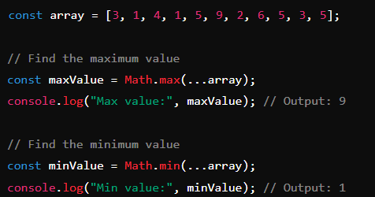

**Using reduce Method**

**You can also use the reduce method to find the maximum and minimum values in an array.**

***Example:***

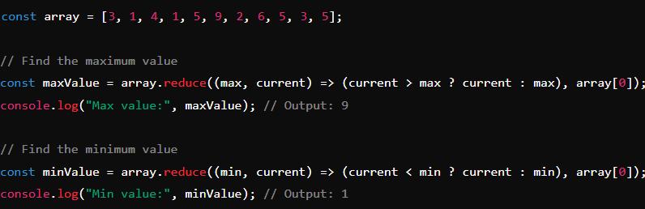

**Using a Loop**

**A more traditional approach involves using a loop to iterate through the array and find the maximum and minimum values.**

***Example:***

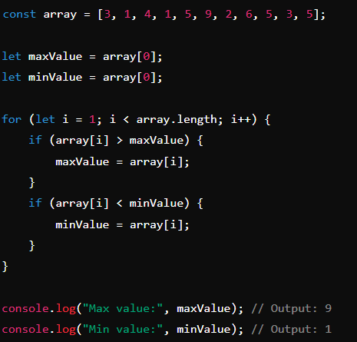

**Using sort Method**

**Another approach is to sort the array and then take the first and last elements for the minimum and maximum values respectively.**

***Example:*** 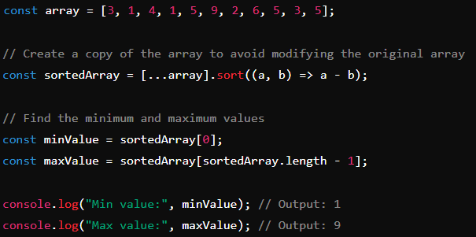

**Summary**

1. **Each of these methods has its own advantages:**
2. **Math.max and Math.min with the spread operator: Concise and easy to use for small to moderately sized arrays.**
3. **reduce method: Functional programming approach, useful for understanding reduce functionality.**
4. **Loop: Traditional and efficient for very large arrays.**
5. **sort method: Simple, but not the most efficient due to the overhead of sorting.**

***Choose the method that best fits your needs based on readability, performance, and array size.***

**Q4. How to find duplicate elements in array ? for javascript?**

**To find duplicate elements in an array using JavaScript, you can use several methods. Below are a few common approaches:**

**1. Using a Set**

**This method uses a Set to track elements that have already been seen, which allows for efficient detection of duplicates.**

***Example:***



**2. Using an Object**

**This method uses an object to count occurrences of each element, and then filters out elements that appear more than once.**

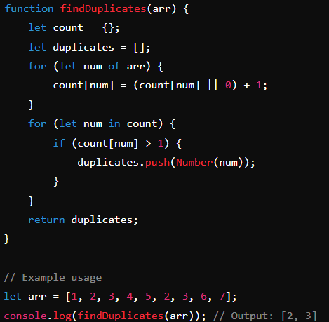***Example:***

**3.Using Array Methods**

**This method utilizes array methods like filter and indexOf to identify duplicates.**

***Example:***

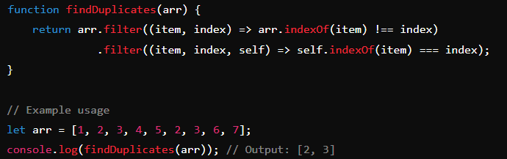

**4. Using Map**

**This method uses a Map to keep track of the occurrences of each element and then collects elements that appear more than once.**

***Example:***

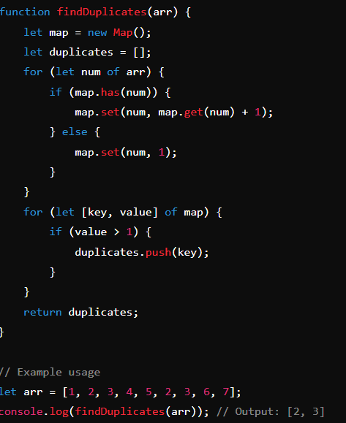

***Each of these methods provides an efficient way to find duplicates in an array, and you can choose the one that best fits your needs.***