Ping

1. rtt min/avg/max/mdev = 0.374/0.451/0.479/0.032 ms
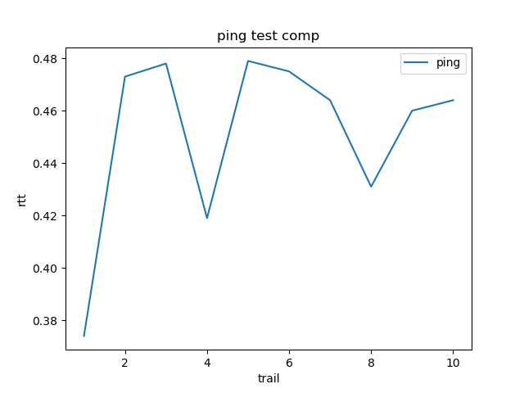

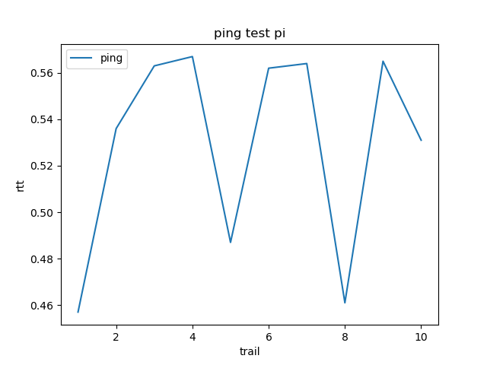
2. rtt min/avg/max/mdev = 0.457/0.529/0.567/0.042 ms

3. rtt min/avg/max/mdev = 0.352/0.468/0.596/0.037 ms
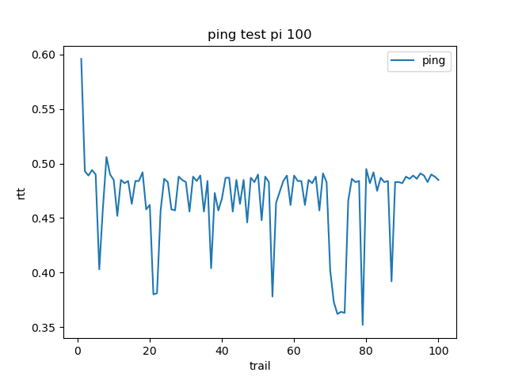
ping 10 times from computer has lower rtt min/avg/max than from pi
ping 100 times with 0.001s interval from pi has a high rtt at the start but decrease to have lower rtt than 10 times 0.2s interval after several trails

4. rtt min/avg/max/mdev = 0.262/0.437/0.640/0.041 ms, ipg/ewma 0.468/0.393 ms

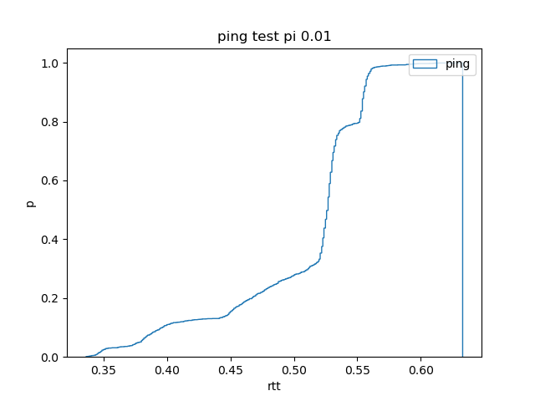
5. rtt min/avg/max/mdev = 0.336/0.505/0.633/0.056 ms

rtt min/avg/max/mdev = 0.324/0.471/0.605/0.031 ms

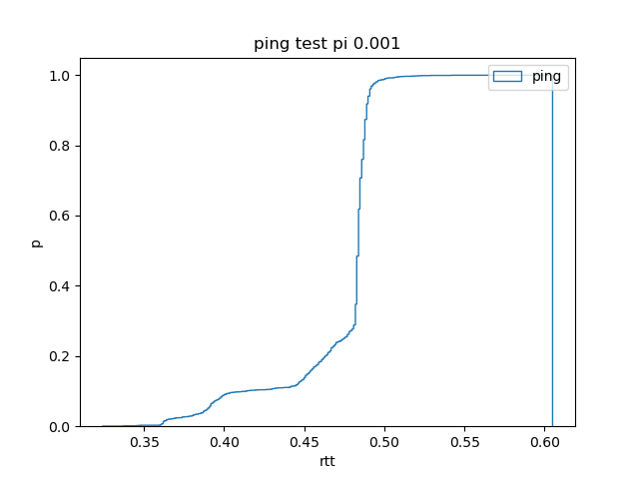

rtt min/avg/max/mdev = 0.296/0.433/0.577/0.044 ms, ipg/ewma 0.465/0.454 ms
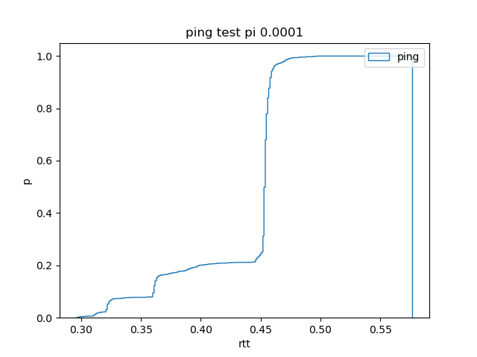

Iperf

1. effective band width : 940Mbits/sec

