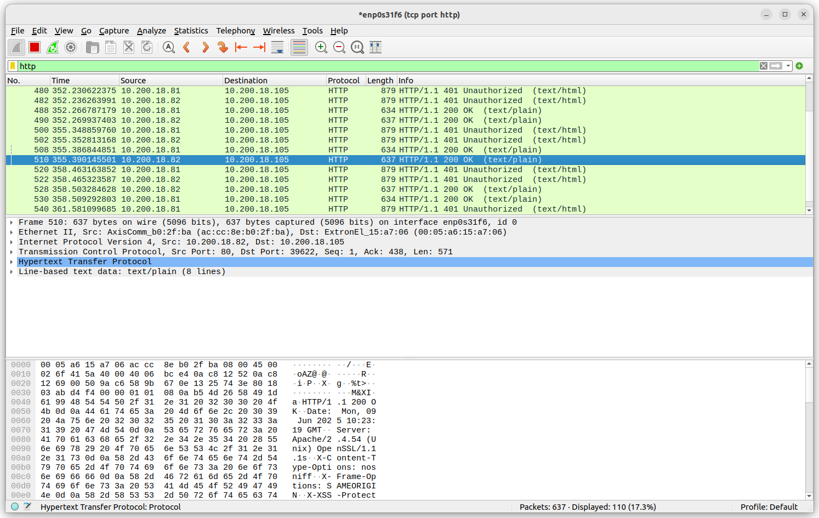
Traffic Capture
Ethernet
I see pachets captured, there are some repeating packets of "standard query"
http traffic
type http in the filter bracket and apply
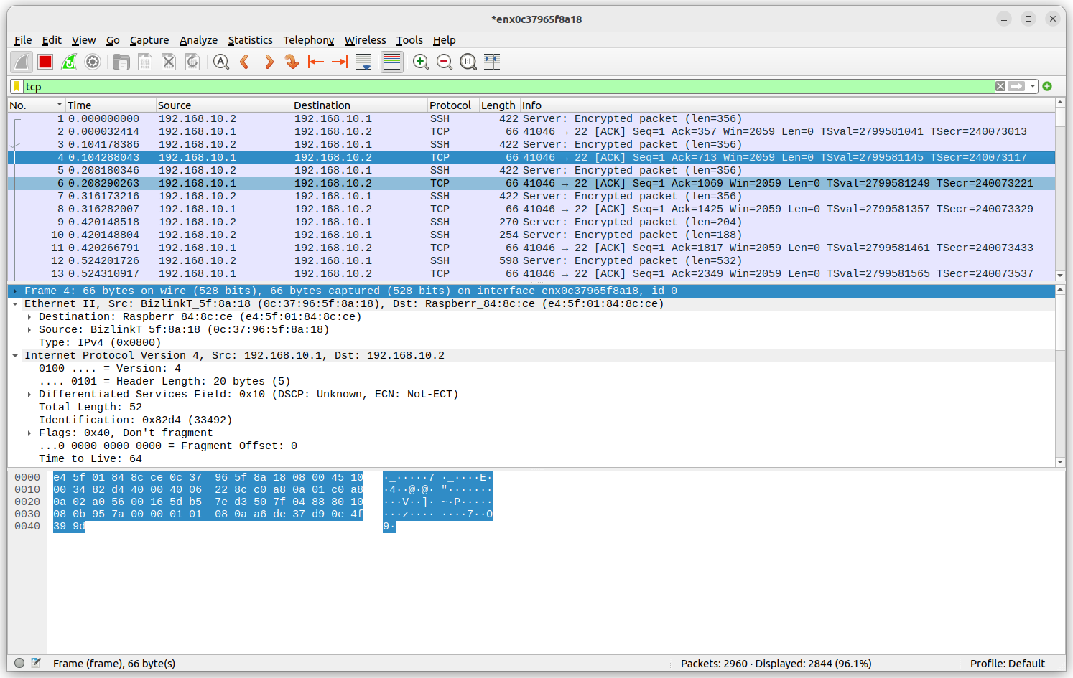
Filter: !(udp.port == 53) && udp filter out DNS message and show only udp packets
Packet size is 64 bytes
Protocol used is UDP
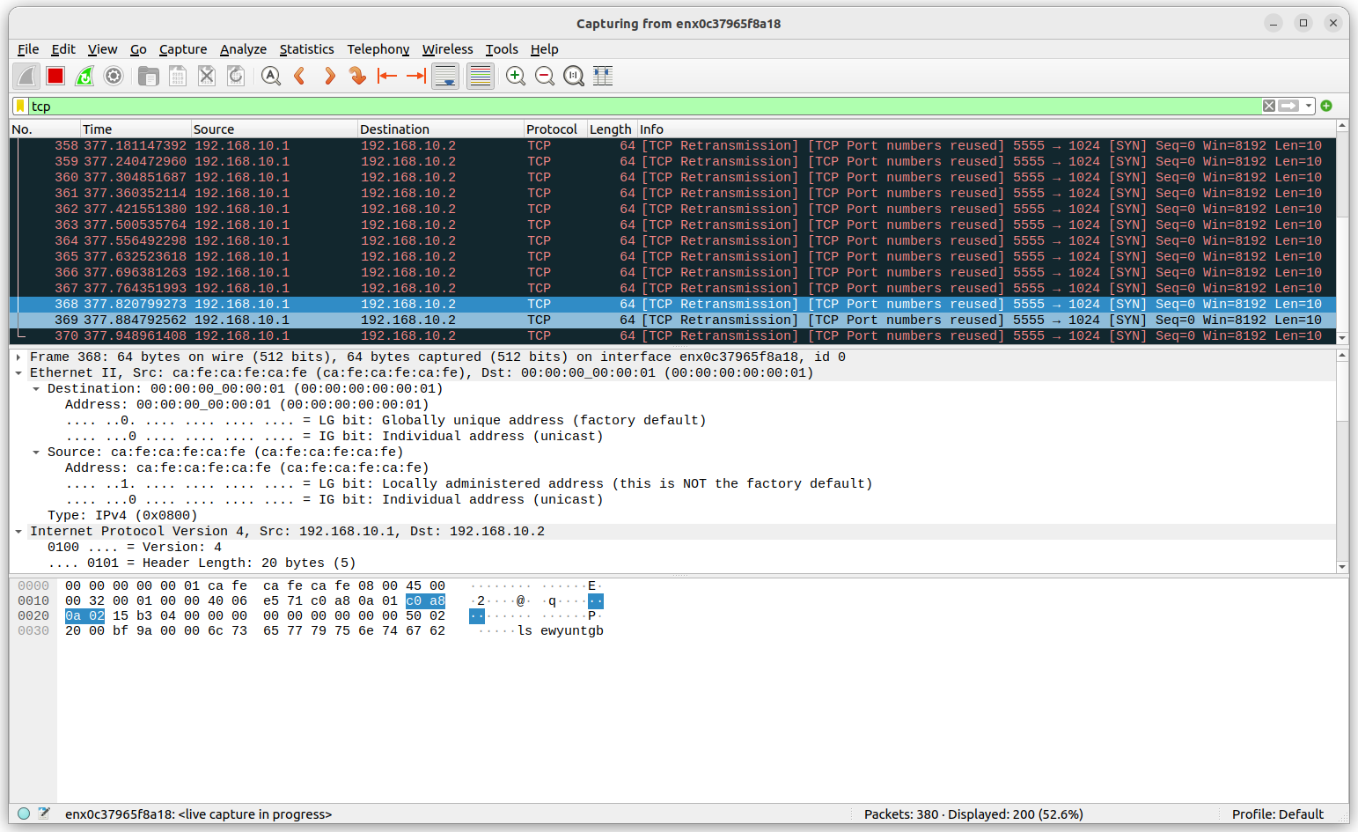
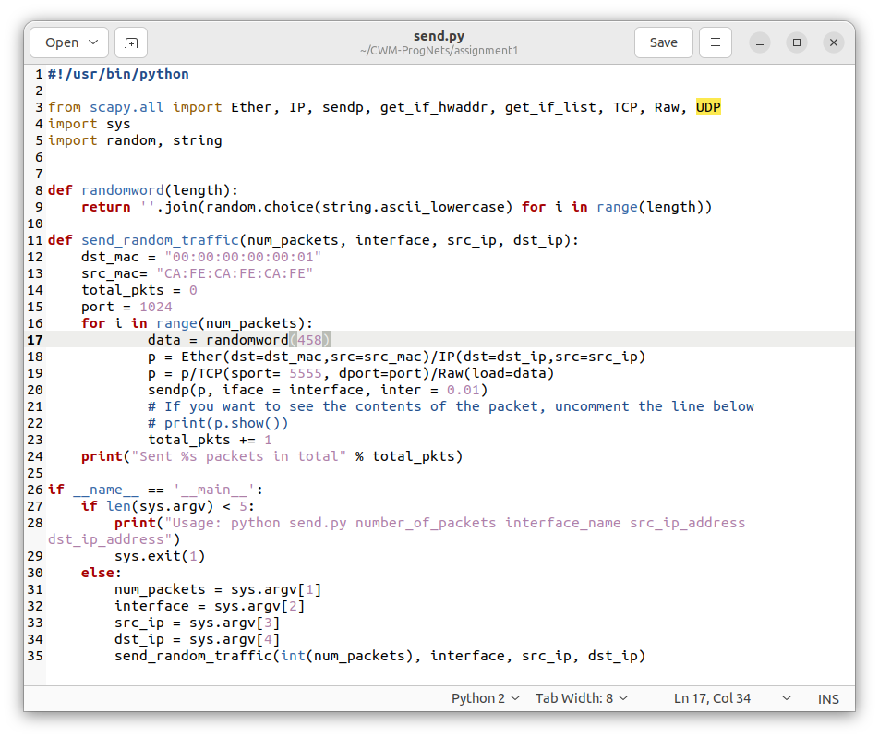
https://github.com/hANK522/CWM-ProgNets/tree/main/assignment1

