Payroll System
User Manual
  - For the WinForms + MySQL project in the GitHub repository hAizen-Nibba/Payroll
Reviewed build | Repository structure and source files reviewed on April 11, 2026
Main users | Admin and Employee
Database | MySQL database name: payrolldb_test

This manual explains how to use the current version of the system based on the code and database included in the repository. It focuses on the actual working flow, not an ideal future version.

1. System overview
The project is a desktop payroll application built in C# WinForms and connected to a local MySQL database. It has two main user roles: Admin and Employee. The admin manages employee records, attendance, overtime, deductions, payroll periods, and payroll slip records. The employee logs in to view payroll details for a selected period and can open a printable payslip preview.

Main screens
• Login screen - accepts employee login credentials and a separate hard-coded admin login.
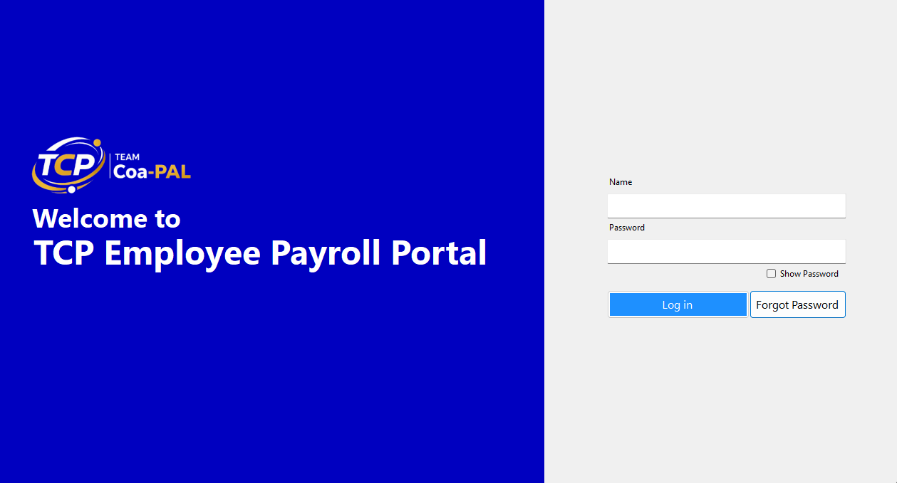

• Admin main screen - a parent form that opens child forms inside a panel.
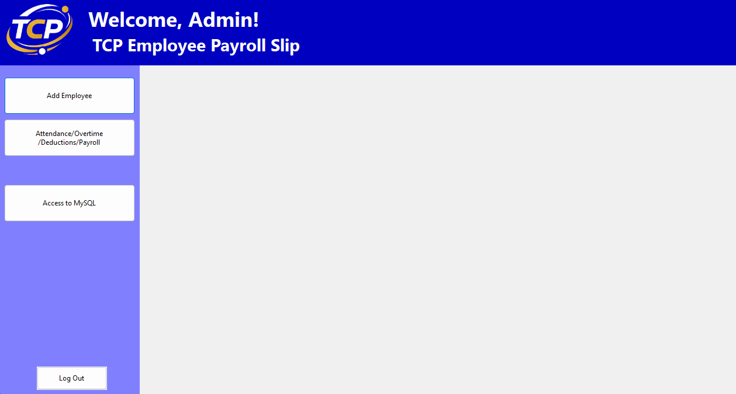

• Add Employee screen (from the side button inside the Admin main screen) - used to create a new employee and their security record.

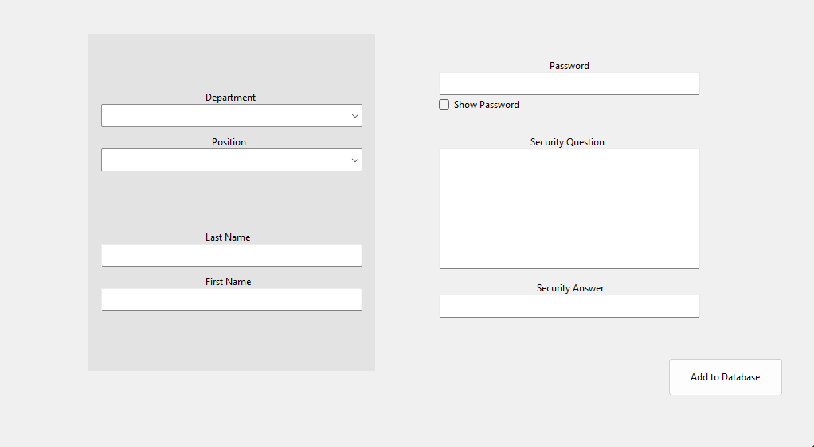

• Attendance / Overtime / Deductions / Payroll screen (from the side button inside the Admin main screen) - the main admin work area with filters and tabs.
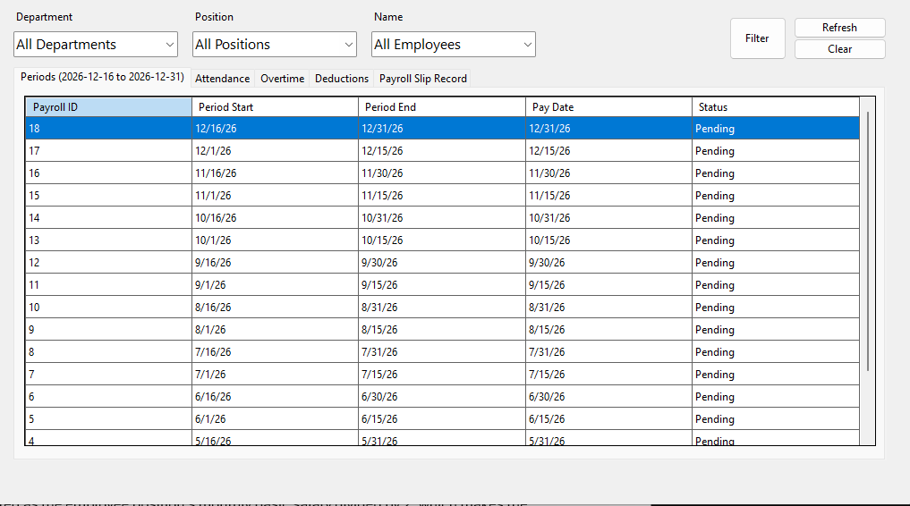

• Employee screen - shows department, position, attendance, overtime, earning items, deductions, and a print button.
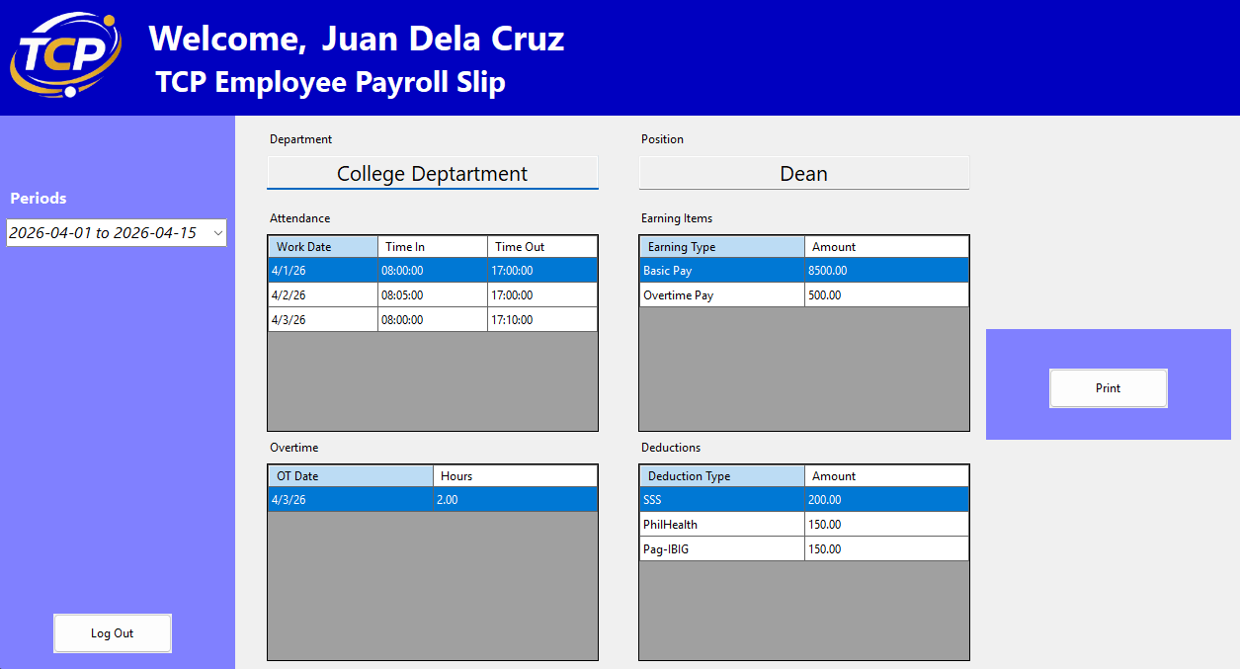

• Payslip preview screen - shows a printable payroll slip and supports printing.

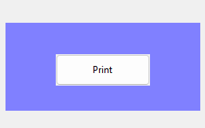

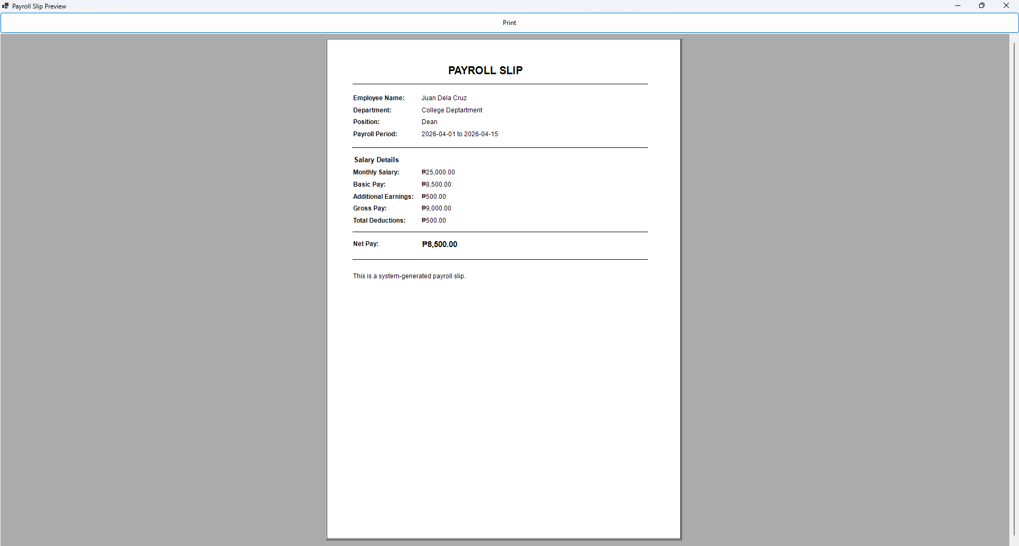

Current payroll logic used by the code
• Basic Pay is computed as the employee position's monthly basic salary divided by 2, which makes the system semi-monthly.
• Overtime Pay is computed from the selected active payroll period using an overtime rate of PHP 250 per hour.
• Gross Pay is the sum of all earning items for a payroll slip record.
• Total Deduction is the sum of all deduction items linked to the payroll slip record.
• Net Pay is Gross Pay minus Total Deduction.
• Attendance is recorded and filtered by period, but in the current code it is not used in the payroll computation.

2. Installation and setup
Use this section when opening the project on a new computer or after cloning the repository.

Software needed
• Visual Studio 2022 with Windows Forms support
• A local MySQL or MariaDB server
• The MySql.Data package available to the project
• The database dump from the repository: Database Schema.md

Database setup
• Create a database named payrolldb_test.
• Import the SQL structure and sample data from Database Schema.md into MySQL. The file contains the tables, inserts, indexes, and foreign keys.
• Confirm that the main tables exist: department, positions, employees, security, attendance, overtime, payroll_periods, payroll_slip_record, payroll_earning_items, and payroll_deduction_items.
• The code currently connects with server=localhost;database=payrolldb_test;uid=root;pwd=; so adjust the connection string in the forms if your local database password is different.

Seed data included in the repository
Included sample data | Notes
Department | One department is seeded: College Deptartment.
Positions | Dean, Program Head, Librarian, Instructor 1, Instructor 2, and Instructor 3, each with a basic salary.
Payroll periods | Semi-monthly periods are seeded from April 2026 to December 2026.
Sample records | Attendance, overtime, earning items, deduction items, payroll slip records, and security rows are already present for testing.

3. Login and access
The application opens with the login form. Both employee and admin access start here.

Employee login
• Enter the employee full name in the Name field.
• Enter the employee password in the Password field.
• Click Log in.
• If the name and hashed password match a row in employees joined to security, the employee form opens.

Admin login
• Enter admin as the name.
• Enter teamcoapal as the password.
• Click Log in to open the admin main form.
Important: The admin login in the current code is hard-coded, not database-driven. Change it in Login.cs before using the project in a real environment.

Forgot password flow
• Click Forgot Password to open the password recovery panel.
• Enter the employee name, then click Okay to load the saved security question.
• Answer the security question and click Okay again.
• Enter and confirm the new password, then click Confirm.
• The new password is hashed with SHA-256 before it is written to the security table.

4. Admin module
After admin login, the system opens the admin main form. This screen acts as a shell. Buttons in the sidebar load child forms into the main panel instead of opening separate windows.

Admin main screen buttons
• Add Employee - opens the employee creation form.
• Attendance/Overtime/Deductions/Payroll - opens the main payroll management form.
• Access to MySQL - currently only shows a placeholder message and has no real function yet.
• Log Out - asks for confirmation and exits back out of the admin area.

4.1 Add Employee form
Use this form to create a new employee and the related login/security row in one step.
• Fill in Last Name and First Name.
• Enter the employee password.
• Enter the Security Question and Security Answer.
• Choose Department from the combo box.
• Choose Position from the combo box.
• Click Add to Database.
When the save succeeds, the program inserts a row into employees, gets the new employee ID, hashes the password, then inserts a matching row into security in the same transaction.

4.2 Payroll management form
This is the main admin work area. At the top are filter combo boxes for Department, Position, and Name, plus Filter, Clear, and Refresh buttons. Below them is a tab control with five tabs: Periods, Attendance, Overtime, Deductions, and Payroll Slip Record.

Periods tab
• The grid shows Payroll ID, Period Start, Period End, Pay Date, and Status.
• Select a row here first to make that period the active payroll period.
• Once a period is active, the other tabs work against that period and the form caption shows the active period label.
• Most add/edit actions validate dates against the active period.

Attendance tab
• Use Add to create an attendance row for the selected employee.
• The form asks for attendance date, time in, and time out through prompt dialogs.
• The date must fall within the active period.
• Edit updates the selected attendance record.
• Delete removes the selected attendance record after confirmation.

Overtime tab
• Use Add to enter OT date and OT hours for the selected employee.
• The OT date must be inside the active period.
• After saving, the system reloads overtime data and rebuilds the employee payroll slip for the active period.
• Edit and Delete are also available for existing OT records.

Deductions tab
• This tab works only after a payroll period is active and an employee is selected.
• Add asks for deduction type and deduction amount.
• The system ensures that a payroll slip record exists for the selected employee and period, then adds the deduction item.
• Edit changes deduction type or amount.
• Delete removes the selected deduction record after confirmation.

Payroll Slip Record tab
• This grid shows the payroll slip header records for employees and periods.
• Typical columns include Record ID, Payroll ID, Employee ID, Employee Name, Payroll Period, Gross Pay, Total Deduction, and Net Pay.
• Values are recalculated by the code after earning or deduction changes.

What happens automatically in payroll rebuild
• The system creates a payroll_slip_record row if it does not exist yet for the selected employee and period.
• It ensures two default earning item types exist: Basic Pay and Overtime Pay.
• Basic Pay is set from the employee position basic salary divided by 2.
• Overtime Pay is set from the sum of overtime hours in the active period multiplied by PHP 250 per hour.
• Gross Pay, Total Deduction, and Net Pay are recalculated and saved back to payroll_slip_record.

5. Employee module
The employee form is a read-only viewing screen for one employee. It is designed for reviewing payroll information for a selected period and printing a payslip preview.

How to use it
• After employee login, the form shows Welcome and the employee name.
• Department and Position fields are loaded automatically and are read-only.
• Choose a payroll period from the Periods combo box.
• Once a period is selected, the grids are filled with Attendance, Overtime, Earning Items, and Deductions for that employee and period.
• The Print button becomes enabled only after a valid payroll period is selected.

Print / preview payslip
• Click Print to open the PreviewSlip form.
• The preview screen shows employee name, department, position, payroll period, monthly salary, basic pay, additional earnings, gross pay, total deductions, and net pay.
• Use the Print button at the top of the preview screen to send the payroll slip to a printer.

6. Recommended operating flow
For smooth testing and demo use, follow the sequence below.
1. Set up the database and confirm all sample tables and data are loaded.
2. Log in as admin.
3. Open Attendance/Overtime/Deductions/Payroll.
4. Go to the Periods tab and select the payroll period you want to work on.
5. Filter by employee when needed.
6. Add or edit attendance records for the employee.
7. Add or edit overtime records so overtime pay can be recalculated.
8. Add deductions as needed.
9. Review the Payroll Slip Record tab to confirm gross pay, deductions, and net pay.
10. Log in as the employee to verify what appears in the employee view and payslip preview.

7. Known limitations in the current version
• Admin credentials are hard-coded in the login form.
• The database connection string is repeated in multiple forms instead of using one shared configuration class.
• Attendance currently does not change payroll amounts; payroll is based on semi-monthly basic pay plus overtime minus deductions.
• The Access to MySQL button is only a placeholder.
• The project uses prompt dialog boxes for add and edit operations, so validation and usability are basic.
• Some sample database values are cle arly test data and should be cleaned before presentation or deployment.
• This is suitable for a school project or prototype, but it still needs hardening before real-world payroll use.

8. Troubleshooting
Issue | What to check
Cannot log in as employee | Check that the full name matches the concatenated first and last name in employees, and that the password in security is stored as a SHA-256 hash.
Database connection error | Confirm MySQL is running, the database is named payrolldb_test, and the connection string matches your local root password settings.
No data appears in employee view | Make sure a payroll slip record exists for that employee and selected period. The employee period combo only loads periods that already have payroll slip records.
Cannot add attendance or overtime | Select a payroll period in the Periods tab first, then select an employee. The entered date must fall inside the active period.
Payroll values do not look updated | Refresh the form and review the Payroll Slip Record tab. Overtime and deductions trigger payroll record recalculation; attendance alone does not change pay in the current code.

9. Quick reference
Item | Value / behavior
Database name | payrolldb_test
Admin username | admin
Admin password | teamcoapal
Payroll style | Semi-monthly
Basic pay rule | Position monthly basic salary divided by 2
Overtime rule | PHP 250 per hour
Employee print action | Opens PreviewSlip form and supports printing

End of manual

