PowerForecast: A Utility Consumption and Bill Prediction System for Households

General Problem

How to develop and validate PowerForecast: A Utility Consumption and Bill Prediction System for Households?

Specific Problem

- How to create a module for appliance recognition?
- How to create a module for appliance management?
- How to create a module for electricity consumption computation?
- How to create a module for electricity cost estimation?
- How to create a module for consumption analytics and visualization?
- How to create a module for electricity bill forecasting?
- How to create a module for energy-efficiency recommendations?
- How do the respondents evaluate PowerForecast with respect to the following software quality metrics:
  - Functionality
  - Reliability
  - Usability
  - Efficiency
- What system architecture was proposed by the researchers?

General Objectives

To be able to develop and validate PowerForecast: A Utility Consumption and Bill Prediction System for Households.

Specific Objectives

- To be able to create a module for appliance recognition. This will allow the system to identify common household electrical appliances from uploaded images and retrieve their corresponding estimated wattage values.
- To be able to create a module for appliance management. This will allow users to store, manage, and maintain appliance records, usage information, and historical consumption data.
- To be able to create a module for electricity consumption computation. This will allow the system to calculate estimated electricity consumption based on appliance wattage and user-defined usage duration.
- To be able to create a module for electricity cost estimation. This will allow the system to compute estimated electricity expenses using current electricity rates.
- To be able to create a module for consumption analytics and visualization. This will allow users to monitor electricity usage patterns through graphical and statistical representations.
- To be able to create a module for electricity bill forecasting. This will allow the system to predict future electricity bills using historical consumption data and usage trends.
- To be able to create a module for energy-efficiency recommendations. This will allow the system to generate personalized suggestions that promote energy-saving habits and cost reduction.

Project Rationale
The research is deemed significant for a number of reasons:
Households and Consumers. The results of the study will provide homeowners and consumers with a convenient tool for monitoring electricity consumption, estimating utility costs, and forecasting future bills. This will help them make informed decisions regarding energy usage and household budgeting.
Energy Analysts and Smart Home Developers. The results of the study will encourage analysts and developers to explore the integration of image recognition, predictive analytics, and energy monitoring technologies in consumer-oriented applications and smart home systems.
Utility Providers. The results of the study may assist utility companies in understanding consumer energy consumption patterns and encourage the development of programs that promote energy efficiency and customer awareness.
Environmental Advocates and Sustainability Organizations. The results of the study will support initiatives aimed at reducing unnecessary energy consumption and promoting environmentally responsible practices among households.
Researchers and Academics. The results of the study will benefit future researchers, students, and educators who are interested in image recognition, predictive analytics, energy management systems, and software development.
Analysts and Programmers. The results of the study will challenge analysts and programmers to further improve energy monitoring and forecasting systems by incorporating advanced technologies and innovative approaches.
Country. As technology plays an increasingly important role in addressing energy-related concerns, PowerForecast may contribute to the development of locally developed solutions that support energy awareness, sustainability, and technological innovation in the Philippines.

Scope

- Appliance Recognition
- Appliance Management
- Electricity Consumption Computation
- Electricity Cost Estimation
- Consumption Analytics and Visualization
- Electricity Bill Forecasting
- Energy-Efficiency Recommendations

Limitations

- The accuracy of appliance recognition depends on the quality, clarity, and angle of the uploaded images.
- Electricity consumption calculations are based on estimated appliance wattage values and user-provided usage duration rather than real-time power measurements.
- The system requires users to manually input appliance usage hours, which may affect the accuracy of the generated results.
- Electricity cost estimates are based on available electricity rate data and may not include all additional charges present in official utility bills.
- Forecasting accuracy depends on the availability and quality of historical consumption data and may not fully account for seasonal or external factors.
- The system is intended solely as a decision-support and budgeting tool and shall not replace official utility meters, billing statements, or professional energy audits.

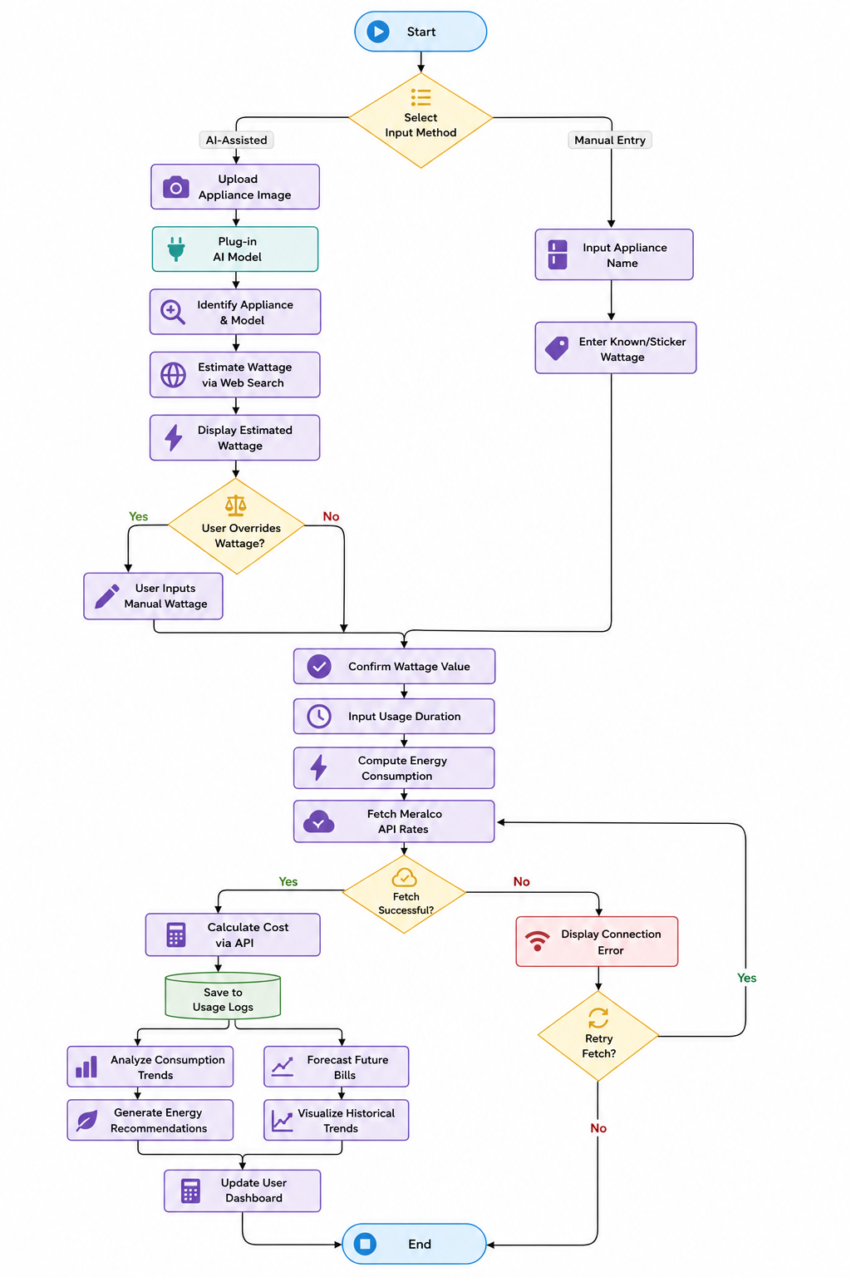
Flowchart
Figure 1. System Flowchart of the Proposed System

