**VISUALIZATION**

In this part we try to analyse the population of two wheeler, three wheeler, four wheeler, bus and total electric vehicles population percentage with respect to the actual vehicle population to the estimates of 2022 for each state in India.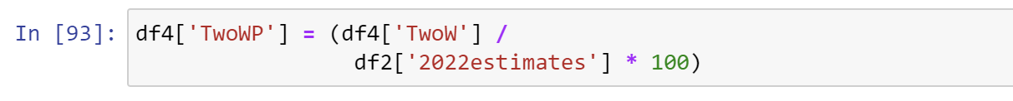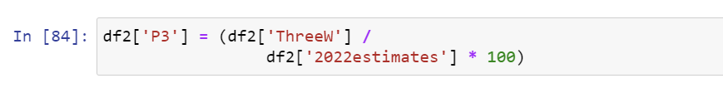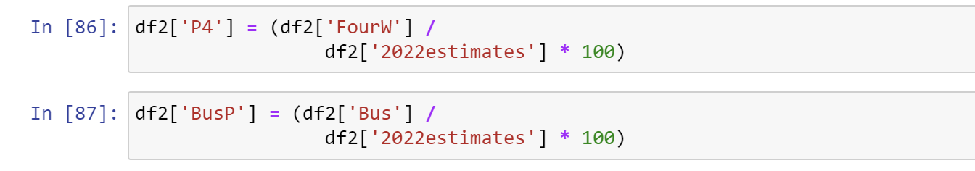

Here we are also finding the electric vehicle charging stations population percentage with respect to the total number of vehicles in that particular state in India.



We stored the population percentage data of each vehicle type in a new separate column in the dataset to visualize them later.

BARPLOT: A bar plot or bar chart is a graph that represents the category of data with rectangular bars with lengths and heights that is proportional to the values which they represent. The bar plots can be plotted horizontally or vertically. A bar chart describes the comparisons between the discrete categories. One of the axis of the plot represents the specific categories being compared, while the other axis represents the measured values corresponding to those categories.

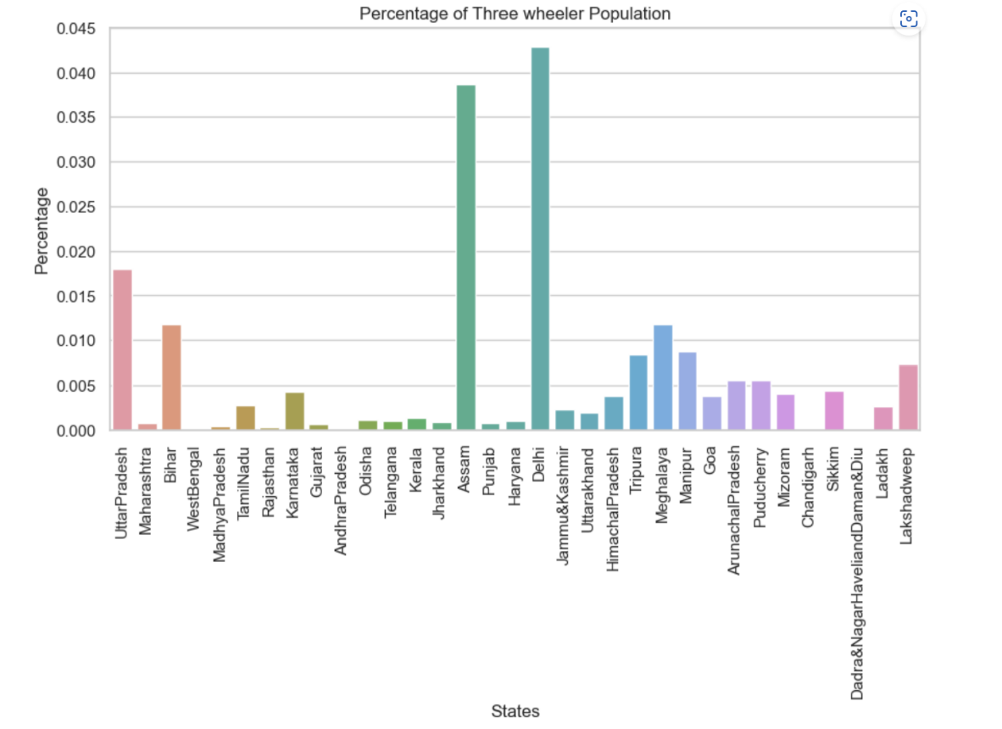

The above bar plot depicts the Three wheeler population percentages with respect to each city. As we can see the percentage of usage of three wheeler is high in cities like Delhi, Assam, and Uttar Pradesh. The percentage is medium in Bihar, Meghalaya and Manipur and low in cities like West Bengal, Chandigarh, Andhra Pradesh etc.

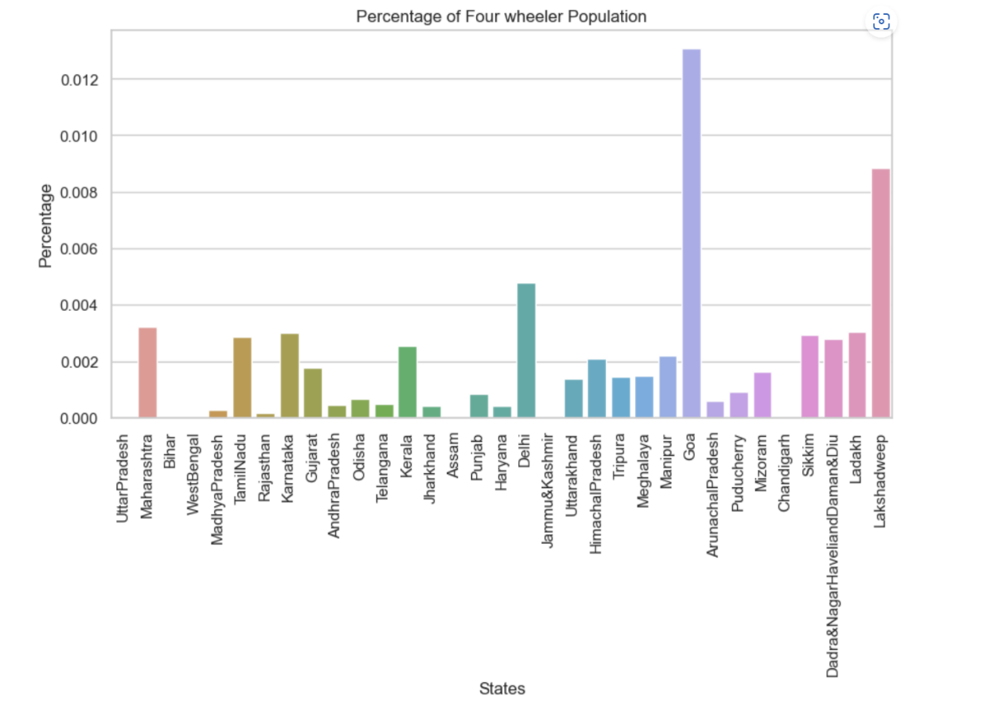

The above bar plot depicts the Four wheeler population percentages with respect to each city. As we can see the percentage of usage of four wheeler is high in cities like Delhi, Goa, and Lakshadweep. The percentage is medium in Maharastra, Karnataka and low in cities like West Bengal, Chandigarh, Bihar etc.

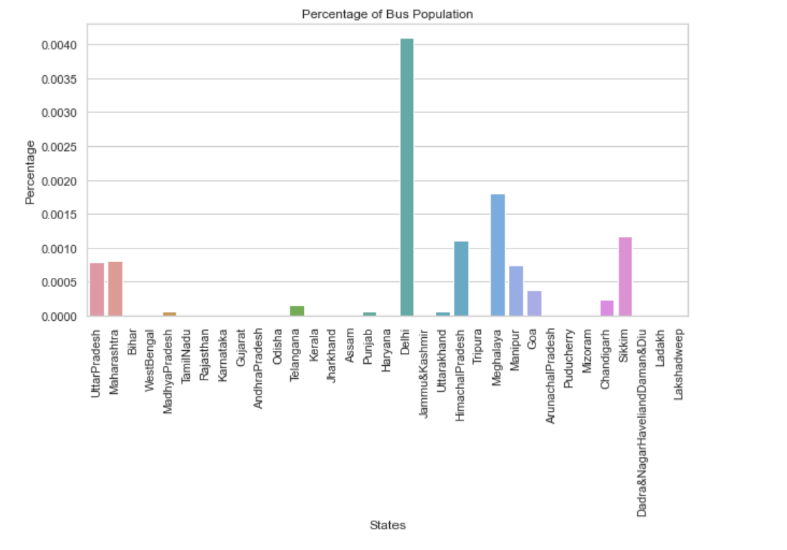

The above bar plot depicts the Bus population percentages with respect to each city. As we can see the percentage of usage of Bus is high in cities like Delhi, Meghalaya and Sikkim. The percentage is medium in Uttar Pradesh and Maharashtra and low in cities like West Bengal, Bihar, Tamil Nadu etc.

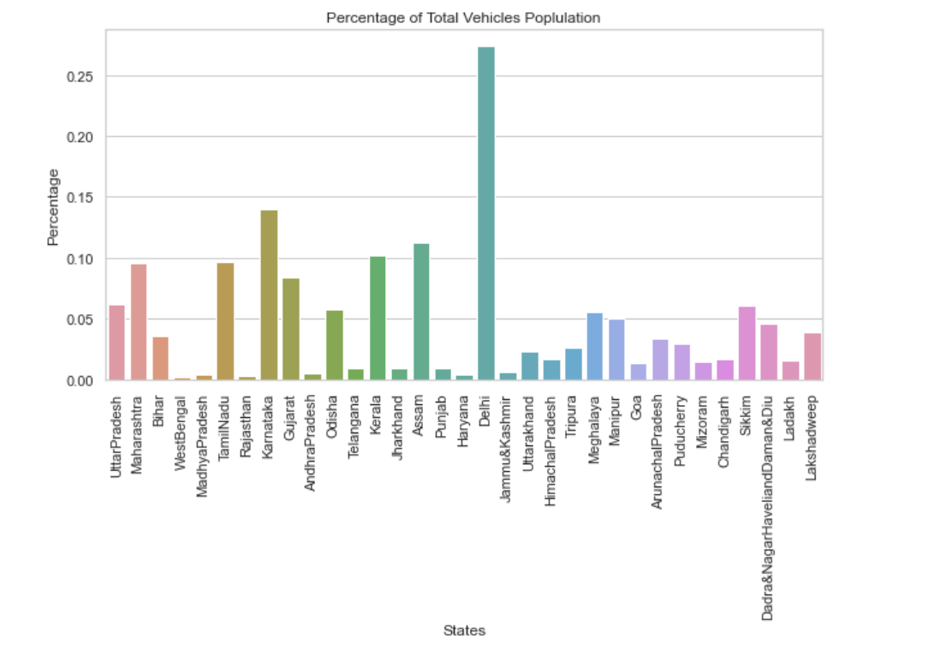

The above bar plot depicts the Total electric vehicle population percentages with respect to each city. As we can see the percentage of usage of electric vehicle is high in cities like Delhi, Assam, and Karnataka. The percentage is medium in Kerala and Maharashtra and low in cities like West Bengal, Rajasthan and Haryana.

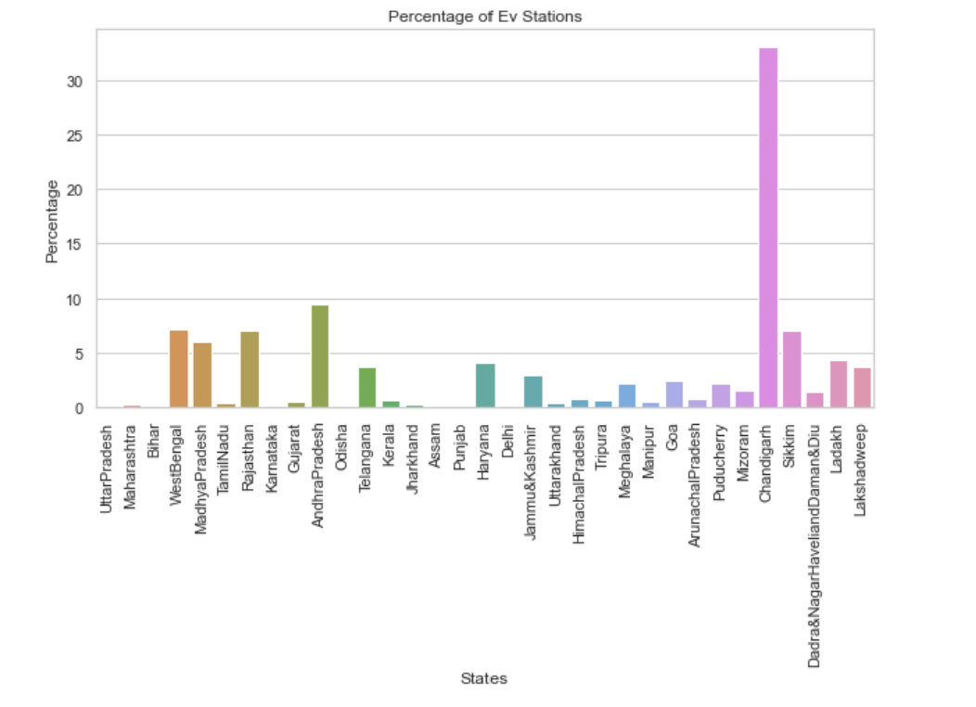

The above bar plot depicts the Ev stations population percentages with respect to each city. As we can see the percentage of usage of Ev stations is high in cities like Delhi, Assam, and Uttar Pradesh. The percentage is medium in Bihar, Meghalaya and Manipur and low in cities like West Bengal, Chandigarh, Andhra Pradesh etc.

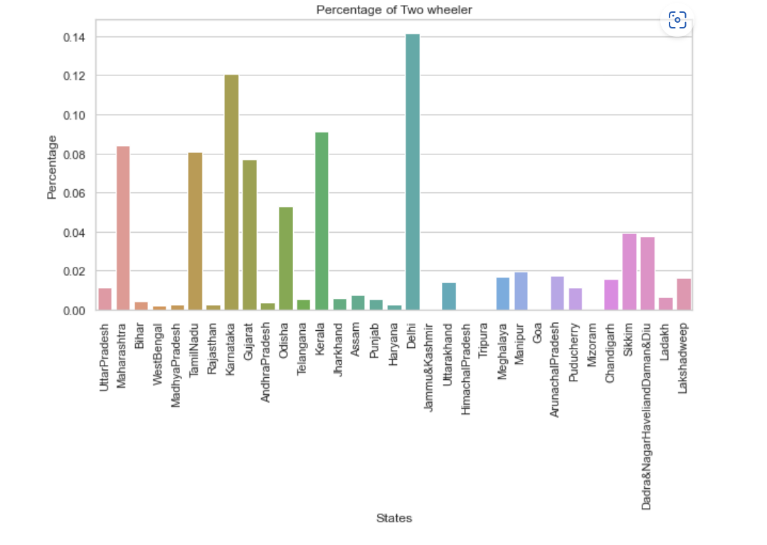

The above bar plot depicts the Two wheeler population percentages with respect to each city. As we can see the percentage of usage of two wheeler is high in cities like Delhi, Karnataka and Kerala. The percentage is medium in Gujarat, Tamil Nādu and Maharashtra and low in cities like West Bengal, Tripura etc.

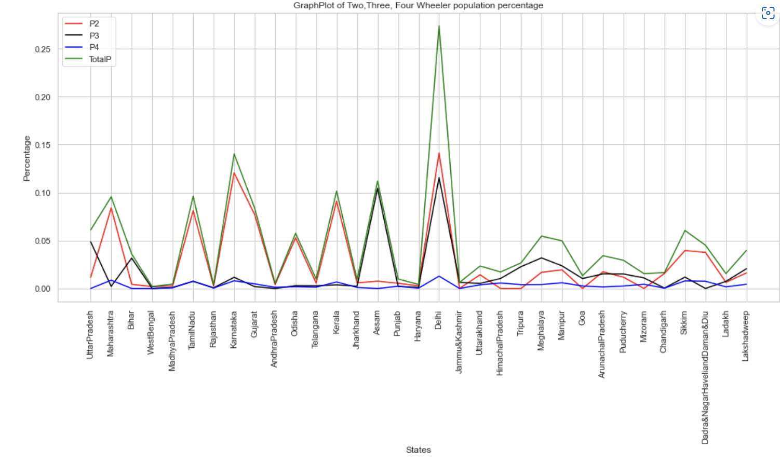

The above Multi line graph depicts the Two wheeler(P2), Three wheeler(P3), Four wheeler(P4) population percentages with respect to each city. We infer that two wheelers usage is more with respect to other types of electric vehicle.