Haley Eakin

Lab7

1. CSS Opacity, Exercise 1.

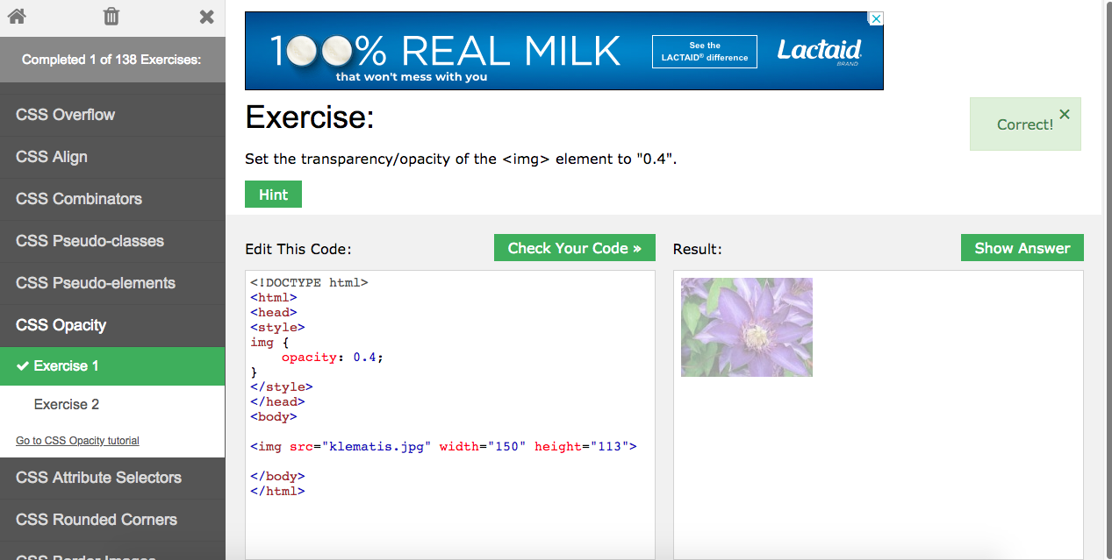

1. CSS Align, Exercise 1.

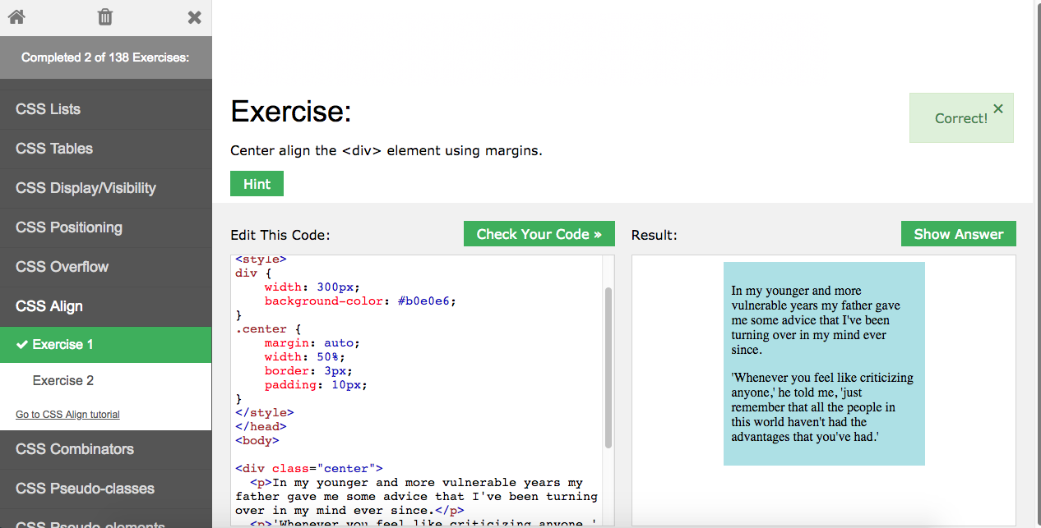

1. CSS Padding, Exercise 1.

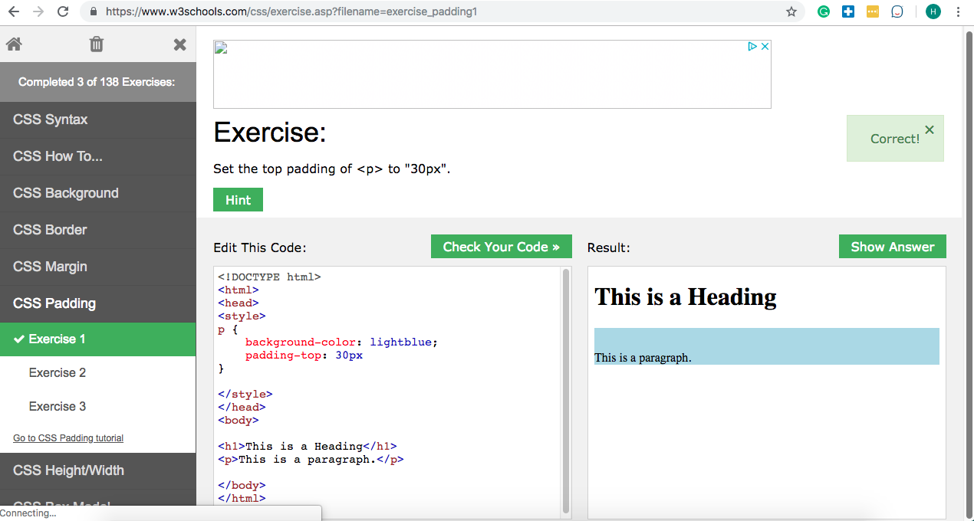

1. 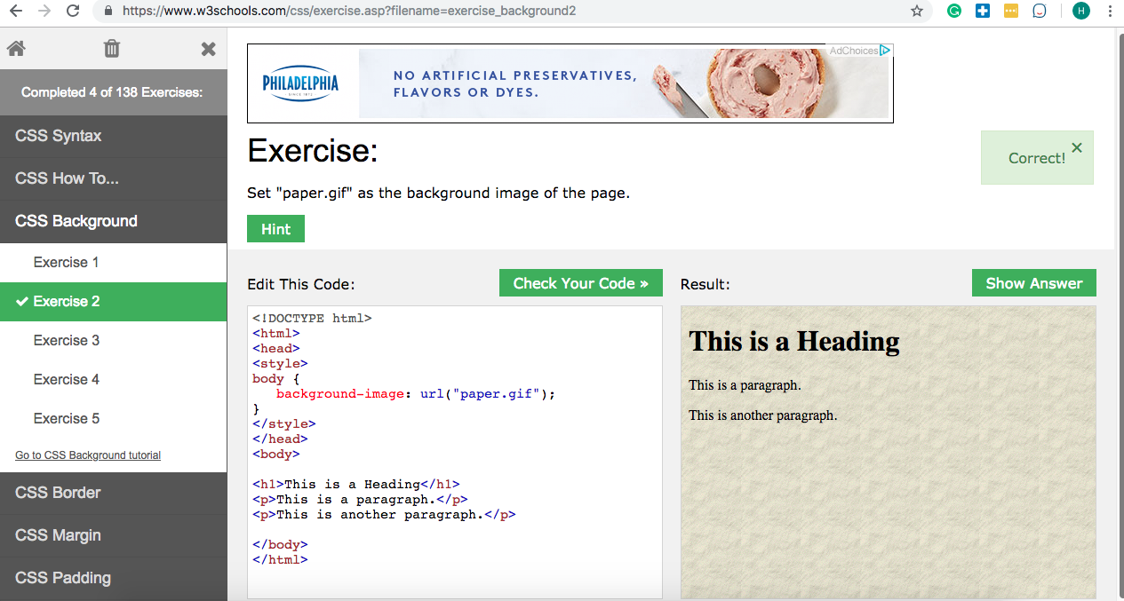CSS Background, Exercise 2
2. CSS Syntax, Exercise 3.

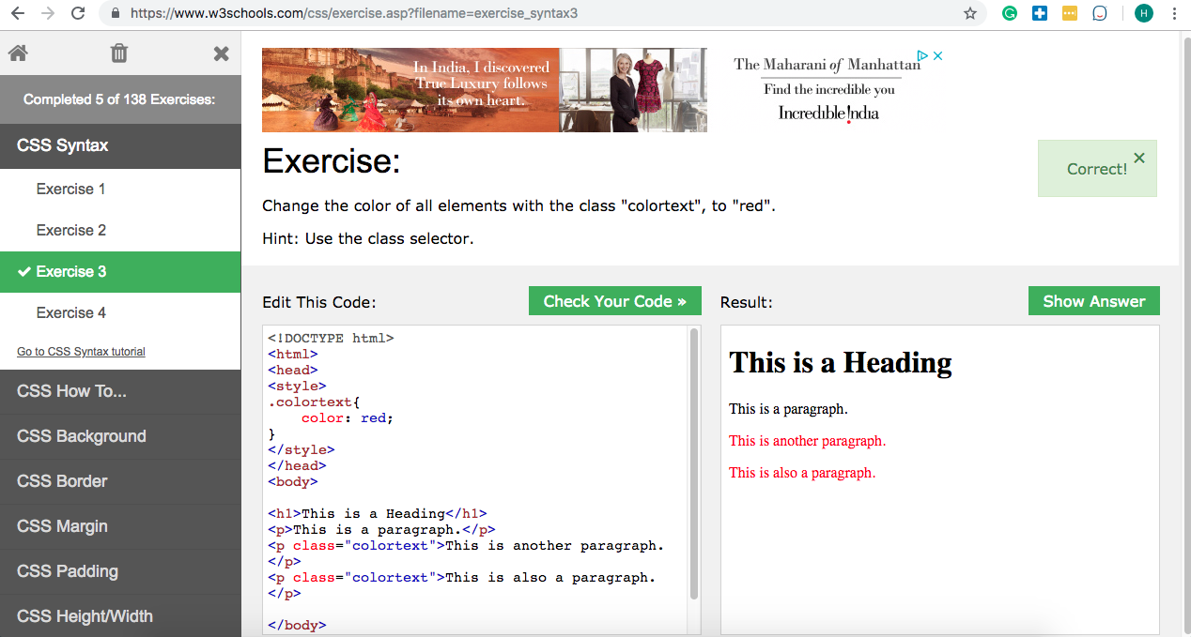

1. CSS Transitions, Exercise 1.

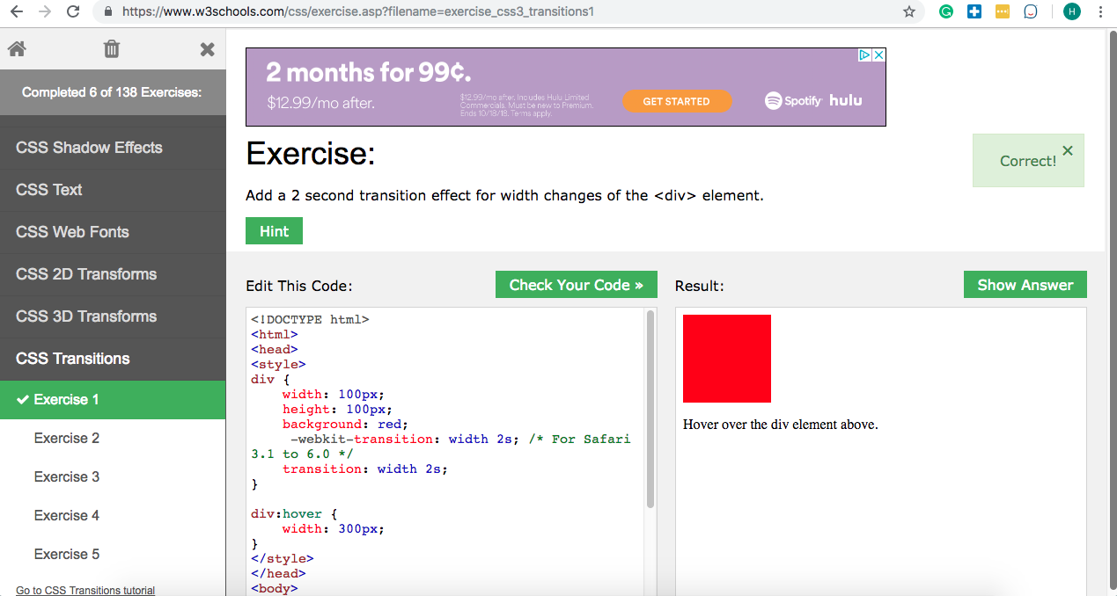

1. CSS Web Fonts, Exercise 1.

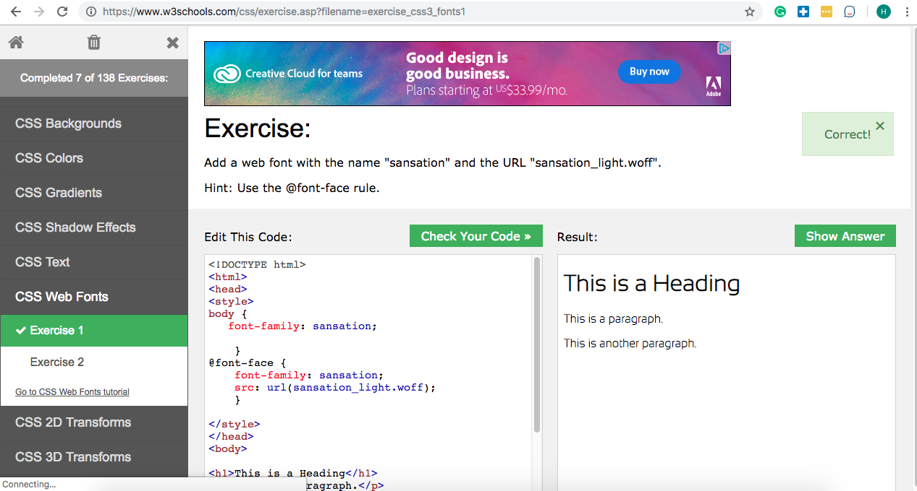

1. CSS 2D Transforms, Exercise 2.

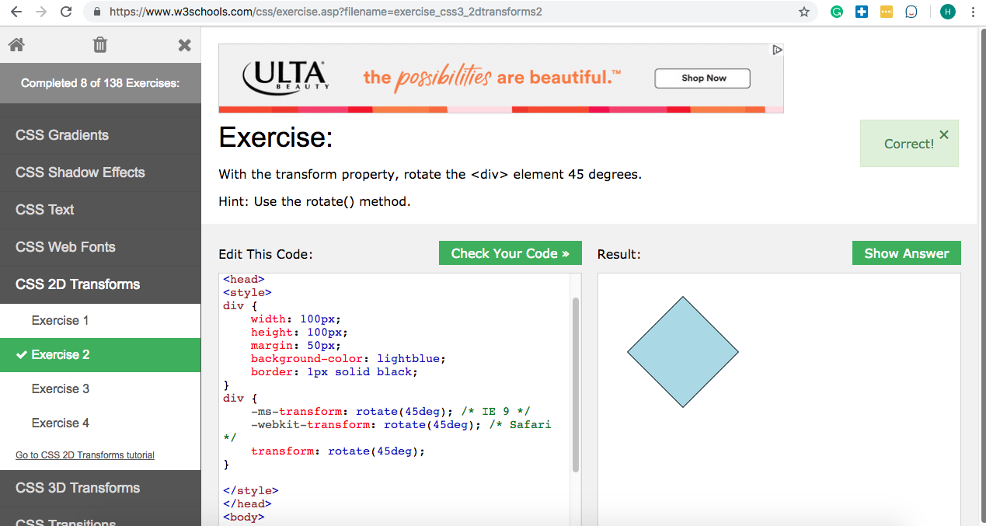

1. CSS 3D Transforms, Exercise 3.

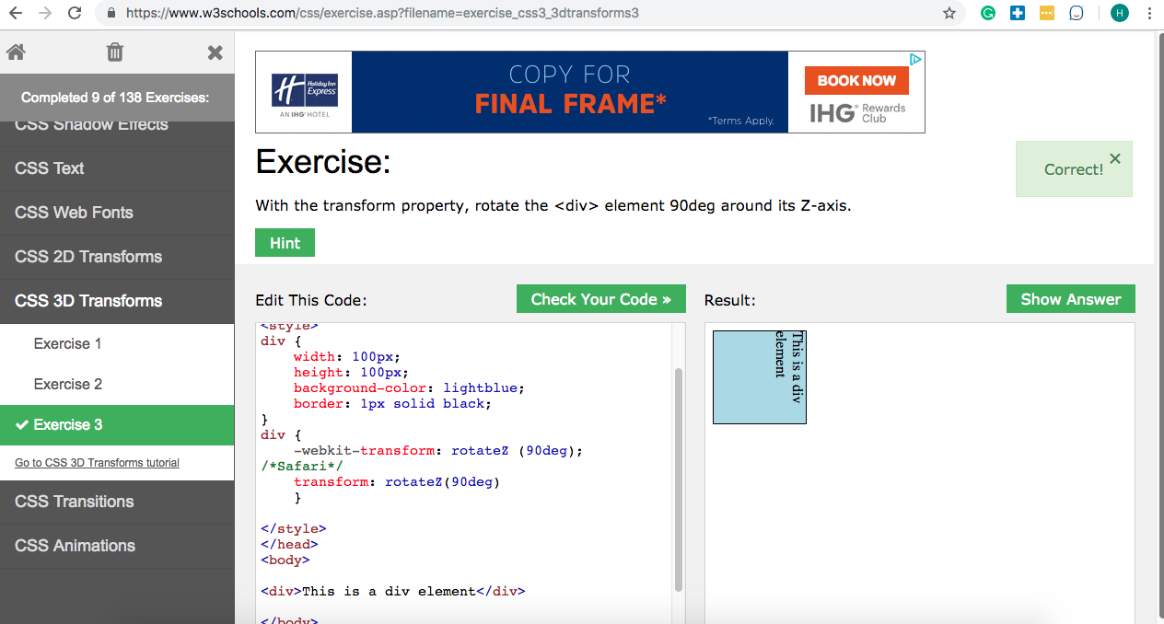

1. CSS Shadow Effects, Exercise 3.

