**Activity Intents Report**

An **Android activity** is one screen of the **Android** app's user interface. In that way an **Android activity** is very similar to windows in a desktop application. An **Android** app may contain one or more **activities**, meaning one or more screens

**Intents** are used to signal to the **Android** system that a certain event has occurred. **Intents** often describe the action which should be performed and provide data upon which such an action should be done. For **example**, your application can start a browser component for a certain URL via an **intent**.

There can be two types of intents

* External Intent
* Internal Intent

**Android Project**

Make another Activity and in its XAML file make the following screen with one button .Edit text of the button as mainactivity. Make this activity as staring activity by changing code in manifest file.

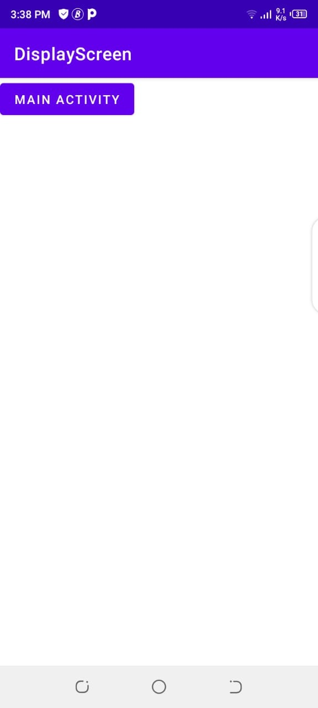

And when you click on this button another activity will be open .Picture of that activity is below.



And the code to move from one activity to another activity is below.

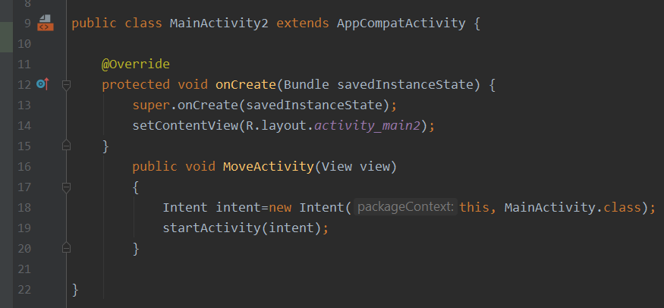

And when you go to the main activity there will be two options website and phone call.If you click on website default website provided in code will be opened .And if you click on phonecall you are able to make a call. Screen shots of both views are below.

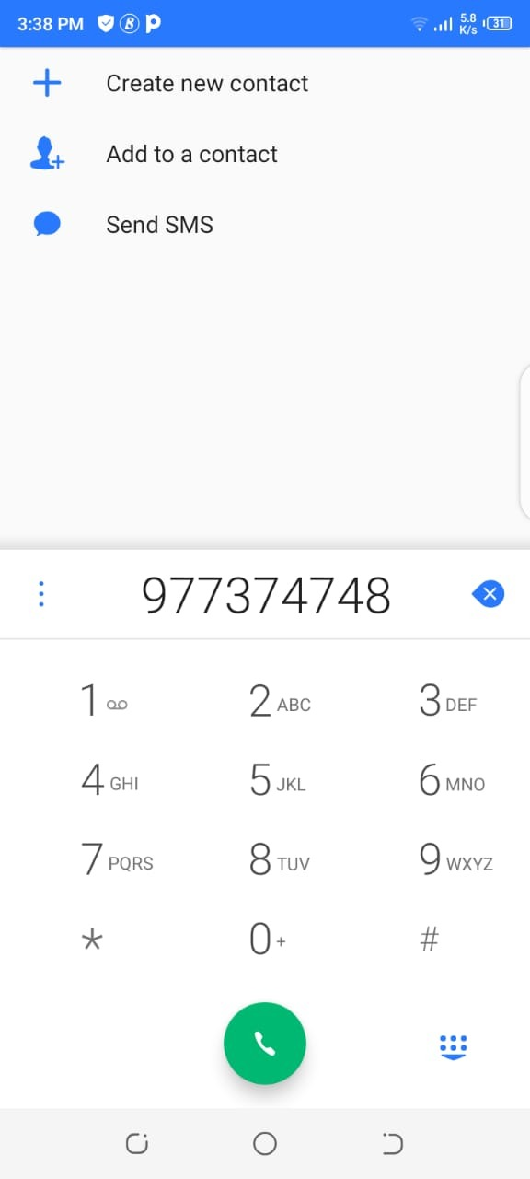

And the code is below

