**Adapters**

In **Android**, **Adapter** is a bridge between UI component and data source that helps us to fill data in UI component. It holds the data and send the data to an **Adapter** view then view can takes the data from the **adapter** view and shows the data on different views like as ListView, GridView, Spinner etc.

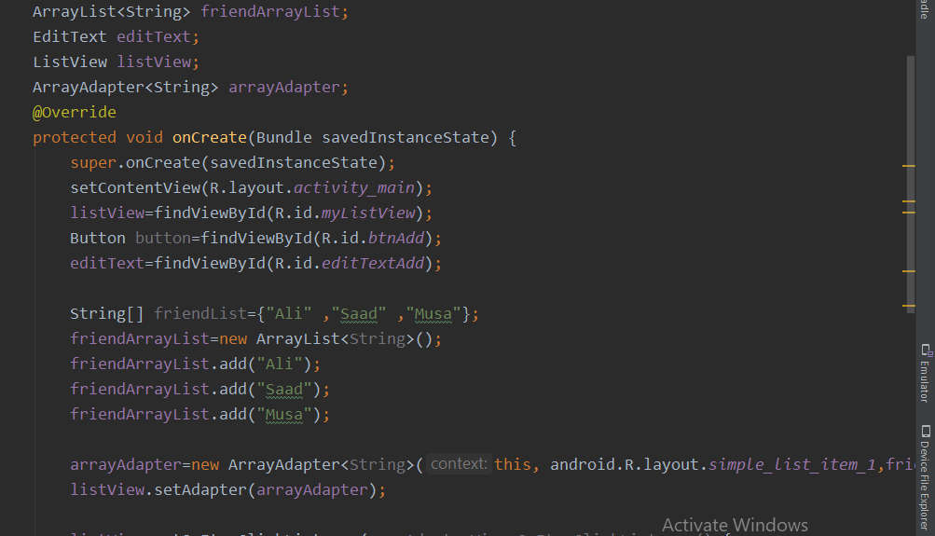

This is the code of main activity in which I have added friend array list and list view which is in xaml file and array adapter.

Arrays adapter is used to bind friend array list with list view.

The second last line is making array adapter and its last argument is friend array list. And in last line we are adding listview.setadapter(arrayadapter).

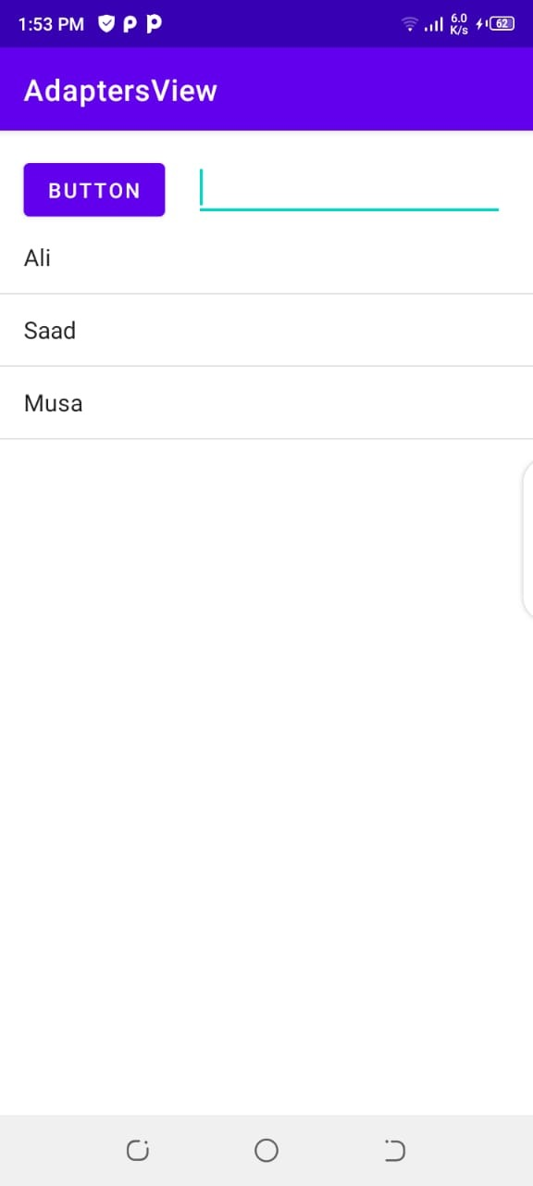

This is the view of main activity. We can add names in the list we have added on click listener to that button.

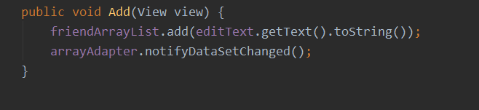

This is the function.

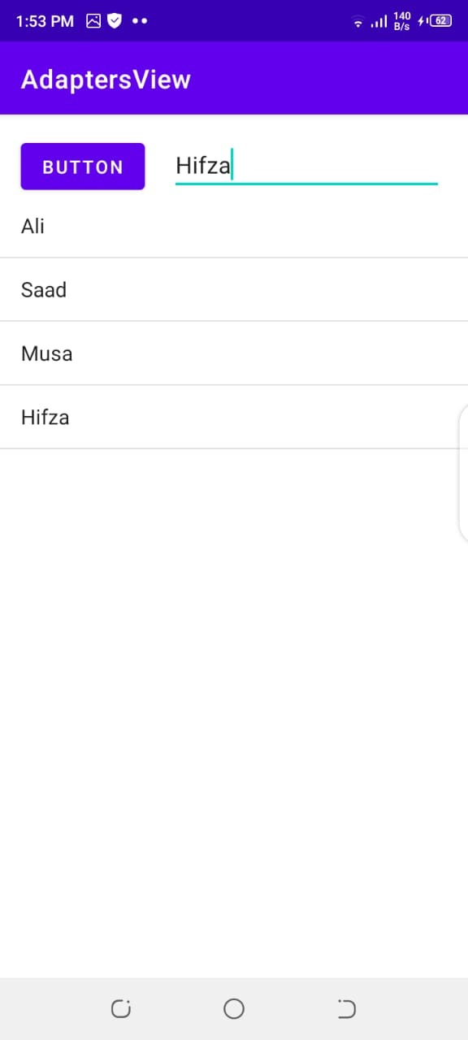

NotifyDataSetChanged is used to refresh list for the new name.

Now we will add click listener to the listView.

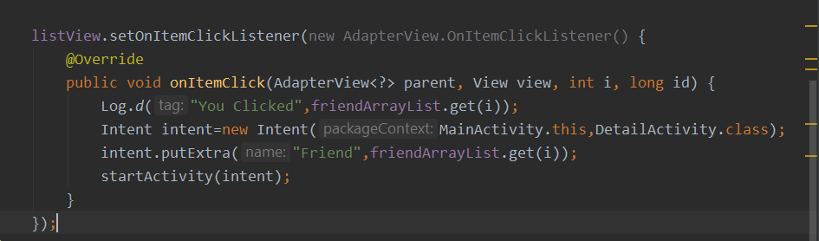

This is the click listener .

And here we are sending data from one activity to another y using inent.putExtra.

And in new activity we are receiving intent

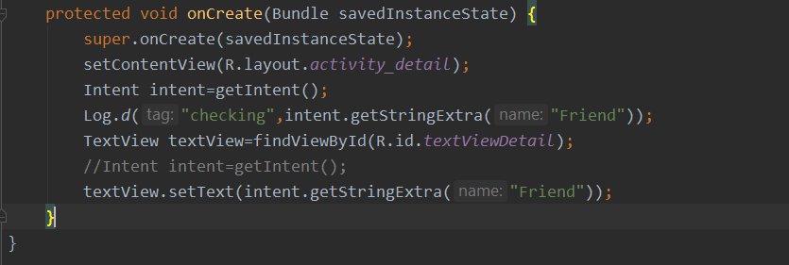

And now we will get this name and set it to the text view .

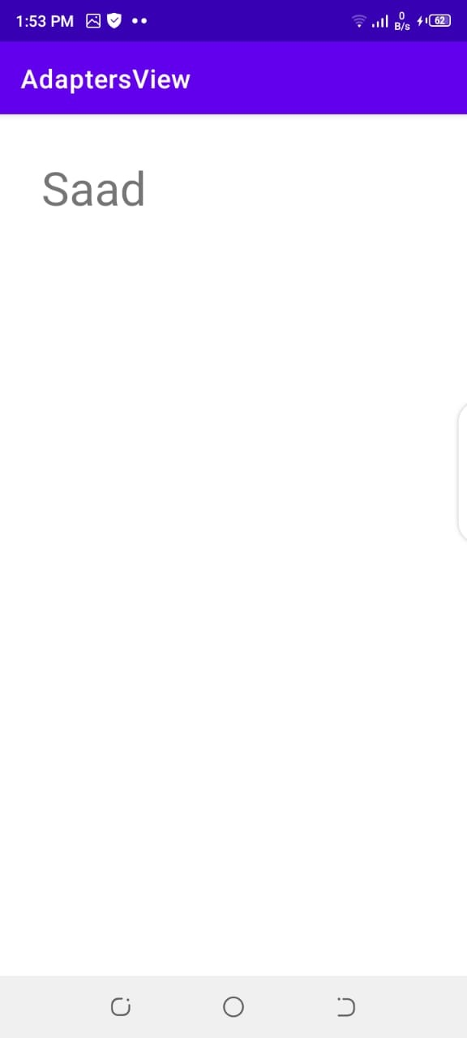

This is the page opens by clicking Saad.