**Notifications:**

A **notification** is a message that **Android** displays outside your app's UI to provide the user with reminders, communication from other people, or other timely information from your app. Users can tap the **notification** to open your app or take an action directly from the **notification**.

In main activity .xaml

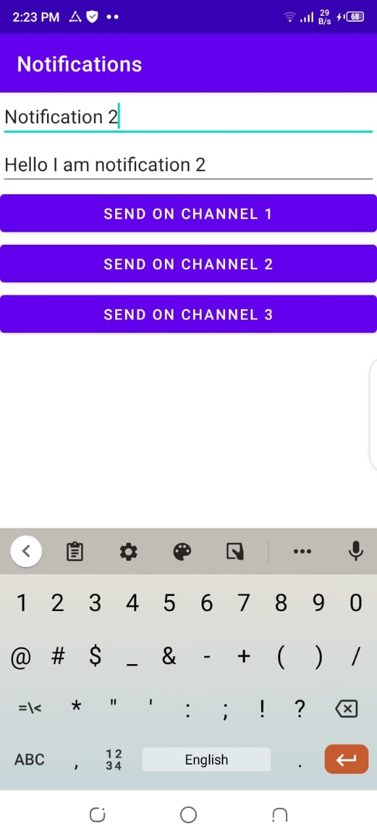

Implement this in main activity.xaml.

Then make a java class the implements three notificatins channel.

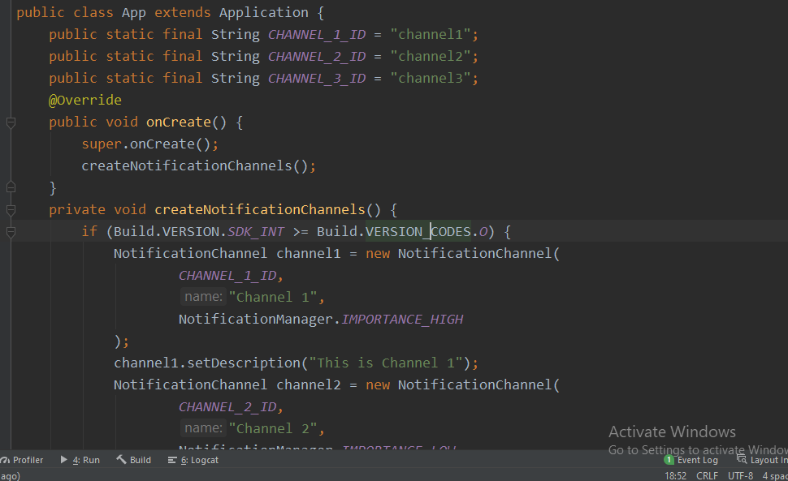

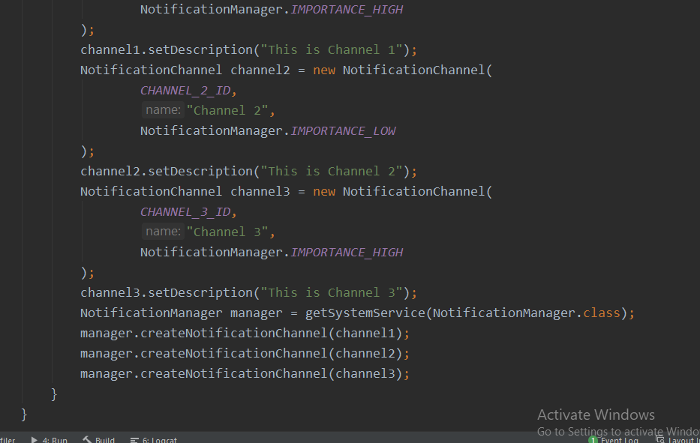

Then in main Activity java class implements the following.

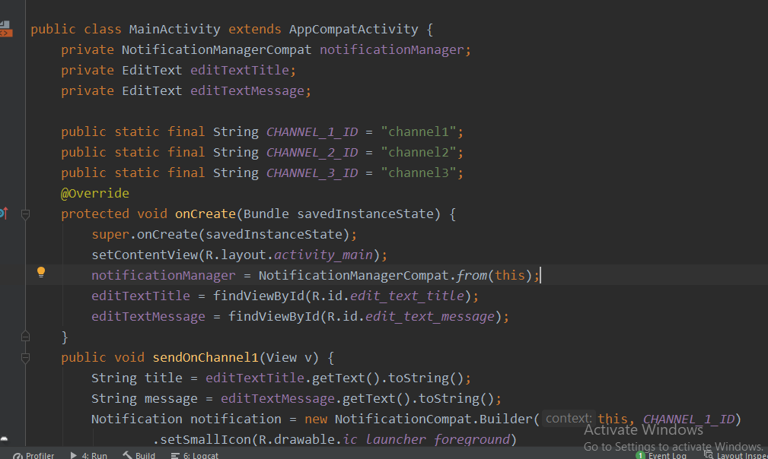

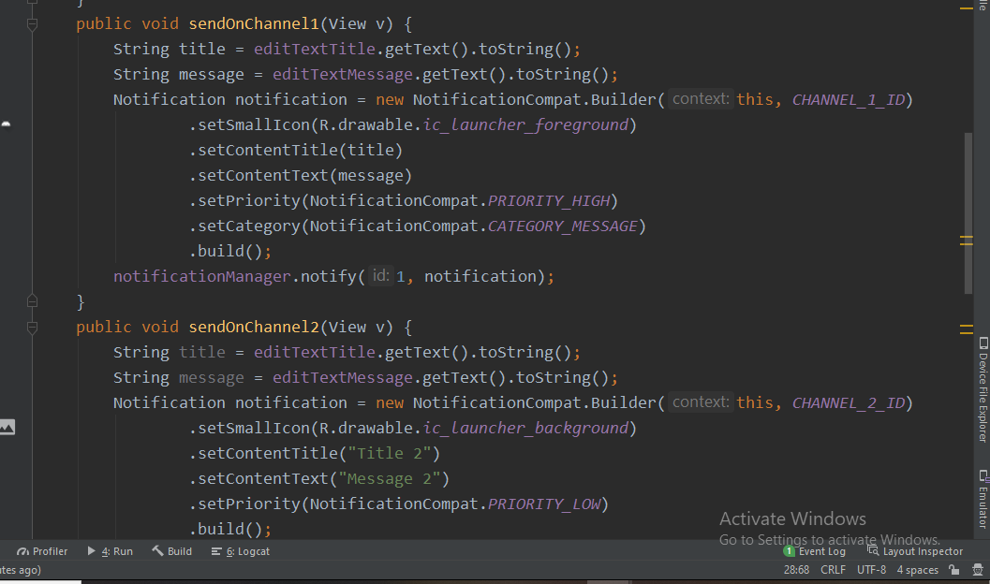

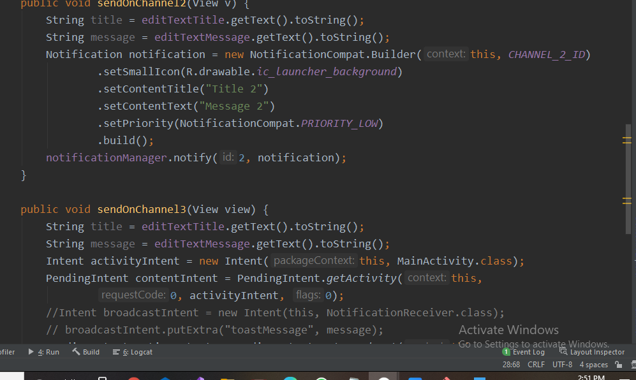

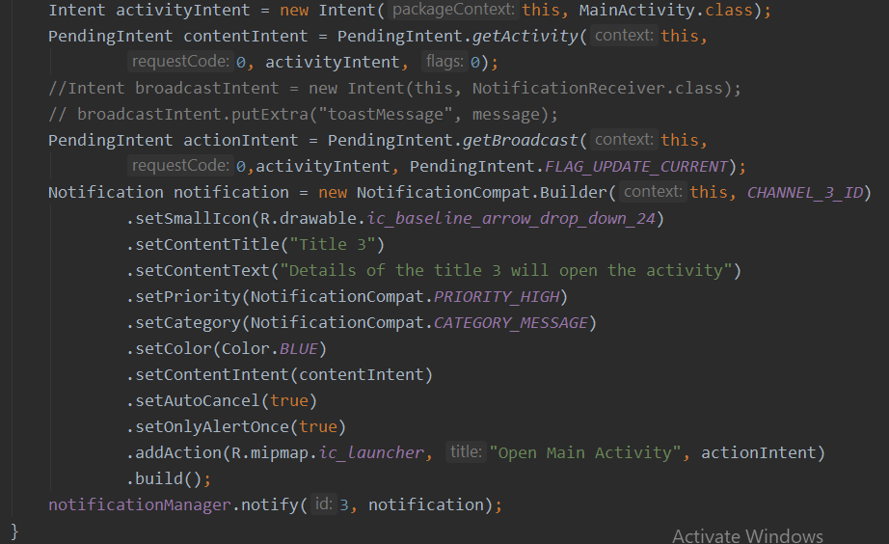

The implements these three functions which sends notifications on channel on button click.

**Channel 1 && Chanel 3::**

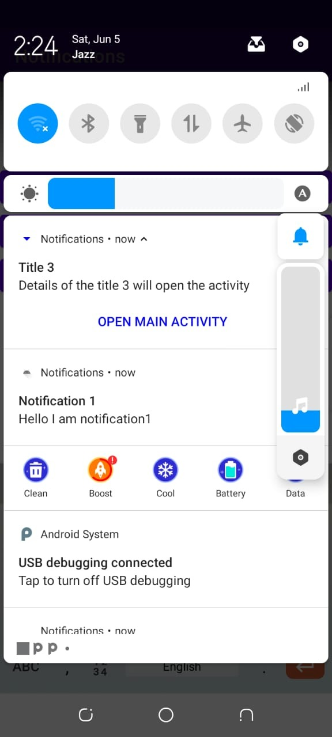

**Channnel 2::**

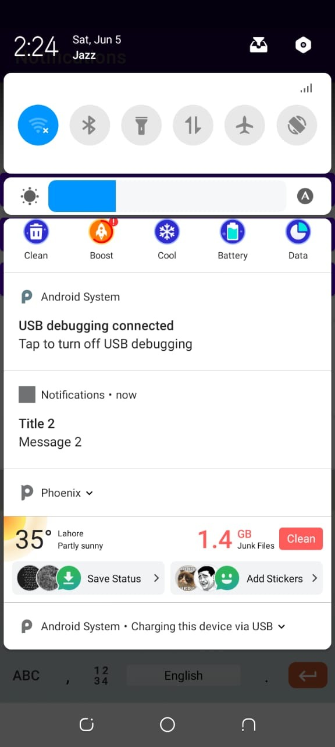

This is channels no 2 Notification .