**Nav Bar**

The **Navigation bar** is the menu that appears on the bottom of your screen - it's the foundation of navigating your phone. However, it isn't set in stone; you can customize the layout and button order, or even make it disappear entirely and use gestures to navigate your phone instead.

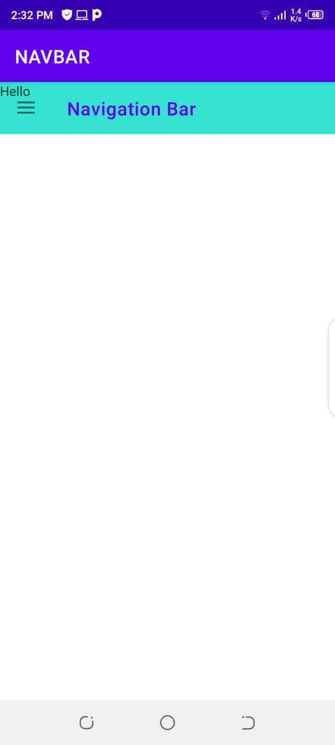

This is the main activity View. In which there is a tollbar and toggle.

In base layout of main activity we have used drawer layout.

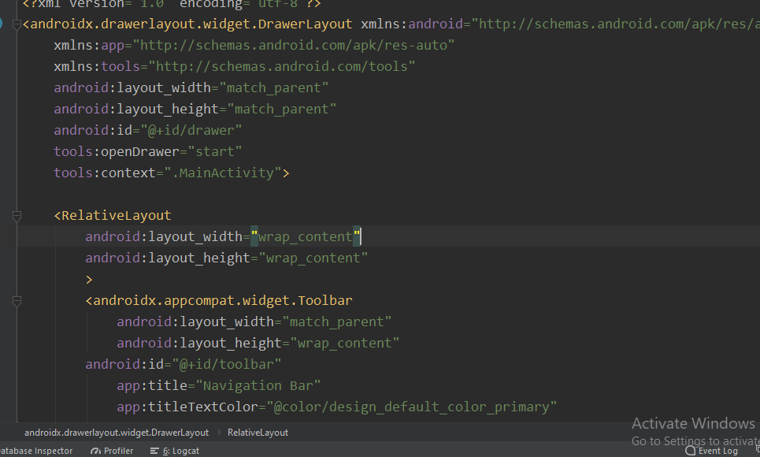

After that in relative layout we placed toolbar.

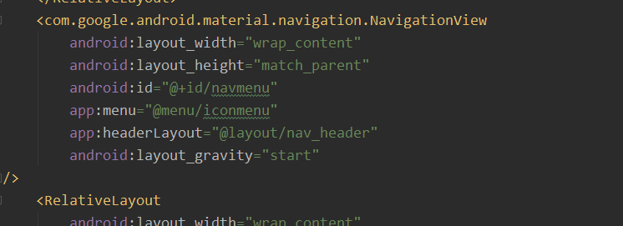

And then navigation view which is the view we want to display on toggle click.

We have user header layout and icon menu . These two will be made separately.

And the navigation view look like.

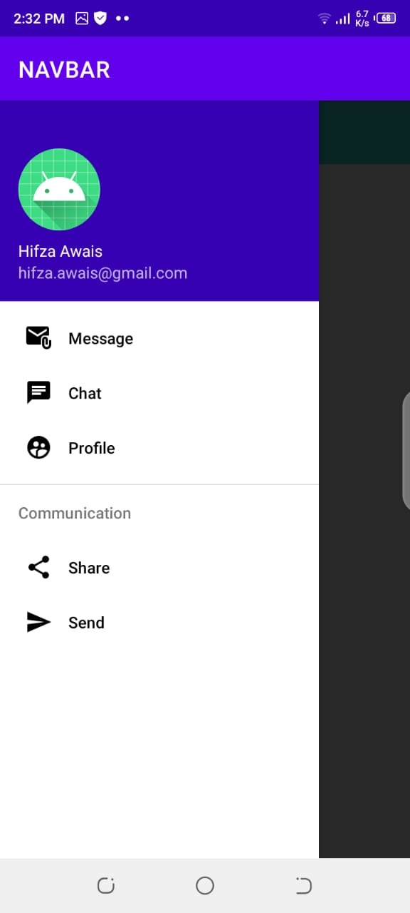

**Nav Header:**

This is the view of nav header which we made by LayoutResource file.

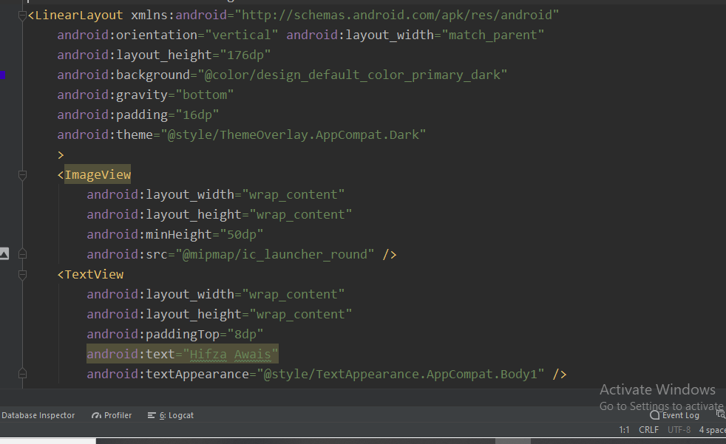

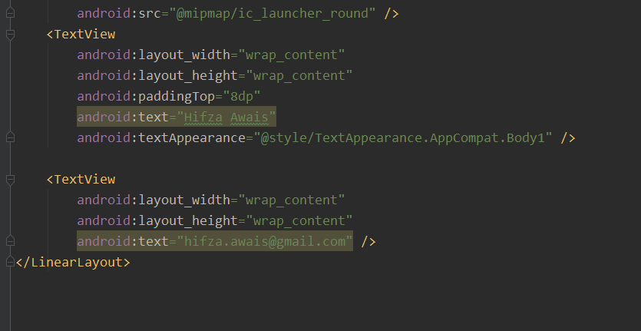

Nav header will look like.

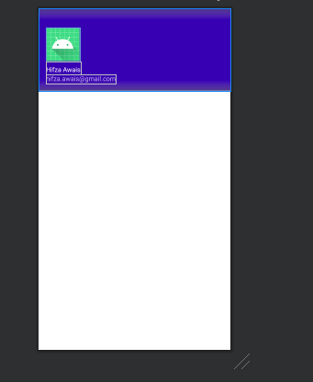

**IconMenu:**

Then make a menu folder in project by new android resource file.

And then add LayoutResource file in it .

Use Vector assests in it .Add vector assesss in drawable folder by right click new vector assests.

Then add the nav bar .

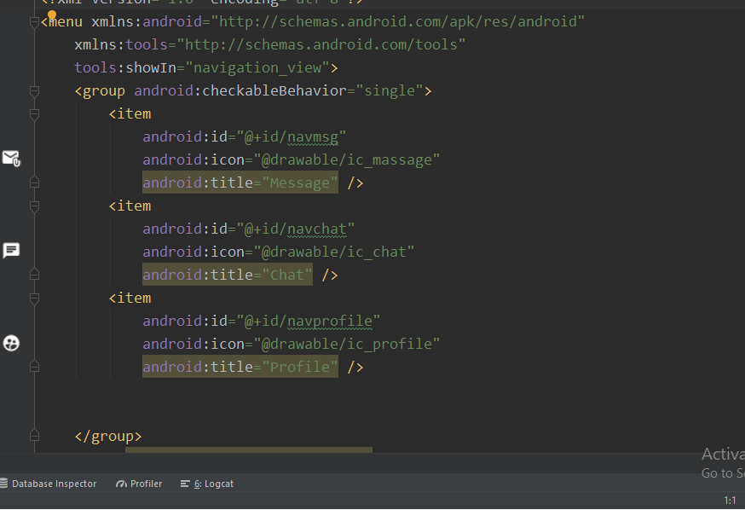

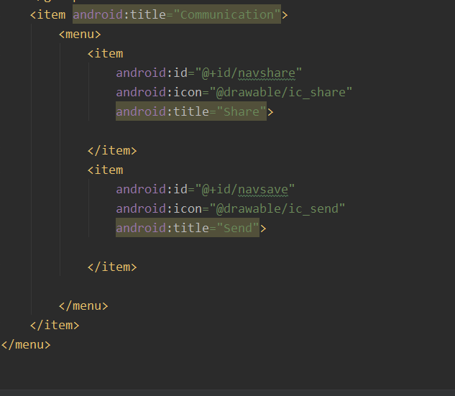

This is the code of icon menu.

And the icon menu will look like

