|  |  |  |  |  |
| --- | --- | --- | --- | --- |
|  | Kỳ vọng giá trị của John account | Giao tác có chạy hoàn tất? | Nếu không, hãy giải thích tại sao | Giá trị account thực tế, nếu giao tác hoàn tất |
| RC | 130 | Có | ------------ | 120 |
| SR | Có | ----------- | 120 |

**Read Commit**

--Step 1&2

--Step 3

--Step 4

--Step 1’ & 2’

--Step 5r

--Step 3’

--Step 4’

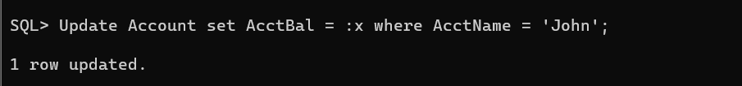

--Step 5’c

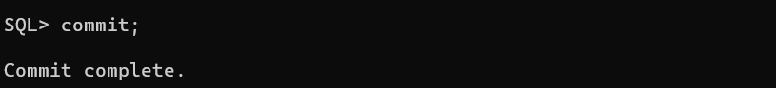

**Serializable**

--Step 1 & 2

--Step 3

--Step 4

--Step 1’ & 2’

--Step 5

--Step 3’

Step 4’

--Step 5’

