1. Requirements

|  |  |  |
| --- | --- | --- |
| Requirement | | Detail |
| deliver | 1. Deliver have to sign up with his information  2. Deliver accept the order  3.Pick up food at the restaurant depends on the order  4.Deliver to the customer  5.after finish the delivery he will accept another order | 1. Driver has to enter his information such as like name, phone number, desired delivery area, delivery method information, driver's license, and account number. And average delivery time. Drivers’ rating. Current Delivery Availability, driver id. So due to this information deliver can accept the order. And deliver have to upload his vehicle information because deliver will get some orders depend on the information. Vehicle would be separate from the vehicle’s number-plate .  2. Deliver accept the order than order give the information about customer’s order information. So, the order sperate from another order for Order ID.  3. After driver accept the order than that order included the restaurant’s information (such as like address, name, Restaurant ID). So, driver will go to the restaurant with that information. And he will pick up his delivery food.  4.Driver go to the customer’s house who ordering the food. Driver will check the customer’s information (address, name, phone number, customer ID) from his accepted order. So, driver deliver the food to the customer.  5. After delivery driver will wait another order. |
| order | 1. Order provide the information about customer and restaurant to the driver. | 1. Order must be connect with customer , driver and restaurant. And provide the information to each other. And order going to seperated by order ID. Order get the customer’s information and update the order ID and customer’s ID (and so on). And provide the customer’s information to the restaurant and driver. |
| Customer & restaurant | 1. Restaurant provide the food to the driver  2. After the delivery customer will be rating the driver’s rate | 1. I will add this after address things  2. After customer get the food. Customer will rate the driver’s service. |

1. 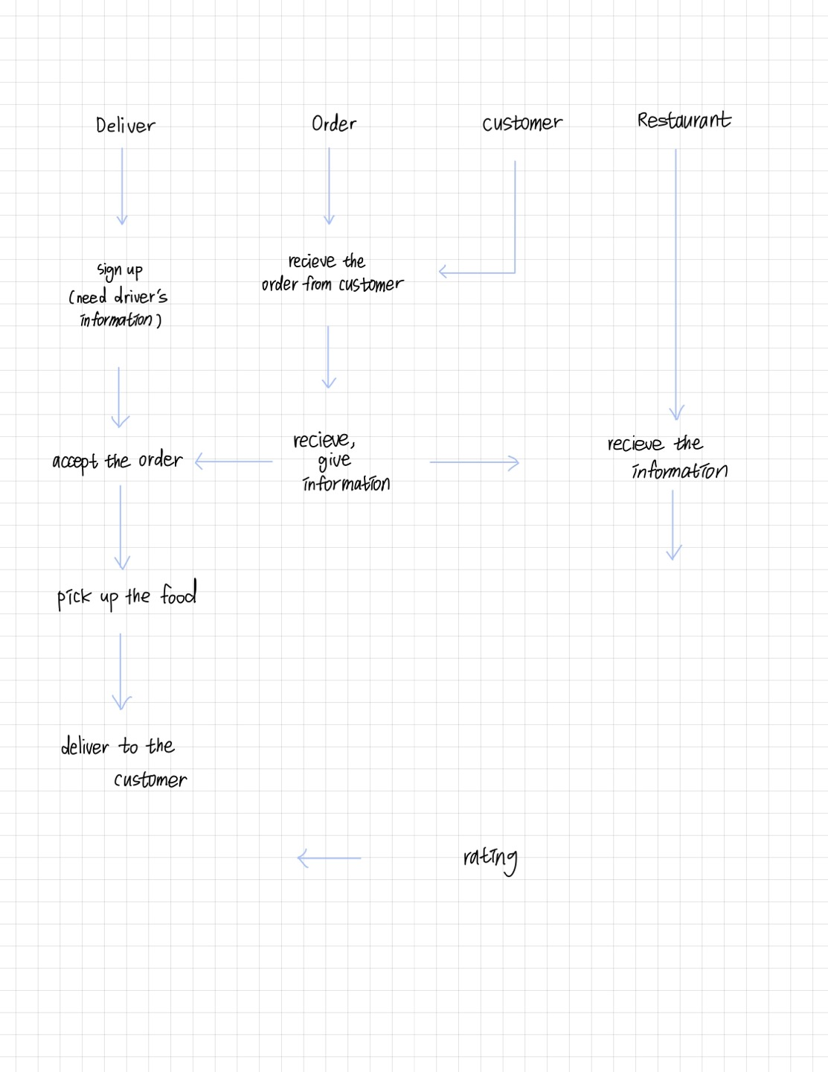Flow Chart
2. Entity, attribute, relationship arrangement

