REPORT

[ Assignment 1: 단일치환암호 분석 ]



과 목 명 | 정보보호론
교 수 명 | 김 효 승
학 번 | 20237107
작 성 자 | 하 태 영
제 출 일 | 2025.03.21

한림대학교
목차

1. 서론

2. 빈도 분석 및 방법

3. 키와 평문 도출

4. 결론

- 서론

치환 암호
- 알파벳 대칭 표를 이용하여 문자를 치환
- 사용 가능한 키의 개수 26!(약 2의 88승가지)
- 전수 키 조사가 불가능 함

치환 암호 분석
- 암호문의 빈도수를 찾아 평문을 추측하여 대입

- 빈도 분석 및 방법

암호문
DS-BVHFV EDM LUTH VH YOGOH NU D TVRJ ADGVSY
DM EOSS DM QJVSUMUQJY, JO EUTBOF VH DMNTUHUGY, DSRJOGY, GDNJOGDNVRM, GOFVRVHO, POUPTDQJY, DHF GDHY UNJOT NUQVRM.
JO LORDGO D GOGLOT UA D MRVOHNVAVR QSDRO UA MNZFY RDSSOF NJO JUZMO UA EVMFUG.
JVM NTODNVMOM UH GZMVR EOTO NJUZPJN NU LO NJO LOMN EUTBM UH NJO MZLIORN UA GZMVR VH DTDLVR.

자주 등장하는 주요 단어
NJO -> the
D -> a

빈도수
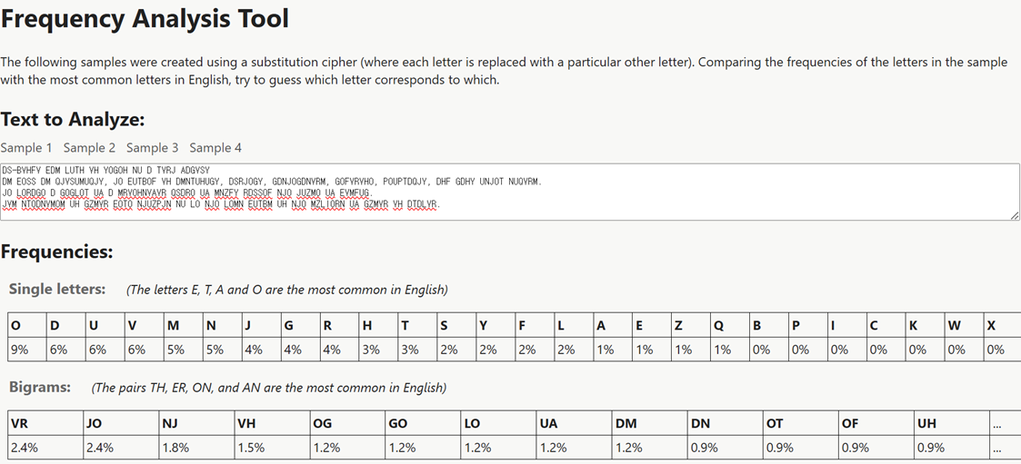

- 키와 평문 도출

NJO → the (N → t, J → h, O → e)
DS-BVHFV EDM LUTH VH YeGeH tU D TVRh ADGVSY
DM EeSS DM QhVSUMUQhY, he EUTBeF VH DMtTUHUGY, DSRheGY, GDtheGDtVRM, GeFVRVHe, PeUPTDQhY, DHF GDHY UtheT tUQVRM.
he LeRDGe D GeGLeT UA D MRVeHtVAVR QSDRe UA MtZFY RDSSeF the hUZMe UA EVMFUG.
hVM tTeDtVMeM UH GZMVR EeTe thUZPht tU Le the LeMt EUTBM UH the MZLIeRt UA GZMVR VH DTDLVR.

한자리 수로 올 수 있는 단어(i, a)
D → a
aS-BVHFV EaM LUTH VH YeGeH tU a TVRh AaGVSY
aM EeSS aM QhVSUMUQhY, he EUTBeF VH aMtTUHUGY, aSRheGY, GatheGatVRM, GeFVRVHe, PeUPTaQhY, aHF GaHY UtheT tUQVRM.
he LeRaGe a GeGLeT UA a MRVeHtVAVR QSaRe UA MtZFY RaSSeF the hUZMe UA EVMFUG.
hVM tTeatVMeM UH GZMVR EeTe thUZPht tU Le the LeMt EUTBM UH the MZLIeRt UA GZMVR VH aTaLVR.

a로 시작하는 두 글자 단어(an, at, as, aw)
aM → as (M → s)
aS-BVHFV Eas LUTH VH YeGeH tU a TVRh AaGVSY
as EeSS as QhVSUsUQhY, he EUTBeF VH astTUHUGY, aSRheGY, GatheGatVRs, GeFVRVHe, PeUPTaQhY, aHF GaHY UtheT tUQVRs.
he LeRaGe a GeGLeT UA a sRVeHtVAVR QSaRe UA stZFY RaSSeF the hUZse UA EVsFUG.
hVs tTeatVses UH GZsVR EeTe thUZPht tU Le the Lest EUTBs UH the sZLIeRt UA GZsVR VH aTaLVR.
tU → to (U → o)
aS-BVHFV Eas LoTH VH YeGeH to a TVRh AaGVSY
as EeSS as QhVSosoQhY, he EoTBeF VH astToHoGY, aSRheGY, GatheGatVRs, GeFVRVHe, PeoPTaQhY, aHF GaHY otheT toQVRs.
he LeRaGe a GeGLeT oA a sRVeHtVAVR QSaRe oA stZFY RaSSeF the hoZse oA EVsFoG.
hVs tTeatVses oH GZsVR EeTe thoZPht to Le the Lest EoTBs oH the sZLIeRt oA GZsVR VH aTaLVR.
otheT → other (T → r)
aS-BVHFV Eas LorH VH YeGeH to a rVRh AaGVSY
as EeSS as QhVSosoQhY, he EorBeF VH astroHoGY, aSRheGY, GatheGatVRs, GeFVRVHe, PeoPraQhY, aHF GaHY other toQVRs.
he LeRaGe a GeGLer oA a sRVeHtVAVR QSaRe oA stZFY RaSSeF the hoZse oA EVsFoG.
hVs treatVses oH GZsVR Eere thoZPht to Le the Lest EorBs oH the sZLIeRt oA GZsVR VH araLVR.

hVs → his (V → i)
aS-BiHFi Eas LorH iH YeGeH to a riRh AaGiSY
as EeSS as QhiSosoQhY, he EorBeF iH astroHoGY, aSRheGY, GatheGatiRs, GeFiRiHe, PeoPraQhY, aHF GaHY other toQiRs.
he LeRaGe a GeGLer oA a sRieHtiAiR QSaRe oA stZFY RaSSeF the hoZse oA EisFoG.
his treatises oH GZsiR Eere thoZPht to Le the Lest EorBs oH the sZLIeRt oA GZsiR iH araLiR.
oH → on, iH → in (H → n)
aS-BinFi Eas Lorn in YeGen to a riRh AaGiSY
as EeSS as QhiSosoQhY, he EorBeF in astronoGY, aSRheGY, GatheGatiRs, GeFiRine, PeoPraQhY, anF GanY other toQiRs.
he LeRaGe a GeGLer oA a sRientiAiR QSaRe oA stZFY RaSSeF the hoZse oA EisFoG.
his treatises on GZsiR Eere thoZPht to Le the Lest EorBs on the sZLIeRt oA GZsiR in araLiR.
Eas → was, Eere → were
aS-BinFi was Lorn in YeGen to a riRh AaGiSYLorn
as weSS as QhiSosoQhY, he worBeF in astronoGY, aSRheGY, GatheGatiRs, GeFiRine, PeoPraQhY, anF GanY other toQiRs.
he LeRaGe a GeGLer oA a sRientiAiR QSaRe oA stZFY RaSSeF the hoZse oA wisFoG.
his treatises on GZsiR were thoZPht to Le the Lest worBs on the sZLIeRt oA GZsiR in araLiR.

Lorn → born, Le → be, Lest → best
aS-BinFi was born in YeGen to a riRh AaGiSY
as weSS as QhiSosoQhY, he worBeF in astronoGY, aSRheGY, GatheGatiRs, GeFiRine, PeoPraQhY, anF GanY other toQiRs.
he beRaGe a GeGber oA a sRientiAiR QSaRe oA stZFY RaSSeF the hoZse oA wisFoG.
his treatises on GZsiR were thoZPht to be the best worBs on the sZbIeRt oA GZsiR in arabiR.
oA → of
aS-BinFi was born in YeGen to a riRh faGiSY
as weSS as QhiSosoQhY, he worBeF in astronoGY, aSRheGY, GatheGatiRs, GeFiRine, PeoPraQhY, anF GanY other toQiRs.
he beRaGe a GeGber of a sRientifiR QSaRe of stZFY RaSSeF the hoZse of wisFoG.
his treatises on GZsiR were thoZPht to be the best worBs on the sZbIeRt of GZsiR in arabiR.
anF → and
aS-Bindi was born in YeGen to a riRh faGiSY
as weSS as QhiSosoQhY, he worBed in astronoGY, aSRheGY, GatheGatiRs, GediRine, PeoPraQhY, and GanY other toQiRs.
he beRaGe a GeGber of a sRientifiR QSaRe of stZdY RaSSed the hoZse of wisdoG.
his treatises on GZsiR were thoZPht to be the best worBs on the sZbIeRt of GZsiR in arabiR.

as weSS as → as well as
al-Bindi was born in YeGen to a riRh faGilY
as well as QhilosoQhY, he worBed in astronoGY, alRheGY, GatheGatiRs, GediRine, PeoPraQhY, and GanY other toQiRs.
he beRaGe a GeGber of a sRientifiR QlaRe of stZdY Ralled the hoZse of wisdoG.
his treatises on GZsiR were thoZPht to be the best worBs on the sZbIeRt of GZsiR in arabiR.
riRh → rich
al-Bindi was born in YeGen to a rich faGilY
as well as QhilosoQhY, he worBed in astronoGY, alcheGY, GatheGatics, Gedicine, PeoPraQhY, and GanY other toQics.
he becaGe a GeGber of a scientific Qlace of stZdY called the hoZse of wisdoG.
his treatises on GZsic were thoZPht to be the best worBs on the sZbIect of GZsic in arabic.
becaGe → became GeGber → member
al-Bindi was born in Yemen to a rich familY
as well as QhilosoQhY, he worBed in astronomY, alchemY, mathematics, medicine, PeoPraQhY, and manY other toQics.
he became a member of a scientific Qlace of stZdY called the hoZse of wisdom.
his treatises on mZsic were thoZPht to be the best worBs on the sZbIect of mZsic in arabic.

worBs → works
al-kindi was born in Yemen to a rich familY
as well as QhilosoQhY, he worked in astronomY, alchemY, mathematics, medicine, PeoPraQhY, and manY other toQics.
he became a member of a scientific Qlace of stZdY called the hoZse of wisdom.
his treatises on mZsic were thoZPht to be the best works on the sZbIect of mZsic in arabic.
familY→ family
al-kindi was born in yemen to a rich family
as well as QhilosoQhy, he worked in astronomy, alchemy, mathematics, medicine, PeoPraQhy, and many other toQics.
he became a member of a scientific Qlace of stZdy called the hoZse of wisdom.
his treatises on mZsic were thoZPht to be the best works on the sZbIect of mZsic in arabic.
Qlace → place
al-kindi was born in yemen to a rich family
as well as philosophy, he worked in astronomy, alchemy, mathematics, medicine, PeoPraphy, and many other topics.
he became a member of a scientific place of stZdy called the hoZse of wisdom.
his treatises on mZsic were thoZPht to be the best works on the sZbIect of mZsic in arabic.

mZsic → music, hoZse → house
al-kindi was born in yemen to a rich family
as well as philosophy, he worked in astronomy, alchemy, mathematics, medicine, PeoPraphy, and many other topics.
he became a member of a scientific place of study called the house of wisdom.
his treatises on music were thouPht to be the best works on the subIect of music in arabic.
PeoPraphy → geography, thouPht → thought
al-kindi was born in yemen to a rich family
as well as philosophy, he worked in astronomy, alchemy, mathematics, medicine, geography, and many other topics.
he became a member of a scientific place of study called the house of wisdom.
his treatises on music were thought to be the best works on the subIect of music in arabic.

- 결론

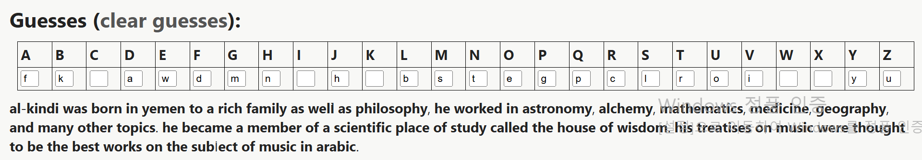

최종 평문
al-kindi was born in yemen to a rich family
as well as philosophy, he worked in astronomy, alchemy, mathematics, medicine, geography, and many other topics.
he became a member of a scientific place of study called the house of wisdom.
his treatises on music were thought to be the best works on the subIect of music in arabic.

평문 해석
알킨디는 예멘의 부유한 가정에서 태어났습니다.
철학뿐만 아니라 천문학, 연금술, 수학, 의학, 지리학 등 다양한 분야에서 활동했습니다.
그는 지혜의 집이라는 과학 연구소의 회원이 되었습니다.
음악에 관한 그의 논문은 아랍어로 된 음악의 하위 분야에 관한 최고의 작품으로 여겨졌습니다.

