**A concise description of what the Arduino application does:**

My application uses the light sensor and takes measurements of the light intensity as input. If below a threshold, the red LED will start flashing otherwise the yellow LED will continuously flash. The results are displayed in a graph via Processing IDE.

**How to set up and run the application, including a circuit diagram (a well positioned photo will do). You can also use the Fritzing software to draw the circuit.**

The circuit connects to the laptop via USB cable.

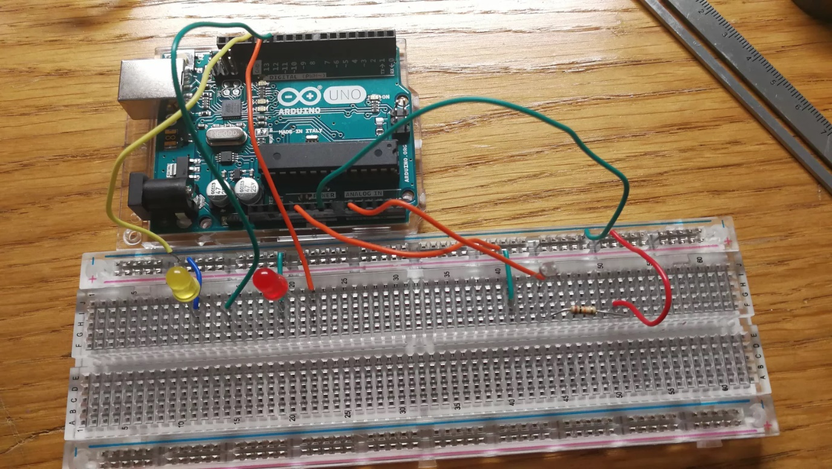

LED

Light Sensor

Resistor

**Any notes about your OpenSCAD design if included and one or more rendered images of the 3D model as produced by OpenSCAD.**

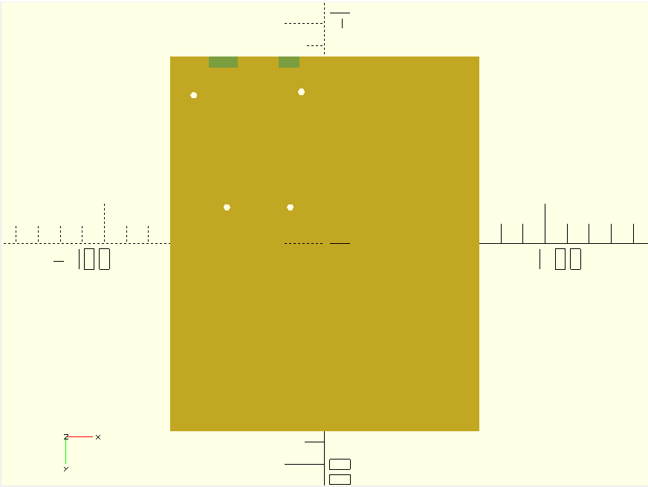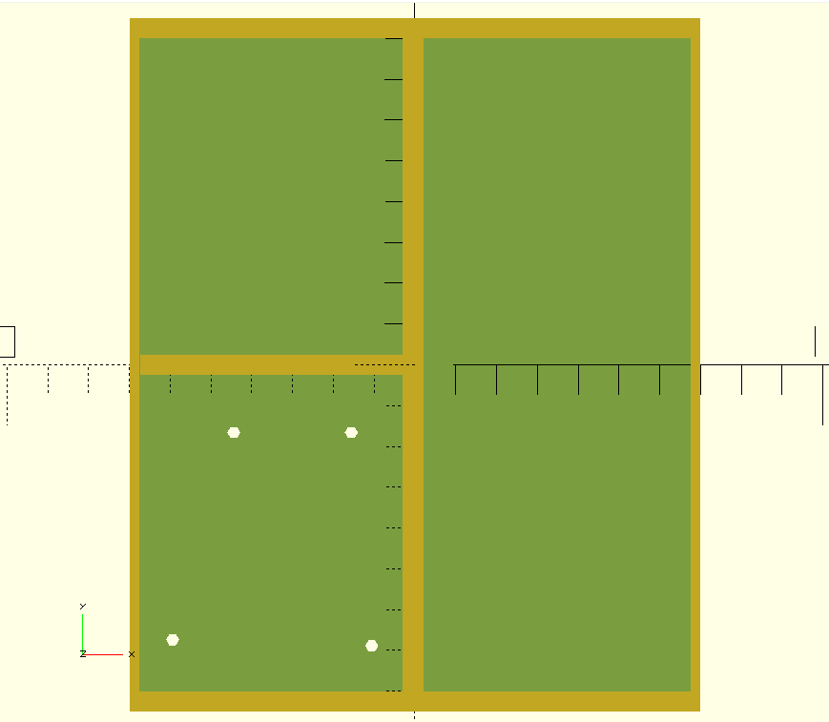My model is a tray with partitions to put the breadboard in one side, a section for the Arduino and a section for extra components. There are two holes for the power and USB cables as well as 4 holes for the Arduino.

