
Department of Computer Science and IT,
Barani Institute of Management Sciences,
Rawalpindi Pakistan

SMART CLIENT SESSION MANAGEMENT SYSTEM

By

Muhammad Ali 22-ARID-5403
Haider Ali 22-ARID-5354
Muhammad Umer Farooq 22-ARID-5438
Muhammad Sami Hafeez 22-ARID-

Supervisor
SIR AHSAN RAEES
Bachelor of Science in Computer Science (20xx-20xx)
OR Information Technology OR Software Engineering

The candidate confirms that the work submitted is their own and appropriate
credit has been given where reference has been made to the work of others.

DECLARATION

We hereby declare that this software, neither whole nor as a part has been copied out from any source. It is further declared that we have developed this software documentation and accompanied report entirely on the basis of our personal efforts. If any part of this project is proved to be copied out from any source or found to be reproduction of some other. We will stand by the consequences. No Portion of the work presented has been submitted of any application for any other degree or qualification of this or any other university or institute of learning.

Student Name 1 Student Name 2 Student Name 3 Student Name 4

MUHAMMAD ALI (5403) HAIDER ALI(5354) M UMER FAROOQ(5438) M SAMI HAFEEZ()
--------------------------- ----------------------- -------------------- ---------------------
CERTIFICATE OF APPROVAL

It is to certify that the final year project of BS (CS/IT/SE) “Smart Client Session Management System” was developed by MUHAMMAD ALI (5403)”, “HAIDER ALI(5354)” and “M UMER FAROOQ(5438)” ,“M SAMI HAFEEZ()” under the supervision of “Mr Ahsan Raees” and that in their opinion; it is fully adequate, in scope and quality for the degree of Bachelors of Science in Computer Science/Information Technology/Software Engineering.

---------------------------------------
Supervisor

---------------------------------------
Administrator UIIT

Executive Summary

The Smart Client Session Management System is designed to provide a secure, efficient, and user-friendly solution for managing client sessions in web applications. The system addresses the increasing need for reliable session control, data privacy, and security in modern digital environments where unauthorized access, session hijacking, and poor monitoring remain critical issues.
The project has been implemented using Node.js, Express.js, and HTML/CSS/JavaScript for the web interface, ensuring a responsive and accessible platform. Key features include:

Session Creation – Users can initiate new sessions easily with unique identifiers.

View Active Sessions – Provides a real-time overview of all ongoing sessions for better tracking.

Reports Generation – Summarizes session activities for analysis and monitoring.

Settings Module – Allows configuration of preferences and system-level adjustments.

Logout Functionality – Ensures proper termination of sessions to maintain security.

The system adopts an Agile Software Development Methodology, which allowed development in incremental stages, ensuring continuous testing, feedback, and refinement. The lifecycle covered requirement gathering, design, coding, testing, and deployment.
Through literature review and analysis of recent studies (2020–2024), it was identified that traditional cookie-based session handling is limited in scalability and security. Token-based methods such as JWT and advanced AI-driven anomaly detection are emerging trends. However, most existing models face limitations in cross-platform support and real-world scalability. This project contributes by implementing a prototype that can be expanded to incorporate AI-based monitoring and database integration in the future.
In conclusion, the Smart Client Session Management System successfully demonstrates the core functionalities of session handling with a focus on security, usability, and extendibility. The project lays a solid foundation for further enhancement, including AI-driven monitoring, cloud database support, and cross-platform compatibility.

Acknowledgement

All praise is to Almighty Allah who bestowed upon us a minute portion of His boundless knowledge by virtue of which we were able to accomplish this challenging task.
We are greatly indebted to our project supervisor “Mr Ahsan Raees” for personal supervision, advice, valuable guidance and completion of this project. We are deeply indebted to her for encouragement and continual help during this work.
We will not be out of place to express my profound admiration for our parents for their continued prayers and support. It was only possible due to their moral support that we continued our education. Many thanks to our colleagues, friends, and cousins who never let us down in hard times.
We always pray for the individuals we mentioned, who helped us to succeed in this and everlasting life. Ameen

Muhammad Ali Haider Ali M Umer Farooq

--------------------------- --------------------------- ---------------------------

Muhammad Sami Hafeez
---------------------------

Abbreviations

Abbreviation | Full Form
SRS | Software Requirement Specification
PC | Personal Computer
UI | User Interface
UX | User Experience
DB | Database
SQL | Structured Query Language
API | Application Programming Interface
HTML | HyperText Markup Language
CSS | Cascading Style Sheets
JS | JavaScript
FYP | Final Year Project
IDE | Integrated Development Environment
LAN | Local Area Network
WAN | Wide Area Network
HTTP | HyperText Transfer Protocol
HTTPS | HyperText Transfer Protocol Secure
AI | Artificial Intelligence
ML | Machine Learning
LMS | Learning Management System

Table of Contents
Introduction 1
1.1. Brief 2
1.2. Relevance to Course Modules 2
1.3 Project Background 3
1.4. Literature Review 3
1.5. Methodology and Software Life Cycle 5
Problem Definition 6
2.1. Purpose 7
2.2. Product Functions 7
2.3. Proposed Architecture 7
2.4. Project Deliverables 8
2.5. Operating Environment 8
2.6. Assumptions and Dependencies 8
Requirement Analysis 9
3.1. Functional Requirments 10
3.2. Non – Functional Requirments 11
3.2.1. Usability 11
3.2.2. Reliability 11
3.2.3. Performance 11
3.2.4. Supportability 11
3.2.5. Design Constraints 11
3.2.6. Licensing Requirements 11
3.3. Use case Model 12
3.3.1. Use Case Diagarm 12
3.3.2. Actors Discription 16
3.3.3. Use Case Discription 17

List of Figures

Figure 1.1: Block Diagram 8
Figure 2.1: Use Case Diagram 9
List of Tables

Table 1.1: Data Table 8
Table 2.1: Results 9

Chapter 1: Introduction
The objective of this chapter is to present the overview of the proposed research, as well as search motivation, and its objectives. After defining the scope of research, the problem statement is elaborated that has been evinced from the detailed literature review and evaluation. Afterwards, the research methodology that is followed by research contribution is presented.

Brief

In recent years, the use of E-learning has increased immensely due to the emergence of advanced technologies and ease of learning from the comfort zone. Nowadays, E-learning is a rapidly expanding industry, with online courses and educational resources becoming increasingly popular for personal and professional development. In the past few years, Traditional tutoring services, such as Chegg Tutoring, often fail to meet the diverse needs of today's students. While they provide access to expert assistance, they lack the flexibility and adaptability required for effective learning. This lack of real-time communication with experts can leave students struggling to understand and correct their mistakes [1].

This project aims to address the challenges faced by existing e-learning platforms, proposing a solution that prioritizes user experience and real time support. By overcoming the limitations of current e-learning platforms, this project strives to deliver a seamless and engaging learning experience that caters to the diverse needs of learners. This project primarily focuses on addressing shortcomings by offering a multitude of functionalities, including real-time chat and video calls for personalized instruction and interactive learning, short-term teacher hiring to cater to specific learning needs or project requirements, and an Al-powered question-answering system for immediate solutions and reinforcement of understanding.
Moreover, Smart Study app is built using the Flutter framework, allowing for a responsive and engaging user interface. With Flutter's Dart programming language, Creating a seamless cross-platform experience. Backend development relies on Firebase, ensuring efficient server-side.

Relevance to Course Modules
This project is highly relevant to various courses studied during the Bachelor of Engineering degree program. The app's development and implementation draw upon concepts and principles from several core disciplines, including:

Modern Programming Languages: The app's design and programming require a strong understanding of computer science fundamentals, including data structures, algorithms, object-oriented programming, and software engineering principles.

Artificial Intelligence: The AI-powered question answering feature utilizes machine learning and natural language processing techniques, which are key areas of study in artificial intelligence courses.

Human-Computer Interaction: The app's user interface and interaction design principles are based on concepts covered in human-computer interaction courses, ensuring a user-friendly and intuitive experience.

Database Management: The app's data storage and retrieval mechanisms require proficiency in database management concepts, including relational databases and SQL queries.

Networking and Security: The app's communication protocols, and security measures are based on principles learned in networking and security courses, ensuring data protection and secure communication.

Through the development of this project, students have the opportunity to apply theoretical knowledge and practical skills gained from these courses to a real-world application, enhancing their understanding and problem-solving abilities.

Project Background
Background:
In modern web applications, secure session management is essential to ensure reliable user authentication, session tracking, and protection against unauthorized access. Manual handling of sessions often leads to problems such as session hijacking, weak logout features, and lack of monitoring.
Project Overview:
The Smart Client Session Management System is designed to provide a structured way of creating, viewing, and managing sessions using Node.js, Express, and frontend UI. The system allows users to create sessions, view active sessions, generate reports, and logout securely.
Motivation:
The motivation is to design a lightweight yet secure solution for session handling that can be applied in enterprise applications, educational systems, and cloud-based solutions.
Scope:
This system will manage user sessions, track active users, and generate reports of user activity. Future versions can integrate with databases and authentication mechanisms.

Literature Review

No. | Author(s) & Year | Methodology | Findings / Accuracy | Deficiency
1 | Alharbi et al., 2021 | Proposed a secure session management framework with encryption & timeout policies; evaluated on web applications | Improved confidentiality and prevented session hijacking; showed resilience in test environments | Tested only on limited dataset; no evaluation for mobile/web hybrid apps
2 | MDPI Authors, 2022 | Designed JWT-based prototype with behavior-weighted authentication | Reduced unauthorized access and improved anomaly detection in test scenarios | Implementation complexity and risk of false positives
3 | Kumar & Singh, 2022 | Comparative survey of modern session/token handling methods (cookies vs OAuth2/JWT) | Found OAuth2 and JWT more scalable and secure compared to traditional cookies | Mostly theoretical survey; lacked real-world implementation testing
4 | DIVA Thesis, 2024 | Empirical study of JWT deployments vs RFC8725 best practices | Found many real-world JWT deployments insecure due to poor expiry/algorithm handling | Dataset limited, not across all industries
5 | Rashid et al., 2023 | AI-enhanced session monitoring system using anomaly detection | Achieved ~92% detection accuracy for abnormal session behavior | Prototype stage only; scalability not fully validated

Analysis of Reviewed Literature
From the reviewed works (2020–2024), several patterns and gaps can be identified:
Focus on Token-Based Security
Recent research emphasizes token-based approaches such as JWT and OAuth2 as
replacements for traditional cookie sessions. This is evident in the works of Kumar & Singh
(2022), MDPI (2022), and the DIVA Thesis (2024).
Integration of Intelligent Monitoring
There is a growing trend toward AI-driven anomaly detection for session monitoring, as demonstrated by Rashid et al. (2023), which achieved ~92% detection accuracy.
·3. Strengths Highlighted
·
Encryption and timeout policies (Alharbi, 2021) enhance confidentiality.

Behavior-based JWT authentication (MDPI, 2022) detects suspicious activity.

RFC-based best practices (DIVA, 2024) improve security compliance.s

·4. Deficiencies in Current Literature
·
….…Most works are evaluated on small datasets or prototypes, limiting real-…….world generalizability.

AI-based models are promising but lack scalability validation

Few studies address cross-platform (mobile, IoT, web) session management.

· 5. Research Gap Identified

Need for multi-device session continuity research.

Lack of robust reporting and visualization frameworks for session data.

Hybrid solutions combining traditional sessions, JWT, and AI anomaly detection remain underexplored.

2.1 Methodology and Software Lifecycle for This Project
Methodology
The development of the Smart Client Session Management System follows the Agile Software Development Methodology. Agile was selected because it allows the project to be developed in iterative increments, providing continuous feedback and flexibility. The project was divided into small sprints, each focusing on a core functionality such as session creation, session viewing, report generation, and logout handling.
This approach ensured that:
Requirements could be refined after each iteration.
Errors were detected early and fixed with minimum effort.
A working prototype was available at
.

2.1 Problem Statement

Traditional web applications lack strong and reliable session management mechanisms.
Common issues include:
Vulnerability to session hijacking and unauthorized access.
Absence of proper session expiration, tracking, and logout controls.
No integrated reporting or analytics tools to monitor session activity.
These limitations create security risks, reduce user trust, and make it harder for
organizations to ensure compliance and accountability in session handling.
Proposed Solution
The Smart Client Session Management System has been designed to overcome these challenges by:
Implementing secure session creation and destruction mechanisms.
Allowing users and administrators to view active sessions in real time.
Providing report generation features to track usage and detect anomalies.
Ensuring secure logout functionality to prevent unauthorized session continuation.
Objectives
The key objectives of the project are to:
Develop a working prototype for session management.
Implement secure mechanisms for session creation, viewing, and termination.
Provide reporting features for monitoring and analysis of sessions.
Establish a foundation for future enhancements, such as database integration and AI-driven
monitoring.

2.2 Deliverables and Development Requirements
To address the limitations of existing session management systems, the project aims to
deliver a secure, reliable, and user-friendly session management platform with the following features:
Key Deliverables
Secure Session Creation and Termination: Each user session is assigned a unique
identifier with proper expiration and destruction policies.
Session Monitoring Dashboard: Users can view their active sessions, and administrators
can track all system sessions.
Reports and Analytics: The system provides detailed reports on session usage for
accountability and anomaly detection.
Settings and Configuration: Options for session timeout duration, access control, and
logout management.
Development Requirements
Front-End Development: Implemented using HTML, CSS, and JavaScript, ensuring a
responsive and user-friendly interface.
Back-End Development: Built on Node.js with Express.js, enabling efficient session
handling and server-side logic.
Session Management: Powered by the express-session library for secure session handling.
Future Enhancements: Integration with databases for persistent session tracking and AI
modules for anomaly detection.
Security Protocols: Ensuring encrypted communication, secure cookies, and safe data storage.
2.3 Current System
Currently, most web applications rely on basic cookie-based session management methods. While these systems allow user login and temporary session handling, they exhibit major shortcomings:
Lack of comprehensive session tracking — users are unable to see all their active sessions.
Inadequate security measures — prone to session hijacking, fixation, and unauthorized reuse.
No proper reporting — administrators cannot monitor patterns or generate reports on session activity.
Complex enterprise tools — although advanced solutions exist, they are expensive, complicated, and unsuitable for smaller-scale applications.
The proposed Smart Client Session Management System directly addresses these gaps by offering a lightweight yet secure framework with session creation, active session monitoring, logout, and reporting. Furthermore, it is designed to be scalable, allowing integration with databases and AI-based monitoring in future versions. This is illustrated in Figure 2.1.

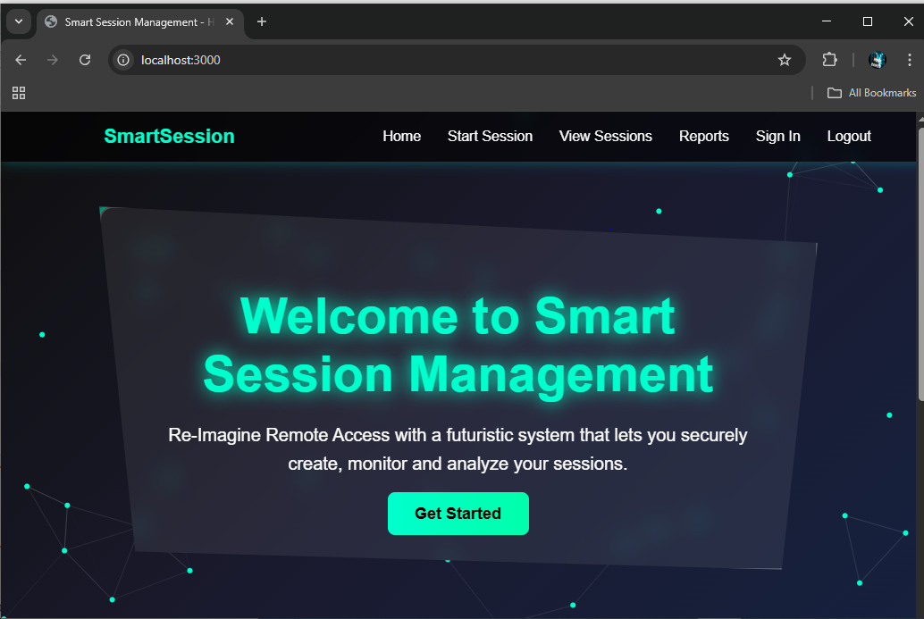

Chapter 3: Requirement Analysis

The Smart Client Session Management System is designed to provide secure, efficient, and user-friendly session handling for web applications. This chapter outlines the key functional and non-functional requirements for the system, based on the project objectives and initial discussions.

3.1 Use Cases
A use case diagram represents the interactions between actors (users, admins, systems) and the application, describing how users achieve their goals through the system [2]. The Smart Client Session Management System uses the use case diagram shown in Figure 3.1 to illustrate the primary interactions between the User and Admin. It depicts various functionalities such as session creation, viewing active sessions, logging out, generating reports, managing settings, and monitoring sessions, highlighting the system’s core capabilities for ensuring secure session control.
Figure 3.1: Use Case Diagram of Smart Client Session Management System

3.1.1 Use Cases
Table 3.1.1: Create Session
Use Case ID: UC-3.1.1
Use Case Name: Create Session
Actors: User (primary), System (secondary)
Description: The user initiates a new session, and the system generates a secure session identifier with proper timeout.
Preconditions: 1. The user must be logged in. 2. The system must be running and accessible.
Postconditions: 1. A new session is created and active. 2. The session is added to the list of active sessions.
Table 3.1.2: View Active Sessions
Use Case ID: UC-3.1.2
Use Case Name: View Active Sessions
Actors: User (primary), Admin (secondary)
Description: The actor requests to view all active sessions, and the system displays the details.
Preconditions: 1. User/Admin must be authenticated.
Postconditions: 1. The list of active sessions is displayed.
Table 3.1.3: Logout Session
Use Case ID: UC-3.1.3
Use Case Name: Logout Session
Actors: User
Description: The user logs out, and the system terminates the active session.
Preconditions: 1. User must have an active session.
Postconditions: 1. The session is securely terminated.
Table 3.1.4: Generate Reports
Use Case ID: UC-3.1.4
Use Case Name: Generate Reports
Actors: Admin
Description: The admin requests reports on session activities, and the system generates summaries.
Preconditions: 1. Admin must be authenticated.
Postconditions: 1. Report is generated and displayed or downloaded.
Table 3.1.5: Manage Settings
Use Case ID: UC-3.1.5
Use Case Name: Manage Settings
Actors: Admin
Description: The admin changes system-level settings, such as session timeout duration.
Preconditions: 1. Admin must be logged in.
Postconditions: 1. New settings are applied.

3.2 Functional Requirements
Functional requirements define the specific behaviors and operations a system must perform to fulfill user needs [3]. In the Smart Client Session Management System, the functional requirements are as follows.
FR-3.2.1: The system shall allow users to create secure sessions with unique identifiers.
FR-3.2.2: The system shall allow users and admins to view active sessions.
FR-3.2.3: The system shall allow users to securely logout from any active session.
FR-3.2.4: The system shall allow admins to generate reports of session activities.
FR-3.2.5: The system shall allow admins to configure session-related settings.

3.3 Non-Functional Requirements
Non-functional requirements describe the qualities and constraints of the system, such as performance, usability, and security [3]. For the Smart Client Session Management System, the non-functional requirements are as follows.
NFR-3.3.1 Scalability: The system should handle multiple concurrent sessions efficiently.
NFR-3.3.2 Security: Sessions should be protected from hijacking and unauthorized access using secure cookies and encryption.
NFR-3.3.3 Reliability: The system should maintain consistent performance and session NFR-3.3.4 Usability: The interface should be simple, user-friendly, and accessible.
NFR-3.3.5 Extensibility: The system should be designed to support future enhancements, such as database integration and AI-based monitoring.
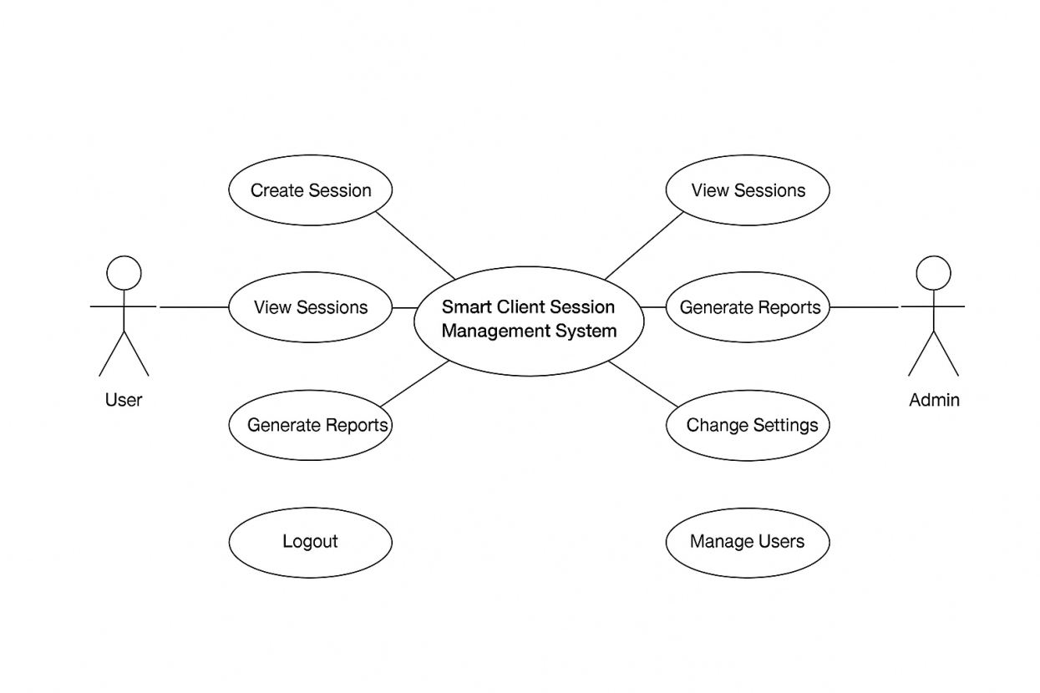

ER Diagram

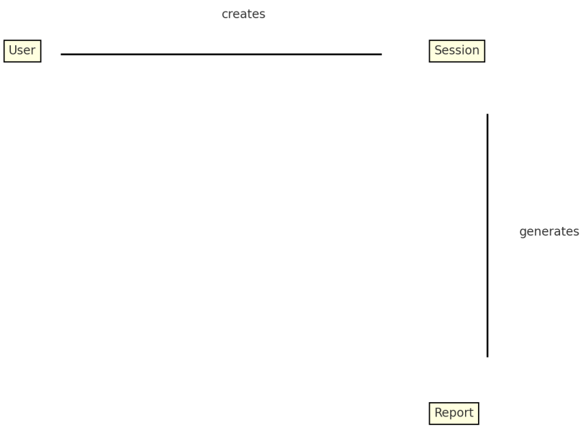

Activity Diagram



