What is Multi-threading?
In this the multiple processes of an application are controlled by threads, threads are light weight programs which execute these multiple tasks simultaneously on multiple cores. Applications can also be designed to leverage processing capabilities on muti-core systems. Such applications can perform several CPU intensive tasks in parallel across the multiple computing cores.
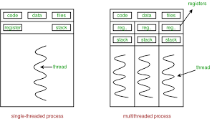

As you can see in above picture the tasks are divided hence reducing the workload on a single core and reducing execution time

What is Multi Tasking?
In multitasking CPU executes multiple programs simultaneously by quickly switching between the processes which creates the illusion that the programs are being executed concurrently other definition of this is the ability of user to perform multiple tasks at the same time but keeping the track of all previous processes by saving there current state for further execution.

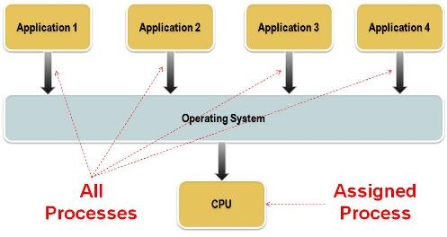

In the above picture you can see multiple programs in being execution.

Comparison between Multi-threading and
Multi-tasking

- The basic difference between multitasking and multi-threading is that in multitasking, the system allows executing multiple programs and tasks at the same time, whereas, in multi-threading, the system executes multiple threads of the same or different processes at the same time.
- In multitasking, CPU has to switch between multiple programs so that it appears that multiple programs are running simultaneously. On other hands, in multi-threading CPU has to switch between multiple threads to make it appear that all threads are running simultaneously.
- Multitasking allocates separate memory and resources for each process/program whereas, in multi-threading threads belonging to the same process shares the same memory and resources as that of the process.

