Decoupled Information-Set MCTS with a Card-Value Model for Sushi Go!

Hakan Coskun
Student no. 241076864
Queen Mary University of London
London, UK
Halit Ozger
Student no. 230625112
Queen Mary University of London
London, UK
Weronika Diana Podgorska
Student no. 230394735
Queen Mary University of London
London, UK

Abstract—Card-drafting games such as Sushi Go! combine hidden hands, simultaneous moves and delayed scoring, which basic Monte Carlo tree search (MCTS) handles poorly. We extended BasicMCTS of the Tabletop Games framework (TAG) with card-value rollouts, a lead-based evaluation, round-end rollouts, max-n backups and a decoupled information-set tree. On held-out deals it wins 52.6%, 47.2% and 44.8% of three-player games (100, 500, 900 ms; chance 33.3%) against TAG's information-set MCTS (ISMCTS) and our previous agent, and 44.4% and 36.5% of four-player games (100, 500 ms; chance 25%). At 100 ms, the evaluation and the decoupled tree each raise its win rate significantly. With more time for all agents, ISMCTS closes in: our lead per seat falls from 26.2 to 8.5 percentage points (three players, 100–900 ms).
Keywords—Monte Carlo tree search, information sets, simultaneous moves, card games, Sushi Go!, TAG

Introduction
Tabletop games combine chance, hidden information and several interacting players within small rule sets; the Tabletop Games framework (TAG) [1] gives many of them a common interface so that agents can be compared. Monte Carlo tree search (MCTS) [2] is the usual starting point for such agents, but its basic form assumes that the state is fully observed and that players move one after another [3]. Sushi Go!, one of TAG's games, breaks both assumptions: every player secretly picks one card from its hand, all players reveal their cards together and pass the rest of their hands on, and after three rounds the highest score wins. Klang et al. [4] implemented the game in TAG and described it as combining simultaneous action selection with complete information; in the TAG version we use, an agent's copy re-deals all unseen cards.
Four properties make the game hard for a search agent. (i) The opponents' hands are hidden until they are passed on. (ii) Moves are simultaneous: no card can be chosen in reaction to an opponent's card of the same turn. (iii) Many points are delayed and conditional – sets pay out only when completed, Maki rolls at the end of the round and Pudding at the end of the game – so short simulations miss them and long ones are noisy. (iv) Hands of nine (three players) or eight cards (four players) give up to 729 or 4096 joint moves per turn (more with Chopsticks), with 0.1–1 s per decision. TAG's BasicMCTS addresses none of the first three: it searches the one shuffled sample of the hidden cards it receives as if it were the true state, treats the players of a turn as moving one after another and evaluates random rollouts by the player's own score.
We ask which adaptations of MCTS to these properties make an agent stronger (RQ1), and how their value changes with the time per decision (RQ2) and the number of players (RQ3). We extend BasicMCTS in steps, keeping every modification as a switch, and test each in 500-game experiments (250 games in some long runs). Our contributions are:
- a model of Sushi Go!'s scoring that values every card for all players' rollouts and estimates every player's final score for a bounded, lead-based evaluation, which is the component our agent depends on most;
- ablations and held-out tests showing that decoupled selection over information sets beats a determinised sequential tree (significantly at 100 ms), while TAG's own decoupled information-set agent, with its own heuristic and rollouts, is not detectably better than our previous agent;
- exploratory evidence that settings tuned for four players hurt with three, and that with four players time beyond 500 ms rarely changes the decision of a wide, shallow joint-move tree.

Background

TAG and Sushi Go!
TAG [1] splits a game into a state, a forward model and parameters; an agent receives a copy of the state, in which every card it has not seen is reshuffled, and uses the forward model to simulate moves. In TAG's Sushi Go! the 108-card deck holds Tempura (5 points per pair), Sashimi (10 per triple), Dumplings (1, 3, 6, 10 or 15 points for one to five), Salmon, Squid and Egg Nigiri (2, 3 and 1 points, tripled on an earlier Wasabi), Maki rolls with one to three icons (6 and 3 points for the most and second-most icons of a round), Chopsticks (two cards in a later turn) and Pudding (+6 for the most and, with three or more players, −6 for the fewest at the end of the game, when Puddings also break ties). As the hands rotate, every hand of a round has been seen after two passes (three with four players), so hidden information is concentrated at the start of each round, while the value of a card depends on what the others will take from the hands we pass on.

Monte Carlo Tree Search
MCTS [2] builds a search tree by repeating selection, expansion, simulation (rollout) and backpropagation. Upper Confidence bounds applied to Trees (UCT) [5] selects the child that maximises the upper confidence bound (UCB1) Q + K√(ln N / n), where Q is the child's mean reward, n its visits and N those of its parent. Domain knowledge can enter through heuristic rollout policies or priors such as progressive bias [2], but a stronger rollout policy does not guarantee better estimates: Silver and Tesauro [6] showed that rollouts should be balanced, i.e., give unbiased value estimates.

Hidden Information, Simultaneous Moves and Several Players
Determinisation, or perfect-information Monte Carlo (PIMC) sampling, samples the hidden information, searches each sample as if it were the true state and combines the results. Long et al. [7] related its success in card games to properties such as how quickly hidden information is revealed during play, which in Sushi Go! happens within two or three turns of each round. Its known flaws are strategy fusion – the search assumes that it can act differently in states it cannot tell apart – and non-locality [3], [7]. Information-set MCTS (ISMCTS) [3] avoids strategy fusion by searching one tree over the searcher's information sets and sampling the hidden information anew in every iteration. In its single-observer form the opponents' choices in the tree are not conditioned on their own private information; the multiple-observer form models it with one tree per player at a higher cost [3], as in TAG's MultiTree MCTS [8].
Simultaneous moves can be modelled as hidden sequential moves (partially observable moves in ISMCTS [3]) or handled by decoupled UCT (DUCT): every player chooses its own action at a node from its own bandit statistics and the joint action leads to a child [9]. UCB-based DUCT need not converge to an equilibrium, so Lanctot et al. [9] compared it in Goofspiel with EXP3, regret matching and their online outcome sampling: regret matching and outcome sampling played best, and decoupled UCT's strategies were the most exploitable. Tak et al. [10] compared decoupled and sequential UCT, EXP3 and regret matching in nine games: the best variant depended on the game and the opponent, although decoupled UCT was best overall. With several players, UCT with max-n backups (every player maximises its own value) computes a mixed-strategy equilibrium and played at least as well as earlier algorithms [11].
MCTS has also been applied to the drafting game 7 Wonders, which passes hands in the same way; many results known from classic games held there too, and Robilliard et al. [12] argued that a hand-made evaluation is hard to build because card values depend on the stage of the game and on the other players' choices; our card-value model is such an attempt. For Sushi Go! and similar drafting games we know of no study that separates the contributions of decoupled selection, information sets and domain knowledge within one agent or measures how they change with the time budget and the number of players; the earlier Sushi Go! study in TAG [4] focused on simultaneous action selection and complete information and concluded that better heuristics should improve the agents, which motivates our card-value model.

Method
Our agent, SushiMCTS, is a modified copy of TAG's BasicMCTS (package players.basicMCTS) and uses no code of TAG's advanced MCTS agent. Every modification is a switch in its parameter class (Table I). We compare the final agent (v4) with two earlier versions, v2 (H, A, B, D) and v3 (H, B, D, P, R, M), whose tree treats the players of a turn as moving in sequence (Fig. 1). The search techniques come from the literature; our own element is the card-value model shared by the evaluation and every player's simulation.

Card-Value Model and Heuristic (H)
For a state s and player p the model estimates the final score
Ŝ_{p} = b_{p} + αu_{p} + m_{p} + πω_{t}d_{p}, (1)
where b_{p} is the banked score (TAG scores Tempura, Sashimi, Dumplings and Nigiri when they are revealed); u_{p} the value of unfinished sets, of unused Wasabi (2ν, the bonus for a Nigiri of average value ν = 2) and of Chopsticks (1), each weighted by min(1, (r − k + 1)/T), or 0 if r < k, when k more cards are needed and r picks are left; m_{p} the Maki points p would get if the round ended now; and d_{p} the Pudding (dessert) points if the game ended now, weighted by ω_{t} = t/3 in round t (α = 0.5, T = 4, π = 1). The value of s for player i is
H_{i}(s) = tanh(Δ_{i} / σ), (2)
Δ_{i} = w(Ŝ_{i} − max_{j≠i} Ŝ_{j}) + (1 − w)(Ŝ_{i} − mean_{j≠i} Ŝ_{j}), (3)
with σ = 15 and w = 0.7: the first term rewards beating the leader, since only first place wins, and the second keeps a gradient when the agent is far ahead or behind. The marginal value mv_{p}(c) of a card c is the change of Ŝ_{p} when p plays it.
- Modifications of BasicMCTS (✓ = used in the final agent with 3 / 4 players)
Id | Modification | 3 p / 4 p
H | heuristic (2)–(3) from model (1) | ✓ / ✓
B | ε-greedy card-value rollouts for every player | ✓ / ✓
R | rollouts end when the round is scored | ✓ / ✓
P | one branch per distinct card | ✓ / ✓
M | max-n backups [11] | ✓ / ✓
S | decoupled UCT, one node per turn [9] | ✓ / ✓
I | single-observer information-set search [3] | ✓ / ✓
X0 | four-player card constants ª | – / ✓
W2 | win-gap value for 4 players (Section III-D) | – / ✓ ^{b}
F, L | fast simulator, 8 rollouts per leaf | – / ✓ ^{b}
A | progressive bias [2] | dropped in v3
D | ensemble of up to 4 determinised trees [3] | replaced by I
ª (σ, w, α, T, β, T_{m}, κ, δ, π, ν, γ) = (15, 0.7, 0.5, 6, 0.5, 3, 0.25, 1.5, 1.25, 3, 3), default (15, 0.7, 0.5, 4, 1, 0, 0, 0, 1, 2, 0). β: Sashimi triple needing two cards; Maki standing weight 1/(1 + r/T_{m}) (1 if T_{m} = 0), κ per icon otherwise; δ: next Dumpling; γ: cards needed per missing card. ^{b} 500 ms or more.
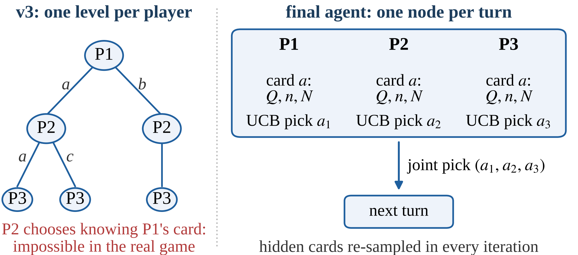
- The sequential tree of v3 (left) and a turn node of the final agent (right): every player picks by UCB on its own card statistics, and the hidden cards are re-sampled in every iteration.

Simulation (B, R)
B: every player plays its card with the highest mv, or a random card with probability ε = 0.2 (the second card of a Chopsticks move in the same way, and greedily in the tree); the same policy models the opponents. R: a rollout stops when the current round has been scored; only Pudding carries over, which (1) captures, so at the leaves u_{p} = m_{p} = 0 and only banked points and the Pudding standing count.

Tree (P, M, S, I)
P: identical cards lead to identical states, so a node has one branch per distinct card. M: a node stores one value per player and every player maximises its own value [11], instead of BasicMCTS's paranoid assumption that every opponent minimises ours. S: one node represents a whole turn; at a node every player p picks a card by
a_{p} = argmax_{a} [Q_{p}(a) + K√(ln N_{p}(a) / n_{p}(a))] (4)
from its own statistics, trying untried cards first; the joint choice is played in the forward model and leads to the child of that joint action [9]; in v3's tree a later player “saw” the card an earlier player had just chosen (Fig. 1). I: every iteration starts from a new sample of the cards we cannot see and walks one shared open-loop tree, whose nodes store statistics but no states [3]; each iteration adds one node, and the agent finally plays the card it chose most often at the root. Statistics are keyed by card kind (type, Maki icons, use of Chopsticks); n_{p}(a) counts how often p chose a at the node and the availability count N_{p}(a) how many iterations reached the node with a in p's sampled hand (without I, the node's visits). I replaces the determinisation ensemble D of v2 and v3, which split the budget between up to four independent trees. With three players K = 0.5.

Four Players
With four players the agent switches parameters. It uses the card constants X0 (Table I), found by a search-free tuner of greedy card-value policies. Its files for 500 ms or more also use W2 – w = 1; finished games valued by tanh((b_{i} − max_{j≠i} b_{j})/2) with Pudding as tie-break; σ multiplied by (ρ/2)^{0.5} for ρ rounds left; opponents in the backup valuing their lead over the others' mean – and F, TAG's rules re-implemented on integer arrays and checked move by move against the forward model, whose speed is spent on L = 8 rollouts per leaf, with K = 1.

Experimental Setup
- Experimental setup
Item | Setting
Framework | TAG as provided for the module (unchanged), Sushi Go! with its default rules; OpenJDK 21
Opponents | v2: our previous agent (H, A, B, D, K 1.41). TAG ISMCTS: SushiGo_3+P_HiBudget at our budget (one tree per player [8], UCB-Tuned [2], K 1, random rollouts to the end, score heuristic). TAG DUCT: SushiGoDUCT (decoupled UCT, K 1, information sets, lead heuristic, 30-move rollouts). BasicMCTS (K 1.41, 10-move rollouts), Rolling Horizon Evolutionary Algorithm (RHEA; horizon 10, population 10), One-Step Look-Ahead (OSLA, score heuristic)
Budget | CPU time per decision, equal for all agents: 100 ms (most development), 500 and 900 ms; submitted agent files: 900 ms (1 s limit) or 430 ms (500 ms limit), with wall-clock guards
Seating | our agent in seat g mod 3 in game g (4 players: g mod 4); the two opponents swap seats every 3 games (4 players: 2 + 1 copies, swapped every 4 games)
Deals | game g uses seed s + g (seed block s); in all seed-7 and held-out runs and the later development runs a fixed deck order is shuffled with it (equal s, equal deals: paired runs); earlier runs used TAG's own deal (independent samples)
Seeds | development s = 1, 2 (v3 also 1001, 2001, 3001); ablation and later candidate tests s = 7; held-out s = 100 000, disjoint from all other deals
Games | 500 per condition; 250 at 900 ms (development and seed block 7) and in four-player development at 500 ms (45–70 s of CPU time per game)
Hardware, records | development, ablation and first seed-7 runs: 18-core laptop; later runs: 4-core machine; per-game results and logs of all 167 runs: available from the authors

Each game is an independent trial whose outcome for our agent is 1 for a win, 1/j for a j-way shared first place and 0 otherwise. Win rates are reported with Wilson 95% confidence intervals (CI) [13]; the score margin (our score minus the best opponent's) as mean ± 1.96 standard errors (SE); differences between runs as the mean of the per-game differences on the same deals ± 1.96 SE (for independent samples, the difference of the means with the two-sample SE; two deal sets are pooled by inverse-variance weighting) and z = |difference|/SE, in percentage points (pp) for win rates. With 500 games a win rate near 50% has a 95% interval of ±4.4 pp, and a difference between two runs about ±5.7 pp even when paired, because the outcomes of two versions of our agent on the same deal correlate only weakly (at most 0.22 in our paired runs); such a comparison detects a difference of about 8 pp with 80% power. We report unadjusted intervals, apply a Holm correction [14] within each group of Fig. 2, and treat the four-player comparisons (60 of our 167 runs) as exploratory. We expected (E1) every component to improve both measures, (E2) the decoupled information-set tree to matter more at longer budgets and (E3) the best settings to depend on the number of players; E2 came from development runs and is tested on held-out deals.

Results

Final Agent (RQ1)
- Final agent on held-out deals and against other agents
Setting | Opponents | Win % [CI] | Margin | ISMCTS
3p/100 | v2, ISMCTS | 52.6 [48.2, 56.9] | +0.73 ± 0.46 | 26.4
3p/500 | v2, ISMCTS | 47.2 [42.9, 51.6] | −0.10 ± 0.40 | 35.9
3p/900 | v2, ISMCTS | 44.8 [40.5, 49.2] | −0.35 ± 0.39 | 36.3
4p/100 | v2, ISMCTS | 44.4 [40.1, 48.8] | −0.61 ± 0.43 | 24.1
4p/500 | v2, ISMCTS | 36.5 [32.4, 40.8] | −1.83 ± 0.45 | 32.1
3p/100 | DUCT, ISMCTS | 55.0 [50.6, 59.3] | +0.72 ± 0.40 | 24.0
3p/100 | ISMCTS × 2 ª | 51.3 [46.9, 55.7] | +1.41 ± 0.51 | 24.3
3p/100 | BasicMCTS, RHEA ª | 84.2 [80.7, 87.1] | +6.68 ± 0.60 | –
3p/100 | OSLA, BasicMCTS ª | 87.2 [84.0, 89.8] | +9.74 ± 0.75 | –
Setting: players / ms per decision; 500 games each. Deals: held-out seed block 100 000; ª seed block 7. Margin: our score minus the best opponent's (± 95% CI). ISMCTS: win % per seat. Chance 33.3% (3p), 25% (4p).
Table III reports the final agent; in every setting its win rate is significantly above chance. On seed block 7 it had won 55.0% at 100 ms (58.1% when re-run on the second machine), within sampling error of the held-out result (z ≤ 1.8). At 100 ms it scores more than both opponents from Nigiri (17.6 points per game against 15.3 and 12.9) and Pudding bonuses, v2 more from Sashimi. TAG's own DUCT agent (Table II) wins 21.0% [17.7, 24.8] of its seats in place of v2, the same share as v2 (0.0 ± 5.0 pp): with TAG's heuristic and rollouts, decoupled information-set search was not detectably better than our previous agent. BasicMCTS, RHEA and OSLA win at most 12.8% of their seats.

Ablation (RQ1)
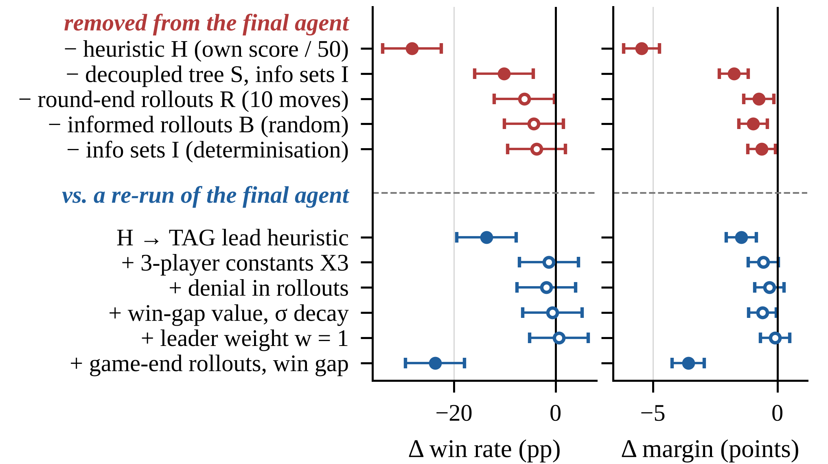
- Paired effects (three players, 100 ms, seed block 7, 500 games each; ± 95% CI; filled: significant after a Holm correction within the group). Top: components removed from the final agent (55.0%). Bottom: TAG's lead heuristic and five later changes against its re-run (58.1%).
Fig. 2 (top) removes one component at a time from the final agent. Every removal lowers both measures; on the score margin all five differences survive a Holm correction, on the win rate only those of H and of S + I, so for these five ablations E1 holds for the margin and only partly for wins. Without H the leaves are valued by TAG's default heuristic (own score / 50); as K was not retuned to its scale, the 28.3 ± 5.8 pp loss mixes the value of H with mis-scaled exploration. TAG's lead heuristic (own score minus the best opponent's, K rescaled to 7.5) in place of H wins 44.5%: 13.6 ± 5.9 pp (z = 4.5) less than H on the same machine (58.1%), but far more than own score / 50 (26.7%). S and I together are worth 10.2 ± 5.7 pp (z = 3.5) here and +6.1 ± 5.9 pp on the held-out deals (pooled +8.2 ± 4.1 pp, z = 3.9). S alone, decoupled selection with v3's determinisation, beats v3 by +6.4 ± 5.7 pp (z = 2.2, unadjusted), and I adds a further, non-significant 3.8 ± 5.7 pp, consistent with Long et al.'s analysis [7] for a game that reveals its hidden information within two turns of each round. P and M were not ablated in the final agent (S requires M; I already merges identical cards); a 2⁴ factorial around v3 (16 × 500 games, independent deals) supported R (+8.7 ± 2.1 pp) and M (+4.1 ± 2.1 pp).
Five later changes (Fig. 2, bottom) brought no detectable gain: four changed the win rate by −1.8 to +0.7 pp (each ±5.8), although one of them, card constants tuned for three players (X3), is the much stronger greedy policy (45.0% of games against two X0 players), consistent with simulation balancing [6]; in another, denial, every simulated player also values taking the card the next player wants most. Game-end rollouts with a win-gap value cost 23.7 ± 5.8 pp (z = 8.0).

Time Budget (RQ2)
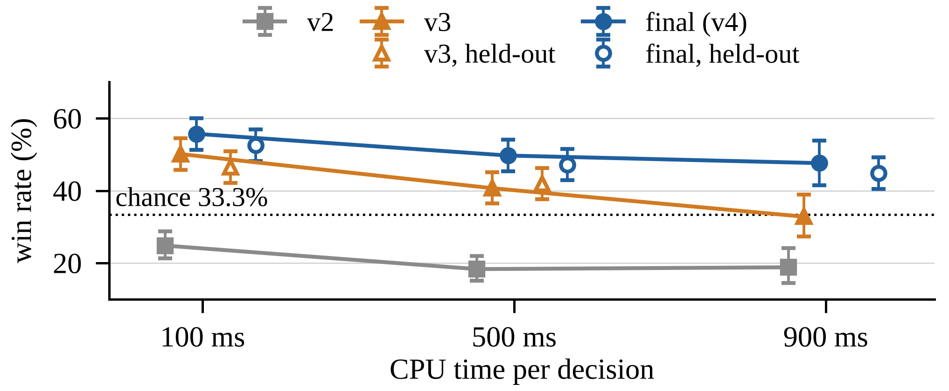
- Three-player win rate against v2 and TAG's ISMCTS. Lines: development (seed 1, independent samples; 250 games at 900 ms); open markers: held-out deals; bars: Wilson 95% intervals.
In development (Fig. 3; independent samples) the gain from S and I grew from +5.6 to +9.0 and +14.8 pp at 100, 500 and 900 ms (100 to 900 ms: +9.2 ± 10.4 pp, z = 1.7), suggesting that v3's sequential tree, in which later players react to cards chosen earlier in the same turn, is a wrong model that more iterations exploit more. The held-out deals do not support this (E2): adding S and I to v3 gained +6.1 ± 5.9 pp at 100 ms and +5.3 ± 5.5 pp at 500 ms (difference −0.8 ± 8.1 pp, z = 0.2; 80% power only for 12 pp), as v3 and the final agent lost 4.6 and 5.4 pp from 100 to 500 ms. The development rise is probably overstated: v3's 50.1% at 100 ms topped 16 factorial cells (45.1–49.4% on new seeds).
Giving every agent more time lowered our win rate: on the held-out deals it changed by −5.4 ± 5.9 pp (z = 1.8) at 500 ms and −7.8 ± 5.8 pp (z = 2.6) at 900 ms against 100 ms; pooled with seed block 7, 500 ms changed it by −5.5 ± 4.2 pp (z = 2.6) and 900 ms by −4.9 ± 4.8 pp (z = 1.97), although on its 250 deals seed block 7 alone gave +1.6 ± 8.7 pp at 900 ms. ISMCTS's share of its seats rose by 9.5 ± 5.7 pp from 100 to 500 ms (Table III): the extra time favoured ISMCTS over our agent. Our agent's iterations per decision rose from 2400 to 21 200, yet its win rate fell; plausibly, more iterations cannot correct the bias of our hand-made rollouts and evaluation, while ISMCTS, without such a model, gained up to 500 ms; our parameters were also tuned at 100 ms.

Four Players and the Limits of Search (RQ3)
With four players S and I added +6.4 ± 5.2 pp over v3 at 100 ms and +3.0 ± 8.4 pp at 500 ms (development, independent samples). No setting tuned for four players gained significantly in development (+1.0 to +5.8 pp at the budgets where we kept them, each ±4–8 pp; F + L lost 6.6 ± 6.0 pp at 100 ms); we kept each where its estimate was positive. The same settings (X0, W2, K = 1) cost 7.7 ± 5.4 pp with three players at 500 ms, 13.5 ± 9.1 pp (z = 2.9) different from their effect with four: consistent with E3, but post hoc and with F + L in the three-player arms only.
With four players, extra time for our agent alone brought no detectable gain: against 500 ms opponents, 500 instead of 100 ms changed its win rate by +3.6 ± 8.4 pp (same settings) and 1000 instead of 500 ms (with K = 1.37) by −4.8 ± 8.1 pp (250 development games each; 80% power only for about 12 pp), although depth matters: at 500 ms a tree cut to depth 1 lost 17.4 ± 8.2 pp. Our 500 ms agent with every agent at 500 ms won 6.7 ± 4.1 pp less than our 100 ms agent with every agent at 100 ms (z = 3.2; seed block 7 and held-out deals pooled), while TAG's ISMCTS rose from 24.1% to 32.1% of its seats; at 500 ms our 36.5% is no longer clearly above its share. Both agents did better on seed block 7 (100 ms: 46.8%, 500 ms: 41.4%), whose deals overlap those used to tune them. The tree statistics suggest why 1000 ms did not help: on 73 random-play positions the 500 ms tree has 704 joint-move children at the root on average, 53% visited once, and doubling time or rollouts per leaf changed the card in 2 and 4 positions, no more often than reruns (4 and 7).

Conclusions and Future Work
For RQ1, the lead-based evaluation H matters most (28.3 pp without it, 13.6 pp with TAG's lead heuristic), then the decoupled information-set tree (+8.2 ± 4.1 pp over v3's sequential, determinised tree, two deal sets pooled); round-end rollouts, card-value rollouts and information sets alone raise the final agent's score margin but not detectably its win rate. For RQ2, our agent's lead shrinks with time: with every agent at 500 ms it won 5.5 ± 4.2 pp less than at 100 ms (and, less clearly, 4.9 ± 4.8 pp less at 900 ms), while TAG's ISMCTS won 9.5 pp more of its seats, and the decoupled tree's value showed no sign of growing (−0.8 ± 8.1 pp, held-out). For RQ3, settings tuned for four players hurt with three, and with four players time beyond 500 ms rarely changes the wide, shallow tree's decision (both exploratory).
Our opponents were framework agents and our own previous version; the leave-one-out ablation used only three players at 100 ms; the four-player 500 ms settings were kept on non-significant 250-game gains; every agent got the same extra time, so RQ2 measures our agent's scaling relative to ISMCTS's; and CPU-time budgets hide wall-clock effects. As hand-tuned changes to the model no longer move the agent, future work should learn the evaluation from game outcomes; regret matching and EXP3 deserve a test, as decoupled UCT is best overall but not in every game [10] and was the most exploitable in Goofspiel [9]; and opponent models fitted to observed picks (an untested option in our code) could replace the greedy policy that now models all players.

Use of Generative AI
As the module's rules permit, we used Claude [15] (Anthropic), through the Claude Code tool, to write and modify the Java code of our agent on top of BasicMCTS, to write and run the experiment and statistics scripts, and to draft the text, tables and figures of this paper from the results of our runs. A second Claude instance checked drafts against the brief and the rubric, and its findings were used in the revisions. Every number in the paper was computed from the result files of our runs. The authors take full responsibility for the code and the paper, including any errors.

References
- R. D. Gaina, M. Balla, A. Dockhorn, R. Montoliu, and D. Perez-Liebana, “TAG: A tabletop games framework,” in Proc. AIIDE Workshop on Experimental AI in Games (EXAG), 2020.
- C. B. Browne et al., “A survey of Monte Carlo tree search methods,” IEEE Trans. Comput. Intell. AI Games, vol. 4, no. 1, pp. 1–43, 2012.
- P. I. Cowling, E. J. Powley, and D. Whitehouse, “Information set Monte Carlo tree search,” IEEE Trans. Comput. Intell. AI Games, vol. 4, no. 2, pp. 120–143, 2012.
- C.-M. E. Klang, V. Enhörning, A. Alvarez, and J. Font, “Assessing simultaneous action selection and complete information in TAG with Sushi Go!,” in Proc. IEEE Conf. Games (CoG), 2021, pp. 1–4.
- L. Kocsis and C. Szepesvári, “Bandit based Monte-Carlo planning,” in Proc. 17th Eur. Conf. Mach. Learn. (ECML), 2006, pp. 282–293.
- D. Silver and G. Tesauro, “Monte-Carlo simulation balancing,” in Proc. 26th Int. Conf. Mach. Learn. (ICML), 2009, pp. 945–952.
- J. Long, N. R. Sturtevant, M. Buro, and T. Furtak, “Understanding the success of perfect information Monte Carlo sampling in game tree search,” in Proc. 24th AAAI Conf. Artif. Intell., 2010, pp. 134–140.
- J. Goodman, D. Perez-Liebana, and S. Lucas, “MultiTree MCTS in tabletop games,” in Proc. IEEE Conf. Games (CoG), 2022, pp. 292–299.
- M. Lanctot, V. Lisý, and M. H. M. Winands, “Monte Carlo tree search in simultaneous move games with applications to Goofspiel,” in Computer Games (CGW 2013), Commun. Comput. Inf. Sci., vol. 408. Cham, Switzerland: Springer, 2014, pp. 28–43.
- M. J. W. Tak, M. Lanctot, and M. H. M. Winands, “Monte Carlo tree search variants for simultaneous move games,” in Proc. IEEE Conf. Comput. Intell. Games (CIG), 2014, pp. 232–239.
- N. R. Sturtevant, “An analysis of UCT in multi-player games,” in Computers and Games (CG 2008), Lect. Notes Comput. Sci., vol. 5131. Berlin, Germany: Springer, 2008, pp. 37–49.
- D. Robilliard, C. Fonlupt, and F. Teytaud, “Monte-Carlo tree search for the game of ‘7 Wonders’,” in Computer Games (CGW 2014), Commun. Comput. Inf. Sci., vol. 504. Cham, Switzerland: Springer, 2014, pp. 64–77.
- E. B. Wilson, “Probable inference, the law of succession, and statistical inference,” J. Amer. Statist. Assoc., vol. 22, no. 158, pp. 209–212, 1927.
- S. Holm, “A simple sequentially rejective multiple test procedure,” Scand. J. Statist., vol. 6, no. 2, pp. 65–70, 1979.
- Anthropic, “Claude” [large language model, used through the Claude Code tool], Oct. 2026. [Online]. Available: https://claude.ai (accessed Oct. 28, 2026).

