REPORT
COMPILER CONSTRUCTION LABORATORY

Full name: Trần Thị Hằng
Student ID: 20176748

- Error IDENTIFICATION TOO LONG

- Example:

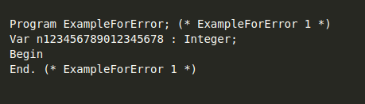

- Result:

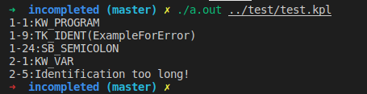

2. Underscore ( “_” ) is considered as a character

- Underscore (“_” ) in Ascii code table has value 95.
So I changed value of charCodes[95] = CHAR_LETTER in file charcode.c

- Example:

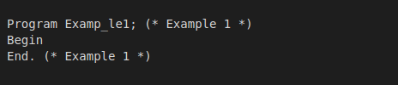

- Result:

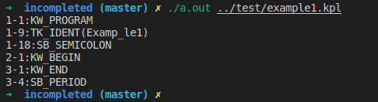

3. All keywords are in lowercase

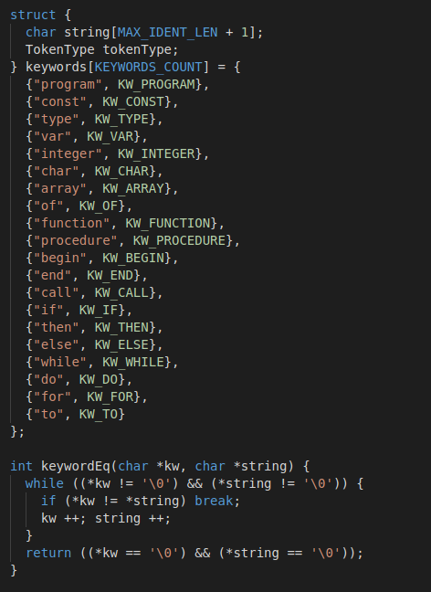
- In file token.c, I changed all keywords to lowercase and used just *string instead of toupper(*string) in function keywordEq (use to check if a string is a keyword)

- Example:

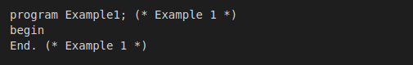

- Result:

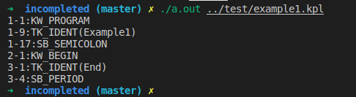

End with E here is consider as an identifier because all keywords are in lowercase

