




Digital Design Verification FYP/Internship Program
Lab 06- Link List

Name: Abdul Hadi Afzal

Date: 9 April 2025

Contents
Task1: 2
Task2: 5
Task3: 8
CONCLUSION: 14

Task1:

SS:

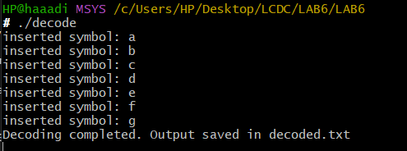

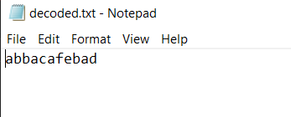
CODE:
Decode.c
/**
* Author: Abdul Hadi Afzal
* Task: Lab 6 – Huffman Decoder (Task 1: Decompress encoded file)
*/

#include <stdio.h>
#include <stdlib.h>
#include <string.h>

#define MAX_SYMBOLS 255
#define MAX_LEN 10

// Huffman tree node structure
struct tnode {
struct tnode* left;
struct tnode* right;
int isleaf;
char symbol;
};

// Global root of the Huffman tree
struct tnode* root = NULL;

/**
* @function talloc
* @desc Allocates a new tree node
*/
struct tnode* talloc() {
struct tnode* p = (struct tnode*)malloc(sizeof(struct tnode));
if (p != NULL) {
p->left = p->right = NULL;
p->symbol = 0;
p->isleaf = 0;
}
return p;
}

/**
* @function build_tree
* @desc Builds the Huffman tree from symbol-code mapping in code.txt
*/
void build_tree(FILE* fp) {
char symbol;
char strcode[MAX_LEN];
int items_read, i, len;
struct tnode* curr = NULL;

while (!feof(fp)) {
items_read = fscanf(fp, " %c %s\n", &symbol, strcode);
if (items_read != 2) break;

curr = root;
len = strlen(strcode);

for (i = 0; i < len; i++) {
if (strcode[i] == '0') {
if (curr->left == NULL)
curr->left = talloc();
curr = curr->left;
} else if (strcode[i] == '1') {
if (curr->right == NULL)
curr->right = talloc();
curr = curr->right;
}
}

curr->isleaf = 1;
curr->symbol = symbol;
printf("inserted symbol: %c\n", symbol);
}
}

/**
* @function decode
* @desc Decodes binary input using the Huffman tree and writes to output
*/
void decode(FILE* fin, FILE* fout) {
char c;
struct tnode* curr = root;

while ((c = getc(fin)) != EOF) {
if (c == '0')
curr = curr->left;
else if (c == '1')
curr = curr->right;
else
continue; // ignore unexpected characters like newline, space

if (curr->isleaf) {
fputc(curr->symbol, fout);
curr = root;
}
}
}

/**
* @function freetree
* @desc Recursively frees memory for Huffman tree
*/
void freetree(struct tnode* root) {
if (root == NULL)
return;
freetree(root->left);
freetree(root->right);
free(root);
}

/**
* @function main
* @desc Entry point: builds tree from code.txt, decodes encoded.txt to decoded.txt
*/
int main() {
const char* IN_FILE = "encoded.txt";
const char* CODE_FILE = "code.txt";
const char* OUT_FILE = "decoded.txt";

FILE* fout;
FILE* fin;

root = talloc(); // allocate root node

// Build tree from code.txt
fin = fopen(CODE_FILE, "r");
if (!fin) {
perror("Error opening code.txt");
return 1;
}
build_tree(fin);
fclose(fin);

// Decode encoded.txt
fin = fopen(IN_FILE, "r");
fout = fopen(OUT_FILE, "w");
if (!fin || !fout) {
perror("Error opening input/output files");
return 1;
}

decode(fin, fout);
fclose(fin);
fclose(fout);

// Free memory
freetree(root);

printf("Decoding completed. Output saved in decoded.txt\n");
getchar(); // pause the program
return 0;
}

Task2:
SS:
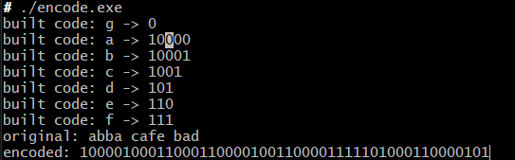

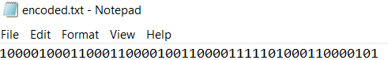
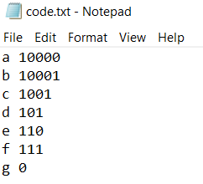
CODE:
Encoded.c
/**
* Author: Abdul Hadi Afzal
* Task: Lab 6 – Huffman Encoder (Task 2: Encode sample string using fixed frequencies)
*/

#include <stdio.h>
#include <stdlib.h>
#include <string.h>

#define MAX_SYMBOLS 255
#define MAX_LEN 10

struct tnode {
struct tnode* left;
struct tnode* right;
struct tnode* parent;
struct tnode* next;
float freq;
int isleaf;
char symbol;
};

// Global variables
char code[MAX_SYMBOLS][MAX_LEN];
struct tnode* root = NULL;
struct tnode* qhead = NULL;

// Allocate new node
struct tnode* talloc(int symbol, float freq) {
struct tnode* p = (struct tnode*)malloc(sizeof(struct tnode));
if (p) {
p->left = p->right = p->parent = p->next = NULL;
p->symbol = symbol;
p->freq = freq;
p->isleaf = 1;
}
return p;
}

// Insert into priority queue
void pq_insert(struct tnode* p) {
struct tnode *curr = qhead, *prev = NULL;

if (qhead == NULL || p->freq < qhead->freq) {
p->next = qhead;
qhead = p;
return;
}

while (curr && p->freq >= curr->freq) {
prev = curr;
curr = curr->next;
}

prev->next = p;
p->next = curr;
}

// Pop from priority queue
struct tnode* pq_pop() {
if (qhead == NULL)
return NULL;
struct tnode* p = qhead;
qhead = qhead->next;
p->next = NULL;
return p;
}

// Generate code using parent pointer
void generate_code(struct tnode* node, int depth) {
if (node->isleaf) {
int symbol = node->symbol;
code[symbol][depth] = '\0';

struct tnode* p = node;
int i = depth - 1;
while (p->parent) {
code[symbol][i--] = (p == p->parent->left) ? '0' : '1';
p = p->parent;
}

printf("built code: %c -> %s\n", symbol, code[symbol]);
} else {
if (node->left) generate_code(node->left, depth + 1);
if (node->right) generate_code(node->right, depth + 1);
}
}

// Write code table to file
void dump_code(FILE* fp) {
for (int i = 0; i < MAX_SYMBOLS; i++) {
if (code[i][0]) {
fprintf(fp, "%c %s\n", i, code[i]);
}
}
}

// Encode string using generated code
void encode(const char* str, FILE* fout) {
while (*str) {
if (*str != ' ') {
fprintf(fout, "%s", code[*str]);
}
str++;
}
}

// Free Huffman tree
void freetree(struct tnode* node) {
if (!node) return;
freetree(node->left);
freetree(node->right);
free(node);
}

// Main function
int main() {
float freq[] = {0.01, 0.04, 0.05, 0.11, 0.19, 0.20, 0.4}; // For a-g
int NCHAR = 7;
const char* test_string = "abba cafe bad";
const char* CODE_FILE = "code.txt";
const char* OUT_FILE = "encoded.txt";
FILE* fout = NULL;

memset(code, 0, sizeof(code));

// Step 1: Insert characters into queue
for (int i = 0; i < NCHAR; i++) {
pq_insert(talloc('a' + i, freq[i]));
}

// Step 2: Build Huffman tree
while (qhead && qhead->next) {
struct tnode* lc = pq_pop();
struct tnode* rc = pq_pop();
struct tnode* parent = talloc(0, lc->freq + rc->freq);
parent->isleaf = 0;
parent->left = lc;
parent->right = rc;
lc->parent = rc->parent = parent;
pq_insert(parent);
}
root = pq_pop();

// Step 3: Generate codes
generate_code(root, 0);

// Step 4: Write code.txt
fout = fopen(CODE_FILE, "w");
dump_code(fout);
fclose(fout);

// Step 5: Write encoded.txt
fout = fopen

Task3:
CODE:
* Author: Abdul Hadi Afzal
* Task: Lab 6 – Huffman Encoder (Task 3)
*/

#include <stdio.h>
#include <stdlib.h>
#include <string.h>

#define MAX_SYMBOLS 256
#define MAX_LEN 64

struct tnode {
struct tnode* left;
struct tnode* right;
struct tnode* parent;
struct tnode* next;
float freq;
int isleaf;
char symbol;
};

char code[MAX_SYMBOLS][MAX_LEN];
struct tnode* root = NULL;
struct tnode* qhead = NULL;
int char_freq[MAX_SYMBOLS] = {0};

// Allocate a tree node
struct tnode* talloc(int symbol, float freq) {
struct tnode* p = (struct tnode*)malloc(sizeof(struct tnode));
if (p) {
p->left = p->right = p->parent = p->next = NULL;
p->symbol = symbol;
p->freq = freq;
p->isleaf = 1;
}
return p;
}

// Insert into priority queue
void pq_insert(struct tnode* p) {
struct tnode *curr = qhead, *prev = NULL;

while (curr && p->freq >= curr->freq) {
prev = curr;
curr = curr->next;
}

p->next = curr;
if (prev) prev->next = p;
else qhead = p;
}

// Pop from priority queue
struct tnode* pq_pop() {
if (!qhead) return NULL;
struct tnode* p = qhead;
qhead = qhead->next;
p->next = NULL;
return p;
}

// Generate code strings using parent pointers
void generate_code(struct tnode* node, int depth) {
if (node->isleaf) {
int symbol = (unsigned char)node->symbol;
code[symbol][depth] = '\0';
struct tnode* p = node;
int i = depth - 1;
while (p->parent) {
if (p == p->parent->left)
code[symbol][i--] = '0';
else
code[symbol][i--] = '1';
p = p->parent;
}
printf("built code: %c (%d) -> %s\n", symbol, symbol, code[symbol]);
} else {
if (node->left) generate_code(node->left, depth + 1);
if (node->right) generate_code(node->right, depth + 1);
}
}

// Output codes to file
void dump_code(FILE* fp) {
for (int i = 0; i < MAX_SYMBOLS; i++) {
if (code[i][0]) {
fprintf(fp, "%c %s\n", i, code[i]);
}
}
}

// Encode input file into binary codes
void encode(FILE* fin, FILE* fout) {
int c;
while ((c = fgetc(fin)) != EOF) {
if (code[c][0]) {
fputs(code[c], fout);
}
}
}

// Free the Huffman tree
void freetree(struct tnode* node) {
if (!node) return;
freetree(node->left);
freetree(node->right);
free(node);
}

int main() {
FILE *fin, *fout;
const char* IN_FILE = "book.txt";
const char* CODE_FILE = "code.txt";
const char* OUT_FILE = "encoded.txt";

memset(code, 0, sizeof(code));
memset(char_freq, 0, sizeof(char_freq));

// Step 1: Read file and count frequencies
fin = fopen(IN_FILE, "r");
if (!fin) {
perror("Error opening book.txt");
return 1;
}

int total = 0, c;
while ((c = fgetc(fin)) != EOF) {
char_freq[c]++;
total++;
}
fclose(fin);

// Step 2: Build priority queue
for (int i = 0; i < MAX_SYMBOLS; i++) {
if (char_freq[i] > 0) {
pq_insert(talloc(i, (float)char_freq[i] / total));
}
}

// Step 3: Build Huffman tree
while (qhead && qhead->next) {
struct tnode* lc = pq_pop();
struct tnode* rc = pq_pop();
struct tnode* parent = talloc(0, lc->freq + rc->freq);
parent->isleaf = 0;
parent->left = lc;
parent->right = rc;
lc->parent = rc->parent = parent;
pq_insert(parent);
}
root = pq_pop();

// Step 4: Generate codes
generate_code(root, 0);

// Step 5: Save code.txt
fout = fopen(CODE_FILE, "w");
if (!fout) {
perror("Error writing code.txt");
return 1;
}
dump_code(fout);
fclose(fout);

// Step 6: Encode book.txt to encoded.txt
fin = fopen(IN_FILE, "r");
fout = fopen(OUT_FILE, "w");
if (!fin || !fout) {
perror("Error during encoding");
return 1;
}
encode(fin, fout);
fclose(fin);
fclose(fout);

printf("✅ book.txt compressed successfully.\n");
printf("→ Output files: encoded.txt and code.txt\n");

freetree(root);
getchar();
return 0;
}

SS:
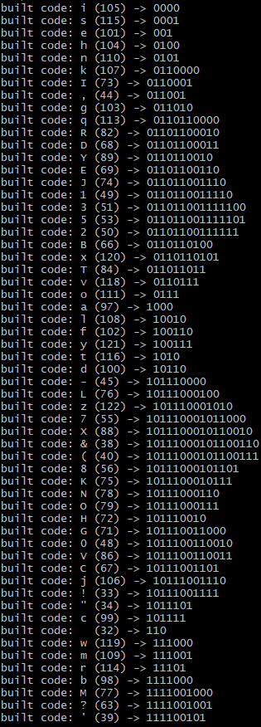
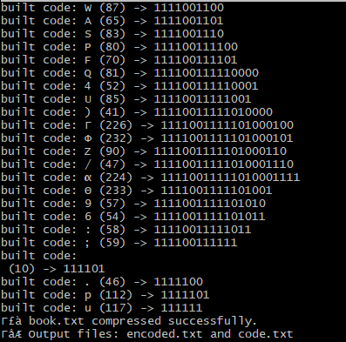
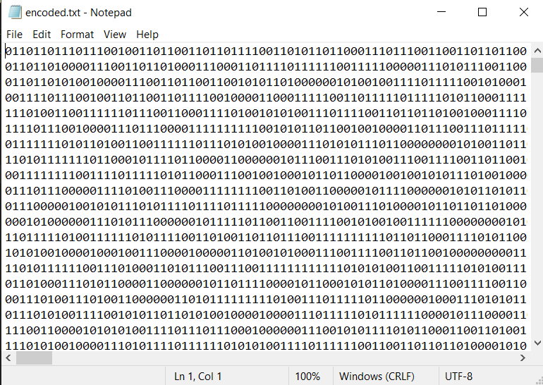

CONCLUSION:

In this lab, we successfully implemented Huffman encoding and decoding algorithms in C. The process began with building a Huffman tree from either a fixed set of frequencies (Task 2) or real character frequencies extracted from a large input file (Task 3). Using this tree, we generated optimal prefix codes for each character and encoded strings or entire files into binary form.

