BANK LOAN REPORT QUERY DOCUMENT
- BANK LOAN REPORT | SUMMARY
KPI’s:
Total Loan Applications
SELECT COUNT(id) AS Total_Loan_Applications
FROM bank_loan_data;

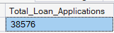
MTD Loan Applications
SELECT COUNT(id) AS MTD_Total_Loan_Applications
FROM bank_loan_data
WHERE MONTH(issue_date) = 12 AND YEAR(issue_date) = 2021;

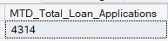
PMTD Loan Applications
SELECT COUNT(id) AS PMTD_Total_Loan_Applications
FROM bank_loan_data
WHERE MONTH(issue_date) = 11 AND YEAR(issue_date) = 2021;

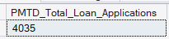

Total Funded Amount
SELECT SUM(loan_amount) AS Total_Funded_Amount
FROM bank_loan_data;

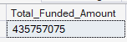
MTD Total Funded Amount
SELECT SUM(loan_amount) AS MTD_Total_Funded_Amount
FROM bank_loan_data
WHERE MONTH(issue_date) = 12 AND YEAR(issue_date) = 2021;

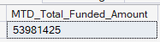
PMTD Total Funded Amount
SELECT SUM(loan_amount) AS PMTD_Total_Funded_AmountFROM bank_loan_data
WHERE MONTH(issue_date) = 11 AND YEAR(issue_date) = 2021;

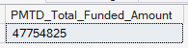

Total Amount Received
SELECT SUM(Total_payment) AS Total_Amount_Received
FROM bank_loan_data;

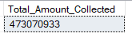
MTD Total Amount Received
SELECT SUM(Total_payment) AS MTD_Total_Amount_Received
FROM bank_loan_data
WHERE MONTH(issue_date) = 12 AND YEAR(issue_date) = 2021;

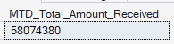
PMTD Total Amount Received
SELECT SUM(Total_payment) AS PMTD_Total_Amount_Received
FROM bank_loan_data
WHERE MONTH(issue_date) = 11 AND YEAR(issue_date) = 2021;

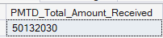

Average Interest Rate
SELECT ROUND(AVG(int_rate)*100, 2) AS Avg_Int_Rate
FROM bank_loan_data;

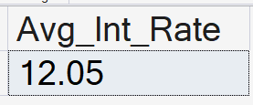
MTD Average Interest
SELECT ROUND(AVG(int_rate)*100, 2) AS MTD_Avg_Interest_Rate
FROM bank_loan_data
WHERE MONTH(issue_date) = 12 AND YEAR(issue_date) = 2021;

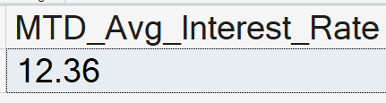
PMTD Average Interest
SELECT ROUND(AVG(int_rate)*100, 2) AS PMTD_Avg_Interest_Rate
FROM bank_loan_data
WHERE MONTH(issue_date) = 11 AND YEAR(issue_date) = 2021;

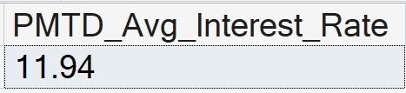

Avg DTI
SELECT ROUND(AVG(dti) * 100, 2) AS Avg_DTI
FROM bank_loan_data;

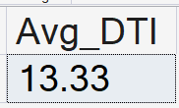

MTD Avg DTI
SELECT ROUND(AVG(dti) * 100, 2) AS MTD_Avg_DTI
FROM bank_loan_data
WHERE MONTH(issue_date) = 12 AND YEAR(issue_date) = 2021;

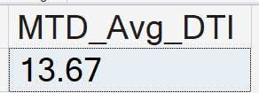

PMTD Avg DTI
SELECT ROUND(AVG(dti) * 100, 2) AS PMTD_Avg_DTI
FROM bank_loan_data
WHERE MONTH(issue_date) = 11 AND YEAR(issue_date) = 2021;

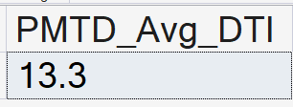

GOOD LOAN ISSUED
Good Loan Percentage
SELECT
(COUNT(CASE WHEN loan_status = 'Fully Paid' OR loan_status = 'Current' THEN id END) * 100)
/
COUNT(id)
AS Good_Loan_Percentage
FROM bank_loan_data;

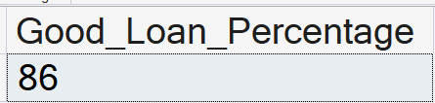

Good Loan Applications
SELECT COUNT(id) AS Good_Loan_Application
FROM bank_loan_data
WHERE loan_status = 'Fully Paid' OR loan_status = 'Current';

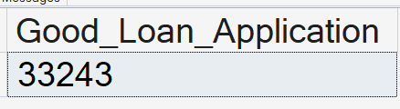

Good Loan Funded Amount
SELECT SUM(loan_amount) AS Good_Loan_Funded_Amount
FROM bank_loan_data
WHERE loan_status = 'Fully Paid' OR loan_status = 'Current';

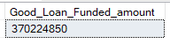

Good Loan Amount Received
SELECT SUM(total_payment) AS Good_Loan_Amount_Received
FROM bank_loan_data
WHERE loan_status = 'Fully Paid' OR loan_status = 'Current';

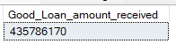

BAD LOAN ISSUED
Bad Loan Percentage
SELECT
(COUNT(CASE WHEN loan_status = 'Charged Off' THEN id END) * 100.0) /
COUNT(id) AS Bad_Loan_Percentage
FROM bank_loan_data

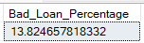

Bad Loan Applications
SELECT COUNT(id) AS Bad_Loan_Applications
FROM bank_loan_data
WHERE loan_status = 'Charged Off';

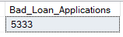

Bad Loan Funded Amount
SELECT SUM(loan_amount) AS Bad_Loan_Funded_Amount
FROM bank_loan_data
WHERE loan_status = 'Charged Off';

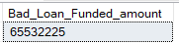

Bad Loan Amount Received
SELECT SUM(Total_Payment) AS Bad_Loan_Amount_Received
FROM bank_loan_data
WHERE loan_status = 'Charged Off';

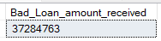

LOAN STATUS
SELECT
loan_status,
COUNT(id) AS LoanCount,
SUM(total_payment) AS Total_Amount_Received,
SUM(loan_amount) AS Total_Funded_Amount,
AVG(int_rate * 100) AS Interest_Rate,
AVG(dti * 100) AS DTI
FROM
bank_loan_data
GROUP BY
loan_status
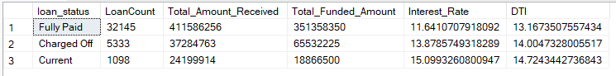

SELECT
loan_status,
SUM(total_payment) AS MTD_Total_Amount_Received,
SUM(loan_amount) As MTD_Total_Funded_Amount
FROM bank_loan_data
WHERE MONTH(issue_date) = 12
GROUP BY loan_status;

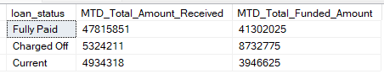

- BANK LOAN REPORT | OVERVIEW
MONTH
SELECT
MONTH(issue_date) AS Month_Munber,
DATENAME(MONTH, issue_date) AS Month_name,
COUNT(id) AS Total_Loan_Applications,
SUM(loan_amount) AS Total_Funded_Amount,
SUM(total_payment) AS Total_Amount_Received
FROM bank_loan_data
GROUP BY MONTH(issue_date), DATENAME(MONTH, issue_date)
ORDER BY MONTH(issue_date);
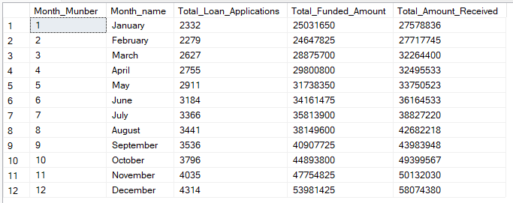

STATE
SELECT
address_state AS State,
COUNT(id) AS Total_Loan_Applications,
SUM(loan_amount) AS Total_Funded_Amount,
SUM(total_payment) AS Total_Amount_Received
FROM bank_loan_data
GROUP BY address_state
ORDER BY address_state;
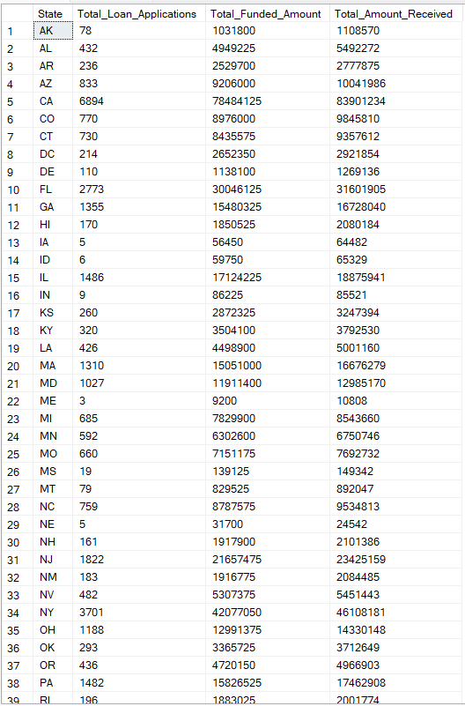

TERM
SELECT
term AS Term,
COUNT(id) AS Total_Loan_Applications,
SUM(loan_amount) AS Total_Funded_Amount,
SUM(total_payment) AS Total_Amount_Received
FROM bank_loan_data
GROUP BY term
ORDER BY term
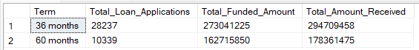

EMPLOYEE LENGTH
SELECT
emp_length AS Employee_Length,
COUNT(id) AS Total_Loan_Applications,
SUM(loan_amount) AS Total_Funded_Amount,
SUM(Total_Payment) AS Total_Received_Amount
FROM bank_loan_data
GROUP BY emp_length
ORDER BY COUNT(id) DESC;

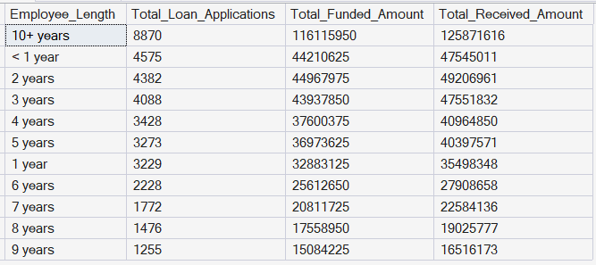

PURPOSE
SELECT
purpose AS PURPOSE,
COUNT(id) AS Total_Loan_Applications,
SUM(loan_amount) AS Total_Funded_Amount,
SUM(total_payment) AS Total_Amount_Received
FROM bank_loan_data
GROUP BY purpose
ORDER BY purpose

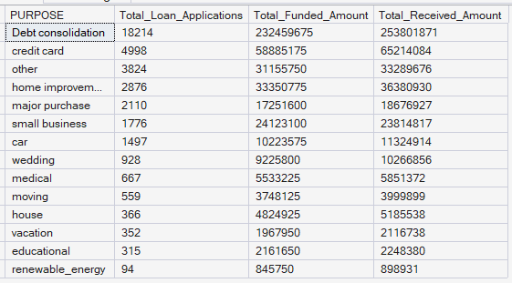

HOME OWNERSHIP
SELECT
home_ownership AS Home_Ownership,
COUNT(id) AS Total_Loan_Applications,
SUM(loan_amount) AS Total_Funded_Amount,
SUM(Total_Payment) AS Total_Received_Amount
FROM
bank_loan_data
GROUP BY home_ownership
ORDER BY COUNT(id) DESC;
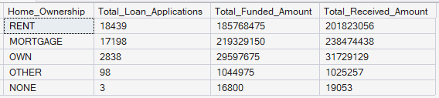

Note: We have applied multiple Filters on all the dashboards. You can check the results for the filters as well by modifying the query and comparing the results.

For e.g
See the results when we hit the Grade A in the filters for dashboards.
SELECT
purpose AS PURPOSE,
COUNT(id) AS Total_Loan_Applications,
SUM(loan_amount) AS Total_Funded_Amount,
SUM(total_payment) AS Total_Amount_Received
FROM bank_loan_data
WHERE grade = 'A'
GROUP BY purpose
ORDER BY purpose

