Sr. No | Component | Observation
1 | Name | name_variable
2 | Consumer number | consumer_number_variable
3 | Site/Location With Complete Address
  address_variable
4 | Category: Govt/Private Sector | Private Sector
5 | Sanction number
6 | Sanctioned Capacity of solar PV system (KW) Installed | Sanctioned_capacity_variable Kw
6 | Capacity of solar PV system (KW) | Reinstalled_capacity_variable Kw
7 | Specification of the Modules
7 | Make of Module | module_make_variable
7 | ALMM Model Number | model_number_variable
7 | Wattage per module | wattage_variable
7 | No. of Module | number_of_pv_modules_variable
7 | Total Capacity (KWP) | Module_capacity_variable Kw
7 | Warrantee Details (Product + Performance) | 12+13 Year
8 | PCU
8 | Make & Model number of Inverter | model_number_inverter_variable
8 | Rating | rating_variable
8 | Type of charge controller/ MPPT | MPPT
8 | Capacity of Inverter | Inverter_capacity_variable Kw
8 | HPD | 30%
8 | Year of manufacturing | 2025
9 | Earthing and Protections
9 | No of Separate Earthings with earth Resistance | THREE . AC 1.5 Ω DC 1.3 Ω
9 | It is certified that the Earth Resistance measure in presence of Licensed Electrical Contractor/Supervisor and found in order i.e. < 5 Ohms as per MNRE OM Dtd. 07.06.24 for CFA  Component.
9 | Lightening Arrester | 4 OHM

We Avidor Innovation Pvt Ltd [Vendor] & name_variable [Consumer] bearing Consumer Number consumer_number_variable Ensured structural stability of installed solar power plant and obtained requisite permissions from the concerned authority. If in future, by virtue of any means due to collapsing or damage to installed solar power plant, MSEDCL will not be held responsible for any loss to property or human life, if any. This is to Certified above Installed Solar PV System is working properly with electrical safety & Islanding switch in case of any presence of backup inverter an arrangement should be made in such way the backup inverter supply should never be synchronized with solar inverter to avoid any electrical accident due to back feeding. We will be held responsible for non-working of islanding mechanism and back feed to the de-energized grid.

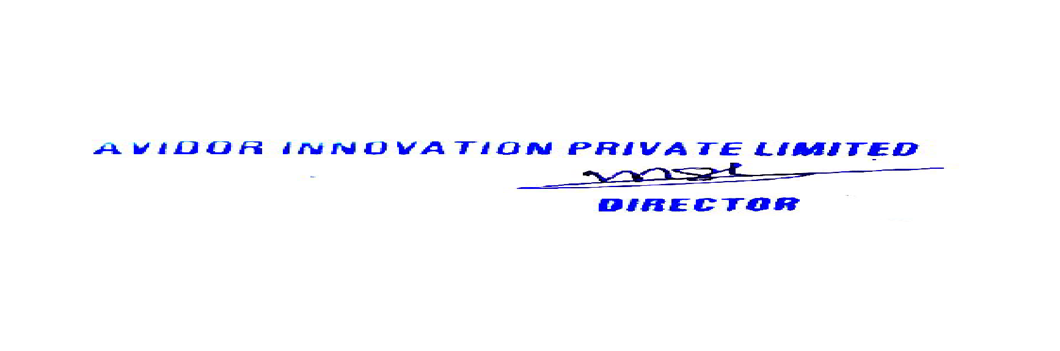 signature_image_variable
Signature [Vendor] Signature [Consumer]

Guarantee Certificate Undertaking to be submitted by VENDOR AVIDOR INNOVATION PVT LTD
The undersigned will provide the services to the consumers for repairs/maintenance of the RTS plant free of cost for 5 years of the comprehensive Maintenance Contract (CMC) period from the date of commissioning of the plant. Non performing/under-performing system component will be replaced/repaired free of cost in the CMC period

Signature [Vendor]
Stamp & Seal

Identity Details of Consumer : - name_variable
Aadhar Number : aadhar_number_variable

aadhar_image_variable

signature_image_variable

