The Economic Cost of Climate Volatility on Indian Agriculture: A District-Level Panel Analysis of Gujarat

Introduction
Climate change has now emerged as an important developmental challenge facing the economies of the Global South. Its effects are being felt in the developing economies, which are structurally more vulnerable to climatic risks. These economies are also facing challenges in adapting to these risks. ([7]) In this context, agriculture, which is structurally more vulnerable to climatic risks, is in the eye of the storm. Changes in rainfall patterns, temperature fluctuations, and increases in drought conditions are expected to have an impact on agriculture. ([9]; [15]) India is an important case in this context, as it supports one-sixth of the global population in its monsoon belt. Gujarat is an important region in India that is structurally more vulnerable to climatic risks due to its semi-arid agro-climatic conditions and dependency on rainfall during the monsoon season. ([13]) The region is mainly dependent on cash crops such as cotton and groundnuts. These crops are structurally more vulnerable to rainfall variability, delay in the onset of monsoon rains, and dry weather. ([20]; [16]; [17]) Saurashtra and Kutch are the worst-affected areas due to erratic rainfall, drought-like conditions, and increase in temperature. A major portion of the region’s arable land is rain-fed, and farmers in that region are structurally less capable of adapting to climatic risks. ([8])
Although the link between the climate factors and the yield of the crops is already established in the previous studies, quantification of the monetary value of the cost of the climate factors is the missing link in this study. The focus of the study in most of the previous studies was on the crop yield, but the monetary value of the loss in the crop yield in terms of the economic cost was not quantified ([5]). This is the missing link, which needs to be known in order to formulate appropriate adaptation strategies.
This paper aims to bridge the information gap by seeking answers to three different but related research questions. What is the historical elasticity of rice production with respect to monsoon rainfall in the districts of Gujarat? What is the monetary value of the loss in crop yield in terms of the economic costs faced by farming communities in Gujarat? To what extent have technology interventions in the form of fertilizers and irrigation been successful in insulating crop yield from the adverse effects of climate variability?
Using the two-way fixed-effects (TWFE) panel regression approach and a comprehensive dataset of all the districts of Gujarat for the period from 1966 to 2011, the author of this paper presents econometric evidence of the asymmetric effect of rainfall deviations on rice production and quantifies the cumulative loss of Rs. 139.41 Crores in terms of monetary values faced by farming communities in Gujarat. The results of this paper are significant and important contributions to the growing literature in climate economics in developing countries.

Literature Review

Impact of Rainfall and Temperature on Agricultural Productivity
A significant amount of literature has already established the strong relationship between climate factors and agricultural productivity in India. The role of rainfall variability is critical in determining crop yields, especially in rain-fed areas where agricultural activities are highly dependent on the success of the monsoon season ([1]). The empirical results have established that deviations in normal rainfall, whether in terms of rainfall deficit or excess, can cause significant damage to crop yields ([5]).
An increase in temperatures beyond optimal levels has also been established as having adverse effects on agricultural productivity in India. The rise in temperatures during critical crop growth stages has been established as having signi- ficant adverse effects in terms of yield loss, and even marginal increases in temperatures beyond optimal levels can cause significant damage to crop yields ([4]). Further, the relationship between climate factors and crop yield is non-linear in nature, and the effect of extreme events is more negative than that of normal events ([12]).

District-Level Evidence and Spatial Heterogeneity
Recently, research has started using district-level data to account for the spatial dimension of the impact of climate change on agriculture. This research shows that the impact of climate variability varies significantly across different regions due to the differing quality of the soil, irrigation facilities, and crop patterns ([3]). Panel data at the district level show the significance of rainfall, temperature, and the number of wet days in crop yields in different agro-climatic zones ([13]).
Though the recent literature has been helpful in understanding the impact of climate change on crop yields, the literature has been limited to crop yields and has not taken into account the overall impact of climate change. Moreover, the literature has been more focused on the state-level impact of climate change, whereas the impact of climate change is more relevant at the district level ([11]).

Adaptation Strategies and Policy Responses
Literature highlights the significance of adaptation strategies in minimising the impacts of climate change on agricultural activities. The strategies include expansion of irrigation facilities, adoption of climate-resilient crops, and enhancement of efficient water management practices ([10]). Studies have shown that expansion of irrigation facilities and efficient resource management help in minimising vulnerability to rainfall shocks ([8]).
Drought mitigation strategies, climate adaptation funding, and micro-irrigation facilities have been introduced as policy measures to build agricultural resilience ([2]; [14]). However, the success of these strategies varies as a result of regional differences and limitations of adaptive capacity of small and marginal farmers ([18]). In Gujarat, there has been a rise in the adoption of micro-irrigation facilities through the Gujarat Green Revolution Company (GGRC), but there is a need for expansion of facilities in the most vulnerable regions of Saurashtra and Kutch, where climate change impacts are high ([21]).

Research Gap and Objectives
While there is considerable economic literature on the climate-agriculture interface, there is still a significant knowledge gap in quantifying economic costs associated with yield impacts. Most of the previous studies have been concerned with yield impacts, but there is little focus on quantifying economic costs in terms of money lost by farmers ([5]). Moreover, there is little emphasis on district-level climate vulnerability, especially in districts with high rain-fed agriculture.
This study aims to fill in these knowledge gaps by: (1) estimating the elasticity of rice crop yields with respect to rainfall shocks using a panel regression model; (2) quantifying economic costs using farm Harvest Prices; and (3) assessing whether technology inputs have been able to ’decouple’ climate volatility from crop yields.

Data and Methodology

Data Sources
To estimate the economic damages of climate volatility, the present study constructs a comprehensive district-level panel dataset for the state of Gujarat, covering a period of 42 years (1966–2011) across 18 districts. The geographical scope provides a robust framework for empirical validation within climate economics, given the pronounced agro-climatic heterogeneity of the state. This variation ranges from the arid regions of Kutch and Saurashtra to the high-rainfall districts of South Gujarat.
Data on agricultural and socioeconomic variables are sourced primarily from the Meso-Level Database of the International Crops Research Institute for the Semi-Arid Tropics (ICRISAT-VDSA), supplemented by data from the Directorate of Economics and Statistics (DES), Government of Gujarat.
The panel dataset is constructed by merging eight distinct data files, comprising the following variables:
    - Crop-wise area sown and production volumes for major crops such as rice and wheat, which are relatively more sensitive to climatic variations and are typically associated with assured irrigation.
    - Farm Harvest Prices (FHP), used for the monetary valuation of crop output and associated damages.
    - Gross and net irrigated area.
    - Total consumption of nitrogen (N), phosphorus (P), and potassium (K) fertilizers.
    - Availability of agricultural implements and tractors.
    - Gross and net cropped area.
    - Actual monthly monsoon rainfall data (June, July–August), along with total seasonal monsoon rainfall.
    - Potential Evapotranspiration (PET), capturing atmospheric water demand.
The final merged dataset comprises 828 observations across 117 variables, making it sufficiently rich for rigorous econometric analysis.

  - Definition of Variables
The key variables used in the empirical analysis are defined as follows:
    - Rice Production (log( RICE TQ)): The natural logarithm of total rice production, measured in thousand quintals, in the i^{th} district during the t^{th} year.
    - Peak Monsoon Rainfall (log(JULAUGRF)): The natural logarithm of actual rainfall (in millimeters) during July–August. This variable captures critical growing-season rainfall for Kharif crops.
    - Drought Shock (DROUGHT): A binary indicator equal to 1 if the July–August rainfall in the i^{th} district and
t^{th} year falls below the long-term mean minus one standard deviation, and 0 otherwise.
    - Fertilizer Consumption (log(NPK TC)): The natural logarithm of total nitrogen (N), phosphorus (P), and potassium (K) Fertilizer Consumption, measured in tons. This serves as a proxy for agricultural input intensity.
    - Net Irrigated Area (NIA): Net irrigated area measured in thousand hectares, used as a proxy for technological resilience to rainfall variability.

Empirical Strategy
We posit that climate shocks, defined in terms of deviations in normal monsoon rains, have a non-linear, asymmetric impact on agricultural outputs. To verify our hypothesis, we utilize a two-way fixed-effects panel regression model with clustered standard errors. The panel design enables us to capture how identical geographic units respond to different climatic stressors. We have 18 districts with 42 years of data.
The empirical specification is defined as:
log(Y_{it}) = α + β₁ log(PeakRain_{it}) + β₂Drought_{it} + β₃ log(NPK_{it}) + β₄NIA_{it} + µ_{i} + δ_{t} + ϵ_{it}
Where:
    - log(Y_{it}) is the log of rice production (thousand quintals) for district i in year t.
    - log(PeakRain_{it}) is the log of July–August rainfall, capturing the continuous elasticity of output with respect to growing-season precipitation.
    - Drought_{it} is the binary drought shock variable, capturing the discrete impact of severe rainfall deficit years.
    - log(NPK_{it}) controls for fertilizer input intensity.
    - NIA_{it} controls for irrigation coverage as a measure of technological resilience.
    - µ_{i} captures district-specific entity fixed effects, eliminating omitted variable bias from time-invariant characteristics such as inherent soil fertility and topography.
    - δ_{t} captures year-specific time fixed effects, controlling for state-wide macroeconomic shocks such as changes in Minimum Support Prices (MSP) or agricultural policies.
    - ϵ_{it} is the idiosyncratic error term.
The standard errors are clustered at the district level to account for serial correlation at the entity level. The coefficient on β₁ represents the elasticity of yield with respect to peak monsoon rainfall, whereas β₂ represents the discrete impact of drought shock years.
To value the economic cost of climate volatility, we estimate the production shortfall as the difference between the backward-looking rolling average of rice production (taken over five years as a proxy for expected production) and actual production in deficit years. We then multiply this by the farm Harvest Price of rice (where paddy price is used as a proxy if necessary).

Results and Discussion
This section presents the results of the empirical investigation based on the district-level panel data analysis, moving from simple descriptive correlations towards more causal econometric results. The results collectively show the asymmetric and significant effect of climate variability on agricultural output.

Descriptive Correlation Analysis
The correlation between some of these input variables and rice production offers an initial indication of the existence of the climate-agriculture nexus (Figure 1). Annual rainfall is found to have a positive correlation of 0.34 with total rice production (RICE TQ), reinforcing its role in rice production. Similarly, other technological input variables such as NPK Fertiliser Consumption are found to have a positive correlation of 0.37 with rice production. Also, the availability of tractors is found to have a positive correlation of 0.40 with rice production. Interestingly, the gross cropped area (GCA) is found to have a negative correlation of -0.25 with rice production.
It is also worth noting here that although the correlation analysis indicates a positive relationship between rainfall and
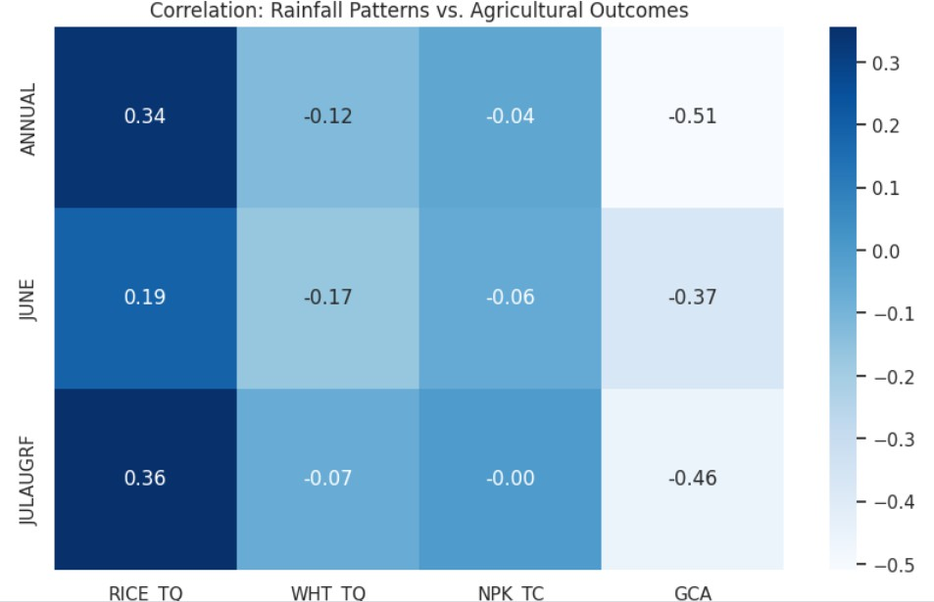
rice production, in reality, the regression analysis captures a non-linear effect of rainfall. In other words, although rainfall is found to have a positive effect in the correlation analysis, its marginal effect may be negative once extreme rainfall and drought shocks are controlled for in the regression analysis.
Figure 1: Correlation Analysis: Input factors vs. Rice Production

On the other hand, the link between rainfall patterns and fertilizer use displays an interesting disconnect (Figure 2). The correlation between rainfall levels and total NPK use is negligible at −0.04, whereas rainfall in the months of July- August displays a near-zero correlation of −0.00 with total NPK use. Only potassium use (K TC) displays a moderate correlation of 0.20 with rainfall levels. This pattern suggests that fertilizer use decisions are primarily driven by subsidy policies and fertilizer market factors, rather than agro-climatic factors.

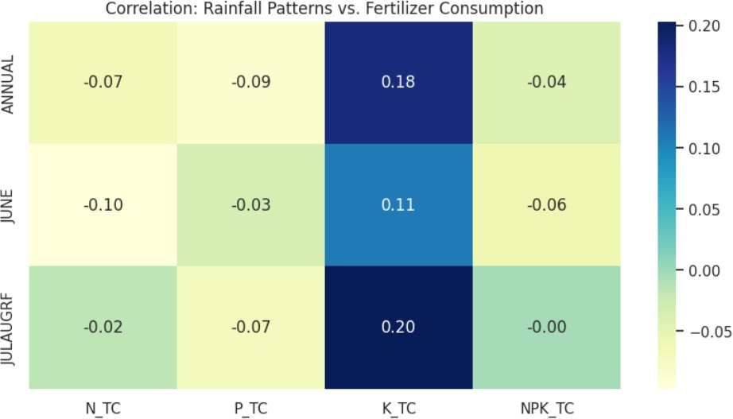

Figure 2: Correlation: Rainfall Patterns vs. fertiliser Consumption

Rainfall Timing and Sowing Behaviour
The data shows that the timing of rainfall shocks affects economic outcomes in unique ways. The study of planting decisions (Figure 3) shows that there is a positive linear relationship between early monsoon rainfall and total sown area for Kharif season crops like rice. Rainfall in June acts as an important signal for farmers. If there is deficient rainfall during this time, it affects the gross cropped area since farmers become risk-averse and do not want to invest in seeds during a delayed onset.
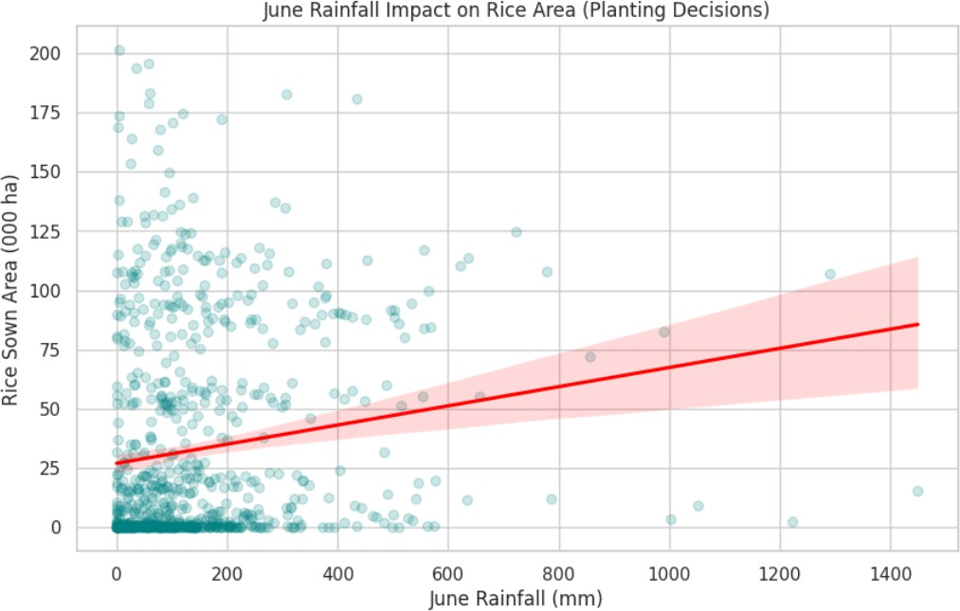
Figure 3: June Rainfall Impact on Rice Area (Planting Decisions)

The relationship that the scatter plot of July-August rainfall and rice quantity in Figure 4 reinforces is the dependence on the growth season. In this figure, we observe the concentration of crop failure at the low end of the spectrum. Beyond the 400 mm of peak monsoon rains, the quantities produced are significantly higher. However, the relationship is highly non-linear: the marginal benefit of more rains diminishes at the high end, and the marginal loss of rains is extremely high.

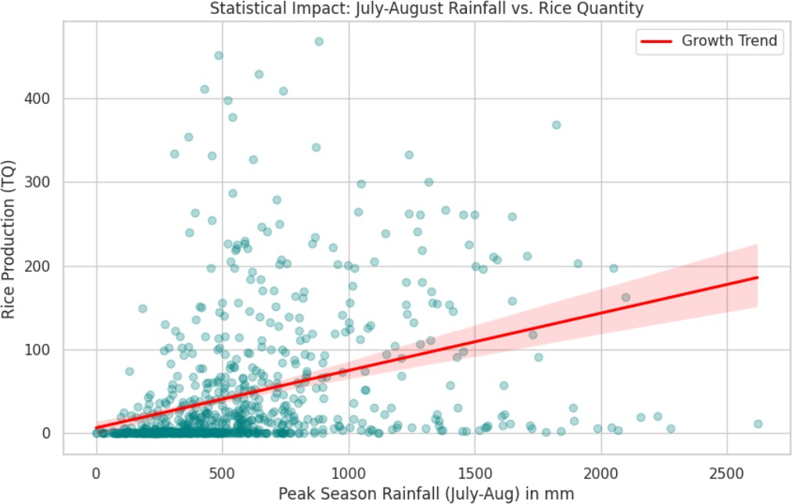

Figure 4: Statistical Impact: July–August Rainfall vs. Rice Quantity

Asymmetric Impact of Monsoon Quality on Output
The most striking result is the severe and non-linear economic impact of deficient monsoons. The categorization of historical seasons according to the quality of the monsoon—deficient, normal, and abundant—highlights the stark asymmetry in output levels (Figure 5). The average rice production under a deficient monsoon drops to near negligible levels. However, the output under abundant monsoons is significantly higher and illustrates the asymmetric impact of the economy in Gujarat with respect to the risk of deficient rainfall.

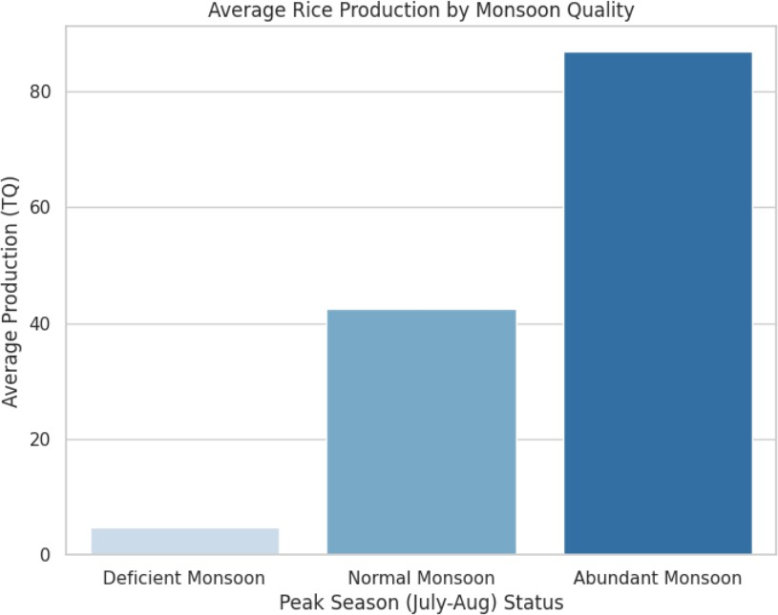

Figure 5: Average Rice Production by Monsoon Quality

The historical data on yearly peak monsoon rainfall vs. rice production (Figure 5) verifies this correlation over the entire period. While there is an upward trend in production capacity due to technological improvements, the correlation between rainfall troughs and production crashes is unmistakable, with every drought year in the 45-year history corresponding to an immediate collapse in production.
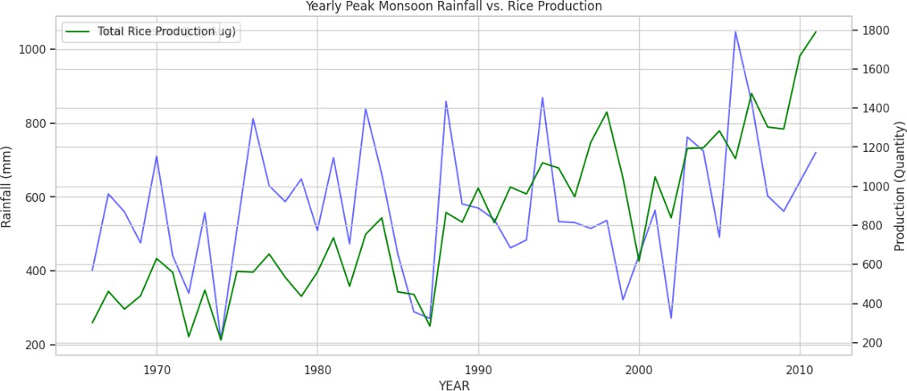

Figure 6: Yearly Peak Monsoon Rainfall vs. Rice Production

Technological Adoption vs. Climate Vulnerability
To test if technology has acted as a buffer for farmers against climate-related shocks, the study examined the relationship between rainfall and fertilizer consumption. The scatter plot for rainfall against total NPK consumption (Figure 7) reveals that the trend line is flat with almost negligible slope (R² ≈ 0), further supporting that fertilizer consumption is completely unrelated to rainfall.

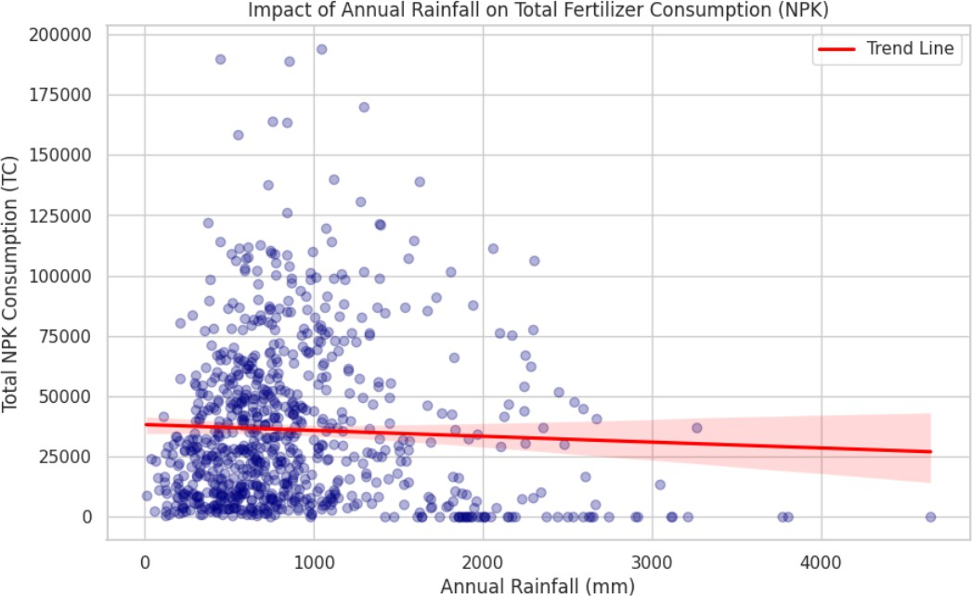

Figure 7: Impact of Annual Rainfall on Total Fertiliser Consumption

Moreover, the longitudinal time series plot (Figure 8) again points to an important difference: whereas fertilizers have been monotonically increasing over time due to state subsidies and policies like the Green Revolution, rainfall fluctuates wildly between extremes. This demonstrates that though fertilizers have certainly increased the level at which production capacity is maintained, fertilizers have not managed to insulate Gujarat’s agricultural economy at all from climatic fluctuations.
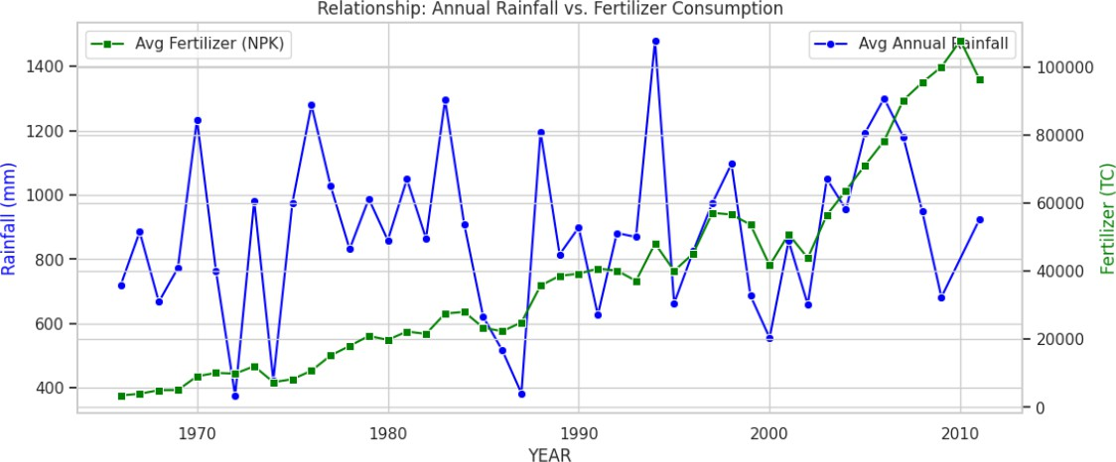

Figure 8: Relationship: Annual Rainfall vs. Fertiliser Consumption (1966–2011)

Panel Regression Estimates
The estimates from the two-way Fixed effects PanelOLS regression with entity clustered standard errors are provided in Table 1. The regression model is estimated on 756 observations, spanning 18 districts and 42 time periods.
The moderate within R² of 0.081 is common for panel models with strong two-way fixed effects, in which much of the cross-sectional and temporal variation is captured by the entity- and time-control variables. The overall R² of 0.341, as well as the highly significant robust F -test (F = 8.651, p < 0.001), support the model’s ability to explain a significant proportion of total variation, as well as the significance of the included regressors.

Table 1: Two-Way Fixed-Effects Panel Regression Results
Variable | Coefficient | Std. Error | t-stat | p-value
log(PeakRain) | −0.1235 | 0.0517 | −2.387 | 0.017∗∗
Drought Shock | −0.2981 | 0.0709 | −4.206 | 0.000∗∗∗
log(NPK) | 0.1601 | 0.1012 | 1.582 | 0.114
Net Irrigated Area | 0.0008 | 0.0023 | 0.339 | 0.735
R² (Within) | 0.081
R² (Overall) | 0.341
F-statistic (robust) | 8.651 (p = 0.000)
Observations | 756
Entities (Districts) | 18
Time Periods | 42
Fixed Effects | Entity + Time
Cov. Estimator | Clustered (Entity)
Significance: ∗∗∗p<0.01; ∗∗p<0.05; ∗p<0.10.
Dependent variable: log(RICE TQ).

Two findings warrant further discussion. first, the coefficient estimate for log(PeakRain) is − 0.1235 and is statistic- ally significant at the 5% level (p = 0.017). The negative sign of this coefficient requires careful interpretation. In the pres- ence of the binary Drought Shock variable, which captures the large discrete effects of severe rainfall deficits, log(PeakRain) reflects residual variation in peak monsoon rainfall within districts. This residual variation is primarily driven by excessive rainfall events, such as water logging, flooding, and crop submergence, which are known to reduce yields in low-lying rice-growing regions of Gujarat ([19]). Consequently, the negative coefficient is economically intuitive: conditional on the absence of drought shocks, higher-than-normal peak rainfall is associated with diminishing and eventually negative marginal productivity. This finding is consistent with the non-linear, inverse-U relationship between precipitation and crop yields documented in the literature ([12]; [5]).
Second, and more dramatically, the Drought Shock dummy is highly significant (β = −0.2981, p < 0.001). This shows that a change into a drought state, defined as a peak rainfall that is more than one standard deviation away from the historical mean for the district, results in a 29.81% collapse in rice production, regardless of the effect of rainfall.
These results offer powerful evidence for the hypothesis that climate variability has asymmetric and economically significant effects on agricultural output in semi-arid regions.
The lack of significance of log(NPK) (p = 0.114) and Net Irrigated Area (p = 0.735), after including the fixed effects of entity and time, is also noteworthy. The lack of significance of irrigation suggests that the current level of irrig- ation in Gujarat is either too low in aggregate or too unevenly distributed in districts to deliver year-over-year resilience against rainfall shocks. The improvements in fertilizers and irrigation, which are visible over the sample period, are en- tirely explained by the time fixed effects and do not deliver any additional climate resilience in districts. Technology has improved baseline productivity but has not succeeded in delivering decoupling of agricultural output from the variability of the monsoon.

Economic Cost Estimation
To convert the results of the econometric analysis into a concrete form of monetary costs, the “production shortfall” is defined as the positive difference between a five-year backward-looking rolling mean of rice production (taken as a proxy for expected rice production) and actual rice production. The “production shortfall” is then multiplied by the “Farm Harvest Price” (using “paddy” prices as a proxy for rice prices where rice prices are not available).
The total monetary value of climate change-induced rice production shortfalls in all 18 districts of Gujarat for the entire study period amounts to Rs. 139.41 Crores.
This result should be viewed as a conservative lower bound, as it only focuses on rice crops and does not account for any general equilibrium effects. However, even this conservative lower bound of Rs. 139.41 Crores highlights the significant macro-economic impact of rainfall variability on the agricultural economy of Gujarat. Table 2 and Figure 9 show the results of the analysis of the district-wise distribution of the total cumulative costs.

Table 2: Cumulative Economic Cost of Rice Production Losses by District (1966–2011)

District | Total Loss (Rs. Crores)
Panch Mahals | 34.02
Kheda | 28.05
Ahmedabad | 17.45
Valsad | 12.79
Surat | 10.71
Sabarkantha | 9.16
Kaira | 8.00
Baroda | 5.95
Vadodara | 4.25
Bulsar | 3.84
Dangs | 1.24
Bharuch | 1.04
Mehsana | 1.00
Broach | 0.99
Junagadh | 0.34
Bhavnagar | 0.18
Rajkot | 0.13
Banaskantha | 0.08
Amreli | 0.05
Jamnagar | 0.04
Surendranagar | 0.03
Dang | 0.03
Total | 139.41

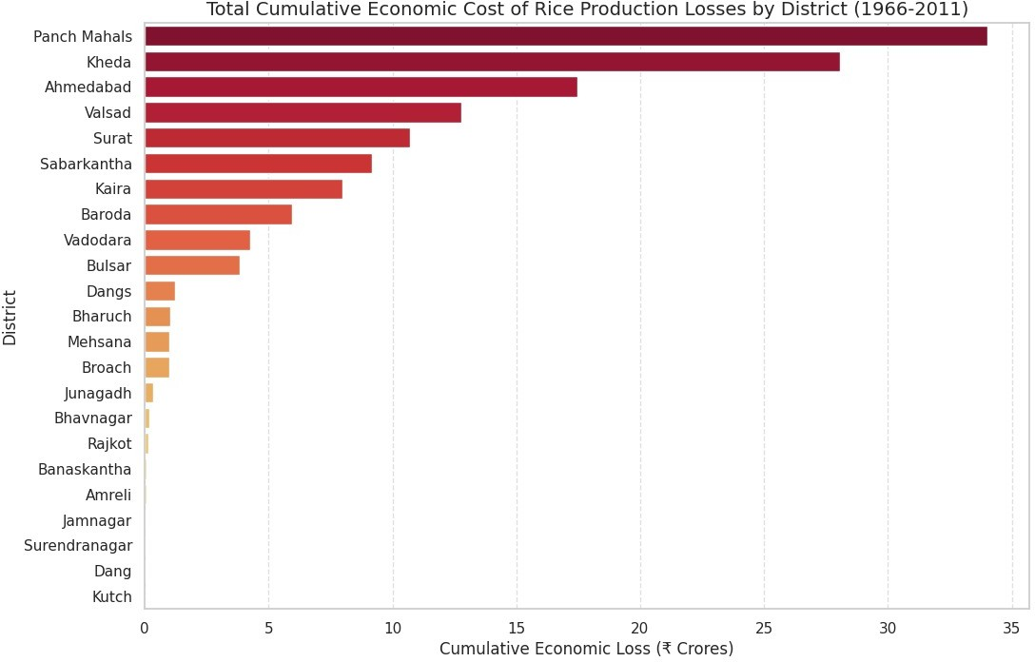
The distribution is highly skewed, with Panch Mahals and Kheda contributing disproportionately to total economic losses.

Figure 9: Total Cumulative Economic Cost of Rice Production Losses by District (1966–2011)
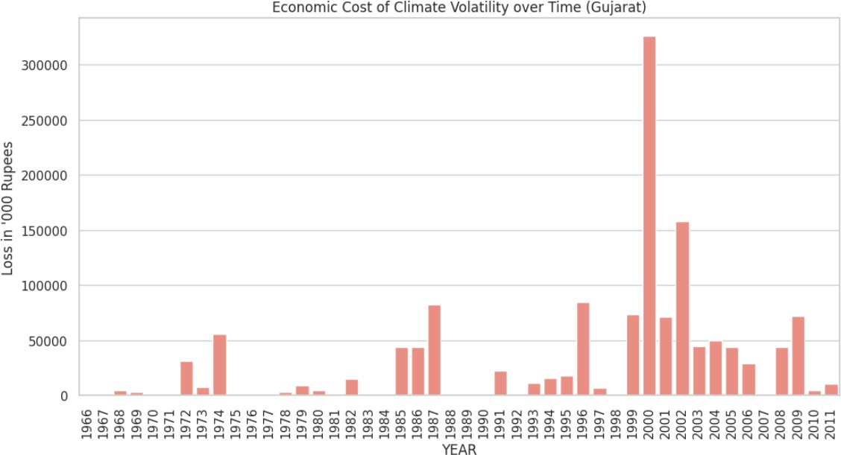

Figure 10: Economic Cost of Climate Volatility over Time (1966–2011)

Policy Implications
The empirical results provided in the preceding section provide direct motivation for the policy interventions that follow. The magnitude and asymmetry of the climate-related shocks necessitate the transition from reactive and responsive relief measures to proactive and integrated adaptation strategies.
The empirical results provided in this study underscore the harsh reality that faces developing economies: climate volatility is no longer in the future but is presently causing severe macro-economic losses in the agricultural sector. The asymmetric effects of rainfall deviations across the districts of Gujarat underscore the imperative for developing economies to transition from reactive and responsive disaster relief to proactive and integrated climate adaptation.

Scaling Precision Irrigation in High-Risk Zones
Moreover, our results show that the existing level of irrigation has not provided statistically significant in-district resili- ence against rainfall shocks, although this is likely explained by the prevalence of traditional flood-based irrigation systems, which are water-intensive and ecologically unsustainable in water-scarce regions such as Saurashtra and Kutch districts of Gujarat. State interventions should therefore focus on precision agriculture. The structure established by the Gujarat Green Revolution Company (GGRC) is a viable basis ([21]). However, subsidies for micro-irrigation (drip and sprinkler systems) should be dynamically rescaled, with support inversely proportional to the district’s historical groundwater availability, thus creating incentives to drive rapid adoption in the most climatically vulnerable agro-climatic zones.

Transitioning to Weather-Indexed Insurance Models
However, the estimated loss figure of Rs. 139.41 Crores also points to the limitations of conventional crop insurance products that focus on yield as an underlying factor. These products face severe reporting problems and basis risks. The statistically significant Drought Shock dummy (β = −0.2981, p < 0.001) offers an opportunity for a trigger for para- metric insurance products. By employing high-resolution gridded weather data from the India Meteorological Depart- ment (IMD), insurance claims can be automatically generated if peak monsoon rainfall is observed to be one standard deviation lower than normal for a given district. This eliminates time-consuming crop-cutting experiments and directly infuses capital into rural communities.

Incentivising Agro-Ecological Crop Diversification
The structural dependence of the districts on water-intensive cash crops, especially Bt cotton and groundnut, is an ex- treme case of maladaptation to the changing realities of climate change. The state government, in association with the central procurement agencies, should strengthen the Minimum Support Price (MSP) commitment and procurement infrastructure for climate-resistant coarse grains such as sorghum (jowar) and pearl millet (bajra). The drought-resistant crops should be made economically viable in comparison to traditional cash crops, which would help in an agro-ecological transformation that ensures farmer incomes without groundwater depletion.

Aligning Adaptation with Sustainable Development
Ultimately, the adaptation strategies in developing economies cannot be isolated from the larger development agenda. The trade-off between agricultural development and ecological protection is significant. It is essential to consider the agricultural development strategies from a multi-dimensional angle, such that the strategies to improve agricultural yield resilience in the short term are not at the expense of long-term ecological stability, aligning agricultural development in the region with the Sustainable Development Goals (SDG 2: Zero Hunger, SDG 13: Climate Action).

Conclusion
This study provides a fine-grained estimate of the economic costs associated with climate volatility on agricultural pro- ductivity in Gujarat. Using a two-way fixed-effects panel regression model applied to district-level data covering 18 dis- tricts over 42 years (1966–2011), the analysis identifies localized, within-district elasticities of rice production with respect to monsoon rainfall shocks. This approach moves beyond state-level averages and uncovers the underlying spatial heterogeneity in climate risk.
The empirical results yield three key findings. first, peak monsoon rainfall (July–August) is statistically significant in explaining rice production, with drought years leading to an immediate 29.81% decline in output (p < 0.001). The continuous rainfall elasticity (β = −0.12, p = 0.017) captures additional damages arising from excessive rainfall, con- ditional on the absence of drought conditions, consistent with the well-established non-linear relationship between pre- cipitation and crop yields. Second, the cumulative economic damages associated with climate-induced rice production losses are estimated at Rs. 139.41 crores, representing a conservative lower-bound estimate of the macroeconomic costs of rainfall variability in Gujarat. Third, the statistical insignificance of fertiliser consumption and irrigation coverage as within-district resilience factors, even after controlling for secular trends, suggests that input-driven agricultural modern- ization has improved productivity but has not effectively mitigated vulnerability to monsoon-related climate shocks.
These findings carry important policy implications. The economic damages associated with climate-driven agricul- tural losses substantially exceed the compensatory capacity of conventional disaster relief mechanisms. By quantifying the monetary cost of climate volatility at a disaggregated level, this study contributes to the broader climate impact literature and provides evidence for the need to design more targeted and climate-resilient agricultural policies in Gujarat.

6.1 Limitations
This study also has a number of limitations that need to be considered. firstly, the time dimension of the data only goes up to 2011. Although this allows us to compute long-run baseline elasticities, it does not allow us to capture any potential structural changes that may have occurred in climate-agriculture dynamics in the subsequent decade, including the expansion of micro-irrigation, the introduction of new crop varieties, and the evolution of rainfall patterns. Secondly, this study only focuses on rice. Expanding this analysis to include other important crops such as cotton, groundnut, and wheat would give a more holistic picture of the aggregate economic costs. Thirdly, the monetization of the damages does not include a structural estimation but instead relies on a rolling mean shortfall approach, and does not consider general equilibrium effects such as multiplier effects on rural consumption, employment, and input markets. fourthly, the study’s spatial analysis only focuses on 18 districts.

6.2 Future Research Directions
There are also several directions for further research that emerge from this study. Extension of the sample period up to more recent years, with additional data on micro-irrigation adoption and weather insurance coverage since 2011, would allow for a comparison of the effectiveness of adaptation. Using spatial econometrics techniques to control for cross- district spillovers of rainfall shocks could also offer deeper insights into regional climate change risk. furthermore, using structural estimation of welfare losses, which takes into account equilibrium effects and farmers’ risk behavior, could make the results on economic cost more policy-relevant. finally, linking up the econometric approach with climate model projections using general circulation models (GCMs) could allow for projections of economic costs of climate change in the future, depending on emission scenarios.x`

7. References
[1] Bal, S. K., et al. (2022). Assessing impact of dry spells on the principal rainfed crops in major dryland regions of India. Agricultural and Forest Meteorology, 314.
https://doi.org/10.1016/j.agrformet.2021.108768
[2] Datta, A., & Behera, B. (2024). State action plans on climate change and agricultural adaptation in India. Environmental Science & Policy.
https://doi.org/10.1016/j.agsy.2023.103840
[3] Bora, P. (2022). Rainfall shocks and fertilizer use: A district-level study of India. Environment and Development Economics, 27(3), 1–20.
https://doi.org/10.1017/S1355770X21000413
[4] Somanathan, E., et al. (2021). The impact of temperature on productivity and labor supply: Evidence from Indian agriculture. American Economic Journal: Applied Economics, 13(2), 179–214.
https://doi.org/10.1086/713733
[5] Chuang, Y. (2019). Climate variability, rainfall shocks, and farmers’ income diversification: Evidence from India. Economics Letters, 176, 40–44.
https://doi.org/10.1016/j.econlet.2018.10.015
[6] Davis, K. F., et al. (2019). Sensitivity of grain yields to historical climate variability in India. Environmental Research Letters, 14(6).
https://doi.org/10.1088/1748-9326/ab22db
[7] Costinot, A., Donaldson, D., & Smith, C. (2016). Evolving comparative advantage and the impact of climate change in agricultural markets. Journal of Political Economy, 124(1), 205–248.
https://doi.org/10.1086/684719
[8] Fishman, R. (2018). Groundwater depletion limits the scope for adaptation to climate change in India. Climatic Change, 148(1–2), 195–209.
https://doi.org/10.1007/s10584-018-2146-x
[9] Guntukula, R. (2020). Assessing the impact of climate change on Indian agriculture. Journal of Public Affairs, 20(1).
https://doi.org/10.1002/pa.2040
[10] Hebsale, M., et al. (2023). Climate-smart agriculture technologies adoption: Evidence from Gujarat, India. Frontiers in Sustainable Food Systems, 7.
https://doi.org/10.3389/fsufs.2023.1202485
[11] Lamichhane, P., Hadjikakou, M., Miller, K. K., & Bryan, B. A. (2022). Climate change adaptation in smallholder agriculture: Adoption, barriers, determinants, and policy implications. Mitigation and Adaptation Strategies for Global Change, 27, Article 32. https://doi.org/10.1007/s11027-022-10010-z
[12] Mujtaba, A., et al. (2023). Examining asymmetric impact of climatic factors on crop yields in India. Applied Economics Letters, 30(10).
https://doi.org/10.1080/13504851.2022.2064416
[13] Singh, S., et al. (2022). Association of sustainable food security and climate change in Gujarat. In Climate Change and Agriculture. Springer.
https://doi.org/10.1007/978-3-030-98617-9_16
[14] Narayanamoorthy, A. (2017). Economics of drip irrigation in India. Agricultural Economics Research Review, 30(2), 255–264.
https://doi.org/10.25175/jrd/2017/v36/i3/118062
[15] Praveen, N., & Sharma, P. (2020). Climate change and its impacts on Indian agriculture. Journal of Public Affairs, 20(4).
https://doi.org/10.1002/pa.1972
[16] Rajput, K., et al. (2021). Crop diversification in Gujarat. Agricultural Economics Research Review, 34(1), 67–78.
https://doi.org/10.13140/RG.2.2.24401.25440
[17] Birthal, P. S., et al. (2014). Impact of climate change on yields of major food crops in India. Agricultural Economics Research Review, 27(2), 145–155.
https://doi.org/10.5958/0974-0279.2014.00019.6
[18] Dell, M., Jones, B. F., & Olken, B. A. (2012). Temperature shocks and economic growth. American Economic Journal: Macroeconomics, 4(3), 66–95.
https://doi.org/10.1257/mac.4.3.66
[19] Sur, K., & Lunagaria, M. (2020). Association between drought and agricultural productivity in Gujarat. Journal of Water and Climate Change, 11(S1), 189–202.
https://doi.org/10.2166/wcc.2020.157
[21] Kumar, M. D., & van Dam, J. C. (2013). Drivers of change in agricultural water productivity in India. Water Internation–al, 38(2), 162–180.
https://doi.org/10.1080/02508060.2013.793572

