Cc2652P Firmware Flashing

Firmware acquisition
Download the ZNP firmware of CC2652P USB Dongle from the following link:
https://www.home-assistant.io/integrations/zha
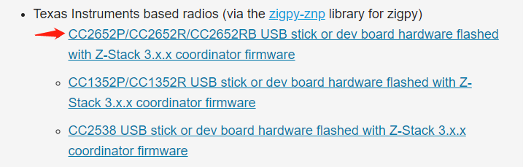
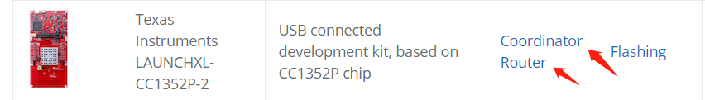

Firmware flashing
CC2652P USB Dongle supports serial port Bootloader to flash firmware.

1.2.1 Enter the serial port Bootloader
There are two ways for Dongle to enter Bootloader:
- Manual mode
Keep pressing the Boot button, restart the device, and release the Boot button after Dongle enters the serial port Bootloader.
- Automatically enter the serial port Bootloader through a python script
Step to execute python script:
- Download, unzip and execute the file
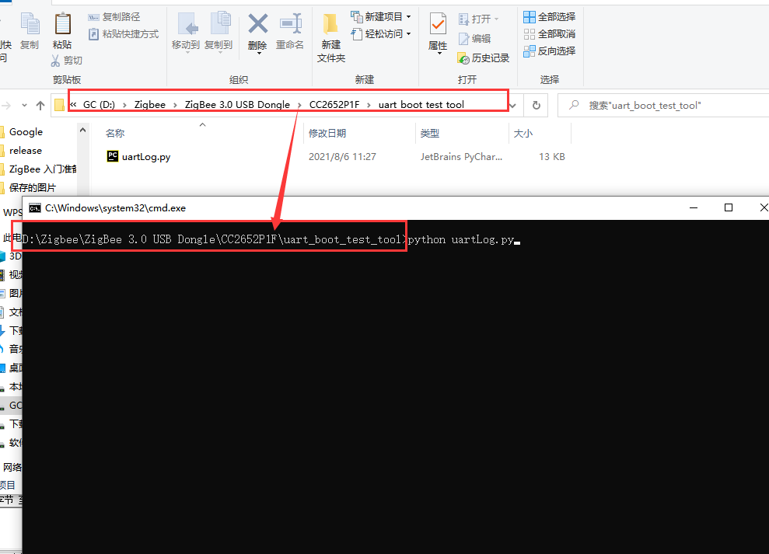
- Enter the serial port number inserted into the dongle
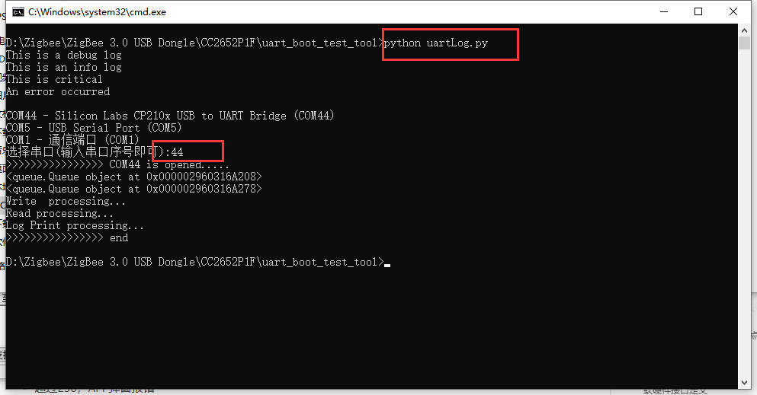
- After executing the file, enter 55 55 in the serial port assistant tool, and receive the returned result 00 CC, which means that the dongle has successfully entered the Bootloader.
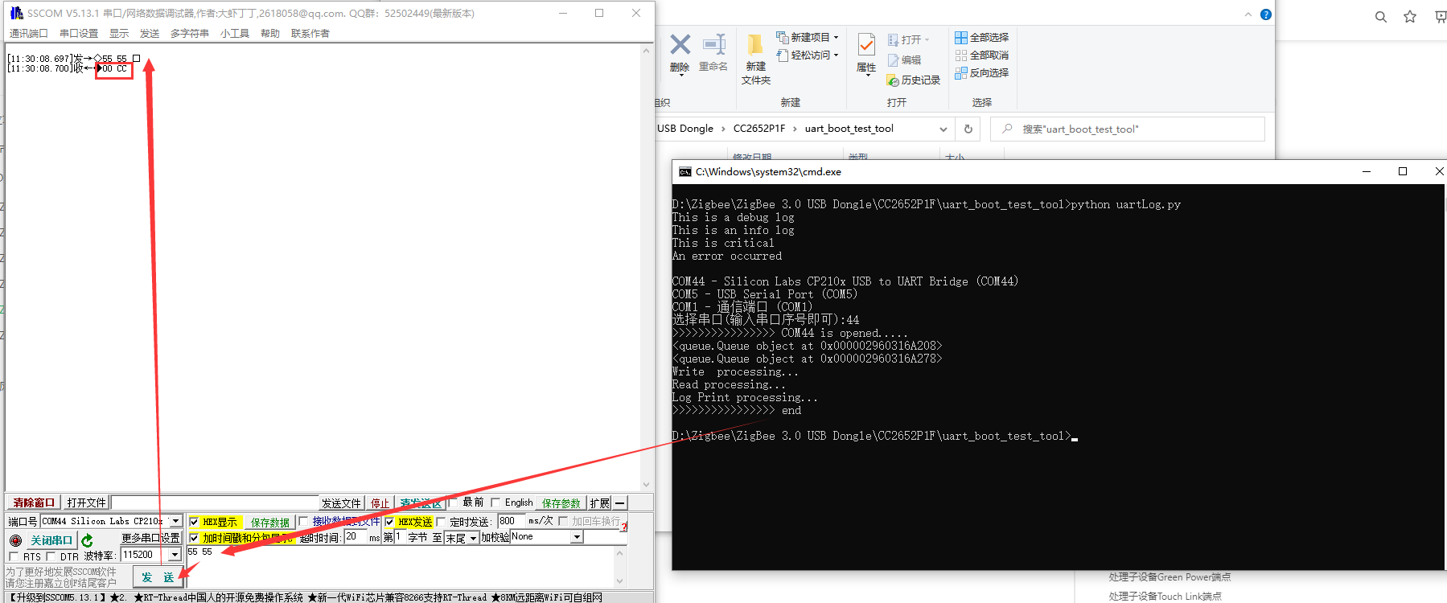

Note: The serial port Bootloader does not enable hardware flow control.

1.2.2 Using Flash Programmer2 serial port flashing firmware
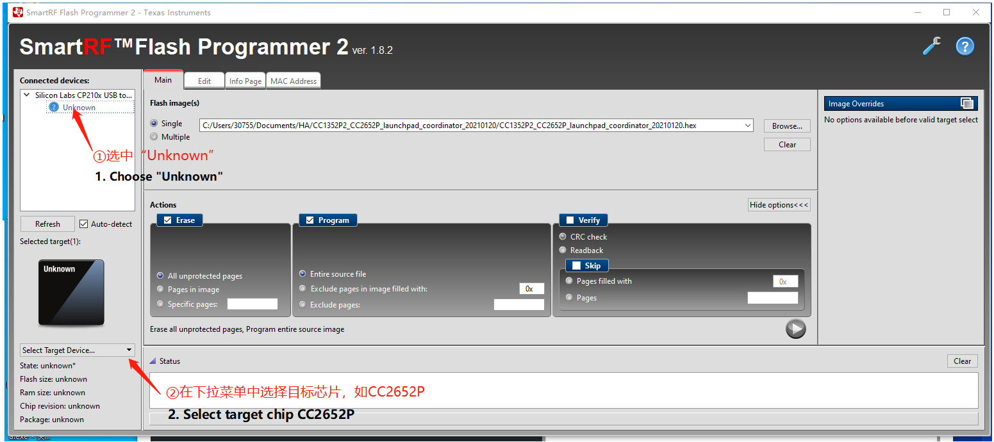
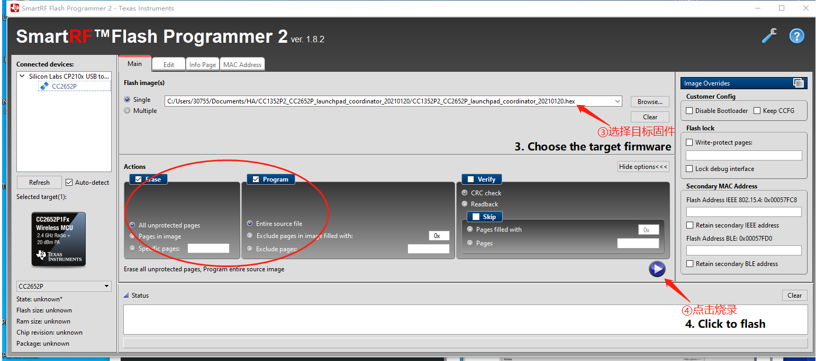
Note: There is no difference between the coordinator and routing firmware flashing steps.

Enable hardware flow control and generate firmware (optional)
If you need to enable the hardware flow control of the CC2652P USB Dongle, you need to use CCS to import the ZNP project to configure and compile the firmware that supports the hardware flow control.

Import the ZNP project of CC1352P into CCS
CCS【Project】 - 【Import CCS Project】
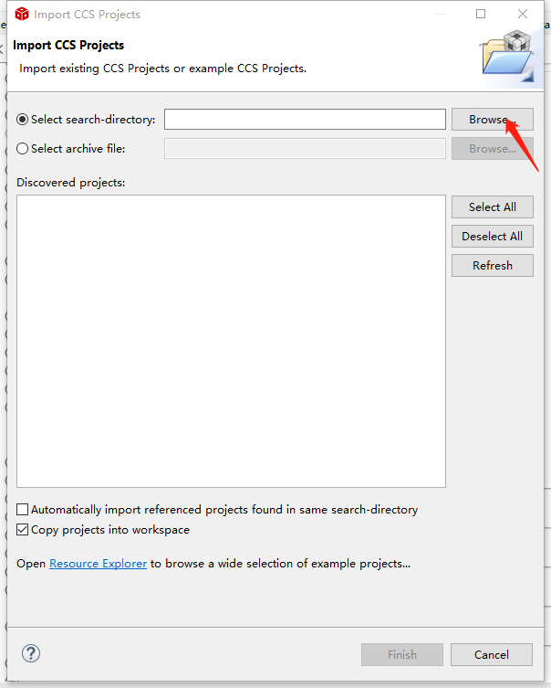
Click [Browse] and select the ZNP project file under SDK:
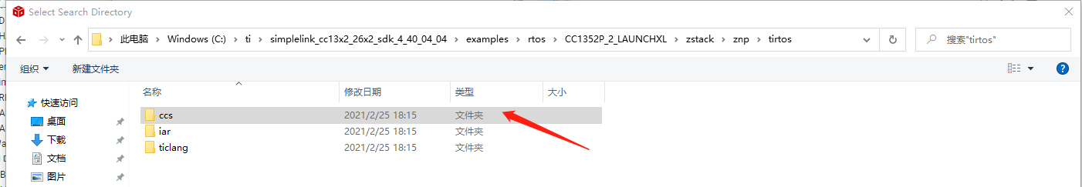
Click [Finish]

Configure engineering hardware flow control
Open the .syscfg configuration file in the ZNP project:

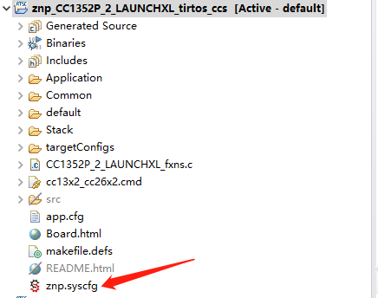
Enable serial flow control in the UART option in the .syscfg configuration file:
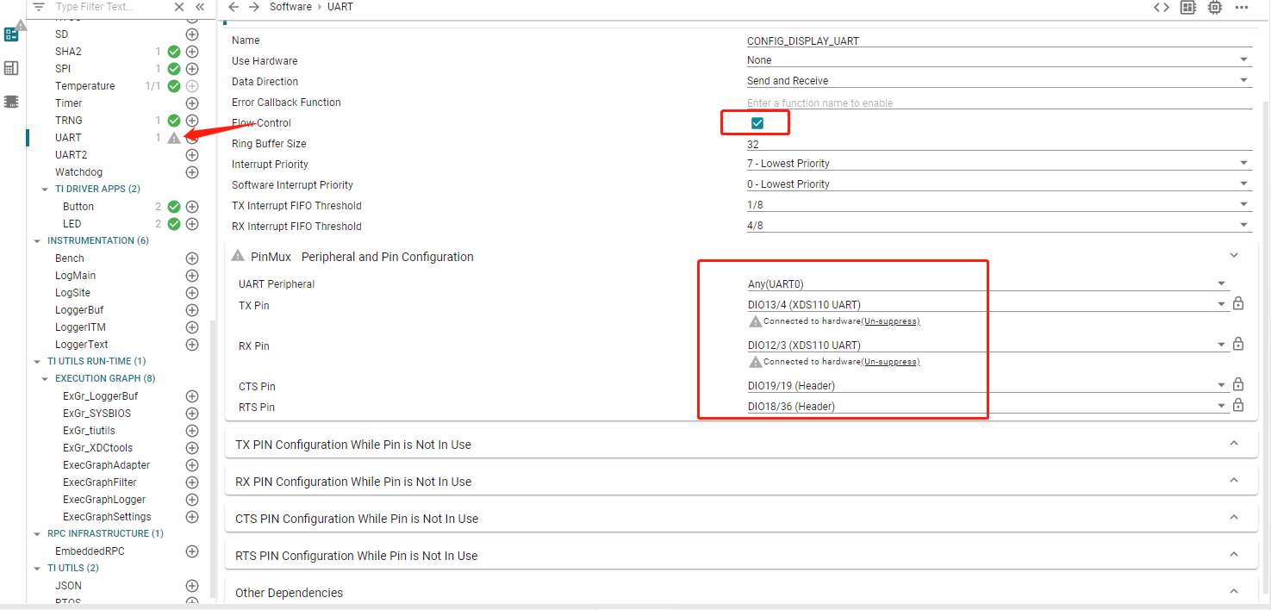
Then save and compile.

Adding routers to the gateway
The guide is for the routers that flashed with the official router firmware.
- Download the official host computer SDK
https://www.ti.com.cn/tool/cn/SIMPLELINK-CC13X2-26X2-SDK
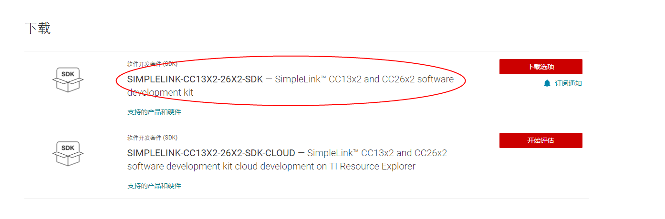
- execute the Z-Tool.exe
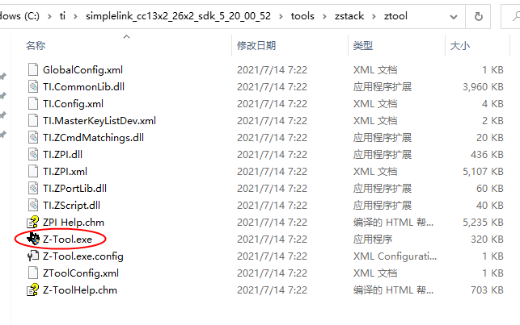
- Set the serial port baud rate to 115200
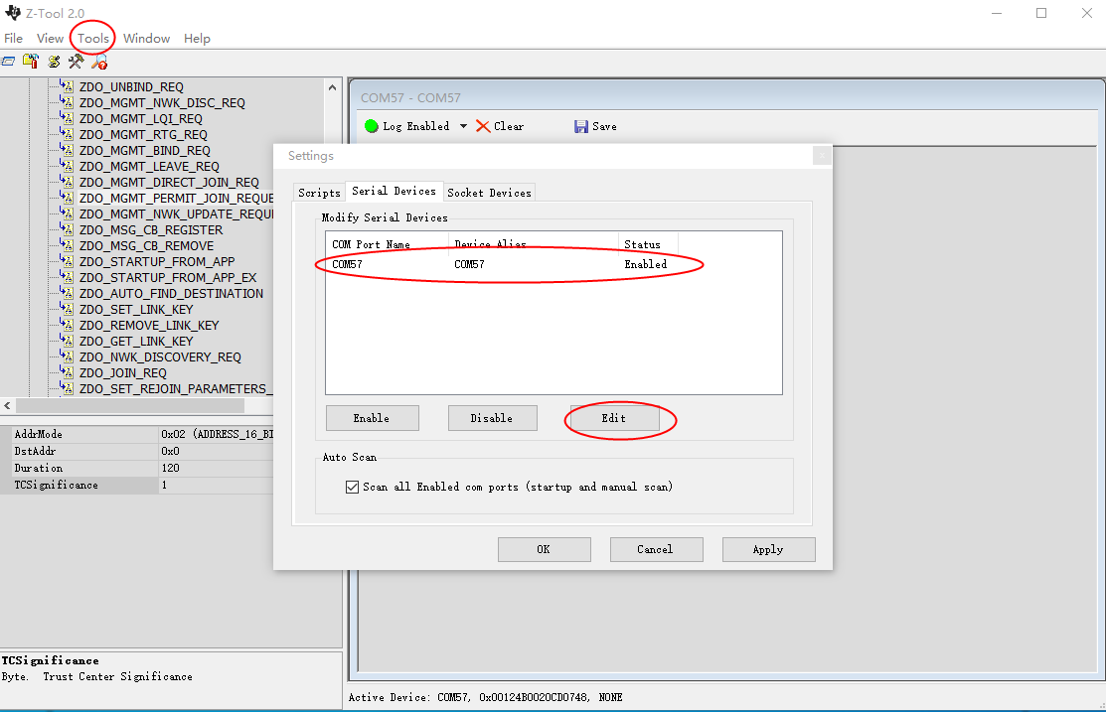
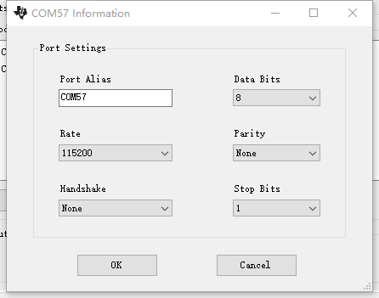
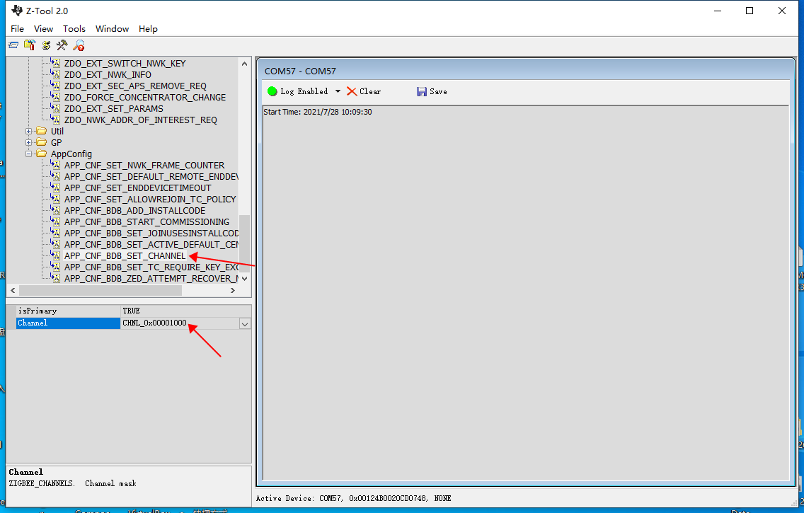
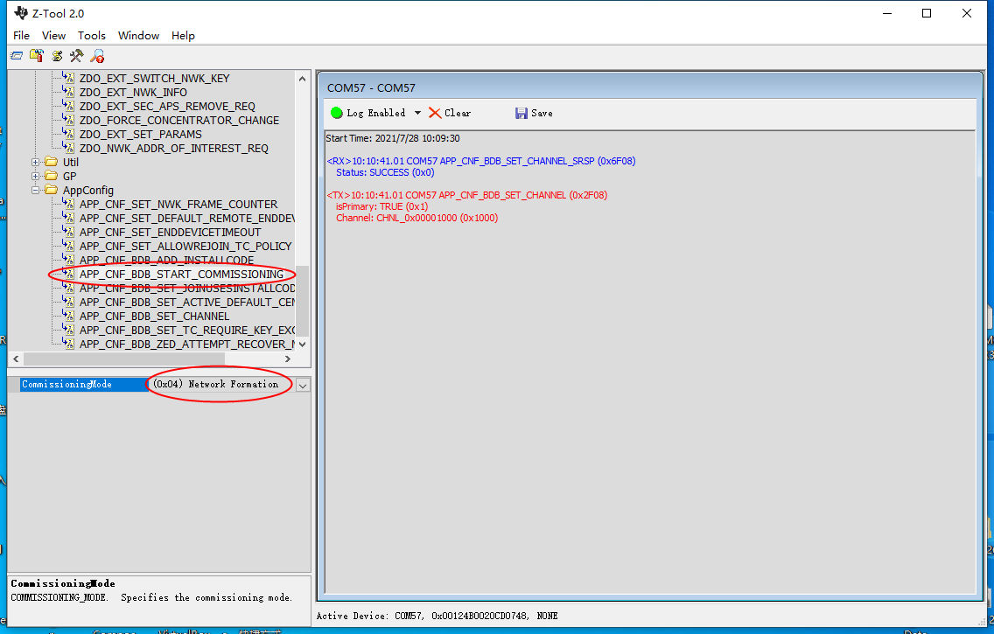
- 0x09 means establish network successfully
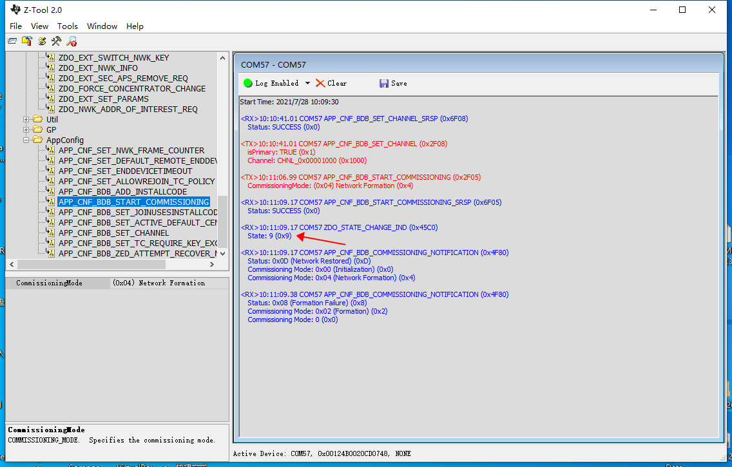
- Open network, and add device
